Installing Bootstrap in visual studio for mac.

Right click on Dependencies folder:

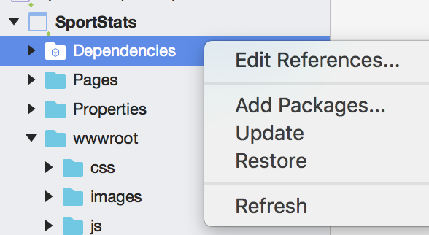

Select “Add Packages”:

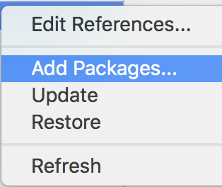

Then select the package you want to install:

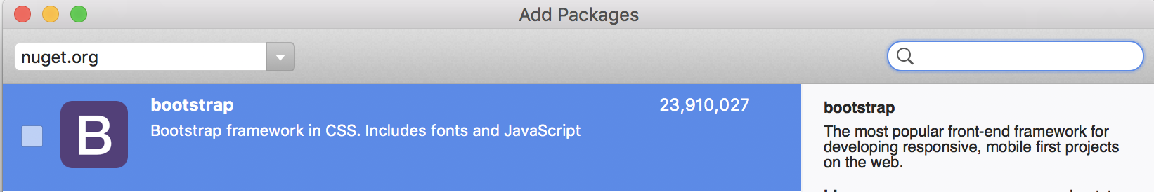

Source template:

<https://www.c-sharpcorner.com/article/asp-net-core-2-0-apply-bootstrap-template/>

**STEP3 - Change Layout**

The default bootstrap template used in Visual Studio 2017 is Jumbotron. Jumbotron’s original source code is available [here](http://getbootstrap.com/getting-started/#download) on the Bootstrap website.

In this sample, we will change this template to a free bootstrap template named "Creative" that could be downloaded from [here](https://startbootstrap.com/template-overviews/creative/).

To make that change we need to

* Add a stylesheet, creative.css to the CSS folder
* Add a stylesheet creative.js to the JS folder
* Add the image folder from the template downloaded
* Add the CSS folder from the template downloaded
* Add the vendor folder from the template downloaded
* 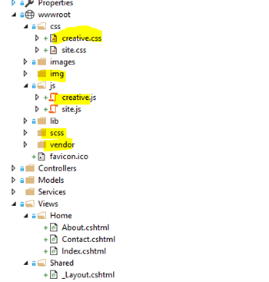
* Now, open the layout file _Layout.cshtml in the Shared folder under Views folder.

Copy the content from index.html to layout.cshtml according to your layout.

This is the sample created with the solution.

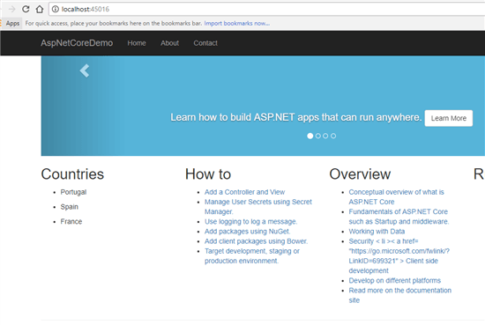

This is the sample after our changes.

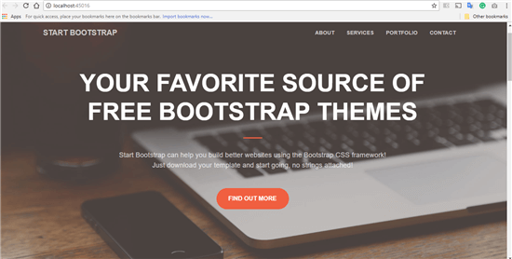

Start Bootstrap

* Home (current)
* About
* Services
* Contact

# Business Name or Tagline

Lorem ipsum dolor sit amet, consectetur adipisicing elit. Non possimus ab labore provident mollitia. Id assumenda voluptate earum corporis facere quibusdam quisquam iste ipsa cumque unde nisi, totam quas ipsam.

## What We Do

Lorem ipsum dolor sit amet, consectetur adipisicing elit. A deserunt neque tempore recusandae animi soluta quasi? Asperiores rem dolore eaque vel, porro, soluta unde debitis aliquam laboriosam. Repellat explicabo, maiores!

Lorem ipsum dolor sit amet, consectetur adipisicing elit. Omnis optio neque consectetur consequatur magni in nisi, natus beatae quidem quam odit commodi ducimus totam eum, alias, adipisci nesciunt voluptate. Voluptatum.

Call to Action »

## Contact Us

**Start Bootstrap**   
3481 Melrose Place   
Beverly Hills, CA 90210

P: (123) 456-7890   
E: [name@example.com](mailto:)

#### Card title

Lorem ipsum dolor sit amet, consectetur adipisicing elit. Sapiente esse necessitatibus neque sequi doloribus.

Find Out More!

#### Card title

Lorem ipsum dolor sit amet, consectetur adipisicing elit. Sapiente esse necessitatibus neque sequi doloribus totam ut praesentium aut.

Find Out More!

#### Card title

Lorem ipsum dolor sit amet, consectetur adipisicing elit. Sapiente esse necessitatibus neque.

Find Out More!

Copyright © Your Website 2019

Rendor body problems:

<div class="container body-content">  
            @RenderBody()  
            <hr />  
            <footer>  
                <p>&copy; 2019 - SportStats</p>  
            </footer>  
        </div>

@RenderSection("Scripts", required: false)

Get node install which is npm.

With homebrew you need: brew install node

<a class="btn btn-primary btn-lg" href="/MainCalcPage">Calculate &raquo;</a>