Data Synthesis Plan
for Nighttime Streetlight Detection
Controlled synthetic illumination and confounder augmentation for improving physical streetlight recognition
Working document • September 2026

1. Purpose and central idea
The current dataset is dominated by well-lit urban scenes because the available road footage was captured largely in areas with good public lighting. As a result, the detector has insufficient exposure to dim, flickering, or failed streetlights and risks learning a shortcut: detecting bright light sources rather than identifying the physical streetlight structure.
The proposed solution is to create controlled counterfactual versions of real frames. The underlying road, buildings, vehicles, poles, lamp geometry, camera characteristics, and existing distractors remain unchanged while the illumination state of selected streetlights is modified. This should teach the detector that the identity of a streetlight is not equivalent to the intensity of its emitted light.
The primary synthesis mechanism should therefore be deterministic, region-aware image processing rather than unconstrained generative image editing. Generative editing can be useful for a small visual proof-of-concept, but the training dataset should be produced by a reproducible pipeline whose transformations, severity levels, random seeds, and source frames can all be documented.

2. What the representative frames tell us
The representative images show that the project is not operating in a visually simple nighttime environment. They contain several distinct scene regimes that should be deliberately preserved in the synthetic dataset:
- Open or divided roads containing long sequences of relatively regular streetlights.
- Dense commercial streets where shop signs, windows, vehicle lamps, brake lights, and illuminated advertisements create strong competing light sources.
- Narrow residential streets where streetlights may be partly hidden by trees, buildings, wires, parked vehicles, or other street furniture.
- Warm/orange sodium-like illumination as well as cooler white LED illumination.
- Heavy traffic, headlights, taillights, reflections, motion blur, windshield effects, and exposure variation.
- Scenes where a streetlight is visible as a bright source but its supporting pole is difficult to see.
- Scenes with substantial ambient illumination in which the streetlight is only one of many bright objects.
These characteristics make the requested 40% confounder-heavy synthetic subset particularly valuable. It should not mean merely making the whole image darker. It should mean selecting source frames in which realistic competing light sources are already present, then changing the streetlight state while deliberately retaining those competing sources.

3. Design principles
Principle | Operational meaning
Real image first | Every synthetic image should originate from an actual captured frame. Synthetic generation changes a real scene rather than constructing an entirely artificial road scene.
Geometry is preserved | Streetlight/pole locations, shapes, occlusions, perspective, and object annotations remain unchanged unless a transformation is explicitly designed to alter only illumination appearance.
Illumination is the controlled variable | The main intervention is working → dim → severely dim → off, with flicker represented as temporal/state variation.
Confounders remain realistic | Vehicle headlights, shop signs, windows, traffic signals, reflections, and other bright sources should not be removed when creating the difficult subset.
Reproducibility | The same source image plus the same transformation parameters must reproduce the same output.
No synthetic-only evaluation | Real held-out frames should remain the primary validation/test evidence. Synthetic data is principally for training augmentation.
Severity is continuous | Avoid a binary normal/off formulation. Include intermediate degradation levels so the model learns a robust relationship rather than a single artificial appearance.

4. Proposed synthetic dataset composition
The synthetic pool should be explicitly stratified. Exactly 40% of synthetic images should come from confounder-heavy source situations, while the remaining 60% should come from comparatively ordinary nighttime scenes. The 40%/60% split applies to the synthetic pool; it does not require the original real dataset to have the same distribution.
Synthetic subset | Share | Source-frame requirement | Main purpose
Confounder-heavy | 40% | Strong headlights, brake lights, shop signage, windows, reflections, dense traffic or multiple bright objects. | Break the 'brightest light = streetlight' shortcut.
Ordinary nighttime | 60% | Streetlight scenes with fewer competing luminous objects; retain natural scene diversity. | Teach robustness to illumination degradation without making every sample adversarially crowded.
Within both subsets, use the following initial illumination-state distribution as a starting point:
State | Initial share | What is changed | Annotation
Mildly dim | 25% | Reduce lamp/halo contribution modestly. | Unchanged
Moderately/severely dim | 25% | Progressively reduce emission and local glow. | Unchanged
Flickering | 20% | Generate alternate illumination states/severities. | Unchanged
Off / failed | 20% | Remove most direct emission and halo while preserving physical structure. | Unchanged
Mixed/combined | 10% | Apply a mixture of dim/off/flicker to different eligible lights in one frame. | Unchanged
The percentages above are a proposed starting distribution, not a fixed requirement. They should be adjusted after inspecting the real validation distribution. The important constraint is that dim/off/flicker examples become common enough during training that illumination intensity cannot serve as a reliable shortcut.

5. Transformation families

5.1 Local dimming
For a selected streetlight, attenuate the luminous component within a spatially defined lamp/halo region rather than multiplying the entire image by a global darkness factor. A simple formulation is I'(x) = I(x)·α(x), where α(x) is close to 1 outside the selected light region and decreases smoothly toward the lamp centre.
- Use a soft spatial mask rather than a hard-edged rectangle.
- Support multiple severity levels, e.g. mild, moderate, severe.
- Preserve nearby road/building illumination unless the transformation explicitly models the loss of that light's contribution.
- Avoid creating a conspicuous dark circle around the lamp.

5.2 Failed/off streetlight
The off transformation should suppress the direct luminous source and its halo while retaining the pole, fixture, surrounding background, occlusion relationships, and scene geometry. Where the original light creates spill illumination on nearby surfaces, the implementation should attenuate that spill conservatively rather than globally darkening the neighbourhood.
- The pole must remain visible whenever it was visible in the source frame.
- The resulting image should look like a plausible failed lamp, not like an object was digitally erased.
- For distant lights, allow the halo to disappear while retaining a small physical fixture/pole cue when resolution permits.

5.3 Flicker
Flicker should be represented as a family of illumination states rather than a single visual effect. For example, one source frame can produce several versions corresponding to high, medium, low, and nearly-off emission. If adjacent frames from the original video are used, the state sequence can additionally be made temporally coherent.
- Use small, medium, and large changes in intensity.
- Avoid perfectly periodic synthetic flicker unless there is evidence that such periodicity is realistic.
- If multiple lights are present, different lights may receive different states to model partial failures.

5.4 Confounder-heavy synthesis
This is the most important special subset. Select frames where non-streetlight luminous objects are prominent: vehicle headlights, brake lights, shop signs, illuminated windows, traffic signals, advertisements, reflections, or combinations of these. Then alter the streetlights while leaving the confounders untouched.
- Do not artificially brighten confounders just to make the image difficult; real confounder-rich frames are preferable.
- A useful counterfactual is: bright streetlight → dim streetlight while the vehicle headlights/signage remain exactly as captured.
- Another useful counterfactual is: bright streetlight → off while nearby shop/window/headlight sources remain bright.
- This directly tests whether the model uses physical streetlight structure rather than raw brightness.

6. Selecting source frames
The source-frame selection step should happen before synthesis. The goal is to maximize scene diversity and avoid producing hundreds of nearly identical synthetic images from adjacent video frames.
- Recover the original frame timestamps or source frame indices for the existing 1-FPS extraction.
- Create a candidate pool from the original videos at a higher temporal sampling rate than 1 FPS.
- Reject candidates that are exact or near duplicates of already-used frames.
- Prefer candidates separated in time and, more importantly, sufficiently different in visual content.
- Stratify selected candidates into ordinary and confounder-heavy groups before applying transformations.
- Prefer frames containing visible streetlight structure because synthetic illumination degradation is intended to change appearance, not invent missing geometry.
A timestamp-only exclusion rule is not sufficient. A frame at 137.0 s and one at 138.0 s may be nearly identical if the vehicle is moving slowly, while a frame only a fraction of a second later can be meaningfully different in a busy scene. Therefore, timestamp separation should be combined with perceptual redundancy filtering.

7. FFmpeg-based frame provenance and timestamp handling
Since the existing extraction was performed with FFmpeg rather than OpenCV, the provenance pipeline should remain FFmpeg/ffprobe-based. The exact timestamp relationship depends on the extraction command, source frame rate, presentation timestamps (PTS), and whether the input is constant-frame-rate or variable-frame-rate.
If the original extraction used a filter such as fps=1, the intended sampling interval is one second, but the most reliable way to recover the actual selected times is to inspect the stream/frame timestamps rather than infer them solely from the output filename.
For a new extraction, record timestamps explicitly. For example, FFmpeg's showinfo filter can expose the timestamps of frames passing through the filter:
ffmpeg -i input.mp4 -vf "fps=1,showinfo" -f null - 2> timestamps.txt
For deeper provenance, ffprobe can be used to inspect frame-level timestamps. The exact command should be chosen after checking the original video container and codec. The key point is that every source image selected for synthesis should eventually have metadata such as video_id, source_timestamp, source_frame_index (when available), transformation_type, severity, random_seed, and synthetic_image_id.

8. Near-duplicate filtering
The recommended selection rule is a two-stage filter. First apply a temporal exclusion window to avoid taking adjacent frames from the same driving segment. Then apply a visual similarity test to remove frames that remain redundant.
- Exact duplicate check: file hash or decoded-pixel hash.
- Perceptual duplicate check: perceptual hash (pHash/dHash) for a cheap first pass.
- Optional stronger check: SSIM or a feature-embedding distance for borderline cases.
- Keep the candidate if its visual distance from recently selected frames exceeds a chosen threshold.
- Tune the threshold on a small manually inspected sample rather than choosing it arbitrarily.
This produces a dataset whose diversity is determined by scene change rather than simply by the number of seconds in the video.

9. Annotation strategy
The principal advantage of deterministic illumination synthesis is that labels can usually be inherited directly from the source frame. If a transformation changes only appearance and not object geometry, the streetlight bounding boxes and class labels remain unchanged.
Object/label | Synthetic treatment | Reason
Full Streetlight | Bounding box unchanged. | Physical object remains in the same location.
Bulb/Halo Only | Bounding box unchanged; emitted intensity changes. | The target class should not become equivalent to brightness.
Pole | Geometry unchanged. | Pole visibility/structure is the desired physical cue.
Illumination region | Update only if the dataset's illumination mask is defined as emitted/spill illumination and the transformation changes that region. | Prevents inconsistent auxiliary supervision.
If the illumination segmentation target represents illuminated road area rather than the streetlight object itself, the mask cannot simply be copied unchanged for an off-light transformation. That target should either be regenerated from the synthetic illumination model or omitted from that particular synthetic supervision task. The detector labels, however, should remain unchanged when only illumination is modified.

10. Preventing synthetic-data leakage and shortcut learning
- Split source videos/scenes before synthesis. Do not create synthetic versions of a source frame and then place one version in training and another version in validation/test.
- Keep a real-only validation/test set untouched by synthesis.
- Do not evaluate success only on synthetic images.
- Record the source image for every synthetic sample so that related samples can be grouped during splitting.
- Avoid one transformation signature becoming an unintended label: for example, every 'off' sample should not have the same halo shape, mask edge, or local contrast artifact.
- Randomize transformation severity and selected lights, but keep the random seed recorded.

11. Recommended experimental design
The synthesis should be introduced as a controlled training-data intervention so that its effect can be measured independently from the architectural modifications already being studied.
Experiment | Training data | Purpose | Expected interpretation
E0 | Real training set only | Baseline. | Measures current detector behaviour.
E1 | Real + synthetic, ordinary subset only | Measure benefit of illumination synthesis without confounder targeting. | Tests whether counterfactual illumination alone helps.
E2 | Real + synthetic with 40% confounder-heavy | Primary proposed experiment. | Tests whether synthesis specifically reduces bright-confounder errors.
E3 | Real + synthetic with alternative confounder ratio | Optional sensitivity analysis. | Checks whether 40% is unusually good or part of a broader trend.
For the primary comparison, keep model architecture, optimizer, epochs, augmentation policy, image resolution, random seed policy, and evaluation set fixed. Only the training-data composition should change.

12. What success should look like
The objective is not simply a higher aggregate mAP. The strongest evidence would be a reduction in false detections of non-streetlight light sources while maintaining or improving recall for dim/weakly illuminated streetlights.
- mAP50 and mAP50-95 on the untouched real test set.
- Precision, recall, and F1.
- False positives per frame, especially for headlights, brake lights, illuminated signs, windows, and reflections.
- Per-condition recall for clearly visible, dim, severely dim, and occluded streetlights, where enough real examples exist to support a meaningful estimate.
- Performance broken down by confounder-heavy versus ordinary real scenes.
- Optional confusion/error taxonomy: 'bright non-streetlight detected', 'streetlight missed', 'wrong class', 'poor localization'.

13. End-to-end implementation pipeline
The proposed pipeline is:
Original driving videos
→ Existing 1-FPS frame inventory + timestamp provenance
→ Candidate extraction at higher temporal density
→ Exact/near-duplicate filtering
→ Scene stratification: ordinary vs confounder-heavy
→ Select source frames
→ Identify eligible streetlight regions from existing annotations
→ Apply deterministic illumination transformations
→ Generate metadata + inherited labels
→ Quality-control pass
→ Merge with real training data
→ Train detector
→ Evaluate only on fixed real validation/test data

14. Quality-control checklist
- Does the modified lamp still look like the same physical object?
- Is there any obvious rectangular/circular editing boundary?
- Has the transformation accidentally altered vehicles, signs, windows, or road markings?
- Does an 'off' lamp still have a plausible pole/fixture appearance?
- Does a dim lamp have a realistic intermediate intensity rather than a simple black/white switch?
- Are confounders still present in the 40% difficult subset?
- Are synthetic examples visually diverse enough that the model cannot identify the transformation itself?
- Can the exact source frame and transformation parameters be recovered from metadata?
- Are all related variants of one source frame kept in the same dataset split?

15. Practical implementation phases
Phase 1 — Provenance: Recover/record timestamps for the existing FFmpeg extraction and build a candidate-frame selector that performs temporal + perceptual redundancy filtering.
Phase 2 — One-light synthesis: Implement deterministic local dimming and off transformations for a single annotated streetlight. Manually inspect 20–50 outputs.
Phase 3 — Severity and flicker: Add multiple severity levels and flicker-state generation. Validate that no transformation artifacts become obvious.
Phase 4 — Confounder selection: Build a 40% confounder-heavy source subset using real frames with strong competing light sources.
Phase 5 — Dataset generation: Generate the full synthetic pool with complete metadata and inherited labels.
Phase 6 — Controlled experiment: Train real-only, synthetic-augmented, and primary 40%-confounder-heavy variants under the same training protocol.
Phase 7 — Error analysis: Inspect false positives and false negatives to determine whether the detector has actually shifted from brightness-based recognition toward physical streetlight cues.

16. Recommended first implementation
Do not generate thousands of images immediately. The first milestone should be a small, auditable pilot set. Take approximately 50–100 diverse real frames, with roughly 40% deliberately selected from confounder-heavy scenes. For each frame, generate several illumination states for one or more eligible streetlights. Inspect the outputs side by side with the source images and confirm that the only intended semantic change is the streetlight's illumination state.
Once the visual transformations are convincing, scale the same deterministic pipeline to the full candidate pool. This two-stage approach prevents spending significant compute and annotation effort on a synthesis method that produces visually implausible artifacts.

Appendix A — Representative source scenes
The following representative frames were supplied for planning purposes. They illustrate the scene diversity and, in particular, the confounders that motivate the 40% difficult subset.
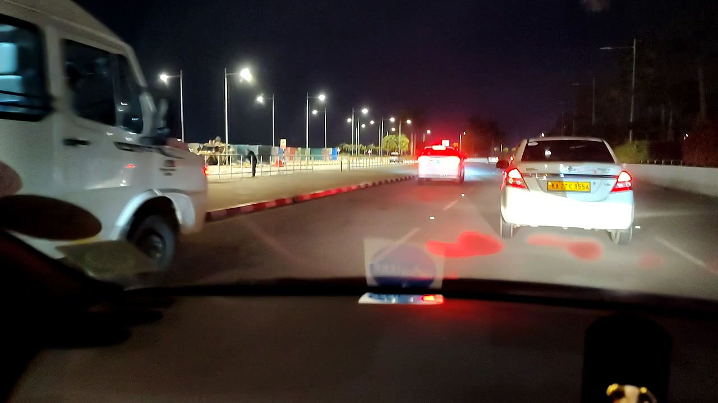
Open/divided road with repeated streetlights and vehicle traffic.
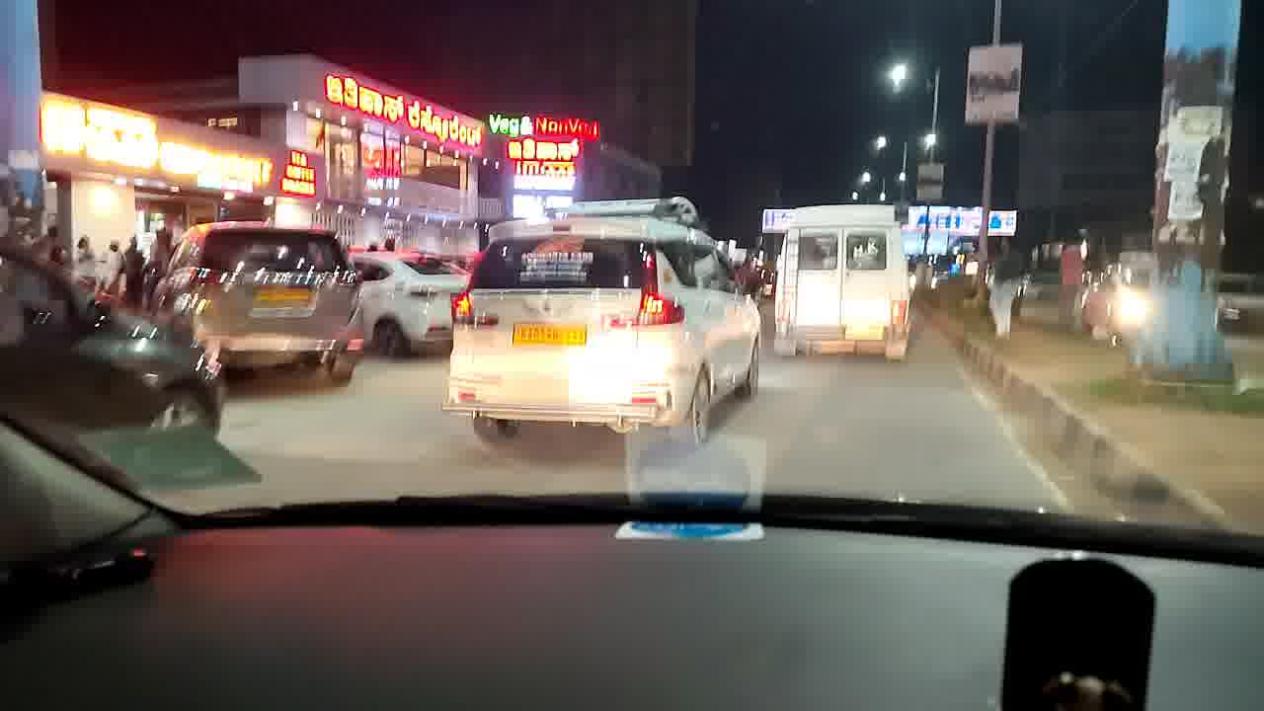
Dense commercial scene with strong signage and multiple competing lights.
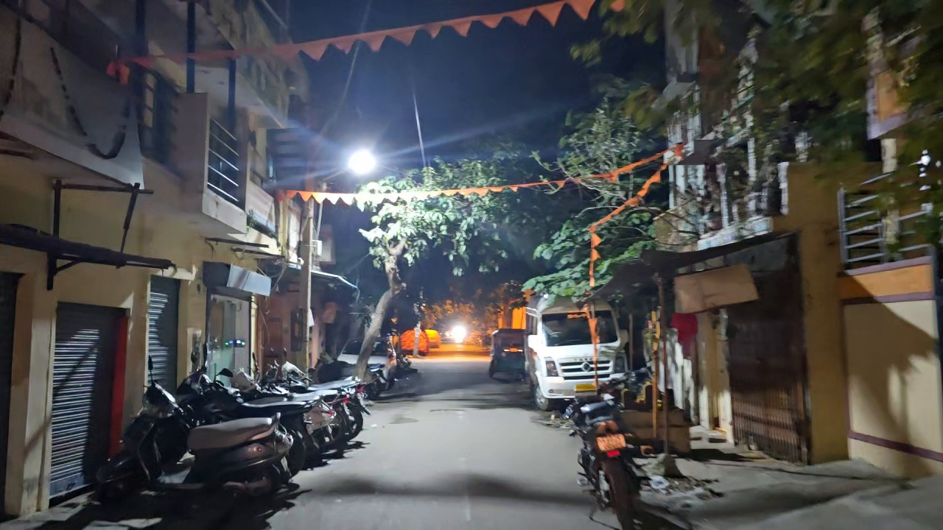
Narrow residential street with trees, parked vehicles and a strong lamp source.
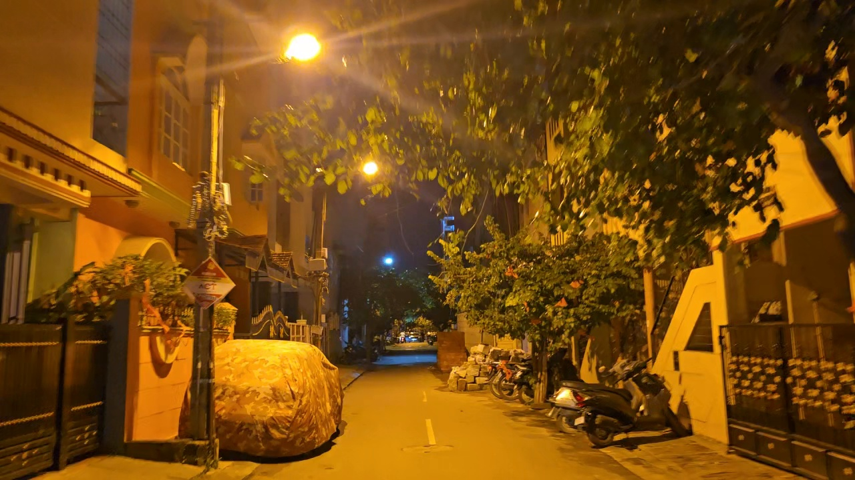
Warm/orange residential illumination with multiple lamps and occlusion.
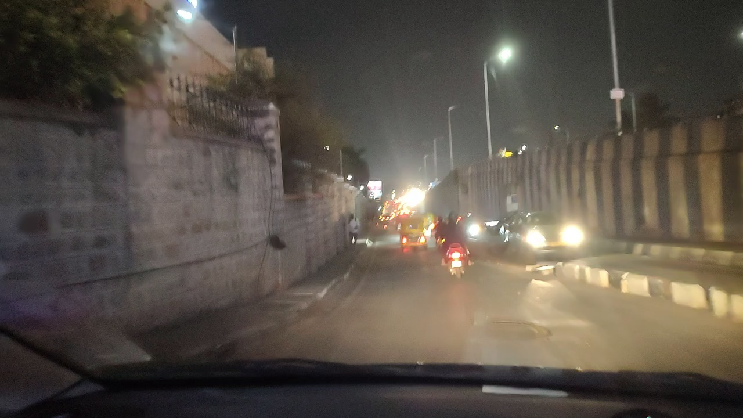
Road scene with wall, median lighting and oncoming headlights.
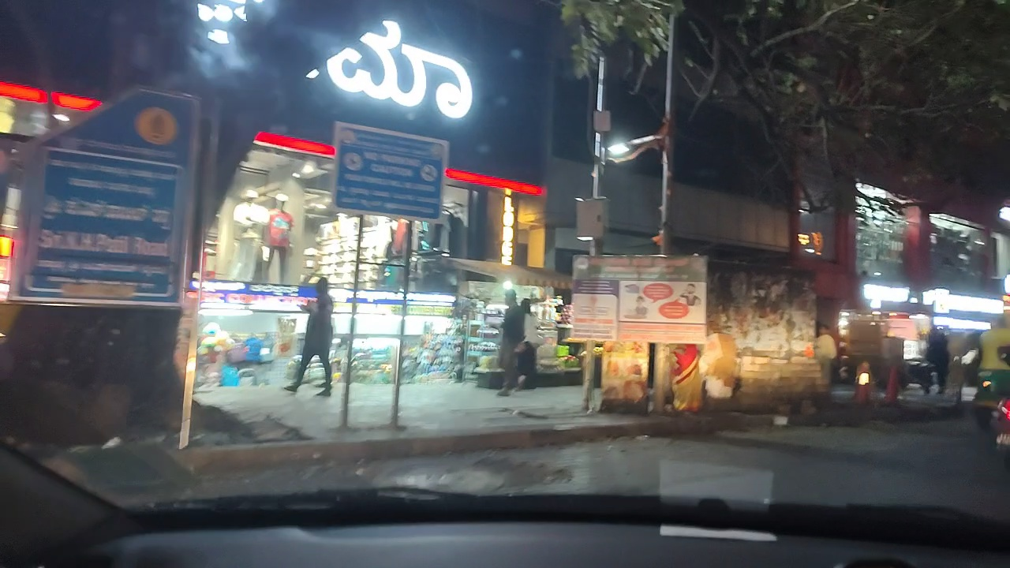
Commercial frontage with bright signs and illuminated storefronts.
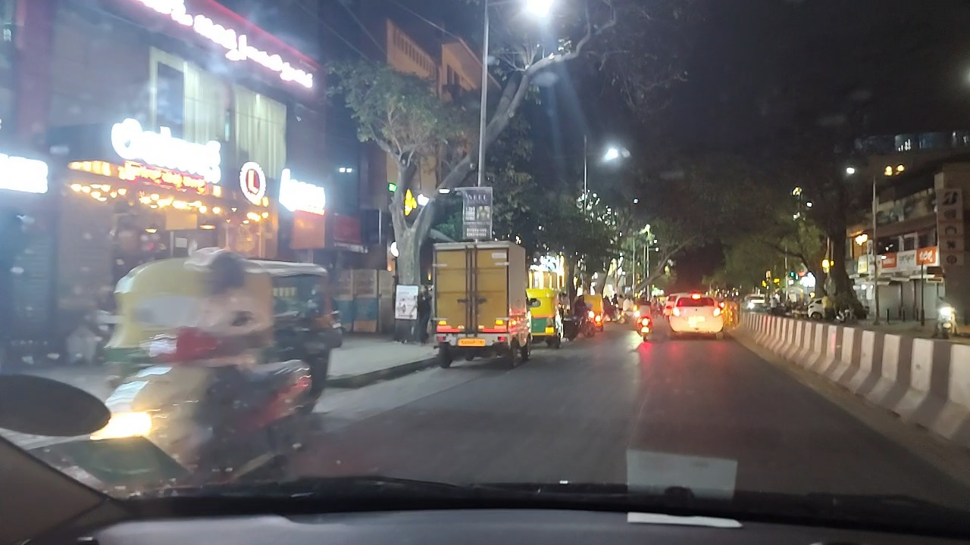
Busy arterial with shop lighting, traffic and multiple light sources.
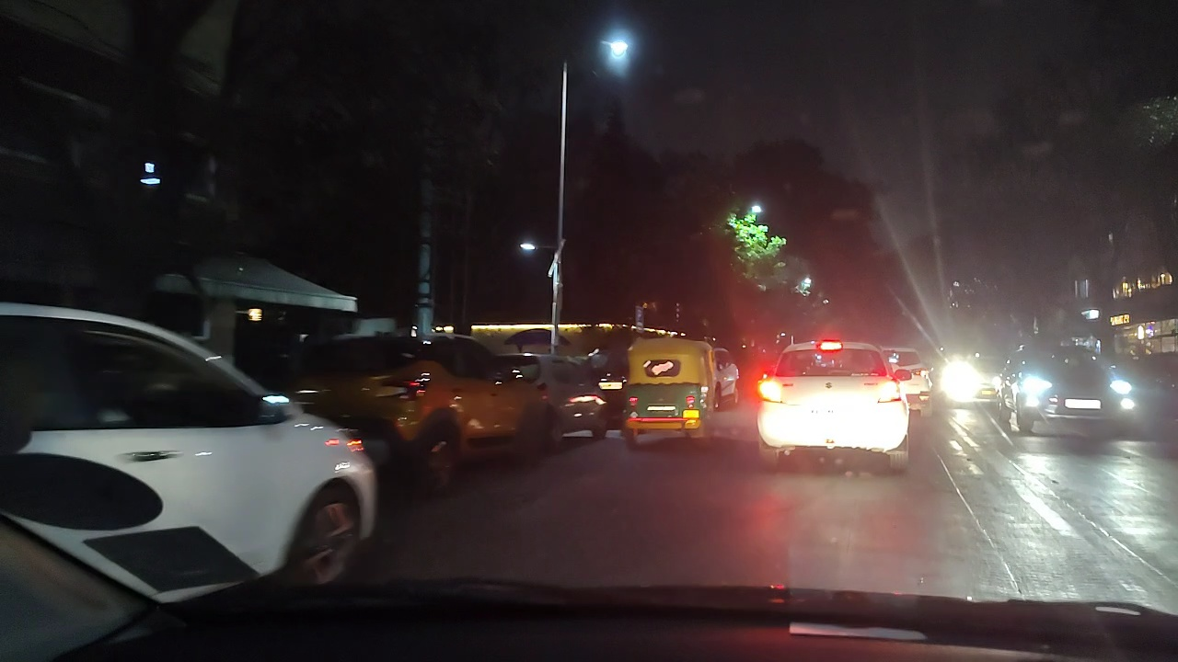
Heavy-traffic scene with headlights, taillights and street lighting.

