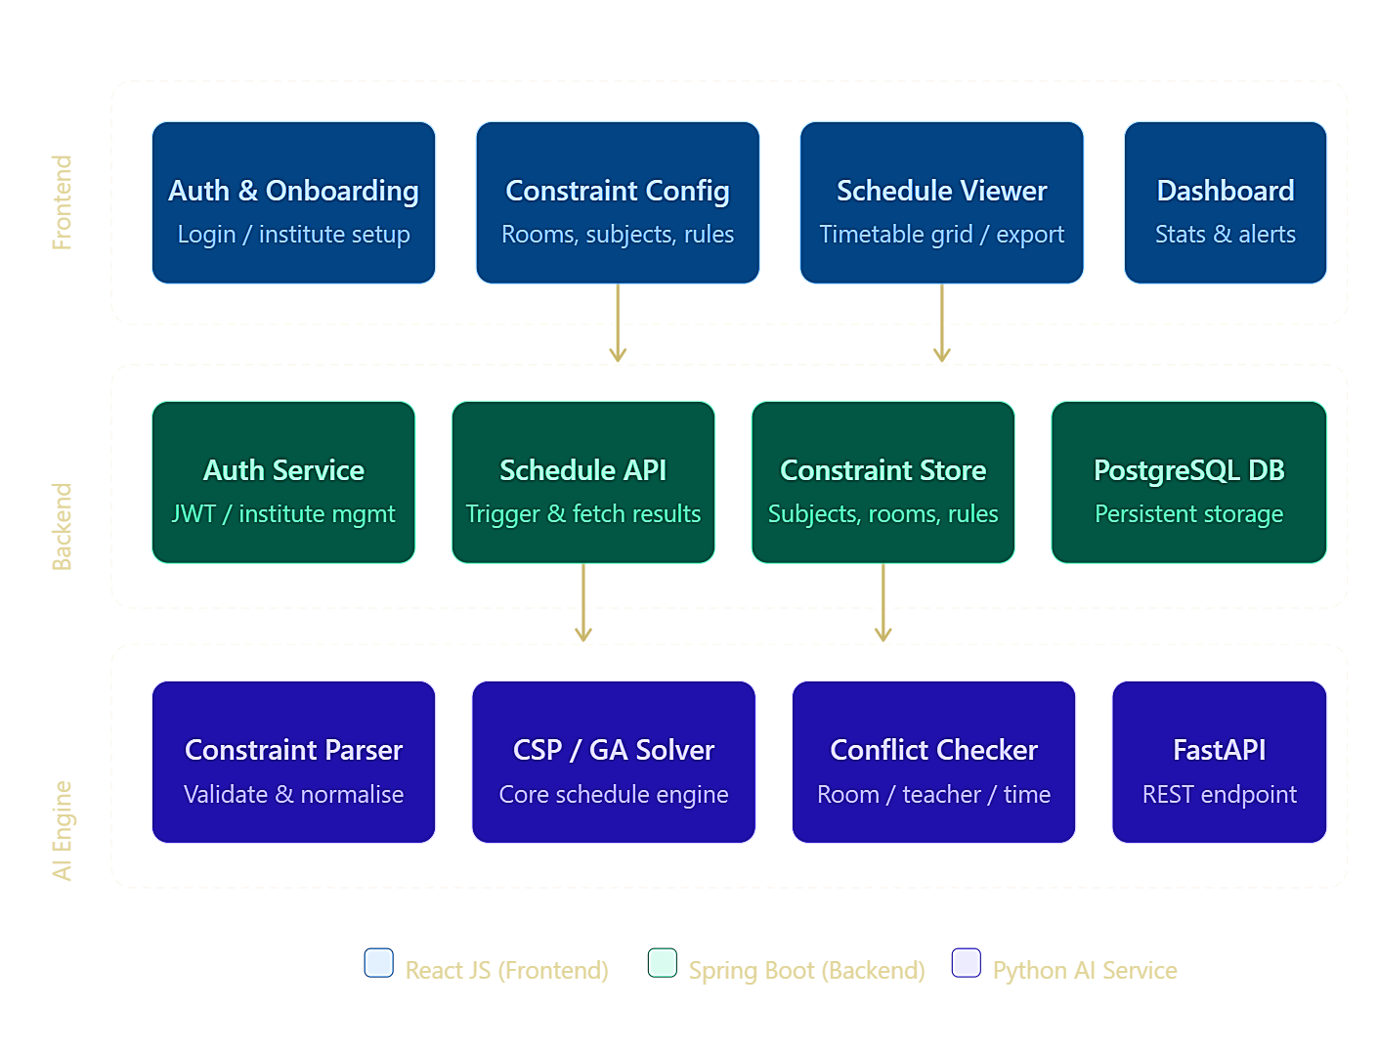
1. Time Slot Model (The Foundation)
Before any code, you need to define the time grid. Given the constraints:
- Day: 9:30 AM – 5:00 PM = 450 minutes
- Lunch: 12:50 – 1:40 PM (50 min, fixed)
- Net teaching time: 400 minutes
- Period: 50 minutes → 8 periods per day (4 before lunch, 4 after)
- Lab block: 2 consecutive periods = 100 minutes
- Week: 5 days × 8 slots = 40 slots total
The slot grid looks like: Day[1-5] × Period[1-8], where periods 4→5 are the lunch boundary and labs must occupy two adjacent slots within the same half.
V
visualize
V
visualize show_widget

2. Python AI Scheduling Service
This is the core of the system. The recommended approach is a hybrid: Constraint Satisfaction Problem (CSP) + Genetic Algorithm (GA) fallback.
V
visualize
V
visualize show_widget
Key Python libraries:
- python-constraint or OR-Tools (Google) — for CSP
- DEAP — for Genetic Algorithm fallback
- FastAPI — to expose a REST endpoint to Spring Boot
- Pydantic — for input validation
The scheduler encodes each "class session" as a variable: (subject, teacher, section) → assigned to a (day, slot, room) tuple. Hard constraints eliminate illegal assignments; soft constraints (like teacher not having back-to-back classes all day) feed the fitness function.

3. Spring Boot Backend
The backend is a REST API + orchestrator. It doesn't contain scheduling logic — it manages data and calls the Python service.
Core entities / tables:
Entity | Key Fields
Institute | id, name, config (JSON)
Subject | id, name, type (theory/lab), periods_per_week, teacher_id
Room | id, name, type (theory/lab), capacity
Teacher | id, name, available_days
Schedule | id, institute_id, semester, status, result (JSON)
TimeSlot | id, day, period_number, start_time, end_time
Key API endpoints:
- POST /api/institutes/{id}/schedule/generate — triggers Python service async
- GET /api/institutes/{id}/schedule/{scheduleId} — fetch result
- POST /api/institutes/{id}/constraints — save constraint config
- GET /api/institutes/{id}/schedule/export?format=pdf|xlsx — export
The Spring Boot service calls Python via RestTemplate or WebClient (async, since scheduling can take seconds). Use a job queue pattern — return a jobId immediately, poll for result.

4. React Frontend — Key Screens
There are four main screens the institute interacts with:
V
visualize
V
visualize show_widget
React tech stack recommendations:
- React Query (TanStack) — for polling schedule job status
- FullCalendar or a custom CSS grid — for the timetable view
- React Hook Form + Zod — for the constraint configuration forms
- Zustand — lightweight state management
- Recharts — for dashboard metrics (utilization %, conflict rate)

5. Constraint Encoding (The Rules)
Here's how each business rule maps to code:
Rule | How it's enforced
No teacher conflict | Two sessions with same teacher cannot share (day, slot)
No room conflict | Two sessions in same room cannot share (day, slot)
Lab = 2 consecutive slots | Lab variable must be assigned (slot_n, slot_n+1) in same half-day
Lab cannot span lunch | Slots 4→5 are forbidden as a lab pair
Min classes per subject/week | Sum of assigned slots per subject ≥ min_periods
Max 5 days/week | Enforced by day domain {1..5}
4 theory + 1 lab per day | Daily quota checker after each assignment
Slot type match | Theory sessions only go in theory rooms, lab sessions in lab rooms

6. Recommended Build Order
Build it in this sequence to validate incrementally:
- Sprint 1 — Spring Boot skeleton + DB schema + Institute auth + basic CRUD APIs
- Sprint 2 — Python FastAPI service with a naive brute-force scheduler (small inputs only), wired to Spring Boot
- Sprint 3 — CSP solver with all hard constraints, real test data
- Sprint 4 — React config forms + timetable grid viewer
- Sprint 5 — GA fallback, conflict highlighting, export (PDF/Excel)
- Sprint 6 — Dashboard, polish, multi-institute isolation, edge cases

