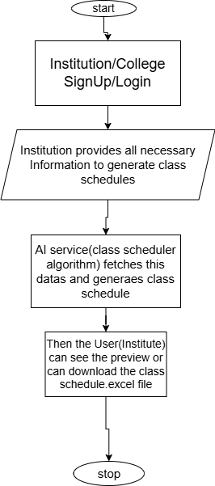

Example:- ABC Institute of Engineering SignUp & Login in our app, then our app will ask them the information, and they will provide that.
Total No. of Departments:- 5 (eg.)
Department Names:- 1. CSE, 2.IT, 3. ECE, 4.Mechanical, 5. Electrical
Then Our app will ask them the subjects in each dept.
CSE:-
Total theory subjects? = 5
Theory subject Names:= DBMS, DSA, Operating System(OS), Discrete Math, Digital Electronics
Total lab classes= 3
Lab class names= DBMS lab, OS lab, Electronics Lab

Now, Our app will also ask the same questions for the other departments like IT, ECE etc.

Fixed Constraints:-
- Day: 9:30 AM – 5:00 PM = 450 minutes
- Lunch: 12:50 – 1:40 PM (50 min, fixed)
- Net teaching time: 400 minutes
- Period: 50 minutes → 8 periods per day (4 before lunch, 4 after)
- Lab block: 2 consecutive periods = 100 minutes
- Week: 5 days × 8 slots = 40 slots total
The slot grid looks like: Day[1-5] × Period[1-8], where periods 4→5 are the lunch boundary and labs must occupy two adjacent slots within the same half.

