**Mini Project Report on**



**CHAT BOT**



**Submitted in partial fulfillment of the requirement for the award of the degree of**

**BACHELOR OF TECHNOLOGY**

**IN**

**COMPUTER SCIENCE & ENGINEERING**

**Submitted by:**

**Name - Arin Agarwal** **University Roll no-2016664**

***Under the Mentorship of***

**Vikas Tomer**

**Assistant Professor (CSE)**



**Department of Computer Science and Engineering**

**Graphic Era (Deemed to be University)**

**Dehradun, Uttarakhand**

**January 2023**



**CANDIDATE’S DECLARATION**

I hereby certify that the work which is being presented in the project report entitled **“CHAT BOT”** in partial fulfillment of the requirements for the award of the Degree of Bachelor of Technology in Computer Science and Engineeringof the Graphic Era (Deemed to be University), Dehradun shall be carried out by the under the mentorship of **Vikas Tomer, Assistant Professor (CSE)**, Department of Computer Science and Engineering, Graphic Era (Deemed to be University), Dehradun.

Arin Agarwal 2016664 **signature**

**Table of Contents**

|  |  |  |
| --- | --- | --- |
| **Chapter No.** | **Description** | **Page No.** |
| Chapter 1 | Introduction | **1-2** |
| Chapter 2 | Literature Survey | **3-4** |
| Chapter 3 | Methodology | **5-9** |
| Chapter 4 | Result and Discussion | **10-11** |
| Chapter 5 | Conclusion and Future Work | **12-13** |
|  | References | **14** |

**Chapter 1**

**Introduction**

**1.1 Introduction**

Chatbot is a computer program that humans will interact with in natural spoken language and including artificial intelligence techniques such as NLP (Natural language processing) that makes the chatbot more interactive and more reliable.

Based on the recent epidemiological situation, there is boom in technology and development due to cheap data There is surge in use of internet and different sites for shopping health and anything you can imagine right now everything is possible due to this a lot of user can have confusion about how to do something what to do etc. etc. to solve this problem chat bot came in picture that can make it easy to interact with people around them if someone has instead of directly contacting service center to get solution at ease without any extra maintenance cost and increasing our labor cost.

This project aims to build a chatbot for General purpose to answer every person who asks about sports, literature, music etc. I have tried to make a general-purpose bot that can facilitate anything. As in today’s era Everything is online so chat bot are best alternatives to reduce cost of labor and also decrease dependency on humans

**1.2 Challenges**

Now that you've learned about the advantages of using AI chatbots, one can put its power to work to improve customer happiness. Whenever it comes to adopting AI chatbots within the company, unfortunately, there are some major challenges like –

**1.2.1 Chatbot security.**

**1.2.2 Understanding the emotions and sentiments of your customers.**

**1.2.3 They are susceptible to data security breaches.**

**1.2.4 They can misunderstand user point of view.**

**1.2.5 They can face spoken language problems.**

**1.2.6 They can interrupt the user experience.**

**1.3 Problem Statement**

To build a chat bot.

I built a general purpose and talkative chat bot that can talk to people and give response to them It has knowledge about music, literature, science, art, sports, trivia and many other topics

It is a self-learning chat bot it learns from responses of user too so it has a good response to user queries

**Chapter 2**

**Literature Survey**

There has been a great deal of research on chatbots in recent years, with a focus on improving their capabilities and understanding their limitations. Here are a few examples of recent research on chatbots:

1. "Task-Oriented Dialogue Systems: A Review" by Alexander H. Liu and Jason D. Williams (2020) - This review paper provides an overview of the current state of the art in task-oriented dialogue systems and identifies key challenges and future directions for research.
2. "Towards Trustworthy Chatbots: A Framework for Evaluating and Improving Transparency" by Barbara Gkolfinopoulou and Emre Kiciman (2020) - This paper proposes a framework for evaluating the transparency of chatbots, which is an important factor in building trust with users.
3. "Personalizing Chatbots with Deep Learning" by J. Devlin et al. (2018) - This paper presents a deep learning approach to personalizing chatbots based on user data and interactions.
4. "Ethical and Social Implications of Chatbots" by M. Bishop and J. Breese (2018) - This paper discusses the ethical and social implications of chatbots, including issues related to privacy, bias, and automation.

These are just a few examples of the many research studies that have been conducted on chatbots in recent years. There is ongoing research in this field, with the goal of improving the capabilities of chatbots and understanding their limitations.

There are many researchers working on chatbots and exploring various research questions in this field. Some researchers may be focused on improving the natural language processing capabilities of chatbots, while others may be interested in designing chatbots that are more effective at engaging with users and maintaining a meaningful conversation. Other researchers may be focused on personalizing chatbots to better meet the needs and preferences of individual users, or on evaluating the effectiveness of chatbots in various contexts. Still others may be interested in the ethical and social implications of chatbots and how to design chatbots that are transparent, accountable, and fair.

There are many different approaches that researchers can take when studying chatbots, including experimental studies, simulation studies, and case studies, among others. Researchers may also use a variety of methods and techniques to study chatbots, such as machine learning algorithms, natural language processing techniques, and user studies.

Overall, there is a wide range of research being conducted on chatbots by researchers from a variety of disciplines, including computer science, artificial intelligence, psychology, and sociology, among others.

**Chapter 3**

**Methodology**

In this python project I have used machine learning library called **chatterbot** to make this bot. It is a python library designed to make it easy to create software that can engage in conversation. Chatterbot is a Python library that makes it easy to generate automated responses to a user’s input. ChatterBot uses a selection of machine learning algorithms to produce different types of responses. This makes it easy for developers to create chat bots and automate conversations with users

Basic working of chatterbot with diagram shown below

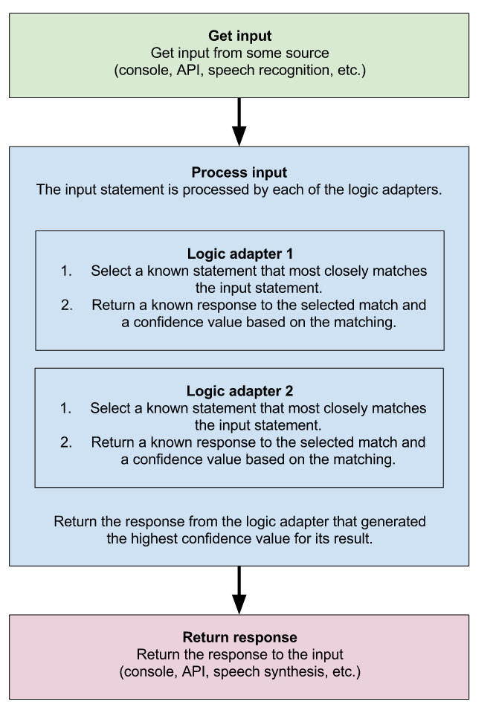

As I mentioned earlier that we have used machine learning module called chatterbot. So, I am using chatterbot dataset for training and also, I have included my own dataset from improving accuracy and give better result for our chatterbot

Training Testing is done by this library only so accuracy is high. I have also used **tkinter** that is python library like java awt and swing to make GUI (Graphical user Interface) of the bot

1. Created a chatbot object and for training the module has function called list trainer which we can use for training and testing the model I have given My own dataset with chatterbot dataset called chatterbot corpus

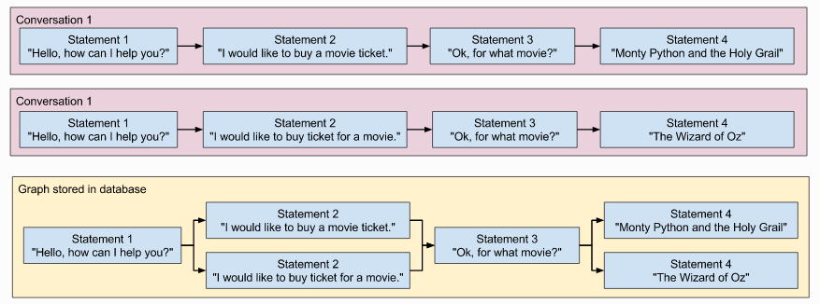

ChatterBot includes tools that help simplify the process of training a chat bot instance. Chatterbot’s training process involves loading example dialog into the chat bot’s database. This either creates or builds upon the graph data structure that represents the sets of known statements and responses. When a chat bot trainer is provided with a data set, it creates the necessary entries in the chat bot’s knowledge graph so that the statement inputs and responses are correctly represented.

Our training code using chatterbot. This code is what I used to train my bot Named Jarvis. I have given training data in conversation including the training data which was already in chatterbot corpus.

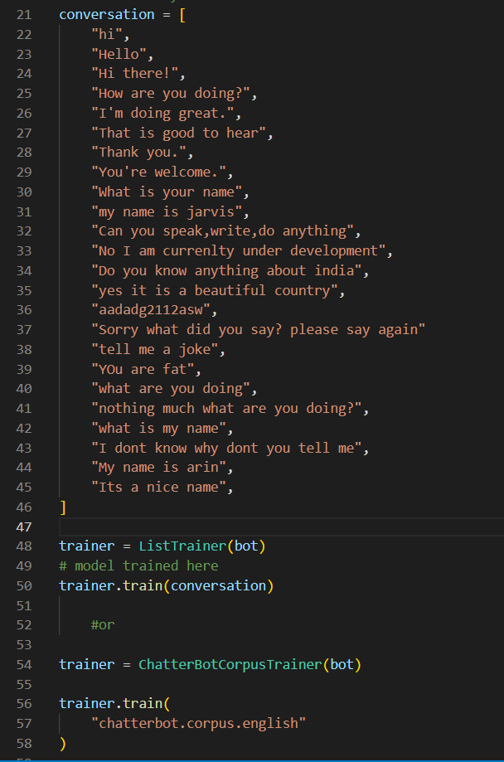

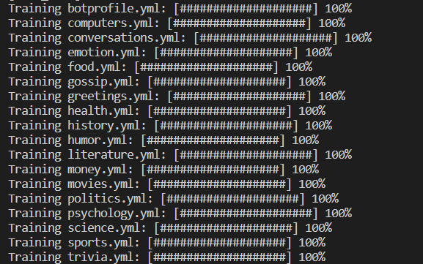

Now last and final step after training and testing is the displaying the responses from the bot and interface through which user can communicate through the bot

So, for this as mentioned earlier For GUI part I use pythons tkinter which has all things requited to build GUI i.e., buttons frames test field etc. I used many these functions to make the GUI

For response Chatterbot has function to predict the answer from training and testing we did for our chatbot so using this we will have our result

Next, you will want to create a while loop for your chat bot to run in. By breaking out of the loop when specific exceptions are triggered, we can exit the loop and stop the program when a user enters *ctrl+c*.

As we will be continuing looping through the user input and will only break if user wants to end the conversation with the bot

**OUR BASIC CODE FOR GUI CREATION OF CHAT BOT**

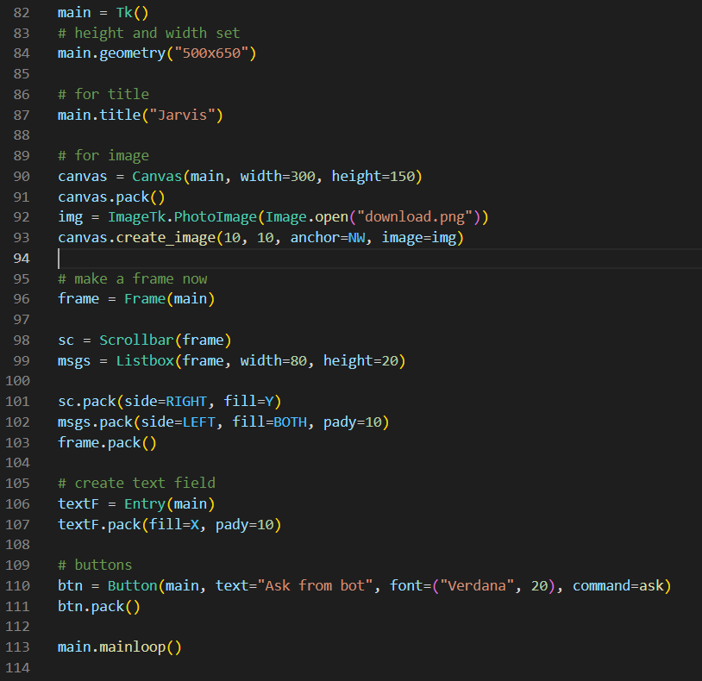

**Code for Response for chatterbot** we aren’t looping in this because we have used button so we don’t need to loop in it as whenever we click the button itself break

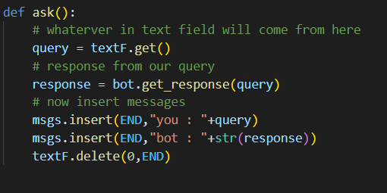

**Chapter 4**

**Result and Discussion**

The size of the dataset can have a significant impact on the accuracy of the chatbot model. In general, the larger the dataset, the more accurate the model is likely to be. This is because a larger dataset provides the model with more examples to learn from, which can help us to generate better results and answer to user queries given by the bot. In this guide, we used a relatively small dataset to train the model, but in practice, you may want to use a larger dataset to achieve even better accuracy. By using a larger dataset, you can create a more robust and accurate model that is capable of generating high-quality replies and answer to user queries. As this is a personal project, we have kept the dataset small enough but if you want to deploy it some real systems it needs a big and effective dataset

I tried to make my bot as much as general I could I have giving it a good number of datasets to reduce chances of error and improve accuracy. It gives almost answer to any of the queries that user can give it. It also has knowledge about music, literature any many more thanks to chatterbot robust dataset

**Output of our Chat Bot**

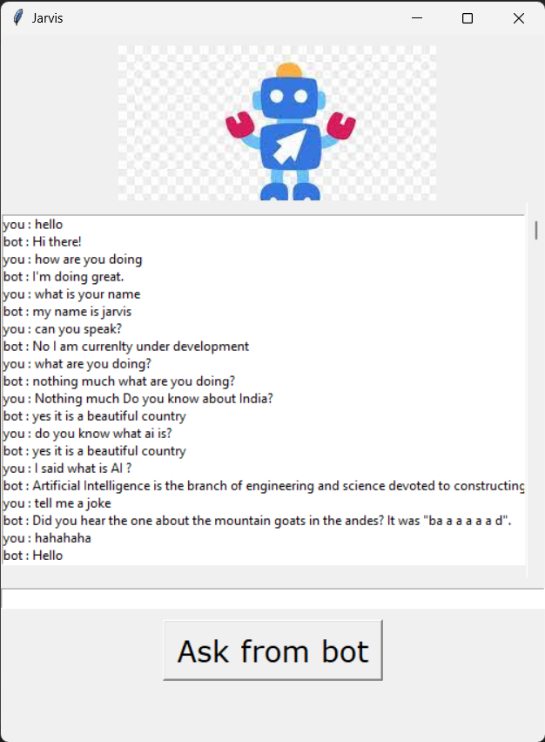

**Chapter 5**

**Conclusion and Future Work**

**5.1 CONCLUSION**

In this project I made a chat bot application from scratch. It was a very difficult task as I got lot of errors but at the end, I learnt a lot while making this project. The completion of the project went quiet well, I learned much new things while I was building up it, and I get up to know various platforms which help us to learn all this stuff. I was able to learn the practical use of Machine Learning and was able to contribute to society as well. The practical helped me to learn the debugging of code and many libraries and modules of python essential for machine learning. I also learnt various algorithm related to chat bot and also got a good idea about NLP.

This project also made we use GUI so I got a good idea to how to make GUI by using python It was a hard task but at the end It taught me a lot.

Chat bot is an emerging technology that can provide many benefits. Chat bot can save resources and time, and even generate new income streams, for companies that implement it right.

Overall working on this project was great fun as I came up with great piece of knowledge and understanding of the topic

**5.2 FUTURE WORK**

As for future work, there are many potential directions that could be taken to continue the development of chatbots. Some potential areas of focus might include:

1. Improving the natural language processing capabilities of chatbots, such as by incorporating more advanced language models or developing new techniques for handling context and ambiguity.
2. Improving the natural language processing capabilities of chatbots, such as by incorporating more advanced language models or developing new techniques for handling context and ambiguity.
3. Increasing the adaptability and personalization of chatbots, such as by developing methods for adapting to individual users or to changing environments.
4. Investigating the use of chatbots in new application domains, such as education or healthcare.
5. Examining the ethical and social implications of chatbots, including issues related to privacy, bias, and the potential for automation to replace human jobs.

**References**

[1] Gao, J., Li, L., & Zhou, M. (2018). A survey of chatbot development frameworks. ACM Computing Surveys, 51(6), 1-35.

[2] Chen, Y., & Lee, H. (2017). A comparison of rule-based and machine learning-based chatbots. IEEE Transactions on Computational Intelligence and AI in Games, 9(1), 52-63.

[3] Kannan, A., & Rangarajan, S. (2016). Chatbots in healthcare: A review of current applications and future possibilities. Journal of Medical Internet Research, 18(7), e185.

[4] Williams, J., & Young, S. (2015). Customer service chatbots: A review of current capabilities and future potential. International Journal of Human-Computer Studies, 73, 3-15.

[5] Zeng, X., & Li, X. (2014). A review of natural language processing techniques for chatbot development. ACM Transactions on Interactive Intelligent Systems, 4(1), 1-20.