A PROJECT REPORT ON

Face Recognition

### Bachelor of Technology

**By**

Arin Agarwal Roll No:2016664

**Under the guidance of:**

Mr. Akshay Rajput



**DEPARTMENT OF COMPUTER SCIENCE & ENGINEERING GRAPHIC ERA DEEMED UNIVERSITY**

**DEHRADUN**

**2022-2023**

**DECLARATION**

I, **Arin Agarwal** student of **B-Tech, Semester IV,** Department of Computer Science and Engineering, Graphic Era Deemed to be University, Dehradun, declare that the project work entitled **“FACE RECOGNITION”** has been carried out by me and submitted in fulfillment of the course requirements for the award of degree in B. Tech of **Graphic Era Deemed University** during the academic year **2022-2023**. The matter embodied in this synopsis has not been submitted to any other university or institution for the award of any other degree or diploma.



**CERTIFICATE**

This is to certify that the project report entitled **“FACE RECOGNITION”** is a bonafide project work carried out by **Arin Agarwal**, **University Roll No – 2016664**. in partial fulfillment of award of degree of B- tech of Graphic Era Deemed University, Dehradun during the academic year **2021-2022**. It is certified that all corrections/suggestions indicated for internal assessment have been incorporated. The project has been approved as it satisfies the academic requirements associated with the degree mentioned.

**Dr. Devesh Pratap Singh, HOD (Computer Science)**

# ACKNOWLEDGEMENT

Here by I am submitting the project report on **“FACE RECOGNITION”** as per the scheme of Graphic Era Deemed University, Dehradun.

I would like to express our sincere gratitude to **Dr. Devesh Pratap Singh,** Head of Dept. of Computer Science, for providing a congenial environment to work in and carry out our project.

I consider it mine cardinal duty to express the deepest sense of gratitude to **Mr. Akshay Rajput** Asst. Professor, Department of Computer Science and Application for the invaluable guidance extended at every stage and in every possible way.

Finally, I am very much thankful to all the faculty members of the Department of Computer Science and Technology, friends and our parents for their constant encouragement, support and help throughout the period of project conduction.

**Arin Agarwal Roll no. 2016664**

# INTRODUCTION

## Problem Statement

Face Recognition (To detect face of a person through the webcam or any camera and recognize him with his name)

## Motivations

As a Computer Science Student, I always had interest in ML and AI. I have seen many projects of ML and they always fascinated me so I found this to be the best one out of curiosity and exploration in the field of ML. Face Recognition is a very important aspect in today’s world it is there in every part of life whether in security camera or attendance system. Hence, I wanted to explore this domain and learn more in this. I had a senior who also motivated me in taking such projects. Hence, I took this project as my mini project

The main goal of the project was to study and apply as many Machine Learning Algorithms as possible on a dataset involving a particular domain, of Face Recognition, as opposed to coming up with a newer (and/or better) algorithm that is more efficient in predicting the face of a person.

So, being interested in this field, I also explored this topic and tried to build a project of my own.

# Tools And Software Used

* + 1. For coding purpose, VS code IDE was used and code was written in Python language.
    2. Various Python Modules and libraries were used

1. **Open CV-** OpenCV is the huge open-source library for the computer vision, machine learning, and image processing and now it plays a major role in real-time operation which is very important in today’s systems. By using it, one can process images and videos to identify objects, faces, or even handwriting of a human. When it integrated with various libraries, such as NumPy, python is capable of processing the OpenCV array structure for analysis. To Identify image pattern and its various features we use vector space and perform mathematical operations on these features.
2. **NumPy**- NumPy is a very popular python library for large multi-dimensional array and matrix processing, with the help of a large collection of high-level mathematical functions. **It is very useful for fundamental scientific computations** in Machine Learning It is a Python library used for working with arrays
3. **face_recognition -** It recognize and manipulate faces from Python or from the command line with the world's simplest face recognition library. Built using dlib's state-of-the-art face recognition built with deep learning. The model has an accuracy of 99.38% on the Labelled Faces in the Wild benchmark.
4. **os -** The OS module in Python provides functions for interacting with the operating system. OS comes under Python’s standard utility modules. This module provides a portable way of using operating system-dependent functionality. The *os* and *os. path* modules include many functions to interact with the file system.
5. **dlib -** Dlib is a modern C++ toolkit containing machine learning algorithms and tools for creating complex software in C++ to solve real world problems. It is used in both industry and academia in a wide range of domains including robotics, embedded devices, mobile phones, and large high performance computing environments. It is used in face_recognition module of python made in c++ for recognizing face

# Methodology

The face recognition method we used inside the combination of **Davis King’s dlib library** and **Adam Geitgey’s face_recognition module**.

Davis has provided a ResNet-based Siamese network that is super useful for face recognition tasks. Adam’s library provides a wrapper around dlib to make the face recognition functionality easier to use.

These both libraries are dependent on each other for working as face_recognition is made using dlib and c++. Also, the dlib library, maintained by Davis King, contains our implementation of **“deep metric learning” which is used to construct our face embeddings used for the actual recognition process.**

Our project has **2 top- level directories:**

1. **photos –** This is basically set of photos I created for recognition purpose the photos which are in this dataset are only recognized by our model because it is trained on it and encodings are done only for those photos. Photos other than that can’t be recognized it first need to be added in our dataset
2. **main.py** – It is basic script or code of our code which contains code of our face recognition. It is written in python.

* For the dlib facial recognition network, the output feature vector is **128-d** (i.e., a list of 128 real-valued numbers) that is used to *quantify the face*. Training the network is done using **triplets**:

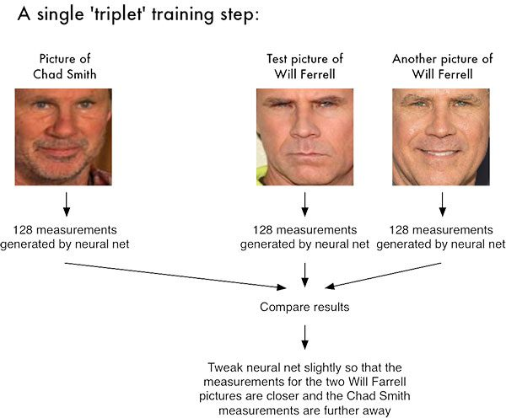

* These 128 values which are generated by face_recognition library function which is defined in the function called face_encodings () which help in representation of face in 128 measurement values
* These encodings are then used in comparing faces with the trained dataset using function compare_face () which compares face with trained dataset which is defined in face_recognition library of python
* This is encoding function I used in my code for face representation it’s the most crucial step in this project

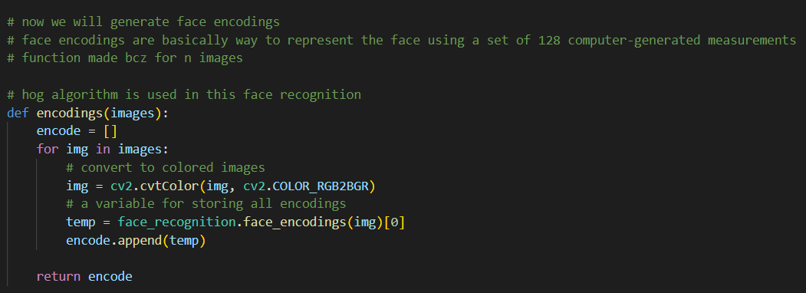

* I have made function for encodings because for multiple images encodings will be done and return a list of these values encoded which will be use later for matching
* Hogs’ algorithm is used here in this project
* Then finally we detected faces using open cv and did encodings for it so that we can test it with trained data set and encodings value of other images
* face_location () and face_encodings () functions are used for doing encodings and facial locations detection
* then just we found out matching and face distance parameters which are used for matching we found out the minimum distance between faces and use it in matching so that we could find out the faces in this
* below is code I implemented for doing this approach

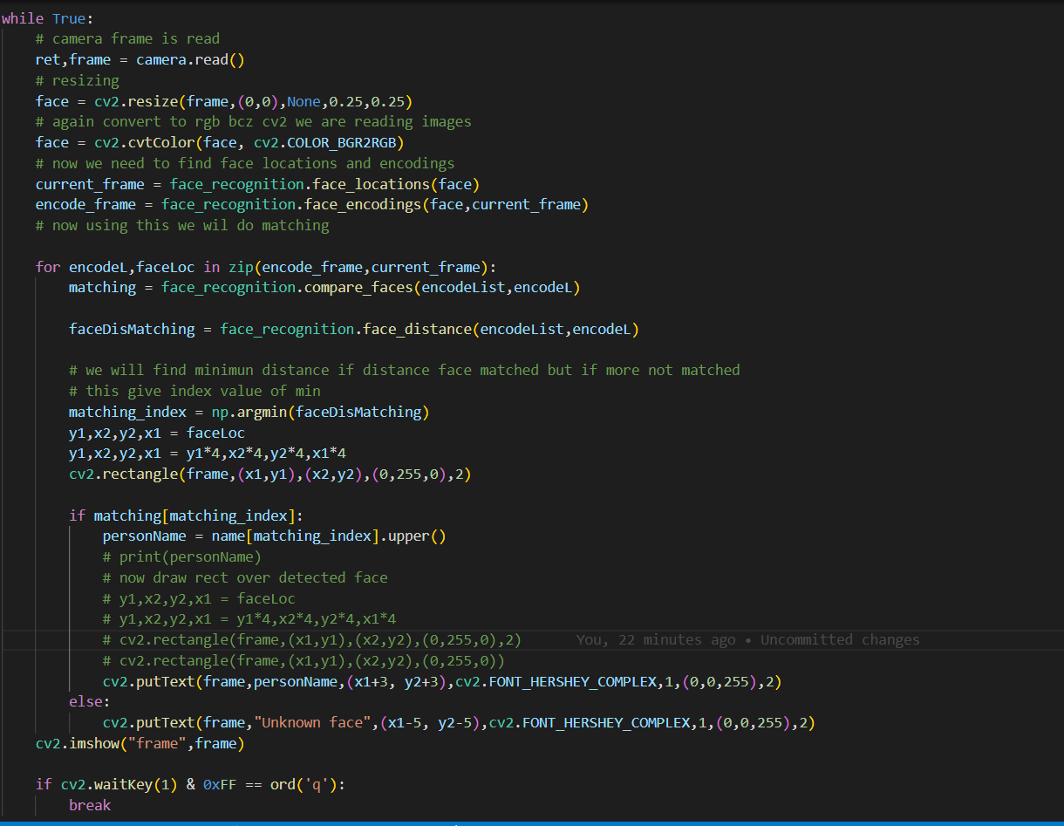

**Our Face Recognition System**

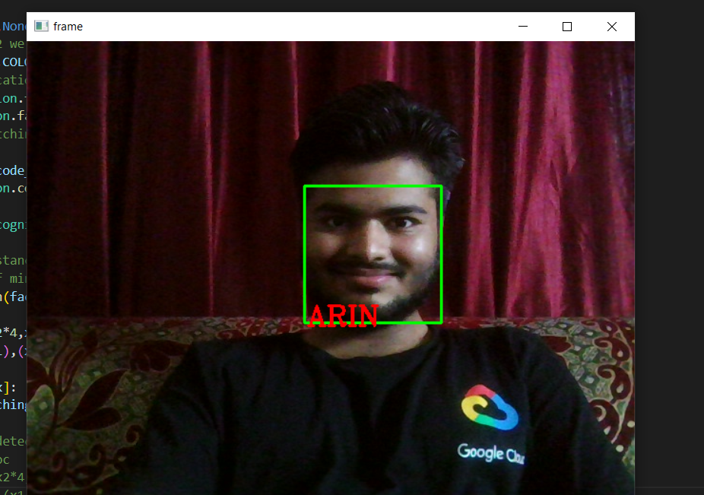 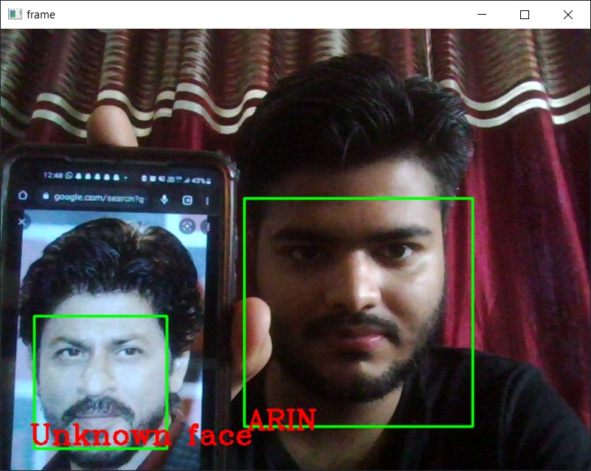

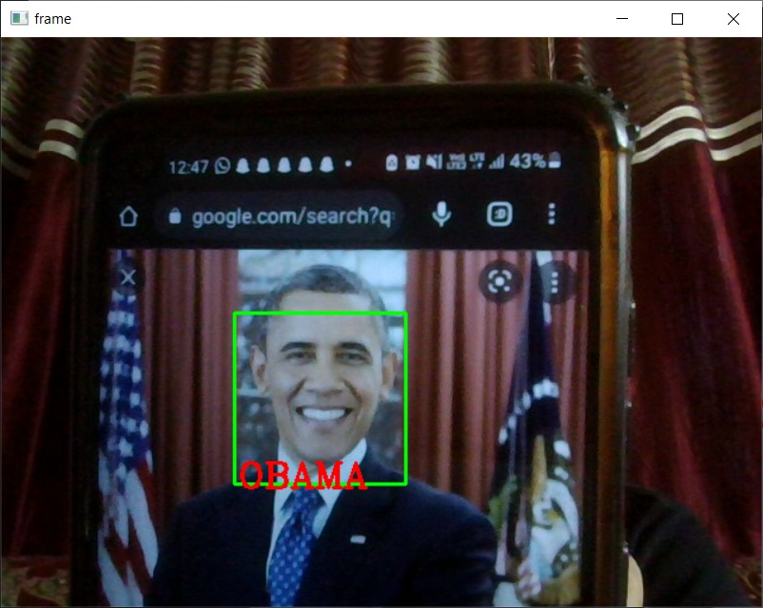 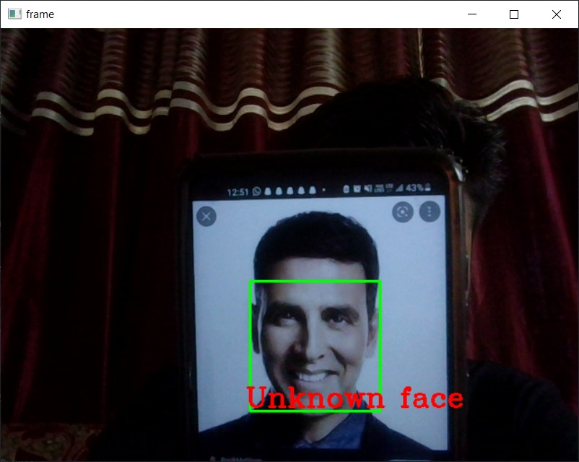

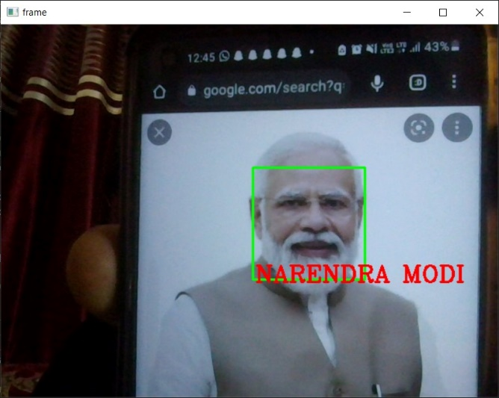 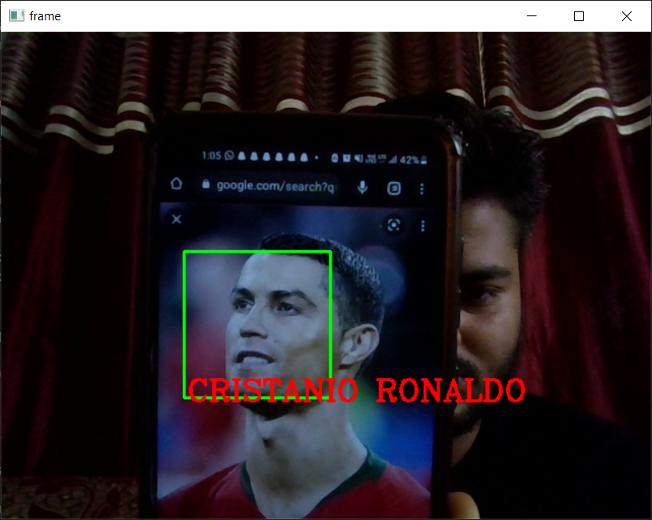

**Conclusion**

**The completion of the project went quiet well, I learned much new things while I was building up it, and I get up to know various platforms which help us to learn all this stuff. I was able to learn the practical use of Deep Learning and was able to contribute to society as well. The practical helped me to learn the debugging of code and many libraries and modules of python essential for deep learning. I also learnt various algorithm related to face recognition and also learnt dlib and face_recognition modules of python. This will also help in society**

**Face recognition is an emerging technology that can provide many benefits. Face recognition can save resources and time, and even generate new income streams, for companies that implement it right.**

**Overall working on this project was great fun as I came up with great piece of knowledge and understanding of the topic.**

***Reference: YouTube Google Wikipedia Git Hub***