Move-In
High Level Requirements Document
Version 1.3
Date: 9/22/2025

Project Identification

Project: | Move-In
Prepared By: | Group 1:  Lakshay Dhawan  Arina Mirzakhani  Suthan Sureshkumar  Ayesha Akbar  Sofiia Beliak
Document Version: | 1.3
Published Date: | 22-09-2025

Contributors
The following individuals contributed to this document.
Name | Title
Arina Mirzakhani | Front-End Developer
Lakshay Dhawan | DevOps Engineer
Suthan Sureshkumar | Database Management
Ayesha Akbar | Back-End Developer
Sofiia Beliak | Design/documentation

Distribution
This document is distributed to all the following people.
Name | Title
Laily Ajellu | Professor

Referenced Documents
This document refers to the following materials
Version number | Title | Author | Date | Source / Location
1.3 | Project Vision Template | Arina, Suthan, Sofia, Lakshay, Ayesha | 20-09-2025 | Project Summary
1.3 | Project Summery | Arina, Suthan, Sofia, Lakshay, Ayesha | 22-09-2025 | Project Vision

Revision History

Version Number | Revision Date | Summary of Changes | Modified by
1.1 | 15-09-2025 | The document has been created, and all required sections have been completed. | Arina, Suthan, Sofia, Lakshay, Ayesha
1.2 | 25-09-2025 | All work has been completed. Changes have been implemented, and the file has been updated. | Arina, Suthan, Sofia, Lakshay, Ayesha
[Note: It is recommended that drafts be numbered 0.1 to 0.9, and that the first approved version be numbered 1.0. Thereafter, new version numbers will depend upon changes: 1.01, 1.1, etc for minor updates, 2.0, 3.0 etc for major changes.]

TABLE OF CONTENTS
1. Business Context Diagram 3
2. REquirements Scope Statements 4
3. High Level Business Requirements Sign-Off 5

- Business Context Diagram
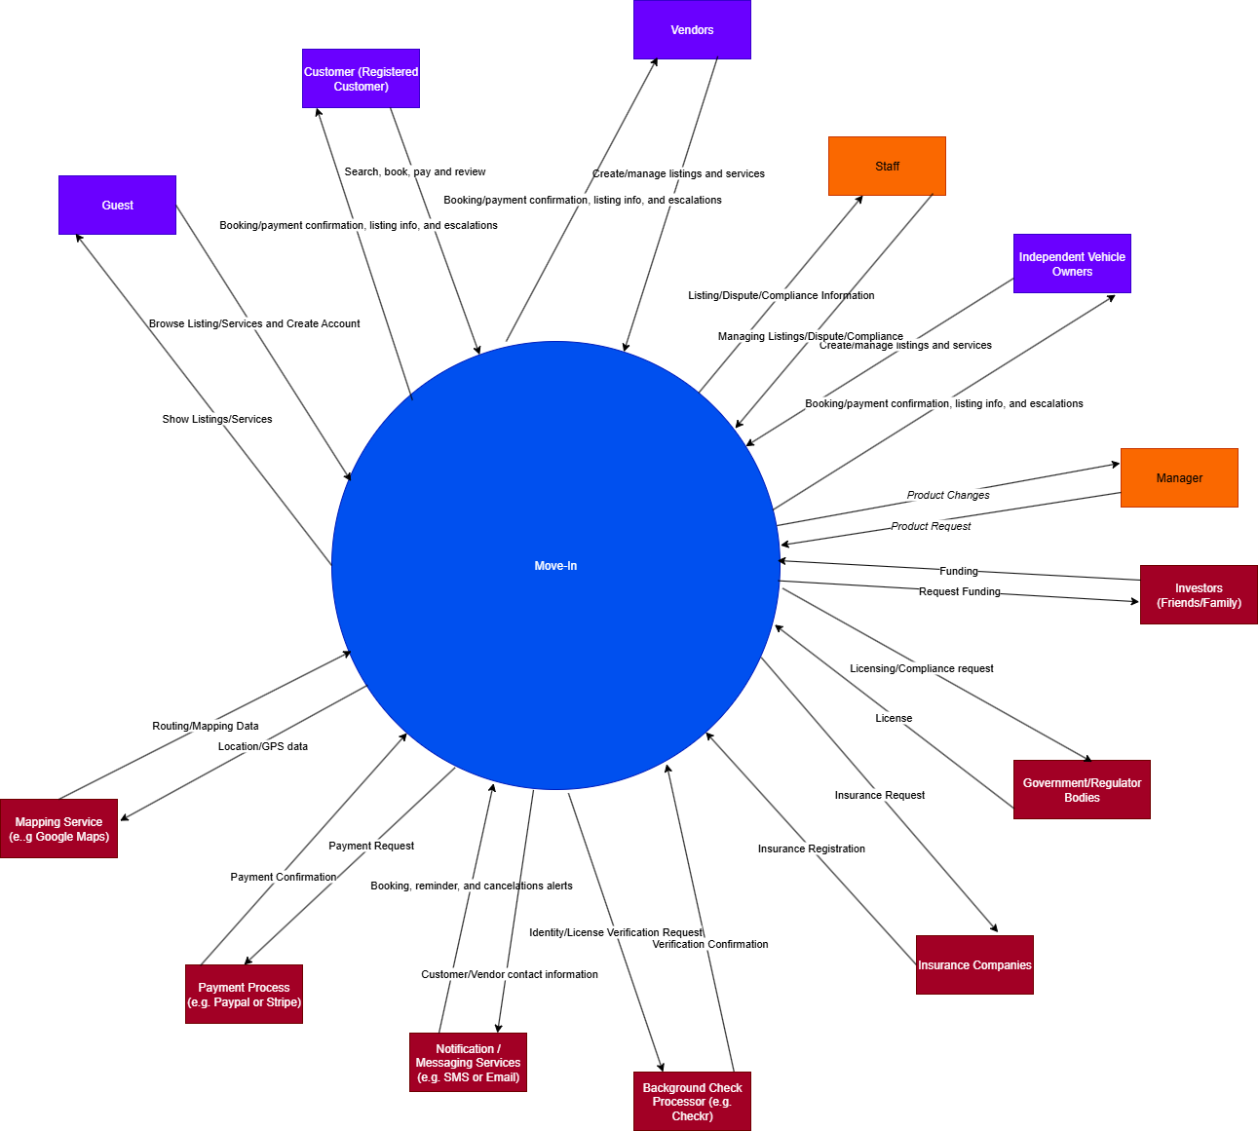

Requirement Scope Area | Description
User Accounts and access(vision) | Guests can create accounts, customers can log in, staff/manager roles to help customers and vendors.
Listing Management (vision) | Vendors and owners create, edit and publish vehicle and service listings.
Search and discovery (vision) | Guests and customers browse listings, view details, availability, location.
Booking and Reservations (vision) | Create, cancel and store reservations and handle escalations.
Payments (vision) | Process payments and refunds through external payment processors and obtain confirmations.
Insurance Integration (New stakeholder) | Send insurance requests and register coverage with the insurance companies and receive confirmations for all bookings.
Identity/License and compliance (New stakeholder) | Run license verifications via background check processors, manage licenses and compliance with the government, and store approvals as per rules and bylaws.

External Entity | Description
Payment Processor | External payment processing gateway for customers and vendors to securely handle all monetary transactions.
Registered User | Users who have registered accounts can browse, book and leave reviews about the services they have received.
Vendors | Vendors can create, manage and edit moving service listings to customers and communicate with staff as well as customers.
Independent Vehicle Owners | List and provide vans, trucks and other vehicles for moving purposes.
Background Screening Company | External processor to verify identities and perform background checks on vendors and independent vehicle owners on behalf of Move-In.
Mapping Services | Providing locational data through routes to the vehicle and verifying the area for service.
Insurance Company | Provide insurance coverage for vehicles, goods and liability.
Government Bodies and Regulators | Ensuring compliance with the Ministry of Transportation, as well as following commercial and privacy laws.
Notification Services | Sending alerts about bookings, reminders, cancelations and a variety of other information through SMS/Email.

Information Flows | Description
Payment Processor | Payments are requested for services and payments are deposited once the booking is complete.
Registered Users | Users sign up for their account by proving the required information. They can browse listings, book services and communicate with vendors/ truck owners and staff.
Vendors | Vendors list their moving services on the app, communicate with potential customers and staff.
Independent Vehicle Owners | Independent Vehicle Owners list their vehicles on the marketplace and communicate with customers and staff.
Background Screening Company | Vendors and Vehicle owners will submit verification which then will be validated by the background screening company and approved/flagged by the system.
Mapping Services | Mapping services such as distance, time and service area data will be given to Registered Users, Vendors and Independent Vehicle Owners.
Insurance Company | Insurance companies will provide coverage options during the booking process and handle claims in case of accidents or losses by communicating with customers, merchants and staff.
Government Bodies and Regulators | Regulatory bodies will deal with any compliance checks (license, insurance verification) and receive any required data.
Notification Services | Sending customers and merchants real time alerts about bookings, changes and confirmations through SMS/Email.
- Requirements Scope Statements
HLR# | Description | Priority  (H, M, L)
 | Users can sign up and log in with roles: Customer, Vendor, Staff or Manager. | H
 | Vendors/Owners can edit, add or publish listings with price, date and location. | H
 | User can search and browse listing with filters and map view | H
HLR04 | Review and rating for vendors after completed booking. | M
HLR05 | Notification: Booking confirmation, reminders, changes and cancellation. | M
HLR06 | Manager admin: approve or reject product and view dashboards | M
HLR07 | Investore and funding requests: submit and track fundings requests with basic statues update. | L

- High Level Business Requirements Sign-Off
The undersigned acknowledge their agreement with the contents of Version 1.2 of the High-Level Requirements document for Move-In

Following approval of this document, requirements changes will be governed by the project’s change management process, including impact analysis and appropriate reviews and approvals, under the general control of the Project Plan and according to company policy. Approved Change Request Documents, if present, will be attached to this Requirements Document as updates.

Name | Project Role and  Functional Area | Date Signed
𝒜𝓇𝒾𝓃𝒶𝑀𝒾𝓇𝓏𝒶𝓀𝒽𝒶𝓃𝒾 | Front-End Developer | 9/28/2025
 | DevOps Engineer | 9/26/2025
ayesha | Back-End Developer | 9/28/2025
Suthan Sureshkumar | Database Management | 9/28/2025
Sofiia Beliak | Design/documentation | 9/28/2025

* Note: physical signatures are not required. Email approvals are acceptable and should be appended to project documents.

