**Log In window.**

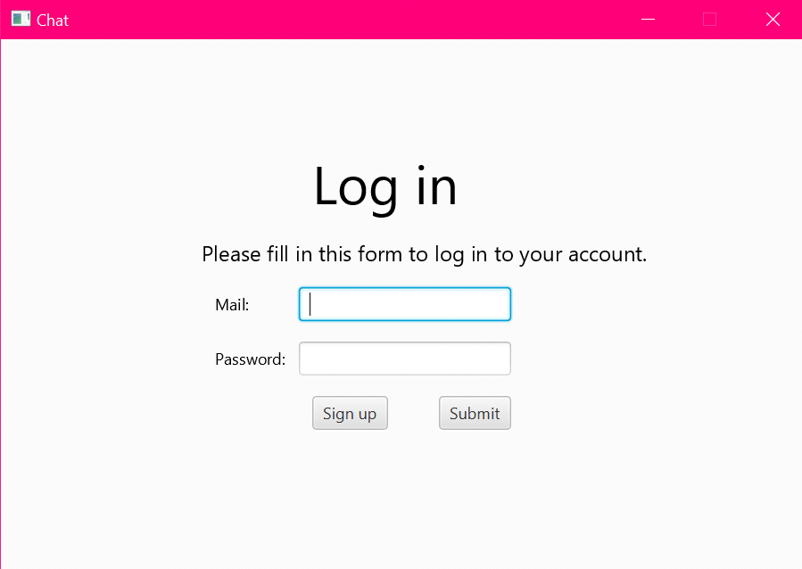After launching the app, login form will be opened. Here you need to login or register, if you don't have an account yet.

Press the button “Sign up” for creating a new account. The registration window will be open.

If you already have an account, enter your data and click the „Submit“ button. After that, the data will be checked. If the data is entered correctly, the main window of the application will open, otherwise the incorrectly filled field will be colored in red and you will need to re-enter data.

**Registration window.**

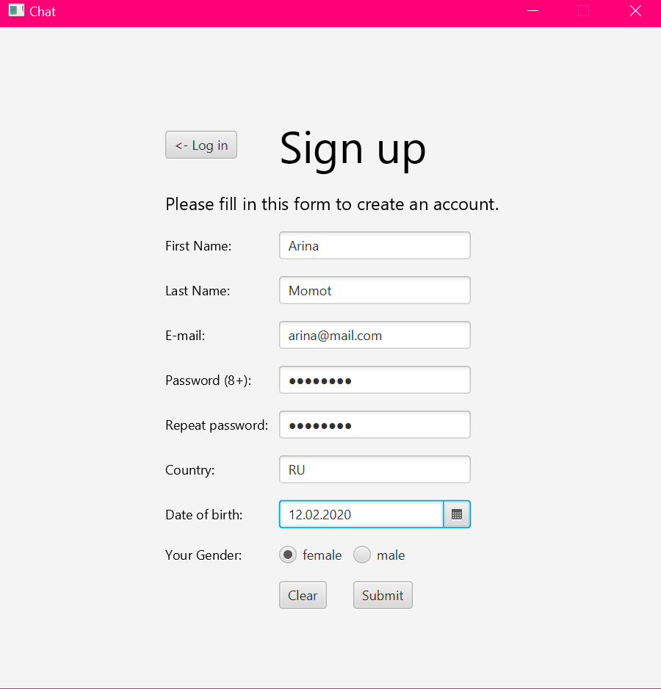When you click the ”< - Login” button, you will go back to the Login window and the entered data on the page will be cleared. When you click the "Clear" button, all fields will be cleared. In this registration window, the user enters their real data and after clicking the ”Submit” button, they will be successfully registered, or the fields where the data was entered incorrectly will be highlighted in red.

**The main window of application.**

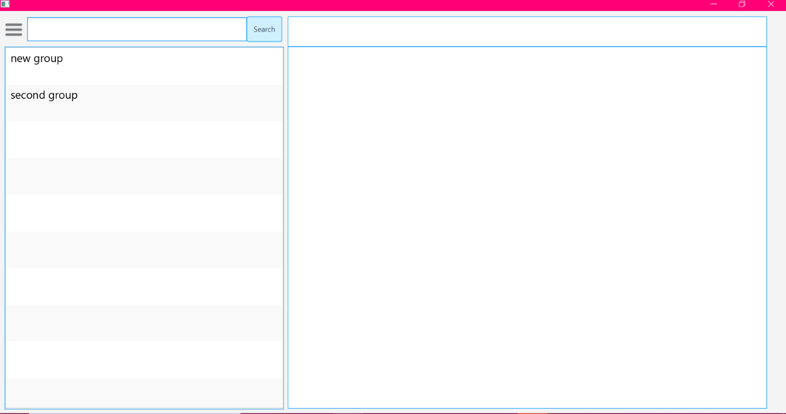In the left field there is a list of groups that the user belongs to.

**Searching in user’s groups.**

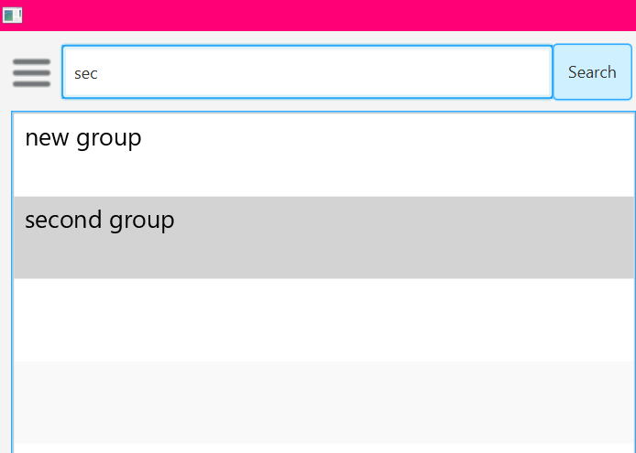 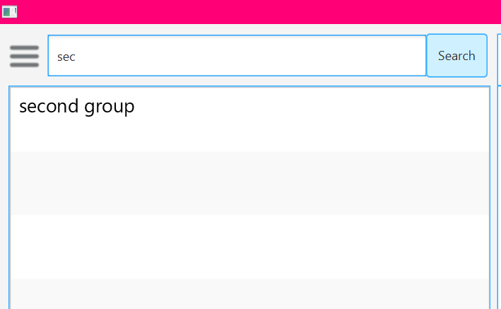

In the ”input” field, you must enter the name of the group you are looking for and find it by clicking the "Search" button.

To see the list of all your groups again, you must clear the “input” field and click the “Search” button.

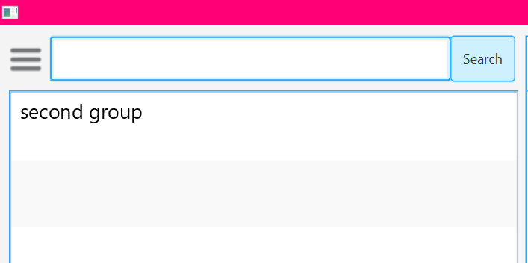 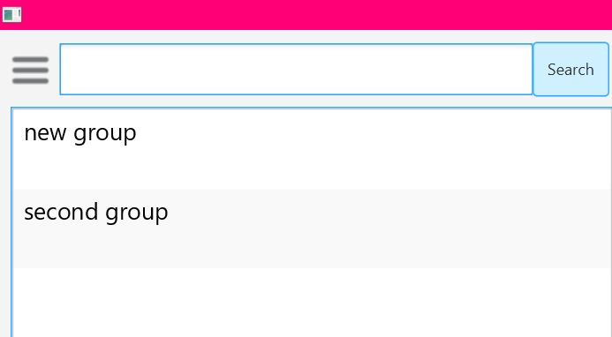

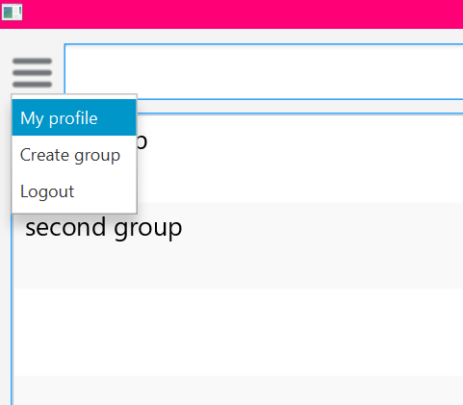When you click on the "Manage" button, you will see the "My profile", "Create group" and "Logout" tabs.

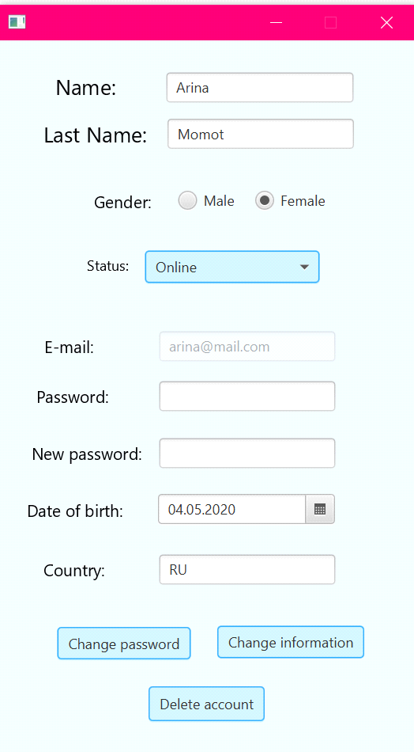**The window "My profile".**

Here the user can change information about yourself by changing the fields that you want and then clicking "Change information" button.

User can change his status by clicking on tab ”Status:” and selecting the one from the list.

Change password by filling in the field „Password“ your password that valid now and in the field „New password“ the new password that you want, then you must click on the button "Change password".

All data will be checked!

User can delete his profile by clicking "Delete account" button.

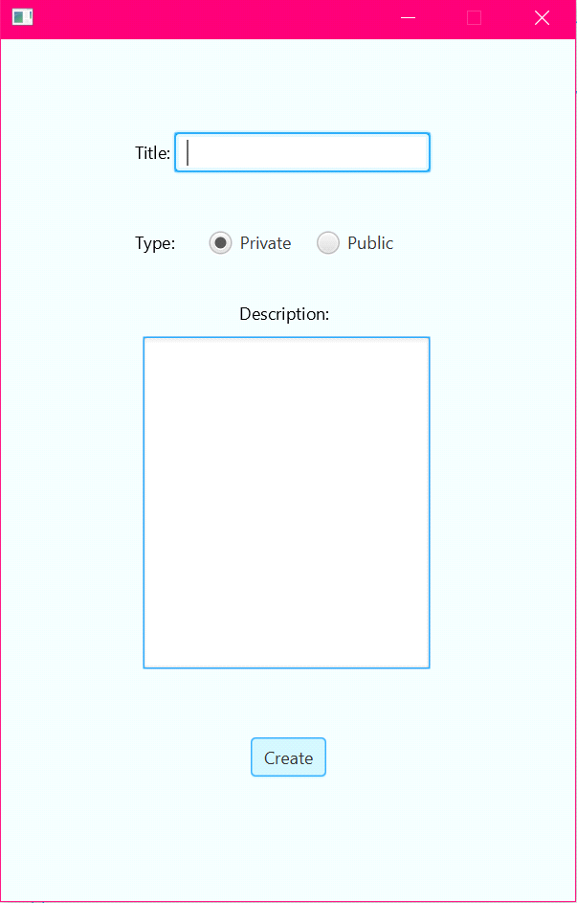**The window "Create group".**

Here user can create a chat group, add its title, select privacy by switching radiobuttons and add a description. The "Create group"button is responsible for creating a group.

Title must be unique, otherwise will be an error.

**The main window after clicking on one of the user’s group.**

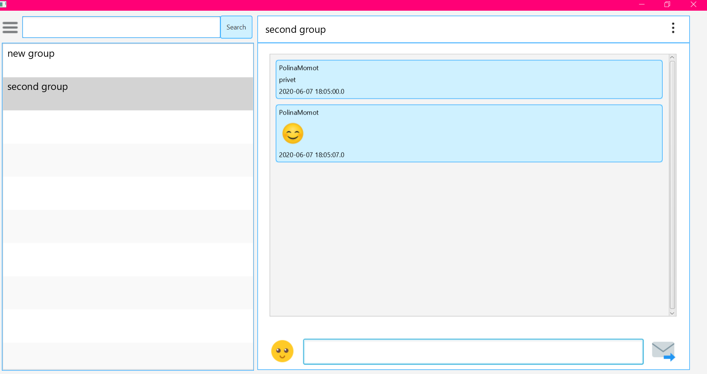

After clicking on one of the groups, you will see messages from this group, an „input“ field for writing messages, a button for adding smile and sending message. You will also see a button for managing the group in the upper-right corner.

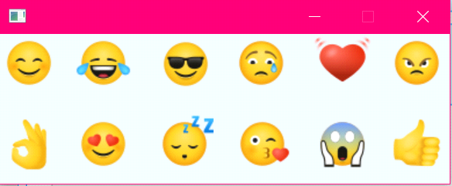**Smile window.**

When you click on a ”Smile", it will be sent.

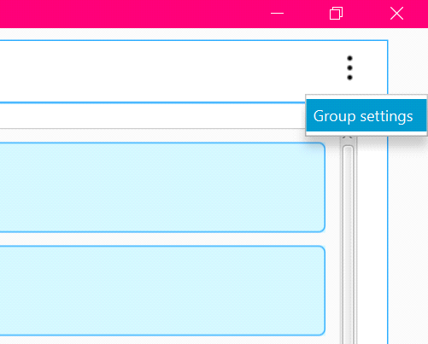When you click on the "Manage" button, you will see the "Group settings" tab.

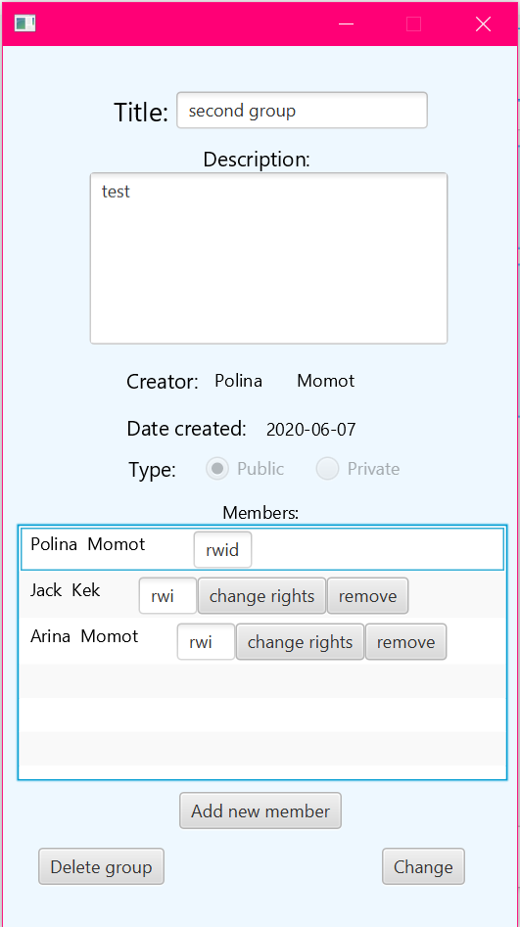

**Group settings window.**

In this window user can change title and description of the group.

Users, who has rights can change rights of other users or remove them from group. They can also add members to the group.

You can leave the group, if you want.

Creator of the group can delete group.

After clicking the “Add new member“ button, a new window will be open.

You can also see information of the members of the group by clicking on one of them.

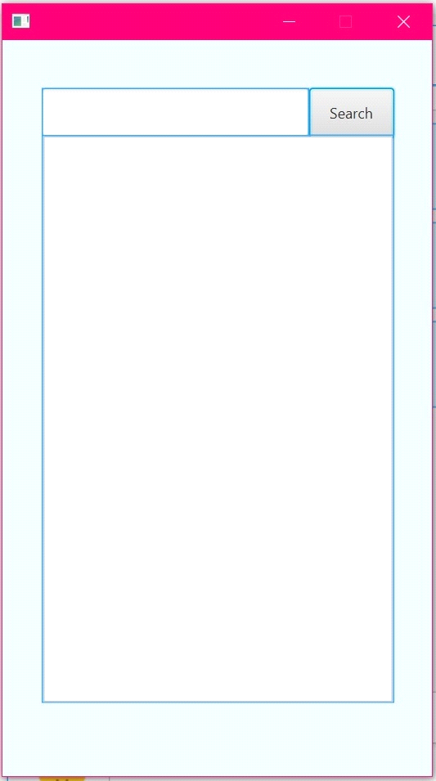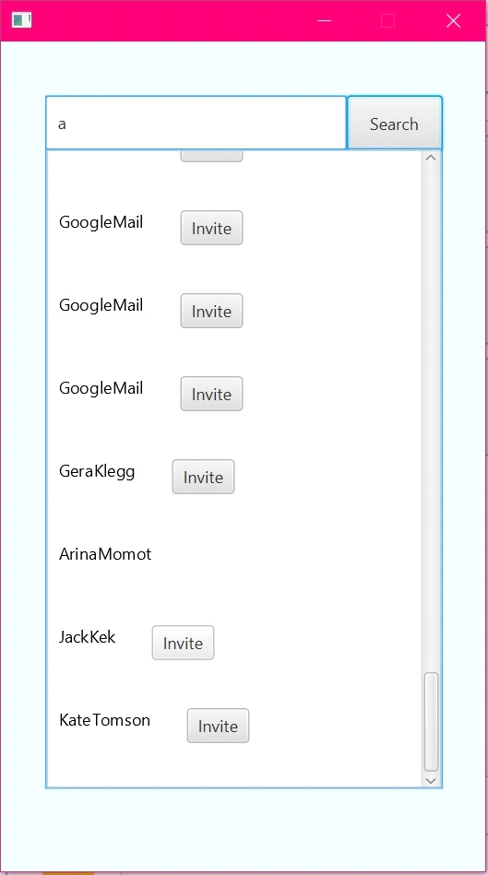

**Adding users window.**

You must enter the other user name or last name and click on button „Search“. Then you will see the list of users and button „invite“. After clicking on it user will be added to the group.

**The window with information about the one of the members of group.**

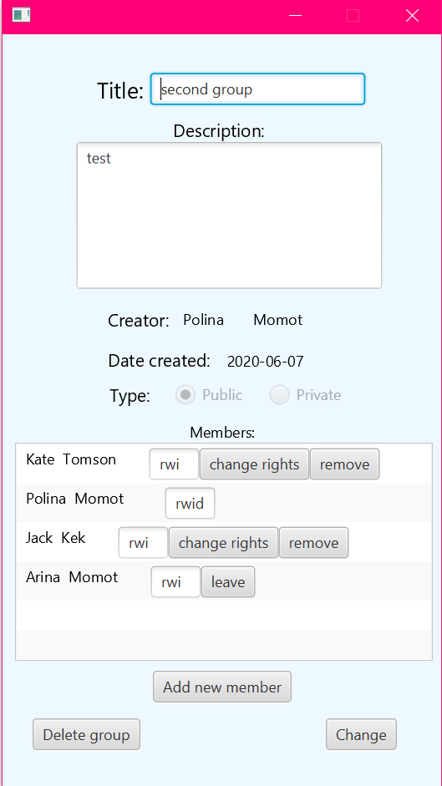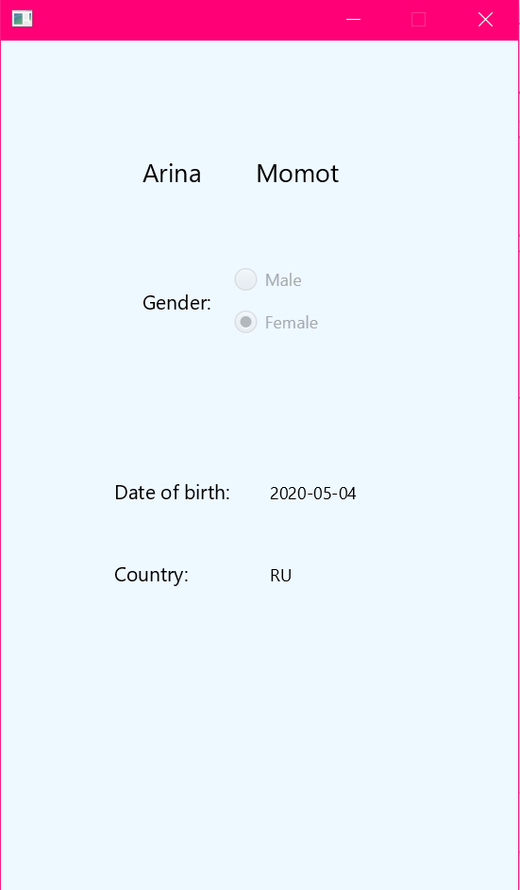If you are not creator of the group, yoy can leave it by clicking on „leave“ button.