**TECHNOLOGY AND INFORMATION SYSTEM**

**SECP1513-02**

**Design Thinking Project Report:**

**Laundry Tracking System**

PREPARED FOR: DR. ARYATI BINTI BAKRI

| NO. | GROUP MEMBERS NAME | MATRIC NO. |
| --- | --- | --- |
| 1. | ANGELA NGU XIN YI | A24CS0226 |
| 2. | ARINA SOFIAH BINTI HAMEDE | A24CS0227 |
| 3. | MICHELLE HO CHIA XIN | A24CS0110 |
| 4. | MIKAEL HAQIMI BIN NAHAR JUNAIDI | A24CS0111 |

**Table of Contents**

**1.0 Introduction 3**

1.1 Background information 3

1.2 About us 3

1.3 Objective and overview of this project 4

2.0 Target Consumer 5

3.0 Problems and Solutions 6

4.0 Team Working 9

**5.0 Design Thinking 11**

5.1 Design Thinking Process 11

5.1.1 Empathy 11

5.1.2 Define 11

5.1.3 Ideate 11

5.1.4 Prototype 12

5.1.5 Test 12

5.2 Design Thinking Evidence 13

5.2.1 Sample Work 13

5.2.2 Record for each phase 14

5.3 Design Thinking Assessment 28

5.3.1 During the end of the project demonstration 28

5.3.2 During the transition between design thinking phases 29

**6.0 Reflections 29**

**7.0 References 35**

**8.0 Video 36**

# 

# **1.0 Introduction**

## **1.1 Background information**

In today's fast-paced world, self-service laundromats or “dobi” have become an essential part of modern living, especially for university students, working professionals, travellers and also individuals without access to in-home laundry facilities. These laundromats offer convenience and affordability, but it is not without Achilles heel. They also come with several challenges that affect user experience and service efficiency.

Traditional laundromats typically operate on a first-come, first-served basis. As a result, users have to manually wait for their turn to use washing machines and dryers. This manual queuing process often leads to overcrowding, wasted time, and user frustration. Additionally, users have to remain physically present to track when their turn will arrive and when their clothes finish drying or washing, making the experience inconvenient and time-consuming.

Thus, in order to solve this problem, our team decided to design an app named ‘StainSlayer’ that can track the laundry process.

## **1.2 About us**

‘StainSlayer’ is an Internet of Things (IoT) application-based technology that incorporates four main elements for efficient data processing which are sensors, connectivity, communication and user interface. By integrating sensors within washing machines and dryers, the users can track machine status, queue numbers and operational conditions in real time. Moreover, users can remotely monitor their laundry progress and receive alerts for queue positions, turn reminders and cycle completion through the user interface. The system's connectivity is enabled through a Wi-Fi connection that links the application to the cloud-based server, ensuring users can access information and control the system remotely. This connectivity enables enhanced control and monitoring which would offer users a more efficient and automated laundry experience. Lastly, essential user data is stored within the system, allowing for seamless user authentication, customized wash or dry settings and also personalized queue tracking.

## **1.3 Objective and overview of this project**

The objective of ‘StainSlayer’ is to revolutionize the laundromat experience by providing users with a smart, connected platform that enhances convenience and efficiency. This app aims to reduce waiting times, improve queue management, enable multiple payments rather than cash only and provide real-time status updates for washing and drying cycles. Ultimately, the goal is to increase user satisfaction, reduce operational inefficiencies and promote the adoption of smart self-service laundromats.

By leveraging IoT technology, ‘StainSlayer’ will offer users a more modern and stress-free laundry experience. For example, the users can track machine availability, monitor queue positions and receive notifications for both turn alerts and also completion statuses. Most importantly, an AI chatbot is integrated to assist users with troubleshooting and customer support inquiries. Through real-time data sharing and smart automation, the Laundry Tracking App represents a significant step toward modernizing the self-service laundromat industry.

# **2.0 Target Consumer**

‘StainSlayer’ addresses an essential need for convenience, efficiency, and automation in laundromat services. This innovative solution incorporates IoT (Internet of Things) technology with smart sensors, machine connectivity, and user-friendly interfaces. It is designed to cater to a diverse range of users, including students, working professionals and also travellers. For this reason, ‘StainSlayer’ enables them to track machine availability, monitor queues, and receive alerts when it’s their turn to use a washing machine or dryer, minimizing their time spent at the laundromat. Moreover, it provides cashless payments and real-time updates, allowing them to manage laundry with ease and flexibility.

The laundry tracking app is designed for busy individuals, including students and office workers, who rely on shared or public laundry facilities and need a convenient way to manage their laundry time efficiently. ‘StainSlayer’ targets users who often experience long waiting times at laundromats or struggle with managing their laundry schedules due to their hectic lifestyles. By enabling real-time tracking of laundry status and queue positions, the app minimizes the inconvenience of waiting at the laundromat, giving users the freedom to spend their time productively. With additional features like reminders, chatbot and digital payments, the app provides a seamless, modern solution for an everyday chore.

# **3.0 Problems and Solutions**

| **Problem** | **Description** | **Solution** |
| --- | --- | --- |
| Lack of status update | Users often lack clear visibility of the number of people ahead of them in the queue, making it difficult to accurately estimate their waiting time. Additionally, users are generally unaware of the current status of their laundry, leading to uncertainty about when it will be ready. This situation results in wasted time and an inefficient laundry experience. For instance, users may leave the laundromat to run errands but miss the completion of their wash or dry cycle, causing delayed pickups and potential conflicts with other users, which may lead to inconvenience or discomfort for others. | ‘StainSlayer’ offers real-time tracking and status updates for washing and drying cycles, along with turn reminders. Users receive timely notifications when their turn is approaching or when the cycle is complete. For instance, they may receive alerts like, *“It’s your turn to WASH/DRY now!”* or *“Your clothes have finished washing/drying! Come and collect now!”* This feature keeps users well-informed, allowing them to manage their time more efficiently without needing to wait on-site. By minimizing idle wait times and providing clear updates, StainSlayer enhances the overall laundry experience with greater convenience and time-saving benefits. |
| Confusion about exact amount of detergent used | Many users struggle to determine the correct amount of detergent required for various load sizes. This uncertainty can lead to either overuse or underuse of detergent. Overusing detergent may cause excessive foam, which can be challenging to rinse out properly, potentially leaving a soapy residue on clothes. On the other hand, using an insufficient amount of detergent may result in clothes not being cleaned effectively, leaving behind stains, unpleasant odors, or dirt. This issue highlights the need for clear guidance on detergent usage to ensure optimal cleaning performance and resource efficiency. | ‘StainSlayer’ addresses this issue by providing precise guidance on detergent usage based on the size of the laundry load. It offers specific recommendations for light, medium, and heavy loads. This guidance helps users avoid overuse or underuse of detergent, ensuring effective cleaning while promoting eco-friendly washing practices. By reducing detergent waste, 'StainSlayer' supports sustainability and encourages more responsible consumption. |
| Limited payment methods | Many laundromats, including the Dobi at Arked Angkasa, only accept cash or offer a limited range of payment methods. This creates inconvenience for users who prefer cashless payment options. As a result, users are often forced to carry cash or search for nearby ATMs to withdraw money solely for the purpose of doing their laundry. | ‘StainSlayer’ integrates multiple payment options, including e-wallets (TNG, GrabPay, ShopeePay and Boost) as well as bank transfers and cash payment. This enables users to make payments quickly and securely, By accommodating both digital and cash transactions, ‘StainSlayer’ offers flexibility for those who prefer cash while still promoting a cashless economy. |
| Lack of chatbots/assistance | Users frequently face difficulties in resolving technical problems or understanding how to operate the machines or accompanying mobile apps. This issue gets even worse  during non-business hours when immediate support is unavailable, leaving users without timely assistance. | ‘StainSlayer’ features an AI-powered chatbot that offers 24/7 support. The chatbot offers real-time assistance and troubleshooting guidance, enabling users to receive instant responses to frequently asked questions, step-by-step troubleshooting instructions, and live support for processes such as payments, queue tracking, and machine operation. |

Table 3.1 Problems and Solutions

# **4.0 Team Working**

To ensure a more seamless workflow, our group has divided tasks among ourselves. Angela is responsible for creating and distributing the Google Form for data collection besides designing the prototype. At the same time, Michelle conducted the interview. Meanwhile, Arina, Michelle, and Mikael are tasked with enhancing and developing the prototype. All group members also contribute to writing the report and creating presentation slides. For the video, Michelle will be focusing on the video editing.

Although each member has specific responsibilities, we collaborate on our tasks to facilitate discussion and provide feedback so the process is more efficient and cohesive. Initially, we utilized the time between classes to discuss our design thinking topic and decide on our project focus. However, as the design thinking process became more complex and detailed, we began dedicating our free time after classes to ensure the timely completion of our tasks.

| **NAME** | | **ANGELA NGU XIN YI** | **ARINA SOFIAH BINTI HAMEDE** | **MICHELLE HO CHIA XIN** | **MIKAEL HAQIMI BIN NAHAR JUNAIDI** |
| --- | --- | --- | --- | --- | --- |
| **TASKS** | **Interview, Discussion,**  **Prototype and Test** | Give Idea about Design of Prototype | Improve Prototype & Test | Interview (Empathy) Prototype & Test | Improve Prototype |
| Discussion for Define and Ideate Stages | | | |
| **Documentation** | Slide Presentation | | Editing Videos | |
| **Report** | Brainstorm Idea | | | |
| Problems and Solutions | | Work Progress & Distribution Table | |
| Target Consumer | Design Thinking Assessment | Introduction | Merge and Summary the Report |
| Detail Description for Design Thinking Phase | | | |
| Design Thinking Evidence & Reflection | | | |

Table 4.1 Tasks for Each Member

# 

# **5.0 Design Thinking**

## **5.1 Design Thinking Process**

### **5.1.1 Empathy**

The first stage of the design thinking process, empathy, focuses on user-centric research. The goal is to develop a deep understanding of the problem we aim to solve. The primary objective of the empathy stage is to gain insights into the users, their needs, and the underlying challenges that influence the development of the product we want to create.

During this stage, we conduct observations to actively engage with users and develop a sense of empathy. To achieve this, we designed a Google Form to collect data from the community, particularly UTM students. Through the google form, we gained detailed insights into their laundry experiences, the challenges they face and their suggestions for improvement. Additionally, we conducted an interview with a UTM student, Miss Tay Xin Ying, to better understand the specific issues she encounters during her laundry routine and to gather her ideas for potential solutions.

From the survey and interview, we discovered that most users face common issues, such as the lack of real-time status updates, uncertainty regarding the appropriate amount of detergent to use, limited payment methods, and insufficient customer support or assistance.

### **5.1.2 Define**

During the Define stage, we organize the information gathered in the Empathize stage through survey responses and interview sessions. We analyze our observations to identify and articulate the core problems faced by users. After collecting the data and conducting interviews, our team engages in a discussion to review user response and pinpoint key issues, establishing a clear problem statement.

### **5.1.3 Ideate**

In the third stage of the design thinking process, known as "Ideate," creative solutions are ready to be generated. This phase involves viewing the problem from multiple perspectives and brainstorming innovative ideas to address the problem statement. During this stage, our team collaboratively brainstormed strategies to effectively tackle these challenges. We proposed the development of a product designed to track queue orders and monitor cycle completion, providing users with real-time updates. Additionally, we incorporated innovative features into our product, such as detergent usage recommendations and an AI-powered chatbot to enhance user support. Most importantly, the app supports multiple payment methods, ensuring greater convenience for users.

We have proposed different solutions to address the issues users are encountering, categorized into two main approaches which are smart kiosk systems and application-based solutions.

### **5.1.4 Prototype**

The next stage is the "Prototype" phase, where we aim to identify the best possible solutions for each of the problems identified during the first three stages. After our discussion, we concluded that developing a new application would provide a better user experience and greater convenience compared to the Smart Kiosk System. In this phase, we also transform our ideas and concepts into a tangible prototype. After discussing the design and features of our application, we began creating it using materials like A4 paper and pens, among others. We sketched and developed a user interface for our application.

### **5.1.5 Test**

The last stage, which is the testing stage, is really crucial for us to ensure that our product is fully functional and free of any deficiencies. User testing allows us to identify areas for improvement and make necessary adjustments. To facilitate this process, we created a tutorial video outlining the steps for users, enabling them to follow along easily and provide valuable feedback. This helps us verify that our product meets the needs and expectations of the community and satisfies its requirements. Moreover, we have given our prototype for the users to test, such as students and working professionals. Luckily, most of them were satisfied with this final solution.

## **5.2 Design Thinking Evidence**

### **5.2.1 Sample Work**

|  | **Data Collection**  We collected the problems faced by users and suggestions from them. |
| --- | --- |
|  | **Interview session**  Interviewer: Michelle Ho Chia Xin  Interviewee: Miss Tay Xin Ying  We asked about the problems she struggled with during laundry service and her suggested solution. |
|  | **Discussion**  We chose the topic which is laundry tracking system. |
|  | **Further Discussion**  We analyzed the problems faced by users and listed out all the possible solutions. Then we chose the best one after making a comparison. |
|  | **Building a prototype**  After the discussion, we started to build a prototype which is the app interface. |
|  | **Testing**  When our prototype was done, we demonstrated and tested our prototype with different users. |

Table 5.2.1 Design thinking evidence

### 

### **5.2.2 Record for each phase**

1. Empathy

a. Data Collection (Google Form)

The chart below illustrates the data collected on questions and answers gathered through the survey.

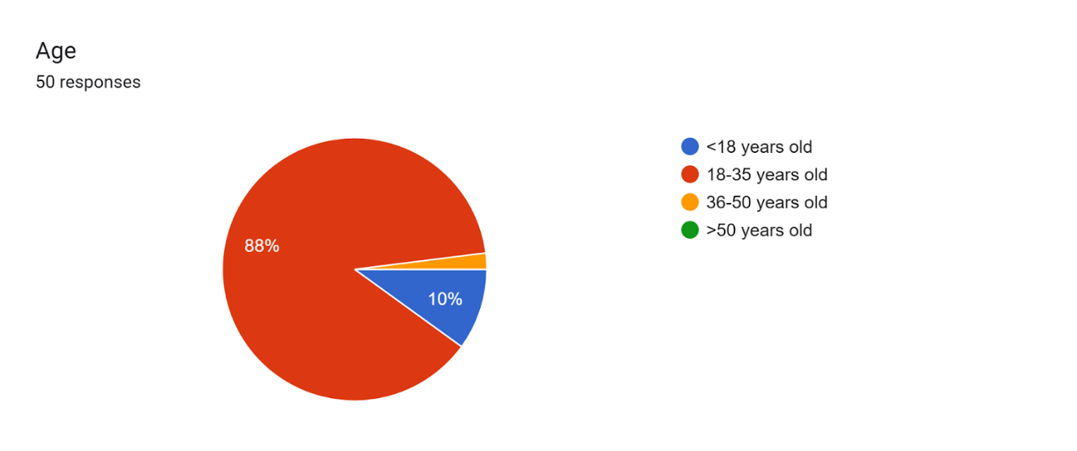

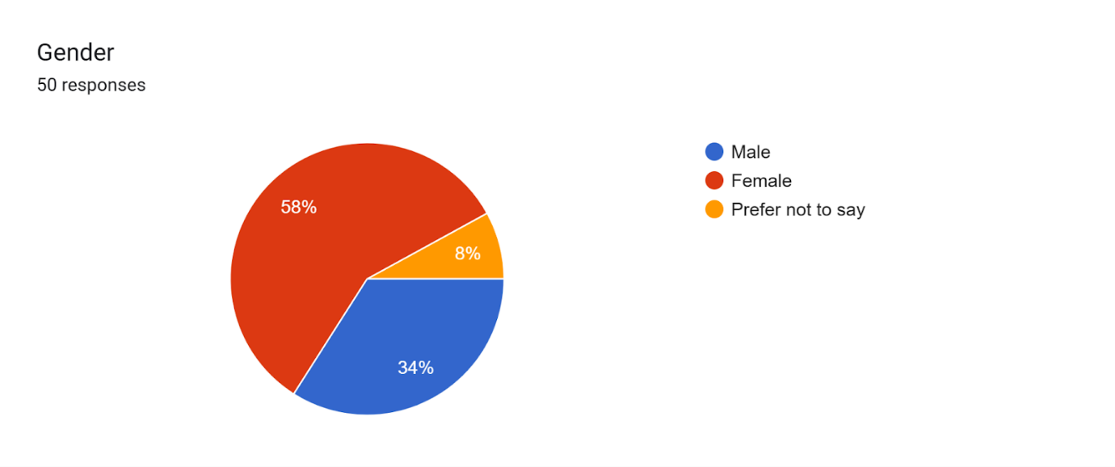

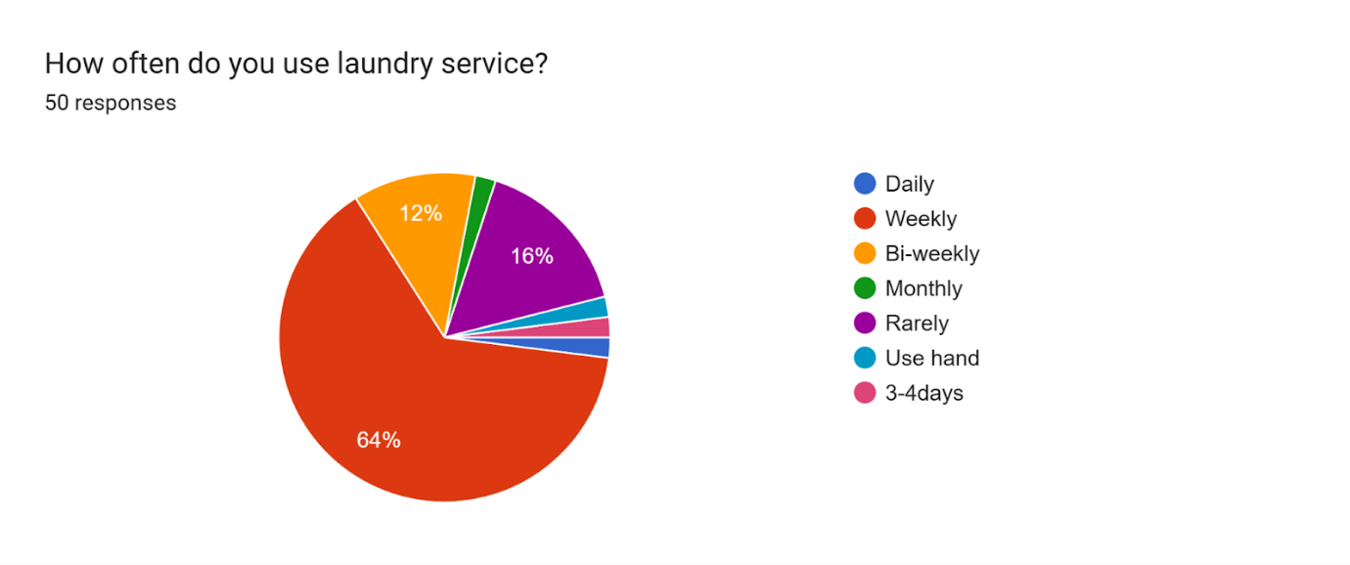

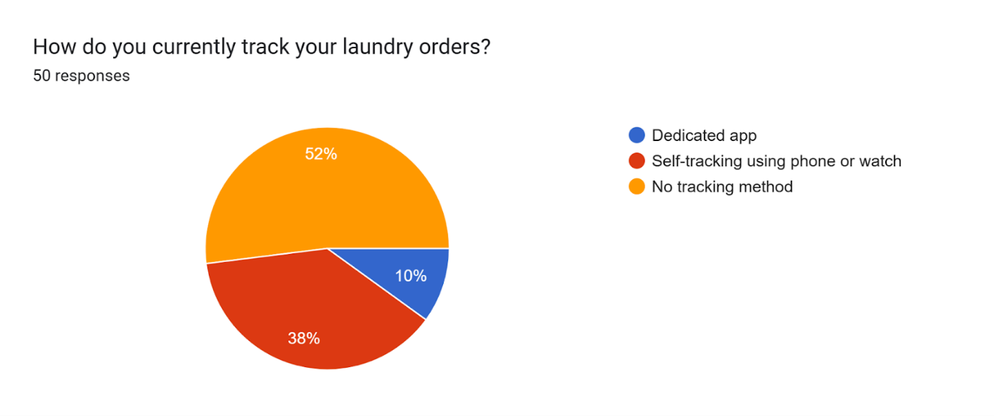

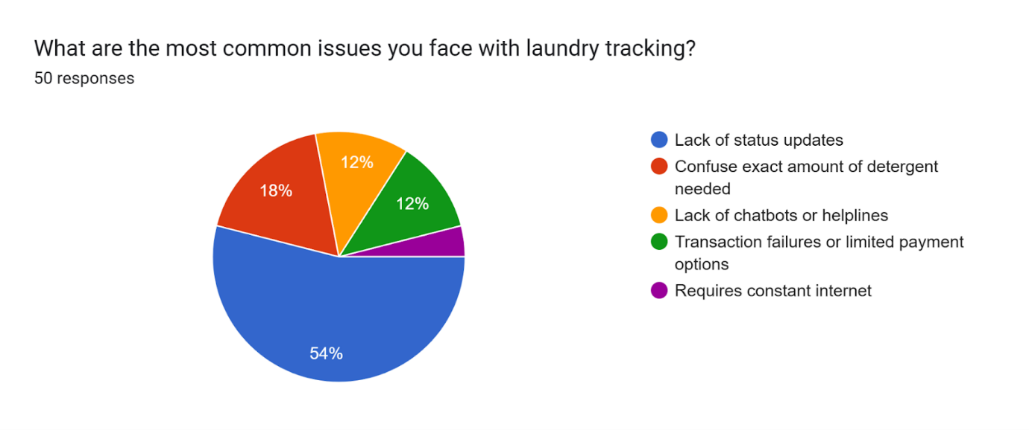

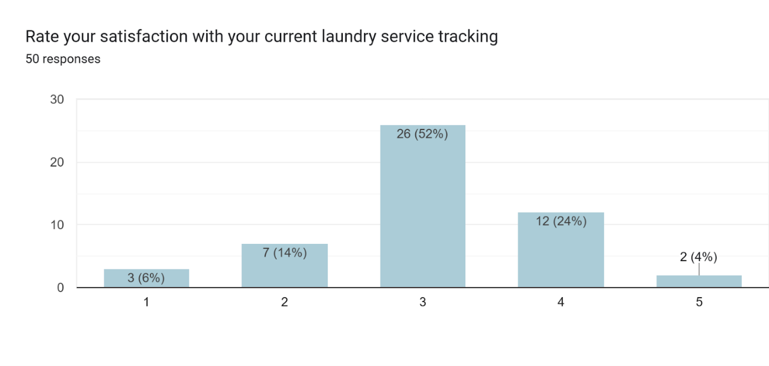

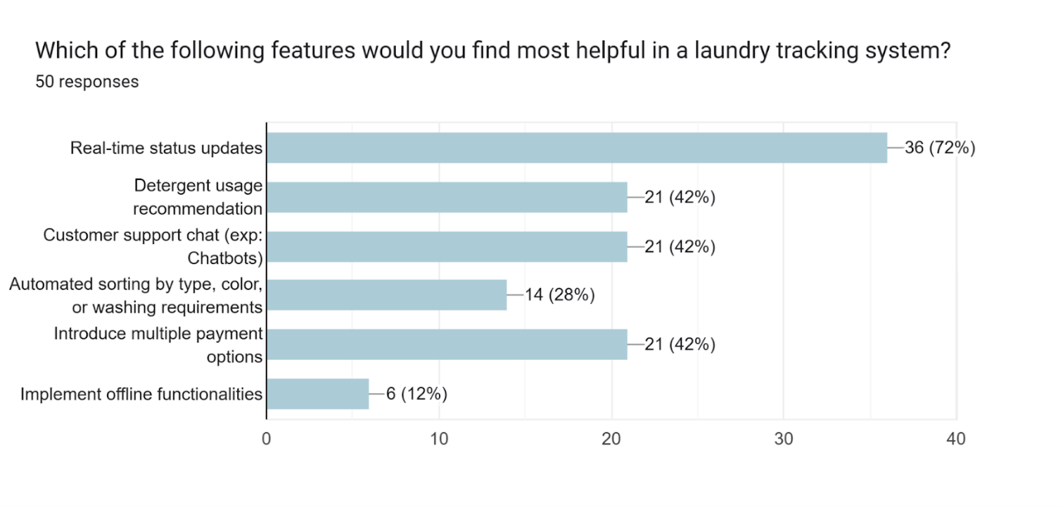

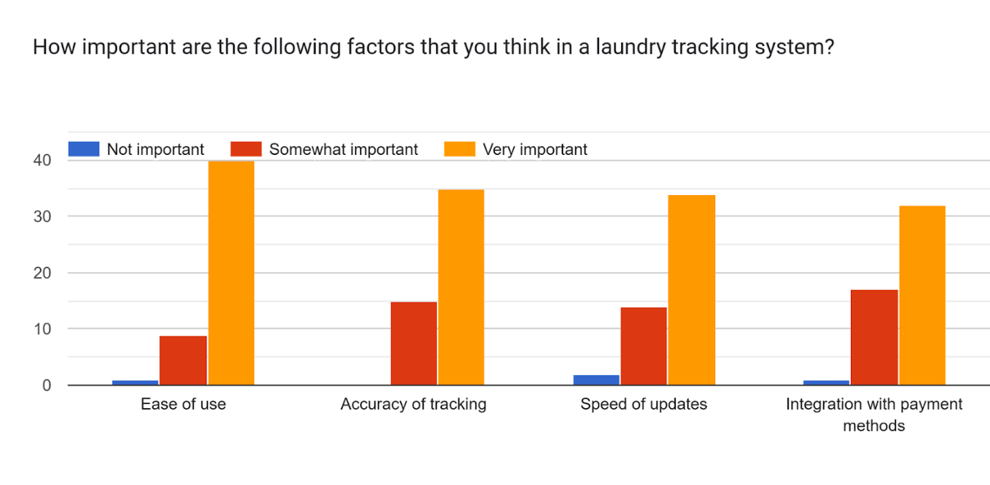

b. Interview

The table below presents the questions and answers obtained during the interview.

| **Questions** | **Answers** |
| --- | --- |
| Good morning, Miss Xin Ying. We are here today to interview about the topic of the Internet of Things for our TIS assignment. | Morning, Michelle. |
| How do you do your laundry? | I usually go to Arked Angkasa and use the dobi provided there. |
| How often do you use laundry service? | I use it about once a week. |
| How do you currently track your laundry orders? | I will set my phone timer or just wait at the dobi. |
| What are the common issues you face with laundry tracking? | The first issue I faced is the lack of status update system so I need to wait at the dobi or set a timer to track my order. Secondly, I’m usually unsure about the amount of detergent to be used per laundry load. Lastly, I think the Arked Angkasa dobi doesn’t accept TouchnGo or any e-wallet. They only accept cash, which is quite inconvenient for me as I don't always have enough cash on hand. |
| Do you have any suggestions to solve these problems? | Yes. I think the first thing that needs to be implemented is the real time status update system so that i don't have to wait there the whole time. Secondly, I think there could be a detergent suggestion system to prevent the overuse of detergent. Lastly, if there could be multiple payment methods instead of relying solely on cash then it could be better for me because you know-i don't always have cash. |
| Thank you for accepting our interview, hope you have a nice day. | Welcome. |

Table 5.2.2.1 Questions and Answers during Interview Session

2. Define

The table below shows some problems faced by users.

| **Problems** | **Descriptions** |
| --- | --- |
| Lack of Status Update | Users often struggle to gauge the number of people waiting ahead of them, making it challenging to predict their wait time accurately. Moreover, they typically have no real-time updates on the status of their laundry, leaving them unsure of when it will be ready for collection. This lack of transparency leads to inefficient time management and a frustrating laundry experience. |
| Confusion about exact amount of detergent used | Many users are uncertain about the appropriate amount of detergent to use for different load sizes. This can result in either detergent wastage or ineffective cleaning. For instance, using too much detergent may produce excess suds, which can be difficult to rinse out. Conversely, using too little detergent may fail to clean clothes thoroughly, leaving stains or odors behind. |
| Limited payment methods | Many laundromats, including the Dobi at Arked Angkasa, only support cash payments or have limited payment options. This poses a significant inconvenience for users who prefer digital payment methods. Consequently, customers are often compelled to carry physical cash or search for nearby ATMs to withdraw money specifically for laundry services. |
| Lack of chatbots/assistance | Users often encounter challenges in troubleshooting technical issues or understanding how to operate the machines or app. As a result, they lack immediate assistance, especially outside of business hours. |

Table 5.2.2.2 Problems and Description

3. Ideate

The table below shows the possible solutions that can be used to solve users’ problems.

| **Problem** | **Smart Kiosk System** | **Application** |
| --- | --- | --- |
| Lack of Status Update | The smart kiosk displays the current status of each washing and drying machine on a screen, showing estimated completion times and the queue position. | The application provides comprehensive real-time updates, allowing users to monitor the progress of their washing and drying cycles seamlessly. It includes automated reminders to inform users when their turn is approaching and notifications when the laundry cycle is complete. |
| Confusion About Detergent Usage | The kiosk can offer step-by-step instructions for users, including detergent recommendations based on load size and type of fabric. | The application provides tailored recommendations for detergent usage based on the size of the laundry load. It calculates precise amounts for different categories such as small, medium, or large loads. |
| Limited Payment Methods | Smart kiosks can be equipped with cash acceptors, card readers, and QR code scanners to support payments through cash, debit/credit cards, and popular e-wallets. | The application supports a variety of payment methods, including popular e-wallets like Touch 'n Go (TNG), GrabPay, ShopeePay, and Boost, as well as direct bank transfers, offering users greater flexibility and convenience. |
| Lack of AI-Powered Chatbots | The kiosk can have an AI-powered support system where users interact through a touch screen to get help with troubleshooting and frequently asked questions. | An AI-powered chatbot is integrated into the application to deliver round-the-clock support. This intelligent assistant provides instant solutions to common user concerns, offering guidance on troubleshooting issues, step-by-step instructions for payments, queue management, and machine operations. |

Table 5.2.2.3 Possible solutions to solve the problems

4. Prototype

After our discussion, we made a conclusion that developing a new application would provide a better user experience and greater convenience.

The reasons for this decision are outlined in the table below.

| **Reasons** | **Smart Kiosk System** | **Application** |
| --- | --- | --- |
| Cost-effectiveness | Developing a kiosk will be much more expensive as it involves hardware procurement, installation and upkeep. Moreover, when it breaks down, it will disrupt services for all users at that location. | Developing an application has lower upfront and ongoing costs if compared to installing and maintaining kiosks. |
| Accessibility and Convenience | Users have to stay at the laundromat because smart kiosks are limited to the physical location of the laundromat. | With an application, users can access the system anytime and anywhere using their handphone without being physically present at the laundromat. |
| Portability and Future-Proofing | Kiosk are fixed installations and may become outdated quickly as technology evolves. | Application is portable which means users can carry them in their smartphone whenever they go. Moreover, it can also be updated regularly with new features, ensuring them to remain relevant and useful over time. |
| Seamless Integration with other Technologies | Kiosks have limited integration capabilities because of hardware constraints and lack of ability to provide real-time notifications to users. | Application can easily integrate with other digital services, namely AI-powered chatbots for customer support, payment gateways for cashless transactions. |

Table 5.2.2.4 Comparison between Smart Kiosk System and Application

Hence, our team decided to develop an application that allows users to monitor their turn and track the progress of their laundry in real time. Additionally, the app provides detergent usage recommendations to prevent overuse or underuse. It is also equipped with multiple payment options, offering greater convenience to users. Furthermore, the app features an AI-powered chatbot to assist customers, particularly during non-business hours.

The table below shows the features of our application “StainSlayer”.

| **Features** | **Description** |
| --- | --- |
| Real-time Status Update | ‘StainSlayer’ provides real-time updates for washing and drying cycles to ensure users are informed about their laundry's progress, along with turn reminders. Notifications are sent when it’s their turn or when their laundry is done, with messages such as, *“It’s your turn to WASH/DRY now!”* or *“Your clothes have finished washing/drying! Come and collect now!”* |
| Detergent Usage Recommendation | To solve detergent usage concerns, ‘StainSlayer’ offers tailored recommendations based on the laundry load size, which are light, medium or heavy. This helps users avoid wasting detergent or using too little. |
| Multiple Payment Methods | ‘StainSlayer’ supports a variety of payment options, including e-wallets (like TNG, GrabPay, ShopeePay, and Boost), alongside bank transfers. |
| AI Chatbot | ‘StainSlayer’ incorporates a 24/7 AI-powered chatbot for support. It provides instant assistance, including answers to common queries, step-by-step troubleshooting for payment or machine issues, and live guidance for managing queues and using the system. |

Table 5.2.2.5 Features for “StainSlayer” application

Prototype Showcase

| **Feature Overview** | **Interface Design** |
| --- | --- |
| The login and create account interface with clean design ensures quick and easy account setup. | Login & create account interface |
| The option interface allows users to choose an available laundry service (washer & dryer). | Option interface |
| The washing machine queue status interface provides real-time updates on machine availability, showing which machines are in use and which are free. It also shows the queue number and notifies users when their turn in the queue is up, ensuring they can start their laundry right away. | Washing machine queue status interface |
| The prototype shows a washer selection interface to choose water temperature (cold, warm, hot), choose laundry size to predict the amount of detergent to be used, as well as a payment option interface supporting cash and digital methods. | Washer interface & payment option |
| The prototype shows a washing status interface with a timer and an "Add On" button to add washing time, and a completion notification that alerts users to collect their clothes. | Washing status interface |
| The dryer queue status Interface provides real-time updates on machine availability, showing which machines are in use and which are free. It also shows queue numbers and notifies users when their turn in the queue is up, ensuring they can start their laundry right away. | Dryer queue status interface |
| The prototype shows a dryer selection interface to choose temperature out of low, medium, and high options, as well as a payment option interface supporting cash and digital methods. | Dryer interface & payment option |
| The prototype shows a drying status interface with a timer and an "Add On" button to add drying time, and a completion notification that alerts users to collect their clothes. | Drying status interface |
| The prototype shows a chatbot interface to assist with user inquiries. | Chatbot |
| The user profile interface provides users with account management (e.g. change username and email) and account actions (log out and delete account) features. | User profile |

Table 5.2.2.6 “StainSlayer” Showcase

5. Test

Once our prototype was completed, we presented it to Miss Xin Ying. We thoroughly explained the functions and features of our product, highlighting how it addresses key user needs. She was impressed with our work and provided positive feedback, commending the design and functionality. Miss Xin Ying expressed her hope that our solution would effectively address the common challenges faced by laundromat users. Specifically, it could help users track their laundry status, see the number of people waiting in line, monitor the exact amount of detergent used, access assistance when needed, and enjoy the convenience of multiple payment methods.

## 

## 5.3 Design Thinking Assessment

### **5.3.1 During the end of the project demonstration**

To conclude our project demonstration, creating a product or application that serves society is undeniably a challenging endeavor. Conducting interview and utilizing Google survey are critical steps in understanding the issues faced by users. This foundation enables us to generate ideas more effectively although it requires considerable effort to ensure the solution functions seamlessly and efficiently. For example, it is essential to align our technologies with societal demands and market trends. Additionally, collaborative discussions are indispensable for achieving a unified concept and vision. Nonetheless, we take pride in our application and remain committed to enhancing it further, aspiring to genuinely address user challenges.

### **5.3.2 During the transition between design thinking phases**

In the initial phase of the design thinking process, integrating IoT to address the identified issues proved to be quite challenging. However, after thorough discussions, we decided to create a solution leveraging IoT to tackle the challenges faced by laundry users. We conducted user interviews and gathered insights from the community regarding their laundry experiences. Then, we identified the problems faced and thought about the solutions. Additionally, we explored various technologies that could be incorporated into our design and products. Subsequently, we created a prototype, enabling users to test it and provide feedback. Fortunately, our design thinking process was smooth, which allowed us to clearly determine each subsequent step. This clarity helped us stay on track and complete all tasks within the given timeline.

# 

# **6.0 Reflections**

| **Name** | **Reflection** | |
| --- | --- | --- |
| Angela Ngu Xin Yi | a. What is your goal/dream with regard to your course/program?  b. How does this design thinking impact on your goal/dream with regard to your program?  c. What is the action/improvement/plan necessary for you to improve your potential in the industry? | a. I hope to develop the skills required for my career, especially coding skills in languages like C++, HTML, and JavaScript, to name a few. Moreover, I aspire to master all the topics and subjects in my course. Since our program follows a 2u2i structure, which provides an extended internship period, I need to enhance my skills to effectively manage the responsibilities during my future internship.  b. In my opinion, design thinking undoubtedly impacts my goals as it has significantly improved my soft skills, particularly problem-solving, critical thinking, collaboration, and communication. For instance, when my teammates and I encountered challenges, we held discussions and brainstormed solutions together. Additionally, this design thinking approach allowed me to delve deeper into IoT, gaining more detailed knowledge about it. I firmly believe that these skills and insights will be invaluable in the future, especially during internships, and when completing projects or assignments.  c. To enhance my potential in the industry, I aim to improve my problem-solving and critical thinking skills by attending as many workshops as possible, which can help me refine my abilities and gain useful tips. Additionally, since I often lack confidence, especially when presenting in front of crowds, I plan to improve my communication and presentation skills by participating in events such as the Youth Speak Forum. Furthermore, I intend to take part in more challenging and nurturing competitions to advance my skills and stay updated with new knowledge. Most importantly, I strive to fully understand all the topics in my course so that I can effectively apply them in the future. |
| Arina Sofiah binti Hamede | a. My dream regarding this course is to sharpen my critical and problem solving skills by involving myself with all of the industry visits and talks that are prepared by the faculty. I also hope that by joining and exposing myself in how the industry works through the 2u2i program will make me become even more prepared to face my future endeavours in the workforce.  b. The design thinking project definitely helps me in challenging myself and team members in terms of my creativity and solving problem skills that will certainly be helpful in the future. With the Stain Slayer, I also managed to learn the impact of artificial intelligence and how much the users and I depend on the technology due to its ease of use when most of the responses agreed on implementing chatbots to help the users. Next, with my team members I managed to practise my teamwork skills and I am very thankful to meet and join hands with such amazing and diverse team members that I personally think would be quite impactful especially when meeting with new colleagues during my working days.  c. In my opinion, I would engage myself with most of the activities and programs that are done by the faculty and college to gain more insights and knowledge with what is currently trending in the world of evolving technology these days, for example the blockchain tech talk that was held by PESAKA themselves. Lastly, I would also partake in becoming crew members of certain programs that will help in my communicating skills and also team building that will be a crucial part in the industry where meeting with clients and also colleagues will become a new norm in the future. Therefore, I would join more programs and activities to gain more insightful skills. |
| Michelle Ho Chia Xin | a. I’m good at following steps and working in a structured way. If there’s a clear process, I can do things very well, but I’m not very strong in creativity. I chose Data Engineering course because I enjoy the sense of accomplishment that comes from following steps to build a working program from scratch. However, this course isn’t just about following steps—some parts require thinking out of the box to complete, which helps to develop my creative thinking to some extent. Back to the question, my goal is to become someone who is both strong in logical thinking and creative problem-solving, not only in school or at work, but also in my everyday life, helping me make thoughtful decisions, and find innovative solutions to everyday problems.  b. In this design thinking task, my groupmates and I had to think creatively to design an innovative app that is needed by the public but not yet widely implemented. We followed the methodical steps of the design thinking process: empathize, define, ideate, prototype, and test. Each stage required careful planning and problem-solving, but also challenged us to think out of the box. For example, while designing the interface of the laundry tracking app, we combined logical thinking with creativity to make it user-friendly and visually appealing. There is no doubt that this is a great opportunity for me to grow in both areas.  c. The most important quality and skill that I need to acquire is undoubtedly programming skill, as I need to build a strong foundation that will enable me to turn my ideas into reality. I aim to learn at least three programming languages before starting my internship, as this will give me confidence to tackle real-world projects. To achieve this, I have already taken steps by signing up for an upcoming C++ workshop organized by PERSAKA. I also plan to participate in more programming-related events and workshops in the future to continuously improve my skills. In addition to programming, I also want to improve both my logical thinking and creativity. To achieve this, I will treat every coursework and assignment, no matter how small, as an opportunity to learn and grow. By taking every task seriously, I believe I can learn something valuable from each experience. |
| Mikael Haqimi bin Nahar Junaidi | a. My goal is to use the knowledge and skills gained in my Data Engineering program to design and implement innovative solutions for real-world problems, particularly by leveraging IoT and smart technologies through the SECP1513 course. From projects like StainSlayer, I aspire to modernize traditional systems, enhance user convenience, and promote sustainability with my team. Ultimately, my dream is to become a technology expert who contributes to improving everyday experiences and advancing industries by creating impactful, user-focused solutions.  b. Design thinking plays a crucial role in achieving my goals by fostering a user-centered, innovative approach to problem-solving. By understanding users’ challenges through empathy, defining core issues, brainstorming creative solutions, and testing prototypes like StainSlayer, I learn to deliver impactful products tailored to users’ needs. This iterative and collaborative process enhances my problem-solving, critical thinking, and teamwork skills, which are essential for excelling in data engineering and developing practical, user-oriented technologies.  c. To improve my potential in the industry, I plan to deepen my technical skills in IoT systems, cloud computing, and app development while improving my knowledge of user-centric design. Engaging in internships, collaborative projects, and real-world applications will provide valuable experience and help me build a strong portfolio. Additionally, I will focus on networking with industry professionals, staying updated with emerging trends, and integrating sustainable and innovative practices into my work to ensure my solutions are both impactful and relevant. |

Table 6.0 Individual reflection from each group member

# **7.0 References**

Dam, R. F. (2024, March 21). The 5 Stages in the Design Thinking Process. *The Interaction Design Foundation*. <https://www.interaction-design.org/literature/article/5-stages-in-the-design-thinking-process>

Group 7. (2024, November 18). Laundry Tracking System. *Laundry tracking system*. <https://forms.gle/jWeCEVT7qpvicdq67>

Ibm. (2023, May 12). Internet of things. *What is the Internet of Things (IoT)?* <https://www.ibm.com/think/topics/internet-of-things>

# **8.0 Video**

<https://drive.google.com/file/d/1Auqq9nvePBwRj7YkC7GAWtDV_oDXbAEu/view?usp=sharing>

