# Ethics in telehealth: comparison between guidelines and field experience – the case for learning healthcare

C Kuziemsky, Telfer School of Management, University of Victoria, British Columbia

I Hunter, School of Management, Massey University

S Gogia, SATHI

S Iyenger, University of Arizona College of Medicine

G Kulatunga, {please write your university/institution affiliation here}

V Rajput {please write your uni/inst affiliation}

V Subbian {please write your uni/inst affiliation}

S John {please write your uni/institutional affiliation}

{Replace this text to add your initial and last name, university/institutional affiliation}

A Basu, School of Health Sciences, University of Canterbury

Corresponding author:

Arindam Basu,

Room 405F

Manawa,

St Asaph Street,

Christchurch 8011,

Email: [arindam.basu@canterbury.ac.nz](mailto:arindam.basu@canterbury.ac.nz)

Phone: +64033693509

## Summary

**Objectives**

The objective of this study was to compare and contrast field notes of telehealth practitioners with exemplar telehealth ethics guidelines issued by organisations involved in telehealth. Telehealth is the practice of offering education, health promotion, prevention, and medical care for patients separated from their health providers across time and place; health care ethics define principles regarding patient autonomy, confidentiality, justice, beneficence, and non-maleficence. We report here the extent to which ethics guidelines of telehealth map on field-based experiences of the practitioners.

**Methods**

We conducted computational text analysis on the guidelines of telemedicine ethics issued by the American Medical Association (AMA), the World Medical Association (WMA), and the South African Medical Association (SAMA). We compared with ‘insights and vignettes from the field’ to generate insights on the overlap and contrasts between the perspectives from field and established guidelines. We used word frequency to identify ‘words’ used to represent ideas in telehealth ethics guideline documentation.

**Results**

The practitioners’ field notes identified variability in international practice, physician-patient interactions, artificial intelligence, and elderly care as emergent themes. In contrast, guidelines ranked technology higher than themes of patient-provider interactions.

**Conclusions**

Guidelines on telehealth ethics tend to prioritise themes different from those with ‘boots on the ground’. To reconcile the differences, we therefore recommend telehealth practitioners and ethics guideline developers may adopt a learning healthcare systems approach that uses emergent data and evidence-based analyses to course correct and set priorities and guidelines.

Keywords

Ethics, telehealth, learning healthcare, moral policy, eHealth

## Introduction

The existing paradigm of healthcare focuses on establishing interactions across patients, providers, and settings [(1)](http://f1000.com/work/citation?ids=7667024&pre=&suf=&sa=0). Telehealth -- the use of distance-based technology to foster preventive and health promotion, as well as telemedicine -- involving health care delivery over distance -- are deemed as key facilitators of such interactions [(2)](http://f1000.com/work/citation?ids=6587083&pre=&suf=&sa=0). Common technologies that transfer information electronically include telephone, radio, fax, e-mail, the internet, video conferencing and satellite-based communications. The key concept in all telehealth applications is that a client (e.g. patient or provider) receives opinion/advice from an expert in the relevant field using telecommunication; the two parties are separated by space/distance/time. There are unintended consequences of telehealth interactions including ethical consequences [(3)](http://f1000.com/work/citation?ids=7700260&pre=&suf=&sa=0), [4,5)](http://f1000.com/work/citation?ids=7712649,7712585&pre=&pre=&suf=&suf=&sa=0,0). Such interactions and subsequent consequences can occur under any of the following circumstances, e.g., an automated system, a telecare physician, being monitored by remote device, and being communicated through mobile health applications. In these circumstances normative medical ethics need to be addressed within telehealth practice.

In 1803 Thomas Percival used term “medical ethics” to describe moral principles that govern practice of medicine [(6)](http://f1000.com/work/citation?ids=7700279&pre=&suf=&sa=0), based on the Hippocratic Oath and included beneficence (‘do good’) and non-maleficence (‘do no harm’). Two more concept, respect for autonomy indicating the right of a competent person to make informed decisions about their own medical care and justice as notions of fairness and equality was added. The principles of biomedical ethics framework behooves the clinician to balance these four principles. These are intended to represent a core set of fundamental moral ideals relevant to any society, regardless of culture, forming a system for moral reasoning and ‘guidelines for professional ethics’ in medicine [(7)](http://f1000.com/work/citation?ids=7700294&pre=&suf=&sa=0).

The focus of this paper is deontological ethics that emphasise morality rather than legal statutes. This concept is integral to healthcare delivery over distance and asynchronous care; implementation of telehealth would need to incorporate ethical frameworks as in any other health and social care implementation.

Ethical frameworks, such as the CoRE-values compass and grid are useful tools, as they incorporate ideas and processes identified as important in ethical decision-making, derived from systematic review of literature and from published empirical evidence [(8)](http://f1000.com/work/citation?ids=1382471&pre=&suf=&sa=0) The NHS National Information Board of the United Kingdom has published “A Framework for Action” on the use of data and technology within healthcare system. There is a proposed roadmap for moving to a whole-system, consent-based approach, which respects citizens’ preferences and objections about how their personal and confidential data is used [(9)](http://f1000.com/work/citation?ids=7700352&pre=&suf=&sa=0). What needs to be examined is the inter-relationships of frameworks based on morality, and normative ethics with what issues do telehealth practitioners and tele-clients face while working in the field.

We signpost four potential ethical issues related to telehealth from the perspective of practitioners in the field, in no particular order of importance. First, telehealth-mediated interactions should facilitate, if not foster, patient-provider relationships. For example, eCoaching of patients towards healthy behaviours for patient groups e.g., monitoring and management of chronic illness [(10)](http://f1000.com/work/citation?ids=6775089&pre=&suf=&sa=0). While patient-provider telehealth monitoring may achieve positive outcomes for the patient, such a process nevertheless has the potential to create undesired outcomes if patients are passively steered towards outcomes by the “app” rather than acting in a participatory manner [(11)](http://f1000.com/work/citation?ids=3400757&pre=&suf=&sa=0). Thus there is a need to frame the boundaries between passively steering patients towards adopting practices as opposed to empowering them.

Second, telehealth ethicists should consider the formation, nurturing, and development of patient-provider communication patterns. As an illustrative example of this point, consider an event reported in March of 2019. A patient was informed of his imminent death by a physician using a telehealth application [(12)](http://f1000.com/work/citation?ids=7709510&pre=&suf=&sa=0). The response from the patient’s family and the general members of the public was of overwhelming outrage with the physician and hospital being accused of delivering grim news with a lack of dignity. While the hospital acknowledged shortcomings in care provision, the example itself raises a significant ethical issue: one cannot always ‘predict’ the outcomes from telehealth mediated interactions; further, no matter how well-intentioned the messaging may be, messaging in a distance-based care context cannot be value-free. What are the ethical imperatives of such communication processes and channels?

Is it ethically appropriate for physicians to communicate with their terminally ill patients via telemedicine? A relative of the patient who was informed over a telemedicine consultation that he was near death told the reporter of New York Times that in her opinion, critically ill patients should not see a screen, rather that such individuals should be seen “a human being with compassion.” [(13)](http://f1000.com/work/citation?ids=7709513&pre=&suf=&sa=0).

Third, telehealth mediated interactions relate to the indirect outcomes such as patient data being collected or shared inappropriately by either the patient, the provider, or yet other stakeholders they may be engaged within the telehealth applications [(2,14)](http://f1000.com/work/citation?ids=6587083,1826142&pre=&pre=&suf=&suf=&sa=0,0) . Issues around data integrity and security can be contentious as implications of inappropriate sharing will only be noticed downstream by which time significant damage may have already occurred. This calls for deliberations on the issues of data protection and privacy tailored towards telehealth applications distinct from other data privacy and data sharing considerations, leading to laws such as HIPAA in the USA and DISHA in India. India Increasing incorporation of artificial intelligence and machine learning based algorithms within telehealth, distance based careand also lifestyle interventions raise some fresh issues.

Fourth, any discussion around ethical imperative around telehealth needs to take into account that it serves special populations, different age groups, differences in culture, ethnicity, as well as supporting health systems. We highlight one such: those related to ageing populations. As an illustrative example of how cultural values and ethnic groups relate to telecare, privacy of physician-patient communication becomes important as telecare clients in the Asian region are attracted to Telemedicine mostly to resolve their medical problems associated with social stigma such as genitourinary and behavioral diseases [(15)](http://f1000.com/work/citation?ids=7709525&pre=&suf=&sa=0)

How do generic ethical frameworks deal with telehealth-specific issues? One way to examine such tensions would be to examine the guidelines issued by healthcare organisations and associations in different countries regarding telehealth practice. It would inform the practice of an individual elsewhere for two reasons. First, medical ethics pertain to both direct care provision (telemedicine) and as an enabler of a wider range of health related preventive and health promotional activities (telehealth). Second, there is a need to ensure that ethics guidelines take into account the themes that emerge from practice based evidence. Hence we have combined perspectives of telehealth practitioners (practice-based evidence) and computational text analysis of terms contained in the texts of ethics guidelines for telehealth from three sources: the AMA guidelines, the ethics guidelines from the South Africa, and the WMA ethics guidelines for telehealth practice. We consider these three sources as exemplars of written guidelines for telehealth ethics.

We have used words as data to indicate policy positions in texts on ethics of telehealth [(16)](http://f1000.com/work/citation?ids=2448650&pre=&suf=&sa=0). The goal of this analysis is to provide an indicative, descriptive, and exploratory view of how guidelines aimed at regulating provider behaviour in practice map on the lived realities of everyday telehealth practitioners. We also discuss how overlaps and differences can be reconciled to enable sensemaking in telehealth to build a learning healthcare system.

## Methods

The members of the telemedicine working group of the International Medical Informatics Association, deliberated the following open-ended questionss from practitioners’ perspectives. These questions were derived from the four themes discussed in the introduction section.

1. What cultural and regional differences are significant in the practice of telehealth?
2. What are the ethical implications of big data and artificial intelligence generated by telemedicine services?
3. What is the link between ethics in telemedicine and other ethical practices linked to new medical technologies (personalized medicine, precision medicine, robots)?
4. In what ways ethics of telemedicine differ from face-to-face medical practice?
5. What are some of the ethical issues involved in special populations using care of elderly as an exemplar special subpopulation using telehealth services?
6. What ‘cross-border’ and ‘cross-jurisidiction’ issues are important for the practice of telehealth?
7. Should medical councils consider it differently or leave it to their peers to decide whether consultations over the phone are appropriate to their ends? Medical doctors are allowed to open a body to perform a surgical procedure, but may not decide what is appropriate to order after talking over the phone to a patient?
8. Should patients be exposed to ethical principles too? How local physicians consulting a patient will deal when been confronted with prescriptions from physicians from abroad for the same patient and condition?

We analysed responses to these questions around the four foundations of ethical issues in telehealth with computational text analysis of telehealth guidelines from the World Medical Association, the American Medical Association, and the South African guidelines to assess the extent to which they were addressed.

Steps of computational text analysis:

In conducting the computational text analyses, we followed the principles of computational text data analysis described by Welbers et.al [(17)](http://f1000.com/work/citation?ids=7062944&pre=&suf=&sa=0). In brief, these were as follows. We first extracted text data from the ethical guidelines from each of these three documents and created corpuses using quanteda software. Next, we tallied term frequencies present in the documents to include terms “patient-physician” or “patient-doctor” to indicate interactions. We also used these as keywords in context. Finally, we used term frequencies pertaining to patient-physician or patient-provider interaction (the term used was ‘patient-practitioner’ OR ‘patient-physician’), data (the term used: ‘data*’ with wildcard entry to capture as many terms in the documentation, and ‘confidentiality’. As these terms were representative of the themes or concepts that indicated patient-provider relationships, we hypothesised that documents that would contain more instances of these terms would put more emphasis on patient-physician (alternatively patient-doctor) relationships to be found in the corpus. If such terms were absent, it would indicate lower emphasis on themes associated with such phrases or words.

## Results

### Vignettes from field notes

What cultural and regional differences exist in telehealth ethics?

These notes were selected as indicative responses from the WG members based in representative countries. While these do not present a comprehensive picture of global practices, these were included to provide vignettes of the state of the regulations with respect to telehealth practices in the respective countries.

Sri Lanka:

Medical ordinance in Sri Lanka (1927), Cosmetics Devices and Drugs (CDD) Act no 27 of 1980 and National Medicines Regulatory Authority Act, No. 5 Of 2015 do not provide information on digital health, neither have provisions to regulate internet-based prescriptions. Even though telemedicine continue to expand in Sri Lanka [(18)](http://f1000.com/work/citation?ids=7716706&pre=&suf=&sa=0), the Sri Lankan National eHealth Guidelines and Standards [ NeGS ] document [(19)](http://f1000.com/work/citation?ids=7716714&pre=&suf=&sa=0) by the Ministry of Health Sri Lanka 2016 doesn’t mention about regulations on Telemedicine consultations.

United States:

The Federation of US State Medical Boards (FSMB) has prioritised telemedicine as an important medical regulatory topic that need to be addressed since 2016 (cite??). The Federal Council of Medicine, the regulatory and professional body, issued a new regulation for telemedicine in February 2019 but was met with resistance from some physicians and they had to revoked it, falling back to a 2001 regulation (cite??). It is now set for a new trial next year.

Colombia:

The Colombian Ministry of Health Resolution 1448 [(20)](http://f1000.com/work/citation?ids=7716768&pre=&suf=&sa=0) had set agenda for telehealth. In Colombia telehealth is delivered complementary to face to face interactions and only as an additional resource when the physical encounter is limited in some way. An informed consent is mandatory for enrolment for patients, and telehealth delivery is mediated by a health care provider. In Colombia, the most common risks related to telehealth include loss of privacy (right of the patient), loss of confidentiality (duty of provider), and loss of data.

Argentina:

In Argentina, telehealth is governed by The National Directorate of Health Information Systems (DNSIS) under the Ministry of Health and Social Action. The overall impact on access measures, acceptability, cost and supplier satisfaction remain positive. Argentina’s eConsult services has been extended both geographically and in terms of specialized services offered. By allowing a larger population to be served, access to care is improved; The Ministry of Health promotes telemedicine as a tool to expand the window of opportunity for people to access health services using eConsults (cite??).

In summary, while adoption of telehealth is relatively well in the countries surveyed, there is no uniformity around the legal frameworks or ethical guidelines or best practices. This imply that the onus is on physicians who practice telemedicine for ethical behaviour.

Ethics of not offering remote support due to cross border, legal or regulatory issues

The existing regulations on Telemedicine around the world concentrate on controlling cross border practice. Conventionally in all of those regulations, the Telephysician should be registered in the country where patient is receiving medication [(21)](http://f1000.com/work/citation?ids=7716949&pre=&suf=&sa=0).

Widespread availability of licensing raises the question whether a professional who is asked for a remote consult ever refuse to proffer advice when requested. The request made could be based on false information about the capabilities of the physician, albeit intentional. For a professional, once financial transaction is completed, it is difficult to refuse to tender advice. On the other hand, the context of telecare makes for easy negotiation or settlement of grievance due to in-built documentation around the care process. Thus incorrect advice can be identified against established norms. A related issue would also be spoofing with an unqualified person (cite??).

Ethics of Artificial Intelligence (AI) in telehealth:

In face-to-face care, clinicians rely on history, evaluation of symptoms and signs to arrive at a differential diagnosis. This is then further refined by special investigations and imaging to confirm diagnosis and plan patient management. In telehealth, time, technology, and lack of comprehensive clinical data sets available for an AI-based system or computer algorithms to provide decision support are constraints. Besides, there is increasing concern about computer algorithms perpetuating existing racial and gender disparities by reflecting the human biases and other risks that are carried in the training datasets (citation??).

As synchronous telehealth consultation in most instances rely on real-time video conversations between providers and clients/patients, some telehealth offerings are incorporating face recognition algorithms to enable ascertaining the mood and psychological status of the care seekers. While face recognition and affective computing are powerful tools to enable care delivery through recognition of mood disorders, depression, or other psychiatric illnesses, there is a potential risk of application of facial recognition algorithms that could result in profiling of the care seekers and misuse of the same by law enforcement authorities.

Facial recognition systems have been reported to perform sub-optimally while introducing gender and racial biases. These pose significant ethical issues around anonymity and confidentiality of patients who receive care through these services. These risks are higher in telehealth considering many telehealth systems rely on commercial, proprietary “black box” solutions with near opaque approaches for the explainability of the decision or predictive algorithms, application of these approaches into a telehealth ecosystem could exponentially increases the risk of harm (citation??).

Application of AI approaches in telehealth would therefore need careful assessment of the risks of biases that these emerging technologies pose. In the current context and with the emerging hype around AI, coded inequity is perpetuated precisely because those who design and adopt such tools are not thinking carefully about systemic issues.

### Medical and healthcare ethics for elderly care

Continuing to live in their preferred place of residence (known as “aging in place”) is the preferred option for most older adults and has better health outcomes [(22–25)](http://f1000.com/work/citation?ids=3563990,3974218,6732270,7717005&pre=&pre=&pre=&pre=&suf=&suf=&suf=&suf=&sa=0,0,0,0)

Monitoring of an individual, for example to detect falls or to detect changes in health and wellbeing, is an important use of telehealth that may enable an older adult to stay living in the community as opposed to entering supported residential care (which is expensive). Some of the ethical issues that are associated with telehealth use for aging in place include poorer access to telehealth, monitoring of an individual, automation of data collection, information processing, and empowerment of the older adult. Privacy and security of health information, especially between an older adult, their family, and their healthcare providers remain an important ethical issue, more so when complicated with health issues such as dementia. Cost is a significant issue for those dependent on the family for the payment. Many telehealth systems have an initial purchase cost and then ongoing licence fees, some may need qualified installation and ongoing technological support [(23,26,27)](http://f1000.com/work/citation?ids=3974218,5684105,6275844&pre=&pre=&pre=&suf=&suf=&suf=&sa=0,0,0) . These issues can lead to a digital divide, yet another ethical issue with telehealth and elderly care.

While home care is making it easier for the aged to live longer, but if quality of life is not improved, we need to understand that mere prolonging of life and associated suffering affects not only the patient himself – who in some cases due to problems like dementia or coma maybe oblivious of the suffering but also all the care givers especially the family. Such care consumes resources – which with the looming danger of climate change needs to considered as a not insignificant issue. Besides monitoring with sensors, cameras, and similar technologies can also be seen to intrude on an individual’s right to privacy, especially if imposed by well-meaning family or healthcare providers without including the older adult in the decision making. Decisions will depend upon what to monitor, how often, who sees the data etc. Automation may increase privacy concerns like availability of monitoring systems to all but methods do exist to lessen these- for a blurred video can still detect falls.

Involving an elderly person in the decision making process of telehealth systems implementation can be empowering, enabling them to determine their own needs and lifestyle choices, yet the balance remains contentious. Ethical issues arise when such needs are interpreted differently by the patients, family caregivers, and health care providers. Establishment of robust communication to resolve these issues that best supports the elderly can be non-trivial in the face of family disagreement or deteriorating cognitive ability of the elderly.

A recent New Zealand co-designed research project with community-dwelling older adults sought to investigate these ethical issues and determined 15 requirements for technology to support older adults to continue living in their preferred place of residence (aging in place). The majority of these 15 requirements were found to be unmet by existing commercial telehealth systems [(28)](http://f1000.com/work/citation?ids=7717065&pre=&suf=&sa=0).

Access to telehealth implies either the ability to attend a local health provider, e.g. access to specialist medical care at a distance, or presence of telehealth technology in the home. Current systems tend to be ‘one size fits all’, requires the older adult to adapt to the technology rather than the technology to adapt to the individual, and provides communication pathways to formal health care providers neglecting the older adults’ informal support networks of family and local community [(29,30)](http://f1000.com/work/citation?ids=7717072,6821647&pre=&pre=&suf=&suf=&sa=0,0). At home use of telehealth technology requires such systems, rather to be easy to use, low cost, personalised to an older adult’s needs including privacy, scalable to changing health needs and increase communication between the older adult and their informal support network [(28)](http://f1000.com/work/citation?ids=7717065&pre=&suf=&sa=0).

Ethics of telehealth compared with face-to-face care:

Arguably, much of the ethical challenges with telehealth relate to lack of face-to-face contact that traditionally takes place in healthcare. With an unknown patient, physicians have to envision they are working with the ideal. (Medical Economics, 2015, need reference). Ethical medical practice therefore remain focused on the patient as a whole person who is more than a data set or collection of digital images [(31)](http://f1000.com/work/citation?ids=7717073&pre=&suf=&sa=0). It is imperative on the physicians to ensure that they have the information they need to make well-grounded clinical recommendations when they cannot personally conduct a physical examination, such as by having another health care professional at the patient’s site conduct the exam or obtaining vital information through remote technologies.

Irrespective of the emergence of new technologies and models of care, the physicians’ fundamental ethical responsibilities remain the same [(32)](http://f1000.com/work/citation?ids=7709517&pre=&suf=&sa=0). The responsibility rests with the healthcare providers to appreciate the difference between how fundamental responsibilities play out in the context of telehealth compared with face-to-face interactions. In as much as physicians’ fundamental ethical responsibilities remain invariant, the continuum of possible patient-physician interactions in telehealth/telemedicine give rise to differing levels of accountability for physicians [(33)](http://f1000.com/work/citation?ids=5965420&pre=&suf=&sa=0).

In principle, ethical issues remain same whether the setting is that of telehealth or face-to-face care. These include a sharp focus on maintaining a strong patient/client-physician/caregiver/relationship, protecting patient privacy, promoting equity in access and treatment, and seeking the best possible outcomes. In practice though, telehealth can be a double-edged sword. On the one hand, telehealth can enhance medical practice and patient care in ways that the providers can feel comfortable [(34)](http://f1000.com/work/citation?ids=7717077&pre=&suf=&sa=0). On the other, the providers need to contend with confidentiality and related privacy concerns perceived to be difficult to maintain due to high risk of data breach and issues around information security. With the growing trend of information being stored on the cloud, the incidence of possible breaks rise as mobiles may be stolen or lost along with their privileges of information access [(35)](http://f1000.com/work/citation?ids=7717081&pre=&suf=&sa=0) That these are more for gaining financial access [(36)](http://f1000.com/work/citation?ids=7717083&pre=&suf=&sa=0) does not absolve the healthcare provider. Added to this dilemma is the issue of fixing responsibility of any such breach of ethics as it may be related to poor security of the system and software – occurring without the knowledge and control of the physician. Indian government recently debated a law in the parliament titled Digital Information Security in Healthcare Establishments (DISHA) that have draconian punishment for the physician including a jail term for any break in confidentiality. Taken to an extreme, would it be ethical to deny tele-support to a patient at a site that otherwise lacks health support, yet the provider is concerned about the legal implications of offering such advice.

### Results of computational text modelling of ethics guidelines

Analysis of the term frequencies in ethical practice guidelines for telehealth from the American Medical Association, the World Medical Association, and South African Telehealth association show that terms ‘ethics’, ‘patients-provider interactions’ and ‘data’ have low frequencies relative to the more general conceptual topics around telehealth and terms expressing telemedicine (Figures 1 and 2).

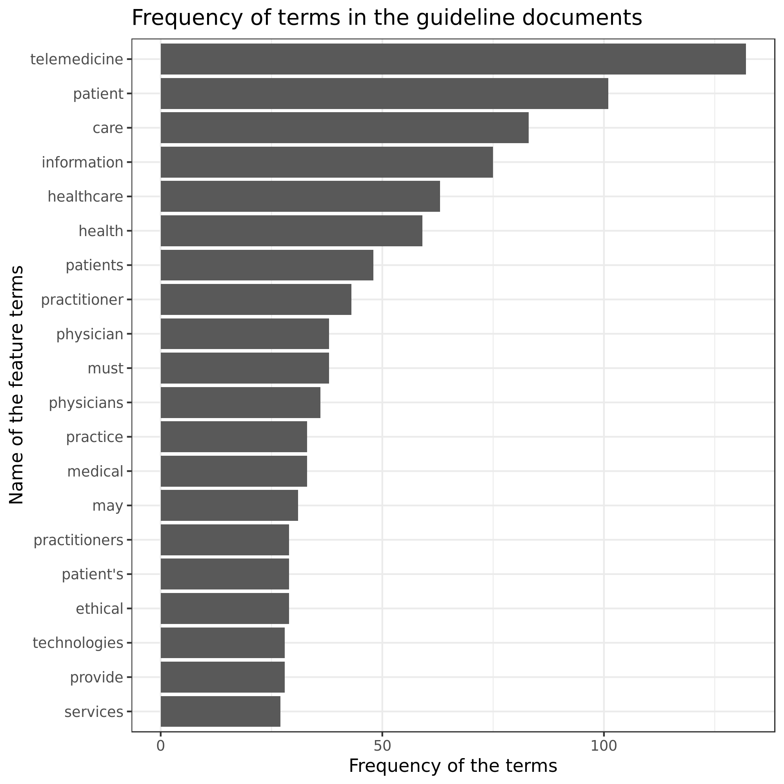

Figure 1. The relative frequency of the terms expressed in the three documentations about ethics in telehealth practice

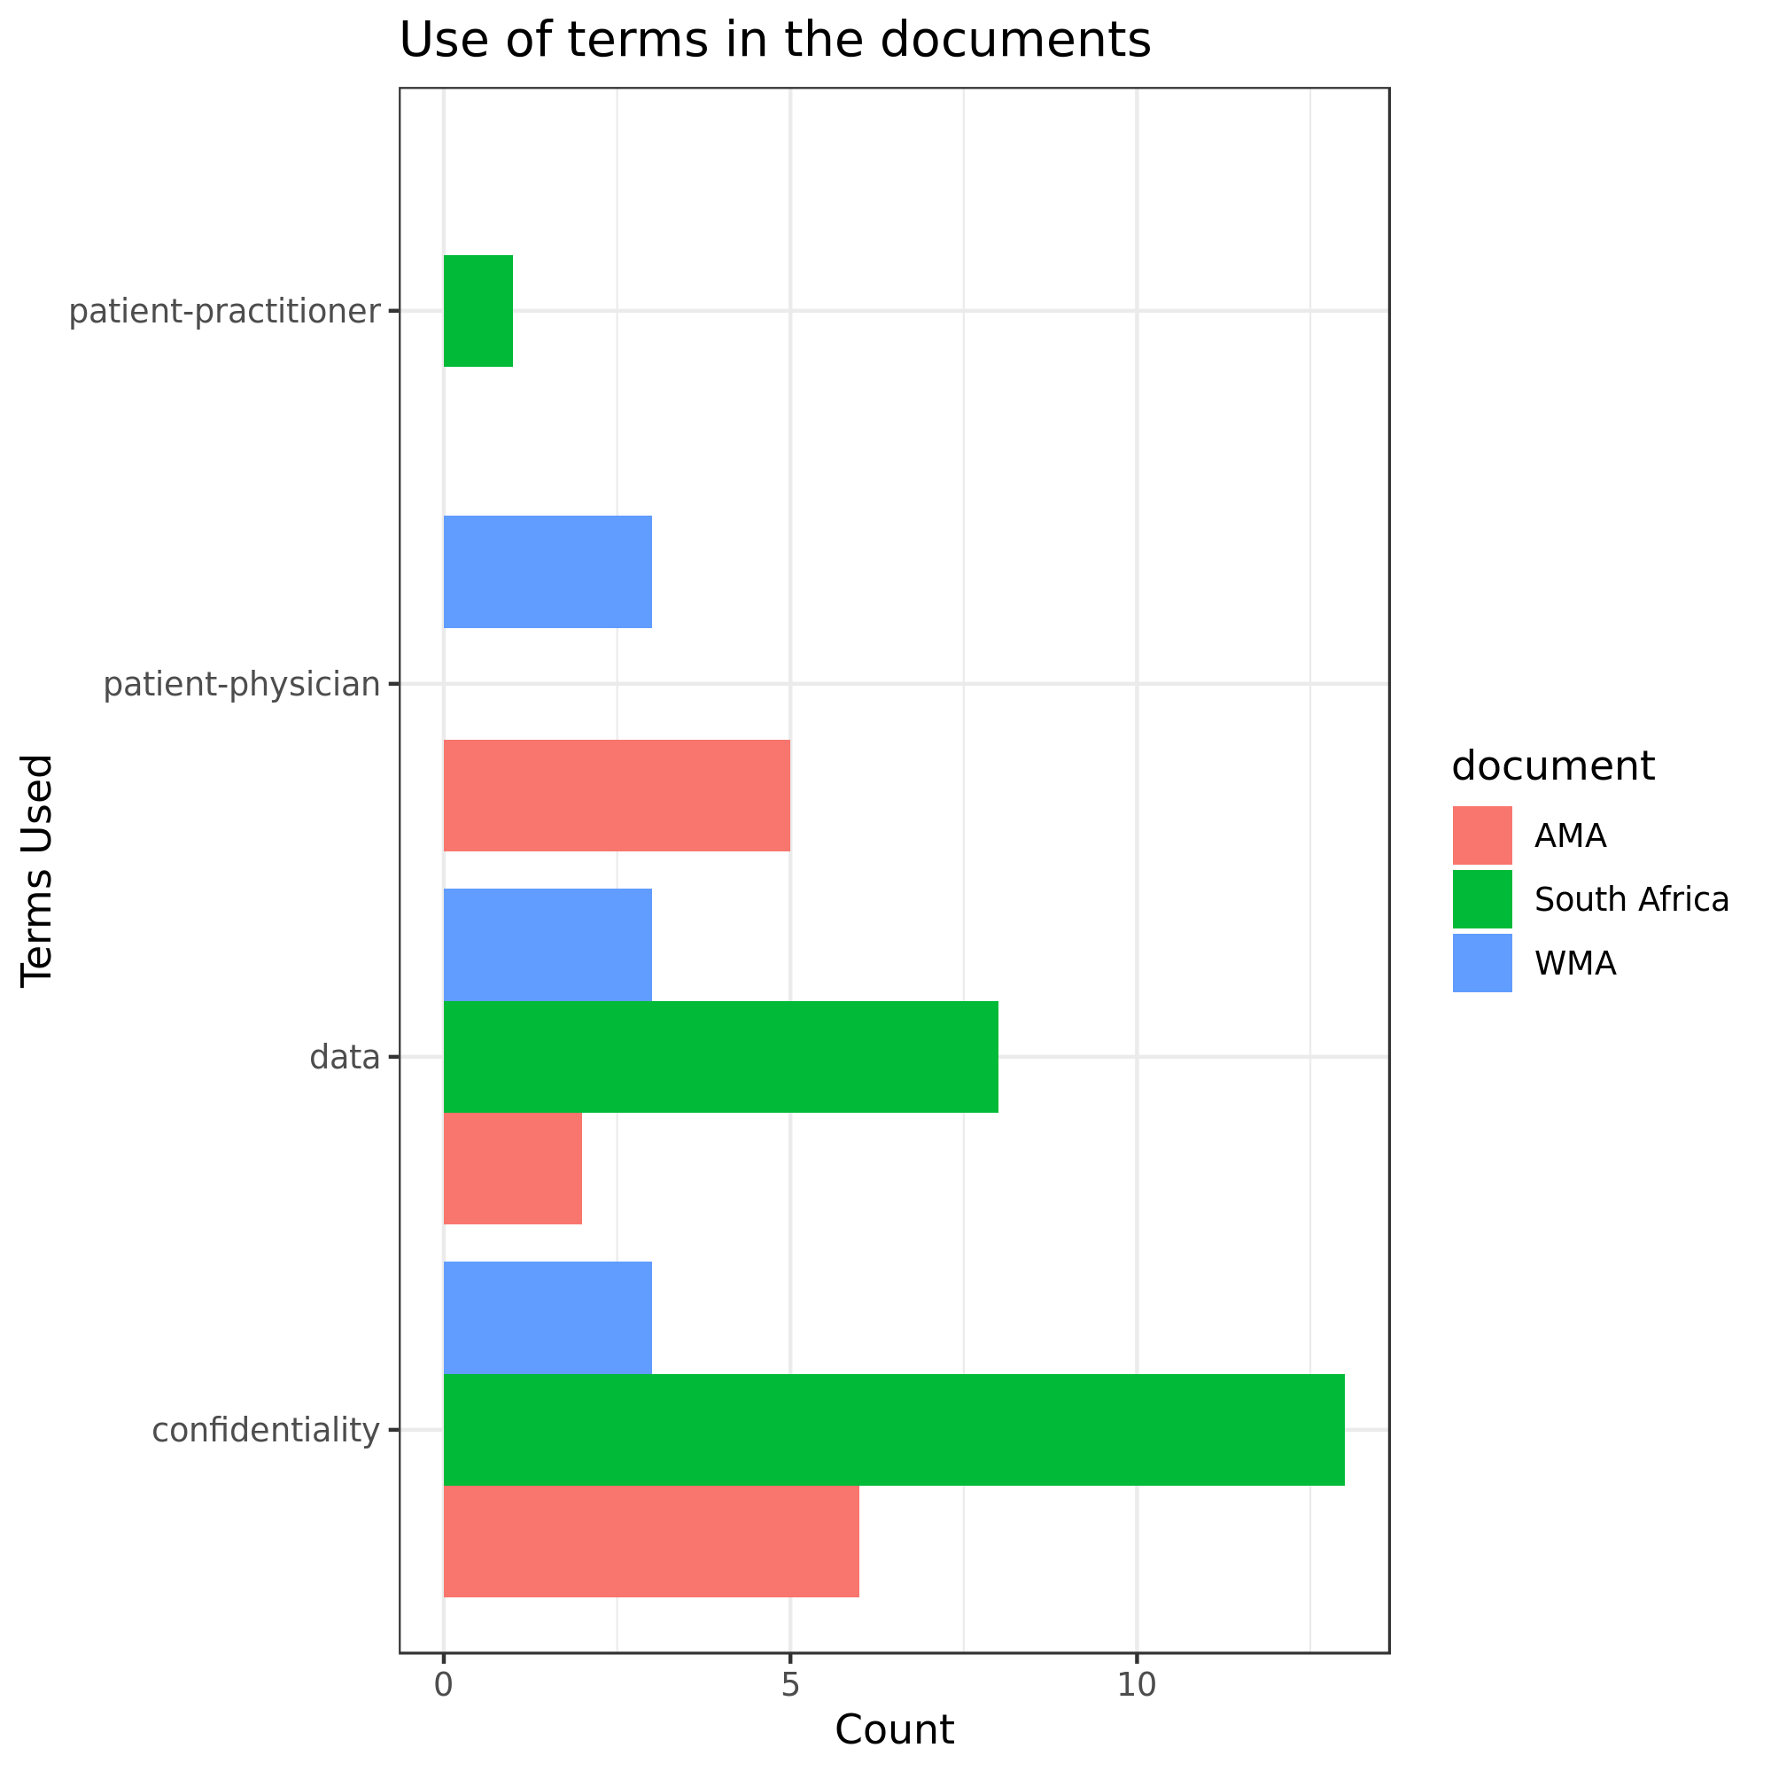

Figure 2. The extent of the presence of terms that denote physician/provider-patient interactions, confidentiality and data are represented in the ethics guidelines documentation.

## Discussion

Telemedicine will continue to be an essential part of healthcare delivery as patient care delivery becomes more complex and requires care coordination and information sharing across providers and settings. However, telemedicine enabled care can also introduce ethical issues due to changes in patient-provider communication patterns, access to care delivery services and how patients interact with telehealth tools. While we are often quick to criticize these new care delivery models, we need to remember that healthcare is a learning health system and we must learn from past situations (both positive and negative) to improve care delivery moving forward [(37)](http://f1000.com/work/citation?ids=2960372&pre=&suf=&sa=0). While we always strive for positive outcomes from telemedicine usage, it is not rational to assume that we can always predict, or even fully understand how telemedicine mediated interactions will develop across complex iterations of patients, providers and settings. The medical informatics field has long been interested in understanding how unintended consequences occur and how to best manage them in different contexts [(4,5)](http://f1000.com/work/citation?ids=7712585,7712649&pre=&pre=&suf=&suf=&sa=0,0)

This paper used a set of eight discussion questions to provide insight on ethics and telemedicine. We identified potential ethics issues that may arise from different patterns of telemedicine use and how we can use these issues to better design and manage telemedicine delivery going forward.

Strengths and limitations of the approach

// need more stuff

## Conclusions

The scope and reach of telemedicine has greatly increased in recent years due to advances in Information and Communications technologies such as greatly increased internet speeds, 4G, LTE, and 5G cellular data connectivity, medical sensors, improvements in cloud computing hardware and software, and others. The increasing use of telemedicine to serve an ever greater number of people correspondingly raises the old and new ethical concerns related to fundamental principles of patient autonomy, benevolence, confidentiality, and non-maleficence. Technological advances that result in increased monitoring of patients in their homes raises new concerns about patient confidentiality. Government regulations have not kept up with these advances. Telemedicine practitioners and providers need to be educated in this regard and provided with ethics guidelines to ensure the continued integrity of this important technology.

Acknowledgments

## References

[1. Kuziemsky C, Abbas RM, Carroll N. Towards a connected health delivery framework. Proceedings of the International Workshop on Software Engineering in Healthcare Systems - SEHS ’18. New York, New York, USA: ACM Press; 2018. p. 46–9.](http://f1000.com/work/bibliography/7667024)

[2. Kuziemsky CE, Gogia SB, Househ M, Petersen C, Basu A. Balancing Health Information Exchange and Privacy Governance from a Patient-Centred Connected Health and Telehealth Perspective. Yearb Med Inform. 2018 Aug;27(1):48–54.](http://f1000.com/work/bibliography/6587083)

[3. Gogia SB, Maeder A, Mars M, Hartvigsen G, Basu A, Abbott P. Unintended Consequences of Tele Health and their Possible Solutions. Contribution of the IMIA Working Group on Telehealth. Yearb Med Inform. 2016 Nov 10;(1):41–6.](http://f1000.com/work/bibliography/7700260)

[4. Coiera E, Ash J, Berg M. The unintended consequences of health information technology revisited. Yearb Med Inform. 2016 Nov 10;(1):163–9.](http://f1000.com/work/bibliography/7712649)

[5. Kuziemsky CE, Randell R, Borycki EM. Understanding Unintended Consequences and Health Information Technology:. Contribution from the IMIA Organizational and Social Issues Working Group. Yearb Med Inform. 2016 Nov 10;(1):53–60.](http://f1000.com/work/bibliography/7712585)

[6. Pellegrino ED. Percival’s Medical Ethics. Arch Intern Med. 1986 Nov 1;146(11):2265.](http://f1000.com/work/bibliography/7700279)

[7. World Medical Association. WMA Statement on Guiding Principles for the Use of Telehealth for the Provision of Health Care – WMA – The World Medical Association [Internet]. 2009 [cited 2019 Oct 31]. Available from: https://www.wma.net/policies-post/wma-statement-on-guiding-principles-for-the-use-of-telehealth-for-the-provision-of-health-care/](http://f1000.com/work/bibliography/7700294)

[8. Manson HM. The development of the CoRE-Values framework as an aid to ethical decision-making. Med Teach. 2012;34(4):e258-68.](http://f1000.com/work/bibliography/1382471)

[9. NHS UK. Clinical leadership — a framework for action | NHS Improvement [Internet]. Clinical leadership — a framework for action | NHS Improvement. 2019 [cited 2019 Oct 31]. Available from: https://improvement.nhs.uk/resources/clinical-leadership-framework-action/](http://f1000.com/work/bibliography/7700352)

[10. DeJesus RS, Clark MM, Rutten LJF, Hathaway JC, Wilson PM, Link SM, et al. Wellness coaching to improve lifestyle behaviors among adults with prediabetes: patients’ experience and perceptions to participation. J Patient Exp. 2018 Dec;5(4):314–9.](http://f1000.com/work/bibliography/6775089)

[11. Adams S, Niezen M. Digital ‘solutions’ to unhealthy lifestyle ‘problems’: the construction of social and personal risks in the development of eCoaches. Health Risk Soc. 2016 Feb;17(7–8):530–46.](http://f1000.com/work/bibliography/3400757)

[12. BBC news. Man told he’s going to die by doctor on video-link robot - BBC News [Internet]. BBC News. 2019 [cited 2019 Nov 3]. Available from: https://www.bbc.com/news/world-us-canada-47510038](http://f1000.com/work/bibliography/7709510)

[13. Jacobs J. Doctor on Video Screen Told a Man He Was Near Death, Leaving Relatives Aghast - The New York Times [Internet]. New York Times. 2019 [cited 2019 Nov 3]. Available from: https://www.nytimes.com/2019/03/09/science/telemedicine-ethical-issues.html](http://f1000.com/work/bibliography/7709513)

[14. Denecke K, Bamidis P, Bond C, Gabarron E, Househ M, Lau AYS, et al. Ethical issues of social media usage in healthcare. Yearb Med Inform. 2015 Aug 13;10(1):137–47.](http://f1000.com/work/bibliography/1826142)

[15. Kulatunga G, Hewageegana NR. Understanding the Tele-health needs of Suwásariya (Health Net) users. Indian Journal of …. 2014;](http://f1000.com/work/bibliography/7709525)

[16. Laver M, Benoit K, Garry J. Extracting Policy Positions from Political Texts Using Words as Data. Am Pol Sci Rev. 2003 May;97(02).](http://f1000.com/work/bibliography/2448650)

[17. Welbers K, Van Atteveldt W, Benoit K. Text analysis in R. Commun Methods Meas. 2017 Oct 2;11(4):245–65.](http://f1000.com/work/bibliography/7062944)

[18. Razick S. How Sri Lanka’s Healthcare Industry Is Experimenting With Technological Solutions [Internet]. 2019 [cited 2019 Nov 5]. Available from: https://roar.media/english/life/in-the-know/how-sri-lankas-healthcare-industry-is-experimenting-with-technological-solutions/](http://f1000.com/work/bibliography/7716706)

[19. Sri Lankan Ministry of Health. National eHealth Guidelines and Standards . Colombo; 2016.](http://f1000.com/work/bibliography/7716714)

[20. Ministerio de Salud y Protección Social. DIJ - tienda terminos [Internet]. 2006 [cited 2019 Nov 5]. Available from: https://www.minsalud.gov.co/sites/rid/Lists/BibliotecaDigital/RIDE/DE/DIJ/](http://f1000.com/work/bibliography/7716768)

[21. Economics E. Regulatory Approaches to Telemedicine. GMC; 2018.](http://f1000.com/work/bibliography/7716949)

[22. Wiles JL, Leibing A, Guberman N, Reeve J, Allen RES. The meaning of “aging in place” to older people. Gerontologist. 2012 Jun;52(3):357–66.](http://f1000.com/work/bibliography/3563990)

[23. Peek STM, Luijkx KG, Rijnaard MD, Nieboer ME, van der Voort CS, Aarts S, et al. Older Adults’ Reasons for Using Technology while Aging in Place. Gerontology. 2016;62(2):226–37.](http://f1000.com/work/bibliography/3974218)

[24. Boldy D, Grenade L, Lewin G, Karol E, Burton E. Older people’s decisions regarding “ageing in place”: a Western Australian case study. Australas J Ageing. 2011 Sep;30(3):136–42.](http://f1000.com/work/bibliography/6732270)

[25. New Zealand Ministry of Health. Healthy  Ageing Strategy. New Zealand Ministry of Health; 2017.](http://f1000.com/work/bibliography/7717005)

[26. Kapadia V, Ariani A, Li J, Ray PK. Emerging ICT implementation issues in aged care. Int J Med Inform. 2015 Nov;84(11):892–900.](http://f1000.com/work/bibliography/5684105)

[27. Yusif S, Soar J, Hafeez-Baig A. Older people, assistive technologies, and the barriers to adoption: A systematic review. Int J Med Inform. 2016 Jul 7;94:112–6.](http://f1000.com/work/bibliography/6275844)

[28. Elers P, Hunter I, Whiddett D, Lockhart C, Guesgen H, Singh A. User requirements for technology to assist aging in place: qualitative study of older people and their informal support networks. JMIR Mhealth Uhealth. 2018 Jun 6;6(6):e10741.](http://f1000.com/work/bibliography/7717065)

[29. Carretero S, Stewart J, Centeno C. Can technology-based services support long-term care challenges in home care. Analysis of evidence …. 2012;](http://f1000.com/work/bibliography/7717072)

[30. Fischer SH, David D, Crotty BH, Dierks M, Safran C. Acceptance and use of health information technology by community-dwelling elders. Int J Med Inform. 2014 Sep;83(9):624–35.](http://f1000.com/work/bibliography/6821647)

[31. WP Cheshire JR. Telemedicine and the Ethics of Medical Care at a Distance. Ethics & Medicine. 2017;](http://f1000.com/work/bibliography/7717073)

[32. Mills R. AMA adopts new guidance for ethical practice in telemedicine | American Medical Association [Internet]. AMA Press Releases. 2018 [cited 2019 Nov 3]. Available from: https://www.ama-assn.org/ama-adopts-new-guidance-ethical-practice-telemedicine](http://f1000.com/work/bibliography/7709517)

[33. Chaet D, Clearfield R, Sabin JE, Skimming K, Council on Ethical and Judicial Affairs American Medical Association. Ethical practice in Telehealth and Telemedicine. J Gen Intern Med. 2017 Oct;32(10):1136–40.](http://f1000.com/work/bibliography/5965420)

[34. Mehta SJ. Telemedicine’s potential ethical pitfalls. AMA Journal of Ethics. 2014;](http://f1000.com/work/bibliography/7717077)

[35. West K. Patient medical information at risk from stolen computers. Mo Med. 2014 Feb;111(1):10–2.](http://f1000.com/work/bibliography/7717081)

[36. Carroll L. Healthcare data hacking could lead to identity thefts [Internet]. Reuters. 2019 [cited 2019 Nov 5]. Available from: https://in.reuters.com/article/us-health-privacy-cyber/healthcare-data-hacking-could-lead-to-identity-thefts-idINKBN1W82K3](http://f1000.com/work/bibliography/7717083)

[37. Friedman CP, Allee NJ, Delaney BC, Flynn AJ, Silverstein JC, Sullivan K, et al. The science of Learning Health Systems: Foundations for a new journal. Learn Health Sys. 2016;](http://f1000.com/work/bibliography/2960372)