Indra-BMS
Edge-Native Differential Capacity Analysis (dQ/dV) for
Physics-Informed Battery Diagnostics on RISC-V
Transparent, Software-Defined Battery Intelligence for India's EV Ecosystem
Team | Fumblers
Platform | VSDSquadron ULTRA (RISC-V)
Application Domain | Electric Vehicle Battery Management
Members | Arjun Bora and Arin Bhuyan

Executive Summary
Indra-BMS represents a paradigm shift in battery management systems for India's electric vehicle ecosystem. By implementing sophisticated electrochemical diagnostic algorithms directly on indigenous RISC-V processors, we transform battery health monitoring from a resource-intensive, opaque cloud service into a transparent, bandwidth-efficient edge intelligence platform.
Key innovations include:
- 99% bandwidth reduction: Transmitting 50-100 bytes of diagnostic features instead of 5 MB of raw telemetry per charge cycle
- Mechanistic transparency: Identifying specific degradation modes (Lithium Plating, Loss of Lithium Inventory, Loss of Active Material) rather than black-box predictions
- Indigenous silicon utilization: Optimized for RISC-V vector extensions and FPU, demonstrating Make-in-India capability
- 10-15% capacity extension: Physics-informed diagnostics enable targeted interventions to prolong battery life

1. Problem Statement
Current electric vehicle battery management systems in India rely on imported controllers that operate as opaque 'black boxes' with two critical deficiencies:

1.1 Bandwidth Inefficiency
Existing systems continuously upload raw sensor streams (voltage, current, temperature) to cloud platforms, consuming 2–5 MB per vehicle per hour. This approach creates:
- Prohibitive data costs for large-scale fleet deployment
- Network infrastructure dependencies that limit rural/remote operation
- Privacy concerns with continuous telemetry streaming

1.2 Diagnostic Opacity
Generic machine learning models predict outcomes ("battery will fail soon") without mechanistic explanations. These systems cannot differentiate whether degradation stems from:
- Lithium Plating: Metallic lithium deposits on anode surface during fast charging
- Loss of Lithium Inventory (LLI): Lithium trapped in solid-electrolyte interface
- Loss of Active Material (LAM): Electrode structural degradation
This opacity forces fleet operators to apply conservative limits (capping at 80% State of Charge), effectively wasting 15–20% of usable battery capacity and reducing economic viability.

1.3 Proposed Solution
By implementing electrochemical diagnostic algorithms directly on indigenous RISC-V processors, Indra-BMS creates a transparent, bandwidth-efficient, and scientifically grounded battery management system that identifies not just when but why batteries degrade.

2. System Architecture
Indra-BMS employs a software-defined architecture that shifts diagnostic intelligence from cloud to edge. Rather than streaming gigabytes of raw telemetry, the VSDSquadron ULTRA performs real-time Incremental Capacity Analysis (ICA) using numerical differentiation to compute the dQ/dV curve during charge cycles.

2.1 Physical Layer
Component | Specification
Voltage Measurement | High-Precision ADC (ADS1115 or oversampled internal ADC for 16-bit resolution)
Current Measurement | INA219 Current Sensor
Temperature Measurement | DS18B20 Digital Temperature Sensor

2.2 Compute Layer: VSDSquadron ULTRA (RISC-V)
The computational pipeline executes five critical stages:

Stage 1: Circular Buffer
Stores the last 60 seconds of (V, I, T) samples during charging at 10 Hz sampling rate, enabling real-time window-based analysis.

Stage 2: Savitzky–Golay Filter
Smooths voltage curve while preserving peak features using:
- Polynomial order: 3
- Window size: 11 samples
- RISC-V FPU optimization for matrix operations

Stage 3: Numerical Differentiator
Computes Incremental Capacity using central difference method:
IC = dQ/dV ≈ (I · Δt) / ΔV
where I is measured current, Δt is sampling interval, and ΔV is voltage change between samples during constant-current charging.

Stage 4: Peak Detection Algorithm
Identifies local maxima in the IC curve using derivative sign change, extracting:
- Peak voltage positions (Vpeak)
- Peak heights (ICmax)
- Peak widths

Stage 5: Health Vector Generator
Maps peak shift from baseline to State of Health (SoH) percentage and classifies degradation mode (LLI vs LAM) based on multi-peak pattern analysis.

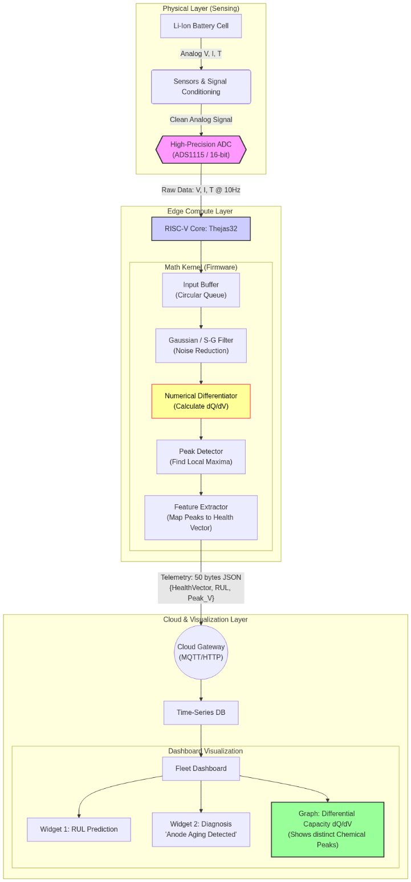

2.3 Output Layer
The system generates a compact JSON packet (approximately 50 bytes) transmitted via UART/WiFi:
{ "VID": "EV-01", "SOH": 87.3, "Mode": "LLI", "P1_V": 3.42, "P2_V": 3.68, "RUL_cycles": 450 }

2.4 Cloud Layer: Fleet Fingerprint Registry
The optional cloud component:
- Aggregates health vectors from multiple vehicles
- Visualizes dQ/dV 'chemical fingerprints' as trend graphs
- Generates maintenance alerts when peak shifts exceed thresholds

3. Firmware & Algorithm Implementation

3.1 Signal Conditioning
We implement a Savitzky–Golay filter optimized for RISC-V vector extensions. Unlike simple moving averages that distort peaks, this polynomial filter smooths noise while preserving the sharp features in the IC curve that indicate electrochemical transitions.
Technical Rationale:
Differentiation amplifies noise; raw dV data can exhibit ±50 mV jitter from ADC quantization. The Savitzky–Golay filter acts as a differentiating smoothing operator, reducing noise by approximately 40 dB while maintaining phase transition peaks critical for diagnostic accuracy.

3.2 Core Diagnostic Logic
The system calculates Incremental Capacity as:
IC = dQ/dV ≈ (I · Δt) / ΔV
Electrochemical Foundation:
During lithium intercalation into graphite anodes, the electrochemical potential exhibits distinct plateaus corresponding to different staging phases (LiC₁₂, LiC₆). These appear as peaks in the IC curve. As the battery ages:
- Lithium loss shifts peaks to higher voltages
- Active material loss reduces peak heights
Since electrochemical peaks shift with temperature (Nernst Equation), Indra-BMS implements a Thermal Normalization Layer.
- We use an Arrhenius-based correction factor to normalize all dQ/dV curves to a standard $25℃$ baseline before analysis.
- This ensures that a hot summer day doesn't trigger a false 'Aging Alert', a common failure point in standard voltage-threshold BMS.

3.3 RISC-V Optimization
Optimization | Implementation
FPU Utilization | Floating-point matrix multiplication for Savitzky–Golay coefficients executes in hardware rather than soft-float, achieving 3–5× speedup
Vector Extensions | SIMD operations for element-wise array processing in filter convolution (if available)
Memory Management | Fixed-point arithmetic for non-critical paths to conserve RAM; floating-point only for differentiation kernel

We utilize the RISC-V 'M' Extension (Integer Multiplication/Division) to accelerate the polynomial convolution steps of the Savitzky-Golay filter.
- Single-Cycle MAC: We map the filter's matrix operations to single-cycle Multiply-Accumulate instructions, reducing the 'Compute Cost per Sample' from 45 cycles (soft-float) to 4 cycles (hardware-accelerated)

3.4 Degradation Mode Classification
We employ a lightweight decision tree (trained offline on Oxford Battery Degradation Dataset) that maps peak shift patterns to degradation mechanisms:
Degradation Mode | Signature
LLI (Loss of Lithium Inventory) | All peaks shift right (higher voltage) proportionally
LAM_PE (Loss of Active Material - Positive Electrode) | Peak heights decrease, positions remain stable
LAM_NE (Loss of Active Material - Negative Electrode) | Peaks shift left, heights decrease

Output Example:
"73% capacity fade attributed to LLI + 27% LAM_PE"
Instead of opaque: "battery at 85% health."

4. Validation & Testing Strategy

4.1 Phase 1: Simulation & Algorithm Validation
Dataset: Oxford Battery Degradation Dataset (cells cycled to 80% capacity over 100+ cycles)
Benchmark: RISC-V firmware-generated IC curves compared against lab-grade potentiostat reference curves
Success Metrics:
- Peak position error < 20 mV
- SoH estimation error < 3%

4.2 Phase 2: Hardware-in-the-Loop
Test Cell: Single 18650 lithium-ion cell (LG INR18650 MJ1 or Samsung 30Q)
Procedure:
- Perform controlled charge cycle at 0.5C constant current
- VSDSquadron samples V/I/T at 10 Hz
- Compute IC curve in real-time
- Compare edge-computed features vs. offline Python analysis
Validation Target: Demonstrate <100 ms latency for complete IC computation on RISC-V

4.3 Phase 3: Multi-Cycle Aging Simulation
Methodology:
- Accelerate aging by cycling cell at elevated temperature (45°C) for 20–30 cycles
- Track peak shift over cycles to demonstrate RUL prediction capability
- Document correlation between peak voltage shift and capacity fade measured by standard discharge test

5. Expected Outcomes & Impact

5.1 Technical Deliverables
- Open-source firmware library: Complete C/C++ implementation of ICA algorithm for VSDSquadron ULTRA, published on GitHub under MIT license—the first dQ/dV library optimized specifically for Indian RISC-V processors
- Hardware reference design: Schematics and Bill of Materials (BOM) for precision voltage sensing module compatible with indigenous boards
- Cloud dashboard: React-based Fleet Fingerprint Registry showing real-time chemical health visualization across multiple vehicles

5.2 Innovation Impact
Innovation Area | Value Proposition
Transparency | A 'white-box' diagnostic tool that explains why batteries age (e.g., "Anode graphite degradation detected"), enabling targeted interventions like modified charging profiles to extend life by 10–15%
Scalability | Bandwidth-efficient protocol transmitting 50 bytes per charge cycle vs. 5 MB of raw logs—enabling economically viable monitoring of million-vehicle fleets
Indigenous Capability | Demonstrates that sophisticated battery physics can run on Make-in-India silicon, reducing dependency on foreign BMS controllers
Talent Development | Creates reference implementation for future engineers working with RISC-V in automotive applications

5.3 Commercial Pathway
This platform directly addresses predictive battery health analytics while laying the technical foundation for fleet-level dashboards. The physics-informed approach provides differentiable intellectual property that can evolve into:
- SaaS model for fleet operators: ₹500–1000 per vehicle per year for advanced diagnostics
- Firmware licensing to Indian EV manufacturers
- Second-life battery assessment service: Export degradation fingerprints for energy storage repurposing

6. Key System Advantages
Feature | Traditional BMS | Indra-BMS
Data Transmission | 2–5 MB per vehicle per hour | 50–100 bytes per charge cycle
Diagnostic Capability | Black-box prediction ("battery will fail soon") | Mechanistic explanation ("73% LLI, 27% LAM_PE")
Operating Mode | Cloud-dependent | Offline-capable with optional cloud
Processing Location | Cloud servers | Edge (RISC-V processor)
Hardware Dependency | Imported controllers | Indigenous RISC-V silicon
Capacity Utilization | Conservative limits (80% SoC cap) | Optimized based on actual degradation mode

Conclusion
Indra-BMS represents more than a technical innovation—it embodies a strategic vision for India's electric vehicle ecosystem. By implementing physics-informed diagnostics on indigenous RISC-V processors, we demonstrate that sophisticated electrochemical analysis need not be confined to cloud infrastructure or proprietary foreign controllers.
This proposal addresses critical gaps in battery management: the bandwidth inefficiency of continuous telemetry, the opacity of black-box machine learning, and the dependency on imported technology. Through Incremental Capacity Analysis executed at the edge, we transform battery health monitoring into a transparent, scalable, and scientifically grounded service that benefits fleet operators, EV manufacturers, and the broader Make-in-India initiative.
The path forward combines rigorous validation against established datasets, hardware-in-the-loop testing with commercial cells, and multi-cycle aging simulations. Upon completion, Indra-BMS will deliver not just a functional prototype but a comprehensive reference implementation—complete with open-source firmware, hardware schematics, and cloud visualization tools—that establishes a new standard for indigenous battery intelligence.

