PRE-INCORPORATION AND FINANCING DOCUMENT
Mbarara Integrated
Concrete Products Factory
Business Plan 2026-2035
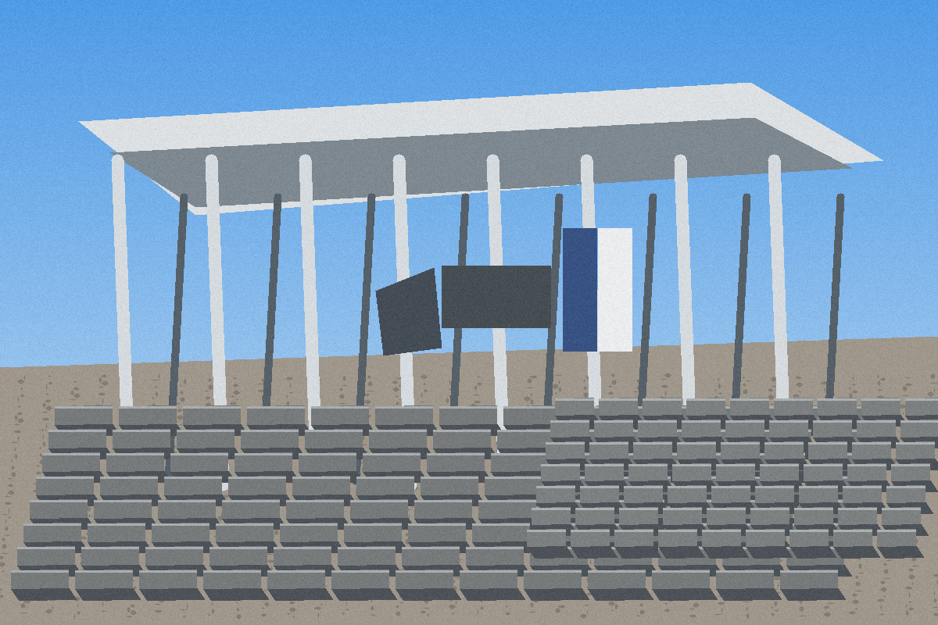
Concept illustration of the planned lean facility; not evidence of an existing factory.
STARTING CAPITAL | ESSENTIAL PHASE 1 COST | PROTECTED BUFFER
UGX 130.0 Mio. | UGX 128.0 Mio. | UGX 2.0 Mio.

Prepared for | Founder | Location | Date
FAU Startup Advisory / Bianca Niemann | Hillary Arindamukama | Mbarara City, Uganda | 11 August 2026

CONFIDENTIAL - WORKING DOCUMENT FOR ADVISORY AND FINANCING PREPARATION

Table of Contents
Table of Contents 2
1. Executive Summary 3
2. Founder, Mentor and Organisation 4
2.1 Planned Phase 1 Organisation 4
3. Company and Business Model 4
4. Customer Problem, Solution and Value 5
5. Market and Target Customers 5
5.1 Evidence Required Before Machine Ordering 5
6. Competition and Positioning 6
7. Product Portfolio and Phase 1 Priority 6
8. Product Mix Assumptions and Technical Validation 6
9. Production, Machinery and Capacity 7
10. Site, Layout and Logistics 7
11. Raw Materials, Supply and Inventory Control 8
12. Quality Management and Laboratory 8
13. Digital Management System 8
14. Legal, Tax and Regulatory Roadmap 9
15. Sales, Pricing and Payment Strategy 9
16. Sustainability and Impact 11
17. Implementation and Milestones 11
18. Phase 1 Investment Budget 12
19. Financial Model and Monthly Result 12
20. Break-even, Profit Target and Sensitivity 13
21. Financial Plan 2026-2035 14
22. Financing and Capital Strategy 16
23. Risk Register 16
24. Decision Gates and 90-Day Work Plan 17
25. Conclusion 17
Appendix A: Assumptions and Data Register 18
Appendix B: Sources 18
Appendix C: Verification and Disclaimer 18

1. Executive Summary
Mbarara Integrated Concrete Products Factory (MICPF) is a planned, phased manufacturer of concrete blocks, paving products and selected precast items in Mbarara, Western Uganda. Phase 1 deliberately focuses on a small number of regularly demanded products and one semi-automatic starter line. Capital-intensive additions such as owned delivery trucks, heavy lifting equipment, large culvert moulds, ready-mix concrete and a second production line will be introduced only after demand and positive cash flow are demonstrated.
The funding requirement is strictly capped at UGX 130,000,000. UGX 128,000,000 funds essential equipment, site preparation, opening inventory and market entry, while UGX 2,000,000 remains a protected liquidity buffer. Feasibility depends on securing a site without purchasing land, keeping machine and mould quotations within the stated limits, and using hired delivery vehicles during the launch period.
Key metric | Value | Interpretation
Monthly revenue at stable base utilisation | UGX 140.020.000 | Estimated; sales mix requires order evidence
Production and material cost | UGX 93.701.422 | Current integrated costing model
Gross profit | UGX 46.318.578 | 33,1%
Monthly operating expenses | UGX 14.100.000 | Labour, maintenance, administration and sales/logistics
Operating profit before tax | UGX 32.218.578 | 23,0%
Illustrative profit after 30% model tax | UGX 22.553.005 | Before depreciation, financing and reinvestment
System break-even revenue | UGX 42.623.977 | Assumes unchanged gross margin
Revenue for UGX 20m pre-tax profit | UGX 103.083.519 | Approximately 74% of base revenue
Revenue for UGX 20m model profit after tax | UGX 128.994.751 | Approximately 92% of base revenue

Investment decision
The model shows a credible opportunity, not a guarantee. Funding should be released only after site rights, three comparable machine and mould quotations, raw-material quotations, utility confirmation and initial customer letters of intent are documented.

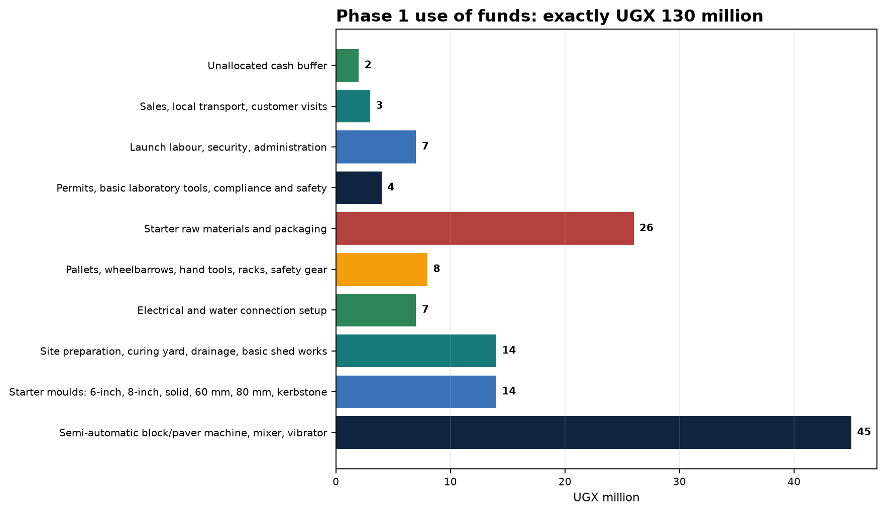
Figure 1: Phase 1 use of funds. Total including the protected buffer is UGX 130,000,000.

2. Founder, Mentor and Organisation
 | Hillary Arindamukama  Founder and intended Managing Director  International student at Friedrich-Alexander-Universität Erlangen-Nürnberg, studying B.Sc. Clean Energy Processes. Responsible for project leadership, strategy, financing coordination, business development and the integrated digital management platform.  Email: arindahillary222@gmail.com
Prakhar Singh is a mentor and professional sounding board. He is not presented as a co-founder, shareholder, director, authorised signatory or operating manager. Any later formal role requires a separate written agreement.

2.1 Planned Phase 1 Organisation
Function | Primary responsibility | Staffing status
Managing Director / Founder | Financing, strategy, partnerships and control | Hillary Arindamukama
Production supervisor | Daily plan, material usage, shift and machine control | Recruit locally before start
Machine operator | Mixing, mould changes, compaction and first-line control | Train before commissioning
QC / warehouse lead | Batches, curing, testing, stock and release | Combined launch role
Sales / administration | Quotations, customer files, invoicing and receipts | Lean part-time/shared role
General labour / safety | Handling, cleaning, pallets and site safety | Demand-led

Governance principle
Banking, procurement, discounts, customer credit and payments will have documented approval limits. Personal and business money will remain fully separate. The mentor has no ownership or signing rights without written authority.

3. Company and Business Model
MICPF is intended to be incorporated as a Ugandan private limited company. It will manufacture standardised concrete products, sell ex-factory and arrange site delivery for economically qualifying bulk orders through hired vehicles. Revenue will come from product margins, delivery charges and later project-specific manufacture. Credit sales will be limited to verified customers with approved limits.
Building block | Phase 1 configuration
Value proposition | Reliable dimensions, documented mixing and curing, batch release and planned delivery
Customers | Contractors, hardware stores, developers, schools, hospitals, hotels, churches, NGOs, public projects and residential builders
Sales | Direct outreach, dealer partnerships, site visits, website/WhatsApp enquiries and disciplined follow-up
Production | Semi-automatic line, limited mould set, planned mould changes and demand-led schedules
Payment | Deposits for made-to-order work; balance before dispatch; credit only after checks
Logistics | Ex-factory pricing, hired trucks and free delivery only where bulk-order economics support it
Scaling | New moulds and products only against confirmed orders or retained earnings

4. Customer Problem, Solution and Value
Concrete products in the target market are supplied by businesses with different levels of professionalisation. Builders can face variable dimensions, weak compaction, insufficient curing, absent batch records and unreliable delivery. MICPF addresses these risks through controlled production, recorded material use, defined hold/release status and transparent quotations and payment terms.
Customer problem | MICPF response | Measurable evidence
Variable product quality | Batch mixing and curing records | Test results, rejection rate and release status
Unreliable availability | Production and inventory planning | Confirmed order, committed delivery date
Unclear prices | Written UGX quotation with delivery and payment schedule | Quotation number and validity
Transport damage or delay | Route-based hired transport and documented handover | Dispatch plan and delivery note
Weak complaint process | Batch-linked complaint and corrective action | Traceable response by batch

5. Market and Target Customers
Market entry will be validated bottom-up. This business plan does not use an unverified market-size claim. Demand will be established through quotation requests, dealer interviews, construction-site visits and customer letters of intent. The initial focus is Mbarara City and short delivery corridors, followed by Rwampara, Isingiro, Ntungamo, Bushenyi, Ibanda, Kiruhura, Sheema, Lyantonde, Kabale and Rukungiri.
Segment | Need | Initial offer | Route to market
Contractors | Large scheduled quantities | 6/8-inch blocks, pavers and kerbstones | Direct visits and framework quotations
Hardware stores | Regular smaller releases | 6-inch blocks and standard pavers | Dealer terms with minimum order
Developers | Quality, timing and documentation | Blocks, pavers and kerbstones | Project quotation and delivery plan
Institutions | Building and external works | Blocks, 60 mm pavers; drainage later | Needs calendar and site meeting
Public/NGO projects | Documentation and formal procurement | Kerbstones, pavers; drainage later | Prequalification and tender monitoring
Residential builders | Price, advice and availability | Blocks and pavers | Website, WhatsApp and dealers

5.1 Evidence Required Before Machine Ordering
- At least 20 structured customer interviews in Mbarara and neighbouring districts.
- At least five written purchase-intent letters or credible quotation requests.
- Three price checks for every core product, each recording date, location, unit and delivery terms.
- At least two potential hardware partners with a defined monthly minimum purchase.
- Documented payment habits and accepted deposit levels by customer segment.

6. Competition and Positioning
The existing competitor list is a research starting point rather than a verified market study. Named businesses and local producers must be confirmed by telephone, website or social-media review, quotation or field visit. No market-share conclusion is drawn from the starting list.
Competitor group | Examples from the starting list | Preliminary risk | Required check
Local block yards | Mbarara yards and BIMS Bloks Mbarara | High on price and proximity | Price, capacity, quality and delivery time
Paver/precast makers | iConic Concrete, Master Industries and Nicomah | Medium to high | Range, references and delivery area
Raw-material suppliers | Stone Providers Ltd and local quarries | Supply-chain relevance | Tonne price, moisture, weighing, credit
Cement distribution | Hima, Tororo, Kampala and Simba distributors | Supply relevance | Price, minimum order, delivery and credit

MICPF will not position itself as the cheapest supplier. Differentiation will come from documented quality, reliable dimensions, planned curing, clear delivery commitments, traceable prices and professional complaint handling. Discounts will be exchanged for volume, deposits and efficient delivery routes.

7. Product Portfolio and Phase 1 Priority
Product | Phase 1 status | Planned price | Strategic role | Data status
6-inch hollow blocks | Core | UGX 2,600/unit | Volume product for contractors and dealers | Estimated
8-inch hollow blocks | Core | UGX 3,400/unit | Structural wall applications | Estimated
60 mm pavers | Selective | UGX 2,400/unit | External works; only with confirmed margin | Quotation required
Kerbstones | Order-led | UGX 18,000/unit | High unit contribution, lower volume | Estimated
Solid blocks | Secondary | UGX 3,000/unit | Made only to verified demand | Estimated
80 mm pavers | Secondary | UGX 3,200/unit | Heavy-duty surfaces; verify price | Quotation required
4-inch hollow blocks | Conditional | UGX 1,800/unit | Only if mould is included or customer-funded | Estimated
Special pavers/drainage/culverts/ready-mix | Deferred | Quotation only | Only after proof of demand | Quotation required

Clear launch rule
The base revenue mix relies on 6-inch and 8-inch hollow blocks, 60 mm pavers and kerbstones. Solid blocks, 80 mm pavers and 4-inch blocks are made only against confirmed demand, protecting the UGX 130 million cap.

8. Product Mix Assumptions and Technical Validation
Product | Working mix assumption | Release condition
4-inch hollow block | 1 cement : 6 stone dust | Trial mix, dimensions, strength and absorption
6-inch hollow block | 1 cement : 7 stone dust | Trial mix, dimensions, strength and absorption
8-inch hollow block | 1 cement : 6 stone dust | Trial mix, dimensions, strength and absorption
Solid block | 1 cement : 5 stone dust : 1 sand | Trial mix and application-based release
60 mm paver | 1 cement : 3 sand : 3 aggregate | Strength, abrasion, dimensions and surface
80 mm paver | 1 cement : 2.5 sand : 3 aggregate | Strength and heavy-load suitability
Kerbstone | 1 cement : 2 sand : 3 aggregate | Dimensions, edges, strength and handling

These ratios are launch assumptions rather than certified recipes. The final recipe must be set for each material source through controlled trials. No strength or standards-conformity claim will be published before testing and the UNBS pathway are confirmed.

9. Production, Machinery and Capacity
The UGX 45,000,000 machinery allowance covers a semi-automatic block/paver machine, mixer and vibration equipment. The specific manufacturer is not yet selected. At least three written quotations must be compared on the same technical specification before an order is placed.
Assessment criterion | Minimum evidence before deposit
Actual output | Guaranteed units by mould and eight-hour shift, not theoretical cycles only
Product changeover | Time, labour and waste during mould change
Power requirement | Motor rating, starting current, phases, protection and generator requirement
Moulds | Dimensions, material, service life and replacement cost
Service | Warranty, installation, operator training and response time
Spare parts | Critical wear parts held locally and lead time
Acceptance | Test production using local materials and defined QC checks

Product | Monthly quantity | Daily requirement at 26 days | Planned price | Monthly revenue
6-inch hollow block | 26,000 | 1,000 | UGX 2,600 | UGX 67,600,000
8-inch hollow block | 12,000 | 462 | UGX 3,400 | UGX 40,800,000
60 mm paver | 5,000 | 192 | UGX 2,400 | UGX 12,000,000
Kerbstone | 1,000 | 39 | UGX 18,000 | UGX 18,000,000
Delivery charges | - | - | - | UGX 1,620,000
TOTAL | 44,000 units | Approx. 1,693 | - | UGX 140,020,000

Capacity gate
The sales plan is released only if the selected supplier confirms the combined daily output after mould changes, cleaning, downtime and normal rejection.

10. Site, Layout and Logistics
The UGX 130 million plan contains no land purchase. It assumes a legally secured lease or use right for a suitable site in or near Mbarara. Before investment, the project must check heavy-vehicle access, drainage, power, water, neighbour separation, dust/noise control and expansion space.
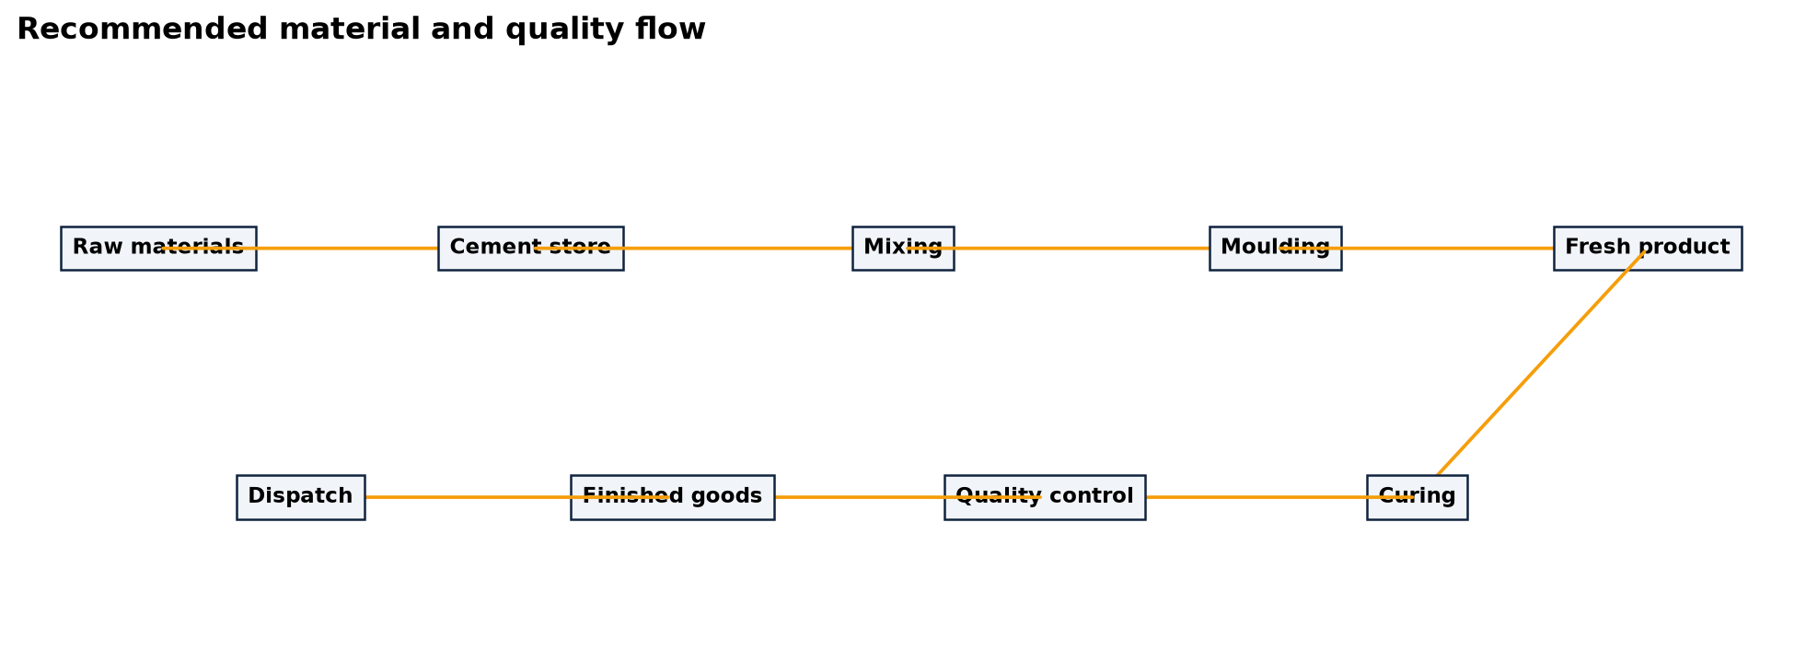
Figure 2: Recommended material and quality flow. Final arrangement requires surveying, drainage planning and authority review.
- Raw materials are separated, drained and protected from mixing.
- Cement remains dry, locked and issued under dosage control.
- Curing areas receive batch identification and controlled watering.
- Finished goods move into saleable stock only after internal release.
- Customer and delivery traffic remain separate from raw-material unloading.
- No delivery truck is purchased in Phase 1; vehicles are hired by route or order.

11. Raw Materials, Supply and Inventory Control
Input | Planned price | Primary control | Data status
Cement, 50 kg bag | UGX 36.000 | Brand, manufacturing date and dry storage | Estimated
Stone dust, tonne | UGX 45.000 | Grading, moisture and weighbridge evidence | Estimated
Sand, tonne | UGX 38.000 | Cleanliness, grading and moisture | Estimated
Aggregate, tonne | UGX 60.000 | Grading, strength and weighbridge evidence | Estimated
Electricity, kWh | UGX 780 | Tariff, connection capacity and meter | Estimated
Water, m3 | UGX 4.200 | Quality, availability and curing need | Estimated
Diesel, litre | UGX 6.600 | Delivery note and use by vehicle/generator | Estimated
Hired transport per truck | UGX 260.000 | Route, payload, return load and unloading | Estimated

The UGX 26,000,000 opening-material allocation will not be spent at once. Purchasing will be released in tranches against confirmed orders and actual storage capacity. After the first production month, minimum stock, reorder points and consumption per product will be recalculated from measured data.

12. Quality Management and Laboratory
Quality is both the main point of differentiation and a material liability risk. Every production batch receives a batch ID, product description, operator, material quantities, mix ratio, water addition, production time, curing start, test status and release decision. Product on hold or failed status may not be dispatched.
Test | Phase 1 method | Decision
Dimensions | Measuring device/tape; batch sample | Pass, hold or rework
Visual defects | Edges, cracks, voids and surface | Reject or inspect again
Density | Mass and volume | Trend control
Water absorption | Defined laboratory procedure | Product-specific limit
Compressive strength | External accredited testing by product and age | Release against test plan
Curing age | Daily register and batch sign | No early sale

Relevant standards include US 2032:2019 for hollow concrete blocks, US 2033:2019 for solid concrete blocks and US 65:2019 for precast concrete paving units. The mandatory scope and product-certification process will be confirmed with UNBS before conformity claims or formal market release. [S8-S10]

13. Digital Management System
The existing React and TypeScript platform links financial simulation, inventory, production, quality control, sales, expenses, market intelligence and reporting. It is currently a functional planning and demonstration prototype. Until productive PostgreSQL migration, formal access controls and accounting integration are completed, it does not replace audited accounting, statutory tax records or controlled quality documentation.
Module | Business value | Go-live control
Financial simulation | Price, cost and profit scenarios | Monthly reconciliation to evidence
Inventory | Stock, valuation, consumption and reorder levels | Physical count and dual control
Production | Daily output, materials, machine hours and rejection | Batch ID and supervisor release
QC/laboratory | Test results and certificates | Held product cannot be sold
ERP/sales | Customers, invoices, receipts and balances | Role permissions and daily backup
Market intelligence | Price and competitor monitoring | Source, date and confidence required

Public website: https://mbarara-concrete-factory.pages.dev
Integrated platform: https://mbarara-concrete-platform.pages.dev

14. Legal, Tax and Regulatory Roadmap
The recommended structure is a Ugandan private limited company. Legal and tax implementation must be confirmed by qualified Ugandan advisers. Formalisation includes company registration, TIN, the relevant trading licence and all applicable site, environmental, labour and product requirements. [S5-S7]
Authority/topic | Required action | Timing | Status
URSB | Check/reserve name and incorporate company | Before contracts and bank account | Open
URA | TIN, tax heads and record obligations | Before trade | Open
VAT/EFRIS | 18% standard rate; plan exceeds UGX 150m annual or UGX 37.5m three-month threshold; confirm registration and EFRIS | Before first taxable invoice | Critical
Mbarara City/local authority | Trading licence and planning/building/use approval | Before site operation | Open
NEMA | Determine Project Brief or ESIA requirement | Before works/installation | Open
MGLSD/OSH | Register workplace, safety systems and machinery inspection | Before commissioning | Open
UNBS | Obtain standards and confirm testing/certification pathway | Before conformity claims | Open
NSSF/PAYE | Establish employer and employee obligations | Before/at recruitment | Open
Insurance | Plant, liability, accident, fire and transport cover | Before production | Open

Tax treatment
The base model treats UGX 32,218,578 as operating profit before tax. A simplified 30% corporation-tax illustration leaves UGX 22,553,005. The standard VAT rate is 18%; until confirmed by an adviser, planned selling prices should be read as net prices before VAT. Actual taxable profit depends on depreciation, allowable deductions, VAT, financing and legal structure. [S11-S12]

EXIST is not a core funding route for the Uganda-only model because incorporation and commercialisation in Germany may be required. A German structure will be considered only if it has genuine operational and legal substance. StArfrica is treated as a networking, learning and investor-access channel; funding is not assumed.

15. Sales, Pricing and Payment Strategy
The launch will begin with a controlled list of specific buyers rather than broad advertising. Each opportunity will record product, quantity, location, decision date, payment capacity and delivery route. Prices are maintained in UGX. Planned prices are ex-factory and before VAT unless an adviser confirms another presentation.
- Build a top-50 target-customer list for Mbarara City and neighbouring districts.
- Contact ten decision-makers and visit at least five sites or dealers each week.
- Issue quotations within 24 hours, showing validity and delivery conditions.
- Require deposits for made-to-order products and the balance before loading.
- Grant credit only after documented checks, limits and due dates.
- Record the reason for every lost order: price, quality, lead time, relationship or finance.
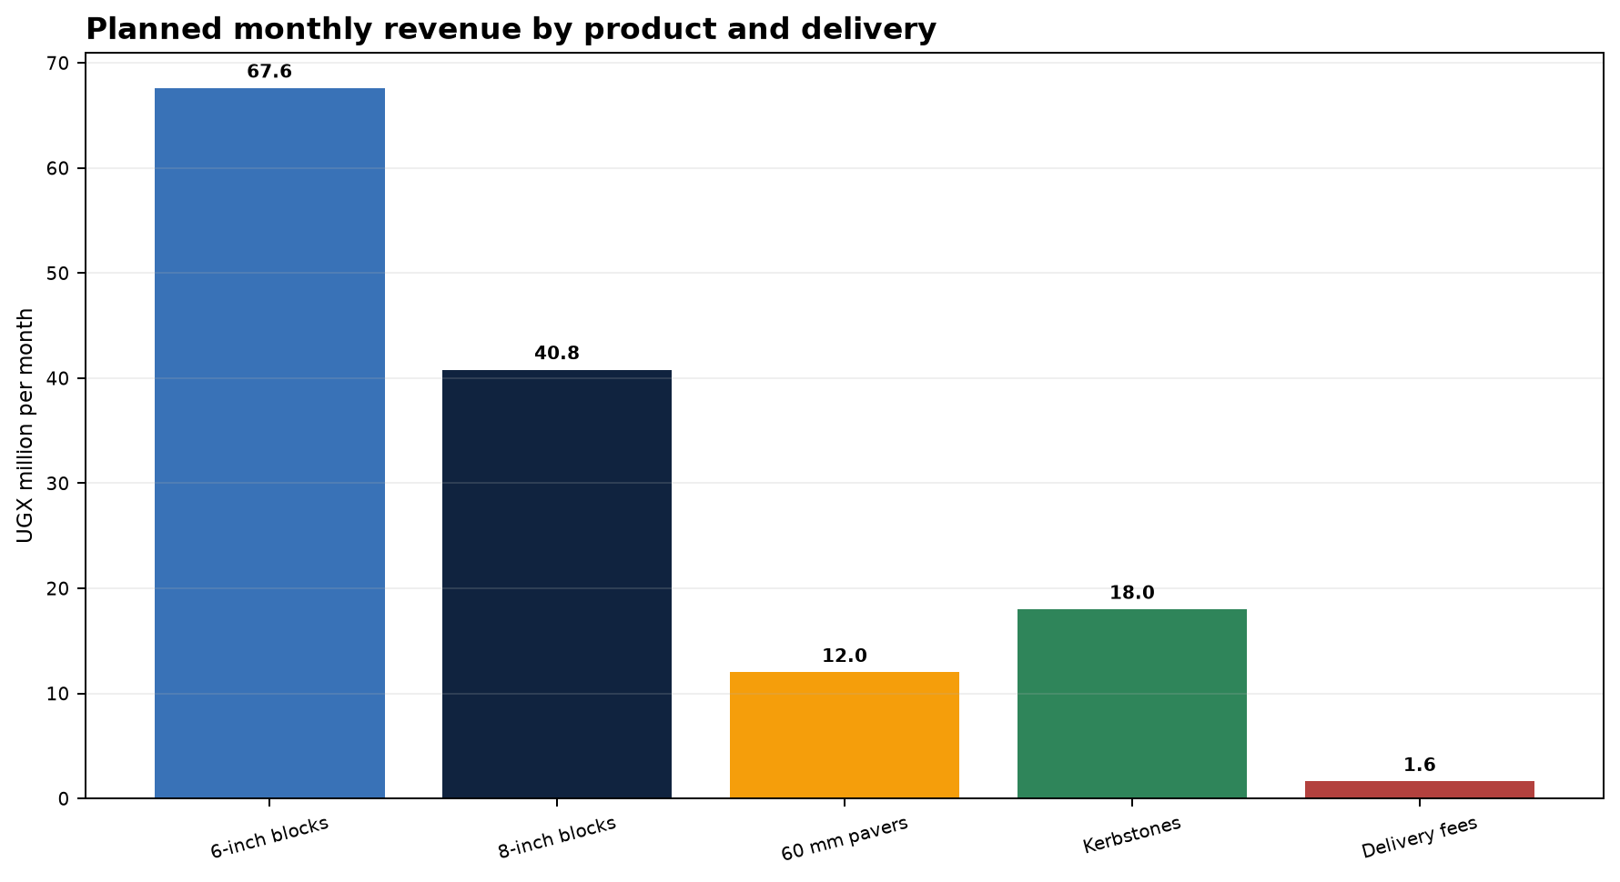
Figure 3: Revenue mix under the stable base model. Every selling price remains subject to market confirmation.

16. Sustainability and Impact
Environmental positioning will be cautious and measurable. The project does not claim carbon neutrality. Initial contributions come from longer-lasting products, lower rejection, shorter regional delivery routes, controlled dosing, process-water reuse where technically acceptable and later permeable paving systems. Socially, the factory will create formal local jobs and improve dependable construction-material supply in Western Uganda.
Impact area | Indicator | Phase 1 target
Material efficiency | Rejection rate | Below 3% after month three, then reduce further
Quality | Batches with complete dataset | 100%
Water | m3 per 1,000 products | Measure from day one; set target after baseline
Energy | kWh per 1,000 products | Measure from day one; maintenance/load management
Employment | Formal local positions | Lean team, growing with secured sales
Supply chain | Share of regionally sourced inputs | Maximise subject to quality conformity

17. Implementation and Milestones
Period | Work package | Release criterion
Days 0-30 | Site rights, customer interviews, quotation structure and three supplier quotations | Evidence folder complete
Days 31-60 | Company, TIN, bank account and site/environment/OSH pre-check | Legal and approval pathway confirmed
Days 61-90 | Machine decision, contract, mould list and site works | Budget not exceeded
Days 91-120 | Delivery, installation, power/water and recruitment | Acceptance and safety training
Days 121-150 | Trial mixes, test plan, rejection and capacity test | QC release for core products
Days 151-180 | Controlled market start and first deliveries | Deposits, positive contribution and batch records
Months 7-12 | Increase utilisation to 75-100% | Repeat customers and monthly management close

18. Phase 1 Investment Budget
The following use of funds is the binding maximum for the starter project. Items marked quotation required may be committed only after written confirmation. The cash buffer is not a general purchasing allowance.
Use of funds | Amount | Control
Semi-automatic block/paver machine, mixer, vibrator | UGX 45.000.000 | Essential quotation required
Starter moulds: 6-inch, 8-inch, solid, 60 mm, 80 mm, kerbstone | UGX 14.000.000 | Essential only
Site preparation, curing yard, drainage, basic shed works | UGX 14.000.000 | Lean starter works
Electrical and water connection setup | UGX 7.000.000 | Essential utilities
Pallets, wheelbarrows, hand tools, racks, safety gear | UGX 8.000.000 | Starter handling
Starter raw materials and packaging | UGX 26.000.000 | Working stock
Permits, basic laboratory tools, compliance and safety | UGX 4.000.000 | Basic QC only
Launch labour, security, administration | UGX 7.000.000 | Opening month reserve
Sales, local transport, customer visits | UGX 3.000.000 | Launch campaign
Unallocated cash buffer | UGX 2.000.000 | Do not spend unless necessary
TOTAL | UGX 130.000.000 | Exactly within the cap

Excluded from the Phase 1 budget
Land purchase, owned delivery truck, ready-mix plant, transit mixer, heavy culvert moulds, crane/forklift, second line, large laboratory equipment, regional depots and the founder's private costs.

19. Financial Model and Monthly Result
The model uses 26 working days per month and the defined sales mix. Monthly revenue of UGX 140,020,000 requires the sale of 44,000 products plus UGX 1,620,000 in delivery charges. All values are before financing cost, and tax is a simplified illustration.
Monthly line item | UGX | % of revenue
Revenue | UGX 140.020.000 | 100.0%
Production/material cost | UGX 93.701.422 | 66,9%
Gross profit | UGX 46.318.578 | 33,1%
Operating expenses | UGX 14.100.000 | 10,1%
Operating profit before tax | UGX 32.218.578 | 23,0%
Illustrative corporation tax at 30% | UGX 9.665.573 | 6,9%
Illustrative profit after tax | UGX 22.553.005 | 16,1%

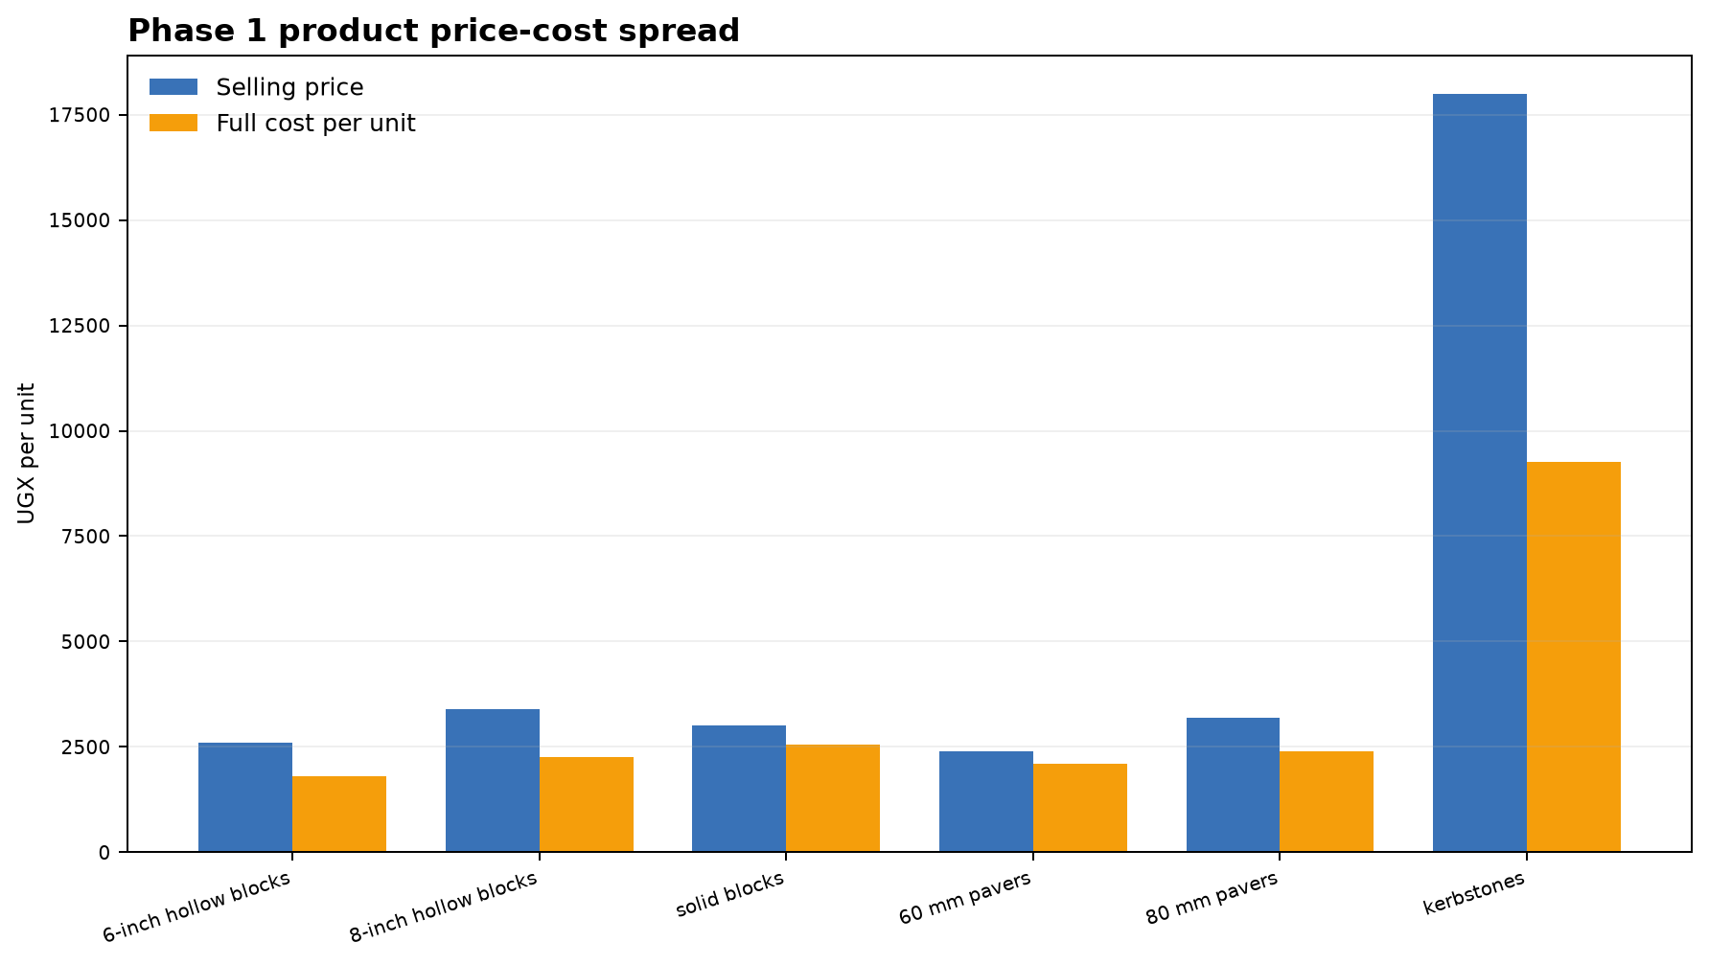
Figure 4: Planned selling price and full cost per unit. 60 mm pavers and solid blocks require particularly strict pricing discipline.
Product | Planned price | Full cost | Unit contribution | Margin | Status
6-inch hollow blocks | UGX 2.600 | UGX 1.796 | UGX 804 | 30,9% | Estimated
8-inch hollow blocks | UGX 3.400 | UGX 2.264 | UGX 1.136 | 33,4% | Estimated
solid blocks | UGX 3.000 | UGX 2.551 | UGX 449 | 15,0% | Estimated
60 mm pavers | UGX 2.400 | UGX 2.112 | UGX 288 | 12,0% | Quotation Required
80 mm pavers | UGX 3.200 | UGX 2.400 | UGX 800 | 25,0% | Quotation Required
kerbstones | UGX 18.000 | UGX 9.261 | UGX 8.739 | 48,5% | Estimated

20. Break-even, Profit Target and Sensitivity
The integrated model produces monthly break-even revenue of UGX 42,623,977. The more important management threshold is the target profit: at the same gross margin, approximately UGX 103,083,519 of monthly revenue is required for UGX 20,000,000 of pre-tax profit. For a simplified UGX 20,000,000 profit after 30% model tax, the revenue threshold rises to approximately UGX 128,994,751.
Scenario | Assumptions | Revenue | Total cost | Pre-tax profit | Model profit after tax
Downside | 65% volume; -5% price; +8% unit cost; +5% OPEX | UGX 86.462.350 | UGX 80.583.398 | UGX 5.878.952 | UGX 4.115.266
Base model | Defined sales mix and current assumptions | UGX 140.020.000 | UGX 107.801.422 | UGX 32.218.578 | UGX 22.553.005
Upside | +10% volume; +3% price; -2% unit cost; +8% OPEX | UGX 158.642.660 | UGX 116.238.133 | UGX 42.404.527 | UGX 29.683.169

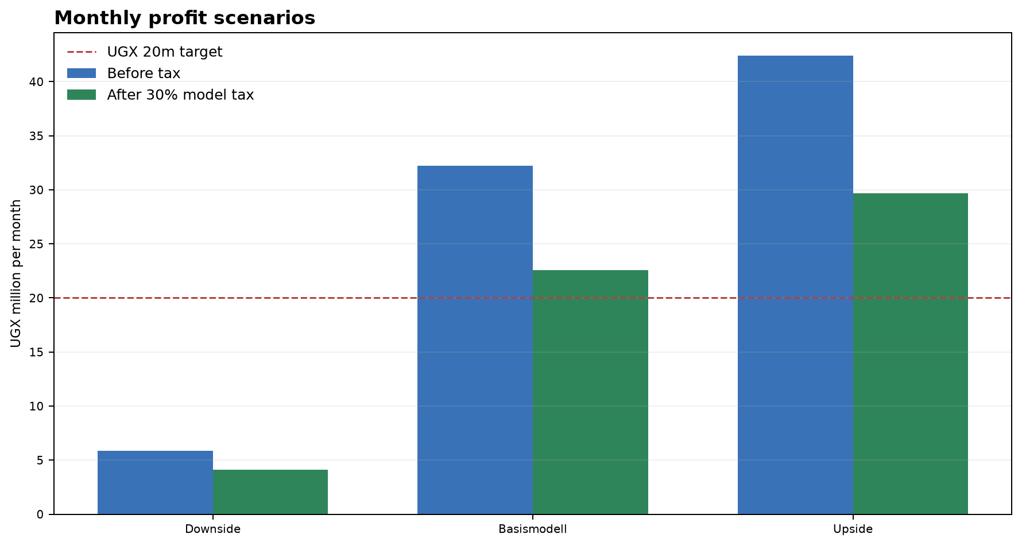
Figure 5: The UGX 20 million target is achieved in the base model but missed materially in the downside case.
Management response in the downside case
Stop expansion investment, produce 60 mm pavers only against orders, review prices weekly, buy inputs in smaller tranches, suspend credit sales and concentrate machine and staff time on profitable core products.

21. Financial Plan 2026-2035
The plan treats 2026 as a preparation, financing and procurement year with no operating revenue. The first full operating year is 2027 at an average 70% of stable base utilisation. From 2031, limited capacity expansion from retained earnings is assumed. Revenue and production cost escalate by 3% a year and operating expenses by 5%. Expansion capital expenditure, depreciation, financing and specific tax deductions are excluded.
Year | Utilisation | Revenue | Total cost | Pre-tax profit | Model profit after tax
2026 | Preparation | UGX 0 | UGX 0 | UGX 0 | UGX 0
2027 | 70% | UGX 1.18 Mrd. | UGX 956.3 Mio. | UGX 219.9 Mio. | UGX 153.9 Mio.
2028 | 85% | UGX 1.47 Mrd. | UGX 1.16 Mrd. | UGX 309.0 Mio. | UGX 216.3 Mio.
2029 | 95% | UGX 1.69 Mrd. | UGX 1.32 Mrd. | UGX 373.6 Mio. | UGX 261.6 Mio.
2030 | 100% | UGX 1.84 Mrd. | UGX 1.42 Mrd. | UGX 411.5 Mio. | UGX 288.0 Mio.
2031 | 105% | UGX 1.99 Mrd. | UGX 1.53 Mrd. | UGX 451.2 Mio. | UGX 315.8 Mio.
2032 | 110% | UGX 2.14 Mrd. | UGX 1.65 Mrd. | UGX 492.8 Mio. | UGX 345.0 Mio.
2033 | 115% | UGX 2.31 Mrd. | UGX 1.77 Mrd. | UGX 536.5 Mio. | UGX 375.5 Mio.
2034 | 120% | UGX 2.48 Mrd. | UGX 1.90 Mrd. | UGX 582.2 Mio. | UGX 407.6 Mio.
2035 | 125% | UGX 2.66 Mrd. | UGX 2.03 Mrd. | UGX 630.1 Mio. | UGX 441.1 Mio.

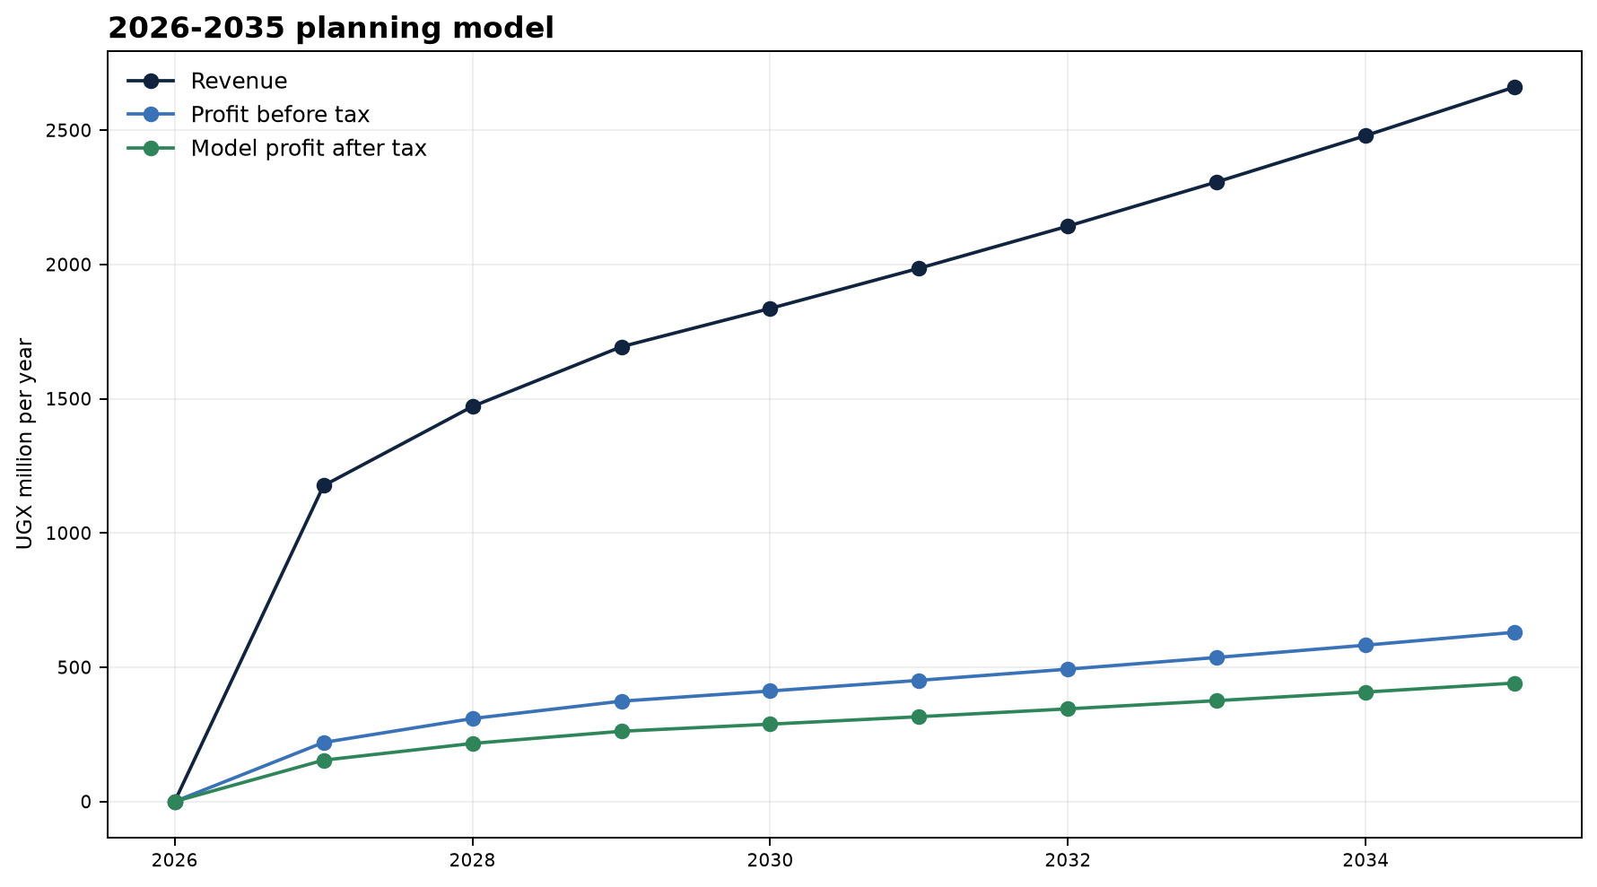
Figure 6: Ten-year planning model. Values after 2031 assume capacity additions financed from retained cash flow.

22. Financing and Capital Strategy
The total requirement is UGX 130,000,000. Suitable funding may combine grant support, patient equity, a shareholder loan, equipment finance or supplier credit. Valuation and equity percentage should be set only after the site, quotations, customer evidence and legal structure are documented.
Capital source | Suitability | Protection condition
Grant/impact award | Useful for prototype, testing and environmental action | Avoid dependence on a single competition
Patient equity | Suitable for long-term industrial build | Written valuation, governance and exit rights
Shareholder loan | Clear repayment while founder retains control | Repayment only from sufficient cash flow
Equipment/supplier finance | Reduces immediate cash requirement | Verify total cost, guarantees and title
Customer deposits | Strengthens working capital and validates demand | Clear delivery schedule and secure custody

The theoretical run-rate profit could imply a very short payback period, but this document does not present that number as a return promise. The operating objective is payback within 12 to 18 months after commercial start, subject to ramp-up, tax, rejection, working capital, investor terms and reinvestment.

23. Risk Register
Risk | Likelihood | Impact | Control
Machine offer exceeds UGX 45m | High | High | Three comparable quotations; reduce specification rather than use buffer
Site rights not secured | Medium | High | Signed lease/use right and land-use review before order
Sales below plan | High | High | Interviews, letters of intent, deposits and weekly pipeline
Cement/input inflation | High | High | Frequent pricing, quotation validity and escalation clauses
Paver contribution too low | High | Medium | Order-only production with minimum contribution
Quality or curing failure | Medium | High | Batch limits, tests, training and external reference tests
Machine breakdown | Medium | High | Maintenance plan, spare-parts pack and service clause
Power/water interruption | Medium | High | Storage, alternatives, load plan and emergency operation
Payment delay | Medium | High | Deposits, credit limits, due-date control and delivery stop
Approval delays | Medium | High | Early URSB, URA, NEMA, local authority, OSH and UNBS checks
Founder operates remotely | Medium | High | Local accountable lead, digital control and clear authority
Fraud or inventory loss | Medium | High | Segregated duties, counts, document trail, access control and banking
Premature expansion | Medium | High | Defer ready-mix, culverts and specialist moulds until gates are met

24. Decision Gates and 90-Day Work Plan
- Site file: ownership/lease evidence, plan, access, power, water, drainage and neighbour conditions.
- Legal file: URSB incorporation route, TIN, trading licence and NEMA, OSH and UNBS pre-consultation.
- Procurement file: three machine quotations, three mould quotations, warranty, spare parts, training and acceptance plan.
- Market file: 20 interviews, five letters of intent or credible quotation requests and three price checks per core product.
- Finance file: UGX 130 million budget, milestone drawdown, bank account and evidence/approval rules.
- Quality file: work instructions, sampling plan, curing register, release tests and complaint process.
- People/governance file: local roles, contracts, authority, controls and reporting frequency.
Gate | Required condition | Action if not met
G1 Finance | UGX 130m committed and milestone drawdown agreed | Do not order
G2 Site | Rights, approval path and connections confirmed | Change site or renegotiate
G3 Machine | Capacity, moulds, power, warranty and cost documented | Reduce specification or supplier
G4 Market | Letters/quotations support the core sales plan | Reduce start volume and raw stock
G5 Quality | Trial mixes and release criteria passed | Do not sell; adjust recipe/process
G6 Expansion | Six positive cash-flow months and confirmed orders | Continue starter portfolio

25. Conclusion
MICPF is financeable in principle as a lean starter project restricted to core products. Its strength is the combination of local demand validation, production discipline, documented quality and digital management. The critical success factor is controlled execution of four core products, positive unit contribution, customer deposits and strict adherence to the investment ceiling.
The next sensible decision is conditional financing rather than immediate full investment. Once the six gates are supported by evidence, Phase 1 can proceed and later be updated using actual monthly data.
Recommendation for startup advisory
Support the founder with financing strategy, investor readiness, relevant networks, Green Impact Award preparation, governance and realistic milestone funding. The venture remains a Ugandan company; German programmes should be pursued only where site and commercialisation conditions are genuinely satisfied.

Appendix A: Assumptions and Data Register
Category | Planned value/claim | Status | Next evidence
Budget | UGX 130m; UGX 128m essential; UGX 2m buffer | Internally reconciled | Funding commitment and use-of-funds plan
Machine | UGX 45m | Quotation required | Three written quotations
Moulds | UGX 14m | Quotation required | Mould list and service life
Site | Mbarara; no land purchase in budget | Open | Title/lease and authority pre-check
Monthly revenue | UGX 140.02m | Estimated | Letters, orders and capacity evidence
Monthly pre-tax profit | UGX 32.219m | Model value | Actuals after three months
Product prices | See financial model | Estimated/quotation required | Dated market quotations
Input prices | See Section 11 | Estimated | Supplier quotations and weighbridge evidence
Competitors | Starting list | Needs verification | Field visit, phone, website or quotation
Taxes | 30% simplified model tax | Official rate; application to verify | Ugandan tax adviser

Appendix B: Sources
ID | Source | Use/link
S1 | MICPF Funding Data, 9 July 2026 | Local project file; budget, costing and metrics
S2 | MICPF seedData.ts / calculations.ts | Local integrated data and calculation model
S3 | MICPF Master Report 2026-2035 | Structure and context only; stale financial figures excluded
S4 | FAU Spin-off Advisory Checklist | Founder profile, motivation, idea and advisory needs
S5 | Uganda Registration Services Bureau | https://ursb.go.ug/services/business-registration/
S6 | Uganda Revenue Authority: Formalisation/TIN | https://ura.go.ug/en/business-formalisation/
S7 | NEMA: Project Brief and ESIA | https://www.nema.go.ug/en/project-brief/
S8 | UNBS Product Certification | https://unbs.go.ug/content.php?pg=content&src=product-certification
S9 | UNBS US 2032:2019 Hollow concrete block | https://webstore.unbs.go.ug/store.php?preview=&src=3873
S10 | UNBS US 65:2019 Precast paving units | https://webstore.unbs.go.ug/store.php?preview=&src=3872
S11 | URA Corporation Tax | https://ura.go.ug/en/corporation-tax/
S12 | URA VAT registered category / EFRIS | https://ura.go.ug/en/vat-registered-category/
S13 | MGLSD OSHMIS Workplace Registration | https://oshmis.mglsd.go.ug/
S14 | NSSF Uganda Employer Registration | https://www.nssfug.org/media-center/resource-center/resource-center/

Appendix C: Verification and Disclaimer
This business plan is not a promise of funding, return, certification or market success. It is based on the current integrated project model and clearly labelled assumptions. Machinery cost, input price, selling price, competitor information, site rights, construction and environmental requirements, product standards, tax treatment and supplier terms must be reconfirmed before binding contracts. The model tax is not tax advice, and the technical mixes are not certified recipes or structural designs.
Mbarara Integrated Concrete Products Factory | Hillary Arindamukama | August 2026

