**Strategy** is a behavioral design pattern that lets you define a family of algorithms, put each of them into a separate class, and make their objects interchangeable.  
means, if we have a task and there is different ways to implement/perform the task , then we keep each approach in a separate class.

Issue , all ways in a single code base/file

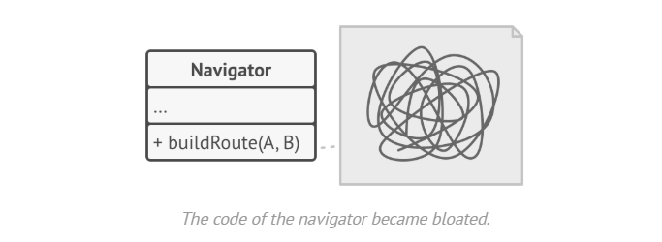

Using strategy , separate algo in separate class

