**Decorator** is a structural design pattern that lets you attach new behaviors to objects by placing these objects inside special wrapper objects that contain the behaviors.

The **Decorator Pattern** is a structural design pattern used to **dynamically add new functionalities** to an object without modifying its structure

Simple notifier only deal email.

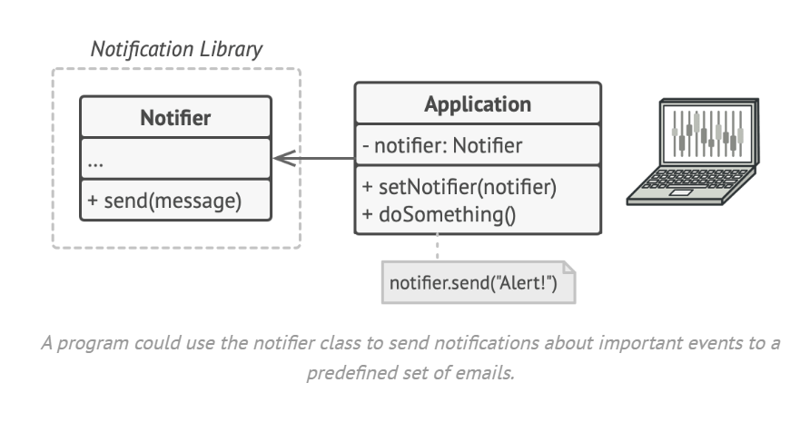

Later need more notifier , so we thought let add child classes.

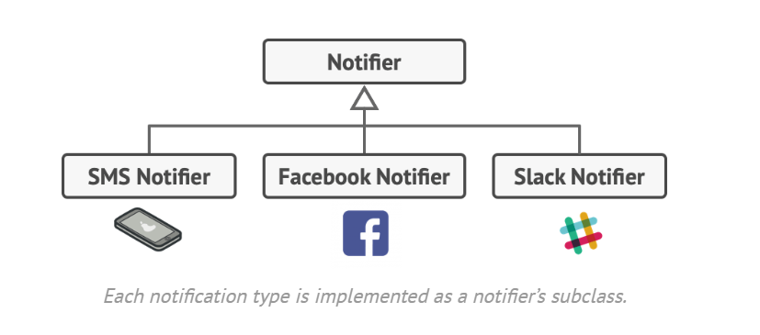

Now need combined notifier, huge number of classes required. (issue – bot able to dynamically add functionality )

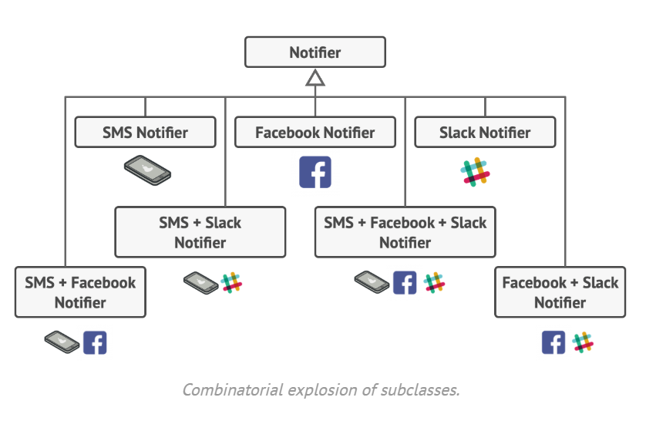

let’s leave the simple email notification behavior inside the base Notifier class, but turn all other notification methods into decorators.

