**Flyweight** is a structural design pattern that lets you fit more objects into the available amount of RAM by sharing common parts of state between multiple objects instead of keeping all of the data in each object.

The **Flyweight Pattern** is a **structural design pattern** that is used to reduce memory usage by **sharing common objects** instead of creating new ones.

Prob:

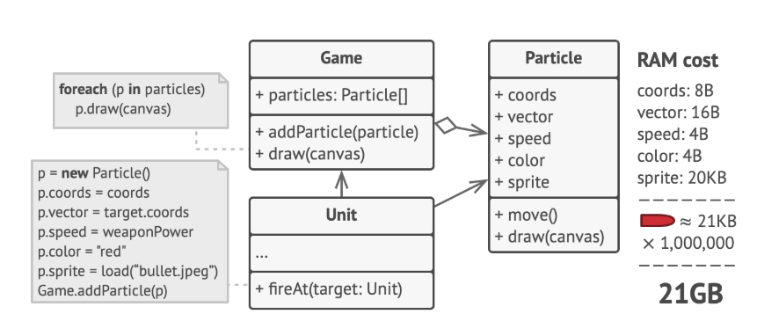

Solution 🡪>

State separation :

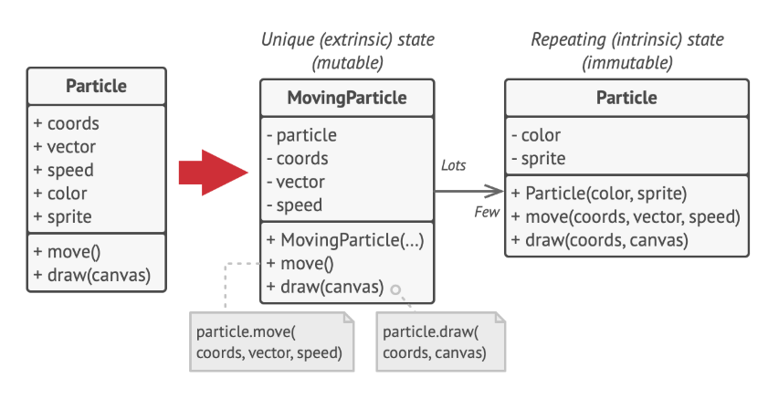

Size reduces :

