P. John Clarkson
e-mail: pjc10@eng.cam.ac.uk
Caroline Simons Claudia Eckert
Cambridge Engineering Design Centre, Department of Engineering, University of
Cambridge, Trumpington Street,
Cambridge, CB2 1PZ, United Kingdom

Predicting Change Propagation in Complex Design
In redesign and design for customization, products are changed. During this process a change to one part of the product will, in most cases, result in changes to other parts. The prediction of such change provides a significant challenge in the management of redesign and customization of complex products where many change propagation paths may be possible. This paper reports on an analysis of change behavior based on a case study in Westland Helicopters of rotorcraft design; the development of mathematical models to predict the risk of change propagation in terms of likelihood and impact of change; and the development of a prototype computer support tool to calculate such information for a specific product. With knowledge of likely change propagation paths and their impact on the delivery of the product, design effort can be directed towards avoiding change to ‘‘expensive’’ sub-systems and, where possible, allowing change where it is easier to imple-ment while still achieving the overall changes required. [DOI: 10.1115/1.1765117]

Introduction
Products are continuously modified and changed. As a result most product development involves the steady evolution of an initial design. This is necessary, both to eliminate mistakes that have been made during the initial design and manufacturing pro-cess, and to adapt the design to new requirements [1]. Regardless of the cause of these changes, the challenges involved in imple-menting them are the same.
At first glance, design changes often seem deceptively simple. A required change is identified, a new solution for this change is generated and the change is carried out. However, the reality is often far more complex. As all parts of a design are connected at least to one other part, design changes can also be connected. If part A is changed then part B might need changing. A change to part B leads to a change in C, which in turn might be connected to part D. A single design change may set off a series of others, transforming the initial modification into a flow of change that propagates, often unexpectedly, through large sections of the design.

Background
The degree to which change propagates through a product de-pends on the complexity of the product itself. Simon [2] defines the complexity of a product in terms of the connections between its parts, and calls engineering products ‘‘almost decomposable systems’’ where connections between parts of a system can never be fully avoided. Suh [3] advocates an axiomatic approach to design, where the functional structure of a product is well orga-nized and its information content minimized, thus clarifying the functional role of each part of the product. Such an approach can reduce complexity and the propagation of change. However, few products are designed with these principles in mind.
Many industries, such as the automotive industry, are working on modular designs, with clearly defined interfaces between sub-systems to reduce the complexity of their products and facilitate the reuse of sub-systems across a product range. The subject of the case study reported in this paper is particularly complex: a helicopter.
The systems of a helicopter are highly interconnected through functional parameters such as balance and vibration, while being minimized for weight. In comparison to other products, military helicopters are produced in very low volumes. Often fewer then

Contributed by the Design Automation Committee for publication in the JOUR-NAL OF MECHANICAL DESIGN. Manuscript received November 2003. Associate Editor: J. Michael McCarthy.
30 identical sub-systems are required which in turn have to be supported throughout the entire 30-year life span of the craft. Over the past 15 years Westland Helicopters have been develop-ing the EH101, a civil and military sea rescue and attack helicop-ter (Fig. 1).
They describe the EH101 as a ‘‘new concept’’—‘‘Based on a common airframe and core systems, the EH101 is configured to meet the multi-role requirements of many diverse customers around the world. It is uniquely capable of mastering the require-ments of any role using the same airframe and core systems’’ [4]. Thus, the basic design is partially redesigned for each new cus-tomer. Even with this philosophy a fully modular helicopter de-sign could not be achieved at reasonable cost and each new ver-sion requires considerable development effort.
As Eckert et al. [5] argue, a part does not have a predetermined change behavior. For example, in most circumstances the helicop-ter rotor is not changed if another part is changed. However, if the rotor would need to be changed the effect on the rest of the craft would be enormous, since the entire craft is designed to suit the rotational frequency of the rotor. Therefore, for each part, how it is affected by change and how its change affects other parts de-pends on the exact change that is implemented. Most parts have a certain redundancy designed into them and can absorb a degree of change. Others pass change on without requiring any change themselves. Where a change is too large to be absorbed, a part can become a change multiplier, resulting in changes to many other parts.
  - Change Prediction. The work discussed in this paper is
concerned with the prediction and management of changes to an
existing product resulting from faults or new requirements. This is very different from the traditional meaning of the term ‘‘change management,’’ which is concerned with managing the change of business processes in any kind of enterprise. It is also different from the business process of configuration management which refers to the tracking and control of design changes during product design and manufacture.
Design Structure Matrices (DSMs) [6,7] can provide an indica-tion as to how change may propagate through a product. They provide a well-established technique for identifying the parts of a product or design tasks, and the parametric or precedence relation-ships between them [8]. Each cell in the matrix may contain a numerical or binary representation of the link between one part/ task (the column heading) and another (the row heading). This is illustrated in Fig. 2 by a DSM that describes the tasks required to design a camera [9].
DSMs can show difficulties that may be encountered in rede-

788 Õ Vol. 126, SEPTEMBER 2004 Copyright © 2004 by ASME Transactions of the ASME

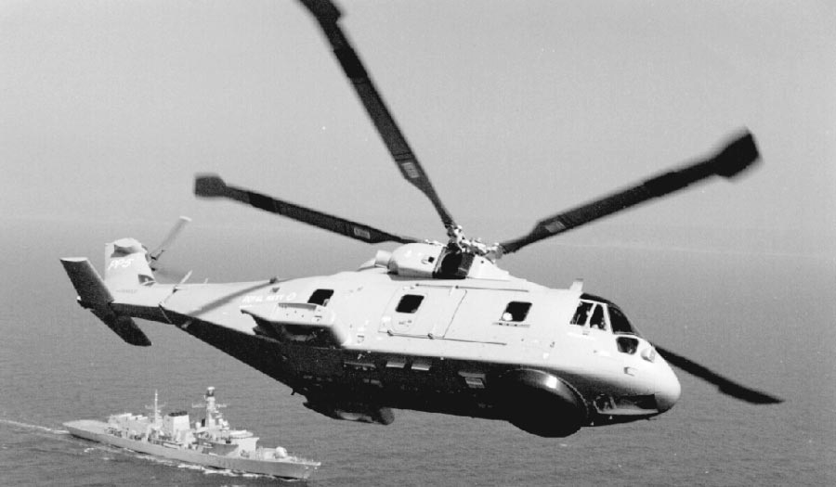

Fig. 1 The Westland helicopter EH101

sign work. The high levels of connectivity frequently found be-
tween design tasks suggest that high levels of interdependence
will also exist between the resulting product components. For ex-ample, since the design of parts C, D, E and F are dependent upon the design of part B (Fig. 2), one would expect that these tasks will be affected by a change to the conceptual design task, B.
The DSM provides no direct indication as to the likelihood or scale of any such redesign. However, it may be used as the basis of a process simulation that includes consideration of rework [10], allowing the identification of critical process features that impact cost and schedule risk. Such an approach can be used, where the underlying process is known, to analyze the impact of planned design changes.
A few relevant methods for predicting change propagation in redesign have appeared. In the field of software engineering, a couple of models consider change in evolutionary software devel-opment [11,12]. These models break down a program into pieces that are then linked in a propagation graph. These methods aim to highlight where subsequent, immediate changes might be neces-sary in software redesign, relying on programming variables to indicate links, and predicting only one step of change at a time. They are not appropriate for mechanical design where the para-metric links between parts may be less explicit or to predictions of change involving more than one step.
Model-based reasoning has also been used to generate and evaluate redesign plans, within which design modifications and accompanying side effects can be explored [13]. This approach focuses on the physical quantities that describe the performance of the design and the causal relationships between them, utilizing a qualitative measure to describe changes. The plans proposed are rather abstract, however, they do focus the designer’s attention of the relevant parts of the design.
In the field of computer-aided mechanical design, the C-FAR system [14] aims to trace and predict change propagation. A prod-uct is broken down into elements that are then considered in terms of their attributes. The attribute interactions are recorded in semi C-FAR matrices that are analyzed to predict the effect (‘‘high,’’

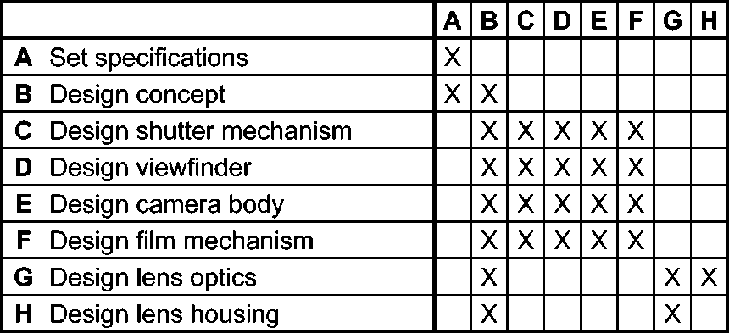
Fig. 2 Design structure matrix for a camera
‘‘medium’’ or ‘‘low’’) of one attribute on another. C-FAR’s com-putational complexity makes it appropriate for small or relatively simple products.
State of the art solid modelers, such as Catia or Dymola, begin to provide analysis of the designs that are generated in them. If a change is undertaken in them, then they show where the new version of the design is no longer technically correct. Catia mainly checks for geometric coherence, whilst Dymola can check for functional connections. In addition, mathematical analysis can identify problems related to structural properties through tech-niques such as finite element analysis. However, the major draw-back with such approaches is that they can generally only identify the immediate implications of a change, rather then the conse-quences that propagate through a product.
New approaches to product modularization (see for example, Sudjianto and Otto [15]) are concerned with cost-effective and brand-enhancing product variation. This in turn requires an under-standing of the differences (or changes) required to distinguish one product from another. Martin and Ishii [16], in their design for variety method, define a coupling index to indicate the strength of coupling between components in a product. Sered and Reich [17] develop this approach further to simulate the total design cost of future generations of the product. However, in both cases the propagation of change through the product is not explicitly ad-dressed.
In summary, whilst a number of approaches exist which are able to predict change, none are suited to products of the scale and complexity of a helicopter, therefore failing to fill the needs of companies like Westland Helicopters.
  - The Management Challenge. The scale and cost of
product redesign depends strongly on the particular changes that
are required. Hence, a company’s ability to undertake and manage
change, can be influenced greatly by their understanding of the
links that exist between different parts of the product and the
impact that these will have on the propagation of change. It is also important to identify the need for change early in the design pro-cess, since the later a change or the impact of a change is detected the more expensive it becomes to undertake [1].
This paper concentrates on capturing past experience about the propagation of change between systems in terms of the likelihood of their occurrence and the impact such changes would have. This
enables managers and designers to access the risk of change early
in the design process. They can assess which systems are most likely to be affected by a change, and what the impact of such a change would be. For example, most changes in a helicopter incur changes to the cabling and wiring of the craft, which is not a problem since the changes are relatively cheap to carry out. On the other hand a change to the rotor is extremely unlikely, but should it occur it would be extremely costly. With this knowledge,
design effort can be directed towards avoiding change to ‘‘expen-
sive’’ sub-systems and, where possible, allowing change where it
is easier to implement whilst still achieving the overall changes
required.
  - Overview of the Paper. This section has set the context for the analysis of change processes and change propagation. Sec-tion 3 describes the case study undertaken with Westland Helicop-ters. The methods used to calculate the risk of direct and indirect change propagation are outlined in section 4. The historic case studies used to validate the methods are discussed in section 5. Conclusions are to be found in section 6.

An Empirical Study of Change
Westland Helicopters originally approached the authors in re-sponse to earlier work involving the capture of complex design processes [18]. They wished to develop a tool to support the man-agement of design changes to existing helicopters. This led to an empirical study in order to analyze the change execution pro-cesses in Westland Helicopters. The study consisted of interviews,

Journal of Mechanical Design SEPTEMBER 2004, Vol. 126 Õ 789

group knowledge acquisition exercises and the collection of spe-cific redesign examples. These will now be described.
  - A Picture of Change. Interviews were conducted in two phases. Initially 17 senior engineers working on specific parts of the helicopter, such as stress, loads or fuselage, were interviewed to elicit a typical process for change execution and access the scope and complexity of the problem of change in existing prod-uct ranges.
In the second phase a further five interviews were conducted: four with chief engineers or deputy chief engineers, who were responsible for the development of a particular product version and all the changes associated with it; and a fifth with a manager responsible for producing tendering estimates for new projects. These interviews focused on all the changes involved in generat-ing a new version of a helicopter and were loosely structured to cover the following topics: the interviewee’s position and experi-ence; the creation of new product requirements; the identification of the version in which they were involved, including its new requirements; the time scale of the version redesign process; the changes involved and how the changes and redesign process were executed; their conception of the nature of change; and finally, their level of interest in a change prediction system. A detailed description of the change process and its potential pitfalls, based on the findings of these interviews, can be found in [5].
The four chief engineers made several consistent points about changes affecting the entire craft:
- Designers frequently fail to realize how their section of the helicopter will affect others;
- Retrofit customer requirements frequently create the most dif-ficult and costly redesign projects;
- The possibility of being unable to create a functional design solution does exist;
- Change flow does occur, resulting in changes propagating up to four steps (components/systems) from the initial change;
- Currently, not all changes are predicted–the interviewee esti-mates of the percentage of unexpected changes ranged from 5% to 50%.
Overall, the relationship of change to cost was highly evident and the commercial importance of effective change management is seen in these comments from the interviews:
- 10-15% of the redesign cost occurs before a contract is signed, spent on planning solutions and predicting changes;
- Weight reduction is essential, as every kilogram added to the EH101 design costs of the order of $25,000;
- Retrofit design changes (from a late requirement or from a delayed problem realization) cost about five times more than an early design change and contracts may have to be renego-tiated for them;
- Individual unexpected changes can be immensely costly—for example, an unexpected change to the helicopter’s wheels in one project cost or the order of $80,000.
Another key fact that emerged from these interviews was the importance of product maturity. Three out of four of the chief engineers interviewed and most of the senior engineers had worked on versions of the EH101. In addition, most interviewees had been in Westland Helicopters for over 20 years and had there-fore had exposure to other projects. The fourth chief engineer worked on the Lynx, which is a much more mature product, hav-ing been in service for about 30 years. For redesign work on the Lynx, designers are able to rely very heavily on past work. Cus-tomer change requirements are likely to be ones previously en-countered and the designers’ experience will guide the changes required. Thus, for this study, the main area of interest is the EH101 where a lower level of experience exists.
It emerged from all the interviews that nobody has a complete, detailed overview of the entire helicopter. The chief engineer in
charge of a specific helicopter, such as the EH101 has a broad understanding of the complete product, but knows little about de-sign details. The deputy chief engineers in charge of a version, like the ones interviewed in this study have probably the greatest understanding of the overall design. However, their view was that they only really understood about half of the design. In addition, their understanding is typically biased by their previous role. For example, a deputy chief engineer who was formerly a structural engineer will have a more detailed understanding of structures, then say of avionics.
The system heads, at the level of the senior engineers inter-viewed in the first phase of the interviews, understood their own field in detail and those of their colleagues with whom they col-laborate regularly. They knew much less about fields with no di-rect impact on their own work and again were biased by their own career path. A stress engineer, who had previously worked in ‘‘loads’’ would know the implication of changes to loads on stress. This again highlights the need for a means to capture knowledge of the interactions within a product that influence change propa-gation. Such knowledge should not be influenced by the knowl-edge of a particular individual, rather it should be governed by the corporate knowledge of the design team.
  - A Consensus View of Dependency. A meeting was held with seven senior engineers to discuss change propagation issues and agree on the structure of a dependency matrix for the EH101. The matrix presented later in this paper was developed from a model of the Helicopter derived with the assistance of Westland Helicopters’ designers. The envisaged purpose of the matrix was to gauge the overall understanding of the engineers and prompt them to think about possible connections between sub-systems. The data for the matrices used in the analysis later in this paper, which differentiate between impact and likelihood, was subsequently elicited from deputy chief engineers by Westland Helicopters’ staff.
  - Redesign Case Histories. As a final phase of this study, the details of several redesign cases were obtained from Westland Helicopters. Each case consists of an isolated initial change that resulted in change propagation. These case histories were recon-structed through a combination of designer interviews and change requirement records.
In the first case, Westland Helicopters encountered a require-ment for the addition of a FLIR (Forward Looking Infra-red Ra-dar) turret. This resulted in modifications to the avionics and to the local fuselage structure and nose cap, in the addition of a power supply and in revisedcabling and piping. In the second case, the installation of crash-worthy troop seats, required adjust-ments to the walls and floor, revisions of intercostal members, cabling and piping modifications and finally, a revised arrange-ment of the stretchers and guns. The final case involved the intro-duction of two additional countermeasure dispenser pods. This initial change resulted in local structural reinforcements, the addi-tion of a deflector plate to protect the in-flight refueling system, repositioning of the UHF antenna, nose cap adjustments, FLIR system modifications, cabling and piping revisions, avionics changes and flotation system adjustments.
These case histories provide clear evidence of the existence of change propagation and can be used to help validate the method described below.
  - The Need for Change Prediction. In summary, change prediction would be useful both at the tendering stage of a new project, to assist project planning, and during the subsequent re-design, to assist identification of previous instances of change propagation. The remainder of this paper focuses on the first of these two scenarios while the later has been investigated sepa-rately by Westland Helicopters.

790 Õ Vol. 126, SEPTEMBER 2004 Transactions of the ASME

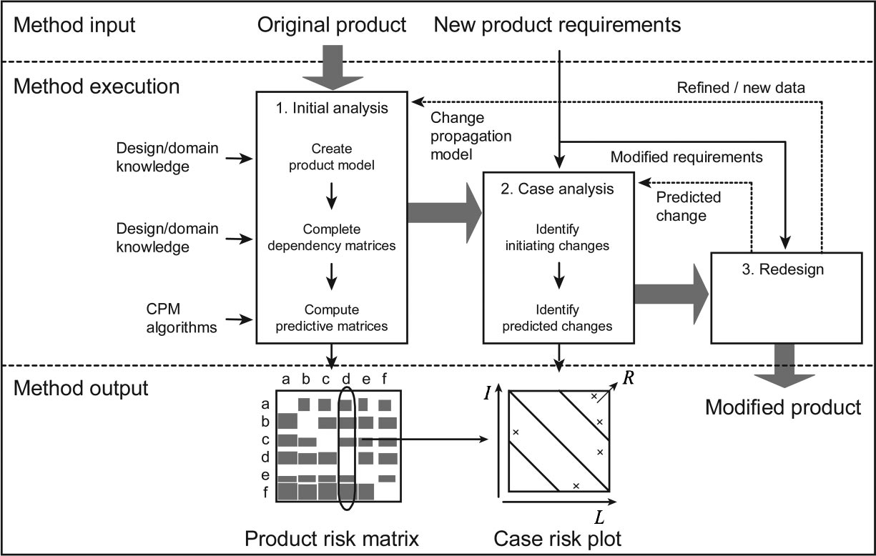

Fig. 3 The change prediction method

A Change Prediction Method
The next phase of the project involved the creation of a change prediction method that included a model of change propagation. This method, illustrated in Fig. 3, is explained in the sections that follow.
  - Initial Analysis. This first stage of the change predic-tion method (CPM) uses product data and a model of change propagation to allow preliminary examination of component rela-tionships. It consists of three steps: creating the product model; completing the dependency matrices and computing the predictive matrices. The basic structure of the model is an amalgamation of Design Structure Matrices and risk management techniques. Prod-ucts are modeled as linked components, where links consist of separate likelihood and impact terms.
    - Create Product Model. Before a product can be ana-lyzed it must first be broken down into sub-systems, allowing the product to be viewed as a collection of parts whose designs affect one another. A sub-system is a part of the overall product and its delineation can be based on location, function, sourcing or any other relevant distinction. Designers and managers familiar with the original design can advise on how it may be broken down into an appropriate number of sub-systems. This requires a careful balance between the level of detail required and the subsequent cost of populating the model. A model with fewer than 50 com-ponents is recommended.
Experience with the Westland Helicopters case study, and other subsequent studies, suggests that the creation of the product model is not as difficult as it sounds. This is particularly true if all the sub-systems are described at a similar level of detail. The West-land Helicopters model, comprising 19 components, took a little over 20 hours to construct. An appreciably more complex model, comprising 41 components, took a total of 50 hours [19], while another of 20 components took 26 hours.
Models can describe the whole of a product in terms of key sub-systems or describe a particular sub-system with reference to individual components. Models that attempt to describe change propagation between individual components and sub-systems are more problematic. Where such range of detail is required it is better to define separate models, where those at the component level provide input to those at the sub-system level.
    - Complete Dependency Matrices. The component breakdown allows interconnectivity within the product design to be presented in a DSM. In particular, it allows the capture of the change relationships between product sub-systems, where change is defined as any alteration to a sub-system’s design. Within the
DSM the column headings show instigating sub-systems and the row headings the affected sub-systems, whose designs change as a result of change to the instigating sub-systems.
The scale of change propagation predicted between sub-
systems is measured as a probabilistic impact, or risk, where risk is defined as the product of the likelihood of the change occurring and the impact of the subsequent change. This terminology is borrowed from risk management, which was first developed as a tool for use in safety management, for example by the UK Min-istry of Defense [20].
Coppendale extends this idea to project management [21] using risk graphs, as in Fig. 4, in which the impact of a particular event is plotted against its likelihood. Thus, the top right-hand corner of the graph is the highest risk area, in which events are both highly probable and their results severe. The low left-hand corner corre-sponds to incidents of lowest risk. Note, the low/medium/high grid is used only to add clarity to the plot and likelihood and impact values may take any value between zero and ten.
Change relationships may be presented as a combination of likelihood and impact, rather than a single composite measure of risk. Figure 5 shows these relationships for a domestic hairdryer, highlighting the change dependencies and their associated likeli-hood, impact and risk. In this context likelihood is defined as the average probability that a change in the design of one sub-system will lead to a design change in another by propagation across their common interface. Likewise, impact is defined as the average pro-portion of the design work that will need to be redone if the

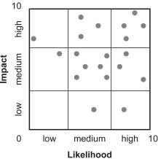
Fig. 4 Risk graph

Journal of Mechanical Design SEPTEMBER 2004, Vol. 126 Õ 791

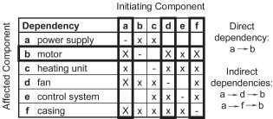

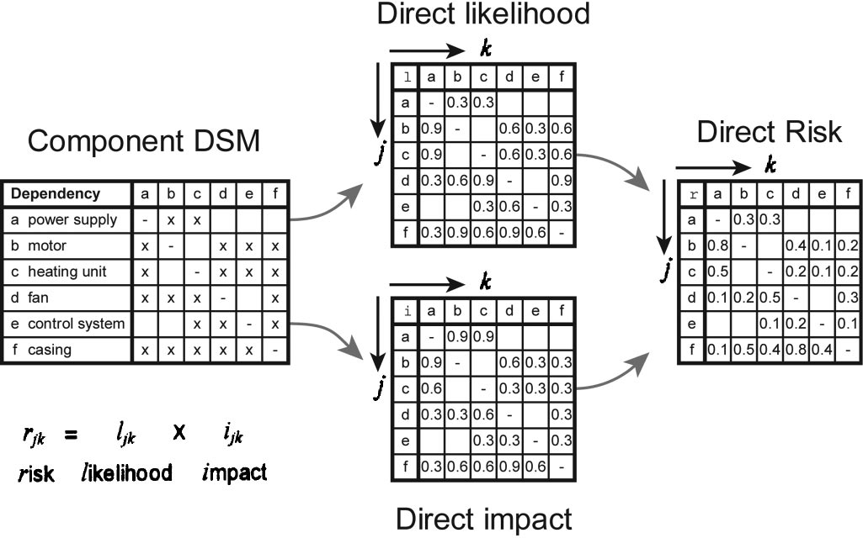
Fig. 5 Likelihood, impact and risk DSMs

change propagates. Both these quantities are assigned values be-tween 0 and 1 and refer to the to the total change experienced during the redesign process.
These likelihood (l) and impact (i) matrices may be derived from a history of previous design changes and from the views of experienced product designers. They capture a view of the aver-age change experienced during a complete redesign process. As such, the views of a group of designers would be preferable to the views of an individual, whilst still giving more weight to the views of a designer in their own area of expertise. Above all a consensus view is desirable.
These dependencies should represent the direct risk (r) of a change in one sub-system resulting in a change to its neighbor by propagation across their common interface. The risk of propaga-tion of these changes to other sub-systems can then be predicted from this data.
Defining impact as the ‘‘average proportion of the design that will need to be redone if the change propagates’’ simplifies the analysis that follows. In practice, a number of levels of impact may be possible depending upon the nature of the changes propa-gating through the design. Further work by the authors has shown that Monte-Carlo simulation can be used in place of the simpler analysis described below, enabling risk to be computed as a func-tion of the type of change mechanism [19]. For example, likeli-hood and impact data can be elicited separately for change propa-gation by mechanical, thermal and electrical means or by some combination of these. The effect of changes propagating along each path can then be summed.
The cost of any subsequent redesign, in terms of time or money, can be estimated by multiplying the impact for each sub-system by the corresponding design costs. This may be done at any stage of the analysis. However, for the purpose of this paper, costs were not calculated since the necessary data remains commercially sen-sitive.
    - Compute Predictive Matrices. Change propagation is contingent upon two processes: first, the flow of change from one sub-system to another; and second, the combination of changes from a number of sources to effect change within a particular sub-system. A predictive model must allow for both these behav-iors and calculate a combined risk of propagation from its direct and indirect components.
Change flow may be modeled as a sequence of links created by the direct sub-system dependencies, where a direct dependency refers to the propagation of change between adjacent sub-systems, for example the power supply a and motor b of Fig. 6. By con-trast, an indirect dependency would require the involvement of at least one intermediate sub-system for a change in a to affect a change in b. For example, changes to b via changes to d and f are indirect.
Fig. 6 Direct and indirect dependencies
These links combine to create a change propagation network, based on the dependency matrix of Fig. 6. A propagation tree, like that illustrated in Fig. 7 for routes between sub-systems a and b, can be derived from the network, where for clarity routes return-ing to previously visited sub-systems are not shown.
Propagation trees allow consideration of the combination of direct and indirect effects. A combined effect is then defined as the change in b caused by a change in a, via both direct and indirect links. The initial likelihood and impact matrices contain only the direct dependency values and are thus referred to as the direct likelihood (l) and direct impact (i) matrices, which combine to provide the direct risk (r) matrix. These three matrices have their parallels in the combined likelihood (L), impact (I) and risk (R) matrices.
Combined likelihood is the probability that the end effect will arise, regardless of the path. Combined impact is the total impact to the affected sub-system, which is expected to appear with prob-ability L. The combined likelihood algorithm views propagation trees as logic trees, such as the one illustrated in Fig. 8. Vertical lines are mathematically represented by U(And), while horizon-tal lines are represented by n (Or). For each tree, the And/Or summation begins at the bottom, farthest from the instigating sub-system. Through a combination of And and Or evaluations, a single combined likelihood value can be computed at the top of the tree. Since the events are not mutually exclusive the summa-tions take the form:
lb,uUlb,v=lb,uXlb,v (1)
lb,unlb,v=lb,u+lb,v-( lb,uXlb,v )=1-(( 1-lb,u )X( 1-lb,v ))
(2)
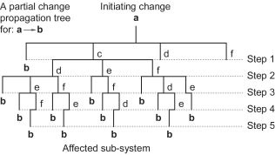
Fig. 7 A partial change propagation tree
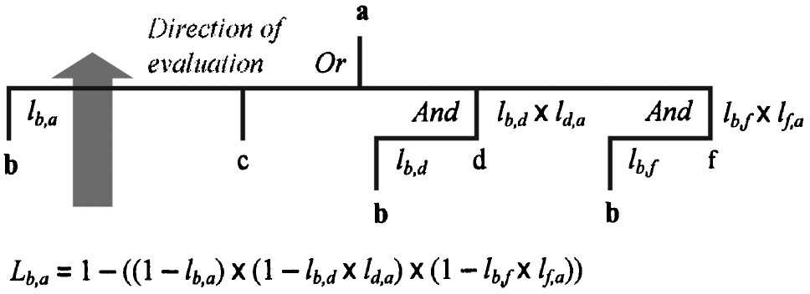

Fig. 8 AndÕOr summation for a propagation tree

792 Õ Vol. 126, SEPTEMBER 2004 Transactions of the ASME

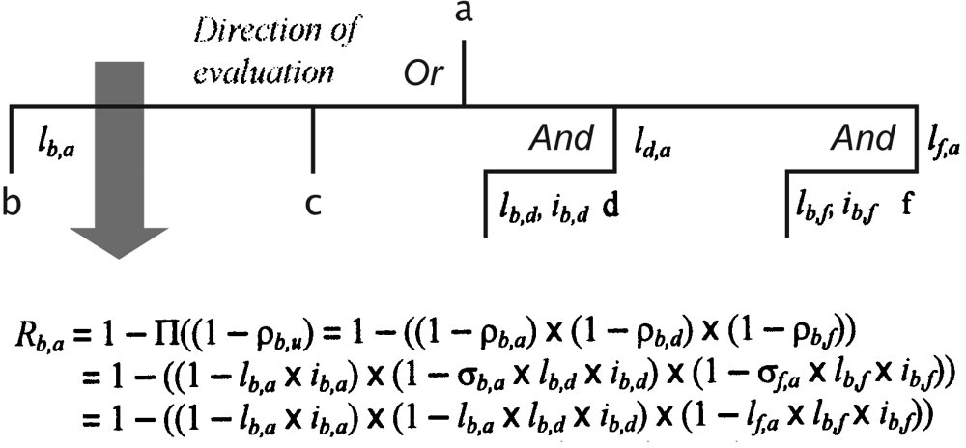

Fig. 9 Combining impact, weighted by probability

where Eq. (1) represents the And function as a product of prob-abilities and Eq. (2) represents the Or function as a sum of prob-abilities minus the product term (the inverse of the product of inverse probabilities). This form of the Or evaluation is not de-pendent on the individual terms being small and ensures that the combined likelihood (L) will always be less than unity. This con-trasts the approach taken in [10] where independence is assumed. Defining likelihood as the ‘‘average probability that a change in the design of one sub-system will lead to a design change in another’’ makes no assumption about the scale of the initiating and subsequent changes. Hence, Eqs. (1) and (2) make no refer-ence to impact values. This in turn simplifies the calculation of
combined risk (R) and combined impact (I).
There are a number of possible algorithms for computing the combined risk, each involving a number of assumptions. The one used in this paper may be summarized as follows. R_{b,a} is the combined risk of change propagating to b from a, where:
R_{b,a}=1-IT ( 1-p_{b,u}) (3)
for all links from the penultimate sub-system u in the chain from
a to b, and:
pb,u=uu,alb,uib,u (4)
where p_{b,u} is the risk of change propagating from u to b, u_{u,a} is the likelihood of change reaching sub-system u from a, l_{b,u} is the direct likelihood of change propagating from u to b and i_{b,u} is the direct impact of such a propagation.
The execution of this algorithm is illustrated in Fig. 9. The likelihoods (u_{u,a}) of change reaching the penultimate sub-systems d and f are l_{d,a} and l _{f} _{,a} respectively, while the direct likelihoods of change propagating from d and f to b are l_{b,d} and l_{b,} _{f} , with corresponding direct impacts of i_{b,d} and i_{b,} _{f} . Note that the direction of the evaluation is now reversed from that of the combined likelihood.
Finally, combined impact can be easily determined from the combined likelihood and risk using the simple equation:
Ib,a=Rb,a /Lb,a (5)
The complete product and propagation model is summarized in Fig. 10. The transformation of this model into executable steps requires an analysis of step limits (path truncation), the creation of a computer program and an appropriate format for presenting results.
Step limits are a practical necessity as trails can become ex-tremely long and data processing times relate exponentially to the number of steps. A simplification is reasonable considering the decrease of trail probability with increasing length and the afore-mentioned change propagation behavior observed in industry. A practical limit of three or four steps is suggested based on the length of propagation paths observed. This issue is discussed fur-ther with the case study presented in section 5.

Fig. 10 The CPM model

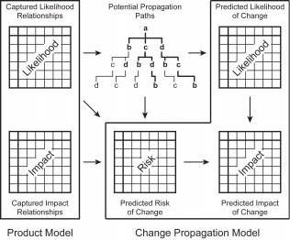
A computer program has been developed to undertake the propagation analysis and verified against results of two sets of manually solved data. The format for presentation of the results will now be discussed.
    - Product Risk Matrix. Once the combined matrices have been derived, the resultant risk data may be presented in a single matrix, as shown on the right of Fig. 11. Each rectangle shows the combined risk of change propagation between the sub-system represented by the column heading and that represented by the row. Its width indicates the likelihood L, its height the impact I and its area the risk R.
The combined risk matrix may also be reordered to reflect con-sideration of sub-system influence on and susceptibility to change. Here influence is taken as the extent to which change to a particu-lar sub-system effects other sub-systems, and susceptibility is how much a sub-system is affected by changes. These properties can be considered by simply comparing the sums of the matrices’ columns and rows. If the columns and rows are reordered such that the highest values are in the top right corner, the relative influence of the sub-systems is given by the order of the column headings while the relative susceptibility is shown by the row headings. Figure 12 illustrates this reordering for the risk matrix of Fig. 11.
The graphical product risk matrix is the main output of the initial analysis. It allows the change characteristics of a product to be inspected and is appropriate for use with both large and small matrices. In general, a matrix with a lot of large rectangles repre-

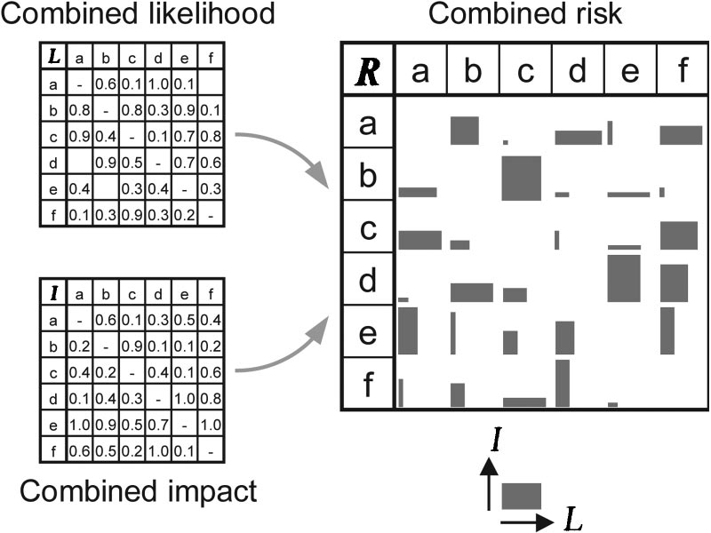
Fig. 11 A graphical product risk matrix

Journal of Mechanical Design SEPTEMBER 2004, Vol. 126 Õ 793

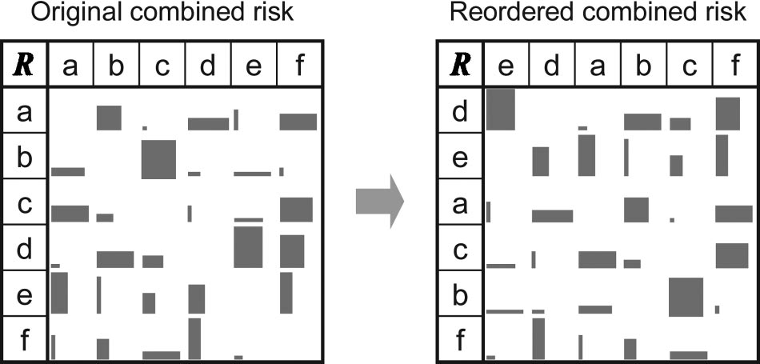

Fig. 12 A reordered graphical product risk matrix

sents a product which will exhibit a significant amount of change propagation, while a sparse matrix will limit change.
The concentration of large rectangles, i.e. significant area, with respect to particular columns or rows reflects the influence on and susceptibility to change. Clustering algorithms could also be em-ployed to identify groups of components that are particularly coupled, or indeed uncoupled. Note, that given the fact that the order of the rows and columns need not be the same, many of the normal ordering algorithms used for design structure matrices are not relevant.
  - Case-by-Case Analysis. A case-by-case analysis, con-sisting of the identification of prospective changes and the presen-tation of predicted changes, is now required.
    - Identify Initiating Changes. The first step is the iden-tification of the instigating sub-system, which consists of two parts: deciding on the new product requirement and associating this requirement with one of the product sub-systems. Often the link will be obvious, but sometimes the identity of the instigating sub-system may not be clear. For this reason, the initial product model must be clearly defined and documented, particularly for highly complex products.
In some instances there may be more than one instigating sub-system. If that is the case, the following analysis can be completed for all relevant systems and the results combined.
    - Identify Predicted Changes. The identification of pre-dicted changes is straightforward following completion of the ini-tial analysis. The likelihood, impact and risk data for the specific case need only be extracted from the complete change propaga-tion data. It is convenient to rank the changes in order of descend-ing risk as a means of prioritizing the possible changes. In addi-tion, more notice should be taken of those changes predicted with higher likelihood for comparable risk.
Note that the list of predicted changes should act as a prompt for discussion within the planning team rather that an absolute indication of the changes that will take place. Indeed, there may be sub-systems for which change should be avoided, since it would not be commercially attractive.
At any point during the case analysis, a re-evaluation of the direct dependency data or change requirements, as a result of team discussions, may be beneficial and is recommended.
    - Case Risk Plot. The L and I values for the given insti-gating sub-system(s) are mapped to a 0→1 log scale and plotted (I vs L for each affected sub-system) on a risk scatter graph of the form shown in Fig. 4. This re-scaling of the results has the advan-tage that lines of equal risk are straight, allowing immediate com-parison of data, as illustrated in Fig. 13.
  - Redesign. Hopefully, by this stage, designers and man-agers will know which sub-systems should be assigned additional resources to respond to likely changes. Hence with combined risk data as a guide, project teams can create cost-efficient project plans, and ultimately design solutions, more quickly.

Fig. 13 A case risk plot

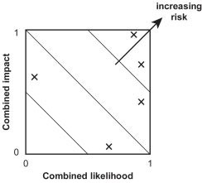
A necessary and final step of the redesign process is to return to the initial analysis in order to update the product model and direct dependency matrices for use in later projects. The greater the ac-curacy of the direct data and the greater care used in selecting change requirements the better the resulting redesign will be, both in terms of functionality and efficiency.

Model Validation
Initial validation of the change prediction method was under-taken with reference to the Westland Helicopters EH101.
  - Initial Analysis. The definition of the product model for the EH101 provoked much debate, in particular with regard to the number of sub-systems to be included. Finally, in order to keep the case study to a manageable size, a model with 19 sub-systems was defined. They comprised geographical units of the EH101, for example the fuselage and engines, and systems that crossed the geographical boundaries, for example the avionics and hydraulics. Direct likelihood and impact matrices were elicited from deputy chief engineers by Westland Helicopters staff. In addition, a half-day workshop was organized to consolidate the individual matri-ces into a single, agreed set. The total time taken to build the model was of the order of 20 hours. The results of this analysis are shown in Fig. 14 in the form of a product risk matrix. Note that the matrix has been reordered following a sub-system influence
and susceptibility analysis.
The change propagation analysis was performed assuming that changes would not propagate appreciably beyond four steps. Fur-ther analysis of the model showed this to be a reasonable assump-tion. The combined likelihoods, for a change initiated by the Weapons and Defensive Systems, are shown in Fig. 15. They tend quickly towards asymptotic values and their rank order does not vary if the propagation is calculated on the basis of at least four steps.
The product risk matrix shows the Engines and Engine Auxil-iaries to be the most influential sub-systems with respect to change, while the Avionics and Main Rotor Blades are the most susceptible to change. These results are consistent with the West-land Helicopters chief engineers’ views. Changes to the Engines and Engine Auxiliaries are highly likely to result in changes to other sub-systems. Avionics are integrated with many other sys-tems and are thus frequently affected by change. Finally, modifi-cations to the Main Rotor Blades are enormously expensive.
Note that while these particular results are based on an assess-ment of risk, alternative results may be derived from an assess-ment of likelihood, impact or some other derived measure.
Thus, a product model and the direct matrices were successfully completed and the combined matrices revealed realistic influence and susceptibility trends. However, the true test of the CPM meth-od’s utility is the case-by-case analysis.

794 Õ Vol. 126, SEPTEMBER 2004 Transactions of the ASME

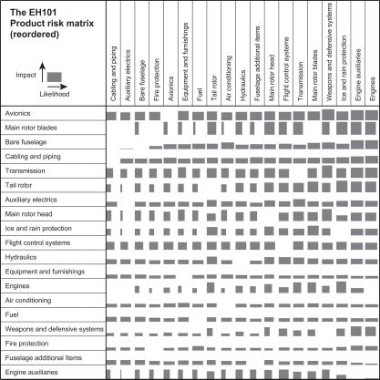
Fig. 14 Product risk matrix for the EH101

  - Case by Case Analysis. As mentioned earlier, three dif-ferent cases were examined: the addition of a FLIR turret, the installation of crash-worthy troop seats and the introduction of two additional countermeasure dispenser pods. The pertinent CPM results for all three cases are shown in tabular form in Fig. 16 and graphically in Fig. 17. Note, for each case the likelihood and impact figures are independently mapped onto a 0→1 log scale. This provides a convenient combined plot with common

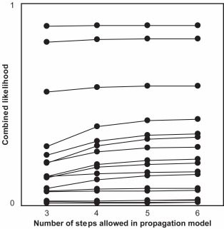
Fig. 15 Variation of likelihood results
scales. In practice, if multiple changes were initiated, nonnormal-ized scales would be required to show the relative risk of subse-quent changes regardless of their source.
For the FLIR turret case, a Fuselage Additional Items (FAI) change, four of the five highest Likelihood changes were observed in the original redesign (outlined cells in Fig. 16). The need for change prediction is not obvious, however, as all of the altered components had direct dependencies (gray cells in Fig. 16) on the instigating component.
In the second case, an Equipment and Furnishings (E&F) change, the two highest likelihood changes were observed in the original redesign (outlined cells)—a good result. This case indi-cates the usefulness of CPM, as the Cabling and Piping revision was not predicted by the direct dependencies (gray cells). How-ever, the further change to the E&F was not predicted by CPM, due to the exclusion of loops in the analysis. In principle, such changes could be identified either by allowing propagation trails to return to the initiating system, or by increasing the number of elements in the model.
The final case involved the introduction of two additional coun-termeasure dispenser pods, a Weapons and Defensive Systems (W&DS) change. A comparison with the changes known to have taken place revealed six out of a possible 18 changes were ob-served in the original redesign (outlined cells), where these repre-sented 2/3 of all the predicted changes found in the upper third of the likelihood scale. In addition, half of the observed changes were not predicted by direct dependencies (gray cells) and only came to light following the application of the change prediction method. This latter point illustrates the power of the method in highlighting all areas of potential design change in response to new product requirements.
The above analysis and discussion did not look at the combined impact data, as case study impact data was not available. How-ever, the high level of agreement between the predicted likelihood and observed results provided overall support for the CPM

Journal of Mechanical Design SEPTEMBER 2004, Vol. 126 Õ 795

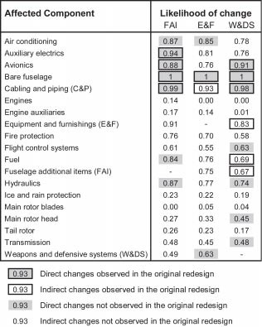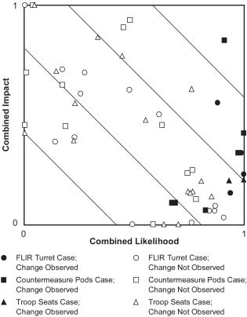

Fig. 16 Case-by-case analysis likelihood results
Fig. 17 Case-by-case analysis risk plots

method. Thus, for the EH101, the CPM method shows promise, with a full half of the W&DS and E&F observed changes were not suggested by the direct links.
  - Validation Summary. The EH101 example provides an initial validation of the change prediction method. The product model and the direct dependency matrices were successfully com-pleted, followed by a propagation analysis. Finally, the case-by-case analyses were executed. The high level of agreement be-tween the predicted and observed results provides support for the CPM method.
These case studies contain several possible sources of error and uncertainty, and with only three change scenarios the results cannot have statistical validity. Thus only tentative conclusions can be made. However, the results of the studies suggest the following:
- The change prediction method gives a good indication of future change likelihood without the need for detailed knowl-edge of the product development process;
- The granularity of the product model and availability of change data critically influence the prediction results
- Loops could be included in the analysis to allow the predic-tion of additional changes to the initiating systems.
There remains a need to check the sensitivity of the model to variations in the input data and to test the method with further case studies. Preliminary results from investigations in both of these areas show promise.

Conclusions
The nature and extent of change propagation is currently nei-ther clearly understood nor predictable. However, it can cause large delays or unexpected spending in design projects.
A change prediction method has been outlined and evaluated. It appears to be highly indicative of the change propagation experi-enced in redesign projects. The relatively successful nature of the method is perhaps surprising, as very generic information (the

direct dependency matrices) gives indications of much more spe-cific behavior (the effects of a specific initial design change, to part of a sub-system).
Experience of a number of case studies, including that pre-sented in this paper, has shown that the time taken to build a moderately sized model (less than 50 components) is acceptable and the companies involved all found the process valuable.
Clearly more work remains to be done. The method presented contained many assumptions, the validity of which need to be further explored. However, the need for and the possible success of the change prediction method seems clear. Further development of the ideas has already been undertaken as a means to analyze product architectures [22].

Acknowledgments
The authors would like to gratefully acknowledge the extensive information from Westland Helicopters and the assistance of Ian Russell, Ben Smith, Geoff Close, Jeremy Graham, Mark Reddick, Dave Ingram and Paul Herring.

References
- Lindemann, U., and Reichwald, R., eds., 1998, Integriertes A¨ nderungsman-agement, Springer-Verlag, Berlin, Germany.
- Simon, H., 1996, The Sciences of the Artificial, MIT Press, Boston, USA.
- Suh, N. P., 1990, The Principles of Design, Oxford University Press, New York, USA.
- Westland Helicopters, 1999, Technical Report No. GKN/EH101/6/99, West-land Helicopters.
- Eckert, C., Clarkson, P. J., and Zanker, W., 2004, ‘‘Customisation in Complex Engineering Domains,’’ Research in Engineering Design, 15(1), pp. 1–21.
- Steward, D. V., 1981, ‘‘The Design Structure System: A Method for Managing the Design of Complex Systems,’’ IEEE Transactions on Engineering Manage-ment, EM-28(3), pp. 71–74.

796 Õ Vol. 126, SEPTEMBER 2004 Transactions of the ASME

- Browning, T. R., 2001, ‘‘Applying the Design Structure Matrix to System Decomposition and Integration Problems: A Review and New Directions,’’ IEEE Transactions on Engineering Management, 48(3), pp. 292–306.
- Eppinger, S. D., Whitney, D. E., Smith, R. P., and Gebala, D. A., 1994, ‘‘A Model-based Method for Organizing Tasks in Product Development,’’ Re-search in Engineering Design, 6(1), pp. 1–13.
- Smith, R. P., and Eppinger, S. D., 1997, ‘‘Identifying Controlling Features of Engineering Design Iteration,’’ Management Science, 43(3), pp. 276 –293.
- Browning, T. R., and Eppinger, S. D., 2000, ‘‘Modelling the Impact of Process Architecture on Cost and Schedule Risk in Product Development,’’ MIT Sloan School of Management Working Paper No. 4130, MIT, Boston, MA.
- Schach, S. R., and Tomer, A., 2000, ‘‘A Maintenance-oriented Approach to Software Construction,’’ Journal of Software Maintenance-Research and Prac-tice, 12(1), pp. 25– 45.
- Rajlich, V., 2000, ‘‘Modeling Software Evolution by Evolving Interoperation Graphs,’’ Annals of Software Engineering, 9, pp. 235–248.
- Ollinger, G. A., and Stahovich, T. F., 2001 ‘‘RedesignIT—A Constraint-based Tool for Managing Design Changes,’’ Proc. ASME International Design En-gineering Technical Conferences, Design Theory and Methodology, Pittsburgh, USA.
- Cohen, T., Navthe, S., and Fulton, R. E., 2000, ‘‘C-FAR, Change Favorable Representation,’’ Comput.-Aided Des., 32, pp. 321–338.
- Sudjianto, A., and Otto, K., 2001 ‘‘Modularization to Support Multiple Brand
Platforms,’’ Proc. ASME International Design Engineering Technical Confer-ences, Design Theory and Methodology, Pittsburgh, USA.
- Martin, M. V., and Ishii, K., 2002, ‘‘Design for Variety: Developing Standard-ized and Modularised Product Platform Architectures,’’ Research in Engineer-ing Design, 13(4), pp. 213–235.
- Sered, S., and Reich, Y., 2003 ‘‘Standardization and Modularization Driven by Minimizing Overall Process Effort,’’ Proc. ASME International Design Engi-neering Technical Conferences, Design Theory and Methodology, Chicago, USA.
- Clarkson, P. J., and Hamilton, J. R., 2000, ‘‘‘Signposting’: A Parameter-driven Task-based Model of the Design Process,’’ Research in Engineering Design, 12(1), pp. 18 –38.
- Jarratt, T. A. W., Eckert, C., and Clarkson, P. J., 2003 ‘‘Linkage Analysis,’’ Technical Report No. CUED/C-EDC/TR124, University of Cambridge, Cam-bridge, UK.
- DefStan 00-56, 1996, Defense Standard 00-56 (PART 1)/Issue 2: Safety Man-agement Requirements for Defense Systems, UK Ministry of Defense, Glas-gow, UK.
- Coppendale, J., 1995, ‘‘Manage Risk in Product and Process Development and Avoid Unpleasant Surprises,’’ Engineering Management Journal, pp. 35-8.
- Jarratt, T. A. W., Eckert, C., Clarkson, P. J., and Schwankl, L., 2002 ‘‘Product Architecture and the Propagation of Engineering Change,’’ Proc. 7th Interna-tional Design Conference, Dubrovnik, Croatia, Vol. 1, pp. 75– 80.

Journal of Mechanical Design SEPTEMBER 2004, Vol. 126 Õ 797

