ARINDAM DEY 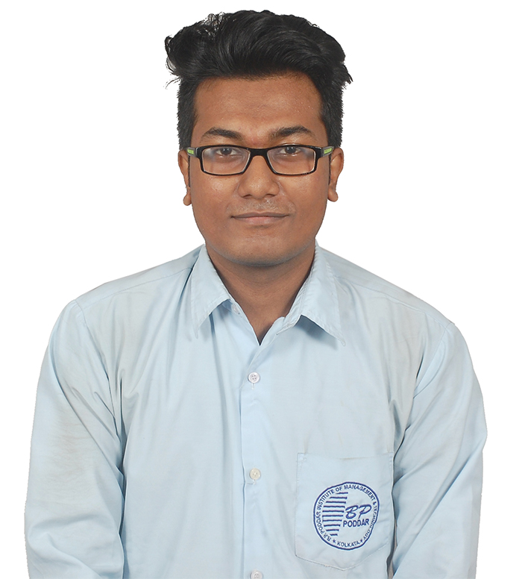
E-Mail ID : arincool58@gmail.com
Mobile : 8013106576

CAREER OBJECTIVE
To work in a firm with a professional work driven environment where I can utilize and apply my knowledge, skills which would enable me as a fresh graduate to grow while fulfilling organizational goals.

BASIC ACADEMIC CREDENTIALS

Qualification | Board/University | INSTITUTE/SCHOOL | Year | MARKS/CGPA
B.Tech (Computer Science Engineering) | Maulana Abul Kalam Azad University of Technology(formerly known as WBUT) | BP Poddar Institute of Management and Technology | 2015-2019 | 7.07(Upto 6th semester)
Class XII | ISC | St.Stephen School | 2015 | 73.40
Class X | ICSE | St.Stephen School | 2013 | 77.50

IT PROFICIENCY
- Language: C, Java
- Subjects: Database Management System, Object Oriented programming.
- Databases: RDBMS (Oracle XE, MySQL)
- Operating System: Windows , Linux.
SOFT SKILLS
- Good Communication both Oral and Written.
- Capable for analyzing and solving problems.
- Fast Learner with positive attitude.

PROJECTS UNDERTAKEN
Basic Media Player: A Basic media player where you can play audio songs,video clips as well as youtube videos built for android platform with android studio.
Technologies: ANDROID,JAVA.

Cab Management Booking: A Website which shows how leading cab company works,through this website a customer can pinpoint his location and our system will automatically select cab for him. Technologies: JSP,JDBC,JAVASCRIPT,HTML,CSS.
TRAININGS

TRAINING NAME | PROVIDER | DATE | DURATION
ADVANCED JAVA | TECHTREE TECHNOLOGIES(SALTALAKE SECTOR 1 BD BLOCK,KOL-700064) | 02 SEPT 2016-10 OCT 2016 | 40 HRS
ANDROID APP  DEVELOPMENT | TECHTREE TECHNOLOGIES(SALTALAKE SECTOR 1 BD BLOCK,KOL-700064) | 25 AUG 2017-28 SEPT 2017 | 50 HRS
ORACLE PL/SQL | ARDENT COMPUTECH PVT.LTD | 06 JUN 2018-10 JULY 2018 | 50 HRS

PERSONAL DETAILS

- Permanent Address :- 1 No Nalta Mahajati road,Dumdum Cantonment Kolkata-700028
- Fathers Name :- Anil Kumar Dey
- Date of Birth :- 17thJanurary 1997
- Gender :- Male
- Language Known :- English , Hindi ,Bengali
- Marital Status :- Single
- Nationality/Religion :- Indian
- Interest & Hobbies :- Internet browsing , Cricket and watching movies

DECLARATION

I do hereby declare that the above information is true to the best of my knowledge.
Place: KOLKATA 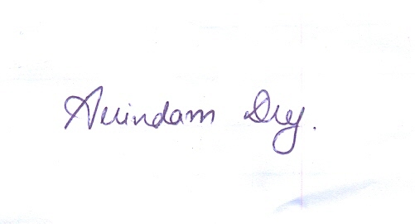
Date: 11/08/18 (Signature)

