Step 1: To download the package installer visit this site:

<https://docs.microsoft.com/en-us/dynamics365/customer-engagement/unified-service-desk/admin/install-upgrade-deploy-unified-service-desk?view=dynamics-usd-4.1>

Step 2: Click on the second link

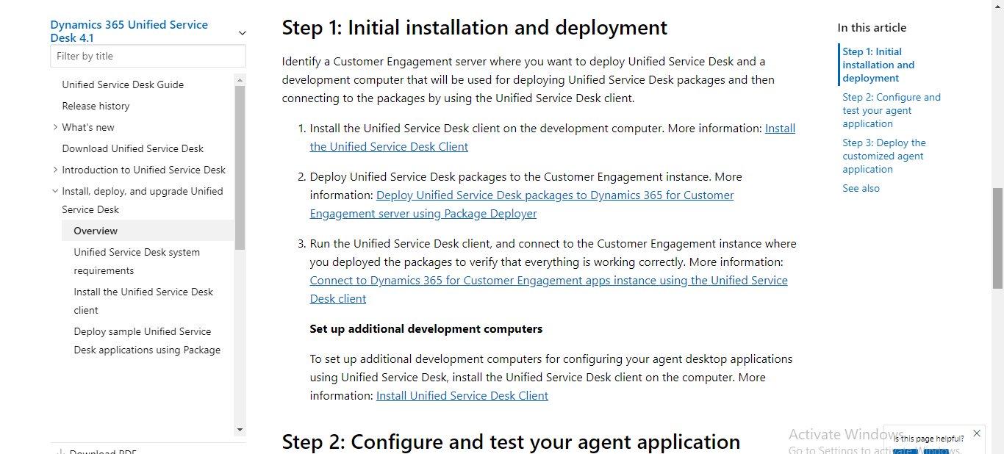

Step 3: Click on Download

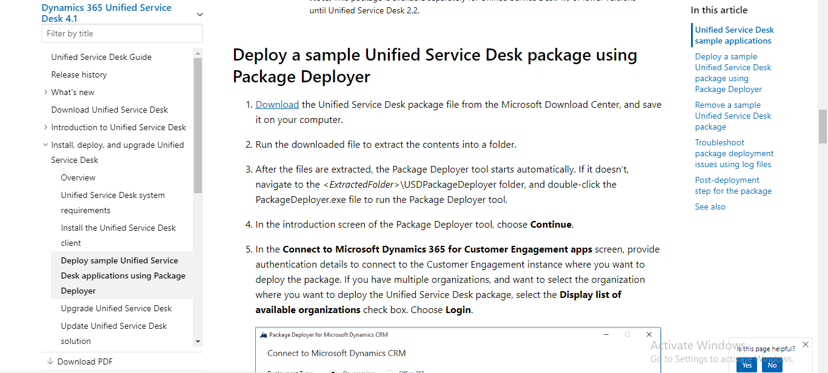

Step 4: Choose language as English or your preferred language. 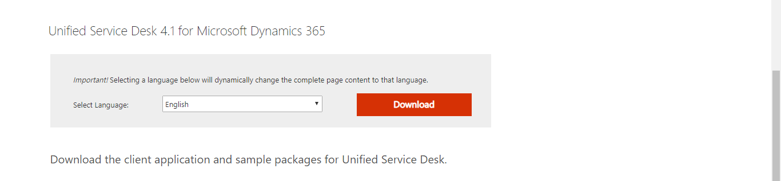

Step 5: Download the Package Deployer. 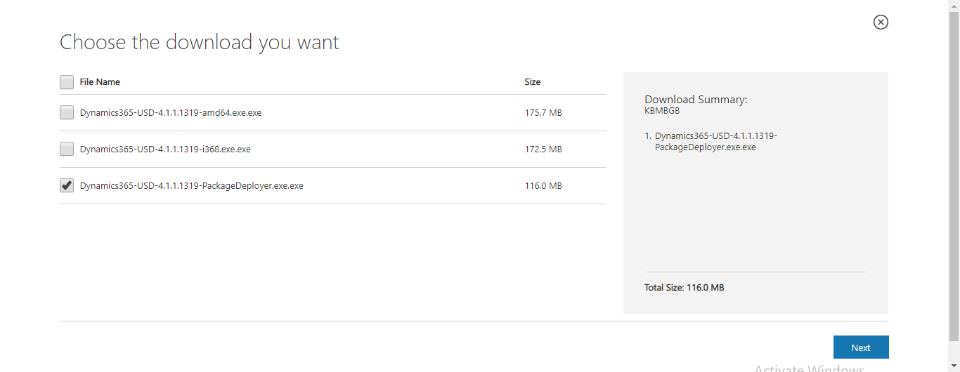

Step 6: Run the .exe downloaded file

Step 7: Accept the terms and conditions and click on next.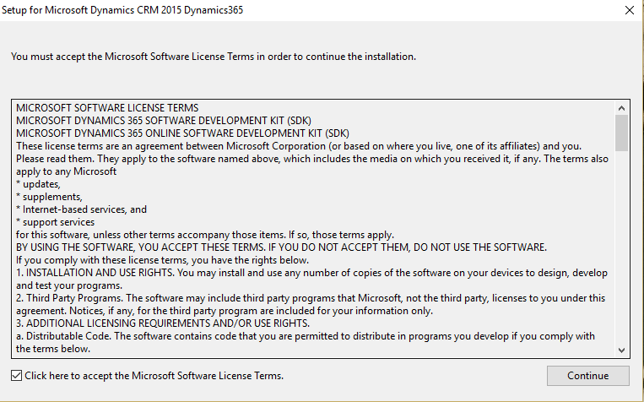

Step 8: Choose the path where files to be extracted.

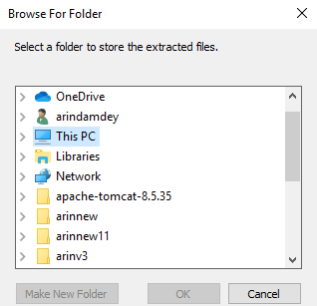

Step 9: Wait till files get extracted.

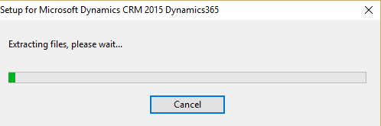

Step 10: Click on continue.

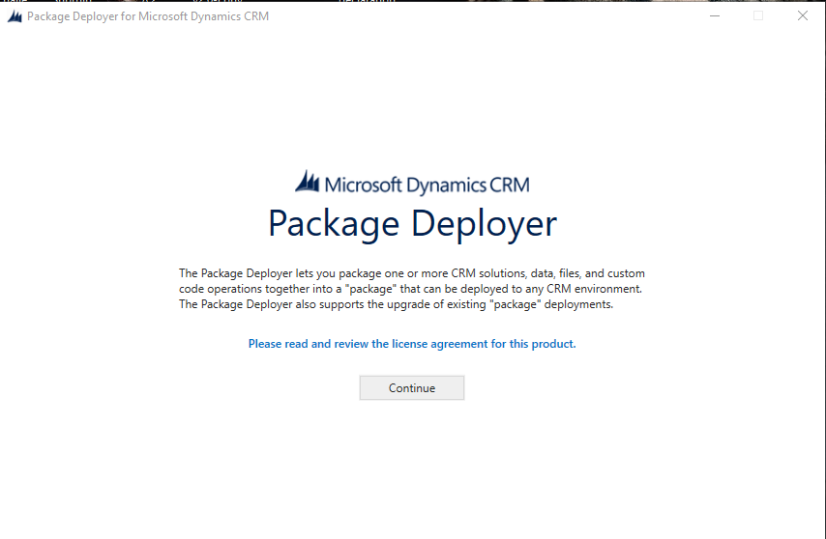

Step 11: Choose office 365 option and click on login.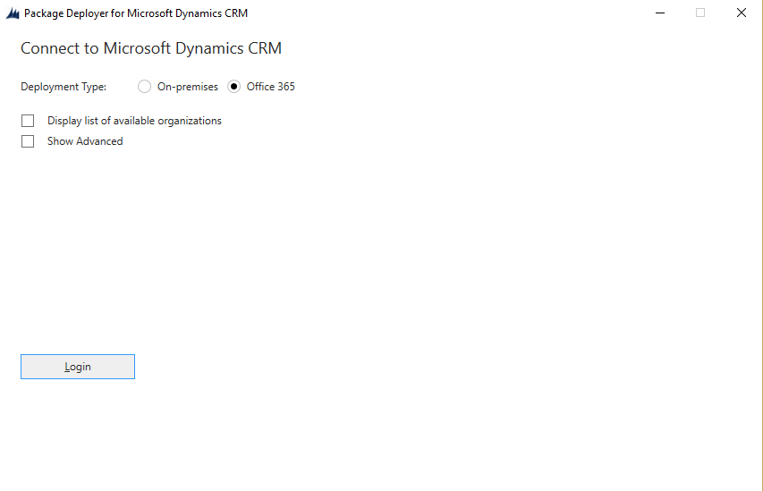

Step 12: Enter your email id or password to login.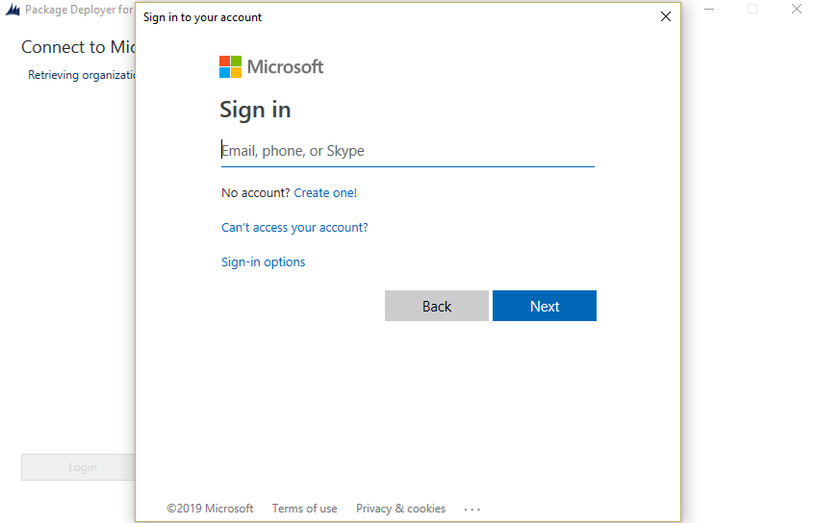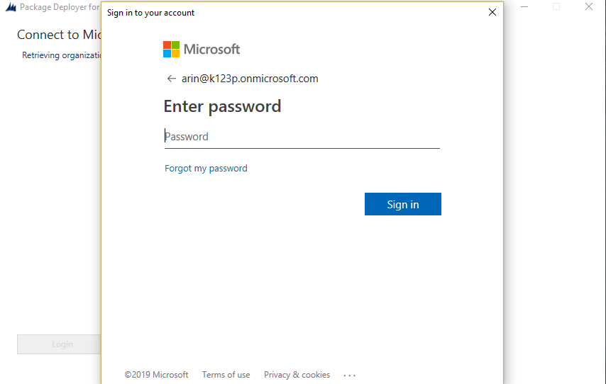

Step 13: Wait till the setup connect to your organizations MS dynamics account.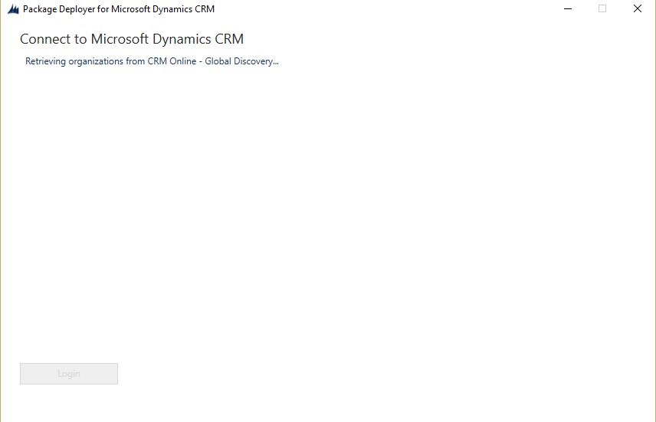

Step 14: Choose the type of package you want to deploy here we are deploying Unified Service Desk-Interactive Service Hub.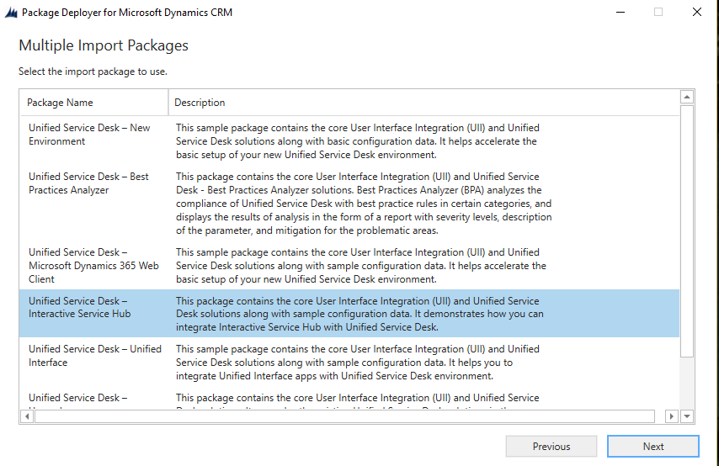

Step 15: Click on Next.

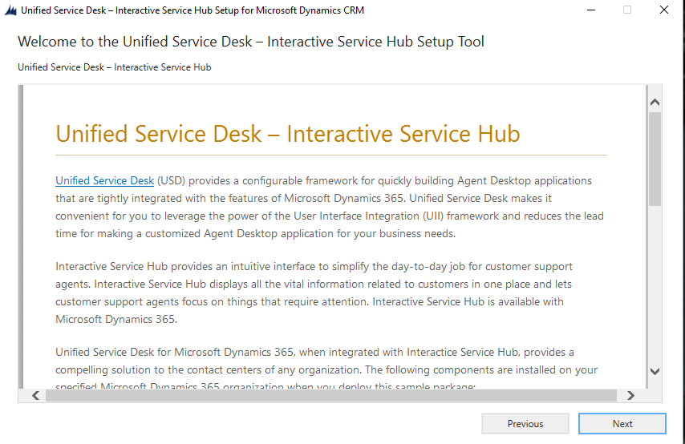

Step 16: The setup will configure and install the package after everything gets finished click on next.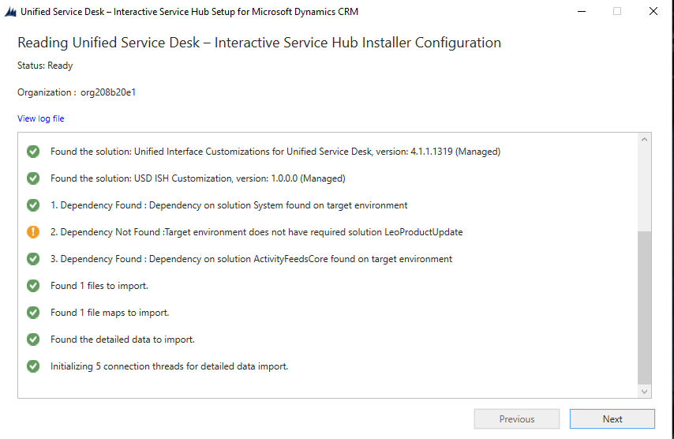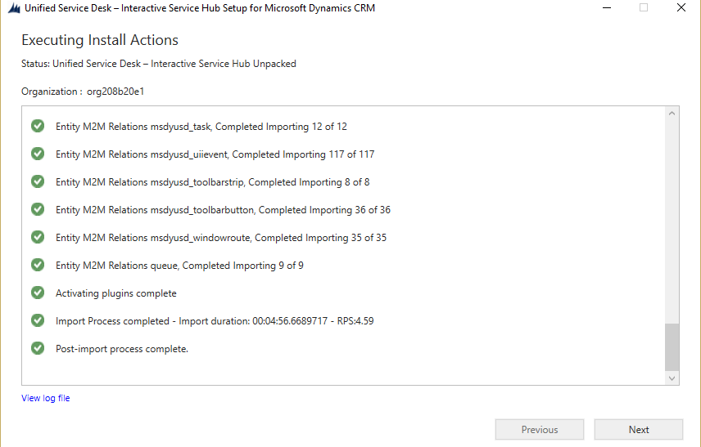

Step 17: Click finish to finish the setup.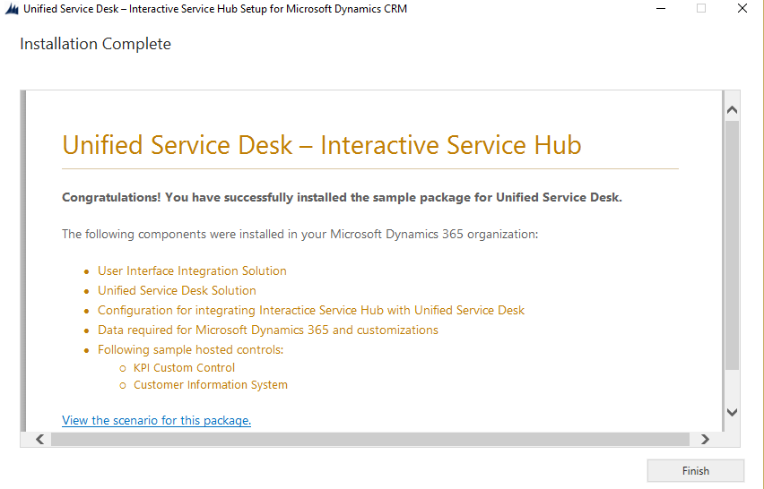

Step 18: Login to your MS Dynamics 365 account and navigate to Sales->Settings->Solutions to check the packages.

