
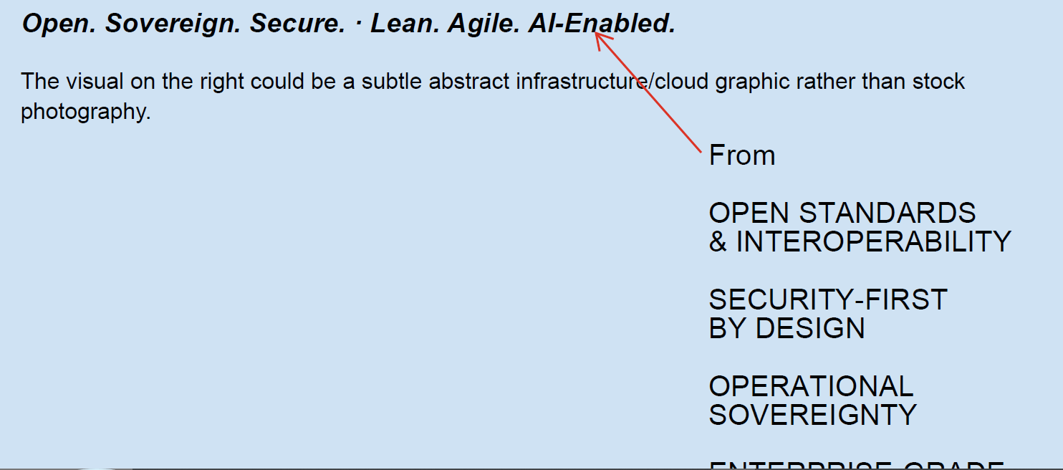
HOME PAGE
Change the content. The final text should be - Open. Sovereign. Secure. · Lean. Agile. AI-Enabled.

Add this in Main page

Section 3 should be ‘WHY CLOUD COM’. But in the website it is in section 4. This comes before ‘OUR APPROACH’

FOOTER
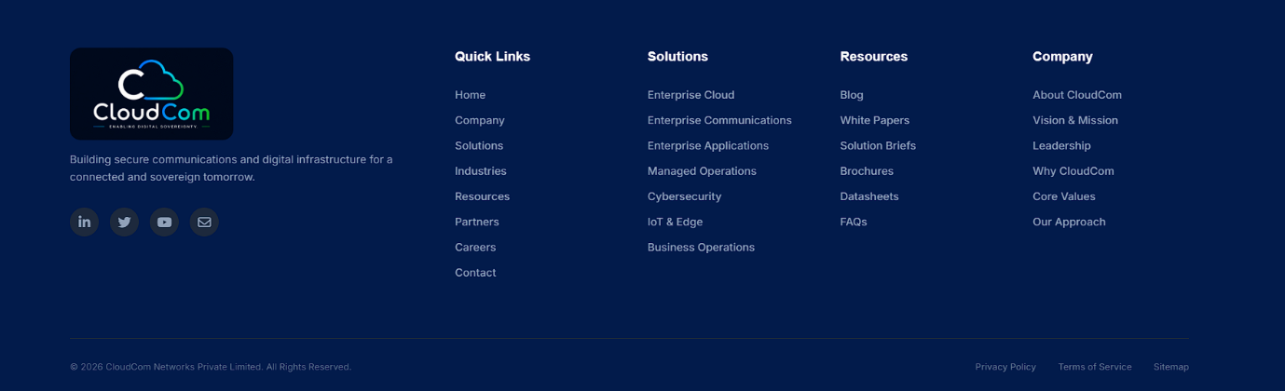

Remove the RESOURCE section and add CONTACT section
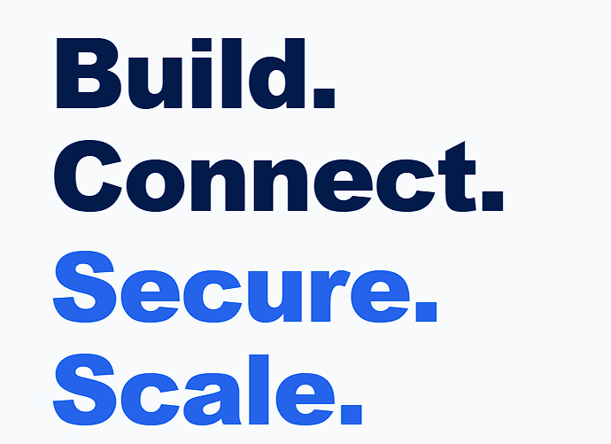

Resize the H1 of HOME page

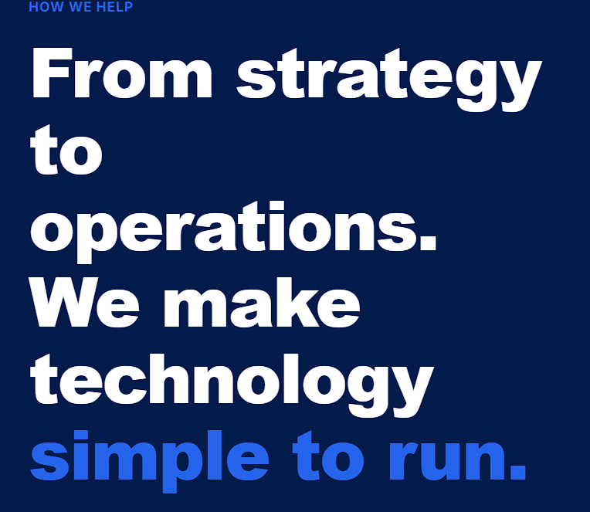

Resize the H1 of SERVICE page

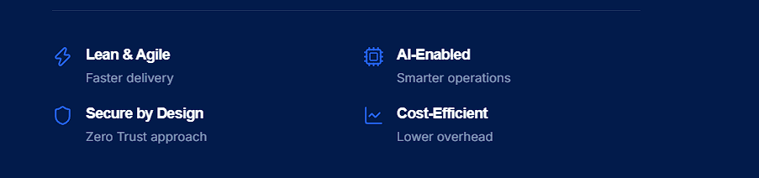
SERVICE PAGE

Change the Design to

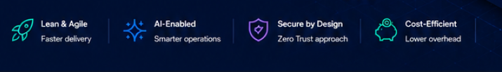
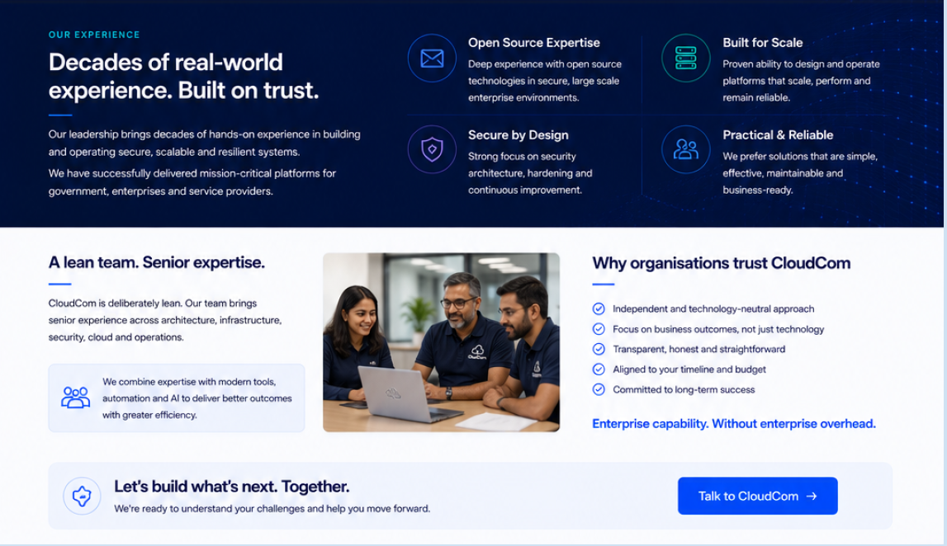
Add this section under ‘OUR PRINCIPLES’
ABOUT PAGE
. Update the Industries page
INDUSTRIES PAGE
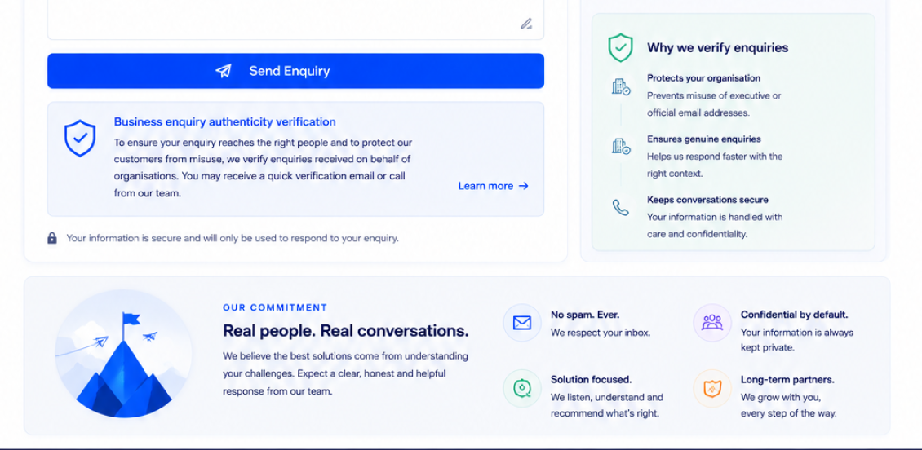
Add this under contact form
CONTACT PAGE

