CARPOOL MOBILITY PLATFORM
Project Code: CMP Brand: TBD

SYSTEM ARCHITECTURE DOCUMENT
SAD
Document ID: CMP-DOC-07

Version | 0.1
Status | Draft — NOT APPROVED
Date | 2026-08-16
Classification | Internal
Author | Solution Architect (AI-assisted)
Reviewer | [TBD]
Approver | Project Owner
Previous Version | None (initial issue)
Predecessor | CMP-DOC-01 … CMP-DOC-06, all v0.1, all Draft, none approved

This document is a controlled engineering artifact.
It is issued for Project Owner review and is not approved for implementation.

0. Document Control

0.1 Document Control Table
Table 1 — 0.1 Document Control Table
Field | Value
Document ID | CMP-DOC-07
Document Name | System Architecture Document
Short Name | SAD
Project Name | Carpool Mobility Platform
Project Code | CMP
Version | 0.1
Status | Draft
Date | 2026-08-16
Author | Solution Architect (AI-assisted)
Reviewer | [TBD]
Approver | Project Owner
Classification | Internal
Brand | TBD
Previous Version | None (initial issue)
Predecessor Documents | CMP-DOC-01 … CMP-DOC-06, all v0.1, all Draft, none approved
Related Documents | 00_Project_Control/README.md, Documentation_Index.md, Documentation_Status.md, Document_Change_Log.md, Glossary.md, Master_Traceability_Matrix.md
Successor Documents | CMP-DOC-08 (Mobile Architecture), CMP-DOC-09 (Backend Architecture) — Not Started

0.2 Revision History
Table 2 — 0.2 Revision History
Version | Date | Author | Change | Status
0.1 | 2026-08-16 | Solution Architect (AI-assisted) | Initial issue. Establishes the system architecture: 12 architectural drivers, 10 principles, 24 Architecture Decision Records resolving all 8 technical decisions routed from CMP-DOC-06 §13.2, container and component views for all six software elements, 5 runtime views, and the data, integration, security and deployment architectures. Issues 148 architecture statements (ARCH-001 … ARCH-148). | Draft

0.3 Distribution List
Table 3 — 0.3 Distribution List
Role | Purpose
Project Owner | Approval authority
Solution Architect | Authoring and ownership
Software Architect (Mobile) | Primary consumer — CMP-DOC-08 derives from §6.1 and §7
Software Architect (Backend) | Primary consumer — CMP-DOC-09 derives from §6.2–6.5
Security Analyst | Security architecture (§10); controls in CMP-DOC-13
DevOps Engineer | Deployment architecture (§11); infrastructure in CMP-DOC-19
Backend Lead | API surface shape (§9.1) feeding CMP-DOC-10; data architecture (§8) feeding CMP-DOC-11
QA Analyst | Runtime views (§7) as integration test scenarios
Product Owner | Architectural trade-offs with product consequences (§14.3)

0.4 Approval
Table 4 — 0.4 Approval
Role | Name | Signature | Date
Author | Solution Architect (AI-assisted) | — | 2026-08-16
Reviewer | [TBD] | — | —
Approver | Project Owner | — | —

This document is NOT approved. It is issued at version 0.1 with status Draft for Project Owner review.

0.5 Purpose of This Document
Every document before this one described what must be true. This document is the
first that decides how.
It does four things:
- Establishes the architectural drivers — the requirements that actually shape
structure, as distinct from the 606 that must merely be satisfied.
- Records 24 architecture decisions, each with its context, the alternatives
considered and its consequences — including all eight technical decisions CMP-DOC-06
routed here rather than taking.
- Specifies the architecture: containers, components, runtime behaviour, data,
integration, security and deployment.
- Evaluates the architecture against its drivers, and states honestly where it
cannot yet be validated.

0.6 Scope and Boundary of This Document
Contains: architectural drivers and principles; architecture decision records; system
context, container and component views; runtime views for the scenarios that stress the
architecture; data, integration, security and deployment architecture; cross-cutting
architecture; technology mapping; architecture evaluation; traceability; risks.
Excludes:
Table 5 — 0.6 Scope and Boundary of This Document
Excluded | Belongs to
Mobile module structure, navigation graph, state-holder design, Compose composition | CMP-DOC-08
Backend service decomposition, class design, framework idiom, job definitions | CMP-DOC-09
Endpoint paths, verbs, request and response payloads, status codes | CMP-DOC-10
Tables, columns, keys, indexes, migrations | CMP-DOC-11
Screen design, interaction, visual language | CMP-DOC-12
Security controls, cryptographic choices, threat model | CMP-DOC-13
Payment provider integration mechanics | CMP-DOC-14
Test design | CMP-DOC-18
Hosting, environments, pipelines, monitoring stack | CMP-DOC-19

0.6.1 What This Document May and May Not Decide
Table 6 — 0.6.1 What This Document May and May Not Decide
May decide | May not decide
That seat allocation is serialised by a pessimistic lock within a transaction. | The exact isolation level and lock timeout — CMP-DOC-09 / CMP-DOC-11.
That external providers are reached through ports with provider-neutral contracts. | The class structure of those adapters — CMP-DOC-09.
That evidential records are append-only with a verifiable chain. | The hash algorithm and key handling — CMP-DOC-13.
That the interface is versioned in the URI path with N and N−1 supported. | The endpoint set and payload shapes — CMP-DOC-10.

0.7 Intended Audience
Solution Architects · Software Architects · Backend and Android Developers · Security
Engineers · DevOps Engineers · QA Engineers · Technical Leads · Product Owners.

0.8 Basis of This Document — and Three Material Qualifications

0.8.1 Source
FACT. Derived from CMP-DOC-01 through CMP-DOC-06, all v0.1, and from the
approved technology direction. No other source.

0.8.2 Qualification 1 — Six Unapproved Predecessors
WARNING. All six predecessors are at status Draft. Architecture derived from an unapproved requirement baseline inherits its instability. Recorded as ARCH-RISK-001 and in Document_Change_Log.md conflict entry CC-007.

0.8.3 Qualification 2 — Structure Is Decidable; Sizing Is Not
FACT. CMP-DOC-05 records 69 unset quality targets (GAP-012), including every
capacity, availability and recovery target.
Consequence, stated plainly:
Table 7 — 0.8.3 Qualification 2 — Structure Is Decidable; Sizing Is Not
Can be decided now | Cannot be decided now
How the system is decomposed | How many instances of anything
How components interact | What hardware or service tier
Where state lives and how it is protected | What redundancy the availability target requires
How concurrency, versioning and configuration work | Whether the design meets a performance target
How failure is contained | The recovery topology the RPO/RTO requires

This document therefore specifies structure and defers sizing. Every sizing-dependent
decision is marked [SIZING — BAD-DEC-018] and carried to CMP-DOC-19. **No capacity
number, instance count, latency figure or availability figure appears anywhere in this
document**, because none has been approved and README.md §9.2 prohibits inventing them.

0.8.4 Qualification 3 — Three Suppliers Are Unselected
FACT. The payment provider (BAD-DEP-004), identity verification means
(BAD-DEP-005) and hosting (BAD-DEP-009) are not selected.
The architecture is designed so that none of these choices is structural: each sits
behind a port (ADR-07), and the deployment view is expressed logically rather than
against a named provider (§11). This is a deliberate response to NFR-100–102 and
SRS-REQ-108.

0.9 Statement Classification Convention
As README.md §9.1. Markers: FACT, ASSUMPTION, BUSINESS DECISION REQUIRED,
TECHNICAL DECISION REQUIRED, OPEN QUESTION, TBD, FUTURE CONSIDERATION,
RECOMMENDATION.

0.10 Identifier Conventions
Table 8 — 0.10 Identifier Conventions
Prefix | Element | Section
ARCH-nnn | Architecture statement (traceable) | 5–13
ADR-nn | Architecture Decision Record | 4
AD-nn | Architectural Driver | 2
AP-nn | Architectural Principle | 3
ARCH-RISK-nnn | Architectural risk | 16.2
ARCH-OQ-nnn | Open Question | 16.3

Table of Contents
If the entries below appear as a placeholder, open in Word and press Ctrl+A then F9 (or right-click → Update Field) to build the contents, figure and table numbering.
…

1. Executive Summary

1.1 What This Document Delivers
Table 9 — 1.1 What This Document Delivers
Element | Count
Architectural drivers | 12
Architectural principles | 10
Architecture Decision Records | 24
— of which resolve technical decisions routed from CMP-DOC-06 | 8 of 8
Architecture statements | 148 (ARCH-001 … ARCH-148)
Containers | 5
Components specified | 31
Runtime views | 5
Sizing decisions deferred | 11
Architectural risks | 12

1.2 The Architecture in One Paragraph
A single Laravel application holds all business authority and exposes two front doors: a
versioned REST interface for the Android client, and a Filament administrative interface
for operators — both reaching business state through one shared domain layer, never
around it. Behind that layer sit MySQL as the store of record with an append-only
evidential log, a queue-and-scheduler subsystem carrying all work that must survive a
client disconnecting, and a set of ports isolating every external provider so that
none of the three unselected suppliers is a structural commitment. The Android client is
a presentation and capture surface that holds no authoritative state and reaches the
system only through the versioned interface.

1.3 The Five Decisions That Shape Everything Else
Table 10 — 1.3 The Five Decisions That Shape Everything Else
ADR | Decision | Why it dominates
`ADR-01` | A single deployable Laravel application containing both the API and the admin interface, sharing one domain layer. | Directly satisfies SRS-REQ-069/070 — the admin element cannot re-implement a rule it does not own. Rejecting this was the alternative most likely to produce the SRS-RISK-003 failure.
`ADR-04` | Seat allocation and booking confirmation serialised by pessimistic row-level locking inside a single transaction. | BAD-RULE-027 is absolute and admits no eventual consistency. This is the one place the architecture deliberately trades throughput for correctness.
`ADR-06` | All work that must complete regardless of the client — payment verification above all — runs as durable, idempotent queued jobs. | FRD-FR-126 requires verification to complete when the passenger never returns. Without this, the payment integrity chain is unimplementable.
`ADR-07` | Every external provider sits behind a port with a provider-neutral contract; no provider type appears in the domain layer. | Three suppliers are unselected. This makes that fact non-structural.
`ADR-11` | Business policy configuration is a first-class, versioned, audited runtime subsystem — distinct from deployment configuration. | 17 open decisions will land as values. This is what makes them configuration changes rather than releases.

1.4 What the Architecture Cannot Yet Validate
Table 11 — 1.4 What the Architecture Cannot Yet Validate
Cannot validate | Blocked by
Whether the design meets any performance target | BAD-DEC-018 — no targets exist
The redundancy the availability target requires | NFR-023 unset
The recovery topology | NFR-038, NFR-039 unset
Cost per trip against a ceiling | NFR-145, NFR-149 unset
Whether matching remains sub-linear at real corridor density | Requires measurement (ADR-03 consequence)

**Structure is complete and reviewable. Sizing is deferred to CMP-DOC-19 with eleven
named decisions.**

1.5 The Uncomfortable Finding
ADR-01 places the administrative interface inside the same deployable unit as the API
— which is correct for integrity, and in tension with `SRS-REQ-082`, which requires
the administrative application to remain available for safety incident handling during
planned maintenance of other capability. One deployable unit means one maintenance
window.
§4.1 ADR-01 records this openly, and ADR-24 resolves it: **safety incident handling
is the one capability permitted to be deployed independently**, as a narrow read-and-act
surface over the same domain layer. This is the only structural exception in the design,
and it exists because a safety obligation demanded it.

2. Architectural Drivers
What a driver is, and what it is not. All 606 requirements must be satisfied. A driver is one that would change the structure if it changed. Twelve qualify. The remainder are satisfied within whatever structure the drivers produce.

Table 12 — 2. Architectural Drivers
ID | Driver | Source | Structural consequence
AD-01 | The backend is the sole business authority. | BAD-RULE-002, SRS-REQ-031 | One domain layer; no business logic in client or admin; all state changes through it.
AD-02 | Confirmed seats may never exceed seats offered — under any concurrency. | BAD-RULE-027, NFR-028 | Serialised allocation; a strongly consistent store; no eventual consistency on seat state.
AD-03 | Payment status is set only by the platform's own verification, which must complete without the client. | BAD-RULE-032/033, FRD-FR-126 | Durable asynchronous work subsystem; idempotency; reconciliation surface.
AD-04 | No safety signal may be lost, under any load or failure. | BAD-RULE-041, NFR-071 | Safety path isolated from general load; durable capture before any processing; independent availability (ADR-24).
AD-05 | Every recordable event produces a durable, unalterable record. | BRD-REQ-179, NFR-129 | Append-only evidential log distinct from mutable operational state.
AD-06 | Route-overlap matching is the differentiator and must not degrade as corridors densify. | BAD-OPP-001, NFR-043/044 | Two-phase matching with a spatially indexed coarse filter; precomputed route geometry.
AD-07 | The administrative interface must not re-implement business rules. | SRS-REQ-069/070 | Admin shares the domain layer rather than calling the API or the database.
AD-08 | Three suppliers are unselected and must remain replaceable. | BAD-DEP-004/005/009, NFR-101 | Ports and provider-neutral contracts; no provider type in the domain.
AD-09 | Seventeen business decisions are open and will arrive as values. | NFR-109, SRS-REQ-173–184 | Runtime policy configuration subsystem, versioned and audited.
AD-10 | The client runs on the user's battery and an intermittent connection. | NFR-151–162 | Client-side durable outbox; server-driven cadence; no client polling loops.
AD-11 | Third-party cost is metered and scales with success. | BAD-RISK-013, NFR-144/145 | Result caching at the port layer; call attribution; cost measurement as a first-class concern.
AD-12 | Six of ten state models are undefined. | CMP-DOC-06 §7.2, SRS-REQ-157 | State machines driven by configuration rather than hard-coded transitions.

2.1 Driver Conflicts
Table 13 — 2.1 Driver Conflicts
# | Conflict | Resolution | ADR
DC-1 | AD-02 (serialised allocation) vs AD-06 (matching throughput) | Separate the read path from the write path: matching reads a denormalised projection; allocation writes to the strongly consistent record. | ADR-04, ADR-05
DC-2 | AD-07 (admin shares the domain) vs SRS-REQ-082 (admin available during maintenance) | Single deployable for integrity, with one narrow exception for safety incident handling. | ADR-01, ADR-24
DC-3 | AD-04 (safety never lost) vs AD-02 (write path under lock contention) | Safety capture never takes a business lock; it writes to its own durable path before any processing. | ADR-13
DC-4 | AD-11 (reduce metered calls) vs AD-06 (fresh routing accuracy) | Cache route geometry, which is stable; never cache seat availability or position, which are not. | ADR-08

3. Architectural Principles
Table 14 — 3. Architectural Principles
ID | Principle | Meaning in practice
AP-01 | One domain layer, one truth. | Every business decision is taken in exactly one place, reached identically by every caller.
AP-02 | Distrust every input, including our own front doors. | Admin requests are validated as strictly as client requests.
AP-03 | Correctness before throughput where money and seats are involved. | Locking is acceptable; a lost seat guarantee is not.
AP-04 | Anything that must happen without the user must be durable work. | If a workflow depends on a client returning, it is wrong.
AP-05 | Record before you process. | Safety signals and payment events are persisted before any business handling.
AP-06 | Undecided values are configuration; decided rules are code. | Policy moves at the speed of a decision; absolute rules do not move.
AP-07 | Providers are replaceable; the domain does not know their names. | No provider identifier appears above the port.
AP-08 | Read paths and write paths have different shapes. | Matching and reporting read projections; transactions write records.
AP-09 | Degrade by withdrawal, never by guessing. | An unavailable capability is removed, not approximated.
AP-10 | Structure for the decisions not yet taken. | Reserve for the three empty areas; make the six undefined state models configurable.

4. Architecture Decision Records
Each record states context, the decision, the alternatives considered and the consequences — including the negative ones. The eight technical decisions routed from CMP-DOC-06 §13.2 are marked ⇢TD-n.

4.1 ADR-01 — Single Deployable Application with Two Front Doors ⇢TD-8
Table 15 — 4.1 ADR-01 — Single Deployable Application with Two Front Doors ⇢TD-8
Field | Content
Context | AD-01 requires one business authority. AD-07 and SRS-REQ-069/070 require the admin interface not to re-implement rules. BAD-CON-003 states Filament is part of the Laravel ecosystem, not a separate backend. SRS-REQ-082 wants admin availability during maintenance of other capability.
Decision | One Laravel application, one deployable unit, containing both the versioned REST interface and the Filament administrative interface. Both reach business state exclusively through a shared domain layer. Neither front door contains business logic.
Alternatives | (a) Separate admin application calling the public API — rejected: forces the admin's elevated operations through a surface designed for untrusted callers, and tempts a parallel API. (b) Separate admin application with its own data access — rejected outright: this is precisely the SRS-RISK-003 failure mode. (c) Modular monolith with independently deployable modules — deferred; adds operational cost before any measured need.
Consequences | ✔ A rule cannot be duplicated because the admin does not own one. ✔ SRS-REQ-069, 070, 126 become structurally true rather than merely required. ✔ Simplest operable topology while capacity targets are unknown. ✘ One deployable unit means one maintenance window — in tension with SRS-REQ-082. Resolved by ADR-24. ✘ Admin and API scale together; acceptable until sizing is possible.
Status | Accepted. Revisit if measurement shows admin load materially affecting API behaviour.

4.2 ADR-02 — Layered Domain-Centric Structure
Table 16 — 4.2 ADR-02 — Layered Domain-Centric Structure
Field | Content
Context | AD-01, AP-01. Six software elements must map onto a structure that keeps the domain reachable identically from two front doors and isolated from providers.
Decision | Four layers: Interface (REST controllers, Filament resources) → Application (use-case services, transaction boundaries) → Domain (entities, business rules, invariants) → Infrastructure (persistence, ports). Dependencies point inward only; the Domain layer depends on nothing outward.
Alternatives | (a) Framework-idiomatic fat controllers and models — rejected: business rules would spread across both front doors, breaking NFR-103. (b) Full hexagonal with strict DTO boundaries everywhere — deferred: the discipline is valuable, the ceremony is not yet justified.
Consequences | ✔ Absolute rules live in one layer that no front door can bypass. ✔ Ports fit naturally at the Infrastructure boundary (ADR-07). ✘ Requires discipline the framework does not enforce — mitigated by ARCH-142 (build-time dependency check).
Status | Accepted. Detailed structure is CMP-DOC-09's.

4.3 ADR-03 — Two-Phase Route-Overlap Matching ⇢TD-1
Table 17 — 4.3 ADR-03 — Two-Phase Route-Overlap Matching ⇢TD-1
Field | Content
Context | AD-06. BAD-RULE-023 left the overlap calculation open. NFR-043 requires sub-linear growth of matching cost as the candidate set grows; NFR-044 requires match quality not to degrade. Precise geometric overlap against every published ride does not scale.
Decision | Matching runs in two phases. Phase 1 — a coarse filter over a spatially indexed representation of each ride's route, narrowing candidates by geographic proximity, direction, date and time window, and available seats. Phase 2 — precise overlap computation only over the surviving candidates, producing the overlap measure presented to the passenger. Route geometry is resolved once at publication (ARCH-051) and stored, never recomputed per search.
Alternatives | (a) Precise computation over all candidates — rejected: violates NFR-043. (b) Endpoint-proximity matching only — rejected: this abandons the differentiator, because partial-segment matches (FRD-FR-078) are invisible to endpoint matching. (c) External matching service — rejected: adds a metered dependency to the platform's core competitive capability.
Consequences | ✔ Cost grows with the filtered set, not the published set. ✔ Route geometry resolved once per ride rather than once per search — directly serves AD-11. ✘ Phase 1 selectivity determines everything; poor selectivity collapses to alternative (a). `ARCH-RISK-004`: selectivity is unmeasurable until real corridor density exists. ✘ The overlap threshold remains a business decision, not a technical one.
Status | Accepted. Threshold [TBD-BUS]. Selectivity to be measured — ARCH-OQ-002.

4.4 ADR-04 — Pessimistic Serialisation of Seat Allocation ⇢TD-2
Table 18 — 4.4 ADR-04 — Pessimistic Serialisation of Seat Allocation ⇢TD-2
Field | Content
Context | AD-02. BAD-RULE-027 and NFR-028 admit zero over-allocation under any concurrency. FRD-FR-107 and SRS-REQ-039 require serialisation. Two passengers requesting the last seat simultaneously is a routine event, not an edge case.
Decision | Seat allocation acquires a pessimistic row-level lock on the ride's allocation record inside a database transaction. Availability is re-evaluated under the lock, the allocation is written, and the booking confirmation is committed in the same transaction. A database-level constraint enforces the invariant independently of application logic.
Alternatives | (a) Optimistic concurrency with retry — rejected as the sole mechanism: correct under low contention, but the contended case is exactly the last-seat case that matters, and retry storms degrade precisely when demand is highest. (b) Queue-serialised allocation per ride — considered; adds latency to a synchronous user decision and an operational component, for a guarantee locking already provides. (c) Application-level distributed lock — rejected: introduces a second source of truth about locking.
Consequences | ✔ The invariant is enforced twice — by lock and by constraint — so an application defect cannot breach it. ✔ Directly testable (NFR-028 negative test). ✘ Lock contention on a popular ride is a real throughput limit. Accepted deliberately per `AP-03`. ✘ Transaction scope must stay narrow; no external call may occur inside it — stated as ARCH-062.
Status | Accepted. Isolation level and timeout are CMP-DOC-09 / CMP-DOC-11.

4.5 ADR-05 — Separate Read Projections for Matching and Reporting
Table 19 — 4.5 ADR-05 — Separate Read Projections for Matching and Reporting
Field | Content
Context | DC-1. Matching (AD-06) is read-heavy and must not contend with allocation (AD-02). Reporting (BRD-RPT-001–018) must not contend with either.
Decision | Search and matching read from a denormalised ride projection maintained from the authoritative records; operational reporting reads from separate aggregates. Neither projection is authoritative, and neither is ever the source for seat availability, which is always read from the authoritative record at the point of decision (`FRD-FR-084`).
Alternatives | (a) Read everything from the normalised authoritative tables — rejected: contention with the write path, and matching queries that fight allocation locks. (b) Full CQRS with separate stores — deferred: unjustified before sizing is possible.
Consequences | ✔ Matching scales independently of allocation. ✔ NFR-048 (operator search as volume grows) becomes tractable. ✘ Projection staleness is now a design concern — bounded by ARCH-055, and explicitly excluded from seat availability. ✘ A second representation to keep correct.
Status | Accepted.

4.6 ADR-06 — Durable Queued Work for Everything Client-Independent ⇢TD-6
Table 20 — 4.6 ADR-06 — Durable Queued Work for Everything Client-Independent ⇢TD-6
Field | Content
Context | AD-03. FRD-FR-126 and SRS-REQ-045/046 require payment verification to complete when the client never returns. SRS-REQ-047/048 require time-triggered work surviving restart. NFR-037 requires no deferred work to be lost.
Decision | A durable job subsystem, with its job store in MySQL, carries all work that must complete independently of a client: payment verification and retry, notification issue, safety incident routing, reconciliation ageing, projection maintenance and scheduled generation. Every job is idempotent and safely re-runnable. A scheduler triggers time-based work.
Alternatives | (a) Synchronous processing within the request — rejected: makes `FRD-FR-126` unimplementable by construction. (b) An external broker — deferred: MySQL is already a required, strongly consistent, backed-up store; introducing a second durable store before sizing adds failure modes without evidence of need. Revisit at scale (ARCH-OQ-005).
Consequences | ✔ Payment verification is structurally independent of the client. ✔ Job durability inherits the database's backup and recovery. ✔ No additional infrastructure while hosting is unselected. ✘ Queue throughput is bounded by database capacity — `[SIZING — BAD-DEC-018]`. ✘ Idempotency becomes a requirement on every job, not an option (ARCH-071).
Status | Accepted. Revisit when capacity targets exist.

4.7 ADR-07 — Ports for Every External Provider ⇢TD-7
Table 21 — 4.7 ADR-07 — Ports for Every External Provider ⇢TD-7
Field | Content
Context | AD-08. Payment, verification and hosting are unselected. NFR-101/102 and SRS-REQ-108 require replacement without change to Platform Services. SRS-REQ-106 requires "the provider reported X" never to become "X is true".
Decision | Each external capability — mapping and routing, messaging, payment, identity verification, transactional email — is reached through a port defined in provider-neutral terms. Adapters implement ports. No provider name, type or error appears above the port boundary. Every port normalises provider outcomes into a platform vocabulary that distinguishes *reported*, *verified* and *unknown*.
Alternatives | (a) Direct SDK use in application services — rejected: makes provider choice structural, in direct breach of SRS-REQ-108. (b) A single generic gateway abstraction over all providers — rejected: forces unrelated capabilities into one shape.
Consequences | ✔ Three unselected suppliers become non-structural. ✔ SRS-REQ-105/106/113 have a natural home — plausibility validation lives in the adapter. ✔ Caching and cost attribution have a single choke point (ADR-08). ✘ An abstraction layer to maintain per capability. ✘ A provider capability that no port models cannot be used without changing the port.
Status | Accepted.

4.8 ADR-08 — Caching and Cost Attribution at the Port Boundary
Table 22 — 4.8 ADR-08 — Caching and Cost Attribution at the Port Boundary
Field | Content
Context | AD-11, DC-4. NFR-144/145/146 bound metered cost; NFR-148 notes zero-result searches still cost money; SRS-REQ-116–118 require call recording, bounding and attribution.
Decision | Every port records each call, its outcome and its attributable cost, and applies a configurable validity period to results it may reuse. Route geometry and place resolution are cacheable; seat availability, position and payment status are never cached.
Alternatives | (a) Cache in application services — rejected: scatters the policy and the measurement. (b) No caching until cost becomes a problem — rejected: cost measurement is required from R1 (NFR-150) and caching without measurement is guesswork.
Consequences | ✔ One place to measure, bound and tune metered cost. ✔ NFR-147 (tracking cadence configurable) and SRS-REQ-119 (validity configurable) are satisfied structurally. ✘ Cache invalidation for route geometry when a ride is amended — handled by ARCH-096.
Status | Accepted.

4.9 ADR-09 — Append-Only Evidential Log, Separate From Operational State ⇢TD-3
Table 23 — 4.9 ADR-09 — Append-Only Evidential Log, Separate From Operational State ⇢TD-3
Field | Content
Context | AD-05. BRD-REQ-179, NFR-129 and SRS-REQ-084/085 require durable records that cannot be altered or removed without detection. NFR-132 and SRS-REQ-091 require that retention removal not destroy another party's evidence.
Decision | Evidential records — every ride, request, booking, payment, trip, safety incident, operator action and configuration change — are written to an append-only log distinct from mutable operational state. Entries are never updated or deleted in place; each carries a chained integrity value making undetected alteration detectable. Corrections are new entries, not edits.
Alternatives | (a) Audit columns on operational tables — rejected: an update path exists, so NFR-129 cannot be assured. (b) External append-only service — rejected: a second store of record before hosting is even selected.
Consequences | ✔ NFR-129 becomes structurally supportable. ✔ Retention can remove personal data while the evidential skeleton of a shared trip survives — the mechanism SRS-REQ-091 needs. ✔ Reconstruction of any matter (NFR-135) is a log read. ✘ Storage grows monotonically — `[SIZING — BAD-DEC-018]`. ✘ The chaining algorithm and key handling are deferred to CMP-DOC-13; this document decides only that a verifiable chain exists.
Status | Accepted. Mechanism: CMP-DOC-13.

4.10 ADR-10 — URI-Path Interface Versioning, N and N−1 ⇢TD-4
Table 24 — 4.10 ADR-10 — URI-Path Interface Versioning, N and N−1 ⇢TD-4
Field | Content
Context | BAD-CON-007 mandates versioned REST at /api/v1/. NFR-099 prohibits unversioned breaking changes; SRS-REQ-033/034 require concurrent version support; SRS-REQ-011 requires client release independence. Android clients update on the user's schedule, not ours.
Decision | Versioning in the URI path, as already mandated. Within a version, changes are additive only. A breaking change increments the version. The platform serves the current version and the immediately preceding one concurrently. Both versions are served by the same domain layer through version-specific interface adapters; the domain is never versioned.
Alternatives | (a) Header-based negotiation — rejected: contradicts BAD-CON-007. (b) Single version, force upgrade — rejected: unenforceable on Android and hostile to a commuter mid-journey. (c) Support all historical versions — rejected: unbounded cost.
Consequences | ✔ Clients release independently (SRS-REQ-011). ✔ Domain complexity does not grow with versions. ✘ Two interface adapter sets during transition. ✘ How long N−1 is served is not decided — ARCH-OQ-004.
Status | Accepted. Retention window [TBD].

4.11 ADR-11 — Policy Configuration as a Runtime Subsystem ⇢TD-5
Table 25 — 4.11 ADR-11 — Policy Configuration as a Runtime Subsystem ⇢TD-5
Field | Content
Context | AD-09, AD-12. SRS-REQ-173–184 require undecided business values to be configuration; SRS-REQ-182 prohibits configuring away an absolute rule; SRS-REQ-183 requires every change audited; NFR-108 keeps environment values out of artefacts.
Decision | Two distinct configuration kinds. (1) *Deployment configuration* — environment-specific, supplied at deploy time, outside the artefact, not changeable at runtime. (2) *Policy configuration* — business values and state-model definitions, held as versioned records, changeable at runtime by an authorised operator, every change audited with author, time and prior value. Absolute business rules are code and are not addressable by either.
Alternatives | (a) One configuration mechanism — rejected: conflates a database password with a cancellation window; the first must never be runtime-editable and the second must be. (b) Feature flags only — rejected: flags toggle behaviour, they do not carry structured values or state models.
Consequences | ✔ Seventeen pending decisions land as policy changes, not releases. ✔ SRS-REQ-157 (configurable state models) has a home. ✔ Policy history is itself evidential (ADR-09). ✘ A policy subsystem is real work, built before the decisions it serves. Justified: the alternative is 17 releases. ✘ Requires strict enforcement of SRS-REQ-182 — ARCH-121.
Status | Accepted.

4.12 ADR-12 — Client Durable Outbox and Server-Driven Cadence
Table 26 — 4.12 ADR-12 — Client Durable Outbox and Server-Driven Cadence
Field | Content
Context | AD-10. SRS-REQ-020/021 require user data to survive interruption and deferred work to submit without duplication. NFR-151–154 bound battery and data. FRD-FR-179 forbids showing an action as complete before the platform accepts it.
Decision | The client holds a durable local outbox for user-initiated actions taken without connectivity, submitting them with an idempotency key on reconnection. The client does not poll; cadence for position reporting and refresh is supplied by the platform and is configurable (`ADR-11`).
Alternatives | (a) Client-chosen polling interval — rejected: hard-codes the trade-off between freshness, battery and metered cost that NFR-147 requires to be tunable. (b) Discard actions taken offline — rejected: breaches NFR-162.
Consequences | ✔ Trade-off TO-1/TO-2 tunable without a client release. ✔ Duplicate submission handled by idempotency (ARCH-071). ✘ The outbox is local state — must never hold anything authoritative (SRS-REQ-001); enforced by ARCH-024.
Status | Accepted.

4.13 ADR-13 — Safety Path Isolated From Business Contention
Table 27 — 4.13 ADR-13 — Safety Path Isolated From Business Contention
Field | Content
Context | AD-04, DC-3. NFR-071 admits zero signal loss under any load; SRS-REQ-056/057 require acceptance irrespective of load or supporting-service availability; SRS-REQ-060 requires safety work prioritised above all other work.
Decision | A safety signal is written to durable storage before any business processing, on a path that acquires no business lock and calls no external provider. Context enrichment, queue routing and notification occur asynchronously afterwards. Safety jobs run on a dedicated queue with priority over all others.
Alternatives | (a) Handle synchronously with full enrichment — rejected: makes signal acceptance depend on provider availability and lock acquisition, breaching NFR-071. (b) Same queue as other work — rejected: breaches SRS-REQ-060 under load.
Consequences | ✔ Signal acceptance is independent of every other subsystem's health. ✔ SRS-REQ-059 (record with partial context) falls out naturally — enrichment is a later step. ✘ The recorded incident is briefly incomplete; acceptable and explicitly required.
Status | Accepted.

4.14 ADR-14 — Idempotency as a Platform-Wide Contract
Table 28 — 4.14 ADR-14 — Idempotency as a Platform-Wide Contract
Field | Content
Context | SRS-REQ-044 requires repeated submission to produce no duplicate effect; ADR-06 requires re-runnable jobs; ADR-12 retries from the client outbox.
Decision | Every state-changing operation accepts an idempotency key and records it with its outcome. A repeat presenting the same key returns the original outcome without re-executing. Every queued job is idempotent by the same mechanism.
Alternatives | (a) Natural-key deduplication per operation — rejected: inconsistent and easy to omit. (b) At-most-once delivery — rejected: unattainable across an unreliable mobile network.
Consequences | ✔ Client retry, job retry and provider callback replay are all safe. ✔ Directly supports NFR-037. ✘ Key storage and expiry to manage; expiry is policy configuration.
Status | Accepted.

4.15 ADR-15 — Configuration-Driven State Machines
Table 29 — 4.15 ADR-15 — Configuration-Driven State Machines
Field | Content
Context | AD-12. Six of ten state models are undefined (CMP-DOC-06 §7.2). SRS-REQ-157 requires configurable values and transitions; SRS-REQ-158 requires rejection of unconfigured values; SRS-REQ-159/160 state invariants that must hold regardless of the eventual model.
Decision | State machines are defined as policy configuration: permitted states, permitted transitions and the guards on each. The engine enforcing them is code. Invariants that must hold under any model — no trip without a confirmed booking, no case closed without an outcome, payment restricted to three states — are code and are not configurable.
Alternatives | (a) Hard-code the proposed models now — rejected: six are undecided, so this is inventing business policy. (b) Defer all state handling — rejected: four models are defined and the system must run.
Consequences | ✔ Four state decisions land as configuration. ✔ SRS-REQ-158 is a natural engine behaviour. ✘ A configuration error can now stall a workflow — mitigated by validation on change and by ARCH-124. ✘ More machinery than hard-coding, justified by AD-12.
Status | Accepted.

4.16 ADR-16 — Domain Events Between Components
Table 30 — 4.16 ADR-16 — Domain Events Between Components
Field | Content
Context | Trip completion must trigger rating invitation (undecided), reward accrual (undecided) and record finalisation (decided). Payment verification must trigger booking confirmation and notification. Coupling each producer to each consumer would embed undecided behaviour in decided code.
Decision | Significant domain occurrences are published as internal domain events. Consumers subscribe. Publishing a domain event does not require the publisher to know its consumers. Events are published only after the transaction that produced them commits.
Alternatives | (a) Direct service calls — rejected: trip completion would need to know about rewards, which do not exist yet. (b) External event bus — rejected: infrastructure before need.
Consequences | ✔ The three reserved areas (CMP-DOC-06 §10.2) attach as subscribers without touching the trip lifecycle. ✔ Audit is a universal subscriber (ADR-09). ✘ Flow is less linear to read; mitigated by an explicit event catalogue in CMP-DOC-09.
Status | Accepted.

4.17 ADR-17 … ADR-23 — Supporting Decisions
Table 31 — 4.17 ADR-17 … ADR-23 — Supporting Decisions
ID | Decision | Rationale | Key consequence
ADR-17 | Authoritative values are never cached anywhere. Seat availability, booking status, payment status, fare, balance and verification standing are read from the record at the point of decision. | AD-01, FRD-FR-084, NFR-086 | Removes an entire class of integrity defect; costs read throughput on the hot path.
ADR-18 | The client transmits captured location as observation, never as position of record. The platform timestamps and records it. | SRS-REQ-012 | A tampered client cannot rewrite trip history.
ADR-19 | Notification delivery is best-effort; the in-application record is authoritative. | FRD-FR-204, SRS-REQ-063 | Push failure never loses information; requires an in-app inbox as a first-class store.
ADR-20 | Payment verification is provider-initiated *and* platform-initiated. The platform polls its own schedule regardless of callbacks. | SRS-REQ-142, FRD-FR-126 | Correct where callbacks are lost or spoofed; costs additional provider calls, bounded by ADR-08.
ADR-21 | Authorisation is evaluated in the Application layer, uniformly for both front doors. | AP-02, SRS-REQ-136 | An admin request cannot skip a check a client request receives.
ADR-22 | Reporting reads only from projections, never from the evidential log or live operational tables. | ADR-05, NFR-048 | Report generation cannot contend with the transactional path.
ADR-23 | Structural constraints are enforced at build time, not by review. Layer dependency direction, absence of provider types above ports, absence of business logic in front doors. | SRS-REQ-123–126, 62 structural verifications | Makes CMP-DOC-06's inspection requirements executable; needs build tooling.

4.18 ADR-24 — Safety Incident Handling as the Sole Independently Deployable Capability
Table 32 — 4.18 ADR-24 — Safety Incident Handling as the Sole Independently Deployable Capability
Field | Content
Context | DC-2. ADR-01 gives one deployable unit and therefore one maintenance window. SRS-REQ-082 requires the administrative application to remain available for safety incident handling during planned maintenance of other capability. NFR-025 requires active trips to survive a maintenance window. This is a genuine conflict between an integrity decision and a safety obligation.
Decision | Safety signal acceptance and safety incident handling may be deployed and operated independently of the remainder of the application. They are the only such exception. The independent surface is narrow — accept a signal, persist it, present incidents to a responder, record actions — and it reaches the same domain layer and the same store; it does not re-implement any rule.
Alternatives | (a) Accept the conflict; schedule maintenance when no trips run — rejected: a commuting platform has no such window, and a safety obligation should not depend on scheduling luck. (b) Make everything independently deployable — rejected: reintroduces the SRS-RISK-003 failure across the whole system to solve one requirement.
Consequences | ✔ SRS-REQ-082 and NFR-025 satisfiable without abandoning ADR-01. ✔ The exception is narrow, named and justified. ✘ A second deployment path exists — the most likely place for drift; mitigated by ARCH-023 (shared domain, verified structurally) and ARCH-147. ✘ Operational complexity in CMP-DOC-19.
Status | Accepted. This is the only structural exception in the architecture.

4.19 Technical Decisions Routed From CMP-DOC-06 — Resolution Status
Table 33 — 4.19 Technical Decisions Routed From CMP-DOC-06 — Resolution Status
Routed TD | Subject | Resolved by | Status
TD-1 | Route-overlap algorithm and threshold | ADR-03 | Resolved (threshold remains a business value)
TD-2 | Concurrency mechanism for seat allocation | ADR-04 | Resolved
TD-3 | Alteration detection for evidential records | ADR-09 | Resolved structurally; mechanism to CMP-DOC-13
TD-4 | Interface versioning scheme | ADR-10 | Resolved (retention window open)
TD-5 | Configuration mechanism | ADR-11 | Resolved
TD-6 | Time-triggered work mechanism | ADR-06 | Resolved
TD-7 | Provider isolation mechanism | ADR-07 | Resolved
TD-8 | Whether admin requires separate deployability | ADR-01 + ADR-24 | Resolved — no, except for safety

All eight are resolved. Two carry a residual open item, both recorded in §16.3.

4.20 Driver → Decision Map
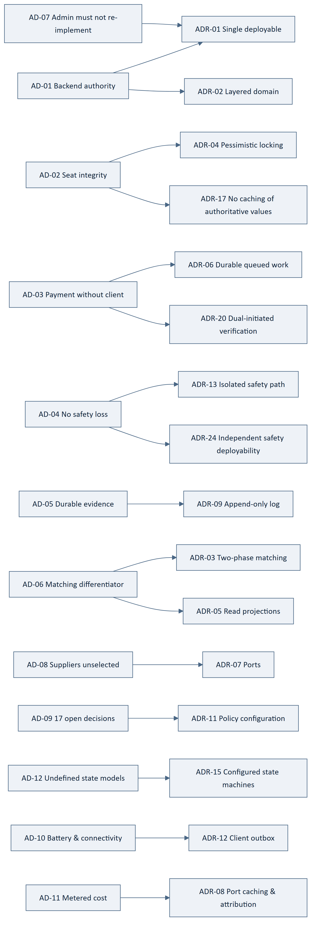
Figure 1 — 4.20 Driver → Decision Map

5. System Context and Container Architecture

5.1 System Context
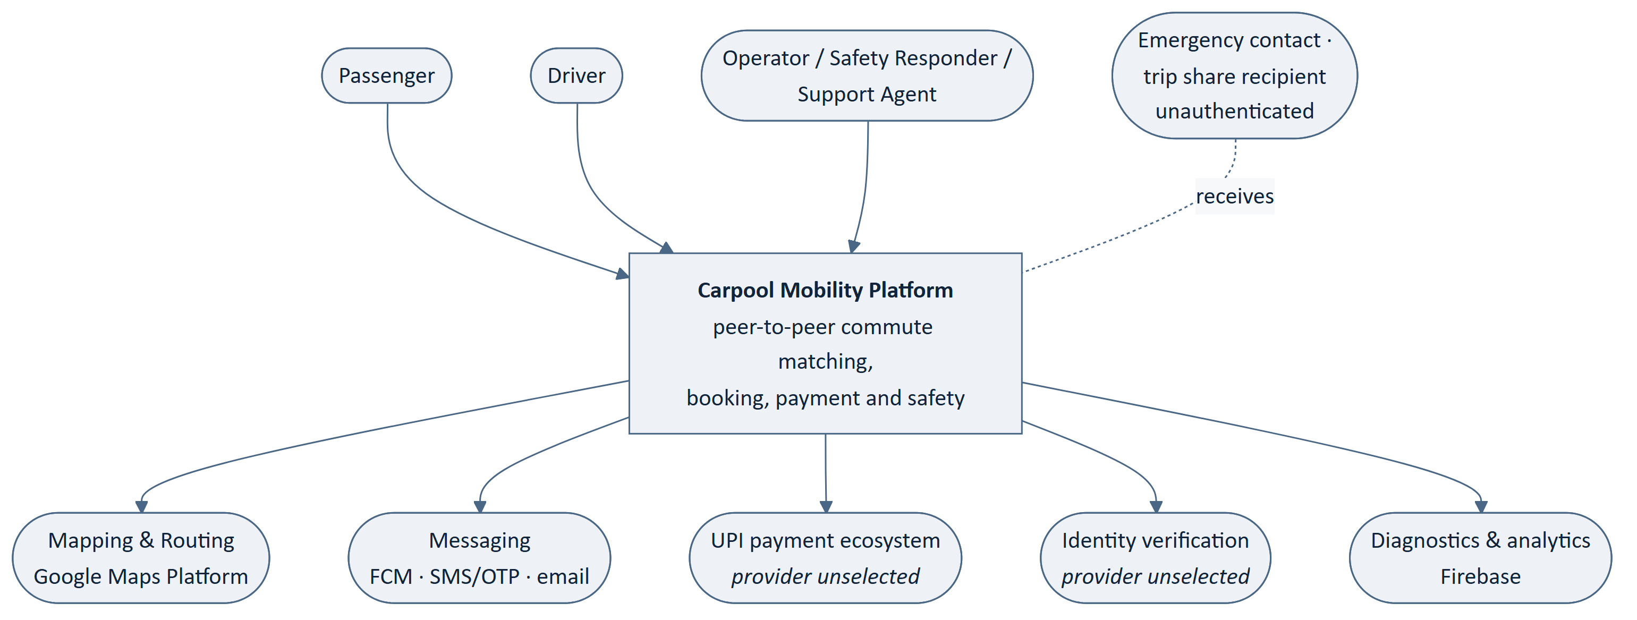
Figure 2 — 5.1 System Context
Table 34 — 5.1 System Context
ID | Architecture Statement | Src
ARCH-001 | The system shall present exactly two human-facing surfaces: the Android client and the administrative interface. | SRS-EL-01, 03
ARCH-002 | The system shall interact with external providers only through the Integration element. | IR-4, ADR-07
ARCH-003 | The system shall expose no interface permitting an external party to alter authoritative state directly. | SRS-REQ-137
ARCH-004 | The system shall treat unauthenticated recipients of shared information as outside its trust boundary. | SRS-REQ-135

5.2 Container View
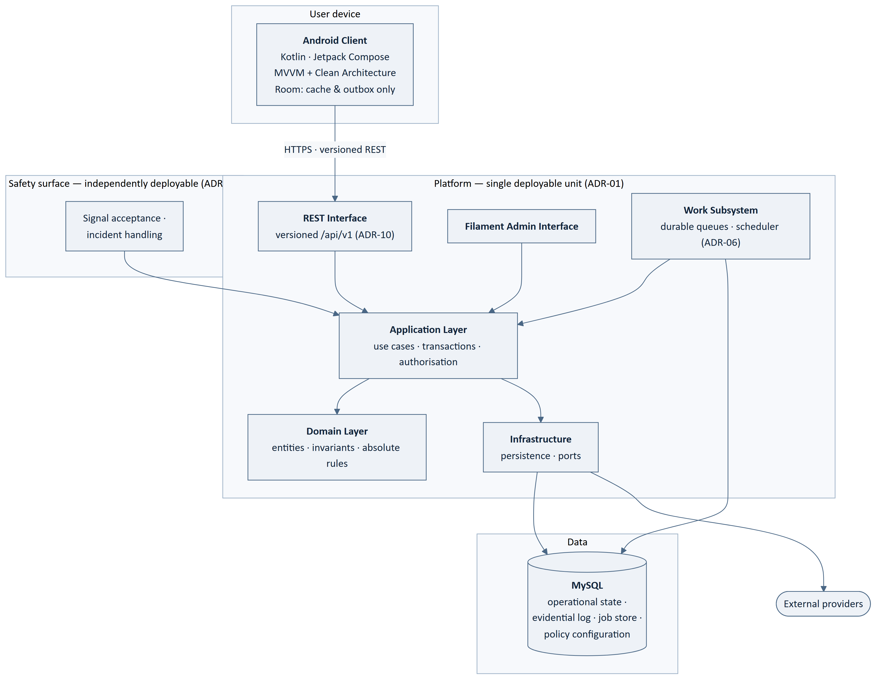
Figure 3 — 5.2 Container View
Table 35 — 5.2 Container View
ID | Architecture Statement | Src
ARCH-005 | The platform shall be realised as a single deployable Laravel application containing both front doors. | ADR-01
ARCH-006 | Both front doors shall reach business state exclusively through the Application layer. | ADR-01, SRS-REQ-069
ARCH-007 | Neither front door shall contain business logic. | SRS-REQ-070, AP-01
ARCH-008 | The Domain layer shall depend on no outward layer. | ADR-02
ARCH-009 | The Android client shall reach the platform only through the versioned REST interface. | SRS-REQ-007
ARCH-010 | No container other than the platform shall reach the database. | SRS-REQ-083, IR-3
ARCH-011 | The work subsystem shall invoke the Application layer, not the Domain or Infrastructure layers directly. | ADR-06, AP-01
ARCH-012 | The safety surface shall be independently deployable and shall share the Application layer, Domain layer and store. | ADR-24
ARCH-013 | The safety surface shall be the only capability permitted independent deployment. | ADR-24
ARCH-014 | MySQL shall hold operational state, the evidential log, the job store and policy configuration. | ADR-06, 09, 11, BAD-CON-005

5.3 Container Responsibilities
Table 36 — 5.3 Container Responsibilities
Container | Holds authoritative state | Makes business decisions | Reaches providers | Independently deployable
Android Client | No | No | Device capability only | n/a
REST Interface | No | No | No | No
Filament Admin Interface | No | No | No | No
Application Layer | No — orchestrates | Enforces via Domain | Via Infrastructure | No
Domain Layer | Yes — invariants | Yes — exclusively | No | No
Infrastructure | Persists | No | Yes — via ports | No
Work Subsystem | No | Via Application | Via Infrastructure | No
Safety Surface | No | Via Application | No | Yes — sole exception
MySQL | Yes — store of record | No | No | n/a

6. Component Architecture
Boundary reminder. This section names components and their obligations. Their internal structure is CMP-DOC-08 (mobile) and CMP-DOC-09 (backend).

6.1 Android Client Components
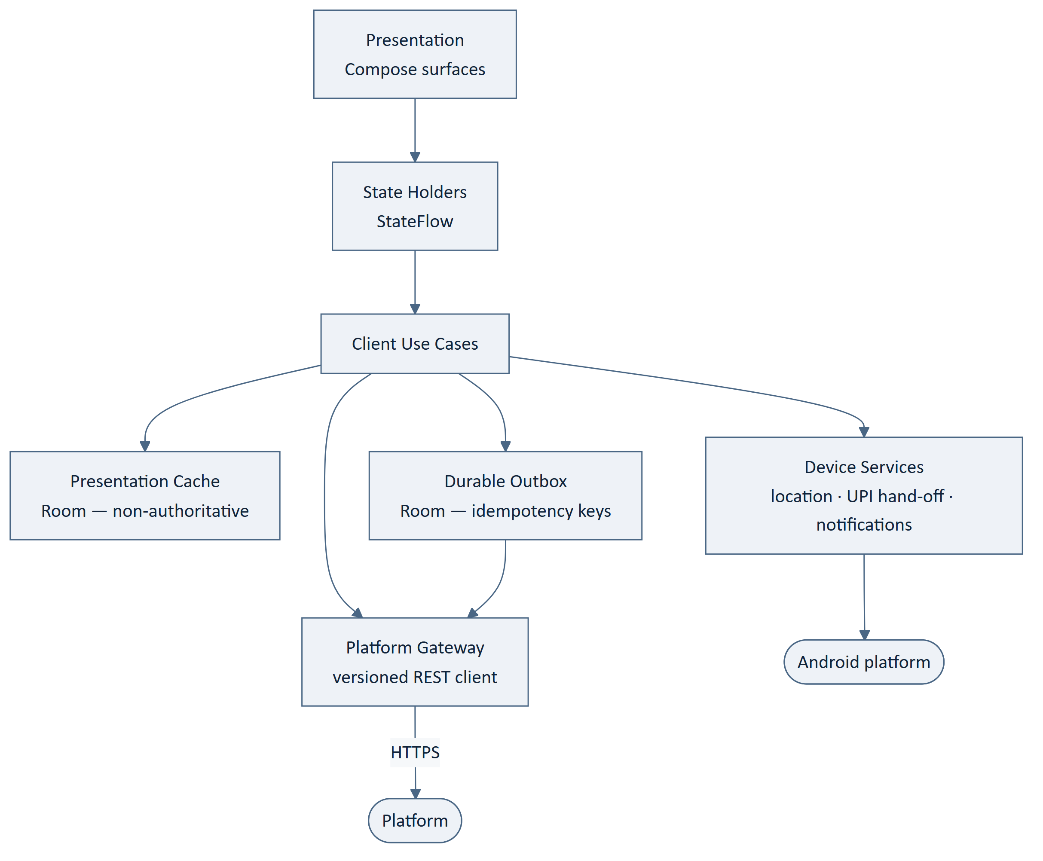
Figure 4 — 6.1 Android Client Components
Table 37 — 6.1 Android Client Components
ID | Architecture Statement | Src
ARCH-015 | The client shall separate presentation, state holding, use-case and gateway concerns. | BAD-CON-001
ARCH-016 | The client shall hold no business rule and shall compute no authoritative value. | SRS-REQ-001, 003
ARCH-017 | The presentation cache shall be marked non-authoritative in every read path. | SRS-REQ-002, 004
ARCH-018 | The client shall discard cached business data on session end. | SRS-REQ-005
ARCH-019 | The client shall re-request rather than reuse any cached value on which a commitment depends. | SRS-REQ-006, ADR-17
ARCH-020 | The durable outbox shall hold user-initiated actions taken without connectivity, each with an idempotency key. | ADR-12, ADR-14
ARCH-021 | The client shall not present an outbox action as complete until the platform confirms it. | SRS-REQ-019
ARCH-022 | Device services shall submit captured location as observation, never as position of record. | ADR-18, SRS-REQ-012
ARCH-023 | Device services shall treat a payment application response as an event to report, never as evidence. | SRS-REQ-013, ADR-20
ARCH-024 | The outbox shall hold no value that the platform treats as authoritative. | SRS-REQ-001, ADR-12
ARCH-025 | The client shall acquire location only while a trip is active, at a platform-supplied cadence. | SRS-REQ-014, ADR-12
ARCH-026 | The client shall not poll the platform on a client-chosen interval. | ADR-12, AD-10
ARCH-027 | The client shall externalise all user-facing text and brand-bearing strings. | SRS-REQ-029, NFR-110
ARCH-028 | The client shall degrade non-essential capability rather than fail on the lowest supported device class. | SRS-REQ-027

6.2 Platform Services Components
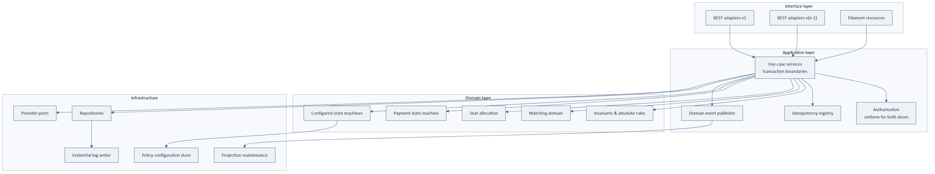
Figure 5 — 6.2 Platform Services Components
Table 38 — 6.2 Platform Services Components
ID | Architecture Statement | Src
ARCH-029 | Interface adapters shall translate between transport representation and application input only. | ADR-02, ADR-10
ARCH-030 | Version-specific adapters shall share one Application layer; the Domain layer shall not be versioned. | ADR-10
ARCH-031 | Authorisation shall be evaluated in the Application layer, identically for both front doors. | ADR-21, SRS-REQ-136
ARCH-032 | Use-case services shall own transaction boundaries; no other layer shall begin a transaction. | ADR-02, ADR-04
ARCH-033 | Absolute business rules shall reside in the Domain layer and shall not be reachable for override. | SRS-REQ-125, NFR-104
ARCH-034 | Each business rule shall be expressed in exactly one Domain component. | SRS-REQ-126, NFR-103
ARCH-035 | Seat allocation shall be a distinct Domain component owning the seat invariant. | ADR-04, AD-02
ARCH-036 | Payment state shall be a distinct Domain component permitting exactly three states. | SRS-REQ-155, 156
ARCH-037 | Configured state machines shall read their definitions from policy configuration and reject unconfigured values. | ADR-15, SRS-REQ-158
ARCH-038 | Invariants that must hold under any state model shall be code, not configuration. | ADR-15, SRS-REQ-159, 160
ARCH-039 | Domain events shall be published only after the producing transaction commits. | ADR-16
ARCH-040 | The idempotency registry shall record every state-changing operation's key and outcome. | ADR-14, SRS-REQ-044
ARCH-041 | The evidential log writer shall be the sole path by which evidential records are created. | ADR-09, SRS-REQ-129
ARCH-042 | Projection maintenance shall be driven by domain events and shall never be authoritative. | ADR-05, ADR-16

6.3 Administrative Interface Components
Table 39 — 6.3 Administrative Interface Components
ID | Architecture Statement | Src
ARCH-043 | Administrative resources shall invoke the same use-case services as the REST interface. | ADR-01, SRS-REQ-069
ARCH-044 | Administrative resources shall implement no business rule and no validation that substitutes for a Domain rule. | SRS-REQ-070
ARCH-045 | Administrative access shall be restricted by administrative role in the Application layer. | SRS-REQ-075, ADR-21
ARCH-046 | Every administrative action shall carry the acting operator's identity into the Application layer. | SRS-REQ-073
ARCH-047 | Administrative reads shall be served from projections, never from the evidential log or live transactional tables. | ADR-22
ARCH-048 | The administrative interface shall present a measure as unavailable where its behaviour is unimplemented. | SRS-REQ-079
ARCH-049 | Operator queues — reconciliation, safety, verification, moderation — shall each expose depth and oldest-item age. | SRS-REQ-078, NFR-121

6.4 Persistence Components
Table 40 — 6.4 Persistence Components
ID | Architecture Statement | Src
ARCH-050 | Operational state, the evidential log, the job store, the idempotency registry, projections and policy configuration shall be logically distinct within MySQL. | ADR-06, 09, 11, 14
ARCH-051 | Route geometry shall be resolved once at publication and stored with the ride. | ADR-03, AD-11
ARCH-052 | Ride routes shall be held in a spatially indexed representation supporting the coarse filter. | ADR-03
ARCH-053 | The seat allocation record shall be lockable independently of other ride attributes. | ADR-04
ARCH-054 | Evidential records shall be append-only, carrying a chained integrity value. | ADR-09
ARCH-055 | Projection staleness shall be bounded and the bound shall be configurable. | ADR-05, ADR-11
ARCH-056 | Seat availability shall never be served from a projection. | ADR-05, ADR-17, FRD-FR-084
ARCH-057 | A completed trip record shall capture referenced entity values as at the time of travel. | SRS-REQ-088, 089
ARCH-058 | Retention removal shall operate on personal data while preserving the evidential skeleton of records shared with another party. | ADR-09, SRS-REQ-091
ARCH-059 | Identity evidence and payment-related data shall be held in protected form; mechanism deferred to CMP-DOC-13. | SRS-REQ-097
ARCH-060 | Authentication credentials shall be held in non-recoverable form; mechanism deferred to CMP-DOC-13. | SRS-REQ-098

6.5 Integration Components
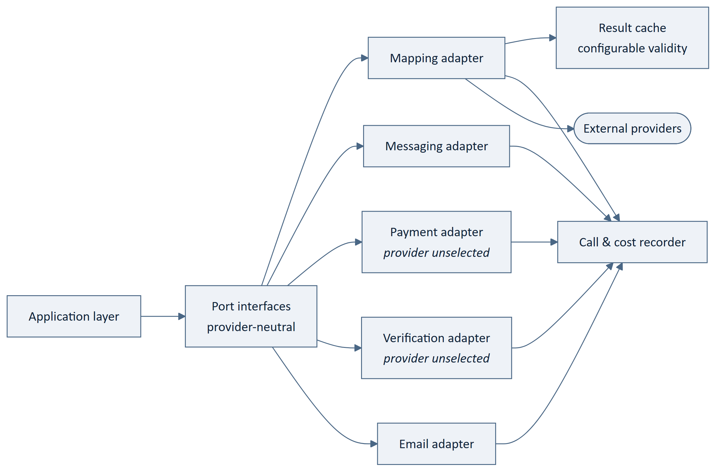
Figure 6 — 6.5 Integration Components
Table 41 — 6.5 Integration Components
ID | Architecture Statement | Src
ARCH-061 | Each external capability shall be defined as a port in provider-neutral terms. | ADR-07, SRS-REQ-109
ARCH-062 | No external call shall occur inside a database transaction. | ADR-04, AD-02
ARCH-063 | No provider name, type or error shall appear above the port boundary. | ADR-07, SRS-REQ-108
ARCH-064 | Each adapter shall validate a provider response for plausibility before returning it. | SRS-REQ-105
ARCH-065 | Each adapter shall return outcomes distinguishing reported, verified and unknown. | SRS-REQ-106, 113
ARCH-066 | No adapter shall synthesise, default or infer a result a provider did not return. | SRS-REQ-113, AP-09
ARCH-067 | Each adapter shall record every call, its outcome and its attributable cost. | ADR-08, SRS-REQ-116
ARCH-068 | Result caching shall apply only to stable results and shall never cache authoritative platform state. | ADR-08, ADR-17
ARCH-069 | Cache validity periods and call cadences shall be policy configuration. | ADR-08, ADR-11
ARCH-070 | Provider unavailability shall be reported upward, never substituted by a result. | SRS-REQ-112, AP-09

6.6 Work Subsystem Components
Table 42 — 6.6 Work Subsystem Components
ID | Architecture Statement | Src
ARCH-071 | Every queued job shall be idempotent and safely re-runnable. | ADR-06, ADR-14
ARCH-072 | Payment verification shall run as a queued job initiated by the platform, independent of any client. | ADR-06, ADR-20, FRD-FR-126
ARCH-073 | The platform shall re-attempt payment verification on its own schedule, bounded and recorded. | SRS-REQ-168, 169
ARCH-074 | Safety work shall run on a dedicated queue with priority over all other work. | ADR-13, SRS-REQ-060
ARCH-075 | Notification issue, projection maintenance, reconciliation ageing and scheduled generation shall be queued work. | ADR-06
ARCH-076 | Deferred work shall survive platform restart without loss. | SRS-REQ-048, NFR-037
ARCH-077 | Job failure shall be bounded by attempt count, with exhaustion recorded rather than retried indefinitely. | SRS-REQ-169

6.7 Component Count
Table 43 — 6.7 Component Count
Element | Components
Android Client | 6
Platform Services | 14
Administrative Interface | 3
Persistence | 6
Integration | 7 (5 adapters + cache + meter)
Work Subsystem | 5 job families
Total | 31 named + 10 supporting

7. Runtime Architecture
Five scenarios are modelled: those that stress the architecture, not those that exercise the most requirements.

7.1 Search and Route-Overlap Matching
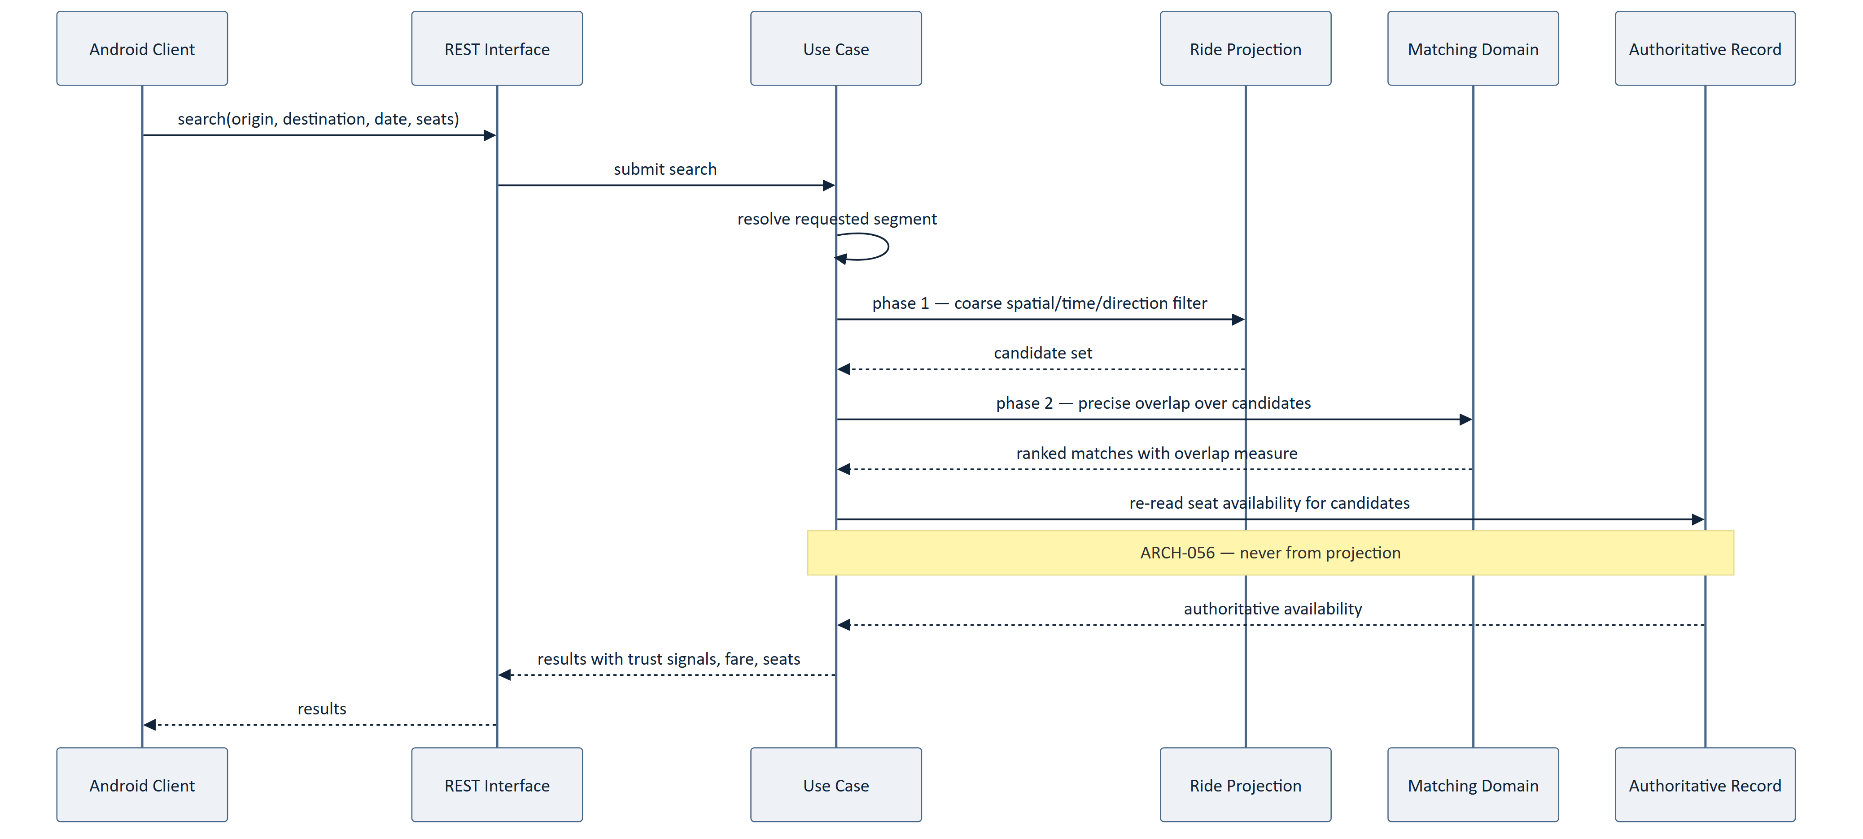
Figure 7 — 7.1 Search and Route-Overlap Matching
Table 44 — 7.1 Search and Route-Overlap Matching
ID | Architecture Statement | Src
ARCH-078 | Search shall resolve the requested segment before any candidate evaluation. | ADR-03
ARCH-079 | Phase 1 shall narrow candidates before any precise geometry is computed. | ADR-03, NFR-043
ARCH-080 | Seat availability presented in results shall be read from the authoritative record. | ARCH-056, FRD-FR-084
ARCH-081 | A search returning no candidate shall not incur precise-overlap computation. | NFR-148, AD-11
ARCH-082 | Search shall be withdrawn, not degraded, when route resolution is unavailable. | AP-09, FRD-FR-096

7.2 Request, Payment and Booking Confirmation
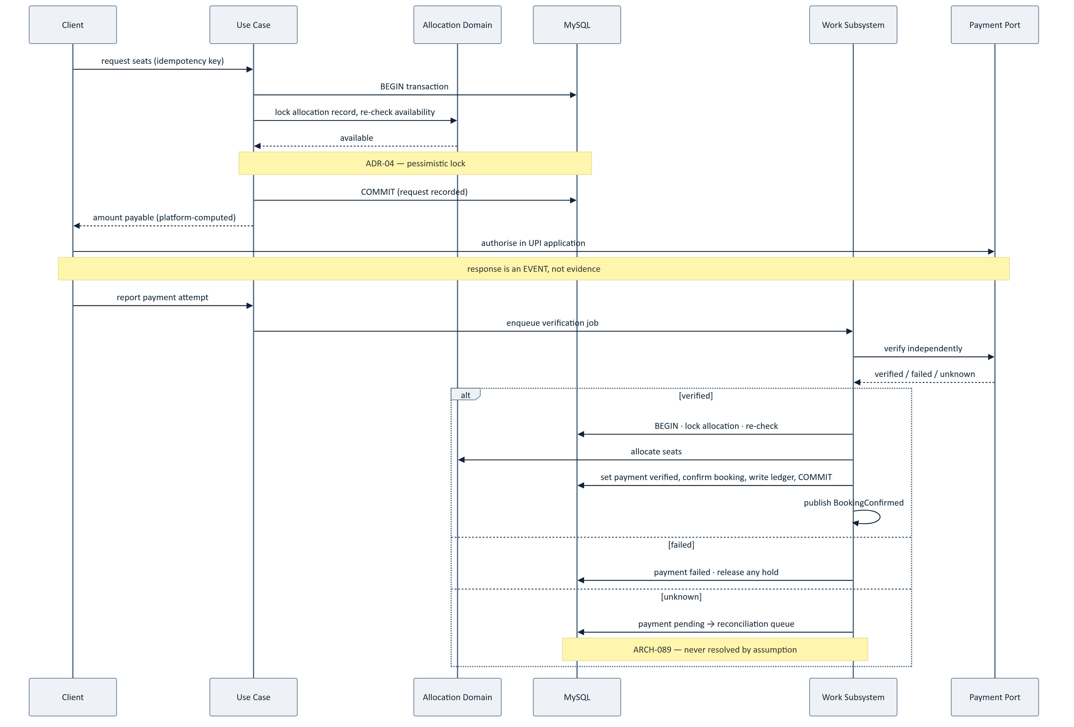
Figure 8 — 7.2 Request, Payment and Booking Confirmation
Table 45 — 7.2 Request, Payment and Booking Confirmation
ID | Architecture Statement | Src
ARCH-083 | The amount payable shall be computed by the platform and never accepted from a client. | FRD-FR-117, 118
ARCH-084 | A client-reported payment outcome shall enqueue verification, never set payment status. | ADR-20, FRD-FR-124
ARCH-085 | Verification shall proceed on the platform's schedule irrespective of client return. | ADR-06, FRD-FR-126
ARCH-086 | Seat availability shall be re-checked under lock at confirmation, not only at request. | ADR-04, FRD-FR-105
ARCH-087 | Payment verification, seat allocation, booking confirmation and the ledger entry shall commit in one transaction. | SRS-REQ-040, 041
ARCH-088 | No external call shall occur within that transaction. | ARCH-062
ARCH-089 | An indeterminate verification shall set pending and route to reconciliation, never resolve by assumption. | FRD-FR-130, 131
ARCH-090 | Seats shall be released when verification fails. | FRD-FR-109

7.3 Active Trip and Position Reporting
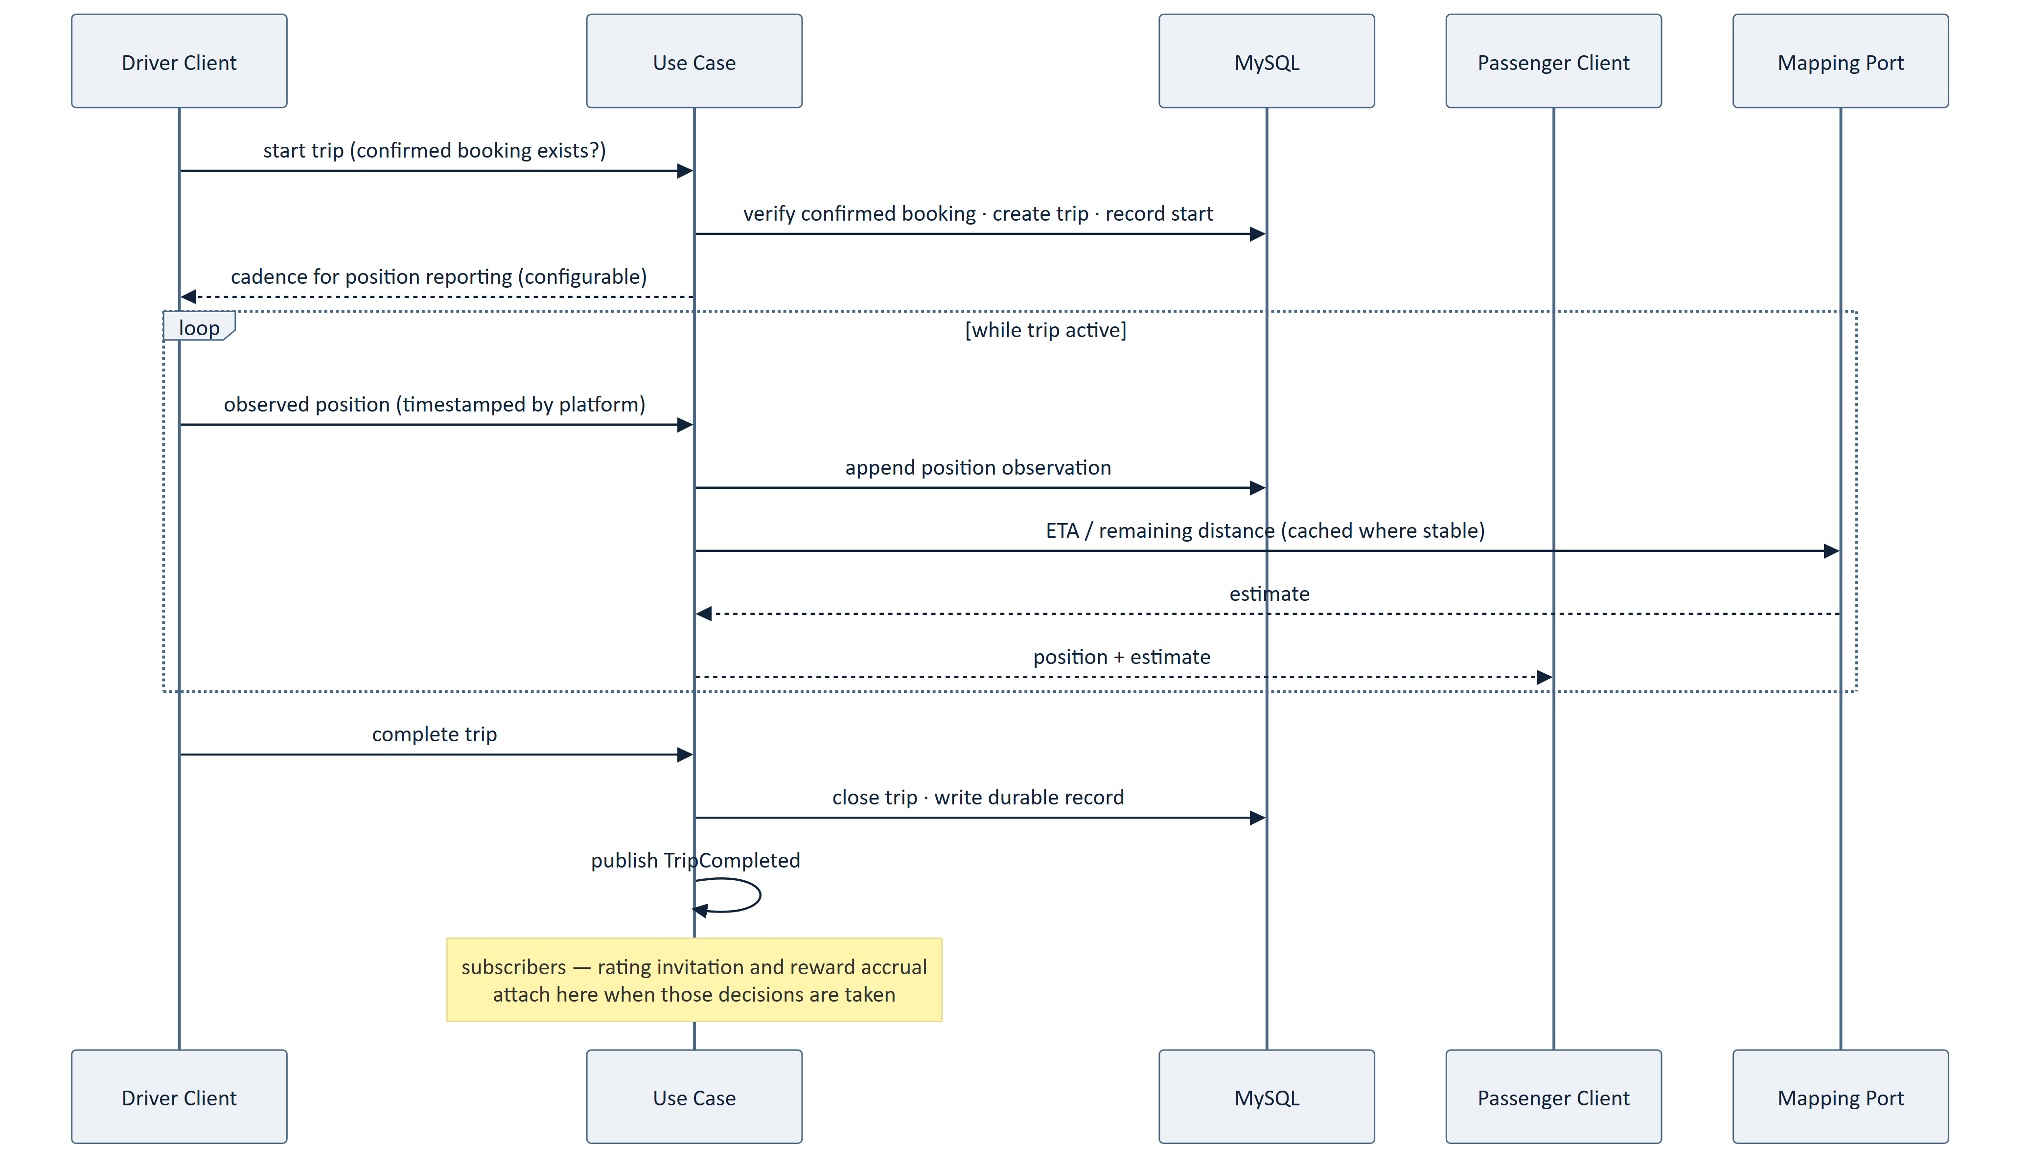
Figure 9 — 7.3 Active Trip and Position Reporting
Table 46 — 7.3 Active Trip and Position Reporting
ID | Architecture Statement | Src
ARCH-091 | A trip shall not start without a confirmed booking, irrespective of the eventual state model. | SRS-REQ-159
ARCH-092 | The platform shall timestamp position observations; client timestamps shall not be authoritative. | ADR-18
ARCH-093 | Position reporting cadence shall be supplied by the platform and configurable. | ADR-12, NFR-147
ARCH-094 | A position shall not be presented as current beyond its configured staleness bound. | NFR-012, FRD-FR-150
ARCH-095 | Trip completion shall write its durable record before the trip is reported complete. | FRD-FR-167
ARCH-096 | Amending a ride shall invalidate its cached route geometry. | ADR-08
ARCH-097 | TripCompleted shall be published as a domain event with no compile-time dependency on its subscribers. | ADR-16

7.4 Safety Signal
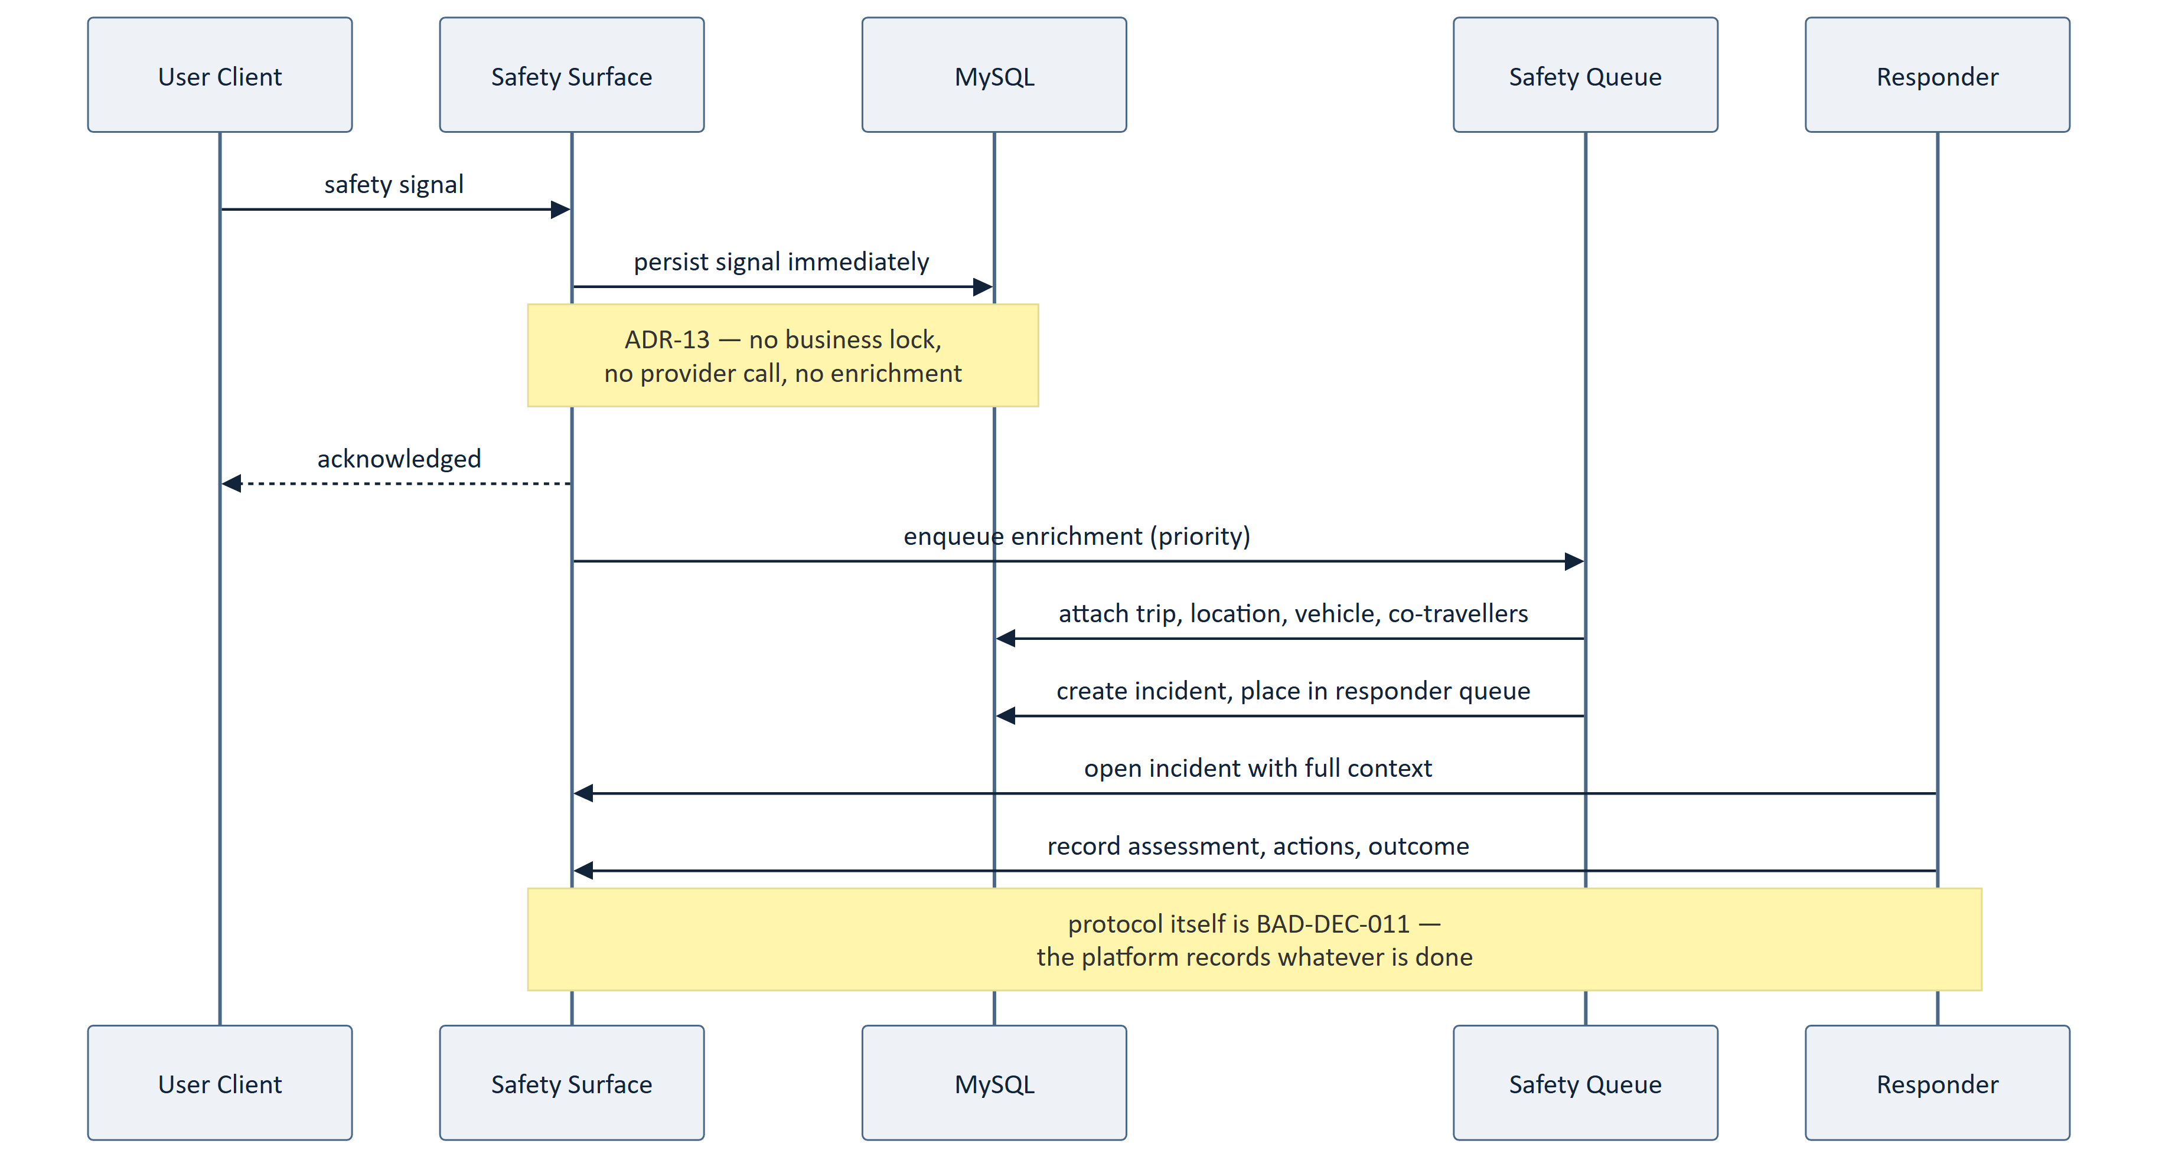
Figure 10 — 7.4 Safety Signal
Table 47 — 7.4 Safety Signal
ID | Architecture Statement | Src
ARCH-098 | A safety signal shall be persisted before any enrichment or routing. | ADR-13, AP-05
ARCH-099 | Safety signal acceptance shall acquire no business lock and call no external provider. | ADR-13
ARCH-100 | Safety signal acceptance shall remain available when other capability is unavailable. | ADR-24, SRS-REQ-082
ARCH-101 | An incident shall be created with partial context rather than rejected. | FRD-FR-187, SRS-REQ-059
ARCH-102 | Enrichment failure shall not discard a signal; the signal shall be retried until recorded and queued. | SRS-REQ-057, NFR-075
ARCH-103 | Safety notifications shall bypass user notification preferences. | SRS-REQ-062, NFR-076

7.5 Degraded Operation
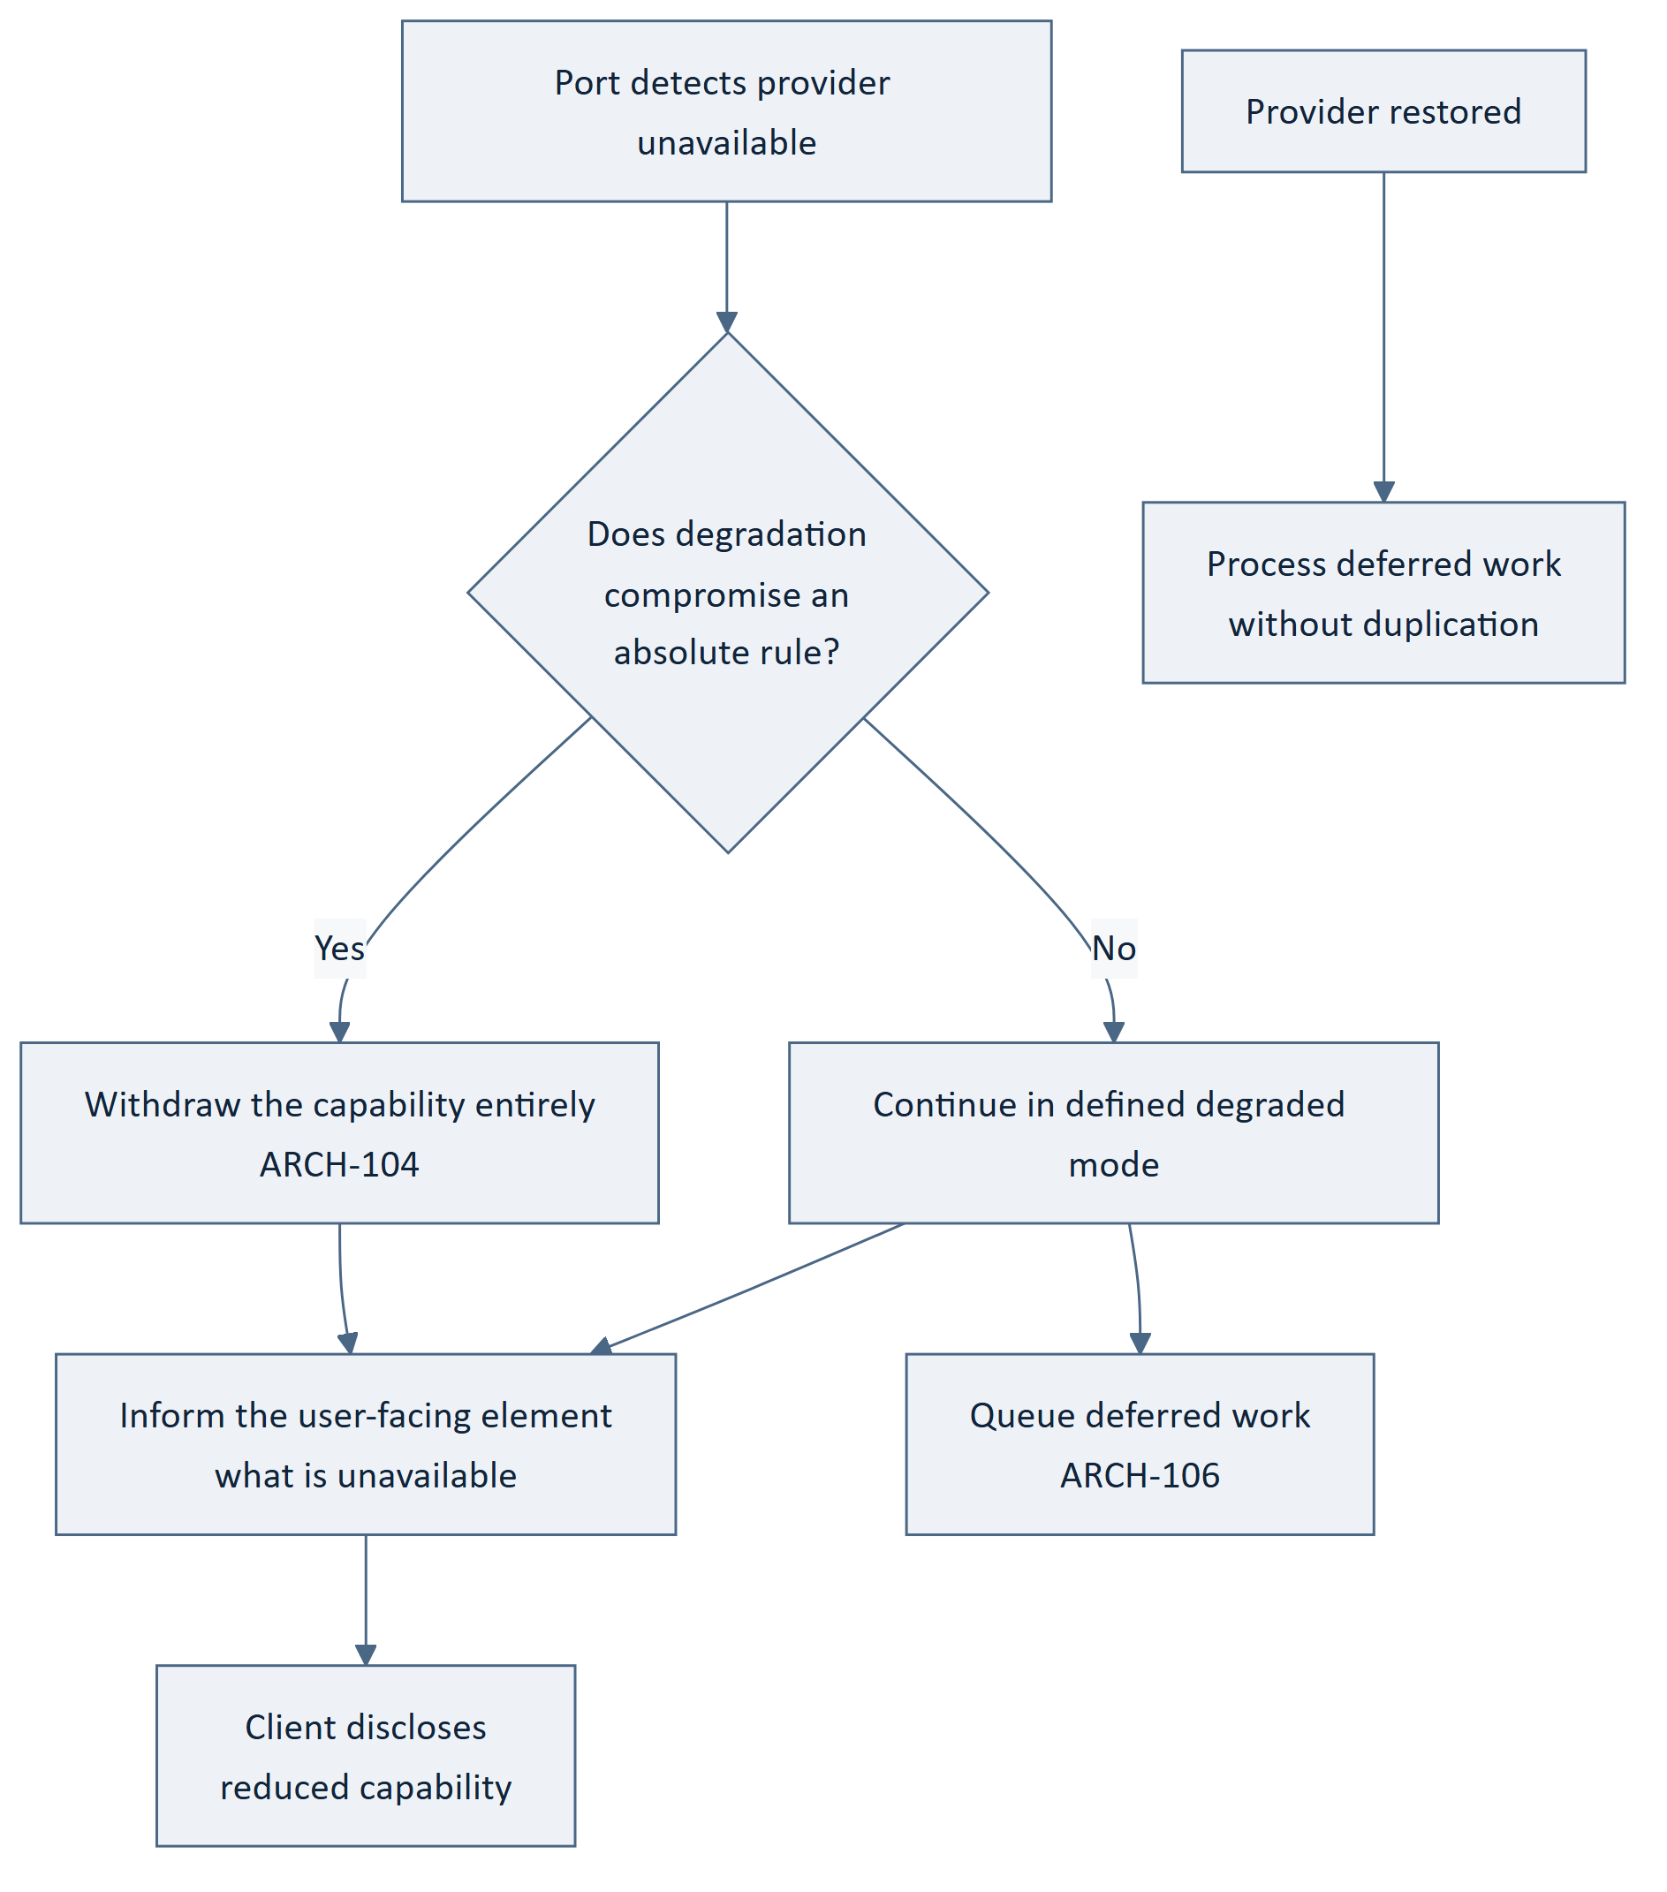
Figure 11 — 7.5 Degraded Operation
Table 48 — 7.5 Degraded Operation
ID | Architecture Statement | Src
ARCH-104 | A capability whose degradation would compromise an absolute rule shall be withdrawn entirely. | SRS-REQ-132, NFR-035
ARCH-105 | Degraded state shall be propagated to the user-facing element for disclosure. | SRS-REQ-133
ARCH-106 | Work deferred by provider unavailability shall be queued and processed on restoration without duplication. | SRS-REQ-114, ADR-14
ARCH-107 | An active trip shall survive the unavailability of any single supporting service. | SRS-REQ-134, NFR-025
ARCH-108 | Payment shall not be initiated when the payment ecosystem is unavailable. | FRD-FR-137
ARCH-109 | Search shall be withdrawn when route resolution is unavailable, rather than return unranked results. | FRD-FR-096, AP-09

8. Data Architecture
Boundary. Logical data architecture only. Tables, columns, keys, indexes and migrations are CMP-DOC-11's.

8.1 The Five Data Categories
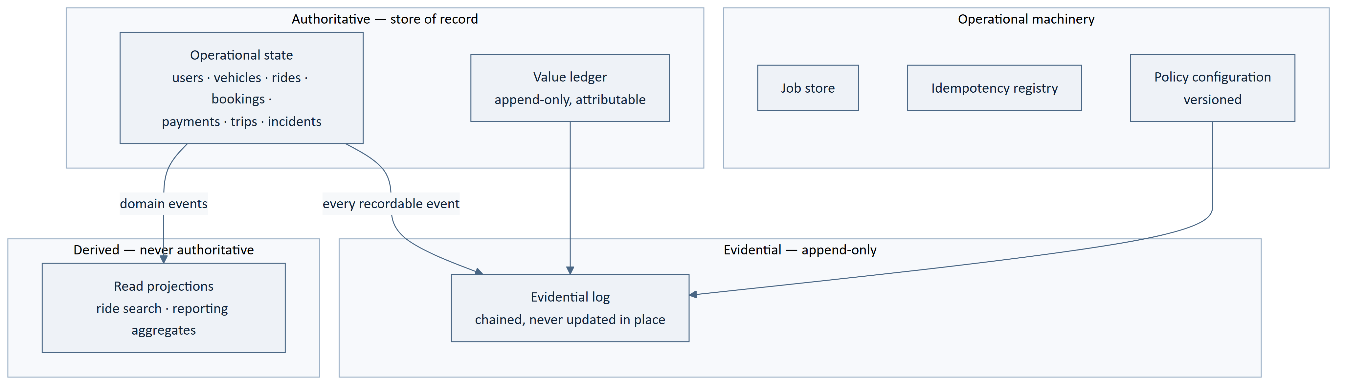
Figure 12 — 8.1 The Five Data Categories
Table 49 — 8.1 The Five Data Categories
ID | Architecture Statement | Src
ARCH-110 | Authoritative state, evidential records, derived projections and operational machinery shall be logically distinct. | ADR-05, 09
ARCH-111 | Balances shall be derived from ledger entries and never stored independently of them. | SRS-REQ-087, NFR-127
ARCH-112 | Every ledger entry shall be attributable to a party and an event. | SRS-REQ-086, NFR-128
ARCH-113 | Projections shall be rebuildable from authoritative state without loss. | ADR-05
ARCH-114 | Loss of a projection shall degrade performance, never correctness. | ADR-05, AP-08
ARCH-115 | Policy configuration changes shall be evidential records. | ADR-11, SRS-REQ-183

8.2 Consistency Model
Table 50 — 8.2 Consistency Model
Data | Consistency | Rationale
Seat allocation | Strong, serialised | AD-02 admits nothing weaker
Payment status | Strong | BAD-RULE-033
Booking confirmation | Strong, same transaction as allocation and ledger | SRS-REQ-040, 041
Evidential log | Strong, append-only | AD-05
Ride search projection | Bounded staleness, configurable | ADR-05 — never used for availability
Reporting aggregates | Eventually consistent | Not decision-bearing
Position observations | Append-only, no update | ADR-18

The single most important line in this section: the search projection may be stale, and seat availability is never read from it (ARCH-056). Staleness is acceptable for what is on offer; it is not acceptable for what remains.

8.3 Data Lifecycle and Retention
Table 51 — 8.3 Data Lifecycle and Retention
ID | Architecture Statement | Src
ARCH-116 | Personal data shall be separable from the evidential skeleton of a shared record. | SRS-REQ-091, NFR-132
ARCH-117 | Retention removal shall not break the integrity chain of the evidential log. | ADR-09
ARCH-118 | Retention periods shall be policy configuration per data category. | SRS-REQ-178, ADR-11
ARCH-119 | Position history shall be retained separately from trip records so that it can be removed independently. | BRD-DATA-009, NFR-131

`ARCH-116` and `ARCH-119` are the architectural answer to `FRD-GAP-028`. A trip record is evidence for every participant; a position track is largely evidence about one. Separating them means retention can remove the latter without destroying the former — which is what NFR-132 requires and what any workable BAD-DEC-021 will need.

9. Integration Architecture

9.1 External Interface Shape
Table 52 — 9.1 External Interface Shape
ID | Architecture Statement | Src
ARCH-120 | The platform shall expose one versioned REST interface for client elements. | BAD-CON-007, ADR-10
ARCH-121 | The interface shall carry no operation permitting direct assignment of authoritative state. | SRS-REQ-137
ARCH-122 | The interface shall distinguish a business refusal from a platform fault from provider unavailability. | SRS-REQ-139, 161
ARCH-123 | The interface shall identify its version in a form the client can act upon. | SRS-REQ-138
ARCH-124 | The interface shall accept an idempotency key on every state-changing operation. | ADR-14
ARCH-125 | The interface shall disclose to a caller only what that caller's actor is entitled to. | SRS-REQ-141

9.2 Provider Ports
Table 53 — 9.2 Provider Ports
Port | Capability | Provider status | Cacheable
Mapping & Routing | Place resolution, route geometry, ETA and distance | Google Maps Platform (direction approved) | Yes — geometry is stable
Messaging | Push notification, OTP channel | Firebase / [TBD] for OTP | No
Payment | Initiation and independent verification | Unselected — BAD-DEP-004 | Never
Identity Verification | Evidence assessment | Unselected — BAD-DEP-005 | No
Transactional Email | Outbound email | Unselected — BAD-DEP-007 | No

Table 54 — 9.2 Provider Ports
ID | Architecture Statement | Src
ARCH-126 | Payment verification outcomes shall never be cached. | ADR-08, ADR-17
ARCH-127 | The payment port shall support platform-initiated verification independent of provider callback. | ADR-20, SRS-REQ-142
ARCH-128 | A provider callback shall be treated as a trigger to verify, never as the verification. | SRS-REQ-143, FRD-FR-124
ARCH-129 | Each port shall bound its wait and its retry behaviour. | SRS-REQ-144, 115
ARCH-130 | Port contracts shall be expressible without reference to any named provider. | SRS-REQ-108, 109

`ARCH-128` matters more than its length suggests. A callback endpoint is externally reachable and its authenticity depends on a provider's implementation. By making a callback only a trigger to run the platform's own verification, the architecture is unaffected by a forged or replayed callback. This is BAD-RULE-032 holding at the integration boundary.

10. Security Architecture
Boundary. Structure and trust boundaries only. Controls, algorithms, key handling and the threat model are CMP-DOC-13's.

10.1 Trust Boundary Realisation
Table 55 — 10.1 Trust Boundary Realisation
Boundary | Realised by | Architecture statements
TB-1 Client → Platform | Versioned REST interface; all input validated in the Application layer; no operation assigns authoritative state | ARCH-121, 125, 131
TB-2 Admin → Platform | Same Application layer, same authorisation evaluation, operator identity carried through | ARCH-043, 045, 046, 132
TB-3 Integration → Platform | Ports normalise outcomes; adapters validate plausibility; reported never becomes true | ARCH-064, 065, 066, 128
TB-4 Platform → Persistence | Repositories are the sole access path; evidential writes go through one writer | ARCH-010, 041

Table 56 — 10.1 Trust Boundary Realisation
ID | Architecture Statement | Src
ARCH-131 | Every inbound value shall be validated against platform state before use, irrespective of origin. | SRS-REQ-032, AP-02
ARCH-132 | Administrative requests shall receive validation identical to client requests. | SRS-REQ-136, ADR-21
ARCH-133 | An attempt to assert authoritative state shall be rejected in whole and recorded as an integrity event. | SRS-REQ-036, 037
ARCH-134 | Authorisation shall be deny-by-default. | NFR-058, AP-02
ARCH-135 | Refused authorisations shall be recorded. | SRS-REQ-074, NFR-060
ARCH-136 | Diagnostic records shall exclude personal data beyond their purpose. | SRS-REQ-130, NFR-123
ARCH-137 | Information shared with an unauthenticated recipient shall be bounded and time-limited by policy configuration. | SRS-REQ-135, ADR-11

10.2 Security Concerns Deferred to CMP-DOC-13
Table 57 — 10.2 Security Concerns Deferred to CMP-DOC-13
Concern | Why deferred
Credential storage mechanism | ARCH-060 states the property; the mechanism is a security design choice
Evidential chaining algorithm and key handling | ARCH-054 states the property; the cryptography is CMP-DOC-13's
Transport protection specifics | Property stated by NFR-062
Session lifetime and rotation | NFR-055 [TBD-TECH]
Rate limiting thresholds | NFR-056, 057 [TBD-TECH]
Fraud detection and response | Unowned — `GAP-013`. No element assigned; see ARCH-OQ-007

11. Deployment Architecture
Hosting is unselected (`BAD-DEP-009`) and no capacity target exists (`BAD-DEC-018`). This section therefore specifies logical deployment topology and its constraints, not physical infrastructure, instance counts or service tiers. Those are CMP-DOC-19's, and cannot be settled until sizing is possible.

11.1 Logical Topology
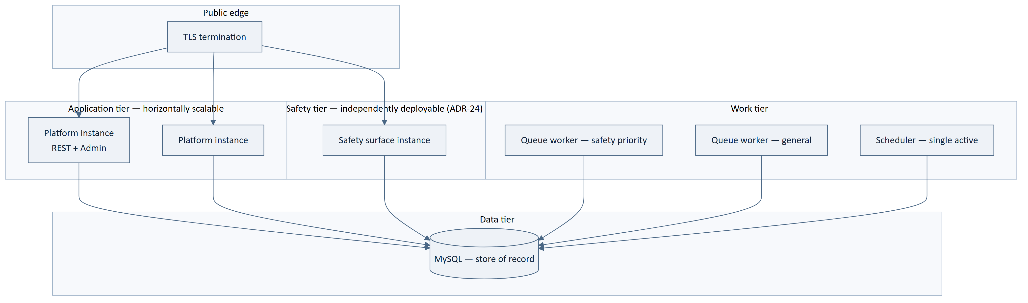
Figure 13 — 11.1 Logical Topology
Table 58 — 11.1 Logical Topology
ID | Architecture Statement | Src | Sizing
ARCH-138 | The application tier shall be stateless between requests, permitting horizontal scaling. | NFR-041, 051 | [SIZING]
ARCH-139 | Session state shall not be held in application-instance memory. | ARCH-138 | —
ARCH-140 | The scheduler shall have exactly one active instance to prevent duplicate triggering. | ADR-06 | —
ARCH-141 | Queue workers shall be scalable independently of the application tier. | ADR-06 | [SIZING]
ARCH-142 | Safety-priority workers shall be separable from general workers. | ADR-13, ARCH-074 | [SIZING]
ARCH-143 | The safety surface shall be deployable and restartable without restarting the application tier. | ADR-24 | —
ARCH-144 | The data tier shall support the recovery objectives once set. | NFR-038, 039 | `[SIZING]`

11.2 Sizing Decisions Deferred to CMP-DOC-19
Table 59 — 11.2 Sizing Decisions Deferred to CMP-DOC-19
# | Decision | Blocked by
1 | Application tier instance count and scaling trigger | NFR-041, 042
2 | Worker pool sizes, general and safety | NFR-072, 073
3 | Database tier and capacity | NFR-041–050
4 | Redundancy topology for the availability target | NFR-023
5 | Backup frequency and retention for the recovery objectives | NFR-038, 039
6 | Read-replica strategy for projections | NFR-048
7 | Evidential log growth provisioning | ADR-09, NFR-050
8 | Cost ceiling and alerting thresholds | NFR-145, 149
9 | Environment count and promotion path | NFR-108
10 | Hosting provider | BAD-DEP-009
11 | Whether the safety surface requires separate infrastructure or only separate deployment | ARCH-OQ-006

Eleven sizing decisions. All eleven trace to `BAD-DEC-018` or an unselected supplier.

12. Cross-Cutting Architecture

12.1 Configuration
Table 60 — 12.1 Configuration
ID | Architecture Statement | Src
ARCH-145 | Deployment configuration shall be supplied at deploy time, outside the artefact, and shall not be runtime-editable. | ADR-11, NFR-108
ARCH-146 | Policy configuration shall be versioned records, runtime-editable by an authorised operator, every change audited. | ADR-11, SRS-REQ-183
ARCH-147 | No configuration of either kind shall alter behaviour fixed by an absolute business rule. | SRS-REQ-182, ADR-11
ARCH-148 | Policy configuration shall be validated on change, and an invalid configuration shall be rejected rather than applied. | ADR-15

12.2 Audit, Observability and Error Handling
Table 61 — 12.2 Audit, Observability and Error Handling
Concern | Architectural realisation
Audit | Universal domain-event subscriber writing to the evidential log (ADR-09, ADR-16); no component writes audit records directly (ARCH-041).
Observability | Call and cost recording at the port boundary (ARCH-067); queue depth and oldest-item age exposed per queue (ARCH-049); the four R1 measures instrumented from first release (NFR-113–115, 150).
Error taxonomy | Four classes — caller error, business refusal, platform fault, provider unavailability — distinguished at the interface (ARCH-122) and never conflated (SRS-REQ-163).
Structural enforcement | Build-time checks for layer dependency direction, absence of provider types above ports, and absence of business logic in front doors (ADR-23).

12.3 How the Reserved Areas Attach
Table 62 — 12.3 How the Reserved Areas Attach
Reserved area | Attaches as | Requires no structural change because
Ratings & Reviews | Subscriber to TripCompleted; reputation read via projection | ADR-16 decouples publisher from subscriber; ADR-05 already provides projections
Wallet & Rewards | Subscriber to TripCompleted and payment events; balance derived from the existing ledger | ARCH-111/112 already require an attributable ledger
Recurring Commute | Scheduled job generating rides through the existing publication use case | ADR-06 already provides durable scheduled work

This is the payoff of `AP-10`. Three undecided product areas attach to machinery the architecture already requires for other reasons. None of them will force a structural change when its decision is taken.

13. Technology Mapping
Table 63 — 13. Technology Mapping
Architectural element | Technology | Status
Android client | Kotlin, Jetpack Compose, MVVM + Clean Architecture, StateFlow, Coroutines | Approved direction
Client cache and outbox | Room — non-authoritative only | Approved direction
Device location | Android Fused Location Provider | Approved direction
Platform application | Laravel | Approved direction
Administrative interface | Laravel Filament, same deployable | Approved direction + ADR-01
Interface style | REST / JSON, versioned at /api/v1/ | Approved direction + ADR-10
Store of record, evidential log, job store, policy store | MySQL | Approved direction + ADR-06, 09, 11
Spatial indexing for phase-1 matching | MySQL spatial capability | ADR-03 — architecture decision
Work subsystem | Laravel queues and scheduler, MySQL-backed | ADR-06 — architecture decision
Mapping and routing | Google Maps Platform | Approved direction
Push, diagnostics, analytics | Firebase — FCM, Crashlytics, Performance, Analytics | Approved direction
Payment | Indian UPI ecosystem | Approved direction; provider unselected
Identity verification | — | Unselected
Hosting | — | Unselected
Excluded throughout | Supabase · PostgreSQL · Spring Boot | Excluded by `BAD-CON-008`

No technology appears in this architecture that is not either an approved direction or an architecture decision recorded in §4. The three unselected items sit behind ports and are not structural.

14. Architecture Evaluation

14.1 Evaluation Against the Drivers
Table 64 — 14.1 Evaluation Against the Drivers
Driver | Satisfied by | Assessment
AD-01 Backend authority | ADR-01, ADR-02, ARCH-006–008, 033 | Satisfied structurally. One domain layer; both front doors pass through it; enforced at build time (ADR-23).
AD-02 Seat integrity | ADR-04, ARCH-035, 053, 086, 087 | Satisfied. Invariant enforced by lock and constraint. Throughput cost accepted.
AD-03 Payment without client | ADR-06, ADR-20, ARCH-072, 085 | Satisfied. Verification is queued work on the platform's own schedule.
AD-04 No safety loss | ADR-13, ADR-24, ARCH-098–102 | Satisfied structurally. Capture precedes processing; path takes no lock; independently deployable.
AD-05 Durable evidence | ADR-09, ARCH-041, 054, 116 | Satisfied structurally. Mechanism for chaining deferred to CMP-DOC-13.
AD-06 Matching differentiator | ADR-03, ADR-05, ARCH-051, 079 | Partially validated. Structure is sound; phase-1 selectivity is unmeasured (ARCH-RISK-004).
AD-07 Admin must not re-implement | ADR-01, ARCH-043, 044, ADR-23 | Satisfied structurally and enforced at build time.
AD-08 Suppliers replaceable | ADR-07, ARCH-061–063, 130 | Satisfied. No provider type above the port.
AD-09 Open decisions arrive as values | ADR-11, ARCH-145–148 | Satisfied. Two configuration kinds, absolute rules excluded from both.
AD-10 Battery and connectivity | ADR-12, ARCH-020, 025, 026, 093 | Satisfied. Server-driven cadence; durable outbox; no client polling.
AD-11 Metered cost | ADR-08, ARCH-051, 067, 081 | Satisfied. One choke point; geometry resolved once; zero-result path bounded.
AD-12 Undefined state models | ADR-15, ARCH-037, 038 | Satisfied. Definitions configurable; invariants remain code.

**Ten of twelve drivers are satisfied structurally. AD-06 awaits measurement.
AD-02 is satisfied at a deliberate throughput cost.**

14.2 Evaluation Against Absolute Rules
Table 65 — 14.2 Evaluation Against Absolute Rules
Absolute rule | Architectural guarantee
BAD-RULE-002 Backend authority | ARCH-006–008; build-time dependency check
BAD-RULE-003 No direct client-to-database | ARCH-009, 010
BAD-RULE-026/027 Seat integrity | ADR-04; lock plus database constraint
BAD-RULE-028 Booking confirmed only by platform | ARCH-087 — one transaction
BAD-RULE-032 Client UPI response never proof | ARCH-084, 128
BAD-RULE-033 Payment status only by verification | ARCH-036, 085, 089
BAD-RULE-034 Fare computed by platform | ARCH-083
BAD-RULE-041 Safety signals recorded | ARCH-098, 102
BAD-RULE-006 Verification backend-held | ARCH-033
BAD-RULE-001 Peer, not professional | No dispatch or assignment component exists anywhere in the architecture

All ten absolute rules have a named architectural guarantee.

14.3 Trade-Offs the Business Should Understand
Table 66 — 14.3 Trade-Offs the Business Should Understand
# | Trade-off | Chosen | Cost accepted | Reversible?
T-1 | Seat correctness vs booking throughput | Correctness (ADR-04) | Lock contention on popular rides | Yes — revisit with measurement
T-2 | Integrity vs independent deployability | Integrity (ADR-01) | One maintenance window, mitigated by ADR-24 | Yes — modular extraction later
T-3 | Provider abstraction vs directness | Abstraction (ADR-07) | An abstraction layer per capability | No — reversing it re-couples the domain
T-4 | Configurability vs simplicity | Configurability (ADR-11, ADR-15) | A policy subsystem built before its decisions | Partially
T-5 | MySQL-backed queues vs a broker | MySQL (ADR-06) | Queue throughput bounded by the database | Yes — ARCH-OQ-005
T-6 | Matching accuracy vs metered cost | Cache stable geometry only (ADR-08) | Cache invalidation on ride amendment | Yes

T-1 and T-5 are the two the Project Owner should expect to revisit once capacity targets exist. Both were decided in favour of correctness and simplicity because there is no measurement against which to justify the alternative, and CMP-DOC-05 §19 recommends measuring before optimising.

14.4 What This Architecture Deliberately Does Not Do
Table 67 — 14.4 What This Architecture Deliberately Does Not Do
Not done | Why
Microservice decomposition | No capacity target justifies it; it would multiply the SRS-RISK-003 surface.
Separate read store | ADR-05 projections within MySQL suffice until sizing is possible.
External message broker | ADR-06; revisit at scale.
Multi-region topology | No availability target exists.
Client-side business caching | Prohibited by ADR-17 and SRS-REQ-001.
Fraud detection subsystem | Unowned — `GAP-013`. Not designed because no requirement exists.

15. Traceability

15.1 Position in the Chain
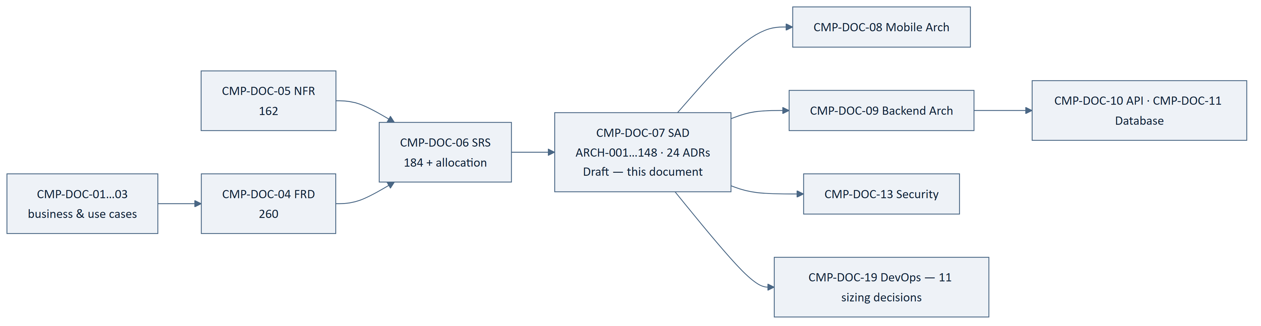
Figure 14 — 15.1 Position in the Chain

15.2 Backward Traceability
Table 68 — 15.2 Backward Traceability
Source | Architecture statements derived
Software requirement (SRS-REQ-) | 96
Architecture decision (ADR-) | 31
Quality requirement (NFR-) | 12
Functional requirement (FRD-FR-) | 6
Approved constraint (BAD-CON-) | 3
Total | 148 — every statement names a source

15.3 Coverage
Table 69 — 15.3 Coverage
Check | Result
Technical decisions routed from CMP-DOC-06 resolved | 8 of 8 (100%)
Architectural drivers with a named realisation | 12 of 12
Absolute business rules with an architectural guarantee | 10 of 10
Software elements with a component architecture | 6 of 6
Trust boundaries with a realisation | 4 of 4
Architecture statements naming a source | 148 of 148
Sizing decisions deferred with a named blocker | 11
Forward links to CMP-DOC-08 / 09 | 0 — `TRACEABILITY: TBD`

15.4 Requirements the Architecture Cannot Yet Serve
Table 70 — 15.4 Requirements the Architecture Cannot Yet Serve
Requirement | Reason | Consequence
NFR-023, 038, 039 availability and recovery | No target | Topology cannot be finalised (ARCH-144)
NFR-041–050 capacity | No target | Instance and pool sizing deferred
NFR-145, 149 cost | No ceiling | Alerting thresholds cannot be set
Fraud detection | No requirement, no element | Nothing designed — GAP-013
29 functional gaps | Behaviour undecided | Elements pre-assigned (CMP-DOC-06 §10.1); reserved per §12.3

16. Assumptions, Risks and Open Questions

16.1 Assumptions
Table 71 — 16.1 Assumptions
ID | Assumption | Impact if wrong
ARCH-ASM-001 | All six predecessors will be approved substantially as written. | Drivers change, and decisions derived from them must be re-examined.
ARCH-ASM-002 | MySQL's spatial capability is sufficient for phase-1 candidate filtering at the densities CMP will reach. | ADR-03 phase 1 needs another mechanism; phase 2 and the overall shape survive.
ARCH-ASM-003 | A MySQL-backed queue is sufficient until capacity targets exist. | ADR-06 requires a broker earlier than planned; job contracts are unaffected.
ARCH-ASM-004 | Pessimistic locking on the allocation record will not become the system's primary bottleneck at MVP scale. | T-1 must be revisited; ADR-04's alternative (b) becomes relevant.
ARCH-ASM-005 | One deployable unit plus the safety exception satisfies operational needs. | ADR-01 revisited toward modular extraction.
ARCH-ASM-006 | Policy configuration can carry the six undefined state models without unbounded generality. | ADR-15 narrows to configurable values only, with transitions coded per model.
ARCH-ASM-007 | Assumptions of all six predecessors are inherited unchanged. | Inherited.

16.2 Architectural Risks
Table 72 — 16.2 Architectural Risks
ID | Risk | L | I | Sev | Response
ARCH-RISK-001 | Six unapproved predecessors beneath an architecture. | 3 | 3 | 9 | Do not baseline until approved; drivers are stated explicitly so change impact is traceable.
ARCH-RISK-002 | Sizing cannot be validated, so the architecture may not meet targets nobody has set. | 3 | 3 | 9 | 11 sizing decisions named; CMP-DOC-05 §19 route; four targets recommended immediately.
ARCH-RISK-003 | The safety deployment exception (`ADR-24`) drifts into a second implementation. | 2 | 3 | 6 | ARCH-012, 143 require shared domain and store; enforced by ADR-23.
ARCH-RISK-004 | Phase-1 selectivity is inadequate, collapsing matching toward brute force. | 2 | 3 | 6 | Measure at synthetic density before R2 (ARCH-OQ-002); NFR-043 is testable now.
ARCH-RISK-005 | Lock contention on popular rides limits booking throughput. | 2 | 2 | 4 | Accepted (T-1); revisit with measurement.
ARCH-RISK-006 | The policy subsystem becomes a second place business logic lives. | 2 | 3 | 6 | ARCH-147 prohibits configuring absolute behaviour; ARCH-148 validates on change.
ARCH-RISK-007 | Projection staleness leaks into a decision path. | 2 | 3 | 6 | ARCH-056 prohibits availability from projections; testable.
ARCH-RISK-008 | Structural constraints are not enforced because build tooling is deferred. | 3 | 3 | 9 | ADR-23; CMP-DOC-06 already requires 62 structural verifications.
ARCH-RISK-009 | MySQL queue throughput becomes a bottleneck under load. | 2 | 2 | 4 | ARCH-ASM-003; ARCH-OQ-005.
ARCH-RISK-010 | Evidential log growth is unprovisioned. | 3 | 2 | 6 | [SIZING] #7; NFR-050 measurable from R1.
ARCH-RISK-011 | Fraud has no architectural home and will be retrofitted into the domain layer. | 3 | 2 | 6 | GAP-013; ARCH-OQ-007; assign before CMP-DOC-13.
ARCH-RISK-012 | Two interface versions drift in behaviour. | 2 | 2 | 4 | ARCH-030 — one Application layer, version-specific adapters only.

16.3 Open Questions
Table 73 — 16.3 Open Questions
ID | Question | Owner | Blocks
ARCH-OQ-001 | What is the minimum route-overlap threshold for a match to be presented? | Product Owner | ADR-03
ARCH-OQ-002 | Does phase-1 filtering achieve adequate selectivity at realistic corridor density? | Solution Architect | ARCH-RISK-004
ARCH-OQ-003 | Should the search projection be a separate store rather than a MySQL projection? | Solution Architect | ADR-05; needs sizing
ARCH-OQ-004 | How long is interface version N−1 served after N is released? | Solution Architect | ADR-10
ARCH-OQ-005 | At what measured load does the MySQL-backed queue require replacement? | Solution Architect | ADR-06, ARCH-RISK-009
ARCH-OQ-006 | Does the safety surface require separate infrastructure, or only separate deployment? | Solution Architect / DevOps | ADR-24; [SIZING] #11
ARCH-OQ-007 | Which architectural component will own fraud detection and response? | Security Analyst | GAP-013; CMP-DOC-13
ARCH-OQ-008 | Should the evidential log be partitioned by time from the outset? | Software Architect | CMP-DOC-11; ARCH-RISK-010
ARCH-OQ-009 | Is idempotency-key retention a policy value or a technical constant? | Solution Architect | ADR-14
ARCH-OQ-010 | Should projections be served from a read replica once one exists? | Solution Architect | ADR-05; [SIZING] #6

16.4 Decisions Required
No new business decision is raised. BAD-DEC-018 remains the binding constraint on
this document: it blocks all eleven sizing decisions and prevents evaluation of the
architecture against any performance, availability or cost target.

17. Acceptance Criteria for This Document
Table 74 — 17. Acceptance Criteria for This Document
# | Criterion | State
AC-1 | Every architectural driver is identified and traced to a source. | Met — 12
AC-2 | Every technical decision routed from CMP-DOC-06 is resolved or explicitly deferred with a reason. | Met — 8 of 8 resolved
AC-3 | Every decision records context, alternatives and consequences including negative ones. | Met — 24 ADRs
AC-4 | Every software element has a component architecture. | Met — 6 of 6
AC-5 | Every trust boundary has a named realisation. | Met — 4 of 4
AC-6 | Every absolute business rule has an architectural guarantee. | Met — 10 of 10
AC-7 | Every architecture statement names a source. | Met — 148 of 148
AC-8 | No capacity, latency, availability or cost figure is invented. | Met — 11 sizing decisions deferred, 0 invented
AC-9 | No excluded technology appears. | Met
AC-10 | Predecessor documents are approved. | NOT MET — all six Draft
AC-11 | The architecture is validated against quality targets. | NOT MET — 69 targets unset
AC-12 | Every capability has an owning component. | NOT MET — fraud unowned (GAP-013)

Nine of twelve met. All three outstanding are held elsewhere.

18. Statistics and Recommendations

18.1 Statistics
Table 75 — 18.1 Statistics
Measure | Value
Architectural drivers | 12
Architectural principles | 10
Architecture Decision Records | 24
Routed technical decisions resolved | 8 of 8
Architecture statements | 148
Containers | 5
Components named | 31
Runtime views | 5
Driver conflicts identified and resolved | 4
Trade-offs recorded | 6
Sizing decisions deferred | 11
Architectural risks | 12 (4 at severity 9)
Open questions | 10
Structural exceptions to the single-deployable decision | 1 (ADR-24)

18.2 Recommendations
Table 76 — 18.2 Recommendations
ID | Recommendation | Rationale | Owner | Urgency
AR-01 | Build the structural enforcement of `ADR-23` first. | ARCH-RISK-008 at severity 9. Layer direction, provider isolation and front-door purity are cheap to enforce on day one and expensive to recover later. | Technical Lead | Immediate
AR-02 | Set the four urgent quality targets. | ARCH-RISK-002 at severity 9. Eleven sizing decisions and the entire evaluation of §14 depend on them. | Project Owner | Immediate
AR-03 | Measure phase-1 selectivity against synthetic corridor density before R2. | ARCH-RISK-004. ADR-03 is the differentiator's implementation and its key assumption is untested. | Solution Architect | Before R2
AR-04 | Assign fraud to an architectural component. | ARCH-RISK-011; unowned through six documents. | Security Analyst | Before CMP-DOC-13
AR-05 | Implement the policy configuration subsystem (`ADR-11`) before any gapped behaviour. | 17 decisions land as values; this is what makes them configuration rather than releases. | Solution Architect | Immediate
AR-06 | Treat `ADR-24` as the only permitted deployment exception, and review any proposal to add another as a change to this document. | ARCH-RISK-003. Exceptions multiply if the first is treated as a precedent. | Solution Architect | Standing
AR-07 | Carry the 11 sizing decisions into CMP-DOC-19 as an explicit agenda. | Otherwise they are settled implicitly by whoever provisions first. | DevOps Engineer | With CMP-DOC-19
AR-08 | Commission CMP-DOC-08 and CMP-DOC-09 in parallel. | Both derive from this document and neither depends on the other. | Project Owner | Next
AR-09 | Commission CMP-DOC-13 early rather than at its sequence position. | Four security properties (ARCH-054, 059, 060, and fraud) are stated but unmechanised, and two are prerequisites for the evidential log. | Security Analyst | Soon

18.3 Overall Assessment
The architecture is decided. Twenty-four decision records resolve every technical
question routed here, including all eight from CMP-DOC-06, and each records what was
rejected and what it costs. One hundred and forty-eight architecture statements specify
the containers, components, runtime behaviour, data, integration, security posture and
logical deployment, and every one names its source.
The shape is conservative on purpose. A single deployable application with one domain
layer, pessimistic locking where an absolute rule demands it, durable queued work in the
database that already exists, and ports around three unselected suppliers. **Nothing here
is elaborate, and that is the point**: there is no measurement to justify elaboration,
and CMP-DOC-05 §19 recommends measuring before optimising. Every place where a more
sophisticated answer might later be right — the queue, the projections, the locking, the
deployment granularity — is recorded as a trade-off with the condition that would
reverse it.
One structural exception exists. ADR-01 puts the admin interface inside the single
deployable unit, which is right for integrity and wrong for the safety availability
obligation; ADR-24 resolves it by permitting safety incident handling alone to deploy
independently. That is the only exception, and it is named as such so it does not become
a precedent.
Two things cannot be done here. Sizing — eleven decisions wait on targets nobody has
set. And fraud, which has now passed through six documents without an owner and is
the one capability this architecture does not provide for.
Recommended next step: build the structural enforcement, set the four targets,
commission CMP-DOC-08 and CMP-DOC-09 in parallel, and bring CMP-DOC-13 forward.

Appendix A — Architecture Statement Index
Table 77 — Appendix A — Architecture Statement Index
Range | Subject | §
ARCH-001–014 | System context and containers | 5
ARCH-015–028 | Android client components | 6.1
ARCH-029–042 | Platform services components | 6.2
ARCH-043–049 | Administrative interface components | 6.3
ARCH-050–060 | Persistence components | 6.4
ARCH-061–070 | Integration components | 6.5
ARCH-071–077 | Work subsystem components | 6.6
ARCH-078–082 | Runtime — search and matching | 7.1
ARCH-083–090 | Runtime — request, payment, booking | 7.2
ARCH-091–097 | Runtime — active trip | 7.3
ARCH-098–103 | Runtime — safety signal | 7.4
ARCH-104–109 | Runtime — degraded operation | 7.5
ARCH-110–119 | Data architecture | 8
ARCH-120–130 | Integration architecture | 9
ARCH-131–137 | Security architecture | 10
ARCH-138–144 | Deployment architecture | 11
ARCH-145–148 | Configuration | 12.1

Appendix B — Decision Record Index
Table 78 — Appendix B — Decision Record Index
ADR | Decision | Routed TD
ADR-01 | Single deployable application with two front doors | ⇢TD-8
ADR-02 | Layered domain-centric structure | —
ADR-03 | Two-phase route-overlap matching | ⇢TD-1
ADR-04 | Pessimistic serialisation of seat allocation | ⇢TD-2
ADR-05 | Separate read projections | —
ADR-06 | Durable queued work | ⇢TD-6
ADR-07 | Ports for every external provider | ⇢TD-7
ADR-08 | Caching and cost attribution at the port | —
ADR-09 | Append-only evidential log | ⇢TD-3
ADR-10 | URI-path versioning, N and N−1 | ⇢TD-4
ADR-11 | Policy configuration as a runtime subsystem | ⇢TD-5
ADR-12 | Client durable outbox, server-driven cadence | —
ADR-13 | Safety path isolated from contention | —
ADR-14 | Idempotency as a platform-wide contract | —
ADR-15 | Configuration-driven state machines | —
ADR-16 | Domain events between components | —
ADR-17 | Authoritative values never cached | —
ADR-18 | Location as observation, not record | —
ADR-19 | Notification best-effort, in-app authoritative | —
ADR-20 | Dual-initiated payment verification | —
ADR-21 | Authorisation in the Application layer | —
ADR-22 | Reporting from projections only | —
ADR-23 | Structural constraints enforced at build time | —
ADR-24 | Safety as the sole independently deployable capability | ⇢TD-8

Appendix C — Terminology Reference
Table 79 — Appendix C — Terminology Reference
Term | Meaning | Glossary action
Architectural driver | A requirement that would change the structure if it changed, as distinct from one the structure must merely satisfy. Twelve identified. | New — add to Glossary
Architecture Decision Record (ADR) | A recorded decision with its context, alternatives and consequences, including negative ones. Twenty-four issued. | New — add to Glossary
Port / adapter | A provider-neutral capability contract and its provider-specific implementation. No provider type appears above the port. | New — add to Glossary
Evidential log | The append-only, chained record of every recordable event, distinct from mutable operational state. | New — add to Glossary
Projection | A derived, non-authoritative read representation. Never the source for seat availability. | New — add to Glossary
Policy configuration | Versioned, audited, runtime-editable business values and state-model definitions — distinct from deployment configuration and from absolute rules, which are code. | New — add to Glossary
Sizing decision | A decision that cannot be taken until a quality target exists. Eleven deferred to CMP-DOC-19. | New — add to Glossary
Structural exception | A deliberate, named departure from an architectural decision. Exactly one exists (ADR-24). | New — add to Glossary

END OF DOCUMENT
CMP-DOC-07 · System Architecture Document · Version 0.1 · Draft · 2026-08-16
Carpool Mobility Platform · Project Code CMP · Brand TBD · Classification: Internal
This document is NOT approved. It is issued for Project Owner review.
Predecessors CMP-DOC-01 … CMP-DOC-06 are all at status Draft — see §0.8.2.

