CARPOOL MOBILITY PLATFORM
Project Code: CMP Brand: TBD

API Specification
API
Document ID: CMP-DOC-10

Version | 0.1
Status | Draft — NOT APPROVED
Date | 2026-08-16
Classification | Internal
Author | Solution Architect / Backend Lead (AI-assisted)
Reviewer | [TBD]
Approver | Project Owner
Previous Version | None (initial issue)
Predecessor | CMP-DOC-01 … CMP-DOC-09, all Draft, none approved (CMP-DOC-09 at v0.2, the remainder at v0.1)

This document is a controlled engineering artifact.
It is issued for Project Owner review and is not approved for implementation.

Carpool Mobility Platform (CMP)

0. Document Control

0.1 Document Metadata
Table 1 — 0.1 Document Metadata
Field | Value
Document ID | CMP-DOC-10
Document Name | API Specification
Short Name | API
Project Name | Carpool Mobility Platform
Project Code | CMP
Version | 0.1
Status | Draft
Date | 2026-08-17
Author | Solution Architect / Backend Lead (AI-assisted)
Reviewer | [TBD]
Approver | Project Owner
Classification | Internal
Brand | TBD
Previous Version | None (initial issue)
Predecessor Documents | CMP-DOC-01 … CMP-DOC-09, all Draft, none approved (CMP-DOC-09 at v0.2, the remainder at v0.1)
Related Documents | 00_Project_Control/README.md, Documentation_Index.md, Documentation_Status.md, Document_Change_Log.md, Glossary.md, Master_Traceability_Matrix.md
Successor Documents | CMP-DOC-11 (Database), CMP-DOC-14 (Payment & UPI), CMP-DOC-15 (GPS / Live Trip), CMP-DOC-16 (Communication & Notification)

0.2 Revision History
Table 2 — 0.2 Revision History
Version | Date | Author | Change | Status
0.1 | 2026-08-17 | Solution Architect / Backend Lead (AI-assisted) | Initial issue. Specifies the platform's external interface: 10 interface drivers, 14 API decisions, the interface model and conventions, versioning and negotiation, representation rules, idempotency, the four-branch error model, authorisation and session carriage, collections, the resource catalogue across 13 functional areas, the safety surface, the provider callback surface, configuration delivery, rate limiting posture and interface quality obligations. Issues 216 statements (API-001 … API-216). | Draft

0.3 Distribution List
Table 3 — 0.3 Distribution List
Role | Purpose
Project Owner | Approval authority
Backend Lead | Authoring and ownership
Backend Developers | Primary consumer — implements the surface
Android Developers | Primary consumer — consumes the surface
Solution Architect | Consistency with CMP-DOC-07 and CMP-DOC-09
Software Architect — Android | Realisation of MOB-047–MOB-057 against this contract
Security Analyst | Authorisation carriage, disclosure limits, callback authentication; mechanisms in CMP-DOC-13
QA Analyst | Contract testing and the negative cases in §8
Product Analyst | Resource catalogue coverage of the specified use cases

0.4 Approval
Table 4 — 0.4 Approval
Role | Name | Signature | Date
Author | Solution Architect / Backend Lead (AI-assisted) | — | 2026-08-17
Reviewer | [TBD] | — | —
Approver | Project Owner | — | —

This document is NOT approved. It is issued at version 0.1 with status Draft for Project Owner review.

0.5 Purpose of This Document
CMP-DOC-09 established that every caller reaches the domain through one application
service layer, and that the REST adapters translate transport representations to
application commands and nothing more (BE-013, BE-065, BE-068). It did not say
what those transport representations are.
This document says. It specifies the contract between the Android client and the
platform: what resources exist, what operations act on them, how a version is
negotiated, how an idempotency key is carried, how the four error branches appear on
the wire, and what a caller may and may not assert.
The contract has one governing property, inherited from BAD-RULE-002 and restated at
every layer above: the interface offers no way to tell the platform what is true.
A caller submits intents and receives outcomes. There is no endpoint by which a client
sets a fare, a verification standing, a payment status or a seat count, because
ARCH-121 forbids the operation from existing rather than merely forbidding its use.

0.6 Boundaries — What This Document Does Not Specify
Table 5 — 0.6 Boundaries — What This Document Does Not Specify
Subject | Owning document
Application services, aggregates, transactions, layer structure | CMP-DOC-09
Tables, columns, keys, indexes, migrations | CMP-DOC-11
Screen design, navigation, copy | CMP-DOC-12
Cryptographic algorithms, token format, key handling, TLS configuration | CMP-DOC-13
Payment provider mechanics, UPI flows, settlement | CMP-DOC-14
Position acquisition cadence behaviour on the device | CMP-DOC-15
Notification channel mechanics and message templates | CMP-DOC-16
Administrative screens and Filament resources | CMP-DOC-17
Test cases and test data | CMP-DOC-18
Hosting, gateways, TLS termination, instance sizing | CMP-DOC-19

0.6.1 The Boundary With CMP-DOC-13
This document states where a credential is carried, what an unauthorised
outcome looks like, and what must never be disclosed. It states nothing about how a
credential is constructed, signed, stored or rotated. API-095–API-110 are
positional and behavioural statements; every mechanism behind them is CMP-DOC-13's.

0.6.2 The Boundary With CMP-DOC-14
This document specifies the payment resources a client may act on and the shape of the
provider callback surface. It specifies no UPI flow, no provider API, no settlement
mechanics and no reconciliation procedure.

0.7 Inputs to This Document
Table 6 — 0.7 Inputs to This Document
Input | Contribution
CMP-DOC-09 §7.1 | BE-065–BE-073 — the REST adapter's obligations
CMP-DOC-09 §14.2 | BE-185–BE-190 — the four error branches
CMP-DOC-07 §12 | ARCH-120–ARCH-139 — interface and security-position statements
CMP-DOC-08 §17.5 | Three obligations placed explicitly on this document
CMP-DOC-06 §6.1 | SRS-REQ-137–SRS-REQ-141 — external interface requirements
CMP-DOC-05 | Quality obligations bearing on the interface
CMP-DOC-04 | The functional behaviour the resources must expose
CMP-DOC-03 | 44 Specified use cases determining which resources are needed

0.8 Qualifications on This Document

0.8.1 Source
Every statement derives from a predecessor statement, from a decision recorded in §3,
or is disclosed in §17.6 as originating here.

0.8.2 Qualification 1 — Nine Unapproved Predecessors
FACT. CMP-DOC-01 … CMP-DOC-09 are all Draft. None is approved.
This document is nine deep on an unapproved baseline, and it is the first document a
developer will implement against literally. Recorded as conflict CC-010 and as
API-RISK-01.

0.8.3 Qualification 2 — The Resource Catalogue Is Bounded by Decided Behaviour
FACT. CMP-DOC-03 records 33 of 83 use cases as Outlined, and CMP-DOC-04 records 29
functional gaps of which 11 are Critical.
A resource cannot be specified for behaviour that has not been decided. §11 covers the
44 Specified use cases. **Where a resource would be needed for an Outlined use case,
§11.14 names the resource and the blocking decision, and no operation is invented for
it.** This is the same discipline CMP-DOC-04 applied, one layer down.

0.8.4 Qualification 3 — No Limit, Window or Page Size Is Stated
FACT. BAD-DEC-018 leaves 69 quality targets unset (GAP-012), and launch scale is
unstated (GAP-016).
This document states that the interface pages, that it rate-limits, and that
a payload is bounded. It states no page size, no rate, no window and no maximum, because
each is a tuning value that should be set from measurement. Nine such values are named as
configuration in §15.3.

0.8.5 Qualification 4 — Two Requirement-Chain Gaps Are Inherited
FACT. CMP-DOC-09 §18.7 recorded that payment credential handling (BE-097) and
injection defence (BE-102) have no upstream requirement.
Both surface here, because both are interface-visible. This document restates them at
the boundary (API-053, API-109) and repeats that **CMP-DOC-13 should close the
requirement gap** rather than let an architecture and an interface document be the only
places either is written down.

0.9 Statement Classification Convention
As README.md §9.1. Markers: FACT, ASSUMPTION, BUSINESS DECISION REQUIRED,
TECHNICAL DECISION REQUIRED, OPEN QUESTION, TBD, FUTURE CONSIDERATION,
RECOMMENDATION.

0.10 Identifier Conventions
Table 7 — 0.10 Identifier Conventions
Prefix | Element | Section
API-nnn | Traceable API specification statement | §4–§16
AADR-nn | API Architecture Decision Record | §3
APID-nn | Interface driver | §2
API-ASM-nn | Assumption | §19.1
API-RISK-nn | Risk | §19.2
API-OQ-nn | Open Question | §19.3

API-nnn is the only traceable prefix. A statement marked ‡ is integrity-critical:
its violation would permit an absolute business rule to be broken.
Table of Contents
If the entries below appear as a placeholder, open in Word and press Ctrl+A then F9 (or right-click → Update Field) to build the contents, figure and table numbering.
…

1. Executive Summary

1.1 What This Document Delivers
Table 8 — 1.1 What This Document Delivers
Element | Count
Interface drivers | 10
API Decision Records | 14
API specification statements | 216 (API-001 … API-216)
Resource groups | 13
Operations specified | 59
Error branches | 4
Tuning values named as configuration | 9
Obligations discharged from CMP-DOC-08 §17.5 | 3 of 3

1.2 The Interface in One Paragraph
One REST interface, versioned in the URI path, serving the current version and the one
before it. JSON only. Every state-changing request carries an idempotency key and every
response carries the interface version. Every business value the platform holds is
returned with the platform's own valuation and never accepted from the caller. Failures
arrive as exactly one of four branches — invalid request, business refusal, dependency
unavailable, internal fault — each with a distinct status code range and a distinct body
shape, so that a client can tell "you may not" from "we could not" without parsing prose.
A separate safety surface answers on the same contract with the narrowest possible
dependency set. Provider callbacks are a trigger to verify, never a verification.

1.3 The Four Decisions That Shape Everything Else
Table 9 — 1.3 The Four Decisions That Shape Everything Else
AADR | Decision | Why it dominates
`AADR-02` | Four error branches, each with its own status range and its own body shape — not a single error envelope with a code. | CMP-DOC-08 MADR-10 requires the client to design four distinct treatments. A single envelope makes the four indistinguishable without agreeing a code list, and code lists rot. This is the obligation from CMP-DOC-08 §17.5 discharged structurally.
`AADR-04` | The idempotency key is required on every state-changing request and the interface refuses a request without one. | ARCH-124 requires acceptance; making it optional means it is absent exactly when the network was unreliable — the case it exists for. A refusal is noisy on day one and silent thereafter.
`AADR-06` | No request body field may name an authoritative value. Such a field does not exist in the schema rather than being ignored. | ARCH-121 and BE-069. A field that is accepted-and-ignored is a field somebody will later honour. Absence from the schema is the only durable form of the rule.
`AADR-09` | Every business value is returned with an explicit as-of marking. | CMP-DOC-08 MADR-02 makes provenance a type-level client property, and MOB-018 forbids rendering a value without it. If the interface does not supply the marking, the client must invent one, and an invented provenance is a lie with a type signature.

1.4 What This Document Could Not Specify
Table 10 — 1.4 What This Document Could Not Specify
Matter | Position
Resources for 33 Outlined use cases | Named in §11.14 with the blocking decision; no operation invented
Page sizes, rate limits, payload bounds | Configuration; 9 values named in §15.3
Token format, signing, TLS profile | CMP-DOC-13
Version support duration | API-OQ-01; SRS-OQ-005 is answered only in part
Emergency dispatch surface | GAP-004; §12.4

2. Interface Drivers
A driver is a requirement that would change the shape of the interface if it changed.
Table 11 — 2. Interface Drivers
ID | Driver | Source | Consequence
APID-01 | The client must never be able to assert authoritative state. | BAD-RULE-002, ARCH-121 | AADR-06: absence from schema, not validation.
APID-02 | The client must distinguish four failure kinds without parsing prose. | MADR-10, BE-185 | AADR-02: four branches, four shapes.
APID-03 | Every state change must survive being retried. | ARCH-124, BE-135 | AADR-04: mandatory idempotency key.
APID-04 | The client must render no business value without provenance. | MADR-02, MOB-018 | AADR-09: as-of marking on every value.
APID-05 | A client build outlives a platform release. | NFR-099, SRS-REQ-010 | AADR-03: N and N−1, explicit unsupported outcome.
APID-06 | Safety must not degrade because unrelated capability is failing. | NFR-030, BE-193 | AADR-11: safety surface on a separate path with a narrow contract.
APID-07 | A provider callback is not evidence. | ARCH-128, BAD-RULE-032 | AADR-12: callbacks accepted as triggers only.
APID-08 | Tuning values must change without a client release. | MADR-11, MOB-123 | AADR-13: configuration delivered over the interface.
APID-09 | The interface must disclose only what the caller is entitled to. | ARCH-125, SRS-REQ-141 | AADR-08: representation varies by relationship, not by flag.
APID-10 | Every endpoint must reach the domain through an application service. | BE-013, CMP-DOC-09 §18.5 | AADR-01: one operation, one service, no exceptions.

3. API Decisions
Each decision records its context, the alternatives considered, and its consequences
including the negative ones, marked ✘.

3.1 AADR-01 — One Operation, One Application Service
Table 12 — 3.1 AADR-01 — One Operation, One Application Service
Context | CMP-DOC-09 §18.5 places an obligation on this document: no endpoint may bypass an application service. Convenience endpoints that "just read a table" are how that obligation is broken.
Decision | Every operation in §11 maps to exactly one application service operation. No endpoint composes two services, and no endpoint reads persistence directly. A composite need is met by a service, not by an adapter.
Alternatives | (a) Allow read-only endpoints to query read models directly — rejected: authorisation lives in the application layer (BE-179), so a direct read is an unauthorised read. (b) Allow adapters to compose services — rejected: composition without a transaction boundary is where partial effects appear.
Consequences | ✔ Authorisation, idempotency and evidencing apply uniformly. ✔ The admin surface and the REST surface stay behaviourally identical. ✘ Some screens need a purpose-built service rather than two cheap calls. ✘ A service must exist before its endpoint can.

3.2 AADR-02 — Four Error Branches, Four Shapes
Table 13 — 3.2 AADR-02 — Four Error Branches, Four Shapes
Context | BE-185 defines four exception branches. MADR-10 requires the client to design four distinct treatments. SRS-REQ-163 forbids representing a refusal as a fault or a fault as a refusal. The common industry practice — one envelope with an application error code — satisfies none of these reliably, because the distinction then lives in a code list rather than in the structure.
Decision | Each branch has its own status code range and its own response body shape: invalid request (`400`), business refusal (`409` / `422`), dependency unavailable (`503`), internal fault (`500`). A client can branch on structure alone. The refusal body carries a presentable reason; the fault body carries a correlation identity and nothing else.
Alternatives | (a) One envelope with a code field — rejected: the four cases become indistinguishable to a client that does not hold the current code list, which is exactly the client that has been in the field longest. (b) Status code alone with no body — rejected: SRS-REQ-140 requires a presentable reason.
Consequences | ✔ MOB-050's four treatments are structurally supported. ✔ A refusal cannot silently become a fault in a later release without the shape changing. ✘ Four schemas to maintain rather than one. ✘ Servers must be disciplined about which branch a condition belongs to; §8.6 gives the classification rules.

3.3 AADR-03 — URI Path Versioning, N and N−1
Table 14 — 3.3 AADR-03 — URI Path Versioning, N and N−1
Context | ARCH-123 requires the version to be identifiable in a form the client can act on. SRS-REQ-034 requires more than one version concurrently for a defined period. CMP-DOC-07 §0.6 already decided path versioning; this document details it. TD-4 is routed here.
Decision | The version is the first path segment: `/api/v1/…`. The platform serves the current version and the immediately preceding one. Every response carries the serving version and a deprecation indication for N−1. A request for an unsupported version receives a distinct outcome — not a `404` — carrying the supported range.
Alternatives | (a) Header-based version negotiation — rejected: invisible in logs, in a browser and in a support conversation, and easy to omit. (b) Unversioned with additive-only change — rejected: SRS-REQ-033 requires a version increment for a breaking change, so a version must exist to increment. (c) Serve N only — rejected: forces a synchronised client release, which SRS-REQ-011 forbids requiring.
Consequences | ✔ The version is visible everywhere a URL is. ✔ MOB-057's version-unsupported application state has a definite trigger. ✘ Two versions to run, test and reason about. ✘ How long N−1 is served is `[TBD – Business Decision Required]` — SRS-OQ-005 is therefore only half answered here, and API-OQ-01 records the remainder.

3.4 AADR-04 — Mandatory Idempotency Key
Table 15 — 3.4 AADR-04 — Mandatory Idempotency Key
Context | ARCH-124 requires the interface to accept a key on every state-changing operation. MOB-049 has the client generate one when an intent is recorded. BE-051 writes the registry entry in the same transaction as the effect. The remaining question is whether a request without a key is accepted.
Decision | A state-changing request without an idempotency key is refused as an invalid request. The key is caller-generated, opaque to the platform, and scoped to the actor and the operation.
Alternatives | (a) Optional key, best-effort deduplication — rejected: the key is absent precisely when the network misbehaved, which is the only case it matters. (b) Server-generated key returned for reuse on retry — rejected: requires a round trip that the failing network just prevented.
Consequences | ✔ Every state change is replay-safe end to end, not merely in the queue. ✔ BE-211's replay test has a wire-level counterpart. ✘ Every client call site must supply a key; a forgotten one fails loudly in development. ✘ Key retention duration is a tuning value (§15.3).

3.5 AADR-05 — JSON Only, One Representation Per Resource
Table 16 — 3.5 AADR-05 — JSON Only, One Representation Per Resource
Context | The only client is the Android application (ARCH-009), plus provider callbacks and, later, whatever CMP-DOC-17 needs. Content negotiation is a cost paid on every endpoint for a flexibility nobody has asked for.
Decision | `application/json` for requests and responses. One representation per resource. No content negotiation, no partial-response syntax, no field-selection query language.
Alternatives | (a) GraphQL — rejected: moves query composition to the client, which conflicts with AADR-01 and with authorisation living in the application layer. (b) Sparse fieldsets — rejected: multiplies the authorisation surface for a payload saving that MOB-054 has not yet measured.
Consequences | ✔ One schema per resource to authorise, test and version. ✔ Contract tests are tractable. ✘ Over-fetching on some screens. ✘ If payload volume becomes a real constraint, this decision is the one to revisit — MOB-136 is the measurement that would justify it.

3.6 AADR-06 — Authoritative Fields Absent From Schema
Table 17 — 3.6 AADR-06 — Authoritative Fields Absent From Schema
Context | ARCH-121 requires that no operation permit direct assignment of authoritative state. ARCH-133 requires an attempt to be rejected in whole and recorded. BE-069 restates it at the adapter. The weak form of this rule is to accept and ignore.
Decision | Fare, verification standing, payment status, seat counts, ratings, balances and trip state do not appear as writable fields in any request schema. An unknown field in a request body causes the request to be refused in whole, and a field matching a known authoritative name is additionally recorded as an integrity event.
Alternatives | (a) Accept and ignore unknown fields — rejected: tolerant readers are how a client comes to believe it set something. (b) Accept and validate against platform state — rejected: still implies the field is meaningful.
Consequences | ✔ The rule is enforced by schema, not by vigilance. ✔ ARCH-133's integrity event has a definite trigger point. ✘ Strict rejection breaks clients that send extra fields, including during their own development. ✘ Additive schema change requires a client that tolerates unknown response fields — stated separately at API-046.

3.7 AADR-07 — Intents Are Resources
Table 18 — 3.7 AADR-07 — Intents Are Resources
Context | Several client actions do not complete synchronously: a booking awaits payment verification, a payment awaits provider confirmation, a recurring ride awaits generation. A synchronous response cannot state an outcome that does not yet exist, and BE-159 forbids assuming one.
Decision | An operation whose outcome is not yet determined returns the created resource in its actual state — `pending` — with a location at which its state may be read. The interface never returns a provisional success.
Alternatives | (a) Block until resolved — rejected: couples a client's responsiveness to a provider's, and BE-050 puts the provider call outside the transaction precisely to avoid this. (b) Return success and correct later by push — rejected: MOB-060 forbids the client presenting an intent as an accomplished fact.
Consequences | ✔ pending is a first-class outcome the client can render honestly. ✔ Reconciliation has a resource to act on. ✘ Every such flow needs a read path and a client-side follow-up. ✘ Clients must not poll on a self-chosen interval (ARCH-026); §14.2 supplies the cadence.

3.8 AADR-08 — Representation Varies by Relationship
Table 19 — 3.8 AADR-08 — Representation Varies by Relationship
Context | ARCH-125 and SRS-REQ-141 limit disclosure to what the caller's actor is entitled to. BAD-RULE-025 forbids exposing a counterparty's precise location beyond what is required. A single representation with nullable sensitive fields leaks by omission pattern and invites a client to infer.
Decision | A resource has one schema, but the platform populates only the fields the caller's relationship entitles them to, and the schema marks which fields are relationship-dependent. Entitlement is evaluated in the application layer (`BE-179`), never by the adapter.
Alternatives | (a) Distinct schemas per relationship — rejected: multiplies representations and drifts. (b) Client-side filtering — rejected: the data has already left the platform.
Consequences | ✔ One schema, one authorisation point. ✔ A new relationship type does not create a new resource. ✘ A client must handle an absent field on every relationship-dependent value. ✘ Absence is itself weak information; API-107 bounds what may be inferred from it.

3.9 AADR-09 — Every Business Value Carries an As-Of Marking
Table 20 — 3.9 AADR-09 — Every Business Value Carries an As-Of Marking
Context | MADR-02 makes provenance a type-level property of client state and MOB-018 forbids rendering a value without it. The client can mark a value Cached from its own store, but it cannot know how current a value was when the platform computed it — a seat count read from an authoritative record and a projection-derived count both arrive as JSON numbers.
Decision | Every response carries the time at which the platform evaluated it, and any value served from a projection additionally carries that projection's maintenance time. A value the platform read under lock is marked as authoritative-at-that-instant.
Alternatives | (a) One response timestamp only — rejected: conflates the freshness of a projection-derived list with that of a locked read, and BE-125 requires the difference to be presentable. (b) Leave it to the client — rejected: the client cannot know, and would have to guess.
Consequences | ✔ MOB-018 becomes satisfiable rather than aspirational. ✔ BE-125's staleness disclosure has a wire representation. ✘ Marking on every value costs payload. ✘ Screens must decide what to do with a stale marking — an obligation this document places on CMP-DOC-12.

3.10 AADR-10 — Search Is a Query Resource, Not a Filtered Collection
Table 21 — 3.10 AADR-10 — Search Is a Query Resource, Not a Filtered Collection
Context | Ride search is route-overlap matching (SRS-REQ-049), not attribute filtering. Expressing it as query parameters on a rides collection implies a filterable list and invites clients to construct arbitrary filters, which NFR-020 and NFR-021 bound and ARCH-081 structures in two phases.
Decision | Search is a distinct resource accepting a journey description and returning a ranked result set with its own representation. It is not `GET /rides?from=…&to=…`.
Alternatives | (a) Filtered collection — rejected: implies composability the matching engine does not have and cannot bound. (b) POST returning a stored search — rejected: adds a resource lifecycle for no current requirement.
Consequences | ✔ The bounded cost of a search is expressible on one operation. ✔ Ranking is part of the contract rather than an accident of ordering. ✘ Search is not cacheable by URL. ✘ A POST that does not change state needs API-018 to say so explicitly.

3.11 AADR-11 — The Safety Surface Is a Separate Path
Table 22 — 3.11 AADR-11 — The Safety Surface Is a Separate Path
Context | BADR-16 makes the safety surface separately bootable. BE-193 forbids it depending on payment, search, matching, rating or projection components. NFR-030 forbids losing a safety signal under any failure condition. If safety shares a path prefix with everything else, a gateway rule or a rate limiter written for the general case will eventually apply to it.
Decision | Safety operations live under a distinct path prefix, carry the narrowest possible request shape, and are specified so that they can be served by a deployment that implements only them. They are exempt from rate limiting to the point of refusal (`BE-196`).
Alternatives | (a) Same prefix, flagged internally — rejected: makes the isolation invisible to every layer in front of the application. (b) A wholly separate protocol — rejected: doubles the client's transport code for no gain.
Consequences | ✔ Isolation is visible to gateways, logs and operators, not only to the application. ✔ CMP-DOC-19 can route the prefix separately without a code change. ✘ Two prefixes to secure and monitor. ✘ The client must not route a safety call through a general-purpose retry policy; API-172 states this.

3.12 AADR-12 — Callbacks Are Triggers, Never Verifications
Table 23 — 3.12 AADR-12 — Callbacks Are Triggers, Never Verifications
Context | ARCH-128 states it, BAD-RULE-032 states it of client-side UPI responses, and BE-160 requires callbacks to be authenticated and idempotent. SRS-REQ-142 forbids depending on a callback as the sole means of learning an outcome.
Decision | A provider callback endpoint records that a callback arrived and enqueues verification. It never sets a payment status from the callback body. The response acknowledges receipt only, and carries no business outcome.
Alternatives | (a) Trust a signed callback body — rejected: a valid signature proves origin, not truth, and BAD-RULE-033 sets status only by backend verification. (b) No callback endpoint, poll only — rejected: wastes the provider's willingness to tell us early.
Consequences | ✔ A forged, replayed or reordered callback cannot move money. ✔ Verification remains the single path to a payment status. ✘ A callback does not shorten the worst case; scheduled verification (BE-145) still bounds it. ✘ Providers expecting an outcome in the callback response must be told the acknowledgement means receipt.

3.13 AADR-13 — Configuration Is Delivered Over the Interface
Table 24 — 3.13 AADR-13 — Configuration Is Delivered Over the Interface
Context | CMP-DOC-08 §17.5 obliges this document to supply cadence, staleness bounds and cache validity as configuration. MOB-123 forbids the client embedding a value the platform holds as policy configuration. BADR-12 makes those values versioned and runtime-editable.
Decision | A configuration resource returns the client-relevant subset of policy configuration with its version. The client fetches it at startup and on demand, and the platform may indicate in any response that configuration has changed. No policy value is compiled into the client.
Alternatives | (a) Push-only via notification — rejected: leaves a cold-started client with nothing. (b) Per-value endpoints — rejected: multiplies round trips at the moment the client is least useful.
Consequences | ✔ The three CMP-DOC-08 obligations are discharged by one resource. ✔ A tuning value changes without a release. ✘ The client must behave sensibly before its first successful fetch; API-193 requires a documented conservative default. ✘ Configuration becomes a startup dependency — bounded by API-194.

3.14 AADR-14 — Refusal Reasons Are Identified, Not Free Text
Table 25 — 3.14 AADR-14 — Refusal Reasons Are Identified, Not Free Text
Context | SRS-REQ-140 requires a reason sufficient for presentation without further enquiry. BE-188 requires it to be fit to show the affected person. SRS-REQ-029 requires the client to keep user-facing text externalised. These pull in opposite directions: presentable text must be localisable, and localisable text cannot come from the server as a fixed string.
Decision | A refusal carries a stable machine-readable reason identifier and a human-readable default. The client presents its own localised text keyed by the identifier, falling back to the default for an identifier it does not recognise.
Alternatives | (a) Server text only — rejected: unlocalisable, and SRS-REQ-029 forbids the client depending on server-supplied display text. (b) Identifier only — rejected: a client older than the identifier has nothing to show.
Consequences | ✔ Old clients degrade to comprehensible text rather than to a blank dialog. ✔ Reasons are enumerable and testable. ✘ Two things to keep in step. ✘ The identifier set becomes part of the contract and is versioned with it.

3.15 Driver to Decision Map
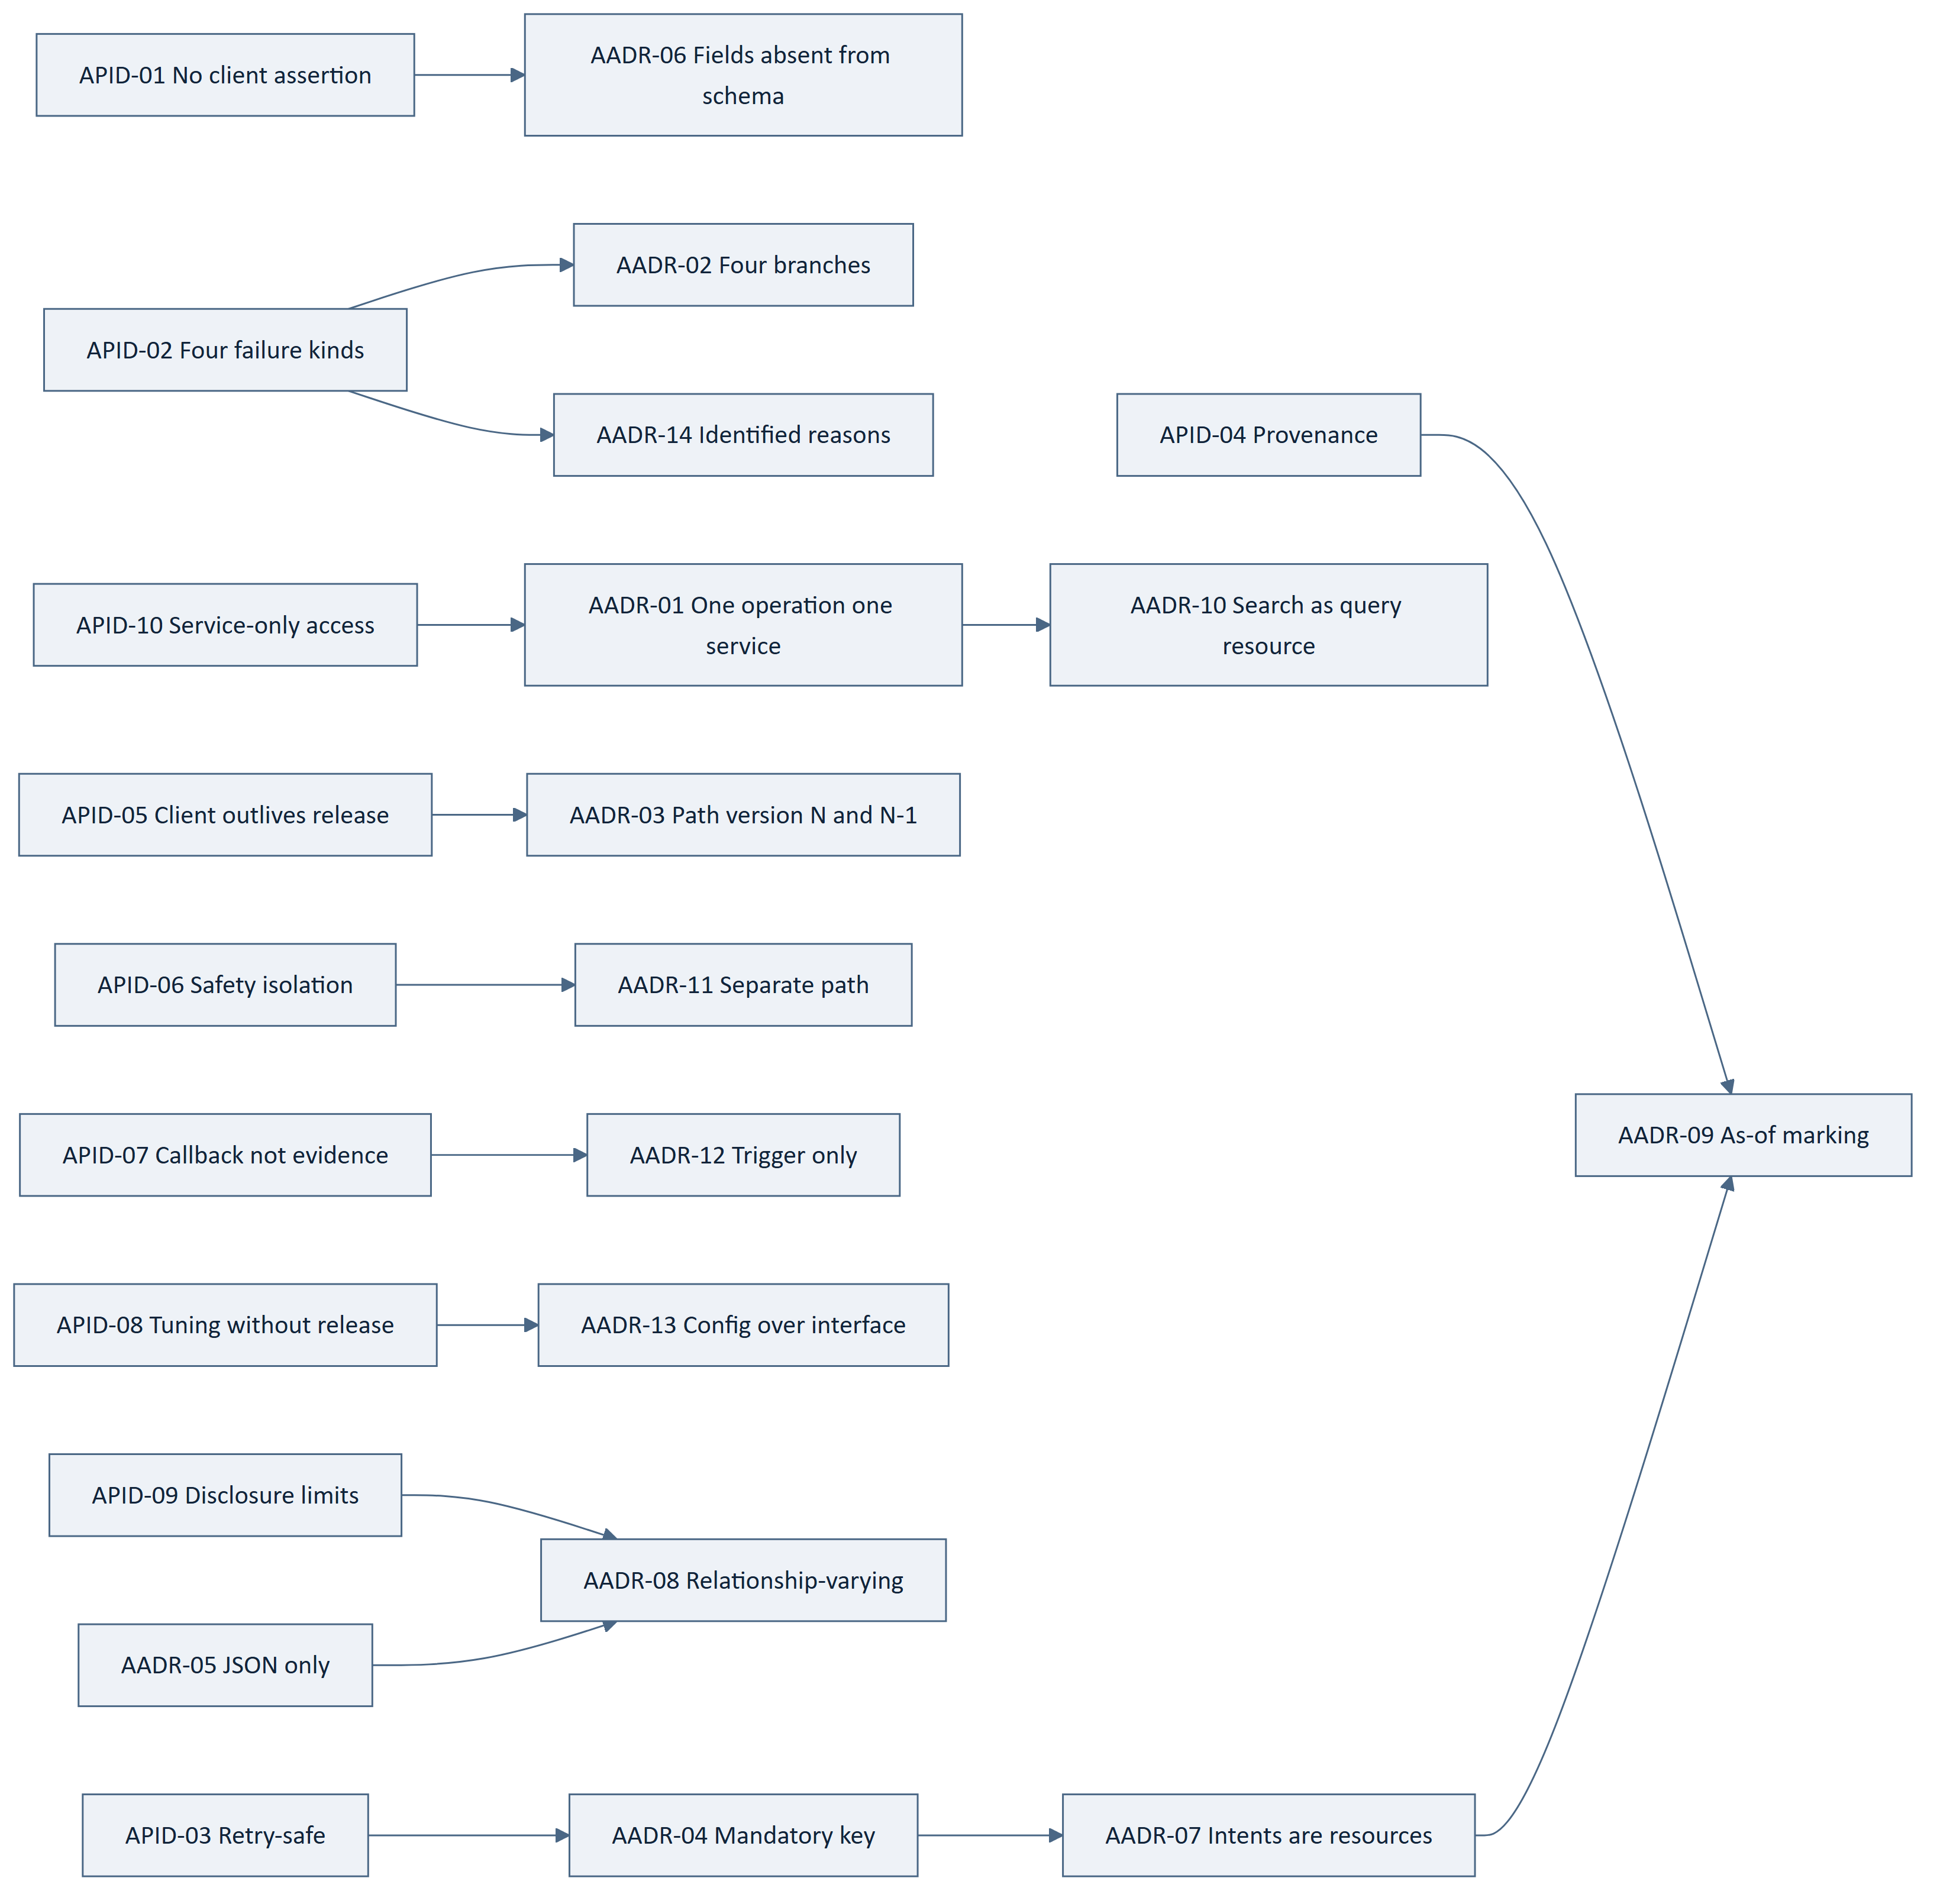
Figure 1 — 3.15 Driver to Decision Map

4. Interface Model and Conventions
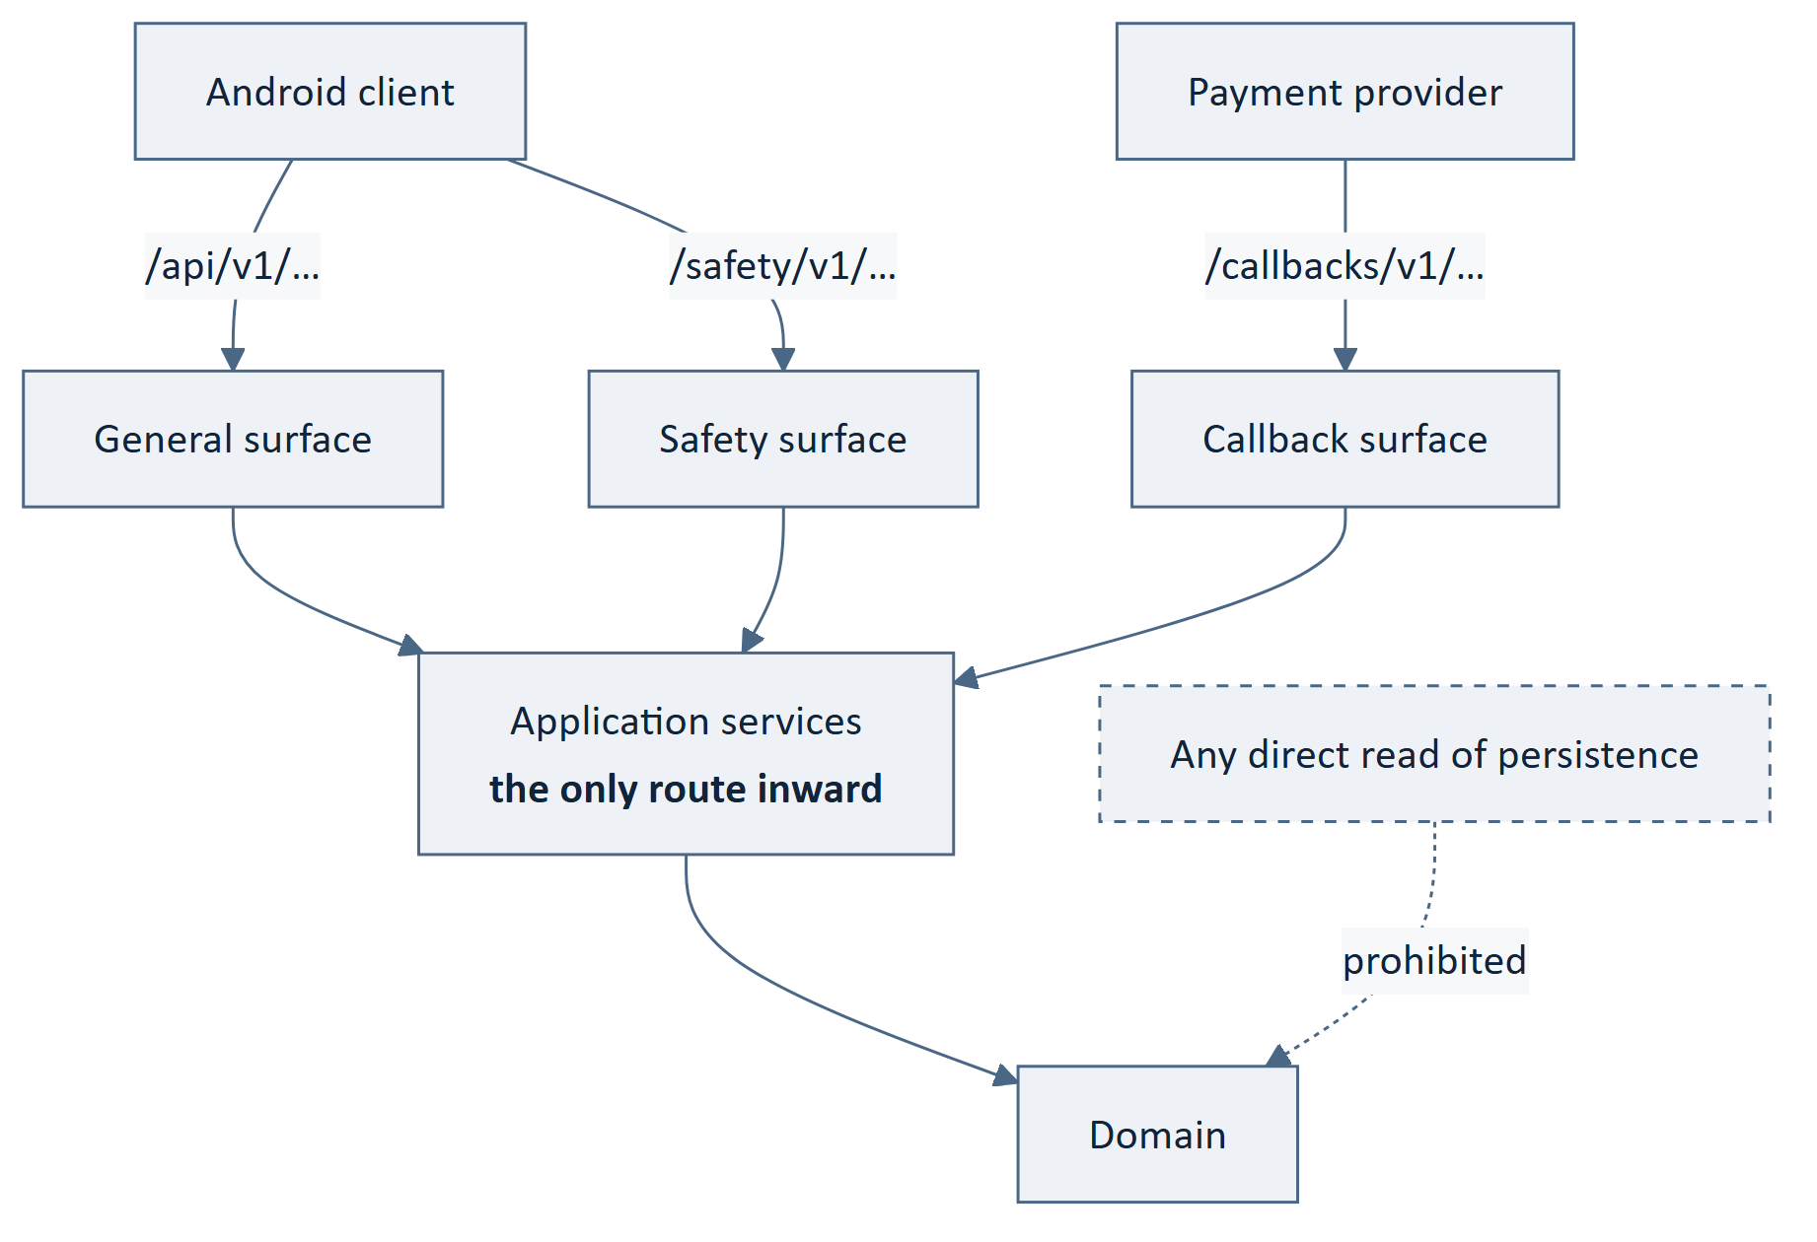
Figure 2 — 4. Interface Model and Conventions
Table 26 — 4. Interface Model and Conventions
ID | Statement | Src
API-001 | The platform shall expose one REST interface over HTTP for client elements. | ARCH-120, BE-065
API-002 ‡ | Every operation shall invoke exactly one application service operation. | AADR-01, BE-013
API-003 ‡ | No operation shall read persistence other than through an application service. | AADR-01, BE-104
API-004 | An operation shall be identified by a path and a method, and shall have one meaning. | AADR-05
API-005 | Resource paths shall name collections in the plural and members by identifier. | AADR-05
API-006 | A path segment shall not encode an action where a method expresses it. | AADR-05
API-007 | GET shall be safe and shall change no authoritative state. | AADR-01
API-008 | PUT and DELETE shall be idempotent by definition of the operation, independently of the idempotency key. | AADR-04
API-009 | POST shall be used where an operation creates a resource or submits an intent. | AADR-07
API-010 | PATCH shall be used for partial amendment of a caller-owned resource. | AADR-05
API-011 | Request and response bodies shall be application/json; no other media type shall be negotiated. | AADR-05
API-012 | The interface shall not offer field selection, sparse representation or a query language. | AADR-05
API-013 | Identifiers exposed by the interface shall be opaque to the caller and shall not encode meaning. | AADR-05, API-014
API-014 ‡ | An identifier shall not be guessable in a way that permits enumeration of another party's resources. | NFR-061, SRS-REQ-141
API-015 | Times shall be expressed in a single unambiguous representation carrying an offset. | AADR-09
API-016 ‡ | Monetary amounts shall be transmitted in an exact representation and never as a floating-point number. | BE-095, NFR-127
API-017 | The interface shall not depend on request or response header order, casing or optional whitespace for meaning. | AADR-05
API-018 | An operation that uses POST without changing state shall be documented as such, and shall be safe to repeat. | AADR-10

5. Versioning and Negotiation
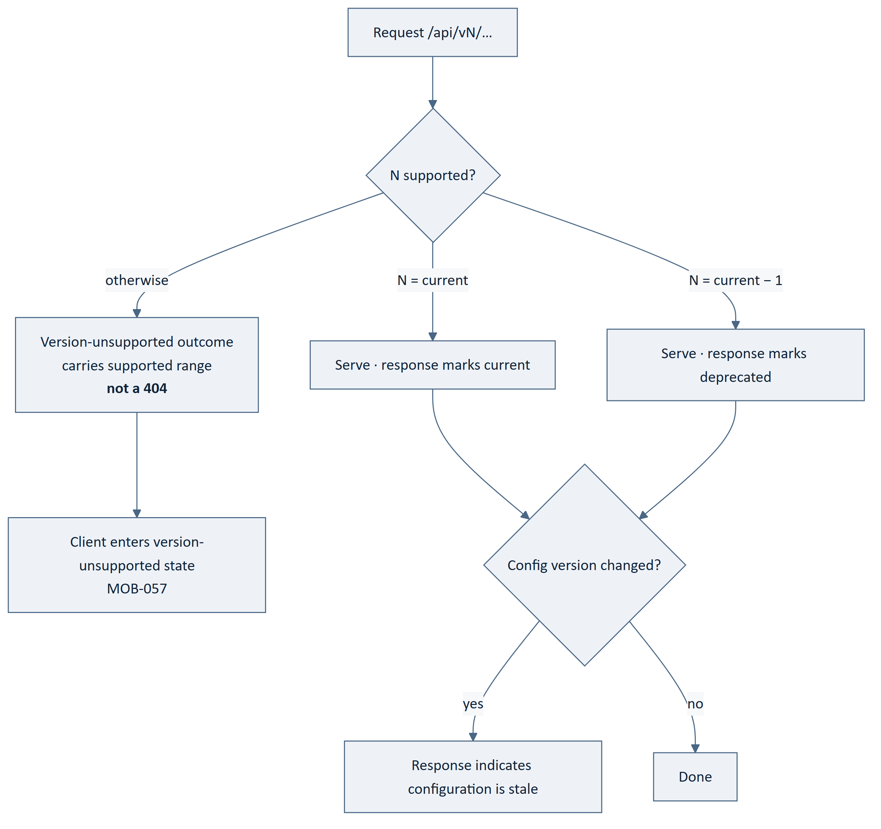
Figure 3 — 5. Versioning and Negotiation
Table 27 — 5. Versioning and Negotiation
ID | Statement | Src
API-019 ‡ | The interface version shall be the first path segment, in the form /api/v{n}/. | AADR-03, ARCH-123
API-020 ‡ | The platform shall not introduce a breaking change within a version. | SRS-REQ-033
API-021 | The platform shall serve the current version and the immediately preceding version concurrently. | SRS-REQ-034, BE-067
API-022 | Every response shall state the version that served it. | ARCH-123, SRS-REQ-138
API-023 | A response served by the preceding version shall additionally indicate that the version is deprecated. | AADR-03
API-024 ‡ | A request for a version that is neither current nor preceding shall receive a distinct version-unsupported outcome, and shall not receive a not-found outcome. | AADR-03, MOB-057
API-025 | The version-unsupported outcome shall state the versions the platform does serve. | SRS-REQ-010, MOB-057
API-026 | The version-unsupported outcome shall be reachable without an authenticated session. | MOB-057
API-027 | The client shall be able to determine the supported range without attempting a business operation. | MOB-057, SRS-REQ-009
API-028 | The following shall be breaking and shall require a version increment: removing a field, removing an operation, narrowing an accepted value set, changing a field's type, changing a field's meaning, adding a required request field, or moving a condition between error branches. | SRS-REQ-033, AADR-02
API-029 | The following shall be non-breaking within a version: adding an optional request field, adding a response field, adding an operation, adding a resource, adding a refusal reason identifier, or widening an accepted value set. | SRS-REQ-033
API-030 ‡ | Moving a condition from one error branch to another shall be treated as breaking, because a client's treatment of it changes. | AADR-02, MADR-10
API-031 | The domain shall not be versioned; both served versions shall reach the same application services. | BE-066
API-032 | A version shall be retired only after a stated notice period. | SRS-REQ-034
API-033 | The duration for which the preceding version is served is [TBD – Business Decision Required]; it depends on the client update profile, which is unmeasured. | SRS-OQ-005, API-OQ-01
API-034 | Deprecation of an operation within a version shall be indicated in its response before the operation is removed in the next version. | AADR-03

`SRS-OQ-005` asked two questions: how many versions, and for how long. API-021 answers the first — two. API-033 records that the second cannot be answered without a client update profile that does not yet exist. Half an answer is recorded as half an answer.

6. Representation Rules

6.1 General
Table 28 — 6.1 General
ID | Statement | Src
API-035 | A resource shall have exactly one representation. | AADR-05
API-036 ‡ | A representation shall contain no field by which the caller may assert an authoritative value. | AADR-06, ARCH-121
API-037 ‡ | Fare, verification standing, payment status, seat counts, ratings, balances and trip state shall be absent from every request schema. | AADR-06, BE-069
API-038 ‡ | A request containing a field the schema does not define shall be refused in whole. | AADR-06, ARCH-133
API-039 ‡ | A request containing a field whose name matches a known authoritative value shall additionally be recorded as an integrity event. | ARCH-133, NFR-069
API-040 ‡ | Every inbound value shall be validated against platform state before use, irrespective of its origin. | ARCH-131, SRS-REQ-032
API-041 | Validation of well-formedness shall not substitute for validation against platform state. | MOB-038, API-040
API-042 ‡ | An administrative request shall receive validation identical to a client request. | ARCH-132, BE-076

6.2 Provenance
Table 29 — 6.2 Provenance
ID | Statement | Src
API-043 ‡ | Every response shall carry the time at which the platform evaluated it. | AADR-09, MOB-018
API-044 ‡ | A value derived from a projection shall carry that projection's maintenance time. | AADR-09, BE-124
API-045 | A value read under lock shall be marked as authoritative at the stated instant. | AADR-09, BE-094
API-046 | A client shall tolerate response fields it does not recognise, so that additive change remains non-breaking. | API-029
API-047 | A representation shall not present a derived value without indicating what it was derived from where the distinction affects a decision. | BE-121, NFR-086
API-048 | Seat availability shall be served from the authoritative record, never from a projection. | ARCH-056, BE-122

6.3 Disclosure
Table 30 — 6.3 Disclosure
ID | Statement | Src
API-049 ‡ | A representation shall include only the fields the caller's relationship entitles them to. | AADR-08, ARCH-125
API-050 ‡ | Entitlement shall be evaluated in the application layer and never by the adapter. | BE-179, AADR-08
API-051 ‡ | A counterparty's precise home or personal location shall not be disclosed beyond what a trip requires. | BAD-RULE-025, NFR-061
API-052 ‡ | Contact details shall be disclosed only where a qualifying relationship exists. | FRD-FR-170, NFR-061
API-053 ‡ | No payment instrument credential shall appear in any request or response. | BE-097, §17.6
API-054 ‡ | Information shared with an unauthenticated recipient shall be bounded and time-limited by policy configuration. | ARCH-137
API-055 | The schema shall mark which fields are relationship-dependent, so that absence is expected rather than exceptional. | AADR-08
API-056 | A field's absence shall not be usable to infer the value it would have carried. | AADR-08

7. Idempotency
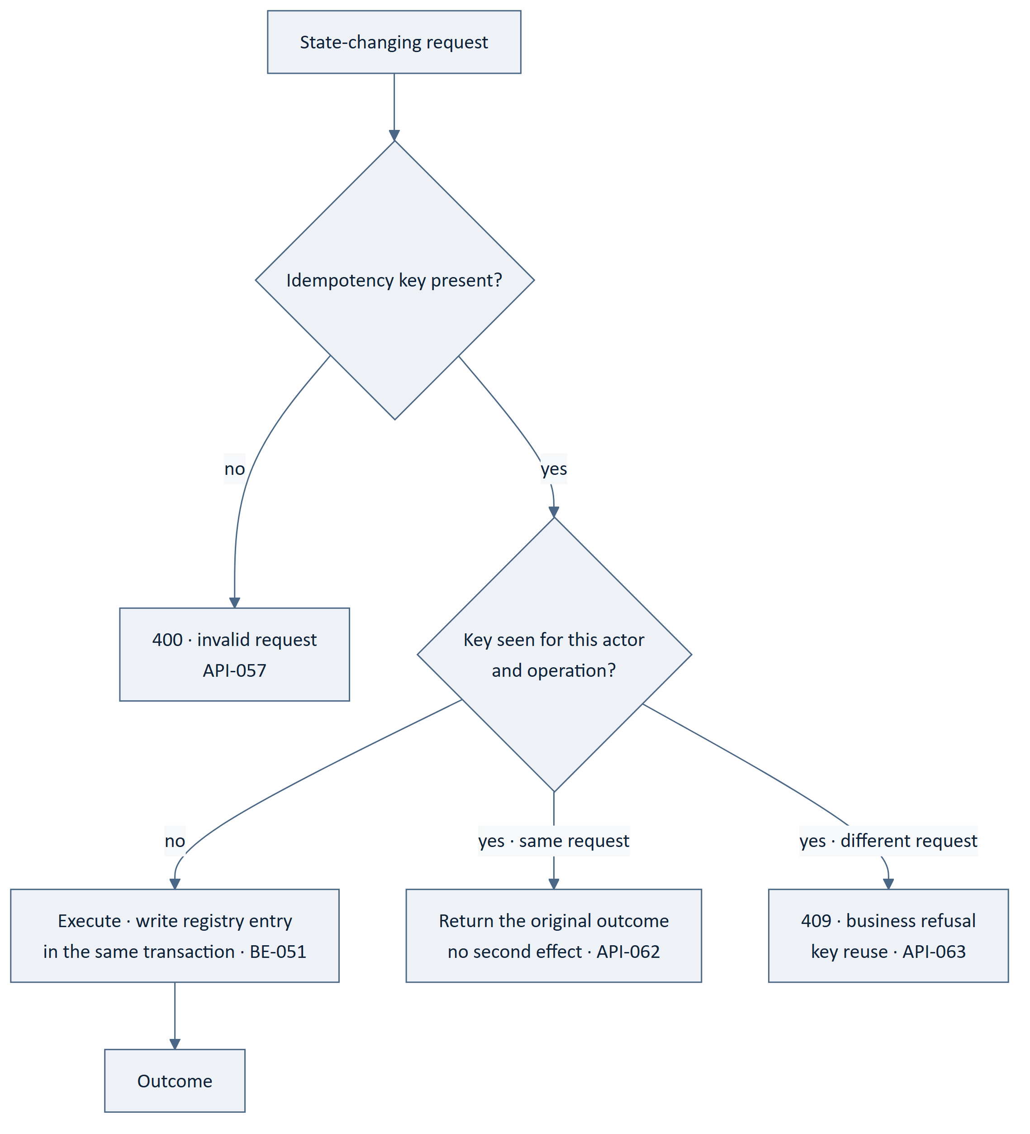
Figure 4 — 7. Idempotency
Table 31 — 7. Idempotency
ID | Statement | Src
API-057 ‡ | Every state-changing request shall carry an idempotency key. | AADR-04, ARCH-124
API-058 ‡ | A state-changing request without an idempotency key shall be refused as an invalid request. | AADR-04
API-059 | The key shall be caller-generated and opaque to the platform. | MOB-049
API-060 | The key shall be scoped to the acting actor and the operation. | BADR-08
API-061 ‡ | The registry entry shall be written in the same transaction as the effect it guards. | BE-051
API-062 ‡ | A repeated request with the same key and the same content shall return the original outcome and shall produce no second effect. | SRS-REQ-044, BADR-08
API-063 ‡ | A repeated key with different content shall be refused as a business refusal, and shall not overwrite the original outcome. | BADR-08
API-064 | A replayed response shall be indicated as a replay, so that a client does not treat it as a fresh outcome. | AADR-04, MOB-068
API-065 | GET shall not require an idempotency key. | API-007
API-066 ‡ | Idempotency shall apply to the safety surface exactly as to the general surface. | AADR-11, BE-135
API-067 ‡ | Idempotency shall apply to provider callbacks. | BE-160, AADR-12
API-068 | The client shall generate the key when the intent is recorded, not when the request is sent. | MOB-049
API-069 | Key retention duration is a tuning value held as configuration. | §15.3
API-070 | A key whose retention has lapsed shall be treated as unseen; retention shall therefore exceed the longest plausible client retry window. | API-069, API-062

8. The Error Model
This section discharges the first of the three obligations CMP-DOC-08 §17.5 placed on
this document.

8.1 The Four Branches
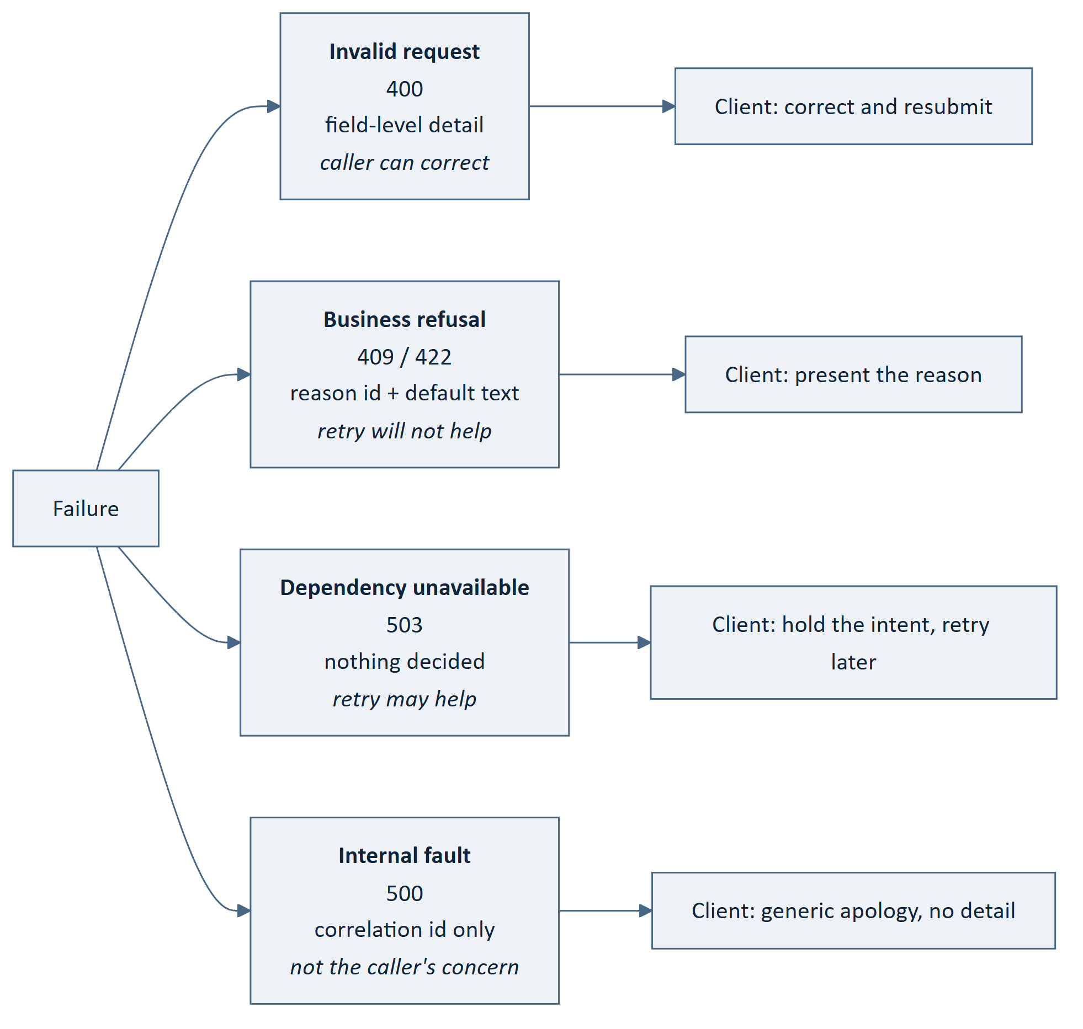
Figure 5 — 8.1 The Four Branches
Table 32 — 8.1 The Four Branches
Branch | Status | Body carries | Retry
Invalid request | 400 | Field-level detail identifying each offending field | After correction
Business refusal | 409 conflict with state · 422 rule declined | Reason identifier and human-readable default | No — the answer will not change
Dependency unavailable | 503 | Nothing decided; optional retry guidance | Yes
Internal fault | 500 | Correlation identity only | Yes, but the platform is at fault

Table 33 — 8.1 The Four Branches
ID | Statement | Src
API-071 ‡ | Every failure shall be represented as exactly one of four branches. | AADR-02, BE-185
API-072 ‡ | Each branch shall have its own status code range and its own body shape, distinguishable by structure alone. | AADR-02, MADR-10
API-073 ‡ | A business refusal shall never be represented as an internal fault. | SRS-REQ-163, BE-186
API-074 ‡ | An internal fault shall never be represented as a business refusal. | SRS-REQ-163, BE-186
API-075 ‡ | A dependency unavailability shall never be represented as a business refusal. | BE-187, ARCH-122
API-076 ‡ | A dependency unavailability shall never be represented as success. | BE-152, SRS-REQ-112
API-077 | The interface shall distinguish a refusal arising from the caller's request from one arising from platform unavailability. | SRS-REQ-139, ARCH-122

8.2 Invalid Request
Table 34 — 8.2 Invalid Request
ID | Statement | Src
API-078 | An invalid-request body shall identify each offending field and why it is offending. | SRS-REQ-140
API-079 | An invalid request shall report all detectable field failures, not only the first. | NFR-087
API-080 | Field-level detail shall not disclose platform state the caller is not entitled to. | API-049, SRS-REQ-141

8.3 Business Refusal
Table 35 — 8.3 Business Refusal
ID | Statement | Src
API-081 ‡ | A business refusal shall carry a stable machine-readable reason identifier. | AADR-14
API-082 ‡ | A business refusal shall carry a human-readable default suitable for presentation. | SRS-REQ-140, BE-188
API-083 | The client shall present its own localised text keyed by the identifier, and shall fall back to the default for an unrecognised identifier. | AADR-14, SRS-REQ-029
API-084 | A reason identifier shall not be removed or repurposed within a version. | API-028, AADR-14
API-085 | Adding a reason identifier shall be non-breaking. | API-029
API-086 ‡ | A refusal reason shall state what the platform declined, and shall not state platform state the caller is not entitled to. | SRS-REQ-141, API-049
API-087 | A refusal arising from a state conflict shall be distinguished from one arising from a rule. | AADR-02
API-088 ‡ | Refused authorisations shall be recorded. | ARCH-135, BE-183

8.4 Dependency Unavailable
Table 36 — 8.4 Dependency Unavailable
ID | Statement | Src
API-089 ‡ | The dependency-unavailable branch shall convey that nothing was decided — neither success nor failure. | BE-152, ARCH-065
API-090 | The branch shall not name the provider or expose its error. | ARCH-063, BE-154
API-091 | Degraded platform state shall be propagated so that the client can disclose what remains available. | ARCH-105, MOB-106

8.5 Internal Fault
Table 37 — 8.5 Internal Fault
ID | Statement | Src
API-092 ‡ | An internal fault shall disclose no internal detail — no stack, no query, no identifier of an internal component. | SRS-REQ-165, BE-189
API-093 | An internal fault shall carry a correlation identity a caller may quote to support. | BE-199, NFR-118

8.6 Classification Rules
Where a condition could plausibly be placed in more than one branch, these rules decide.
Table 38 — 8.6 Classification Rules
Condition | Branch | Why
Field missing, malformed, or of the wrong type | Invalid request | The caller can correct it
Unknown field present | Invalid request | API-038
Idempotency key absent | Invalid request | API-058
Idempotency key reused with different content | Business refusal | The platform declines; correction is not possible
Caller not authenticated | Business refusal | Distinguished from authorisation by reason identifier
Caller not entitled | Business refusal | Never a not-found, which would leak existence
Resource does not exist | Business refusal | Same shape as not-entitled, so the two are indistinguishable to a caller
Seats no longer available | Business refusal | FRD-FR-105
Payment not yet verified | Not a failure | pending is an outcome — AADR-07
Provider did not answer | Dependency unavailable | BE-152
Platform cannot reach its own store | Internal fault | Not the caller's concern
Interface version unsupported | Its own outcome | API-024 — not a branch, and not a 404

Table 39 — 8.6 Classification Rules
ID | Statement | Src
API-094 ‡ | Absence and non-entitlement shall be indistinguishable to a caller, so that existence cannot be probed. | API-014, SRS-REQ-141

9. Authorisation and Session Carriage
This section states position and behaviour only. Token format, signing, storage, rotation and transport configuration are CMP-DOC-13's (§0.6.1).

Table 40 — 9. Authorisation and Session Carriage
ID | Statement | Src
API-095 ‡ | Every operation other than those §9.1 names shall require an authenticated session. | ARCH-134, BE-179
API-096 ‡ | Authorisation shall be evaluated in the application layer on every operation. | BE-179, ARCH-031
API-097 ‡ | Authorisation shall not be implemented in transport middleware alone. | BE-180, ARCH-031
API-098 ‡ | Authorisation shall be deny-by-default; an operation with no stated rule shall be refused. | ARCH-134
API-099 ‡ | Ownership and relationship shall be evaluated against platform state, never against an inbound claim. | BE-181, SRS-REQ-032
API-100 | The session credential shall be carried in a request header and never in a URI, a query parameter or a body field. | NFR-062, SRS-REQ-141
API-101 ‡ | A credential shall never appear in a response. | NFR-053, SRS-REQ-122
API-102 | Session establishment, refresh and termination shall each be a distinct operation. | FRD-FR-016, NFR-054
API-103 ‡ | A terminated session shall be unusable, and a request bearing one shall be refused. | NFR-054
API-104 | Session lifetime shall be bounded, and the bound shall be policy configuration. | NFR-055, BADR-12
API-105 ‡ | The interface shall carry no operation by which a caller may alter its own authorisation. | ARCH-121, AADR-06
API-106 ‡ | An attempt to act outside the caller's entitlement shall be refused in whole and recorded. | ARCH-133, API-088
API-107 | A refusal for non-entitlement shall carry the same shape as one for absence. | API-094
API-108 | Administrative callers shall traverse the same authorisation evaluation as client callers. | BE-179, ARCH-132
API-109 ‡ | Values received from a caller shall never be interpolated into a query, a command or a path. | BE-102, §17.6
API-110 | Which operations are reachable without a session is stated in §9.1 and nowhere else. | API-095

9.1 Operations Reachable Without a Session
Table 41 — 9.1 Operations Reachable Without a Session
Operation | Why
Version discovery (§5) | API-026 — a client must learn it is unsupported before it can authenticate
Session establishment | Otherwise unreachable
Phone verification initiation and completion | FRD-FR-007 — precedes an account
Configuration fetch, public subset (§14) | API-193 — a cold client needs conservative defaults
Platform health indication | BE-203

10. Collections, Filtering and Paging
Table 42 — 10. Collections, Filtering and Paging
ID | Statement | Src
API-111 | A collection shall be paged, without exception. | AADR-05, NFR-049
API-112 | Paging shall be cursor-based, so that an insertion does not shift a page boundary. | AADR-05
API-113 | A cursor shall be opaque and shall not encode a position a caller may manipulate. | API-013
API-114 | A collection response shall state whether a further page exists, and shall not require the caller to infer it from a short page. | AADR-05
API-115 | The default and maximum page size shall be configuration, not a compiled constant. | §15.3
API-116 | A collection shall have one stated ordering, and that ordering shall be total. | AADR-05
API-117 ‡ | A collection shall include only members the caller is entitled to see, and shall not indicate that others were excluded. | API-049, SRS-REQ-141
API-118 | A count shall be returned only where it can be produced without an unbounded scan. | NFR-020
API-119 | Where a count is unavailable, it shall be reported as unavailable and never as zero. | FRD-FR-236, BE-081
API-120 | Filtering shall be limited to the parameters each operation states, and no general filter syntax shall be offered. | AADR-05, AADR-10
API-121 | A collection served from a projection shall carry that projection's maintenance time. | API-044
API-122 | Search shall be a distinct resource and shall not be expressed as a filtered rides collection. | AADR-10
API-123 | A search shall state that it is unavailable rather than return an unranked or unmatched result set. | FRD-FR-096
API-124 | The number of external routing calls a single search may cause shall be bounded, and the bound shall be configuration. | NFR-021, §15.3

11. Resource Catalogue

11.0 How to Read This Section
Every operation below realises behaviour specified in CMP-DOC-04 and invokes exactly one
application service (API-002). All paths are relative to /api/v1/. All state-changing
operations require an idempotency key (API-057). No operation accepts an authoritative
value (API-037).
Coverage is bounded by decided behaviour. §11.14 lists the eleven resources that would be
needed for the 33 Outlined use cases and names the decision blocking each. No operation
appears below for behaviour CMP-DOC-04 did not specify.
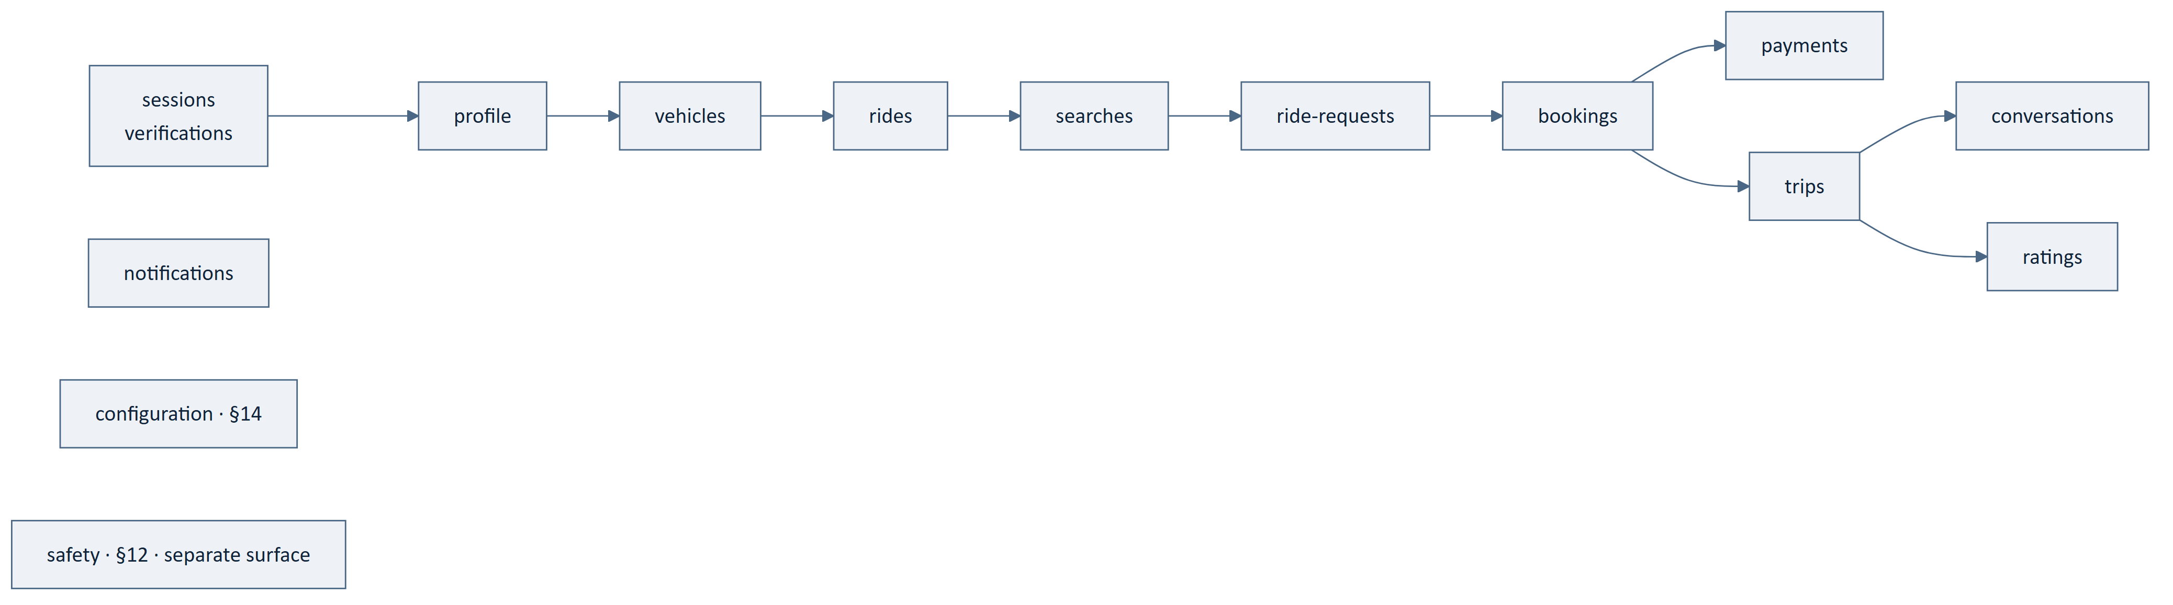
Figure 6 — 11.0 How to Read This Section

11.1 Sessions and Verification
Table 43 — 11.1 Sessions and Verification
Method | Path | Realises
POST | /verifications | FRD-FR-007 — initiate phone verification
POST | /verifications/{id}/attempts | FRD-FR-009, FRD-FR-010 — submit a demonstration
POST | /sessions | FRD-FR-016 — establish a session
POST | /sessions/current/refresh | NFR-055 — extend within the bound
DELETE | /sessions/current | NFR-054 — terminate

Table 44 — 11.1 Sessions and Verification
ID | Statement | Src
API-125 ‡ | Verification standing shall be readable but shall never be writable through the interface. | BAD-RULE-006, BE-033
API-126 | Attempt limits shall be enforced by the platform and reported as a business refusal on exhaustion. | FRD-FR-011, NFR-057
API-127 | Rate limiting on verification shall be a platform behaviour, and its bound shall be configuration. | NFR-057, §15.3

11.2 Profile
Table 45 — 11.2 Profile
Method | Path | Realises
GET | /profile | FRD-FR-022 — read own profile
PATCH | /profile | FRD-FR-023, FRD-FR-024 — amend, with rejection retaining the previous
GET | /users/{id} | FRD-FR-027 — counterparty view, relationship-limited
GET | /profile/emergency-contacts | FRD-FR-181
PUT | /profile/emergency-contacts/{id} | FRD-FR-182, FRD-FR-183
DELETE | /profile/emergency-contacts/{id} | FRD-FR-182

Table 46 — 11.2 Profile
ID | Statement | Src
API-128 ‡ | A counterparty representation shall carry verification standing read from platform state at request time. | FRD-FR-027, BE-033
API-129 ‡ | A counterparty representation shall not disclose precise home location, contact details or trip history beyond the qualifying relationship. | BAD-RULE-025, API-051
API-130 | A rejected profile amendment shall state why and shall leave the stored profile unchanged. | FRD-FR-024
API-131 | An unusable emergency contact shall be reported with the reason it is unusable. | FRD-FR-183

11.3 Vehicles
Table 47 — 11.3 Vehicles
Method | Path | Realises
GET | /vehicles | Own vehicles
POST | /vehicles | FRD-FR-030 — register
GET | /vehicles/{id} | Read
PATCH | /vehicles/{id} | Amend
DELETE | /vehicles/{id} | Withdraw

Table 48 — 11.3 Vehicles
ID | Statement | Src
API-132 ‡ | Lawful seating capacity shall be platform-held and shall not be settable by the caller. | BAD-RULE-017, BE-023
API-133 ‡ | A vehicle shall not be withdrawn where it carries a ride with a confirmed booking; the attempt shall be a business refusal. | FRD-FR-070, BE-018

11.4 Rides
Table 49 — 11.4 Rides
Method | Path | Realises
GET | /rides | Own published rides
POST | /rides | FRD-FR-050, FRD-FR-054 — publish
GET | /rides/{id} | Read, relationship-limited
PATCH | /rides/{id} | FRD-FR-064 — amend
DELETE | /rides/{id} | Withdraw
GET | /rides/{id}/seats | ARCH-080 — authoritative availability

Table 50 — 11.4 Rides
ID | Statement | Src
API-134 ‡ | Seats offered shall be validated against the vehicle's recorded lawful capacity, and a request exceeding it shall be a business refusal. | BE-023, FRD-FR-059
API-135 ‡ | Seat availability shall be read from the authoritative record and marked as such. | API-048, ARCH-080
API-136 | Publication shall be deferred rather than completed where the mapping service is unavailable, and reported as dependency-unavailable. | FRD-FR-053, API-089
API-137 | Amending a ride shall invalidate its cached route geometry. | ARCH-096
API-138 | No recurring-commute resource is specified. CMP-DOC-04 §1.2 records the area as carrying zero functional requirements, withheld pending BAD-DEC-008. See §11.14. | BAD-DEC-008, CMP-DOC-04 §9.2
API-139 ‡ | Withdrawal shall be permitted where the ride carries no confirmed booking, and shall be refused as a business refusal where it does. | FRD-FR-069, FRD-FR-070

11.5 Search
Table 51 — 11.5 Search
Method | Path | Realises
POST | /searches | FRD-FR-090, SRS-REQ-049 — route-overlap matching

Table 52 — 11.5 Search
ID | Statement | Src
API-140 | Search shall accept a journey description and return a ranked result set. | AADR-10, SRS-REQ-049
API-141 | A result shall carry the driver information and verification indicators a travel decision requires, and no more. | FRD-FR-090, API-049
API-142 | Match quality shall be expressed in terms a passenger can act on without explanation. | NFR-085
API-143 | Search shall be re-evaluated in full when repeated, and shall not be served from a cached result set. | FRD-FR-093
API-144 | A search returning no candidate shall be a successful empty result, not a refusal. | ARCH-081, API-071

11.6 Ride Requests
Table 53 — 11.6 Ride Requests
Method | Path | Realises
POST | /ride-requests | FRD-FR-100 — request a seat
GET | /ride-requests | Own requests, or requests on own rides
GET | /ride-requests/{id} | Read
POST | /ride-requests/{id}/acceptance | FRD-FR-103 — driver accepts
POST | /ride-requests/{id}/decline | Driver declines
DELETE | /ride-requests/{id} | Passenger withdraws

Table 54 — 11.6 Ride Requests
ID | Statement | Src
API-145 ‡ | Acceptance shall not confirm a booking; confirmation requires a verified payment. | BE-025, BAD-RULE-028
API-146 | The requesting passenger's verification standing shall be presented to the driver. | FRD-FR-101
API-147 | Whether and for how long seats are held during request and payment is [TBD – Business Decision Required]. | BAD-RULE-030

11.7 Bookings
Table 55 — 11.7 Bookings
Method | Path | Realises
POST | /bookings | FRD-FR-105 — create, pending payment
GET | /bookings | Own bookings
GET | /bookings/{id} | Read
POST | /bookings/{id}/cancellation | Passenger cancels

Table 56 — 11.7 Bookings
ID | Statement | Src
API-148 ‡ | A booking shall be created in pending state and shall not be reported as confirmed until payment is verified. | AADR-07, BE-025
API-149 ‡ | Confirmation shall be refused where seats have become unavailable at the moment of confirmation. | FRD-FR-105, BE-056
API-150 ‡ | The fare shall be computed by the platform, returned in the representation, and never accepted from the caller. | BE-032, ARCH-083
API-151 | Cancellation consequence is [TBD – Business Decision Required]; the operation exists, its effect on money does not. | GAP-008, GAP-009

11.8 Payments
Table 57 — 11.8 Payments
Method | Path | Realises
POST | /bookings/{id}/payments | FRD-FR-120 — initiate
GET | /payments/{id} | FRD-FR-134 — read status
POST | /payments/{id}/verification | FRD-FR-132 — request re-verification

Table 58 — 11.8 Payments
ID | Statement | Src
API-152 ‡ | Payment status shall be one of verified, failed or pending, and no other value shall appear. | BE-026, SRS-REQ-155
API-153 ‡ | Payment status shall never be settable through the interface. | BAD-RULE-033, AADR-06
API-154 ‡ | A response from a client-side payment application shall never be accepted as evidence of payment. | BAD-RULE-032, SRS-REQ-107
API-155 ‡ | An unresolved payment shall be reported as pending; the interface shall not assume an outcome. | BE-159, FRD-FR-131
API-156 ‡ | The passenger shall be informed of the platform's verified outcome, not of the outcome the provider reported. | FRD-FR-135
API-157 ‡ | Payment verification outcomes shall never be cached. | ARCH-126
API-158 | Return of value where a trip does not occur is not specified; see GAP-009 in §11.14. | GAP-009

11.9 Trips
Table 59 — 11.9 Trips
Method | Path | Realises
GET | /trips | Own trips
GET | /trips/{id} | Read
POST | /trips/{id}/start | FRD-FR-142 — driver starts
POST | /trips/{id}/completion | FRD-FR-166 — driver completes
POST | /trips/{id}/positions | ARCH-093 — position reports during an active trip
GET | /trips/{id}/positions/latest | Participant view
POST | /trips/{id}/ratings | FRD-FR-172 — rate a counterparty

Table 60 — 11.9 Trips
ID | Statement | Src
API-159 ‡ | A trip shall not start without at least one confirmed booking. | BE-028, SRS-REQ-159
API-160 ‡ | Trip state shall be platform-determined and shall never be settable directly. | AADR-06, ARCH-121
API-161 ‡ | A position shall not be presented as current beyond its configured staleness bound. | ARCH-094, §15.3
API-162 | Position reporting cadence shall be supplied by the platform through configuration, not chosen by the client. | ARCH-093, ARCH-026, §14

11.10 Communication
Table 61 — 11.10 Communication
Method | Path | Realises
GET | /conversations | FRD-FR-175
GET | /conversations/{id}/messages | Read
POST | /conversations/{id}/messages | FRD-FR-176 — send

Conversation membership derives from a qualifying ride relationship and is not settable
(FRD-FR-170).

11.11 Notifications
Table 62 — 11.11 Notifications
Method | Path | Realises
GET | /notifications | FRD-FR-207 — history with category and time
POST | /notifications/{id}/acknowledgement | Mark seen
GET | /notification-preferences | FRD-FR-200
PUT | /notification-preferences | Amend
PUT | /devices/current | Register the delivery target
DELETE | /devices/current | Deregister

A notification whose subject is no longer accessible shall say so rather than fail
silently (FRD-FR-208).

11.12 Wallet and Rewards
Wallet and reward behaviour is Outlined, not Specified. No operation is stated. See
§11.14.

11.13 Platform
Table 63 — 11.13 Platform
Method | Path | Realises
GET | /health | BE-203 — platform health, distinguished from dependencies
GET | /versions | API-027 — supported version range
GET | /configuration | §14

11.14 Resources Withheld
FACT. 33 use cases are Outlined and 29 functional gaps exist, 11 of them Critical.
A resource is named below where one would be needed. **No operation, path, field or
status is invented for any of them.**
Table 64 — 11.14 Resources Withheld
Resource that would be needed | Blocked by
Recurring commute definition, control and generation | BAD-DEC-008 — CMP-DOC-04 records zero functional requirements for the whole area (UC-065–UC-067 Outlined)
Wallet balance and entries | Wallet behaviour undecided — CMP-DOC-03 Outlined set
Reward accrual and redemption | Reward scheme undecided
Refund and return of value | GAP-009 — Critical; no defined behaviour when a paid trip does not happen
Driver cancellation consequence | GAP-008 — Critical
Dispute and claim | No specified behaviour
Insurance position | [TBD – Business Decision Required]; nothing may be stated (NFR-137)
Referral | Undecided
Fraud reporting and response | GAP-013 — unowned through ten documents
Emergency dispatch | GAP-004 — see §12.4
Operator and support surfaces | CMP-DOC-17

`API-151` and `API-158` are the same defect seen from two resources. FRD-FR-070 prevents a driver withdrawing a ride that carries a confirmed booking, so the interface has an answer for that. It has no answer for the case behind it: a passenger has paid, the trip does not happen, and no document above this one has decided what is returned or on what terms. The cancellation operation exists because the journey reaches it; its monetary effect does not exist because nobody has defined it.

12. The Safety Surface

12.1 Operations
All paths are relative to /safety/v1/.
Table 65 — 12.1 Operations
Method | Path | Realises
POST | /incidents | FRD-FR-185 — raise a safety signal
GET | /incidents/{id} | Read own incident
POST | /incidents/{id}/context | FRD-FR-187 — supply context that was unavailable at raising

12.2 Statements
Table 66 — 12.2 Statements
ID | Statement | Src
API-163 ‡ | Safety operations shall be served under a path prefix distinct from the general surface. | AADR-11, BADR-16
API-164 ‡ | The request shape for raising an incident shall be the minimum that permits recording, so that a signal is never lost to a validation failure on a non-essential field. | FRD-FR-188, BE-194
API-165 ‡ | An incident shall be recorded even where part of its context is unavailable, with the missing context marked. | FRD-FR-187, BE-194
API-166 ‡ | Raising an incident shall not depend on payment, search, matching, rating or projection capability. | BE-193, AADR-11
API-167 ‡ | A safety signal shall never be discarded. | FRD-FR-188, NFR-030
API-168 ‡ | A safety operation shall never be rate-limited to the point of refusal. | BE-196, FRD-FR-188
API-169 ‡ | Acceptance shall be acknowledged only after the signal is persisted. | ARCH-098
API-170 ‡ | The safety surface shall be specifiable and servable by a deployment implementing only these operations. | AADR-11, BE-191
API-171 ‡ | An incident shall not be closable through the client interface, and shall never close without a recorded outcome. | FRD-FR-227, BE-029
API-172 | The client shall not route a safety call through a general-purpose retry or backoff policy. | AADR-11, MOB-150
API-173 | Idempotency shall apply, so that a repeated raise under a poor connection produces one incident. | API-066
API-174 | Safety operations shall carry the same four-branch error model, with the dependency-unavailable branch reserved for the persistence path alone. | API-071, API-166

12.3 What the Safety Surface Deliberately Omits
Table 67 — 12.3 What the Safety Surface Deliberately Omits
Omitted | Why
Search, ride, booking, payment or trip reads | BE-193 — every dependency is a way to fail
Rich validation | API-164 — a rejected signal is a lost signal
Paging and filtering | Not needed to record
Configuration fetch | Would make recording depend on configuration

12.4 Emergency Dispatch
FACT. GAP-004 remains open. Whether the platform contacts an emergency service, and
by what means, is undecided.
No operation is specified. The incident resource exists so that the absence of a
dispatch path is visible rather than assumed, exactly as BE-164 intended at the port.
NFR-137 forbids implying a protection the platform does not provide, so the interface
states nothing about dispatch.

13. The Provider Callback Surface
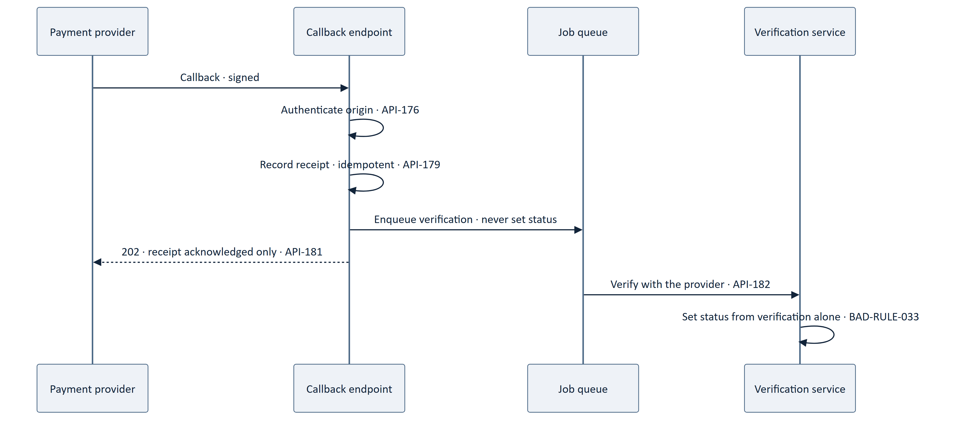
Figure 7 — 13. The Provider Callback Surface
All paths are relative to /callbacks/v1/.
Table 68 — 13. The Provider Callback Surface
ID | Statement | Src
API-175 ‡ | A provider callback shall be treated as a trigger to verify and never as the verification. | ARCH-128, AADR-12
API-176 ‡ | A callback shall be authenticated before it is recorded. | BE-160
API-177 ‡ | A callback body shall never set a payment status. | BAD-RULE-033, API-153
API-178 ‡ | A callback shall never be the sole means by which the platform learns an outcome. | SRS-REQ-142, BE-145
API-179 ‡ | Callback processing shall be idempotent, so that replay produces one effect. | BE-160, API-067
API-180 ‡ | A replayed, reordered or forged callback shall be incapable of moving money. | AADR-12, API-177
API-181 | The callback response shall acknowledge receipt only and shall carry no business outcome. | AADR-12
API-182 | Verification shall be platform-initiated and independent of the callback. | ARCH-127
API-183 | Every callback shall be recorded sufficiently to reconstruct it. | SRS-REQ-145
API-184 | The callback surface shall be reachable without a client session and shall be authorised by provider credential alone. | API-176, API-095
API-185 | The callback path shall not expose any read operation. | API-014
API-186 | Provider-specific callback shapes shall be confined to the adapter and shall not appear in the domain-facing contract. | ARCH-063, BE-153

The provider is not named here. Three of five providers are [TBD – Business Decision Required] (BE-161). The callback surface is specified as a shape a provider adapter fills; CMP-DOC-14 states the payment provider's specifics once chosen.

14. Configuration Delivery
This section discharges the third obligation CMP-DOC-08 §17.5 placed on this document.

14.1 The Resource
Table 69 — 14.1 The Resource
Method | Path | Realises
GET | /configuration | MOB-123, MADR-11

14.2 Values Delivered
Table 70 — 14.2 Values Delivered
Value | Obligation discharged
Position reporting cadence | ARCH-093, MOB-135
Position staleness bound | ARCH-094, API-161
Presentation cache validity per category | ARCH-069, MOB-123
Search result limit | NFR-020
Page size default and maximum | API-115
Session lifetime bound | API-104
Client retry and backoff policy | MOB-051
Refusal reason identifier set | AADR-14

Table 71 — 14.2 Values Delivered
ID | Statement | Src
API-187 ‡ | The client shall obtain every policy value it needs from this resource and shall embed none. | MOB-123, BADR-12
API-188 | The response shall carry the configuration version that produced it. | BE-167, ARCH-146
API-189 | Any response on any surface may indicate that configuration has changed, so that the client refetches without polling. | AADR-13, ARCH-026
API-190 ‡ | The client shall not poll this resource on a client-chosen interval. | ARCH-026, MOB-134
API-191 ‡ | No value delivered here shall be capable of relaxing an absolute business rule. | BE-172, ARCH-034
API-192 | A configuration value shall be typed and shall be validated by the platform before it is served. | BE-166, ARCH-148
API-193 | The client shall hold a documented conservative default for every value, applied only until its first successful fetch. | AADR-13
API-194 ‡ | Failure to fetch configuration shall not prevent the client from raising a safety incident. | API-166, BE-194
API-195 | The public subset reachable without a session shall contain no value that discloses platform state. | API-049, §9.1
API-196 | A configuration change shall not require a client release, and shall not be delivered by any other means. | MADR-11, AADR-13

15. Rate Limiting and Abuse Posture
Table 72 — 15. Rate Limiting and Abuse Posture
ID | Statement | Src
API-197 | The interface shall bound the rate at which an actor may invoke each operation. | NFR-040, NFR-057
API-198 ‡ | Safety operations shall be exempt from rate limiting to the point of refusal. | API-168, BE-196
API-199 | A rate-limit refusal shall be a distinct outcome carrying its own reason identifier, and shall state when the caller may retry. | AADR-14, API-081
API-200 | A rate-limit refusal shall not be represented as an internal fault or as a dependency unavailability. | API-073, API-075
API-201 ‡ | Verification attempts against a phone number shall be bounded independently of the session. | NFR-057, FRD-FR-011
API-202 | The rate of failed user-initiated operations shall be bounded. | NFR-040
API-203 | Request payload size shall be bounded, and an oversized payload shall be an invalid request. | NFR-040
API-204 ‡ | Detected attempts to assert authoritative state shall be recorded, and repetition shall be treatable as abuse. | NFR-069, API-039
API-205 | Rate limiting shall not depend on a client-supplied identifier that the client controls. | API-099
API-206 | Fraud detection is not specified here and is not owned by any document — GAP-013. This interface records integrity events but takes no fraud decision. | GAP-013

15.3 Tuning Values Held as Configuration
Their existence is specified here; their values are not invented.
Table 73 — 15.3 Tuning Values Held as Configuration
Value | Register
Page size default and maximum | [TBD – Technical Decision Required]
Search result limit | [TBD – Technical Decision Required]
External routing calls permitted per search | [TBD – Technical Decision Required]
Per-operation rate limits and windows | [TBD – Technical Decision Required]
Verification attempt limit per number | [TBD – Business Decision Required]
Request payload size bound | [TBD – Technical Decision Required]
Idempotency key retention duration | [TBD – Technical Decision Required]
Session lifetime bound | [TBD – Business Decision Required]
Position staleness bound | [TBD – Technical Decision Required]

No value above is asserted anywhere in this document. Nine values are configurable because nine decisions are outstanding, and because GAP-012 and GAP-016 mean none of them can be set from measurement yet.

16. Interface Quality Obligations
Table 74 — 16. Interface Quality Obligations
ID | Statement | Src
API-207 | Every operation shall carry a correlation identity through to the application service and back to the caller on fault. | BE-199, API-093
API-208 ‡ | Personal data shall be protected in transit; the mechanism is CMP-DOC-13's. | NFR-062, §0.6.1
API-209 ‡ | Diagnostic records of a request shall exclude personal data beyond their purpose. | ARCH-136, BE-201
API-210 | The interface shall function on an intermittent connection without loss of user-entered data, in combination with the client outbox. | NFR-162, MOB-065
API-211 | Response payloads shall be measurable so that data consumption can be attributed. | MOB-136, NFR-153
API-212 | The interface shall not require a platform change in order to release a new client version within a served version. | SRS-REQ-011, API-029
API-213 | Every integrity-critical statement in this document shall have an automated contract test. | NFR-106, BE-207
API-214 ‡ | A contract test shall exist asserting that no request schema accepts an authoritative field. | API-037, AADR-06
API-215 ‡ | A contract test shall exist for each of the four error branches, asserting that a condition of one branch never returns as another. | API-073–API-076
API-216 | Performance targets for the interface are [TBD – Business Decision Required] pending BAD-DEC-018; no latency or throughput figure is stated here. | GAP-012

17. Traceability

17.1 Upward Traceability
Table 75 — 17.1 Upward Traceability
Source document | Basis carried into this document
CMP-DOC-09 BACKEND | BE-065–BE-073 adapter obligations; BE-185–BE-190 error branches; BE-179–BE-181 authorisation
CMP-DOC-08 MOBILE | Three explicit obligations (§17.5 of that document); MOB-047–MOB-057 gateway expectations
CMP-DOC-07 SAD | ARCH-120–ARCH-139 interface and security-position statements
CMP-DOC-06 SRS | SRS-REQ-137–SRS-REQ-141 external interface requirements
CMP-DOC-05 NFR | Quality obligations bearing on the interface
CMP-DOC-04 FRD | The behaviour each operation realises
CMP-DOC-01 BAD | Absolute rules the interface must not permit breaking

17.2 The Three Obligations From CMP-DOC-08 §17.5
All three are discharged. This is the reason they were recorded there.
Table 76 — 17.2 The Three Obligations From CMP-DOC-08 §17.5
Obligation | Discharged by | Where
Must distinguish the four error classes and carry a refusal reason (MADR-10, MOB-050) | AADR-02, AADR-14; API-071–API-094 | §8
Must expose interface version negotiation and a version-unsupported outcome (MADR-12, MOB-057) | AADR-03; API-019–API-034 | §5
Must supply cadence, staleness bounds and cache validity as configuration (MADR-11, MOB-123) | AADR-13; API-187–API-196 | §14

17.3 The Obligation From CMP-DOC-09 §18.5
Table 77 — 17.3 The Obligation From CMP-DOC-09 §18.5
Obligation | Discharged by
Must not introduce an endpoint that bypasses an application service | AADR-01; API-002, API-003; every operation in §11 maps to one service

17.4 Coverage of the SAD Interface Statements
Table 78 — 17.4 Coverage of the SAD Interface Statements
SAD statement | Obligation | Realised by
ARCH-120 | One versioned REST interface | API-001, API-019
ARCH-121 | No operation assigns authoritative state | API-036, API-037, API-105
ARCH-122 | Refusal, fault and unavailability distinguished | API-071, API-077
ARCH-123 | Version identifiable and actionable | API-019, API-022
ARCH-124 | Idempotency key on every state change | API-057
ARCH-125 | Disclose only what the actor is entitled to | API-049, API-117
ARCH-126 | Payment verification never cached | API-157
ARCH-127 | Platform-initiated verification | API-182
ARCH-128 | Callback is a trigger, not a verification | API-175
ARCH-131 | Inbound values validated against state | API-040
ARCH-132 | Administrative validation identical | API-042
ARCH-133 | Assertion rejected in whole and recorded | API-038, API-039, API-106
ARCH-134 | Deny-by-default | API-098
ARCH-135 | Refused authorisations recorded | API-088
ARCH-136 | Diagnostics exclude personal data | API-209
ARCH-137 | Unauthenticated disclosure bounded | API-054

17.5 Downward Traceability
Table 79 — 17.5 Downward Traceability
Consuming document | What it must take from here
CMP-DOC-11 Database Design | Exact monetary representation (API-016), opaque non-enumerable identifiers (API-013, API-014), cursor stability (API-112)
CMP-DOC-12 UI/UX Specification | Four error treatments (§8), as-of markings on every value (API-043–API-045), absent relationship-dependent fields (API-055)
CMP-DOC-13 Security Design | Every mechanism behind §9; and the two requirement-chain gaps at `API-053` and `API-109`
CMP-DOC-14 Payment & UPI | The callback shape (§13) and the payment resources (§11.8)
CMP-DOC-15 GPS / Live Trip | Position operations (§11.9) and the cadence and staleness values (§14.2)
CMP-DOC-16 Communication & Notification | Notification resources (§11.11)
CMP-DOC-17 Admin / Filament | That administrative callers receive identical validation and authorisation (API-042, API-108)
CMP-DOC-18 Testing & QA | API-213–API-215 contract test obligations

17.6 Statements Originating in This Document
FACT. Two statements have no upstream counterpart. Both are inherited disclosures
from CMP-DOC-09 §18.7, restated here because both are interface-visible.
Table 80 — 17.6 Statements Originating in This Document
Statement | Subject | Position
API-053 | No payment instrument credential in any request or response | BE-097 states it in the backend. Nothing in CMP-DOC-04, 05 or 06 states it anywhere. The requirement chain has a hole, and an architecture document plus an interface document are currently the only places it is written.
API-109 | No caller value interpolated into a query, command or path | BE-102 states it in the backend. Same hole.

These are not this document's findings to close. CMP-DOC-13 Security Design should state both as security requirements, at which point API-053 and API-109 acquire a proper upstream source and stop being disclosures. Tracked as API-OQ-05.

17.7 Obligations This Document Places on Others
Table 81 — 17.7 Obligations This Document Places on Others
Document | Obligation
CMP-DOC-11 | Must make identifiers opaque and non-enumerable, not sequential
CMP-DOC-11 | Must support a stable cursor that an insertion does not disturb
CMP-DOC-12 | Must design a treatment for a stale as-of marking on every business value
CMP-DOC-12 | Must design four distinct failure treatments, matching §8 branch for branch
CMP-DOC-13 | Must close the two requirement-chain gaps in §17.6
CMP-DOC-14 | Must not require the callback response to carry a business outcome
CMP-DOC-19 | Must permit the safety prefix to be routed independently of the general prefix

17.8 Statements Awaiting a Decision
Table 82 — 17.8 Statements Awaiting a Decision
Statement | Awaiting
API-033 | Duration N−1 is served — API-OQ-01
API-139, API-151 | Driver cancellation consequence — GAP-008
API-147 | Seat hold during request and payment — BAD-RULE-030
API-158 | Return of value — GAP-009
API-206 | Fraud ownership — GAP-013
API-216 | Interface performance targets — GAP-012
§11.14 | Eleven withheld resources
§12.4 | Emergency dispatch — GAP-004

18. Assumptions, Risks and Open Questions

18.1 Assumptions
Table 83 — 18.1 Assumptions
ID | Assumption | If false
API-ASM-01 | The Android application is the only client for the foreseeable term. | AADR-05's rejection of content negotiation and field selection would need revisiting.
API-ASM-02 | Payload volume is not a launch constraint. | AADR-05 is the decision to reconsider; MOB-136 is the measurement that would justify it.
API-ASM-03 | Two concurrent versions are sufficient for the client update profile. | API-021 would need to widen, and API-033's unknown becomes urgent.
API-ASM-04 | Payment providers will accept a receipt-only callback acknowledgement. | AADR-12 holds regardless, but integration friction rises; CMP-DOC-14 would carry it.
API-ASM-05 | Strict rejection of unknown request fields is tolerable to client development. | AADR-06 would weaken to accept-and-record, which is materially less safe.
API-ASM-06 | Launch scale is unknown; no statement here depends on a figure. | —

18.2 Risks
Table 84 — 18.2 Risks
ID | Risk | L | I | Sev | Response
API-RISK-01 | Nine unapproved predecessors, and this is the first document implemented literally. | 5 | 4 | 20 | CC-010; the contract must not be baselined before its predecessors.
API-RISK-02 | The four branches collapse in practice into "400 or 500" under delivery pressure. | 4 | 5 | 20 | API-215 contract tests per branch; §8.6 classification rules leave less to judgement.
API-RISK-03 | An authoritative field is added to a request schema for convenience. | 3 | 5 | 15 | API-214 contract test; AADR-06 makes absence the rule rather than validation.
API-RISK-04 | Idempotency keys are supplied but not varied, so replay protection is nominal. | 3 | 4 | 12 | API-063 refuses reuse with different content, making the error visible early.
API-RISK-05 | The safety prefix is placed behind the same gateway policy as everything else. | 3 | 5 | 15 | API-163 makes the separation structural; obligation placed on CMP-DOC-19.
API-RISK-06 | As-of markings are emitted but ignored, so provenance is decorative. | 4 | 3 | 12 | Obligation placed on CMP-DOC-12; MOB-018 makes it non-optional client-side.
API-RISK-07 | The eleven withheld resources are implemented ad hoc by developers who need them. | 4 | 4 | 16 | §11.14 names each and its blocker; the gaps are product decisions, not oversights.
API-RISK-08 | Fraud remains unowned, and the interface becomes the de facto place it is handled. | 4 | 4 | 16 | API-206 states explicitly that this interface takes no fraud decision.

18.3 Open Questions
Table 85 — 18.3 Open Questions
ID | Question | Type
API-OQ-01 | For how long is version N−1 served? | [TBD – Business Decision Required]
API-OQ-02 | What is the client update profile that would answer API-OQ-01? | [TBD – Business Decision Required]
API-OQ-03 | Does an administrative client consume this interface, or only Filament? | [TBD – Technical Decision Required] — CMP-DOC-17
API-OQ-04 | What is the interface for a paid trip that does not happen? | GAP-009
API-OQ-05 | Will CMP-DOC-13 adopt API-053 and API-109 as security requirements? | §17.6
API-OQ-06 | Which resource surfaces the emergency dispatch outcome, if any? | GAP-004
API-OQ-07 | Who owns fraud, and does it act at this boundary? | GAP-013
API-OQ-08 | ARCH-075 reserves a scheduled-generation job family, and BE-143 specifies its behaviour, for recurring commute — an area with zero functional requirements. Should the family be deferred until BAD-DEC-008 is resolved? | [TBD – Technical Decision Required]

19. Acceptance Criteria for This Document
Table 86 — 19. Acceptance Criteria for This Document
# | Criterion | Met
1 | All three CMP-DOC-08 §17.5 obligations discharged | Yes — §17.2
2 | The CMP-DOC-09 §18.5 obligation discharged | Yes — §17.3
3 | Every SAD interface statement realised | Yes — §17.4, 16 statements
4 | No operation permits a caller to assert authoritative state | Yes — AADR-06, API-036–API-039
5 | No page size, rate, window, limit or latency figure invented | Yes — §15.3 lists 9 as unresolved
6 | No resource invented for undecided behaviour | Yes — §11.14 names 11 withheld with blockers
7 | No provider named in a domain-facing contract | Yes — §13
8 | Every statement names a source, and every cited identifier resolves to a statement that says what is claimed | Yes — 216 of 216; verified by resolution against source text
9 | Statement identifiers contiguous and unique | Yes — API-001 … API-216
10 | Statements with no upstream counterpart disclosed, not presented as derived | Yes — §17.6

20. Statistics and Recommendations

20.1 Document Statistics
Table 87 — 20.1 Document Statistics
Measure | Value
Interface drivers | 10 (APID-01 … APID-10)
API decisions | 14 (AADR-01 … AADR-14)
API specification statements | 216 (API-001 … API-216)
Integrity-critical statements (‡) | 100
Statements naming a source | 216 of 216
Diagrams | 7
Resource groups | 13
Operations specified | 59
Resources withheld pending a decision | 11
Tuning values held as configuration | 9
Error branches | 4
Contract test obligations | 3
Statements with no upstream counterpart | 2
Assumptions / Risks / Open questions | 6 / 8 / 8
[TBD – Business Decision Required] markers | 11
[TBD – Technical Decision Required] markers | 10

Statements by Section
Table 88 — Statements by Section
§ | Section | Statements
4 | Interface Model and Conventions | 18
5 | Versioning and Negotiation | 16
6 | Representation Rules | 22
7 | Idempotency | 14
8 | The Error Model | 24
9 | Authorisation and Session Carriage | 16
10 | Collections, Filtering and Paging | 14
11 | Resource Catalogue | 38
12 | The Safety Surface | 12
13 | The Provider Callback Surface | 12
14 | Configuration Delivery | 10
15 | Rate Limiting and Abuse Posture | 10
16 | Interface Quality Obligations | 10
 | Total | 216

20.2 The Proportion That Is Integrity-Critical
**100 of 216 statements carry ‡ — 46%, the highest proportion of any document in the
chain.** This is not inflation. The interface is the boundary at which every absolute
rule is either enforced or lost: it is the only place a client can attempt to assert a
fare, a payment status or a verification standing, and the only place a disclosure limit
is actually applied. CMP-DOC-09 could state that the domain owns an invariant; this
document is where the outside world meets it.

20.3 What This Document Could Not Settle
Table 89 — 20.3 What This Document Could Not Settle
Matter | Why not settled
Version support duration | No client update profile exists
Eleven resources in §11.14 | Behaviour undecided upstream
Return of value, driver cancellation | GAP-009, GAP-008 — open since CMP-DOC-04
Fraud at the boundary | GAP-013 — unowned through ten documents
Nine tuning values | GAP-012, GAP-016 — nothing to measure against
Payment credential and injection requirements | API-053, API-109 — chain gaps inherited from CMP-DOC-09

20.4 Recommendations
Table 90 — 20.4 Recommendations
# | Recommendation | Rationale
R-1 | Write the four-branch contract tests (`API-215`) before the first endpoint. | API-RISK-02 is joint-highest at severity 20. The four branches degrade into two the first time a deadline is close, and the degradation is invisible until a client mistreats a refusal as a fault in production.
R-2 | Write the authoritative-field schema test (`API-214`) at the same time. | It is a single test over all request schemas and it makes AADR-06 self-enforcing. Cheap now, a rewrite once forty endpoints exist.
R-3 | Resolve `GAP-008` and `GAP-009` before any payment endpoint is built. | API-139, API-151 and API-158 are three faces of one undefined behaviour, and it sits in the middle of the money path.
R-4 | Give CMP-DOC-13 the two chain gaps explicitly (API-053, API-109). | They have now been carried by two documents that are not the right home for them.
R-5 | Obtain a client update profile. | It is the only input API-OQ-01 needs, and version support duration determines how long every deprecation costs.
R-6 | Assign fraud before CMP-DOC-13. | GAP-013 has survived ten documents. API-206 had to state that this interface takes no fraud decision, which is an odd thing for a specification to have to say.

20.5 Recommendation Status
Table 91 — 20.5 Recommendation Status
Recommendation | Status
R-1 … R-6 | Recorded. None accepted, rejected or scheduled — this document is Draft and unapproved.

Appendix A — Statement Index
Table 92 — Appendix A — Statement Index
Range | Section
API-001 – API-018 | Interface Model and Conventions
API-019 – API-034 | Versioning and Negotiation
API-035 – API-056 | Representation Rules
API-057 – API-070 | Idempotency
API-071 – API-094 | The Error Model
API-095 – API-110 | Authorisation and Session Carriage
API-111 – API-124 | Collections, Filtering and Paging
API-125 – API-162 | Resource Catalogue
API-163 – API-174 | The Safety Surface
API-175 – API-186 | The Provider Callback Surface
API-187 – API-196 | Configuration Delivery
API-197 – API-206 | Rate Limiting and Abuse Posture
API-207 – API-216 | Interface Quality Obligations

Appendix B — Decision Index
Table 93 — Appendix B — Decision Index
AADR | Decision | Section
AADR-01 | One operation, one application service | §3.1
AADR-02 | Four error branches, four shapes | §3.2
AADR-03 | URI path versioning, N and N−1 | §3.3
AADR-04 | Mandatory idempotency key | §3.4
AADR-05 | JSON only, one representation per resource | §3.5
AADR-06 | Authoritative fields absent from schema | §3.6
AADR-07 | Intents are resources | §3.7
AADR-08 | Representation varies by relationship | §3.8
AADR-09 | Every business value carries an as-of marking | §3.9
AADR-10 | Search is a query resource | §3.10
AADR-11 | The safety surface is a separate path | §3.11
AADR-12 | Callbacks are triggers, never verifications | §3.12
AADR-13 | Configuration delivered over the interface | §3.13
AADR-14 | Refusal reasons identified, not free text | §3.14

Appendix C — Resource Index
Table 94 — Appendix C — Resource Index
Resource group | Path root | Operations | Section
Sessions and verification | /verifications, /sessions | 5 | §11.1
Profile | /profile, /users | 6 | §11.2
Vehicles | /vehicles | 5 | §11.3
Rides | /rides | 6 | §11.4
Search | /searches | 1 | §11.5
Ride requests | /ride-requests | 6 | §11.6
Bookings | /bookings | 4 | §11.7
Payments | /payments | 3 | §11.8
Trips | /trips | 7 | §11.9
Communication | /conversations | 3 | §11.10
Notifications | /notifications, /devices | 6 | §11.11
Wallet and rewards | — | 0 — withheld | §11.12
Platform | /health, /versions, /configuration | 3 | §11.13
Safety | /safety/v1/incidents | 3 | §12.1
Configuration | /configuration | 1 | §14.1

End of CMP-DOC-10 API Specification, version 0.1, Draft.

