CARPOOL MOBILITY PLATFORM
Project Code: CMP Brand: TBD

Database Design Document
DATABASE
Document ID: CMP-DOC-11

Version | 0.1
Status | Draft — NOT APPROVED
Date | 2026-08-16
Classification | Internal
Author | Software Architect / Backend Lead (AI-assisted)
Reviewer | [TBD]
Approver | Project Owner
Previous Version | None (initial issue)
Predecessor | CMP-DOC-01 … CMP-DOC-10, all Draft, none approved (CMP-DOC-09 at v0.2, the remainder at v0.1)

This document is a controlled engineering artifact.
It is issued for Project Owner review and is not approved for implementation.

Carpool Mobility Platform (CMP)

0. Document Control

0.1 Document Metadata
Table 1 — 0.1 Document Metadata
Field | Value
Document ID | CMP-DOC-11
Document Name | Database Design Document
Short Name | DATABASE
Project Name | Carpool Mobility Platform
Project Code | CMP
Version | 0.1
Status | Draft
Date | 2026-08-17
Author | Software Architect / Backend Lead (AI-assisted)
Reviewer | [TBD]
Approver | Project Owner
Classification | Internal
Brand | TBD
Previous Version | None (initial issue)
Predecessor Documents | CMP-DOC-01 … CMP-DOC-10, all Draft, none approved (CMP-DOC-09 at v0.2, the remainder at v0.1)
Related Documents | 00_Project_Control/README.md, Documentation_Index.md, Documentation_Status.md, Document_Change_Log.md, Glossary.md, Master_Traceability_Matrix.md
Successor Documents | CMP-DOC-13 (Security), CMP-DOC-14 (Payment & UPI), CMP-DOC-15 (GPS / Live Trip), CMP-DOC-17 (Admin / Filament), CMP-DOC-19 (DevOps / Deployment)

0.2 Revision History
Table 2 — 0.2 Revision History
Version | Date | Author | Change | Status
0.1 | 2026-08-17 | Software Architect / Backend Lead (AI-assisted) | Initial issue. Specifies the MySQL physical design: 10 data drivers, 16 database decisions, six storage domains, schema conventions, the operational schema for nine aggregates, the seat allocation record, the ledger, the evidential log, projections, operational machinery, historical integrity, retention and removal, indexing and access paths, the integrity constraint register, migration, and backup and recovery. Issues 232 statements (DB-001 … DB-232). | Draft

0.3 Distribution List
Table 3 — 0.3 Distribution List
Role | Purpose
Project Owner | Approval authority
Backend Lead | Authoring and ownership
Backend Developers | Primary consumer
Software Architect — Backend | Consistency with CMP-DOC-09
Solution Architect | Consistency with CMP-DOC-07 §8
Security Analyst | Protected-form storage, credential separation, retention (§9.5, §13); mechanisms in CMP-DOC-13
DevOps Engineer | Backup, recovery, capacity and migration (§16, §17); sizing in CMP-DOC-19
QA Analyst | The integrity constraint register (§15) and its tests
Product Analyst | Retention categories awaiting a business decision (§13.2)

0.4 Approval
Table 4 — 0.4 Approval
Role | Name | Signature | Date
Author | Software Architect / Backend Lead (AI-assisted) | — | 2026-08-17
Reviewer | [TBD] | — | —
Approver | Project Owner | — | —

This document is NOT approved. It is issued at version 0.1 with status Draft for Project Owner review.

0.5 Purpose of This Document
CMP-DOC-09 named nine aggregates and stated what must be true of them. CMP-DOC-07 §8
said where the categories of data live. Neither said what a table is.
This document says. It specifies the MySQL physical design: the six logical storage
domains, the tables realising each aggregate, their keys, their types, their constraints,
their indexes, and the rules by which they change.
It has one governing property. **Where an absolute business rule can be enforced by the
database, it is enforced by the database** — not only by the application. CMP-DOC-09
BADR-04 chose a pessimistic lock and a database constraint precisely so that a bug in
the application cannot oversell a seat, and CMP-DOC-09 §18.5 placed that on this document
as an obligation. The same reasoning produces DADR-09: the application is given a
database account that cannot update or delete an evidential record, so that the
guarantee survives a defect rather than depending on the absence of one.

0.6 Boundaries — What This Document Does Not Specify
Table 5 — 0.6 Boundaries — What This Document Does Not Specify
Subject | Owning document
Aggregates, invariants, repositories, transactions | CMP-DOC-09
Endpoint paths, payloads, status codes | CMP-DOC-10
Screen design | CMP-DOC-12
Encryption algorithms, key management, hashing scheme, TLS | CMP-DOC-13
Payment provider records and settlement structures | CMP-DOC-14
Position acquisition behaviour on the device | CMP-DOC-15
Notification channel records | CMP-DOC-16
Administrative screens and Filament resources | CMP-DOC-17
Test data and test cases | CMP-DOC-18
Instance sizing, storage volumes, replica topology, host configuration | CMP-DOC-19

0.6.1 The Boundary With CMP-DOC-13
This document states which columns hold protected data, which hold
non-recoverable data, and which database account may reach what. It states no
algorithm, no key length, no key custody arrangement and no hashing scheme. DB-035,
DB-036 and §9.5 are positional statements; every mechanism behind them is CMP-DOC-13's.

0.6.2 The Boundary With CMP-DOC-19
This document states the structural requirements recovery imposes — that the engine
be transactional and crash-safe, that binary logging permit point-in-time recovery, that
the evidential account be separate. It states no instance class, no storage size, no
replica count, no backup schedule and no RPO or RTO figure, because NFR-038 and
NFR-039 are unset and launch scale is unknown (GAP-016).

0.7 Inputs to This Document
Table 6 — 0.7 Inputs to This Document
Input | Contribution
CMP-DOC-09 §5.1, §8 | Nine aggregates; repository contract; data handling rules BE-093–BE-104
CMP-DOC-09 §18.5 | Two obligations placed explicitly on this document
CMP-DOC-10 §17.7 | Two obligations placed explicitly on this document
CMP-DOC-07 §8, §10 | ARCH-050–ARCH-060, ARCH-110–ARCH-119 — data architecture
CMP-DOC-06 §5.4 | SRS-REQ-083–SRS-REQ-102 — the Persistence element
CMP-DOC-05 | NFR-125–NFR-132 auditability; NFR-036–NFR-039 recovery
CMP-DOC-01 | Absolute rules the schema must make unbreakable

0.8 Qualifications on This Document

0.8.1 Source
Every statement derives from a predecessor statement, from a decision recorded in §3, or
is disclosed in §18.6 as originating here.

0.8.2 Qualification 1 — Ten Unapproved Predecessors
FACT. CMP-DOC-01 … CMP-DOC-10 are all Draft. None is approved.
Recorded as conflict CC-011 and as DB-RISK-01. A schema is more expensive to change
after data exists in it than any other artefact in this chain, which makes the unapproved
baseline more consequential here than it was for the documents above.

0.8.3 Qualification 2 — Structure Is Decidable; Sizing Is Not
FACT. Launch scale is unstated (GAP-016) and 69 quality targets are unset
(GAP-012).
This document decides structure, keys, constraints and access paths. It does not
state a row-count estimate, a storage volume, a partition count, a buffer pool size, an
RPO or an RTO, because each requires a volume figure nobody has supplied. **§14.5 records
the seven index and partitioning decisions that cannot be taken until launch scale
exists**, and states what each depends on rather than guessing.
This is the point at which GAP-016 stops being a note and starts costing something.

0.8.4 Qualification 3 — No Table Is Created for Undecided Behaviour
FACT. CMP-DOC-04 records 29 functional gaps and three functional areas with zero
requirements. CMP-DOC-10 withheld eleven resources for the same reason.
**No table is specified for wallet, rewards, refunds, disputes, referrals, recurring
commute or fraud.** §6.11 names each and the decision blocking it. A speculative table
is worse than an absent one, because a speculative table acquires foreign keys.

0.8.5 Qualification 4 — Two Requirement-Chain Gaps Are Inherited
FACT. CMP-DOC-09 §18.7 and CMP-DOC-10 §17.6 record that payment credential handling
and injection defence have no upstream requirement.
Both reach the database. DB-037 states that no payment instrument credential is stored
in any column, and DB-038 that no statement is constructed by concatenation. Both are
restatements, not new sources. CMP-DOC-13 should close the requirement gap; tracked
here as DB-OQ-08.

0.9 Statement Classification Convention
As README.md §9.1. Markers: FACT, ASSUMPTION, BUSINESS DECISION REQUIRED,
TECHNICAL DECISION REQUIRED, OPEN QUESTION, TBD, FUTURE CONSIDERATION,
RECOMMENDATION.

0.10 Identifier Conventions
Table 7 — 0.10 Identifier Conventions
Prefix | Element | Section
DB-nnn | Traceable database design statement | §4–§17
DADR-nn | Database Decision Record | §3
DBD-nn | Data driver | §2
DB-ASM-nn | Assumption | §19.1
DB-RISK-nn | Risk | §19.2
DB-OQ-nn | Open Question | §19.3

DB-nnn is the only traceable prefix. A statement marked ‡ is integrity-critical:
its violation would permit an absolute business rule to be broken.
Table of Contents
If the entries below appear as a placeholder, open in Word and press Ctrl+A then F9 (or right-click → Update Field) to build the contents, figure and table numbering.
…

1. Executive Summary

1.1 What This Document Delivers
Table 8 — 1.1 What This Document Delivers
Element | Count
Data drivers | 10
Database Decision Records | 16
Database design statements | 232 (DB-001 … DB-232)
Storage domains | 6
Tables specified | 34
Database-enforced integrity constraints | 21
Database accounts | 3
Tables withheld pending a decision | 7
Sizing decisions deferred | 7
Obligations discharged from CMP-DOC-09 and CMP-DOC-10 | 4 of 4

1.2 The Database in One Paragraph
One MySQL instance holding six logically distinct domains: operational state, the
evidential log, the ledger, projections, operational machinery and policy configuration.
Every table carries an internal monotonic surrogate key for clustering and a separate
opaque external identifier for the interface, so that InnoDB gets locality and the API
gets non-enumerability. Money is exact decimal and balances are never stored. The seat
allocation record is a single narrow row per ride, lockable on its own, carrying a
database CHECK constraint that makes overselling impossible even if the application is
wrong. Evidential records are append-only, hash-chained, and written by a database
account that holds no UPDATE or DELETE privilege on them — the guarantee is a grant,
not a convention. Projections are separate, rebuildable and disposable. Retention removes
personal data while leaving the evidential skeleton a counterparty is entitled to.

1.3 The Four Decisions That Shape Everything Else
Table 9 — 1.3 The Four Decisions That Shape Everything Else
DADR | Decision | Why it dominates
`DADR-03` | Dual keys: an internal monotonic BIGINT surrogate for clustering and foreign keys, and a separate opaque external identifier exposed by the interface. | API-013 and API-014 require opaque, non-enumerable identifiers; InnoDB's clustered index wants monotonic insertion. A single random UUID primary key satisfies the first and defeats the second. Two keys satisfy both, and the internal one never leaves the platform.
`DADR-05` | The seat allocation record is one narrow row per ride in its own table, carrying a CHECK constraint. | BADR-04 requires the row to be lockable independently of other ride attributes, and CMP-DOC-09 §18.5 requires the constraint to be in the database. A wide rides row would make every lock contend with every unrelated update.
`DADR-09` | The application connects as three distinct database accounts, one of which can insert into the evidential log but cannot update or delete it. | BE-110 requires the application to hold no credential permitting alteration. A trigger can be dropped and a convention can be forgotten; a privilege the account does not have cannot be exercised by any code path.
`DADR-12` | Retention removal nulls or tokenises personal columns in place and never deletes a row that another party is entitled to as evidence. | ARCH-058, ARCH-117 and SRS-REQ-091. Row deletion would break the evidential hash chain and destroy a counterparty's record of a shared trip. This is the structural answer to the NFR-125 versus NFR-131 conflict CMP-DOC-05 recorded.

1.4 The Two Obligations From CMP-DOC-09 and the Two From CMP-DOC-10
Table 10 — 1.4 The Two Obligations From CMP-DOC-09 and the Two From CMP-DOC-10
Obligation | Source | Discharged by
Seat constraint implemented as a database constraint, not application-only | CMP-DOC-09 §18.5 | DADR-05; DB-083, DB-084
Evidential records physically non-updatable | CMP-DOC-09 §18.5 | DADR-09; DB-118–DB-121
Identifiers opaque and non-enumerable, not sequential | CMP-DOC-10 §17.7 | DADR-03; DB-021–DB-024
A stable cursor an insertion does not disturb | CMP-DOC-10 §17.7 | DADR-04; DB-025–DB-027

1.5 What This Document Could Not Settle
Table 11 — 1.5 What This Document Could Not Settle
Matter | Position
Index, partitioning and archival strategy | §14.5 — seven decisions, all needing launch scale (GAP-016)
Retention periods | §13.2 — nine categories, all [TBD – Business Decision Required]
RPO and RTO | NFR-038, NFR-039 unset; §17 states structure only
Seven tables | §6.11 — behaviour undecided upstream
Monetary precision | DB-032 — depends on the largest plausible amount, which needs a scale figure

2. Data Drivers
Table 12 — 2. Data Drivers
ID | Driver | Source | Consequence
DBD-01 | Seats must never be oversold, even if the application is defective. | BAD-RULE-027, CMP-DOC-09 §18.5 | DADR-05: narrow lockable row with a CHECK constraint.
DBD-02 | Evidential records must be unalterable, not merely un-altered. | NFR-129, BE-110 | DADR-09: privilege separation, not a trigger.
DBD-03 | Balances must reconcile exactly to their entries. | NFR-127, ARCH-111 | DADR-07: append-only ledger, no stored balance, exact decimal.
DBD-04 | Identifiers leaving the platform must not be enumerable. | API-013, API-014 | DADR-03: dual keys.
DBD-05 | A historical record must not change when a referenced entity does. | SRS-REQ-089, ARCH-057 | DADR-11: value capture at completion, not foreign keys alone.
DBD-06 | Personal data must be removable without destroying shared evidence. | SRS-REQ-091, ARCH-058 | DADR-12: in-place removal, never row deletion.
DBD-07 | Projections must be disposable. | ARCH-113, BE-128 | DADR-10: separate domain, no foreign key into it.
DBD-08 | The design must not assume one city or corridor. | SRS-REQ-101, NFR-052 | DADR-14: no geography in a key, a name or a partition.
DBD-09 | Volume is unknown, so the design must be able to grow without redesign. | GAP-016 | DADR-15: sizing decisions named and deferred, not guessed.
DBD-10 | The database must be reachable only from the platform. | ARCH-010, BE-104 | DADR-09: no account is issued to any other component.

3. Database Decisions
Each decision records its context, the alternatives considered, and its consequences
including the negative ones, marked ✘.

3.1 DADR-01 — One MySQL Instance, Six Logical Domains
Table 13 — 3.1 DADR-01 — One MySQL Instance, Six Logical Domains
Context | ARCH-050 requires operational state, the evidential log, the job store, the idempotency registry, projections and policy configuration to be logically distinct within MySQL. ARCH-110 restates it. Distinct does not have to mean separate servers, and separate servers would break the atomicity BE-048 and BE-049 require.
Decision | One MySQL instance and one schema, with six domains distinguished by a table-name prefix and by grant. Cross-domain foreign keys are permitted only from operational state to itself; no domain may hold a foreign key into projections.
Alternatives | (a) Six schemas — rejected: cross-schema transactions work in MySQL but complicate grants and migrations for no isolation gain. (b) Separate instances for the evidential log — rejected: BE-049 requires the operation and its evidential record to commit together, which a second instance makes impossible without distributed transactions.
Consequences | ✔ Atomicity across an operation and its evidence is a plain local transaction. ✔ Domains remain separable later, because the prefix and the grants already exist. ✘ One instance is one failure domain. ✘ Discipline is required to keep the domains from growing references to one another; DB-013 states the rule and §15 tests it.

3.2 DADR-02 — InnoDB, Transactional and Crash-Safe
Table 14 — 3.2 DADR-02 — InnoDB, Transactional and Crash-Safe
Context | BE-047–BE-055 require transactions, row-level locking and SELECT … FOR UPDATE. NFR-038 requires bounded data loss.
Decision | Every table shall use a transactional, crash-safe, row-locking storage engine — InnoDB. No table shall use a non-transactional engine for any reason, including logging or staging.
Alternatives | (a) A non-transactional engine for high-write tables such as position history — rejected: silently breaks BE-053's no-partial-effect guarantee for anything sharing a transaction with it.
Consequences | ✔ Row locking, foreign keys and crash recovery are uniform. ✔ BADR-04's pessimistic lock is available. ✘ Higher write cost on position history than a non-transactional engine; §14.5 records this as a sizing decision rather than resolving it by weakening the engine.

3.3 DADR-03 — Dual Keys: Internal Surrogate, External Opaque
Table 15 — 3.3 DADR-03 — Dual Keys: Internal Surrogate, External Opaque
Context | API-013 requires exposed identifiers to be opaque and to encode no meaning; API-014 requires them to be non-enumerable. InnoDB clusters rows on the primary key, so a random primary key scatters insertions and fragments the index. Both constraints are real and they pull opposite ways.
Decision | Every table has an internal `BIGINT UNSIGNED AUTO_INCREMENT` primary key used for clustering, foreign keys and cursors, and — where the entity is exposed — a separate indexed, unique, random external identifier column. The internal key is never returned by the interface and never appears in a URI, a payload or a log the caller sees.
Alternatives | (a) Random UUID as primary key — rejected: defeats clustered-index locality on every table and inflates every foreign key. (b) Time-ordered identifier (ULID or UUIDv7) as the single key — rejected: monotonic by construction, therefore enumerable, therefore fails API-014. (c) Sequential public identifier with authorisation as the only defence — rejected: API-014 requires that enumeration be impossible, not merely unauthorised.
Consequences | ✔ Both constraints are satisfied without compromise. ✔ Cursors are cheap and stable (DADR-04). ✘ Two keys per exposed table: an extra unique index, extra storage, and a lookup by external identifier on every inbound request. ✘ A developer may expose the internal key by accident; DB-024 makes that a reviewable rule and §15 tests representative endpoints.

3.4 DADR-04 — Cursors Are (Sort Key, Internal Id) Tuples
Table 16 — 3.4 DADR-04 — Cursors Are (Sort Key, Internal Id) Tuples
Context | CMP-DOC-10 §17.7 obliges this document to support a cursor an insertion does not disturb. API-112 requires cursor paging; API-113 requires the cursor to be opaque; API-116 requires a total ordering. Offset paging shifts a boundary whenever a row is inserted before it.
Decision | A cursor encodes the ordering column's value together with the internal surrogate key, opaquely. The internal key breaks every tie, making the ordering total. Because the surrogate is monotonic and never reused, a row inserted after the page was read sorts after the cursor and cannot displace a boundary.
Alternatives | (a) Offset and limit — rejected: an insertion shifts every subsequent page, so a caller both skips and repeats rows. (b) Timestamp-only cursor — rejected: timestamps collide, so the ordering is not total and rows are lost at the boundary.
Consequences | ✔ Stable paging with an index seek rather than a scan. ✔ Every ordering becomes total for free. ✘ Cursors cannot jump to an arbitrary page, only forward and backward. ✘ Every paged access path needs a composite index ending in the surrogate key; DB-190 states this.

3.5 DADR-05 — The Allocation Record Is a Narrow Row With a Constraint
Table 17 — 3.5 DADR-05 — The Allocation Record Is a Narrow Row With a Constraint
Context | BADR-04 chose a pessimistic lock and a database constraint. ARCH-053 requires the allocation record to be lockable independently of other ride attributes. CMP-DOC-09 §18.5 requires the constraint to be in the database, not application-only. BAD-RULE-027 is absolute.
Decision | `ride_seat_allocations` holds one row per ride with the ride reference, seats offered, seats confirmed and a version, and nothing else. It carries `CHECK (seats_confirmed >= 0 AND seats_confirmed <= seats_offered)`. Allocation locks this row; no other operation on the ride touches it.
Alternatives | (a) Columns on rides — rejected: locking the allocation would lock the ride, so amending a description would contend with a booking. (b) Derive confirmed seats by counting bookings — rejected: the count is not lockable as a value, so two transactions can both count correctly and both proceed. (c) Application-only enforcement — rejected explicitly by CMP-DOC-09 §18.5.
Consequences | ✔ Overselling is impossible even with a defective application — the constraint rejects the write. ✔ Lock scope is one narrow row, so contention is confined to concurrent bookings on the same ride. ✘ A second table and a second write on every booking. ✘ The constraint is only enforced if the deployed MySQL version enforces `CHECK`. DB-085 makes that a deployment requirement and §15 tests it at migration time rather than trusting it.

3.6 DADR-06 — Exact Decimal Money, No Stored Balances
Table 18 — 3.6 DADR-06 — Exact Decimal Money, No Stored Balances
Context | BE-095 prohibits floating-point storage; NFR-127 requires every balance to reconcile exactly to its entries; ARCH-111 requires balances to be derived and never stored independently.
Decision | Every monetary column is `DECIMAL` with a scale equal to the currency's smallest indivisible unit. No table holds a balance, a total or a running sum as a persisted column. Balances are computed from ledger entries at read time, and where that becomes costly the answer is a projection (§10), never a stored balance.
Alternatives | (a) Integer minor units — accepted as equivalent in exactness but rejected for legibility: every query and every report would carry a scaling factor, and a forgotten one is a hundredfold error. (b) Stored balance with a reconciliation job — rejected: ARCH-111 forbids it, and the job would be discovering a divergence that the design permitted.
Consequences | ✔ NFR-127 is structural: a balance cannot disagree with its entries because it is not stored. ✔ Rounding is explicit wherever it occurs. ✘ Balance reads cost an aggregation. ✘ Precision is `[TBD – Technical Decision Required]` — it depends on the largest plausible amount, which depends on scale figures nobody has supplied (DB-032).

3.7 DADR-07 — The Ledger Is Append-Only and Double-Entry in Effect
Table 19 — 3.7 DADR-07 — The Ledger Is Append-Only and Double-Entry in Effect
Context | NFR-128 requires every entry attributable to an identified party and an identified event. BE-096 prohibits deleting financial records and requires correction by compensating entry. ARCH-112 restates attribution.
Decision | `ledger_entries` is append-only. Every entry names a party, an event, a direction and an amount, and every movement of value produces balanced entries summing to zero across its parties. A correction is a new compensating entry referencing the original, never an update.
Alternatives | (a) Single-sided entries — rejected: nothing then constrains the books to balance, and NFR-127 becomes an aspiration. (b) Mutable entries with an audit trail — rejected: BE-096.
Consequences | ✔ Every balance is derivable and every correction is visible. ✔ A reconciliation sweep has something definite to check (DB-105). ✘ Corrections are more verbose than edits. ✘ The ledger grows monotonically; archival is a sizing decision (§14.5).

3.8 DADR-08 — Route Geometry Stored With the Ride, Spatially Indexed
Table 20 — 3.8 DADR-08 — Route Geometry Stored With the Ride, Spatially Indexed
Context | ARCH-051 requires geometry resolved once at publication and stored with the ride. ARCH-052 requires a spatially indexed representation supporting the coarse filter. ARCH-081 structures search as a coarse phase then a precise phase.
Decision | The ride carries its resolved route geometry and a derived bounding envelope. The envelope is spatially indexed and serves the coarse filter; the full geometry serves the precise overlap computation and is never scanned without the coarse filter first.
Alternatives | (a) Re-resolve geometry per search — rejected: NFR-021 bounds external routing calls per search, and re-resolution would breach it immediately. (b) Index the full geometry — rejected: the coarse filter exists precisely so that the expensive representation is touched rarely.
Consequences | ✔ The two-phase search has a physical realisation. ✔ Route resolution cost is paid once per ride. ✘ Geometry is duplicated per ride rather than shared between rides on the same corridor. ✘ Amending a ride must invalidate the stored geometry (API-137, DB-055).

3.9 DADR-09 — Three Database Accounts, One Unable to Alter Evidence
Table 21 — 3.9 DADR-09 — Three Database Accounts, One Unable to Alter Evidence
Context | BE-110 requires the application to hold no credential permitting update or deletion on the evidential store. NFR-129 requires alteration to be undetectable-proof. CMP-DOC-09 §18.5 requires evidential records to be physically non-updatable. A trigger enforces this only until someone drops the trigger, and a code convention only until someone forgets it.
Decision | Three accounts. The *application* account holds `SELECT`, `INSERT`, `UPDATE`, `DELETE` on operational, projection and machinery domains, and `SELECT`, `INSERT` only on the evidential and ledger domains — no `UPDATE`, no `DELETE`, no `DDL`. The *migration* account holds `DDL` and is used only by migrations. The *read* account holds `SELECT` and is used for reporting. No account is issued to any component other than the platform.
Alternatives | (a) Triggers rejecting UPDATE and DELETE — rejected as the sole mechanism: a trigger is DDL and the application account would need DDL to run migrations, so it could drop it. Retained as a second layer only. (b) Application-level discipline — rejected: BE-110 asks for the absence of a credential, which is a stronger and cheaper claim.
Consequences | ✔ No application code path can alter an evidential record, whatever the defect. ✔ The claim is verifiable by inspecting a grant rather than by reading every line. ✘ Three connection configurations to manage; a migration needs a deliberate switch. ✘ A correction to a mistaken evidential record is impossible by design — which is the point, and is why DB-124 requires corrections to be new records.

3.10 DADR-10 — Projections Are a Separate Domain With No Inbound References
Table 22 — 3.10 DADR-10 — Projections Are a Separate Domain With No Inbound References
Context | ARCH-113 requires projections rebuildable without loss; ARCH-114 requires their loss to degrade performance and never correctness; BE-128 calls them disposable. A foreign key from operational state into a projection would make a disposable thing undroppable.
Decision | Projections live in their own prefixed domain. No table outside that domain holds a foreign key into it. A projection may be truncated and rebuilt at any time without a schema change and without affecting any other domain.
Alternatives | (a) Projections as views — rejected: a view does not decouple read cost from write contention, which is the reason projections exist. (b) Projections in operational tables as denormalised columns — rejected: makes them undroppable and puts stale data one join away from a business decision, which BE-121 forbids.
Consequences | ✔ Rebuild is a truncate and a replay. ✔ ARCH-114 is structural. ✘ Reads that mix authoritative and projected data must do so in the application, not in a join. ✘ Which projections exist is still [TBD – Technical Decision Required] (BE-129), so §10 specifies the pattern and two instances rather than an inventory.

3.11 DADR-11 — Completed Trips Capture Values, Not Only References
Table 23 — 3.11 DADR-11 — Completed Trips Capture Values, Not Only References
Context | SRS-REQ-089 requires that a change to a referenced entity not mutate a historical record. ARCH-057 requires a completed trip record to capture referenced entity values as at the time of travel. NFR-126 requires it to identify participants, route, payment and outcome. A foreign key to a mutable users row does not satisfy any of these.
Decision | On completion, the trip record captures the values it must preserve — participant names as shown, vehicle description, route as travelled, fare and payment outcome — alongside the references. The references remain for navigation; the captured values are what the record means.
Alternatives | (a) Full temporal versioning of every referenced entity — rejected: correct but disproportionate, and it makes retention removal far harder. (b) References only — rejected: fails SRS-REQ-089 outright.
Consequences | ✔ A completed trip means the same thing a year later. ✔ Retention can remove the live personal record while the captured evidence a counterparty is entitled to survives (DADR-12). ✘ Duplication between live and captured values. ✘ Captured personal values are themselves personal data and are in scope for retention; DB-176 states which are removable and which are not.

3.12 DADR-12 — Retention Removes In Place, Never by Row Deletion
Table 24 — 3.12 DADR-12 — Retention Removes In Place, Never by Row Deletion
Context | CMP-DOC-05 recorded the conflict directly: NFR-125 requires a durable record for every ride, request, booking, payment, trip, safety incident and operator action, and NFR-131 requires personal data to be removed on its retention period. SRS-REQ-091 forbids removal destroying a record another party needs as evidence. ARCH-117 forbids breaking the evidential chain. Deleting a row satisfies the second and breaks the other three.
Decision | Retention removal nulls or tokenises the personal columns of a row and records that it did so. It never deletes a row that participates in a shared record or in the evidential chain. Where a row is wholly personal and shared with nobody — a position history point, for instance — deletion is permitted and `DB-179` names those tables explicitly.
Alternatives | (a) Delete rows and accept chain gaps — rejected: ARCH-117. (b) Retain everything — rejected: NFR-131. (c) Move to an archive schema — rejected: relocates the conflict without resolving it.
Consequences | ✔ Both requirements are met rather than one being sacrificed. ✔ The evidential chain survives, and a counterparty keeps their trip record. ✘ Rows persist after their subject is removed, so row counts do not fall. ✘ Every retention period is `[TBD – Business Decision Required]` (BAD-DEC-021), so §13.2 names nine categories and sets none.

3.13 DADR-13 — Idempotency and Job State Are Machinery, Not Domain
Table 25 — 3.13 DADR-13 — Idempotency and Job State Are Machinery, Not Domain
Context | BE-051 requires the idempotency registry entry written in the same transaction as the effect. BADR-07 puts jobs in the database. ARCH-050 lists both as distinct from operational state.
Decision | The idempotency registry and the job store live in the machinery domain. The registry is written in the same transaction as the effect it guards, which is possible because it is the same instance. Neither holds a foreign key into operational state, so machinery can be pruned without cascade.
Alternatives | (a) Registry rows in each operational table — rejected: repeats the mechanism per table and makes retention of it inconsistent. (b) Registry outside the database — rejected: BE-051 becomes impossible.
Consequences | ✔ One mechanism, one retention rule, atomic with its effect. ✔ Machinery is prunable independently. ✘ No referential integrity between a registry entry and the row it created; the link is by recorded identifier only. ✘ Registry retention duration is a tuning value (API-069) and remains unset.

3.14 DADR-14 — No Geography in Any Key, Name or Partition
Table 26 — 3.14 DADR-14 — No Geography in Any Key, Name or Partition
Context | SRS-REQ-101 and NFR-052 require that no capacity-bearing structure assume a single corridor, city or region. A city column in a partition key or a table named for a launch city is the classic way this is violated on day one and discovered in year two.
Decision | No table name, primary key, partition key or unique constraint shall incorporate a city, corridor, region or market. Geography is ordinary indexed data.
Alternatives | (a) Partition by city for locality — rejected: the assumption becomes structural and unpicking it means a migration of every partitioned table.
Consequences | ✔ A second market is data, not a migration. ✔ NFR-052 is enforceable by inspection. ✘ Forgoes a locality optimisation that might genuinely help at scale; DB-198 records it as available later if measurement justifies it.

3.15 DADR-15 — Sizing Decisions Are Named and Deferred, Not Guessed
Table 27 — 3.15 DADR-15 — Sizing Decisions Are Named and Deferred, Not Guessed
Context | GAP-016 — launch scale is unstated. Index selection beyond the access paths, partitioning, archival and read-replica use all depend on volume and read-write mix. CMP-DOC-07 already deferred 11 sizing decisions to CMP-DOC-19; this document must not quietly resolve them by choosing a number.
Decision | Indexes required by a stated access path are specified here (§14.1–§14.4). Indexes, partitions, archival boundaries and replica strategy that depend on volume are named in §14.5 with what each needs, and none is chosen.
Alternatives | (a) Choose defaults now — rejected: an index chosen without measurement is as likely to cost writes as to save reads, and it is harder to remove than to add.
Consequences | ✔ Nothing is invented, and the seven decisions are visible rather than implicit. ✔ Each names its blocker, so resolving GAP-016 unblocks them mechanically. ✘ CMP-DOC-19 inherits seven open decisions. ✘ The first performance problem will be met without a plan, only with a list.

3.16 DADR-16 — The Interface Version Is Recorded Only Where Interpretation Depends On It
Table 28 — 3.16 DADR-16 — The Interface Version Is Recorded Only Where Interpretation Depends On It
Context | SRS-REQ-102 requires Persistence to record the interface version under which each record was created where the record's interpretation may change between versions. SRS-OQ-008 routes the question here. Recording it everywhere is cheap per row and expensive in aggregate; recording it nowhere loses the ability to interpret an old record.
Decision | The interface version is recorded on rows created directly from an inbound request whose meaning is version-dependent: bookings, payments, ride publications and safety incidents. It is not recorded on projections, machinery, ledger entries or evidential records, whose interpretation is fixed by this design rather than by the interface.
Alternatives | (a) Every table — rejected: a column on the highest-volume tables, including position history, for no interpretive benefit. (b) No table — rejected: SRS-REQ-102 and the loss is unrecoverable once a version is retired.
Consequences | ✔ SRS-OQ-008 is answered, with a stated rule rather than a blanket. ✔ An old booking remains interpretable after its version is retired. ✘ The judgement "interpretation may change" must be applied whenever a table is added; DB-040 makes it a review question.

3.17 Driver to Decision Map
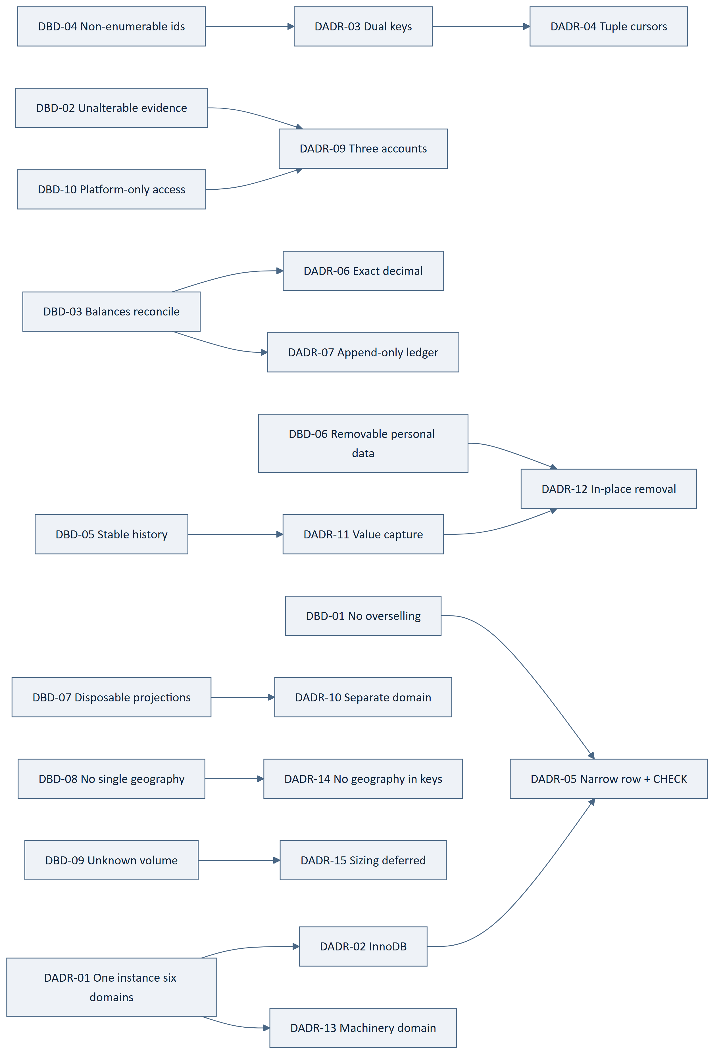
Figure 1 — 3.17 Driver to Decision Map

4. Storage Domains
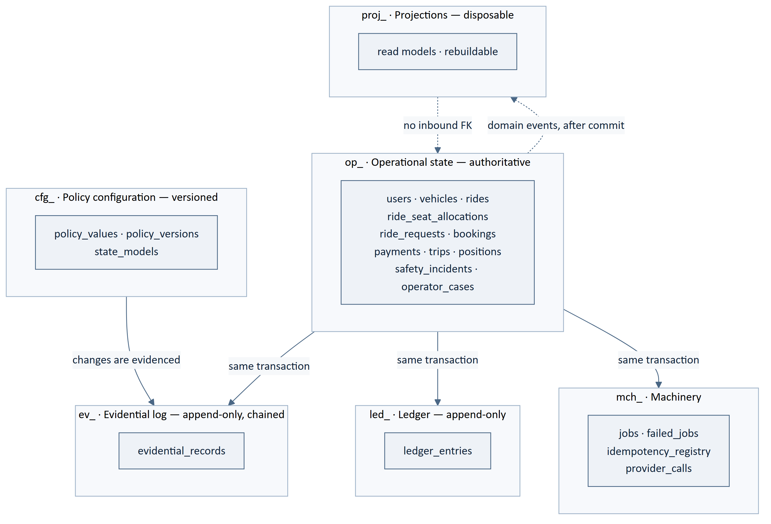
Figure 2 — 4. Storage Domains
Table 29 — 4. Storage Domains
ID | Statement | Src
DB-001 | The platform shall use one MySQL instance and one schema. | DADR-01, ARCH-014
DB-002 | Tables shall be assigned to exactly one of six domains, identified by name prefix: op_, led_, ev_, proj_, mch_, cfg_. | DADR-01, ARCH-050
DB-003 ‡ | Authoritative state shall reside in op_ and in no other domain. | BE-093, ARCH-110
DB-004 ‡ | Evidential records shall reside in ev_ and shall be written only by the evidential writer. | BE-105, ARCH-041
DB-005 ‡ | Movements of value shall be recorded in led_ and nowhere else. | ARCH-112, NFR-128
DB-006 | Derived read models shall reside in proj_. | DADR-10, ARCH-113
DB-007 | Job state, the idempotency registry and provider call records shall reside in mch_. | DADR-13, BADR-07
DB-008 | Policy configuration shall reside in cfg_. | ARCH-146, BADR-12
DB-009 ‡ | Every table shall use the InnoDB storage engine. | DADR-02
DB-010 | The schema and every table shall use a Unicode character set covering the full range, with a deterministic collation. | DADR-01, NFR-052
DB-011 ‡ | An operation and its evidential record shall be committable in one local transaction, which requires them to share an instance. | BE-049, DADR-01
DB-012 ‡ | No table outside proj_ shall hold a foreign key into proj_. | DADR-10, ARCH-114
DB-013 | No table in mch_ shall hold a foreign key into op_; the association shall be by recorded identifier. | DADR-13
DB-014 | Domain membership shall be verifiable from the table name alone, and shall be checked at migration time. | DB-002, DB-216

5. Schema Conventions

5.1 Naming
Table 30 — 5.1 Naming
ID | Statement | Src
DB-015 | Table names shall be lower snake case, prefixed by domain, and plural. | DADR-01
DB-016 | Column names shall be lower snake case and singular. | DB-015
DB-017 | A foreign key column shall be named for the referenced entity followed by _id. | DB-016
DB-018 | Index names shall state their table and their columns, so that a duplicate index is visible by name. | DB-190
DB-019 | Constraint names shall state the rule they enforce, so that a violation message names the rule. | DB-203
DB-020 ‡ | No table, column, index or constraint name shall incorporate a city, corridor, region or market. | DADR-14, SRS-REQ-101

5.2 Keys and Identifiers
Table 31 — 5.2 Keys and Identifiers
ID | Statement | Src
DB-021 | Every table shall have a BIGINT UNSIGNED AUTO_INCREMENT primary key used for clustering and foreign keys. | DADR-03
DB-022 ‡ | Every entity exposed through the interface shall additionally carry a unique, indexed, randomly generated external identifier. | DADR-03, API-013
DB-023 ‡ | The external identifier shall be generated with sufficient entropy that enumeration is infeasible, and shall encode no meaning, no sequence and no timestamp. | API-014, DADR-03
DB-024 ‡ | The internal primary key shall never be returned by the interface, appear in a URI, or appear in a record a caller can read. | DADR-03, API-013
DB-025 | Cursor paging shall order by the access path's ordering column followed by the internal primary key. | DADR-04, API-112
DB-026 ‡ | The internal primary key shall be monotonic and shall never be reused, so that a cursor boundary cannot be displaced by an insertion. | DADR-04, API-112
DB-027 | A cursor shall be opaque to the caller and shall not be constructible by them. | API-113, DADR-04
DB-028 | A natural key shall be enforced by a unique constraint where one exists, and shall not be used as a primary key. | DADR-03
DB-029 | Foreign keys shall be declared and enforced by the database, within op_. | DADR-01, DB-012
DB-030 ‡ | No foreign key shall cascade a delete into a record another party is entitled to as evidence. | DADR-12, SRS-REQ-091

5.3 Types
Table 32 — 5.3 Types
ID | Statement | Src
DB-031 ‡ | Monetary columns shall be DECIMAL with a scale equal to the currency's smallest indivisible unit. | DADR-06, BE-095
DB-032 | Monetary precision is [TBD – Technical Decision Required]; it depends on the largest plausible amount, which depends on scale figures not yet supplied. | DADR-06, GAP-016
DB-033 ‡ | No monetary value shall be stored in a floating-point type under any circumstance. | BE-095, API-016
DB-034 | Timestamps shall be stored in a single time zone reference and shall record the instant, not a local wall-clock reading. | API-015
DB-035 ‡ | Columns holding identity evidence or payment-related data shall be marked as protected; the protection mechanism is CMP-DOC-13's. | ARCH-059, SRS-REQ-097
DB-036 ‡ | Columns holding authentication credentials shall be non-recoverable; the scheme is CMP-DOC-13's. | ARCH-060, SRS-REQ-098
DB-037 ‡ | No column shall store a payment instrument credential in any form, protected or otherwise. | BE-097, API-053
DB-038 ‡ | No statement shall be constructed by concatenating a caller-supplied value; every value shall be bound. | BE-102, API-109
DB-039 | An enumerated column whose value set is a business decision shall not be a database ENUM; it shall reference policy configuration. | BADR-13, ARCH-037
DB-040 | The interface version shall be recorded on a table where the record's interpretation may change between versions, and this question shall be answered whenever a table is added. | DADR-16, SRS-REQ-102

6. The Operational Schema

6.1 Coverage
The nine aggregates of CMP-DOC-09 BADR-02 are realised by the tables below. **Only
behaviour CMP-DOC-04 specified is given a table**; §6.11 names what is withheld.
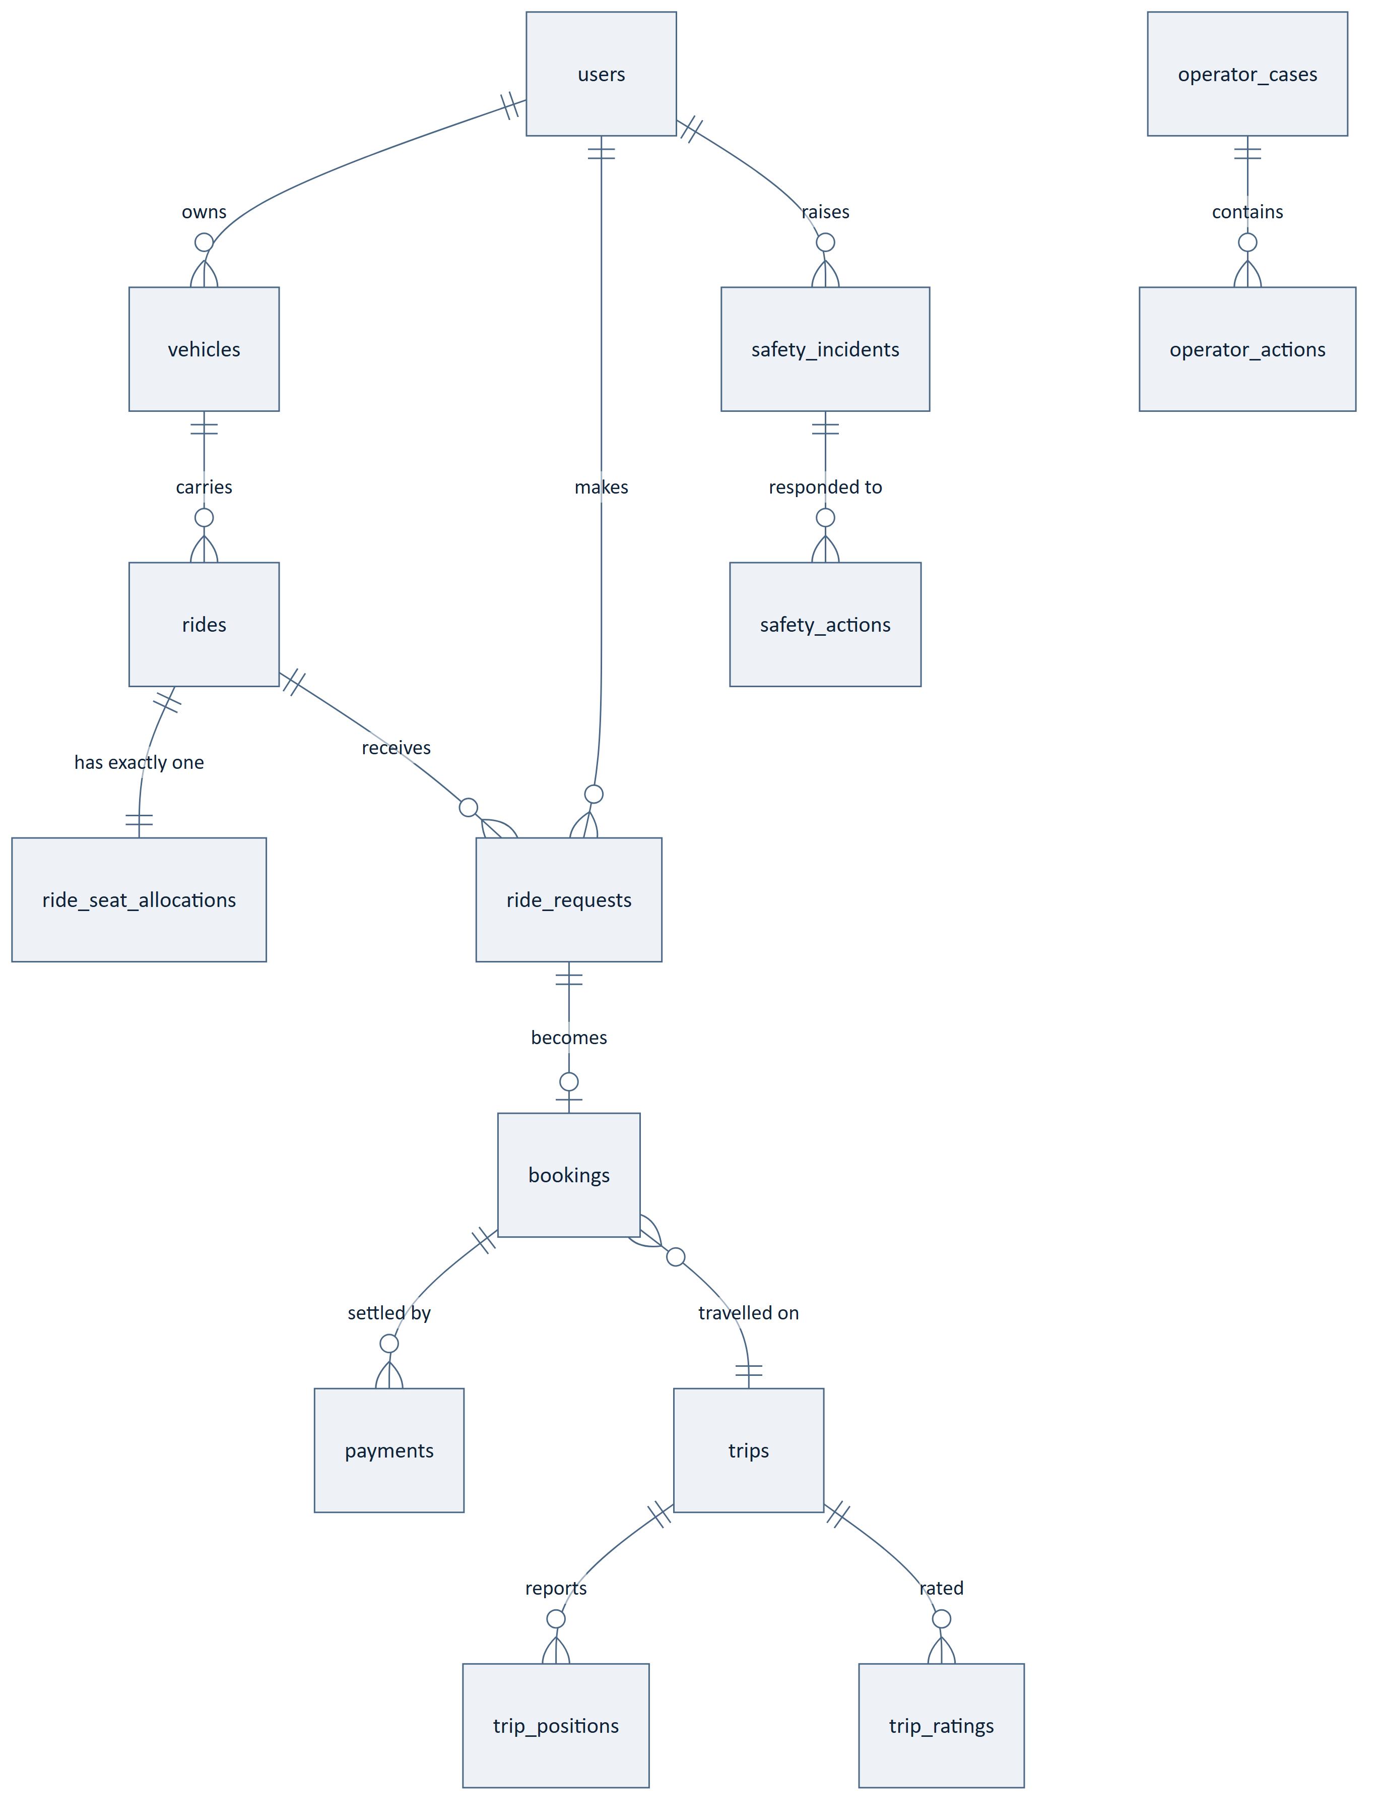
Figure 3 — 6.1 Coverage

6.2 op_users and Identity
Table 33 — 6.2 op_users and Identity
Table | Purpose
op_users | The person. Profile, contact, verification standing, account state.
op_user_verifications | Verification attempts and outcomes per channel.
op_user_credentials | Non-recoverable authentication material.
op_user_emergency_contacts | Nominated contacts.
op_sessions | Established sessions and their termination.

Table 34 — 6.2 op_users and Identity
ID | Statement | Src
DB-041 ‡ | Verification standing shall be a column on op_users written only by the platform, and shall have no inbound write path from the interface. | BAD-RULE-006, API-125
DB-042 ‡ | Authentication material shall be held in op_user_credentials in non-recoverable form and shall never appear on op_users. | SRS-REQ-098, DB-036
DB-043 | Verification attempts shall be retained with their outcome so that an attempt limit is enforceable against state rather than against memory. | FRD-FR-011, API-126
DB-044 ‡ | A terminated session shall be recorded as terminated and shall not be removed, so that reuse is detectable rather than merely impossible. | NFR-054, API-103
DB-045 | Account state shall reference policy configuration rather than a database ENUM. | DB-039, BAD-RULE-010
DB-046 | Account closure treatment shall be [TBD – Business Decision Required]; the schema supports state change and retention marking, and prescribes neither. | SRS-REQ-092, BAD-DEC-021

6.3 op_vehicles
Table 35 — 6.3 op_vehicles
ID | Statement | Src
DB-047 ‡ | Lawful seating capacity shall be a column written only by the platform. | BAD-RULE-017, API-132
DB-048 ‡ | A vehicle row shall not be deleted where it is referenced by a ride; withdrawal shall be a state change. | DB-030, API-133
DB-049 | Vehicle documentation references shall be held as protected columns. | DB-035

6.4 op_rides
Table 36 — 6.4 op_rides
Table | Purpose
op_rides | The published ride: driver, vehicle, origin, destination, departure, state.
op_ride_routes | Resolved geometry and derived bounding envelope, one per ride.
op_ride_preferences | Declared preference positions.
op_ride_seat_allocations | §7 — its own section.

Table 37 — 6.4 op_rides
ID | Statement | Src
DB-050 ‡ | Seats offered shall be held on the allocation record, not on op_rides, so that it is lockable independently. | DADR-05, ARCH-053
DB-051 | Resolved route geometry shall be stored once at publication in op_ride_routes. | ARCH-051, DADR-08
DB-052 | A derived bounding envelope shall be stored alongside the geometry and spatially indexed. | ARCH-052, DADR-08
DB-053 | The coarse filter shall use the spatial index; the precise overlap computation shall read the full geometry only for coarse-filter survivors. | ARCH-081, DADR-08
DB-054 | An undeclared preference shall be stored as undeclared and shall never default to a permissive or restrictive value. | FRD-FR-062
DB-055 | Amending a ride shall invalidate its stored route geometry. | ARCH-096, API-137
DB-056 ‡ | A ride carrying a confirmed booking shall not be deletable; withdrawal shall be a state change and shall be refused where FRD-FR-070 applies. | FRD-FR-070, API-139
DB-057 | Ride state shall reference policy configuration rather than a database ENUM. | DB-039
DB-058 | The interface version shall be recorded on op_rides. | DADR-16

6.5 op_ride_requests and op_bookings
Table 38 — 6.5 op_ride_requests and op_bookings
ID | Statement | Src
DB-059 ‡ | A booking shall carry the fare computed by the platform, and no column shall accept a caller-supplied amount. | BE-032, API-150
DB-060 ‡ | A booking shall not reach a confirmed state without a verified payment; the rule is enforced by the application and the state model, and the schema shall carry the payment reference that makes it checkable. | BE-025, BAD-RULE-028
DB-061 | Booking state and ride-request state shall reference policy configuration. | DB-039, BAD-RULE-031
DB-062 | Whether and for how long seats are held during request and payment is [TBD – Business Decision Required]; the schema carries a hold expiry column that remains unused until the rule exists. | BAD-RULE-030, API-147
DB-063 | The interface version shall be recorded on op_bookings. | DADR-16
DB-064 ‡ | Cancellation consequence is undecided (GAP-008, GAP-009); the schema records that a cancellation occurred, by whom and when, and records no monetary effect, because none is defined. | GAP-008, GAP-009

6.6 op_payments
Table 39 — 6.6 op_payments
ID | Statement | Src
DB-065 ‡ | Payment status shall permit exactly three values — verified, failed, pending — enforced by a CHECK constraint, because the three are fixed by SRS-REQ-155 and are not a business decision. | BE-026, SRS-REQ-155
DB-066 ‡ | Payment status shall have no inbound write path from the interface. | BAD-RULE-033, API-153
DB-067 ‡ | Every payment attempt and its verified outcome shall be recorded, and an attempt row shall never be updated to hide a prior attempt. | FRD-FR-134, BE-096
DB-068 ‡ | No column shall hold a payment instrument credential, a token exchangeable for one, or a provider response body containing either. | DB-037, BE-097
DB-069 | The provider reference shall be stored so that a verification can be re-initiated by the platform without a callback. | ARCH-127, API-182
DB-070 | The interface version shall be recorded on op_payments. | DADR-16

6.7 op_trips and Position History
Table 40 — 6.7 op_trips and Position History
Table | Purpose
op_trips | The journey: state, actual start, completion, captured values.
op_trip_participants | Participant per trip, with captured values.
op_trip_positions | Position reports during an active trip.
op_trip_ratings | Ratings recorded after completion.

Table 41 — 6.7 op_trips and Position History
ID | Statement | Src
DB-071 ‡ | A trip shall not start without at least one confirmed booking; the schema shall carry the booking references that make the rule checkable. | BE-028, API-159
DB-072 ‡ | A completed trip shall capture participants, route as travelled, fare and payment outcome as values, not references alone. | DADR-11, NFR-126
DB-073 ‡ | Position history shall be held in its own table, separable from the trip record so that it can be removed independently. | ARCH-119, DB-179
DB-074 | A position row shall carry the instant of acquisition, distinct from the instant of receipt. | ARCH-094, API-161
DB-075 | Trip state shall reference policy configuration. | DB-039
DB-076 | Position history is the highest-volume table in the design; its retention, partitioning and archival are named in §14.5 and are unresolved. | SRS-REQ-093, GAP-016

6.8 op_safety_incidents
Table 42 — 6.8 op_safety_incidents
ID | Statement | Src
DB-077 ‡ | A safety incident shall be insertable with partial context, so that no validation failure on a non-essential column can lose a signal. | FRD-FR-187, API-164
DB-078 ‡ | Missing context shall be recorded as missing, and shall be distinguishable from context that was absent in fact. | FRD-FR-187, API-165

6.9 op_operator_cases
Operator cases, actions and outcomes. Administrative screen composition is CMP-DOC-17's;
the tables exist here because NFR-125 requires a durable record of every operator
action.

6.10 Tables Realising the Nine Aggregates
Table 43 — 6.10 Tables Realising the Nine Aggregates
Aggregate | Tables
User | op_users, op_user_verifications, op_user_credentials, op_user_emergency_contacts, op_sessions
Vehicle | op_vehicles
Ride (owning SeatAllocation) | op_rides, op_ride_routes, op_ride_preferences, op_ride_seat_allocations
RideRequest | op_ride_requests
Booking | op_bookings
Payment | op_payments, op_payment_attempts
Trip | op_trips, op_trip_participants, op_trip_positions, op_trip_ratings
SafetyIncident | op_safety_incidents, op_safety_actions
OperatorCase | op_operator_cases, op_operator_actions

6.11 Tables Withheld
FACT. No table is specified for the following. Each would require behaviour no
document above this one has decided.
Table 44 — 6.11 Tables Withheld
Table that would be needed | Blocked by
Wallet accounts and entries | Wallet behaviour undecided — CMP-DOC-03 Outlined
Reward accrual and redemption | Reward scheme undecided
Refunds and returns of value | GAP-009 — Critical
Disputes and claims | No specified behaviour
Referrals | Undecided
Recurring ride series | BAD-DEC-008 — the whole area carries zero functional requirements
Fraud signals and cases | GAP-013 — unowned through eleven documents

A speculative table is worse than an absent one. An absent table is a gap somebody notices. A speculative table acquires foreign keys, then data, then a migration cost — and it encodes a guess about behaviour nobody has decided.

7. The Seat Allocation Record
This section discharges the first obligation CMP-DOC-09 §18.5 placed on this document.

7.1 Structure
op_ride_seat_allocations — one row per ride, and nothing on it that is not needed to
decide a seat.
Table 45 — 7.1 Structure
Column | Purpose
internal key | Clustering
ride reference | Unique — exactly one row per ride
seats offered | Set at publication from the vehicle's lawful capacity
seats confirmed | Incremented only under lock
version | Optimistic detection of a lost update, secondary to the lock
updated instant | For the as-of marking API-045 requires

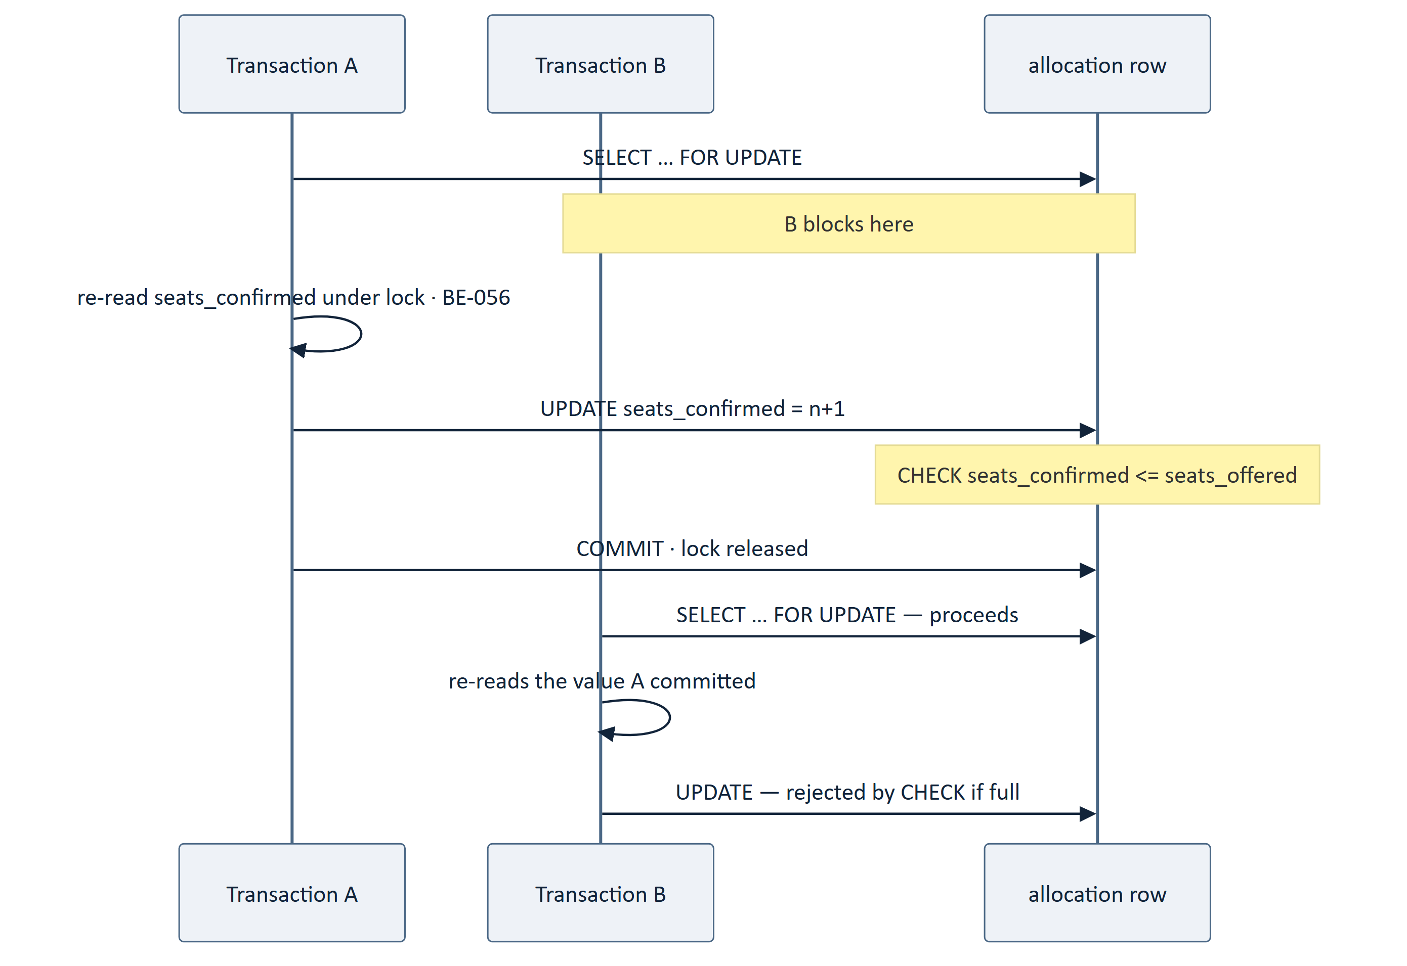
Figure 4 — 7.1 Structure
Table 46 — 7.1 Structure
ID | Statement | Src
DB-079 ‡ | Exactly one allocation row shall exist per ride, enforced by a unique constraint on the ride reference. | DADR-05, BE-018
DB-080 ‡ | The allocation row shall contain no column not required to decide a seat. | DADR-05, ARCH-053
DB-081 ‡ | Seats offered shall be set from the vehicle's recorded lawful capacity and shall not exceed it. | BE-023, API-134
DB-082 ‡ | Allocation shall acquire an exclusive row lock before re-reading seats confirmed. | BE-055, SRS-REQ-039
DB-083 ‡ | The table shall carry a CHECK constraint asserting that seats confirmed is not negative and does not exceed seats offered. | CMP-DOC-09 §18.5, BAD-RULE-027
DB-084 ‡ | The constraint shall be the last line of defence and shall not be relied on as the first; the lock and the re-read remain required. | BADR-04, BE-056
DB-085 ‡ | The deployed MySQL version shall enforce CHECK constraints; a version that parses and ignores them shall not be deployed. | DB-083, DADR-05
DB-086 ‡ | Migration shall verify that the constraint is enforced by attempting a violating write and requiring it to fail. | DB-085, DB-217
DB-087 ‡ | Seats confirmed shall never be derived by counting bookings for the purpose of deciding availability. | DADR-05, BE-094
DB-088 ‡ | Seat availability shall never be read from a projection. | ARCH-056, API-048
DB-089 | The row shall carry the instant it was last updated, so that the interface can supply the as-of marking. | API-045, AADR-09
DB-090 | Reducing seats offered below seats confirmed shall be rejected by the same constraint. | DB-083
DB-091 | Lock wait behaviour shall be configured so that a contended booking fails as a bounded wait rather than an indefinite one. | NFR-040, [TBD – Technical Decision Required]
DB-092 ‡ | A test shall exist that runs concurrent allocations under genuine parallelism and asserts that the constraint was never violated and that no oversell occurred. | BE-208, DB-207

`DB-083` is the single most important statement in this document. Every layer above it also enforces the seat rule — the domain in BE-024, the service in BE-055, the interface in API-149. This is the one that holds when one of those is wrong.

8. The Ledger
Table 47 — 8. The Ledger
ID | Statement | Src
DB-093 ‡ | led_ledger_entries shall be append-only; no code path shall update or delete an entry. | DADR-07, BE-096
DB-094 ‡ | The application account shall hold SELECT and INSERT on the ledger domain and shall hold neither UPDATE nor DELETE. | DADR-09, BE-096
DB-095 ‡ | Every entry shall name a party, an event, a direction and an amount. | NFR-128, ARCH-112
DB-096 ‡ | Every movement of value shall produce entries that sum to zero across their parties. | DADR-07, NFR-127
DB-097 ‡ | No balance, total or running sum shall be stored as a persisted column in any domain. | ARCH-111, DADR-06
DB-098 ‡ | A balance shall be derived from entries at read time. | ARCH-111, NFR-127
DB-099 ‡ | A correction shall be a new compensating entry referencing the original. | BE-096, DADR-07
DB-100 ‡ | Amounts shall be exact decimal. | DB-031, BE-095
DB-101 | An entry shall reference the operational record that caused it, by recorded identifier. | ARCH-112
DB-102 | An entry shall carry the instant of the movement, distinct from the instant of recording. | DB-034
DB-103 | Rounding, where it occurs, shall be recorded as its own entry rather than absorbed silently. | NFR-127, DADR-07
DB-104 | Currency shall be recorded per entry rather than assumed, so that a second market is data. | DADR-14, NFR-141
DB-105 | A scheduled reconciliation shall assert that entries sum to zero per event and shall surface any discrepancy rather than correct it. | FRD-FR-222, BE-146
DB-106 ‡ | Retention shall never remove a ledger entry. | DADR-12, BE-096
DB-107 | Ledger growth is monotonic; archival is a sizing decision named in §14.5 and is unresolved. | DADR-15, GAP-016
DB-108 | Settlement structures, payouts and provider reconciliation records are CMP-DOC-14's and are not specified here. | §0.6

9. The Evidential Log
This section discharges the second obligation CMP-DOC-09 §18.5 placed on this document.

9.1 Structure
ev_evidential_records — append-only, hash-chained.
Table 48 — 9.1 Structure
Column | Purpose
internal key | Clustering and chain order
actor, action, subject | Who did what to what
outcome, reason | What happened and why
occurred instant | When
previous hash, record hash | The chain

9.2 Append-Only Enforcement
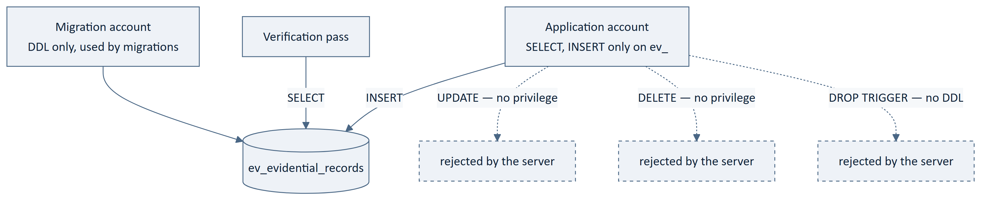
Figure 5 — 9.2 Append-Only Enforcement
Table 49 — 9.2 Append-Only Enforcement
ID | Statement | Src
DB-109 ‡ | Every evidential record shall carry actor, action, subject, time, outcome and reason. | BE-107, NFR-125
DB-110 ‡ | Every record shall carry a hash of its own content and the hash of its predecessor. | ARCH-054, BE-109
DB-111 ‡ | The chain shall be ordered by the internal primary key, which is monotonic and never reused. | DB-026, ARCH-054
DB-112 ‡ | A record shall be written in the same transaction as the operation it evidences. | BE-049, SRS-REQ-042
DB-113 ‡ | The evidential writer shall be the only component that inserts into the domain. | ARCH-041, BE-105
DB-114 ‡ | Administrative overrides, payment state transitions, safety actions, refused operations and policy changes shall each be evidenced. | BE-111–BE-114, ARCH-115
DB-115 | A verification pass shall re-derive the chain and report any break rather than repair it. | BE-115, ADR-13
DB-116 | The hashing algorithm is CMP-DOC-13's; this document requires only that alteration be detectable. | ARCH-059, §0.6.1
DB-117 | Retention of evidential records is [TBD – Business Decision Required]; the design assumes it outlasts any dispute window. | BE-118, GAP-012

9.3 Physical Non-Updatability
Table 50 — 9.3 Physical Non-Updatability
ID | Statement | Src
DB-118 ‡ | The application account shall hold SELECT and INSERT on the evidential domain, and shall hold neither UPDATE nor DELETE. | CMP-DOC-09 §18.5, BE-110
DB-119 ‡ | The application account shall hold no DDL privilege on any domain, so that it cannot remove a constraint or a trigger that constrains it. | DADR-09, BE-110
DB-120 ‡ | A trigger rejecting UPDATE and DELETE shall additionally be present, as a second layer and not as the primary mechanism. | DADR-09
DB-121 ‡ | The grant shall be asserted by an automated check that attempts an update and requires it to be refused by the server. | DB-118, DB-207
DB-122 ‡ | No credential permitting alteration of the evidential domain shall be available to the application in any environment, including development. | BE-110, DADR-09
DB-123 | Migration against the evidential domain shall use the migration account and shall be additive; no migration shall rewrite an existing record. | DB-119, DB-215
DB-124 ‡ | A mistaken evidential record shall be corrected by a new record referencing it, never by amendment. | DADR-09, BE-108

9.4 Retention Interaction
Table 51 — 9.4 Retention Interaction
ID | Statement | Src
DB-125 ‡ | Retention removal shall not delete an evidential record, because deletion would break the chain. | ARCH-117, DADR-12
DB-126 ‡ | Where an evidential record contains personal data, retention shall tokenise it in place — which requires an update, and therefore shall be performed by a separately privileged retention process, not by the application account. | ARCH-058, DB-118
DB-127 ‡ | Tokenisation shall preserve the record hash by hashing the original content, so that the chain still verifies after removal. | ARCH-117, DB-110
DB-128 | The retention process shall itself be evidenced. | DB-114, NFR-125

`DB-126` is the one place the append-only guarantee is deliberately qualified. A record that can never be touched cannot have personal data removed from it, and NFR-131 requires removal. The resolution is a fourth, tightly scoped privilege used by one process, not a relaxation of the application's grant — and DB-127 keeps the chain verifiable across it. This is a real tension, and it is recorded rather than hidden.

10. Projections and Read Models
Table 52 — 10. Projections and Read Models
ID | Statement | Src
DB-129 | Projections shall reside in proj_ and shall be maintained by listeners responding to domain events. | DADR-10, BE-119
DB-130 ‡ | A projection shall never be an input to a business decision. | BE-121, ARCH-042
DB-131 ‡ | Seat availability shall never be projected. | ARCH-056, DB-088
DB-132 | Every projection shall be rebuildable in full from authoritative state, by truncate and replay. | ARCH-113, BE-120
DB-133 | Every projection row shall carry its maintenance instant. | BE-124, API-044
DB-134 | Loss of a projection shall degrade performance and never correctness. | ARCH-114
DB-135 | No table outside proj_ shall reference a projection by foreign key. | DB-012, DADR-10
DB-136 | A rebuild shall be executable without interrupting write traffic. | BE-126
DB-137 | Administrative listing, search and operational counts shall be served from projections. | BE-123, ARCH-047
DB-138 | Where a count cannot be produced without an unbounded scan, the projection shall hold it, and where it is unavailable it shall be reported unavailable rather than zero. | API-118, API-119
DB-139 | The projection inventory is [TBD – Technical Decision Required] pending CMP-DOC-17's screen inventory; this section specifies the pattern, not a list. | BE-129, DADR-10
DB-140 | Whether a projection is maintained synchronously or by job shall be recorded per projection. | BE-130

11. Operational Machinery
Table 53 — 11. Operational Machinery
ID | Statement | Src
DB-141 ‡ | The idempotency registry entry shall be written in the same transaction as the effect it guards. | BE-051, DADR-13
DB-142 ‡ | The registry shall be unique on actor, operation and key, so that a duplicate is rejected by the database rather than by a race-prone read. | BADR-08, API-062
DB-143 | The registry shall record the outcome, so that a replay returns the original rather than re-executing. | API-062, ARCH-040
DB-144 | Registry retention duration is [TBD – Technical Decision Required] and shall exceed the longest client retry window. | API-069, API-070
DB-145 | The job store shall hold queued work with its family, attempt count and availability instant. | BADR-07, BE-142
DB-146 ‡ | Safety-family work shall be selectable without scanning other families, so that it is never delayed by their volume. | ARCH-074, BE-132
DB-147 | Exhausted jobs shall move to a failed table and shall not be deleted. | ARCH-077, BE-137
DB-148 | Queue depth and oldest-item age shall be derivable per family from the job store. | BE-204, NFR-121
DB-149 | Deferred work shall survive restart, which follows from the store being a transactional table. | ARCH-076, DADR-02
DB-150 | Provider call records shall capture the call, its outcome and its attributable cost. | ARCH-067, SRS-REQ-145
DB-151 ‡ | A provider call record shall contain no credential and no response body carrying one. | DB-037, BE-097
DB-152 | Policy configuration shall be versioned records, each change producing a new version rather than an update in place. | ARCH-146, BE-167
DB-153 ‡ | A policy value shall never be capable of relaxing an absolute rule; values that could are absent from the table rather than validated. | ARCH-147, BE-172
DB-154 | Policy changes shall be evidenced. | ARCH-115, BE-173
DB-155 | State model definitions shall be held in cfg_ and referenced by the state columns of op_. | ARCH-037, DB-039
DB-156 | Machinery tables shall be prunable without cascade into op_. | DADR-13, DB-013

12. Historical Integrity
Table 54 — 12. Historical Integrity
ID | Statement | Src
DB-157 ‡ | A change to a referenced entity shall not mutate a historical record. | SRS-REQ-089, DADR-11
DB-158 ‡ | A completed trip shall capture participant identity as shown, vehicle description, route as travelled, fare and payment outcome as stored values. | ARCH-057, NFR-126
DB-159 | References shall be retained alongside captured values, for navigation only. | DADR-11
DB-160 ‡ | A reader of a historical record shall use the captured value, never the reference, where the two may differ. | DADR-11, SRS-REQ-089
DB-161 | Capture shall occur at completion, not at creation, so that it records what was true at travel. | ARCH-057
DB-162 ‡ | A booking shall capture the fare at confirmation, so that a later fare change cannot alter what was agreed. | BE-032, DB-059
DB-163 | Captured values shall be marked as captured, so that a reader can tell them from live ones. | DB-160
DB-164 ‡ | Captured personal values are personal data and are in scope for retention. | DADR-12, NFR-131
DB-165 ‡ | Retention of a captured value shall not remove what the counterparty is entitled to retain as evidence of a shared trip. | SRS-REQ-091, ARCH-058
DB-166 | Data retained per completed trip shall be bounded, and position history shall not be part of the trip record. | SRS-REQ-096, DB-073
DB-167 | The interface version recorded at creation shall be retained with the record, so that an old record stays interpretable after its version is retired. | DADR-16, SRS-REQ-102
DB-168 | Full temporal versioning of referenced entities is a FUTURE CONSIDERATION, not required by any current statement. | DADR-11

13. Retention and Removal

13.1 Mechanism
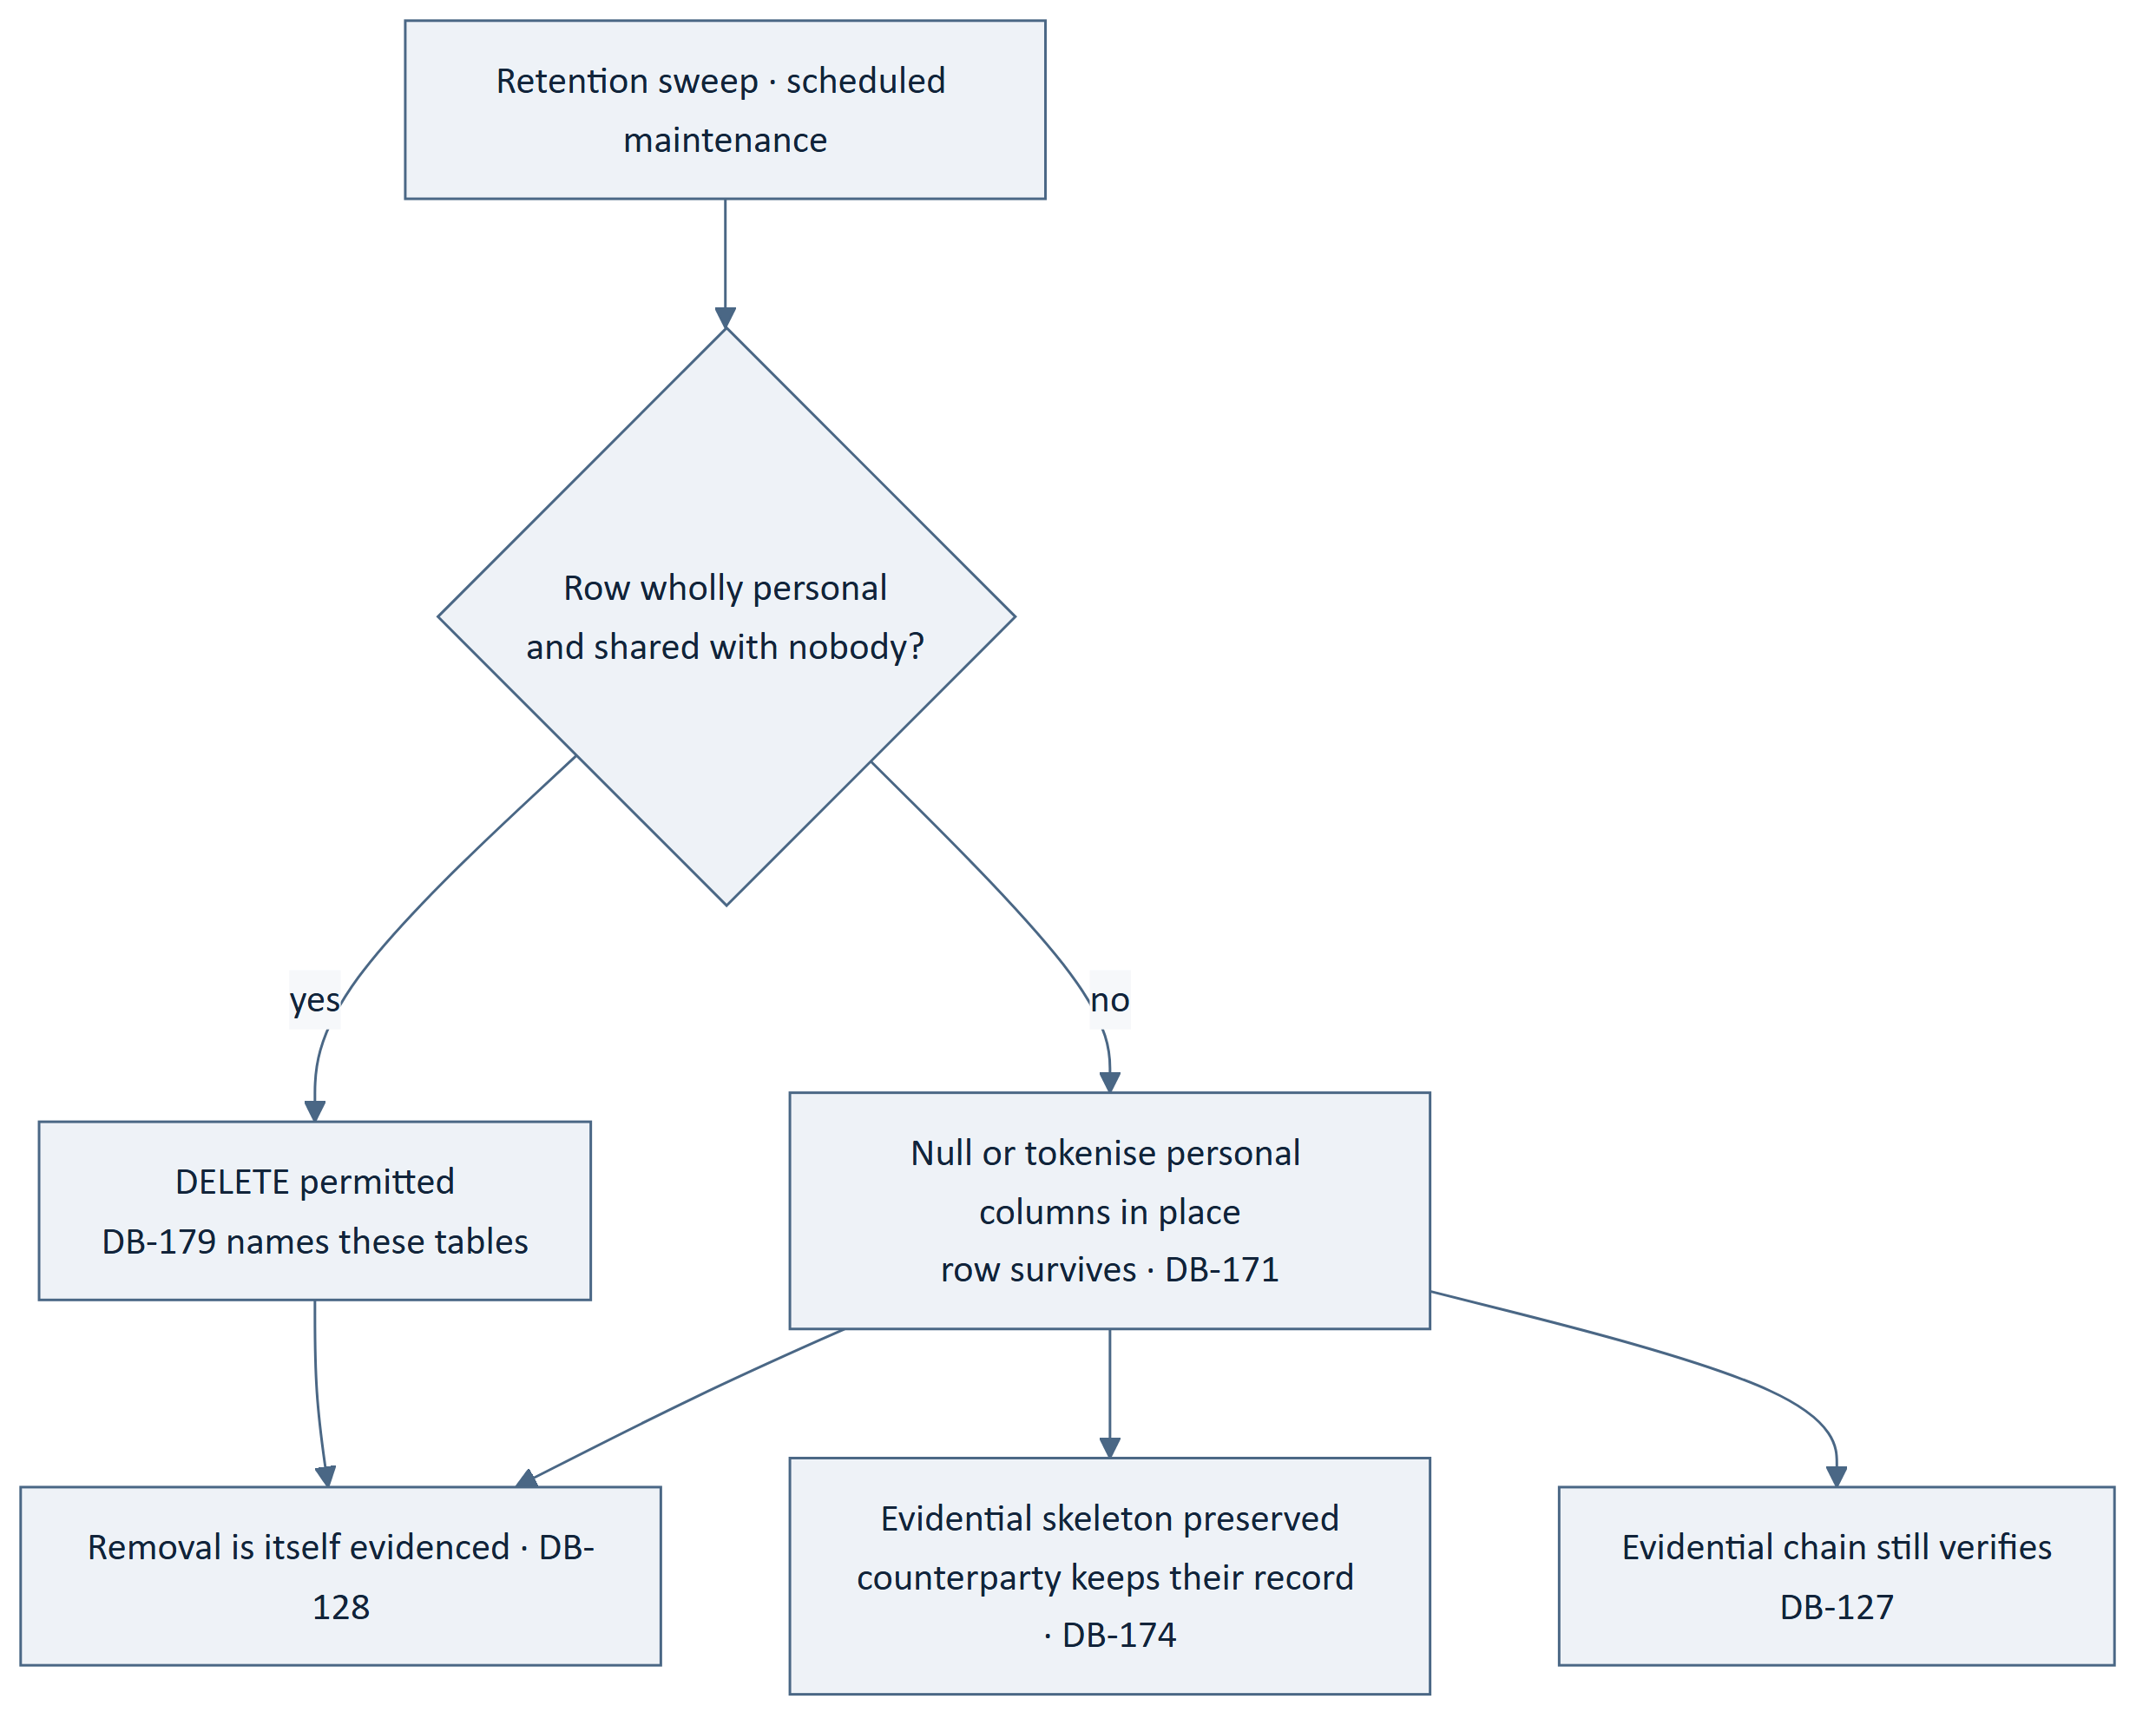
Figure 6 — 13.1 Mechanism
Table 55 — 13.1 Mechanism
ID | Statement | Src
DB-169 | Retention periods shall be policy configuration per data category. | ARCH-118, SRS-REQ-178
DB-170 | Retention removal shall run as scheduled maintenance. | BE-147, BADR-07
DB-171 ‡ | Removal shall null or tokenise personal columns in place, and shall not delete the row, except where DB-179 permits. | DADR-12, ARCH-058
DB-172 ‡ | Removal shall never destroy a record another party is entitled to as evidence. | SRS-REQ-091
DB-173 ‡ | Removal shall never break the evidential chain. | ARCH-117, DB-127
DB-174 ‡ | The evidential skeleton of a shared record — that it happened, between whom by reference, when, and its outcome — shall survive removal of the personal detail. | ARCH-058, ARCH-116
DB-175 | Every removal shall be recorded, so that an absent value is distinguishable from a value never supplied. | DB-128, NFR-125
DB-176 | Each personal column shall be classified as removable, tokenisable or retained-as-evidence, and the classification shall be part of the schema definition rather than a separate list. | DADR-12, NFR-131
DB-177 | A column added without a retention classification shall fail migration review. | DB-176, DB-216
DB-178 ‡ | Personal data shall be separable from the evidential skeleton, which requires it to be in distinguishable columns rather than embedded in a composite value. | ARCH-116
DB-179 | Row deletion is permitted only for op_trip_positions and mch_ tables, being wholly personal or wholly machinery and shared with nobody. | DADR-12, ARCH-119
DB-180 | Position history shall be removable independently of the trip record. | ARCH-119, SRS-REQ-093
DB-181 | Account closure treatment shall follow the same mechanism, and its policy is [TBD – Business Decision Required]. | SRS-REQ-092, DB-046
DB-182 ‡ | Ledger entries shall never be removed. | DB-106, BE-096

13.2 Retention Periods — All Unset
FACT. BAD-DEC-021 is unresolved. Every period below is a business decision and
none is stated here.
Table 56 — 13.2 Retention Periods — All Unset
Category | Register
Position history | [TBD – Business Decision Required] · SRS-REQ-093
Completed trip records | [TBD – Business Decision Required]
Evidential records | [TBD – Business Decision Required] · BE-118
Ledger entries | Never removed — DB-182
Identity evidence | [TBD – Business Decision Required]
Message content | [TBD – Business Decision Required]
Closed accounts | [TBD – Business Decision Required] · SRS-REQ-092
Diagnostic and operational records | [TBD – Business Decision Required] · NFR-124
Idempotency registry | [TBD – Technical Decision Required] · DB-144

Table 57 — 13.2 Retention Periods — All Unset
ID | Statement | Src
DB-183 | Nine retention categories exist and eight have no period; the mechanism is complete and unusable until they are set. | BAD-DEC-021, GAP-012
DB-184 | The conflict CMP-DOC-05 recorded between NFR-125 and NFR-131 is resolved structurally by DADR-12 and not by preferring one requirement. | NFR-125, NFR-131
DB-185 | Legal or regulatory retention obligations are [TBD – Business Decision Required]; this document asserts none and no minimum period is implied by anything stated here. | §19 no-invention rule
DB-186 | Removal shall be verifiable: a test shall assert that a removed value is absent and that the evidential chain still verifies. | DB-173, DB-207

14. Indexing and Access Paths

14.1 Principle
Table 58 — 14.1 Principle
ID | Statement | Src
DB-187 | An index shall exist for a stated access path and shall not be added speculatively. | DADR-15
DB-188 | Every foreign key shall be indexed. | DB-029
DB-189 | Every external identifier shall carry a unique index, since every inbound request resolves through it. | DB-022, DADR-03
DB-190 | Every paged access path shall have a composite index ending in the internal primary key, so that the cursor is an index seek. | DADR-04, DB-025
DB-191 | A redundant index — one whose columns are a left prefix of another — shall be removed. | DB-018
DB-192 | Index cost is a write cost; an index shall be justified by a read path that exists. | DADR-15

14.2 Stated Access Paths
Table 59 — 14.2 Stated Access Paths
Access path | Index
Resolve an entity by external identifier | Unique on the external identifier, per exposed table
Lock the allocation row for a ride | Unique on the ride reference in op_ride_seat_allocations
Coarse-filter candidate rides for a journey | Spatial on the route envelope, with the departure date
A driver's published rides, paged | Driver, departure instant, internal key
A user's bookings, paged | User, created instant, internal key
A booking's payments | Booking reference
Positions for an active trip, most recent first | Trip, acquisition instant descending, internal key
Pending payments awaiting reconciliation | Status, created instant
Queued work by family and availability | Family, available instant, internal key
Idempotency lookup | Unique on actor, operation, key
Evidential records for a subject | Subject reference, internal key
Ledger entries for a party | Party, occurred instant, internal key

Table 60 — 14.2 Stated Access Paths
ID | Statement | Src
DB-193 | The twelve access paths above are the ones this design commits to; an index for any other path requires a stated path first. | DB-187
DB-194 | The spatial index shall serve the coarse filter only; the precise overlap computation shall not be index-driven. | ARCH-081, DADR-08
DB-195 ‡ | The allocation lookup shall be a unique index seek, so that the lock is taken on one row and never on a range. | DB-079, BE-055
DB-196 | Operator record search shall be served from projections, with their own indexes, and shall not add indexes to op_. | SRS-REQ-094, DB-137

14.3 Structures That Must Not Assume Geography
Table 61 — 14.3 Structures That Must Not Assume Geography
ID | Statement | Src
DB-197 ‡ | No index, partition or unique constraint shall incorporate a city, corridor, region or market. | DADR-14, SRS-REQ-101
DB-198 | Partitioning by geography remains available if measurement later justifies it, and is not adopted now. | DADR-14, DADR-15

14.4 Growth
Table 62 — 14.4 Growth
ID | Statement | Src
DB-199 | Capacity increase shall be possible without service interruption. | SRS-REQ-095
DB-200 | The design shall not depend on any table remaining small. | SRS-REQ-094, DADR-15
DB-201 | op_trip_positions, ev_evidential_records and led_ledger_entries are the three monotonically growing tables and are the subjects of §14.5. | DB-076, DB-107
DB-202 | Read replicas, if used, shall serve projections and reporting only, and shall never serve an authoritative read. | BE-093, DB-130

14.5 Sizing Decisions Deferred
FACT. Launch scale is unstated (GAP-016). Seven decisions below cannot be taken
without it. Each names what it needs.
Table 63 — 14.5 Sizing Decisions Deferred
# | Decision | Needs
1 | Partitioning of op_trip_positions | Positions per trip per unit time × concurrent active trips
2 | Archival boundary for op_trip_positions | Its retention period (SRS-REQ-093, unset)
3 | Archival boundary for led_ledger_entries | Entry volume and the dispute window
4 | Archival boundary for ev_evidential_records | Its retention period (BE-118, unset)
5 | Whether search requires a dedicated read path beyond the spatial index | Rides per corridor and search rate
6 | Read replica count and use | Read-write mix and RTO
7 | Buffer pool and connection sizing | Instance class, which is CMP-DOC-19's

This is where `GAP-016` costs something concrete. The first four decisions govern the three tables that grow without bound. Deciding them late means deciding them on a populated table, which is a migration rather than a choice.

15. The Integrity Constraint Register
Twenty-one constraints the database enforces. Each is a rule that holds even if the
application is wrong.
Table 64 — 15. The Integrity Constraint Register
# | Constraint | Protects
1 | CHECK seats confirmed between 0 and seats offered | BAD-RULE-027 · DB-083
2 | UNIQUE one allocation row per ride | DB-079
3 | CHECK payment status in the three permitted values | SRS-REQ-155 · DB-065
4 | UNIQUE external identifier per exposed table | API-014 · DB-022
5 | UNIQUE idempotency actor, operation, key | BADR-08 · DB-142
6 | NOT NULL on actor, action, subject, outcome, time in evidential records | BE-107 · DB-109
7 | NOT NULL on previous hash and record hash | ARCH-054 · DB-110
8 | No UPDATE or DELETE privilege on ev_ for the application account | BE-110 · DB-118
9 | No UPDATE or DELETE privilege on led_ for the application account | BE-096 · DB-094
10 | No DDL privilege for the application account | DB-119
11 | Trigger rejecting UPDATE and DELETE on ev_ | DB-120
12 | NOT NULL on ledger party, event, direction, amount | NFR-128 · DB-095
13 | CHECK ledger amount is exact decimal and non-null | DB-100
14 | FOREIGN KEY booking to ride request, ride, user | DB-029
15 | RESTRICT on delete for any referenced operational row | DB-030 · DB-048
16 | CHECK seats offered does not exceed vehicle lawful capacity at insert | BE-023 · DB-081
17 | NOT NULL on captured values of a completed trip | NFR-126 · DB-158
18 | UNIQUE one rating per rater per trip | FRD-FR-172
19 | NOT NULL on job family and availability instant | DB-145
20 | NOT NULL on policy value version | DB-152
21 | No foreign key from any domain into proj_ | DB-012

Table 65 — 15. The Integrity Constraint Register
ID | Statement | Src
DB-203 | Every constraint above shall be named for the rule it enforces. | DB-019
DB-204 ‡ | A constraint shall not be dropped to make a migration succeed; a migration that requires it dropped shall be rejected. | DB-217
DB-205 ‡ | Constraints 8, 9 and 10 are grants, not schema objects, and shall be asserted by a check that attempts the forbidden operation. | DADR-09, DB-121
DB-206 | Application-level validation shall not be treated as a substitute for any constraint above. | DB-084, BE-012
DB-207 ‡ | Each of the twenty-one constraints shall have a test that attempts to violate it and requires the database to refuse. | NFR-106, BE-207
DB-208 | A constraint added later shall be added to this register and to its test set in the same change. | DB-207
DB-209 ‡ | Where a rule is enforceable by the database and by the application, it shall be enforced by both. | BADR-04, DADR-05
DB-210 | Where a rule is not enforceable by the database — because it depends on policy configuration — that shall be stated rather than left as an apparent omission. | DB-039, DB-057
DB-211 | Rules depending on policy configuration are enforced by the state machine engine and are listed in CMP-DOC-09 §13.3, not here. | BADR-13, DB-155
DB-212 | The register shall be reviewable as a single list, which is why it appears here in full rather than distributed through the schema. | DB-203

16. Migration
Table 66 — 16. Migration
ID | Statement | Src
DB-213 | Migrations shall be forward-only, versioned, ordered and reviewed. | BE-099 — which CMP-DOC-09 §18.7 records as originating there
DB-214 ‡ | A migration shall not encode a business rule. | BE-100, BE-010
DB-215 | A migration shall run under the migration account, which is the only account holding DDL. | DADR-09, DB-119
DB-216 | Migration review shall verify domain prefix, retention classification of every new column, index justification and constraint registration. | DB-014, DB-177, DB-187
DB-217 ‡ | Migration shall verify that CHECK constraints are enforced by the deployed server, by attempting a violating write. | DB-085, DB-086
DB-218 ‡ | A destructive migration — dropping a column, a table or a constraint — shall require explicit recorded approval. | BE-099
DB-219 ‡ | No migration shall rewrite an existing evidential or ledger record. | DB-123, DB-093
DB-220 | A migration shall be runnable against a populated database without requiring exclusive access for an unbounded period. | SRS-REQ-095, DB-199
DB-221 | Seed data shall be limited to policy configuration and reference values, and shall contain no business decision not recorded in CMP-DOC-01. | DB-153, §19 no-invention rule
DB-222 | The schema shall be reconstructible from migrations alone; no manual step shall be required. | DB-213

17. Backup, Recovery and Capacity
Structure only. Every figure below is unset, and this document sets none (§0.6.2).

Table 67 — 17. Backup, Recovery and Capacity
ID | Statement | Src
DB-223 | The engine shall be crash-safe, which follows from DADR-02. | NFR-038, DADR-02
DB-224 | Binary logging shall be enabled so that point-in-time recovery is possible. | NFR-038, NFR-039
DB-225 | Backups shall be taken and shall be restore-tested; an untested backup is not a backup. | NFR-039, ARCH-144
DB-226 | The recovery point objective is [TBD – Business Decision Required]; NFR-038 is unset. | NFR-038, GAP-012
DB-227 | The recovery time objective is [TBD – Business Decision Required]; NFR-039 is unset. | NFR-039, GAP-012
DB-228 | Backup schedule, retention and storage location are CMP-DOC-19's, and follow from the two objectives once set. | §0.6.2, ARCH-144
DB-229 ‡ | A backup contains personal data and identity evidence, and is in scope for the same protection and retention rules as the live database. | SRS-REQ-097, DB-169
DB-230 ‡ | Restoring a backup shall not reinstate personal data that retention has removed; the reconciliation of backup age against retention is a stated procedure, not an accident. | DADR-12, NFR-131
DB-231 | Instance sizing, storage volume and replica topology are CMP-DOC-19's. | §0.6.2, GAP-016
DB-232 | The data tier shall support the recovery objectives once they are set; it cannot be shown to do so until they are. | ARCH-144, DB-226

`DB-230` names a problem that is easy to miss. If a user's data is removed on Tuesday and a backup from Monday is restored on Wednesday, the removal is undone. The structural answer is a procedure that re-applies removals after any restore; this document requires one to exist and CMP-DOC-19 must write it.

18. Traceability

18.1 Upward Traceability
Table 68 — 18.1 Upward Traceability
Source document | Basis carried into this document
CMP-DOC-09 BACKEND v0.2 | Nine aggregates; BE-093–BE-104 data handling; BE-105–BE-118 evidential log; two §18.5 obligations
CMP-DOC-10 API | API-013, API-014, API-016, API-112 and two §17.7 obligations
CMP-DOC-07 SAD | ARCH-050–ARCH-060, ARCH-110–ARCH-119, ARCH-144–ARCH-148
CMP-DOC-06 SRS | SRS-REQ-083–SRS-REQ-102 — the Persistence element in full
CMP-DOC-05 NFR | NFR-125–NFR-132 auditability; NFR-036–NFR-039 recovery
CMP-DOC-04 FRD | The records each behaviour requires
CMP-DOC-01 BAD | Absolute rules the schema must make unbreakable

18.2 The Four Obligations Discharged
Table 69 — 18.2 The Four Obligations Discharged
Obligation | Source | Discharged by
Seat constraint implemented as a database constraint, not application-only | CMP-DOC-09 §18.5 | DB-083, DB-085, DB-086; register entry 1
Evidential records physically non-updatable | CMP-DOC-09 §18.5 | DB-118–DB-122; register entries 8, 10, 11
Identifiers opaque and non-enumerable, not sequential | CMP-DOC-10 §17.7 | DB-022–DB-024; register entry 4
A stable cursor an insertion does not disturb | CMP-DOC-10 §17.7 | DB-025–DB-027, DB-190

18.3 Coverage of the Persistence Element
Every one of the twenty SRS-REQ statements allocated to SRS-EL-04 is realised.
Table 70 — 18.3 Coverage of the Persistence Element
SRS statement | Realised by
SRS-REQ-083 | DB-003, DB-118 (grants), BE-104
SRS-REQ-084 | DB-109, DB-112
SRS-REQ-085 | DB-110, DB-118, DB-120
SRS-REQ-086 | DB-095, DB-101
SRS-REQ-087 | DB-097, DB-098
SRS-REQ-088 | DB-158, DB-161
SRS-REQ-089 | DB-157, DB-160
SRS-REQ-090 | DB-169, DB-176
SRS-REQ-091 | DB-172, DB-174
SRS-REQ-092 | DB-046, DB-181 — mechanism present, policy unset
SRS-REQ-093 | DB-073, DB-180 — mechanism present, period unset
SRS-REQ-094 | DB-137, DB-196
SRS-REQ-095 | DB-199, DB-220
SRS-REQ-096 | DB-166
SRS-REQ-097 | DB-035, DB-229
SRS-REQ-098 | DB-036, DB-042
SRS-REQ-099 | DB-224, DB-226 — structure present, objective unset
SRS-REQ-100 | DB-225, DB-227 — structure present, objective unset
SRS-REQ-101 | DB-020, DB-197
SRS-REQ-102 | DADR-16, DB-040, DB-167

Four of the twenty are realised as mechanism without value — SRS-REQ-092, 093, 099 and 100 each require a figure or a policy that does not exist. The structure is complete; the settings are not, and this is stated rather than papered over.

18.4 Coverage of the Absolute Rules Enforceable in the Database
Table 71 — 18.4 Coverage of the Absolute Rules Enforceable in the Database
Absolute rule | Database enforcement
Seats never oversold | CHECK constraint — DB-083
Financial records never deleted | Grant — DB-094
Evidential records never altered | Grant — DB-118
Payment status only one of three | CHECK constraint — DB-065
No client reaches the database | Grants; no account issued — DB-010, DADR-09
No payment credential stored | Absence of any column — DB-037
Balances reconcile to entries | No stored balance exists — DB-097

Three absolute rules — fare computed by the platform, verification standing platform-held,
safety never degraded — are not database-enforceable, because each depends on
behaviour rather than on structure. DB-210 requires that to be stated rather than left
looking like an omission; they are enforced at BE-032, BE-033 and BE-193.

18.5 Downward Traceability
Table 72 — 18.5 Downward Traceability
Consuming document | What it must take from here
CMP-DOC-13 Security Design | The protected-column set (DB-035), the non-recoverable set (DB-036), the hashing requirement (DB-116), the three accounts (DADR-09), backup scope (DB-229)
CMP-DOC-14 Payment & UPI | That no credential may be stored (DB-037, DB-068) and that the ledger is append-only
CMP-DOC-15 GPS / Live Trip | op_trip_positions structure, independent removability, and that it is the highest-volume table
CMP-DOC-17 Admin / Filament | That operator reads come from projections (DB-137), and the projection inventory it must settle (DB-139)
CMP-DOC-18 Testing & QA | The 21 constraint tests (DB-207), the concurrency test (DB-092), the removal test (DB-186)
CMP-DOC-19 DevOps | The seven sizing decisions (§14.5), the recovery structure (§17), and the restore-versus-retention procedure (DB-230)

18.6 Statements Originating in This Document
FACT. Three statements have no upstream counterpart. Two are inherited disclosures;
one is new.
Table 73 — 18.6 Statements Originating in This Document
Statement | Subject | Position
DB-037 | No payment instrument credential in any column | Inherited from BE-097 and API-053. The requirement chain has no such statement. Third document to carry it.
DB-038 | No statement built by concatenation | Inherited from BE-102 and API-109. Same.
DB-230 | A restore must not reinstate removed personal data | New here. No document above considered the interaction between backup age and retention removal. It emerged from putting DADR-12 and §17 in the same document.

DB-037 and DB-038 have now been stated by an architecture document, an interface document and a database document — none of which is a requirements document. CMP-DOC-13 should adopt both, at which point all three acquire a proper source. Tracked as DB-OQ-08.

18.7 Obligations This Document Places on Others
Table 74 — 18.7 Obligations This Document Places on Others
Document | Obligation
CMP-DOC-13 | Must adopt DB-037 and DB-038 as security requirements
CMP-DOC-13 | Must specify the hashing scheme DB-110 depends on
CMP-DOC-13 | Must specify protection for backups as in-scope personal data (DB-229)
CMP-DOC-17 | Must settle the projection inventory (DB-139)
CMP-DOC-19 | Must deploy a MySQL version that enforces CHECK constraints (DB-085)
CMP-DOC-19 | Must write the restore-versus-retention reconciliation procedure (DB-230)
CMP-DOC-19 | Must resolve the seven sizing decisions in §14.5 once launch scale exists

18.8 Statements Awaiting a Decision
Table 75 — 18.8 Statements Awaiting a Decision
Statement | Awaiting
DB-032 | Monetary precision — launch scale
DB-046, DB-181 | Account closure treatment — BAD-DEC-021
DB-062 | Seat hold during payment — BAD-RULE-030
DB-064 | Cancellation monetary effect — GAP-008, GAP-009
DB-076, §14.5 | Seven sizing decisions — GAP-016
DB-091, DB-144 | Two tuning values
DB-117, §13.2 | Eight retention periods — BAD-DEC-021
DB-139 | Projection inventory — CMP-DOC-17
DB-226, DB-227 | RPO and RTO — NFR-038, NFR-039
§6.11 | Seven withheld tables

19. Assumptions, Risks and Open Questions

19.1 Assumptions
Table 76 — 19.1 Assumptions
ID | Assumption | If false
DB-ASM-01 | One MySQL instance is sufficient for authoritative state at launch scale. | DADR-01 fails, and with it the local-transaction atomicity BE-049 needs. This is BE-ASM-01 restated at the physical layer.
DB-ASM-02 | A narrow allocation row keeps lock contention to concurrent bookings on the same ride. | DADR-05 holds; the throughput consequence would be a sizing problem, not a correctness one.
DB-ASM-03 | The deployed MySQL version enforces CHECK constraints. | `DB-083` becomes decorative and the first obligation is undischarged. DB-086 exists to make this fail loudly at migration rather than silently in production.
DB-ASM-04 | Random external identifiers of sufficient entropy do not collide in practice. | A unique index makes a collision a failed insert rather than a data error, and a retry resolves it.
DB-ASM-05 | Personal data can be separated into distinguishable columns rather than embedded in composite values. | DB-178 and therefore DADR-12 become unworkable.
DB-ASM-06 | Launch scale is unknown; no structural statement depends on a figure. | —

19.2 Risks
Table 77 — 19.2 Risks
ID | Risk | L | I | Sev | Response
DB-RISK-01 | Ten unapproved predecessors, and a schema is the most expensive artefact to change after it holds data. | 5 | 5 | 25 | CC-011; must not be baselined before approval.
DB-RISK-02 | The application account is granted UPDATE on ev_ "temporarily" to fix something, and the grant persists. | 4 | 5 | 20 | DB-121 asserts the grant by attempting a forbidden write; run it in every environment, not only production.
DB-RISK-03 | The CHECK constraint is not enforced by the deployed server and nobody notices. | 3 | 5 | 15 | DB-086 fails migration; DB-ASM-03 records the dependency.
DB-RISK-04 | Sizing decisions are taken late, on populated tables. | 5 | 4 | 20 | §14.5 names all seven now; each becomes a migration if deferred past launch.
DB-RISK-05 | A retention period is never set, so removal never runs and NFR-131 is silently unmet. | 4 | 4 | 16 | §13.2 names nine categories with eight unset; the mechanism is complete and visibly unusable.
DB-RISK-06 | A restore reinstates removed personal data. | 3 | 4 | 12 | DB-230; obligation placed on CMP-DOC-19.
DB-RISK-07 | A speculative table is added for withheld behaviour and acquires foreign keys. | 3 | 4 | 12 | §6.11 names the seven; DB-216 makes migration review the gate.
DB-RISK-08 | The internal primary key is exposed by an endpoint, defeating API-014. | 3 | 4 | 12 | DB-024; a representative endpoint test in the constraint set.

19.3 Open Questions
Table 78 — 19.3 Open Questions
ID | Question | Type
DB-OQ-01 | What is launch scale, in rides, bookings and concurrent active trips? | GAP-016
DB-OQ-02 | What retention period applies to each of the eight unset categories? | BAD-DEC-021
DB-OQ-03 | What are the recovery point and recovery time objectives? | NFR-038, NFR-039
DB-OQ-04 | What monetary precision is required? | DB-032
DB-OQ-05 | Which projections must exist? | DB-139 — CMP-DOC-17
DB-OQ-06 | Is there a legal or regulatory retention floor? | [TBD – Business Decision Required] — none is assumed
DB-OQ-07 | Who owns fraud, and does it require tables? | GAP-013
DB-OQ-08 | Will CMP-DOC-13 adopt DB-037 and DB-038 as security requirements? | §18.6

20. Acceptance Criteria for This Document
Table 79 — 20. Acceptance Criteria for This Document
# | Criterion | Met
1 | All four obligations from CMP-DOC-09 and CMP-DOC-10 discharged | Yes — §18.2
2 | All twenty Persistence requirements realised | Yes — §18.3, four as mechanism-without-value and stated as such
3 | Every absolute rule enforceable in the database is enforced there | Yes — §18.4, 7 of 10; the other 3 are behavioural and named
4 | No retention period, RPO, RTO, volume or sizing figure invented | Yes — §13.2 and §14.5 name them unset
5 | No table created for undecided behaviour | Yes — §6.11 names 7 withheld
6 | No geography in any name, key, index or partition | Yes — DB-020, DB-197
7 | Every statement names a source, and every cited identifier resolves to a statement that says what is claimed | Yes — 232 of 232, verified by resolution against source text
8 | Statement identifiers contiguous and unique | Yes — DB-001 … DB-232
9 | Database-enforced constraints listed in one reviewable register with a test each | Yes — §15, 21 constraints
10 | Statements with no upstream counterpart disclosed | Yes — §18.6, 3 of them

21. Statistics and Recommendations

21.1 Document Statistics
Table 80 — 21.1 Document Statistics
Measure | Value
Data drivers | 10 (DBD-01 … DBD-10)
Database decisions | 16 (DADR-01 … DADR-16)
Database design statements | 232 (DB-001 … DB-232)
Integrity-critical statements (‡) | 103
Statements naming a source | 232 of 232
Diagrams | 6
Storage domains | 6
Tables specified | 34
Tables withheld pending a decision | 7
Database-enforced constraints | 21
Database accounts | 3, plus 1 scoped retention process
Stated access paths | 12
Sizing decisions deferred | 7
Retention categories / periods set | 9 / 1
Statements with no upstream counterpart | 3
Assumptions / Risks / Open questions | 6 / 8 / 8
[TBD – Business Decision Required] markers | 18
[TBD – Technical Decision Required] markers | 8

Statements by Section
Table 81 — Statements by Section
§ | Section | Statements
4 | Storage Domains | 14
5 | Schema Conventions | 26
6 | The Operational Schema | 38
7 | The Seat Allocation Record | 14
8 | The Ledger | 16
9 | The Evidential Log | 20
10 | Projections and Read Models | 12
11 | Operational Machinery | 16
12 | Historical Integrity | 12
13 | Retention and Removal | 18
14 | Indexing and Access Paths | 16
15 | The Integrity Constraint Register | 10
16 | Migration | 10
17 | Backup, Recovery and Capacity | 10
 | Total | 232

21.2 What Changed in the Shape of the Problem
CMP-DOC-09 could state that the domain owns an invariant. CMP-DOC-10 could state that the
interface refuses to let a caller assert one. **This document is the first that can make
a rule true independently of any code at all** — a CHECK constraint and a withheld
UPDATE privilege hold when the application is wrong, which no statement above this layer
can claim. That is why §15 exists as a single reviewable register: twenty-one places where
correctness stops depending on anyone remembering.
It is also the layer at which GAP-016 stops being a note. Seven decisions in §14.5
cannot be taken without launch scale, four of them concerning the three tables that grow
without bound, and each becomes a migration on populated data if deferred past launch.

21.3 What This Document Could Not Settle
Table 82 — 21.3 What This Document Could Not Settle
Matter | Why not settled
Eight retention periods | BAD-DEC-021 unresolved since CMP-DOC-01
Seven sizing decisions | Launch scale unstated (GAP-016)
RPO and RTO | NFR-038, NFR-039 unset
Monetary precision | Depends on the largest plausible amount
Seven tables | Behaviour undecided upstream
Projection inventory | CMP-DOC-17
Fraud | GAP-013 — unowned through eleven documents

21.4 Recommendations
Table 83 — 21.4 Recommendations
# | Recommendation | Rationale
R-1 | Create the three accounts and their grants before the first migration. | DB-RISK-02 is severity 20. Retrofitting privilege separation after the application has run with a single superuser account means auditing every code path to find what breaks — and the pressure will be to widen the grant.
R-2 | Verify `CHECK` enforcement in the first migration (`DB-086`). | It is three lines, and without it DB-083 — the most important statement here — is decorative. DB-ASM-03 is the assumption it protects.
R-3 | Obtain launch scale before the first production migration. | DB-RISK-04 is severity 20. Four of the seven §14.5 decisions govern unbounded tables, and each is a choice today and a migration afterwards.
R-4 | Set the eight retention periods, or set an interim policy and record it as interim. | DB-RISK-05: the removal mechanism is complete and cannot run. An unrunnable mechanism reads as compliance until someone asks for evidence.
R-5 | Write the 21 constraint tests with the schema, not after it. | DB-207. A constraint nobody has tried to violate is a constraint nobody knows is enforced.
R-6 | Give CMP-DOC-13 the three items in §18.7 explicitly. | Two of them have now been carried by three documents, none of which is their home.

21.5 Recommendation Status
Table 84 — 21.5 Recommendation Status
Recommendation | Status
R-1 … R-6 | Recorded. None accepted, rejected or scheduled — this document is Draft and unapproved.

Appendix A — Statement Index
Table 85 — Appendix A — Statement Index
Range | Section
DB-001 – DB-014 | Storage Domains
DB-015 – DB-040 | Schema Conventions
DB-041 – DB-078 | The Operational Schema
DB-079 – DB-092 | The Seat Allocation Record
DB-093 – DB-108 | The Ledger
DB-109 – DB-128 | The Evidential Log
DB-129 – DB-140 | Projections and Read Models
DB-141 – DB-156 | Operational Machinery
DB-157 – DB-168 | Historical Integrity
DB-169 – DB-186 | Retention and Removal
DB-187 – DB-202 | Indexing and Access Paths
DB-203 – DB-212 | The Integrity Constraint Register
DB-213 – DB-222 | Migration
DB-223 – DB-232 | Backup, Recovery and Capacity

Appendix B — Decision Index
Table 86 — Appendix B — Decision Index
DADR | Decision | Section
DADR-01 | One MySQL instance, six logical domains | §3.1
DADR-02 | InnoDB, transactional and crash-safe | §3.2
DADR-03 | Dual keys: internal surrogate, external opaque | §3.3
DADR-04 | Cursors are (sort key, internal id) tuples | §3.4
DADR-05 | Narrow allocation row with a CHECK constraint | §3.5
DADR-06 | Exact decimal money, no stored balances | §3.6
DADR-07 | Append-only, balanced ledger | §3.7
DADR-08 | Route geometry stored with the ride, spatially indexed | §3.8
DADR-09 | Three database accounts, one unable to alter evidence | §3.9
DADR-10 | Projections a separate domain with no inbound references | §3.10
DADR-11 | Completed trips capture values, not only references | §3.11
DADR-12 | Retention removes in place, never by row deletion | §3.12
DADR-13 | Idempotency and job state are machinery | §3.13
DADR-14 | No geography in any key, name or partition | §3.14
DADR-15 | Sizing decisions named and deferred | §3.15
DADR-16 | Interface version recorded only where interpretation depends on it | §3.16

Appendix C — Table Index
Table 87 — Appendix C — Table Index
Domain | Tables | Count
op_ Operational | users, user_verifications, user_credentials, user_emergency_contacts, sessions, vehicles, rides, ride_routes, ride_preferences, ride_seat_allocations, ride_requests, bookings, payments, payment_attempts, trips, trip_participants, trip_positions, trip_ratings, safety_incidents, safety_actions, operator_cases, operator_actions | 22
led_ Ledger | ledger_entries | 1
ev_ Evidential | evidential_records | 1
proj_ Projections | Inventory [TBD] — CMP-DOC-17 (DB-139) | 0 specified
mch_ Machinery | jobs, failed_jobs, idempotency_registry, provider_calls | 4
cfg_ Configuration | policy_values, policy_versions, state_models, retention_policies, refusal_reasons, interface_versions | 6
 | Total specified | 34
 | Withheld — §6.11 | 7

End of CMP-DOC-11 Database Design Document, version 0.1, Draft.

