CARPOOL MOBILITY PLATFORM
Project Code: CMP Brand: TBD

GPS / Live Trip Specification
GPS
Document ID: CMP-DOC-15

Version | 0.1
Status | Draft — NOT APPROVED
Date | 2026-08-16
Classification | Internal
Author | Software Architect (AI-assisted)
Reviewer | [TBD]
Approver | Project Owner
Previous Version | None (initial issue)
Predecessor | CMP-DOC-01 … CMP-DOC-14, all Draft, none approved (CMP-DOC-09 at v0.2, the remainder at v0.1)

This document is a controlled engineering artifact.
It is issued for Project Owner review and is not approved for implementation.

Carpool Mobility Platform (CMP)

0. Document Control

0.1 Document Metadata
Table 1 — 0.1 Document Metadata
Field | Value
Document ID | CMP-DOC-15
Document Name | GPS / Live Trip Specification
Short Name | GPS
Project Name | Carpool Mobility Platform
Project Code | CMP
Version | 0.1
Status | Draft
Date | 2026-08-17
Author | Software Architect (AI-assisted)
Reviewer | [TBD]
Approver | Project Owner
Classification | Internal
Brand | TBD
Previous Version | None (initial issue)
Predecessor Documents | CMP-DOC-01 … CMP-DOC-14, all Draft, none approved (CMP-DOC-09 at v0.2, the remainder at v0.1)
Related Documents | 00_Project_Control/README.md, Documentation_Index.md, Documentation_Status.md, Document_Change_Log.md, Glossary.md, Master_Traceability_Matrix.md
Successor Documents | CMP-DOC-16 (Communication & Notification), CMP-DOC-17 (Admin / Filament), CMP-DOC-18 (Testing & QA), CMP-DOC-19 (DevOps / Deployment)

0.2 Revision History
Table 2 — 0.2 Revision History
Version | Date | Author | Change | Status
0.1 | 2026-08-17 | Software Architect (AI-assisted) | Initial issue. Specifies live trip behaviour: 10 tracking drivers, 14 tracking decisions, the trip lifecycle, position acquisition, position reporting, staleness, estimates, the multi-passenger model, mapping dependency, privacy and retention, cost control, degraded operation, what is not specified, and verification obligations. Issues 196 statements (GPS-001 … GPS-196). | Draft

0.3 Distribution List
Table 3 — 0.3 Distribution List
Role | Purpose
Project Owner | Approval authority; `BAD-DEC-015` and `BAD-DEC-022` are theirs
Software Architect | Authoring and ownership
Android Developers | Primary consumer — §5 acquisition
Backend Developers | §6 reporting, §7 staleness, §8 estimates
Software Architect — Android | Consistency with CMP-DOC-08 §8.1
UI/UX Designer | UXDR-11 realisation and the staleness bound this document supplies
Security Analyst | Position protection and access limits (§10)
DevOps Engineer | Mapping provider cost and the highest-volume table (§11)
QA Analyst | The 10 verification obligations in §14

0.4 Approval
Table 4 — 0.4 Approval
Role | Name | Signature | Date
Author | Software Architect (AI-assisted) | — | 2026-08-17
Reviewer | [TBD] | — | —
Approver | Project Owner | — | —

This document is NOT approved. It is issued at version 0.1 with status Draft for Project Owner review.

0.5 Purpose of This Document
A moving dot on a map is the most confident lie a mobile interface can tell. A dot that
has not moved for four minutes looks identical to one updating live, and a passenger
waiting at a kerb will read it as the truth.
ARCH-094, FRD-FR-150, MOB-075 and UXDR-11 all exist to prevent that, and each of
them defers the same thing: the staleness bound. CMP-DOC-12 §18.7 placed an obligation
on this document to supply it as configuration. §7 does.
This document specifies what the platform knows about where a vehicle is, how it comes to
know it, how long that knowledge stays true, and what it says when it does not know. It
also specifies the multi-passenger trip model, which FRD-FR-161–164 require and which
is the part most likely to be built as an afterthought.

0.6 Boundaries — What This Document Does Not Specify
Table 5 — 0.6 Boundaries — What This Document Does Not Specify
Subject | Owning document
Client module and layer structure | CMP-DOC-08
Endpoint paths and payloads | CMP-DOC-10
Table structure and indexes | CMP-DOC-11
Screen layout and map presentation | CMP-DOC-12
Cryptographic protection of position data | CMP-DOC-13
Payment and fare | CMP-DOC-14
Notification delivery on trip events | CMP-DOC-16
Operator trip views | CMP-DOC-17
Test cases | CMP-DOC-18
Mapping provider cost budgets and instance sizing | CMP-DOC-19

0.6.1 The Mapping Provider
FACT. CMP-DOC-01 directs Google Maps Platform for mapping and Android Fused Location
Provider for device acquisition. These are the two providers this chain has named.
This document specifies the capabilities the platform requires and the **plausibility
rules** every mapping response must satisfy. It specifies no API call, no product tier, no
quota and no pricing, and it requires the behaviour to be confirmed against the provider's
current specification at integration (GPS-152).

0.6.2 No Accuracy, Cadence or Budget Figure Is Stated
FACT. NFR-147 requires the cost consequence of tracking frequency to be explicit and
configurable. NFR-145 and NFR-149 require bounds and thresholds that are unset
(GAP-012), and every mobile resource budget is unset (GAP-015).
This document states that cadence is configurable, that staleness is bounded and
that cost is attributable. It states **no cadence, no staleness bound value, no
accuracy radius, no battery figure, no data figure and no cost threshold**, because each
requires measurement nobody has taken. §15.2 names eleven such values.

0.7 Inputs to This Document
Table 6 — 0.7 Inputs to This Document
Input | Contribution
CMP-DOC-04 §6.1 | FRD-FR-141–168 — 28 trip execution behaviours
CMP-DOC-05 | NFR-064 location access; NFR-143–149 third-party cost
CMP-DOC-07 | ARCH-091–ARCH-097, ARCH-119
CMP-DOC-08 §8.1 | MOB-069–MOB-084 — trip-bound acquisition
CMP-DOC-10 §11.9, §14.2 | Position operations; cadence and staleness as configuration
CMP-DOC-11 | DB-073–DB-076, DB-180 — the highest-volume table
CMP-DOC-12 §18.7 | The obligation to supply a staleness bound as configuration
CMP-DOC-13 §20.5 | Position protection, access limits, mapping plausibility rules

0.8 Qualifications on This Document

0.8.1 Source
Every statement derives from a predecessor statement, from a decision recorded in §3, or
is disclosed in §16.6 as originating here.

0.8.2 Qualification 1 — Fourteen Unapproved Predecessors
FACT. CMP-DOC-01 … CMP-DOC-14 are all Draft. None is approved.
Recorded as conflict CC-016 and as GPS-RISK-01.

0.8.3 Qualification 2 — The Trip State Model Is Undecided
FACT. UC-041 — progress trip state — is Outlined, blocked by BAD-DEC-015.
CMP-DOC-06 §7.2 records six of ten state models as undefined.
FRD-FR-143, FRD-FR-144 and FRD-FR-145 specify that a trip is created, that
transitions are recorded and that state is visible — **without specifying what the states
are*. `ARCH-091` requires the no-unconfirmed-start rule to hold irrespective of the
eventual state model*, which is the chain acknowledging the same gap.
This document specifies the invariants that hold under any state model and the
mechanism by which states are configured. It invents no state name and no transition.
§12.1 records the position.

0.8.4 Qualification 3 — Live Trip Sharing Is Outlined
FACT. UC-049 — share a live trip — is Outlined, blocked by BAD-DEC-022.
CMP-DOC-12 §13.1 already found that trip sharing is one of three undesignable safety
controls. No sharing flow, recipient experience or link mechanism is specified here.
ARCH-137 bounds what an unauthenticated recipient may see, and that bound is the only
part that exists. §12.2 records it.

0.9 Statement Classification Convention
As README.md §9.1. Markers: FACT, ASSUMPTION, BUSINESS DECISION REQUIRED,
TECHNICAL DECISION REQUIRED, OPEN QUESTION, TBD, FUTURE CONSIDERATION,
RECOMMENDATION.

0.10 Identifier Conventions
Table 7 — 0.10 Identifier Conventions
Prefix | Element | Section
GPS-nnn | Traceable live trip specification statement | §4–§14
GADR-nn | Tracking Decision Record | §3
GD-nn | Tracking driver | §2
GPS-ASM-nn | Assumption | §17.1
GPS-RISK-nn | Risk | §17.2
GPS-OQ-nn | Open Question | §17.3

Table of Contents
If the entries below appear as a placeholder, open in Word and press Ctrl+A then F9 (or right-click → Update Field) to build the contents, figure and table numbering.
…

1. Executive Summary

1.1 What This Document Delivers
Table 8 — 1.1 What This Document Delivers
Element | Count
Tracking drivers | 10
Tracking Decision Records | 14
Live trip specification statements | 196 (GPS-001 … GPS-196)
Trip execution requirements realised | 28 of 28
Configuration values supplied to the client | 6
Configuration values named but unset | 11
Verification obligations | 10
Mapping plausibility rules | 6
Cadence, accuracy or budget figures stated | 0
Trip state names invented | 0

1.2 Live Tracking in One Paragraph
Location is acquired only while a trip is active, by a foreground service whose lifetime is
the trip's, at a cadence the platform supplies and the client never chooses. Every position
is timestamped by the platform on receipt, and carries the device's acquisition instant as
a separate reported value that is never authoritative. A position is presented as current
only within a configured staleness bound; beyond it, it is last known, with its age. The
platform never presents a previously known position as the current one. Estimates are
computed per participant against their own next relevant point, and where one cannot be
computed the platform says so rather than showing a stale or default value. A
multi-passenger trip tracks each booking's pickup and drop independently, and one
passenger's absence invalidates nobody else's booking. Position history is the
highest-volume data the platform holds, is removable independently of the trip record, and
is visible only to parties entitled to it.

1.3 The Four Decisions That Shape Everything Else
Table 9 — 1.3 The Four Decisions That Shape Everything Else
GADR | Decision | Why it dominates
`GADR-03` | The platform timestamps every position on receipt, and the device's acquisition instant is carried as a separate, non-authoritative reported value. | ARCH-092 says client timestamps are not authoritative. Two instants are needed — the age the user cares about is the acquisition age, and the value the platform can trust is its own. Collapsing them loses one or the other.
`GADR-05` | Staleness is evaluated per position against a configured bound, and the bound is delivered to the client, not compiled into it. | This discharges CMP-DOC-12 §18.7. UX-140 reads the bound; if the client embedded one, changing it would need a release, and MOB-123 forbids that.
`GADR-07` | An unavailable estimate is stated as unavailable. No estimate is ever extrapolated, defaulted or carried forward. | FRD-FR-158 requires it. An ETA is the value a waiting passenger acts on most directly, and a stale one is worse than none.
`GADR-09` | A multi-passenger trip is one trip with independent per-booking journeys, not several trips sharing a vehicle. | FRD-FR-161 associates every confirmed booking with the same trip; FRD-FR-164 requires one passenger's absence not to invalidate another's booking. Modelling it as several trips breaks the first; modelling it as one undifferentiated journey breaks the second.

1.4 What This Document Discharges
Table 10 — 1.4 What This Document Discharges
Obligation | Source | Discharged by
Supply a staleness bound as configuration | CMP-DOC-12 §18.7 | GADR-05; §7, §15.1
Position protection and access limits | CMP-DOC-13 §20.5 | §10
Plausibility rules for mapping and routing responses | CMP-DOC-13 §20.5 | §11.2
Position operations and their cadence configuration | CMP-DOC-10 §14.2 | §5.2, §6
op_trip_positions independent removability | CMP-DOC-11 §18.5 | GPS-121

1.5 What This Document Could Not Settle
Table 11 — 1.5 What This Document Could Not Settle
Matter | Position
Trip state names and transitions | BAD-DEC-015, UC-041 Outlined — §12.1
Live trip sharing | BAD-DEC-022, UC-049 Outlined — §12.2
Cadence, staleness bound, accuracy, budgets | §15.2 — eleven values unset
Position retention period | SRS-REQ-093, BAD-DEC-021
Cost thresholds and alerting | NFR-145, NFR-149 unset
Navigation instructions and speed | FRD-FR-160 is Release R2 — §12.3

2. Tracking Drivers
Table 12 — 2. Tracking Drivers
ID | Driver | Source | Consequence
GD-01 | A previously known position must never be presented as current. | FRD-FR-150, ARCH-094 | GADR-05: bounded staleness, evaluated per position.
GD-02 | A client timestamp is not authoritative. | ARCH-092 | GADR-03: platform timestamps on receipt.
GD-03 | Location is acquired only while a trip is active. | MOB-069, NFR-160 | GADR-04: trip-bound foreground service.
GD-04 | The client never chooses its own cadence. | MOB-072, ARCH-026 | GADR-06: cadence delivered as configuration.
GD-05 | An unavailable value must be stated, never substituted. | FRD-FR-151, FRD-FR-158 | GADR-07: no extrapolation, ever.
GD-06 | A trip must survive losing tracking. | FRD-FR-152, MOB-077 | GADR-08: tracking is an enhancement, not a precondition.
GD-07 | Each passenger's journey is their own. | FRD-FR-162, FRD-FR-163 | GADR-09: one trip, independent per-booking journeys.
GD-08 | Position is personal data with a narrow entitlement. | NFR-064, SEC-067 | GADR-11: participant-scoped, trip-scoped, time-scoped.
GD-09 | Tracking frequency has a cost consequence. | NFR-147, NFR-145 | GADR-12: cadence and cost are the same decision.
GD-10 | The trip state model is undecided and must not be invented. | BAD-DEC-015 | GADR-14: specify the invariants, configure the states.

3. Tracking Decisions
Each decision records its context, the alternatives considered, and its consequences
including the negative ones, marked ✘. **No decision states a cadence, accuracy or
budget figure** (§0.6.2).

3.1 GADR-01 — Tracking Is a Trip Property, Not a User Property
Table 13 — 3.1 GADR-01 — Tracking Is a Trip Property, Not a User Property
Context | MOB-069 acquires location only while a trip is active. NFR-160 requires tracking behaviour to be understandable to the user. SRS-REQ-150 releases device capability when the activity ends. A user-level "share my location" setting would make tracking a standing capability with a standing risk.
Decision | Tracking exists only in the context of an active trip. There is no user-level location setting, no standing share, no background tracking outside a trip, and no history of the user's movements that is not a history of their trips.
Alternatives | (a) User-level location preference — rejected: creates a standing capability the platform does not need and cannot justify under NFR-065. (b) Track from booking to completion — rejected: a booking may precede a trip by days.
Consequences | ✔ The narrowest possible acquisition window. ✔ NFR-065's minimisation is structural. ✘ No pre-trip position, so a passenger cannot see a driver approaching before the trip starts. ✘ Trip start becomes the moment tracking becomes possible, which §4.3 addresses.

3.2 GADR-02 — Position Is Reported by the Vehicle, Not by Every Participant
Table 14 — 3.2 GADR-02 — Position Is Reported by the Vehicle, Not by Every Participant
Context | FRD-FR-148 obtains the vehicle's position during an active trip. FRD-FR-149 makes it available to participants. Nothing requires a passenger's own position, and acquiring it would double the personal data for no stated purpose.
Decision | Only the driver's device reports position, as the vehicle's position. Passenger devices acquire no location during a trip. A passenger's pickup point is data they supplied, not a position observed.
Alternatives | (a) Track all participants — rejected: no requirement asks for it, and NFR-065 minimises to a stated purpose. (b) Track passengers near pickup — rejected: same, and it is the most privacy-sensitive moment.
Consequences | ✔ Half the position data, half the privacy surface, half the battery cost. ✔ The entitlement model is simple: participants see the vehicle. ✘ The platform cannot confirm a passenger was present, which matters for GAP-008's no-show case — undecided anyway. ✘ Pickup confirmation must be an action, not an observation.

3.3 GADR-03 — Two Instants, One Authoritative
Table 15 — 3.3 GADR-03 — Two Instants, One Authoritative
Context | ARCH-092 requires the platform to timestamp position observations and forbids client timestamps being authoritative. UX-139 requires the displayed position to carry its acquisition age — which is the device's instant, the one that is not authoritative. Both are needed and they are different.
Decision | Every position carries two instants: the platform's receipt instant, which is authoritative and orders the record, and the device's reported acquisition instant, which is what staleness and the user-facing age are computed from and which is never trusted for ordering or for integrity.
Alternatives | (a) Platform instant only — rejected: a position delayed in transit would appear fresher than it is, which is exactly the deception FRD-FR-150 forbids. (b) Device instant only — rejected: ARCH-092, and a wrong device clock would reorder history.
Consequences | ✔ Age is honest and ordering is trustworthy. ✔ A large divergence between the two is itself a signal, and GPS-063 records it. ✘ Two instants on the highest-volume table. ✘ Developers must use the right one; §6.4 states which is which for each purpose.

3.4 GADR-04 — A Foreground Service Bound to the Trip, Disclosed by Its Notification
Table 16 — 3.4 GADR-04 — A Foreground Service Bound to the Trip, Disclosed by Its Notification
Context | MOB-070 runs acquisition in a foreground service bound to the active trip. MOB-071 makes the ongoing notification the disclosure. SRS-REQ-015 requires disclosure that location is being acquired. MOB-078 stops and releases on trip end.
Decision | Acquisition runs in a foreground service started at trip start and stopped at trip end. Its ongoing notification is the disclosure required by `SRS-REQ-015` and shall not be suppressible. The service holds no business logic and reports positions through the client's normal gateway.
Alternatives | (a) Background acquisition — rejected: undisclosed, platform-restricted, and SRS-REQ-015 requires the user to know. (b) Acquisition in the activity — rejected: stops when the screen locks, which is most of a trip.
Consequences | ✔ Disclosure is structural — the notification cannot be hidden. ✔ Acquisition survives the screen locking. ✘ A persistent notification for the trip's duration, which some users dislike and which is the price of honesty. ✘ Platform background restrictions still apply; GADR-08 handles degradation.

3.5 GADR-05 — Staleness Is Per Position, Against a Delivered Bound
Table 17 — 3.5 GADR-05 — Staleness Is Per Position, Against a Delivered Bound
Context | This discharges CMP-DOC-12 §18.7. ARCH-094 forbids presenting a position as current beyond its configured staleness bound. MOB-075 restates it client-side. UX-140 changes presentation at the bound. MOB-123 forbids the client embedding a platform-held policy value.
Decision | Staleness is evaluated per position by comparing its acquisition instant to now against a bound the platform delivers through the configuration resource. The bound is not compiled into the client, not hard-coded in the platform, and not inferred from cadence.
Alternatives | (a) Derive the bound from cadence, as a multiple — rejected: couples two decisions that should move independently, and a cadence change would silently change staleness. (b) Fixed bound in the client — rejected: MOB-123, and changing it would need a release.
Consequences | ✔ CMP-DOC-12's obligation is discharged with a value the operator can change. ✔ Cadence and staleness can be tuned separately. ✘ Two configuration values to set rather than one. ✘ Both values are unset (§15.2), so the mechanism is complete and unusable until they are.

3.6 GADR-06 — Cadence Is Delivered, and the Client Never Chooses
Table 18 — 3.6 GADR-06 — Cadence Is Delivered, and the Client Never Chooses
Context | ARCH-093 supplies cadence from the platform and makes it configurable. MOB-072 forbids the client choosing. ARCH-026 forbids polling on a client-chosen interval. NFR-147 makes the cost consequence of frequency explicit and configurable.
Decision | Acquisition cadence and reporting cadence are separate configured values delivered to the client. The client applies them and never varies them on its own judgement — not for battery, not for connectivity, not for perceived need.
Alternatives | (a) Client-adaptive cadence based on battery or movement — rejected: MOB-072, and it makes cost unpredictable and behaviour unreproducible in support. (b) One cadence for both acquisition and reporting — rejected: acquiring often and reporting in batches is a legitimate tuning axis, and collapsing them removes it.
Consequences | ✔ Cost is predictable and controllable from the platform. ✔ Behaviour is reproducible. ✘ The client cannot protect its own battery, so a badly set cadence is a support problem the operator must fix. ✘ Two more unset values.

3.7 GADR-07 — No Value Is Ever Extrapolated
Table 19 — 3.7 GADR-07 — No Value Is Ever Extrapolated
Context | FRD-FR-150 forbids presenting a previously known position as the current one. FRD-FR-151 requires stating unavailability and when position was last known. FRD-FR-158 requires stating that no estimate is available rather than presenting a stale or default value. MOB-023 forbids substituting a default for an unknown.
Decision | The platform never extrapolates a position from a previous one and a heading, never carries an estimate forward when its inputs are stale, and never substitutes a default. Where a value cannot be computed now, it is unavailable, and unavailability is a value the interface carries.
Alternatives | (a) Dead-reckoning between reports — rejected: manufactures a position the platform did not observe, which is precisely what FRD-FR-150 forbids. (b) Hold the last estimate until a new one arrives — rejected: FRD-FR-158; a passenger acting on a five-minute-old ETA is being misled.
Consequences | ✔ Nothing the platform shows is invented. ✔ FRD-FR-150 and FRD-FR-158 are satisfied by construction. ✘ The interface flickers between available and unavailable on a poor connection, which looks worse than a smooth lie. ✘ Requires the client to design an unavailable state for every live value — UXDR-07 already does.

3.8 GADR-08 — Tracking Is an Enhancement, Never a Precondition
Table 20 — 3.8 GADR-08 — Tracking Is an Enhancement, Never a Precondition
Context | FRD-FR-152 permits a trip to begin when position cannot be obtained, indicating tracking unavailable. MOB-077 continues the trip under background restriction with degraded acquisition. MOB-079 permits starting when location is unavailable. ARCH-107 requires an active trip to survive any single supporting service being unavailable.
Decision | A trip starts, runs and completes without tracking. Loss of position degrades the trip's information and never its validity. No trip state transition depends on a position, and no trip is blocked, paused or ended because tracking failed.
Alternatives | (a) Require position to start — rejected: FRD-FR-152, and it would strand a trip in a car park with poor reception. (b) End a trip on prolonged position loss — rejected: the trip is still happening; the platform has merely stopped watching.
Consequences | ✔ The trip is robust to the least reliable component in the system. ✔ ARCH-107 holds. ✘ A completed trip may have little or no route record, which weakens FRD-FR-166's captured route — GPS-127 states what is captured when nothing was observed. ✘ Tracking cannot be used as evidence a trip occurred.

3.9 GADR-09 — One Trip, Independent Per-Booking Journeys
Table 21 — 3.9 GADR-09 — One Trip, Independent Per-Booking Journeys
Context | FRD-FR-161 associates every confirmed booking on a ride with the same trip. FRD-FR-162 tracks each booking's pickup and drop independently. FRD-FR-163 presents each passenger the trip from their own perspective. FRD-FR-164 is integrity-critical: one passenger's cancellation or absence must not invalidate another's booking. FRD-FR-165 closes the trip recording each booking's outcome independently.
Decision | A trip is a single entity with one vehicle and one position stream, carrying an independent journey per confirmed booking — each with its own pickup point, drop point, progress and outcome. Participants share the vehicle's position and share nothing else.
Alternatives | (a) One trip per booking — rejected: FRD-FR-161, and the vehicle would report position several times. (b) One undifferentiated journey — rejected: FRD-FR-162 and FRD-FR-164; a single outcome cannot record one passenger completing and another absent.
Consequences | ✔ FRD-FR-164 is structural: outcomes are per booking, so one cannot affect another. ✔ Each passenger's view is a projection of one shared position stream. ✘ Every trip-level operation must be examined for whether it is really per-booking; §9.4 lists which are which. ✘ Completion is not a single event but a set of per-booking outcomes plus a trip closure.

3.10 GADR-10 — The Driver Sees the Next Point, Not the Destination
Table 22 — 3.10 GADR-10 — The Driver Sees the Next Point, Not the Destination
Context | FRD-FR-159 requires presenting a driver with the estimate to their next pickup or drop, not to their own destination. On a multi-passenger trip the driver's own destination is the least useful figure they could be shown.
Decision | Estimates are computed per participant against that participant's next relevant point. For a driver on a multi-passenger trip, that is the next pickup or drop in sequence; for a passenger awaiting pickup, it is their pickup; for a passenger travelling, it is their drop.
Alternatives | (a) One trip-level ETA — rejected: FRD-FR-159 and FRD-FR-163; it is the wrong number for everyone.
Consequences | ✔ Every participant sees the figure they act on. ✔ FRD-FR-159 and FRD-FR-163 satisfied. ✘ Estimate computation is per participant, multiplying mapping cost by participants — which GADR-12 makes a cost decision rather than an accident. ✘ Point sequencing depends on the route, and route ordering is undecided (§12.4).

3.11 GADR-11 — Position Access Is Participant-, Trip- and Time-Scoped
Table 23 — 3.11 GADR-11 — Position Access Is Participant-, Trip- and Time-Scoped
Context | NFR-064 limits location history to parties entitled to it. SEC-067 restates it. SEC-083 requires position protected as personal data and independently removable. BAD-RULE-025 forbids exposing a counterparty's precise personal location beyond what a trip requires. ARCH-137 bounds and time-limits what an unauthenticated recipient may see.
Decision | A position is visible to the participants of its trip, for that trip, while it is active. After completion, position history is not presented to participants at all; the completed trip record carries the route travelled, not the position stream.
Alternatives | (a) Participants retain access to position history after completion — rejected: NFR-065; the purpose ended with the trip, and FRD-FR-166 already captures the route. (b) Driver retains access to their own history — rejected: it is also the passengers' history.
Consequences | ✔ The entitlement window is as narrow as the purpose. ✔ Removal of position history (DB-180) affects nothing anyone can currently see. ✘ A dispute after a trip cannot be settled from position history by a participant; only an operator can reach it, and only within retention. ✘ Requires the captured route (§9.5) to be sufficient for the completed trip record.

3.12 GADR-12 — Cadence Is a Cost Decision, and Cost Is Attributed
Table 24 — 3.12 GADR-12 — Cadence Is a Cost Decision, and Cost Is Attributed
Context | NFR-147 requires the cost consequence of tracking frequency to be explicit and configurable. NFR-143 attributes third-party cost to the activity that incurred it. NFR-145 bounds cost per completed trip. NFR-149 alerts when cost per trip exceeds a threshold. ARCH-067 records every adapter call, its outcome and its attributable cost.
Decision | Every mapping call is recorded against the trip and the participant that caused it. Cadence, estimate refresh interval and per-trip call bounds are configuration, and changing cadence visibly changes recorded cost. Cost per trip is an operational measure.
Alternatives | (a) Record cost in aggregate — rejected: NFR-143 requires attribution to the activity, and an aggregate cannot show which trips are expensive.
Consequences | ✔ The cadence-versus-cost trade-off is measurable rather than argued. ✔ NFR-145 and NFR-149 become implementable once thresholds exist. ✘ A cost record per mapping call adds volume. ✘ The bounds and thresholds are unset (§15.2).

3.13 GADR-13 — Mapping Unavailability Degrades Presentation, Not Position
Table 25 — 3.13 GADR-13 — Mapping Unavailability Degrades Presentation, Not Position
Context | FRD-FR-153 requires continuing to report position without map context where the mapping service is unavailable. ARCH-109 withdraws search when route resolution is unavailable — a different decision for a different capability. SEC-012 requires plausibility validation on every provider response.
Decision | Position acquisition and reporting do not depend on the mapping provider. Where mapping is unavailable, positions continue to be acquired, reported and stored; map rendering and estimates become unavailable and are stated as such. Search behaves differently and is `ARCH-109`'s concern, not this document's.
Alternatives | (a) Suspend tracking when mapping fails — rejected: FRD-FR-153, and the position data is still true and still wanted. (b) Cache map tiles to continue rendering — rejected: an availability improvement, not a specification requirement, and it does not restore estimates.
Consequences | ✔ The trip record survives a mapping outage intact. ✔ FRD-FR-153 satisfied. ✘ A position with no map context is of limited use to a passenger; GPS-146 requires it to be stated rather than shown as a blank map. ✘ Estimates disappear during the outage, which GADR-07 makes honest.

3.14 GADR-14 — Specify the Invariants; Configure the States
Table 26 — 3.14 GADR-14 — Specify the Invariants; Configure the States
Context | UC-041 is Outlined and BAD-DEC-015 is unresolved, so the trip state model does not exist. ARCH-091 requires the no-unconfirmed-start rule to hold irrespective of the eventual state model. BADR-13 makes state machines configuration-driven; DB-155 holds definitions in cfg_. BE-177 requires coded invariants to hold under any declared model.
Decision | This document specifies the invariants that must hold under any trip state model, and the mechanism by which states and transitions are configured. It names no state and no transition. When `BAD-DEC-015` is resolved, the model becomes configuration and the invariants are unaffected.
Alternatives | (a) Propose a provisional state model — rejected: a provisional model becomes the model, and UC-041 being Outlined means nobody has decided what progressing a trip means. (b) Defer this document — rejected: acquisition, staleness, estimates and the multi-passenger model are all decided and all specifiable.
Consequences | ✔ Nothing is invented and the invariants are buildable now. ✔ BAD-DEC-015 resolves into configuration, not code. ✘ A developer cannot build the trip screen's state display from this document alone; UX-143 presents state from platform state, and what those states are is undecided. ✘ §12.1 is a real gap in an otherwise complete area.

3.15 Driver to Decision Map
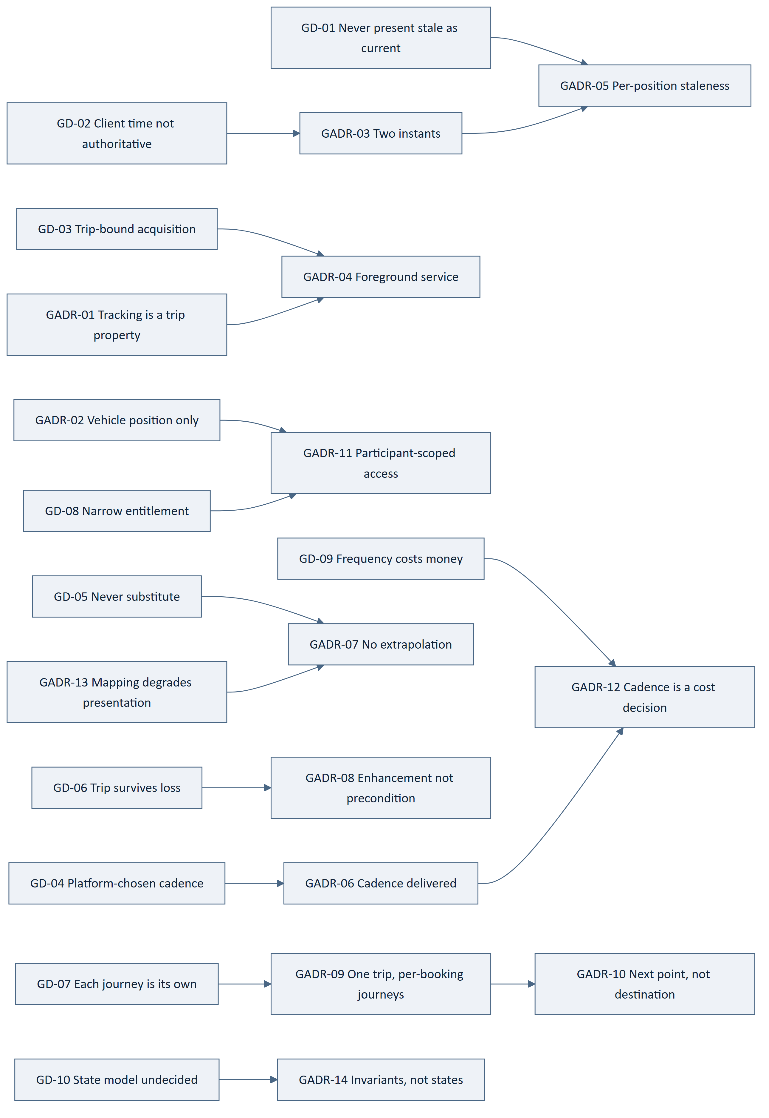
Figure 1 — 3.15 Driver to Decision Map

4. The Trip Lifecycle

4.1 Start
Table 27 — 4.1 Start
ID | Statement | Src
GPS-001 ‡ | A trip shall not start without at least one confirmed booking, irrespective of the eventual state model. | ARCH-091, FRD-FR-142
GPS-002 | A driver shall be able to begin a trip against a ride carrying at least one confirmed booking. | FRD-FR-141
GPS-003 | A trip shall be created on commencement and its start time recorded. | FRD-FR-143
GPS-004 | The actual start time shall be recorded against the scheduled departure time. | FRD-FR-147
GPS-005 | Booked passengers shall be notified when a trip begins; delivery is CMP-DOC-16's. | FRD-FR-146, §0.6
GPS-006 ‡ | A trip shall be permitted to start when position cannot be obtained, with tracking indicated as unavailable. | FRD-FR-152, MOB-079
GPS-007 ‡ | Trip start shall not depend on the mapping provider. | GADR-13, FRD-FR-153

4.2 During
Table 28 — 4.2 During
ID | Statement | Src
GPS-008 | Every trip state transition shall be recorded with the time at which it occurred. | FRD-FR-144
GPS-009 | The current trip state shall be visible to every participant. | FRD-FR-145
GPS-010 ‡ | Trip state shall be platform-determined and shall never be settable by a client. | API-160, UX-160
GPS-011 ‡ | No trip state transition shall depend on a position being available. | GADR-08, ARCH-107
GPS-012 ‡ | An active trip shall survive the unavailability of any single supporting service. | ARCH-107, NFR-034
GPS-013 | Transition definitions shall be read from policy configuration. | BADR-13, DB-155
GPS-014 | The state names and transitions themselves are not specified; see §12.1. | BAD-DEC-015, GADR-14

4.3 End
Table 29 — 4.3 End
ID | Statement | Src
GPS-015 ‡ | Position tracking shall cease when a trip ends. | FRD-FR-154, MOB-078
GPS-016 ‡ | The device shall release location capability when the trip ends. | SRS-REQ-150, MOB-078
GPS-017 ‡ | A trip shall not be reported complete where its record cannot be written. | FRD-FR-167, ARCH-095
GPS-018 ‡ | Completion shall record each booking's outcome independently. | FRD-FR-165, GADR-09
GPS-019 ‡ | A completed trip shall record its participants, route travelled, associated payment and outcome. | FRD-FR-166, NFR-126
GPS-020 | Completion shall publish a domain event with no compile-time dependency on its subscribers. | ARCH-097, BE-063

5. Position Acquisition

5.1 The Service
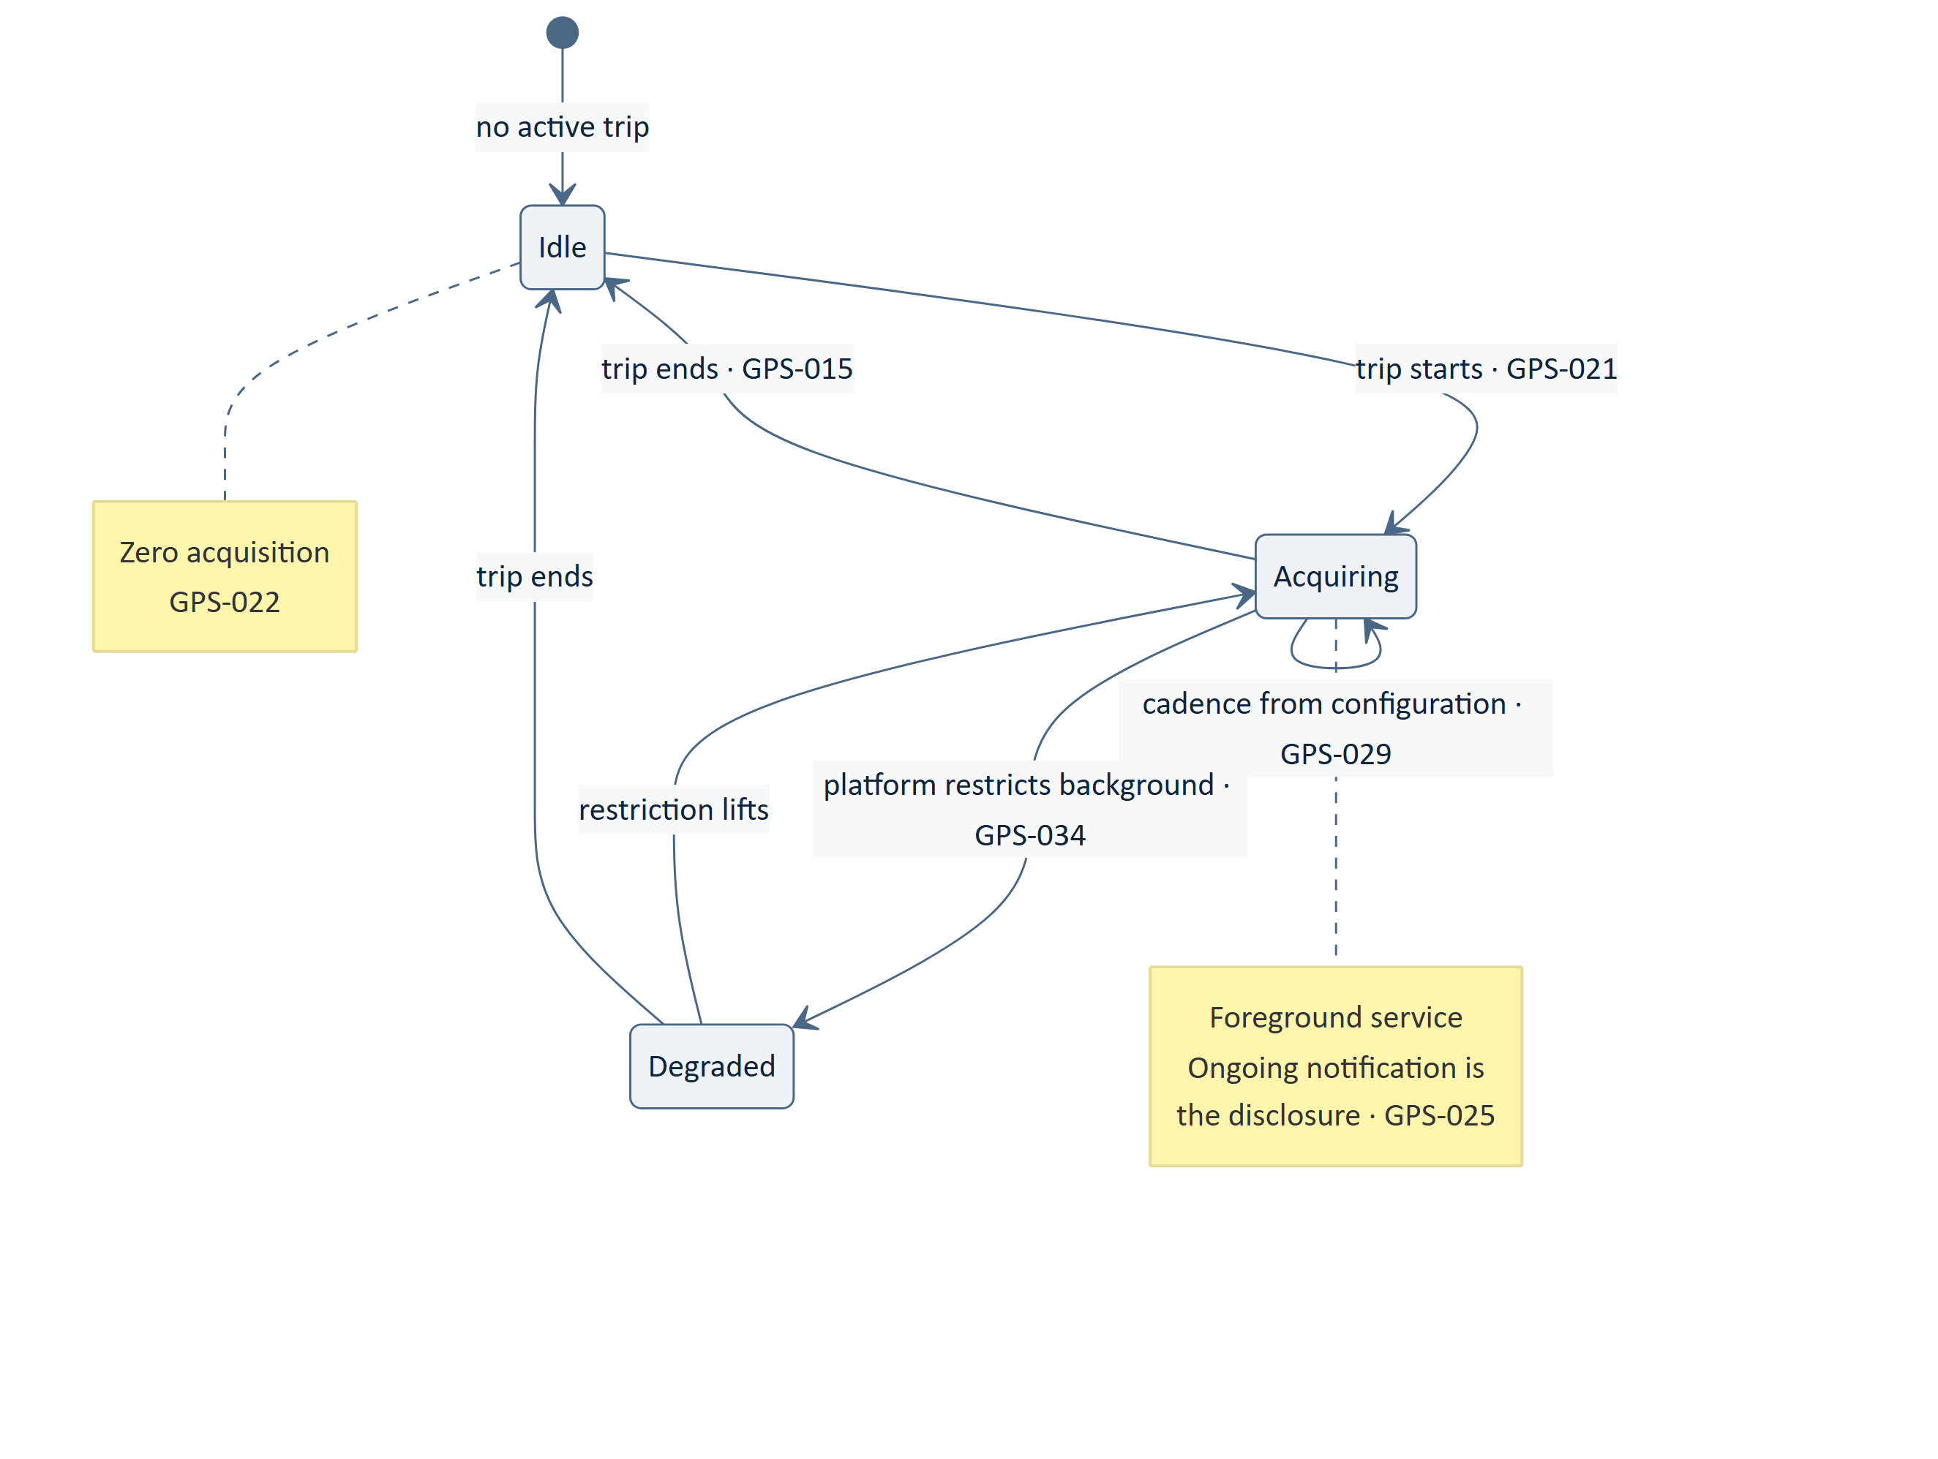
Figure 2 — 5.1 The Service
Table 30 — 5.1 The Service
ID | Statement | Src
GPS-021 ‡ | Location shall be acquired only while a trip is active. | MOB-069, GADR-01
GPS-022 ‡ | Zero acquisition shall occur outside an active trip. | MOB-069, NFR-065
GPS-023 ‡ | There shall be no user-level location setting, standing share or background tracking outside a trip. | GADR-01, NFR-065
GPS-024 ‡ | Acquisition shall run in a foreground service whose lifetime is bound to the active trip. | MOB-070, GADR-04
GPS-025 ‡ | The service's ongoing notification shall constitute the disclosure that location is being acquired, and shall not be suppressible. | MOB-071, SRS-REQ-015
GPS-026 ‡ | Only the driver's device shall report position; passenger devices shall acquire no location during a trip. | GADR-02, NFR-065
GPS-027 | The service shall contain no business rule and shall report through the client's normal gateway. | MOB-010, MOB-047
GPS-028 | A location permission shall be requested only when a trip requiring it is started, with its reason stated first. | SRS-REQ-147, UX-089

5.2 Cadence
Table 31 — 5.2 Cadence
ID | Statement | Src
GPS-029 ‡ | Acquisition cadence shall be supplied by the platform and shall never be chosen by the client. | MOB-072, ARCH-093
GPS-030 | Reporting cadence shall be a separate configured value from acquisition cadence. | GADR-06, NFR-147
GPS-031 ‡ | The client shall not vary cadence on its own judgement — not for battery, not for connectivity, not for perceived need. | MOB-072, GADR-06
GPS-032 | Cadence shall be read from the configuration resource and shall not be embedded. | MOB-123, API-187
GPS-033 | Cadence values are unset; §15.2 records them. | GAP-012, NFR-147

5.3 Degradation
Table 32 — 5.3 Degradation
ID | Statement | Src
GPS-034 ‡ | Under platform background restriction the trip shall continue with degraded acquisition rather than end. | MOB-077, GADR-08
GPS-035 | Degraded acquisition shall be reported as such, so that the platform knows why positions are sparse. | GADR-08, ARCH-105
GPS-036 ‡ | A refused location permission shall reduce capability and shall not end the trip or the flow. | SRS-REQ-148, UX-090
GPS-037 | The client shall not attempt to circumvent a platform restriction on background activity. | MOB-077, SEC-159
GPS-038 | Acquisition accuracy is a device and platform property and no accuracy figure is stated; §15.2. | §0.6.2

6. Position Reporting

6.1 What a Position Carries
Table 33 — 6.1 What a Position Carries
Element | Authoritative? | Purpose
Coordinates | Yes, as reported | The position
Reported accuracy | No — device-supplied | Presentation qualification
Device acquisition instant | No (ARCH-092) | Staleness and user-facing age
Platform receipt instant | Yes | Ordering, integrity, retention
Trip reference | Yes | Scoping

Table 34 — 6.1 What a Position Carries
ID | Statement | Src
GPS-039 ‡ | The platform shall timestamp every position on receipt, and that instant shall be authoritative. | ARCH-092, GADR-03
GPS-040 ‡ | The device's acquisition instant shall be carried as a separate reported value and shall never be authoritative. | ARCH-092, GADR-03
GPS-041 ‡ | Ordering, integrity and retention shall use the platform instant. | GADR-03, DB-074
GPS-042 ‡ | Staleness and the user-facing age shall be computed from the acquisition instant. | GADR-03, UX-139
GPS-043 | Device-reported accuracy shall be carried and shall qualify presentation, never gate acceptance. | GADR-07
GPS-044 ‡ | A position shall be scoped to its trip and shall not exist outside one. | GADR-01, DB-073

6.2 Acceptance
Table 35 — 6.2 Acceptance
ID | Statement | Src
GPS-045 ‡ | A position report shall be accepted only for an active trip the reporting actor drives. | SEC-056, API-099
GPS-046 ‡ | A position report shall be validated against platform state before use. | ARCH-131, API-040
GPS-047 ‡ | A position shall not set, alter or influence any authoritative business value. | API-036, UX-020
GPS-048 | Reports shall be accepted in batches, so that reporting cadence may differ from acquisition cadence. | GADR-06, GPS-030
GPS-049 | A batch shall be idempotent; a replayed batch shall produce no duplicate positions. | API-057, BE-135
GPS-050 | Out-of-order reports shall be accepted and ordered by the platform instant. | GPS-041
GPS-051 | A report for a trip that has ended shall be refused as a business refusal, not silently discarded. | GPS-015, API-059
GPS-052 | A report shall be rejected in whole where any element is malformed, and the rejection reported per branch. | API-038, UX-055

6.3 Distribution
Table 36 — 6.3 Distribution
ID | Statement | Src
GPS-053 | The vehicle's position shall be available to the participants of the active trip. | FRD-FR-149
GPS-054 ‡ | Position shall be served with its acquisition instant so that the consumer can compute age. | API-043, UX-139
GPS-055 | The most recent position shall be readable; the full stream shall not be exposed to participants. | GADR-11, API-049
GPS-056 | The client shall not poll for position on a self-chosen interval. | ARCH-026, MOB-134
GPS-057 | Position distribution shall not depend on the mapping provider. | GADR-13, FRD-FR-153

6.4 Which Instant, Where
Stated so that the choice is not a judgement call.
Table 37 — 6.4 Which Instant, Where
Purpose | Instant
Ordering the position stream | Platform receipt
Retention and removal | Platform receipt
Evidential and integrity records | Platform receipt
Staleness evaluation | Device acquisition
The age shown to a user | Device acquisition
Detecting a divergent device clock | Both, compared

Table 38 — 6.4 Which Instant, Where
ID | Statement | Src
GPS-058 | The mapping above shall be applied without exception. | GADR-03

7. Staleness
This section discharges CMP-DOC-12 §18.7.
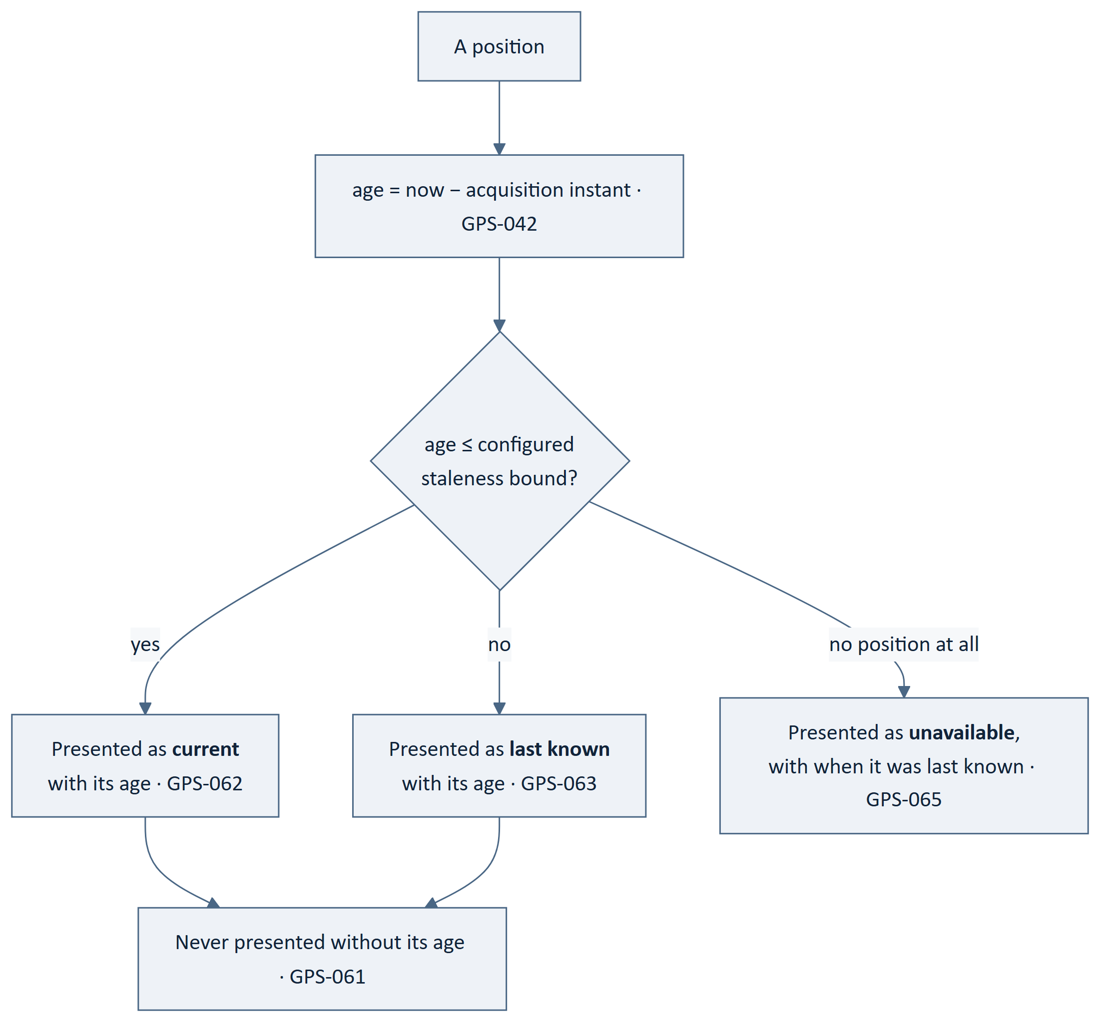
Figure 3 — 7. Staleness
Table 39 — 7. Staleness
ID | Statement | Src
GPS-059 ‡ | A staleness bound shall be delivered to the client through the configuration resource. | CMP-DOC-12 §18.7, MOB-123
GPS-060 ‡ | The bound shall not be compiled into the client, hard-coded in the platform, or derived from cadence. | GADR-05, MOB-123
GPS-061 ‡ | A position shall never be presented without its age. | UX-139, UXDR-11
GPS-062 ‡ | Within the bound, a position shall be presented as current with its age. | ARCH-094, UX-140
GPS-063 ‡ | Beyond the bound, a position shall be presented as last known with its age, and the presentation shall differ perceptibly. | FRD-FR-150, UX-140
GPS-064 ‡ | A previously known position shall never be presented as the current position. | FRD-FR-150, MOB-075
GPS-065 ‡ | Where position cannot be obtained at all, the platform shall indicate that it is unavailable and when it was last known. | FRD-FR-151
GPS-066 ‡ | A stale position shall not be hidden; a last-known position remains useful. | UXDR-11, FRD-FR-151
GPS-067 ‡ | Staleness shall be evaluated per position, never per screen or per session. | GADR-05, UXDR-02
GPS-068 ‡ | No position shall be extrapolated, dead-reckoned or interpolated. | GADR-07, FRD-FR-150
GPS-069 | The bound value is unset; §15.2. | GAP-012
GPS-070 | A large divergence between the acquisition and receipt instants shall be recorded, as it indicates a delayed report or a divergent device clock. | GADR-03, GPS-058

8. Estimates
Table 40 — 8. Estimates
ID | Statement | Src
GPS-071 | The platform shall compute an estimated time of arrival at each participant's next relevant point during an active trip. | FRD-FR-155
GPS-072 | The platform shall compute the remaining distance to each participant's next relevant point. | FRD-FR-156
GPS-073 | Estimates shall update as the trip progresses. | FRD-FR-157
GPS-074 ‡ | Where an estimate cannot be computed, the platform shall state that none is available rather than present a stale or default value. | FRD-FR-158, GADR-07
GPS-075 ‡ | An estimate shall never be carried forward when its inputs are stale. | GADR-07, GPS-074
GPS-076 | A driver shall be presented with the estimate to their next pickup or drop, not to their own destination. | FRD-FR-159, GADR-10
GPS-077 | A passenger awaiting pickup shall be presented with the estimate to their pickup; a passenger travelling, to their drop. | FRD-FR-163, GADR-10
GPS-078 ‡ | Estimates shall be computed by the platform and never on the device. | UX-020, MOB-022
GPS-079 | An estimate shall carry its own as-of marking, distinct from the position's. | API-043, UXDR-02
GPS-080 | Estimate refresh interval shall be configuration, separate from position cadence. | GADR-12, NFR-147
GPS-081 ‡ | Estimates shall become unavailable when the mapping provider is unavailable, and shall be stated as such. | GADR-13, FRD-FR-153
GPS-082 | Current speed, current landmark and the next navigation instruction are Release R2 (FRD-FR-160) and are not specified here. | FRD-FR-160, §12.3
GPS-083 | Point sequencing depends on route ordering, which no upstream rule, decision or requirement covers; §12.4. | originates here (§16.6)
GPS-084 | An estimate shall not be presented as a commitment or a guarantee. | NFR-137, UX-176

9. The Multi-Passenger Trip

9.1 The Model
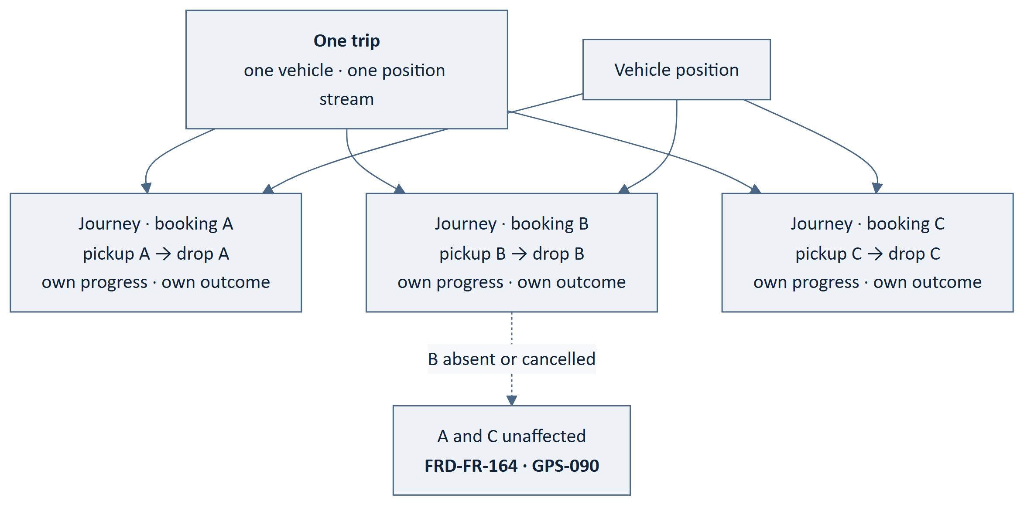
Figure 4 — 9.1 The Model
Table 41 — 9.1 The Model
ID | Statement | Src
GPS-085 ‡ | Every confirmed booking on a ride shall be associated with the same trip. | FRD-FR-161, GADR-09
GPS-086 ‡ | A trip shall carry one vehicle and one position stream. | GADR-02, GADR-09
GPS-087 ‡ | Each booking shall have its own journey with its own pickup point, drop point, progress and outcome. | FRD-FR-162, GADR-09
GPS-088 | Each passenger shall be presented the trip from the perspective of their own pickup and drop. | FRD-FR-163
GPS-089 ‡ | Participants shall share the vehicle's position and shall share nothing else. | GADR-11, API-049
GPS-090 ‡ | The cancellation or absence of one passenger shall not invalidate another passenger's booking on the same trip. | FRD-FR-164
GPS-091 ‡ | Outcomes shall be recorded per booking, so that one cannot affect another. | FRD-FR-165, GADR-09
GPS-092 ‡ | A trip shall not be modelled as several trips sharing a vehicle. | FRD-FR-161, GADR-09
GPS-093 ‡ | A trip shall not be modelled as one undifferentiated journey. | FRD-FR-162, FRD-FR-164

9.4 Trip-Level Versus Per-Booking
Stated so that the distinction is not rediscovered per feature.
Table 42 — 9.4 Trip-Level Versus Per-Booking
Concern | Level
Vehicle position | Trip
Trip state | Trip
Start and end instants | Trip
Route travelled | Trip
Pickup and drop points | Per booking
Progress against those points | Per booking
Estimate and remaining distance | Per booking (and per driver, to the next point)
Outcome | Per booking
Fare and payment | Per booking
Rating | Per booking pair — Outlined, BAD-DEC-012

Table 43 — 9.4 Trip-Level Versus Per-Booking
ID | Statement | Src
GPS-094 | The mapping above shall be applied when any trip capability is added. | GADR-09
GPS-095 | A trip-level operation shall be examined for whether it is really per-booking before it is built. | FRD-FR-164, GPS-094
GPS-096 | Completion is a set of per-booking outcomes plus a trip closure, not a single event. | FRD-FR-165, GPS-018

9.5 The Captured Route
Table 44 — 9.5 The Captured Route
ID | Statement | Src
GPS-097 ‡ | A completed trip shall capture the route travelled as a value on the trip record. | FRD-FR-166, DADR-11
GPS-098 ‡ | The captured route shall be derived from observed positions and shall not be the planned route. | FRD-FR-166, GADR-07
GPS-099 ‡ | Where few or no positions were observed, the captured route shall record that, rather than substituting the planned route. | GADR-07, GADR-08
GPS-100 ‡ | The captured route shall survive removal of the position history it was derived from. | DB-180, GADR-11
GPS-101 | The captured route shall be bounded in size; the position stream is not part of the trip record. | SRS-REQ-096, DB-166

10. Position Privacy and Retention
Table 45 — 10. Position Privacy and Retention
ID | Statement | Src
GPS-102 ‡ | Position shall be treated as personal data. | NFR-064, SEC-083
GPS-103 ‡ | Location history shall be accessible only to parties entitled to it. | NFR-064, SEC-067
GPS-104 ‡ | A position shall be visible to the participants of its trip, for that trip, while it is active. | GADR-11, API-049
GPS-105 ‡ | After completion, the position stream shall not be presented to participants. | GADR-11, NFR-065
GPS-106 ‡ | A counterparty's precise home or personal location shall not be disclosed beyond what coordinating the trip requires. | BAD-RULE-025, SEC-068
GPS-107 ‡ | Position shall be protected at rest; the mechanism is CMP-DOC-13's. | SEC-083, DB-035
GPS-108 ‡ | Position shall not appear in a log, a diagnostic record or a crash report. | SEC-157, BE-201
GPS-109 ‡ | Position shall not be transmitted to any third party other than as a mapping query, and a mapping query shall carry no participant identity. | SEC-060, NFR-065
GPS-110 ‡ | Position shall never be used as a cache key, a correlation value or an external identifier. | SEC-087
GPS-111 | Acquisition shall be disclosed to the user while it occurs. | SRS-REQ-015, GPS-025
GPS-112 | Tracking behaviour shall be understandable to the user, including when it occurs and when it stops. | NFR-160, MOB-071
GPS-113 ‡ | Only the driver's position is acquired; the platform holds no passenger position. | GADR-02, NFR-065
GPS-114 | An operator may reach position history only through the specified operator surface, and the access shall be recorded. | SEC-057, BE-078
GPS-115 ‡ | Position access by an operator shall be evidenced. | SEC-206, DB-114
GPS-116 | Unauthenticated recipients are bounded and time-limited by ARCH-137; the sharing flow itself is Outlined (§12.2). | ARCH-137, §12.2

10.2 Retention
Table 46 — 10.2 Retention
ID | Statement | Src
GPS-117 ‡ | Position history shall be held in its own table, separable from the trip record. | ARCH-119, DB-073
GPS-118 ‡ | Position history shall be removable independently of the trip record. | ARCH-119, DB-180
GPS-119 | Position rows are wholly personal and shared with nobody, so deletion is permitted rather than in-place removal. | DB-179, DADR-12
GPS-120 ‡ | Removal of position history shall not affect the captured route on a completed trip. | GPS-100, DB-174
GPS-121 ‡ | This discharges CMP-DOC-11 §18.5's obligation on independent removability. | CMP-DOC-11 §18.5, DB-180
GPS-122 | The position retention period is `[TBD – Business Decision Required]` (SRS-REQ-093, BAD-DEC-021). | SRS-REQ-093, BAD-DEC-021
GPS-123 | Position history is the highest-volume data the platform holds; its partitioning and archival are unresolved sizing decisions. | DB-076, DB-201
GPS-124 | Retention enforcement shall run as scheduled maintenance. | BE-147, DB-170

11. Mapping Dependency and Cost

11.1 Dependency
Table 47 — 11.1 Dependency
ID | Statement | Src
GPS-125 ‡ | Position acquisition, reporting and storage shall not depend on the mapping provider. | GADR-13, FRD-FR-153
GPS-126 ‡ | Where mapping is unavailable, positions shall continue to be acquired, reported and stored. | FRD-FR-153
GPS-127 | Where mapping is unavailable, map rendering and estimates shall become unavailable and shall be stated as such. | GADR-13, GPS-081
GPS-128 | Mapping shall be reached through a port declared in domain terms, naming no provider. | BE-150, ARCH-130
GPS-129 | The mapping adapter shall be substitutable without change above Infrastructure. | BE-162, ADR-11

11.2 Plausibility
This discharges CMP-DOC-13's obligation to state plausibility rules for mapping.
Table 48 — 11.2 Plausibility
# | Rule | Statement
1 | A returned route must connect the points requested | GPS-131
2 | A returned distance must be consistent with the geometry returned | GPS-132
3 | A returned duration must be consistent with the distance at a plausible speed | GPS-133
4 | A geocoded point must lie within the bounds of the query it answered | GPS-134
5 | A response must reference the query the platform issued | GPS-135
6 | A response must be in a recognised structure with a recognised vocabulary | GPS-136

Table 49 — 11.2 Plausibility
ID | Statement | Src
GPS-130 ‡ | Every mapping response shall be validated for plausibility before it is returned above the adapter. | SEC-012, ARCH-064
GPS-131 ‡ | A route that does not connect the requested points shall fail plausibility. | GPS-130, SEC-060
GPS-132 ‡ | A distance inconsistent with the returned geometry shall fail plausibility. | GPS-130
GPS-133 ‡ | A duration inconsistent with the distance at a plausible speed shall fail plausibility; the plausibility band is configuration and its value is unset. | GPS-130, §15.2
GPS-134 ‡ | A geocoded point outside the bounds of its query shall fail plausibility. | GPS-130, SEC-012
GPS-135 ‡ | A response not referencing the platform's query shall fail plausibility. | SEC-004, GPS-130
GPS-136 ‡ | An unrecognised structure or vocabulary shall fail plausibility. | SEC-012
GPS-137 ‡ | A response failing plausibility shall be returned as Unavailable, never as a result, and recorded. | BE-152, PAY-108
GPS-138 ‡ | The adapter shall not synthesise, default or infer a result the provider did not return. | ARCH-066

11.3 Cost
Table 50 — 11.3 Cost
ID | Statement | Src
GPS-139 | Every mapping call shall be recorded with its outcome and its attributable cost. | ARCH-067, SRS-REQ-145
GPS-140 | Cost shall be attributed to the trip and the participant that caused it. | NFR-143, GADR-12
GPS-141 | Third-party cost per completed trip shall be bounded; the bound is unset. | NFR-145, §15.2
GPS-142 | The cost consequence of tracking frequency shall be explicit and configurable. | NFR-147, GADR-12
GPS-143 | Cost per trip shall be an operational measure. | NFR-149
GPS-144 | An alert threshold on cost per trip is unset; §15.2. | NFR-149, GAP-012
GPS-145 | Result caching shall apply only to stable results and shall never cache a position or an authoritative value. | ARCH-068, BE-121
GPS-146 | Where mapping is unavailable, the client shall state it rather than render a blank map. | UX-069, GADR-13
GPS-147 | Route geometry resolved at publication is stored with the ride and is CMP-DOC-11's; it is not re-resolved per trip. | ARCH-051, DB-051
GPS-148 | The number of mapping calls per trip shall be bounded by cadence and by the estimate refresh interval, both configuration. | GADR-12, GPS-080
GPS-149 | Cost budgets, quotas and pricing are CMP-DOC-19's. | §0.6
GPS-150 | The directed providers are Google Maps Platform for mapping and Android Fused Location Provider for device acquisition; no API, tier or quota is specified. | CMP-DOC-01, §0.6.1
GPS-151 | Provider capability shall be reached only through the port, and no provider type shall appear above the adapter. | BE-153, ARCH-063
GPS-152 | Provider behaviour shall be confirmed against the provider's current specification at integration, and divergence raised as a change. | §0.6.1, PAY-192

12. What Is Not Specified

12.1 The Trip State Model
FACT. UC-041 — progress trip state — is Outlined, blocked by BAD-DEC-015.
Table 51 — 12.1 The Trip State Model
ID | Statement | Src
GPS-153 | No trip state name and no transition is specified. | BAD-DEC-015, GADR-14
GPS-154 ‡ | The invariants in GPS-001, GPS-011, GPS-017 and GPS-090 shall hold under any eventual state model. | ARCH-091, BE-177
GPS-155 | When BAD-DEC-015 is resolved, the model shall become policy configuration and no code change shall be required to adopt it. | BADR-13, DB-155
GPS-156 | A developer cannot build the trip state display from this document alone; UX-143 presents state from platform state, and what those states are is undecided. | UX-143, §0.8.3

12.2 Live Trip Sharing
Table 52 — 12.2 Live Trip Sharing
ID | Statement | Src
GPS-157 | No live trip sharing flow, recipient experience or link mechanism is specified. UC-049 is Outlined, blocked by BAD-DEC-022. | BAD-DEC-022, §0.8.4
GPS-158 ‡ | If sharing is later specified, what an unauthenticated recipient may see shall be bounded and time-limited by policy configuration. | ARCH-137, SEC-007
GPS-159 | CMP-DOC-12 §13.1 records sharing as one of three undesignable safety controls; this document does not change that. | UX-153, BAD-DEC-022

12.3 Navigation and Speed
Table 53 — 12.3 Navigation and Speed
ID | Statement | Src
GPS-160 | Current speed, current landmark and the next navigation instruction are Release R2 and are not specified here. | FRD-FR-160
GPS-161 | The platform is not a navigation application, and no statement here shall be read as providing turn-by-turn guidance. | NFR-137, FRD-FR-160

12.4 Pickup and Drop Sequencing — A New Gap
Table 54 — 12.4 Pickup and Drop Sequencing — A New Gap
ID | Statement | Src
GPS-162 | The order in which pickups and drops are sequenced on a multi-passenger trip is `[TBD – Business Decision Required]`, and no upstream rule, decision or requirement covers it. BAD-RULE-022 and BAD-RULE-023 govern route matching at search time, not point sequencing during a trip. | originates here (§16.6)
GPS-163 ‡ | Until decided, the driver's next relevant point cannot be determined by the platform and FRD-FR-159 is unimplementable for a multi-passenger trip. | FRD-FR-159, GPS-162
GPS-164 | This is a new gap identified by this document — it is not recorded in CMP-DOC-01 as a business decision, not in CMP-DOC-04 as a functional gap, and not in the gap register. It is escalated at §19.4 R-3 and registered as GAP-017. | GPS-162, GAP-017

12.5 Other Absences
Table 55 — 12.5 Other Absences
ID | Statement | Src
GPS-165 | Geofencing, arrival detection and automatic pickup confirmation are not specified by any requirement and are not invented here. | §19 no-invention rule
GPS-166 | Driver behaviour monitoring — harsh braking, speeding, phone use — is not specified by any requirement and is not invented here. | §19 no-invention rule
GPS-167 | Offline map storage is not specified and is a FUTURE CONSIDERATION. | FRD-FR-153
GPS-168 | Position-based fare adjustment does not exist; the fare is captured at confirmation and is immutable. | PAY-020, DB-162

13. Degraded Operation
Table 56 — 13. Degraded Operation
Condition | Trip continues? | What the user is told
No position at trip start | Yes | Tracking unavailable (GPS-006)
Position lost during trip | Yes | Last known, with its age (GPS-063)
Platform restricts background activity | Yes, degraded | Acquisition degraded (GPS-034)
Location permission refused | Yes, no tracking | Capability reduced (GPS-036)
Mapping provider unavailable | Yes | Map and estimates unavailable (GPS-127)
Platform unreachable from the client | Yes | Positions queued; client discloses degraded state
Trip record cannot be written at completion | Trip not reported complete | GPS-017

Table 57 — 13. Degraded Operation
ID | Statement | Src
GPS-169 ‡ | No degradation in this table shall invalidate a trip, a booking or a payment. | GADR-08, ARCH-107
GPS-170 ‡ | Every degradation shall be disclosed rather than hidden. | ARCH-105, UX-069
GPS-171 ‡ | Degraded state shall be propagated to the client for disclosure. | ARCH-105, MOB-106
GPS-172 | Positions acquired while the platform is unreachable shall be queued on the device and reported on restoration. | MOB-065, NFR-162
GPS-173 | Queued positions shall retain their acquisition instants and shall be ordered by the platform on receipt. | GPS-040, GPS-050
GPS-174 ‡ | A queued batch shall be idempotent on restoration. | GPS-049, API-062
GPS-175 ‡ | The safety surface shall remain reachable throughout every degradation above. | UX-080, BE-193
GPS-176 ‡ | A capability whose degradation would compromise an absolute rule shall be withdrawn entirely rather than degraded; no tracking capability meets that description. | NFR-035, ARCH-104
GPS-177 | A trip shall not be ended by the platform because tracking failed. | GADR-08, GPS-011
GPS-178 | Recovery shall update positions and their provenance without disrupting the user's position in a flow. | UX-215, NFR-162

14. Verification Obligations
Table 58 — 14. Verification Obligations
# | Obligation | Verifies
1 | No location is acquired when no trip is active, in any application state | GPS-021, GPS-022
2 | Acquisition stops and location is released when the trip ends | GPS-015, GPS-016
3 | A position older than the configured bound is never presented as current | GPS-062, GPS-064
4 | Changing the configured bound changes presentation without a client release | GPS-059, GPS-060
5 | No position is extrapolated between reports | GPS-068
6 | An estimate whose inputs are stale is reported unavailable, not carried forward | GPS-074, GPS-075
7 | A trip starts, runs and completes with no position at all | GPS-006, GPS-011
8 | One passenger's cancellation leaves every other booking on the trip valid | GPS-090
9 | An implausible mapping response returns Unavailable, never a result | GPS-137
10 | Removing position history leaves the completed trip's captured route intact | GPS-120

Table 59 — 14. Verification Obligations
ID | Statement | Src
GPS-179 ‡ | The ten obligations above shall be automated tests. | NFR-106, SADR-16
GPS-180 ‡ | Obligations 1, 3 and 8 shall be non-suppressible; each guards an integrity-critical statement. | GPS-022, GPS-064, GPS-090
GPS-181 | Obligation 1 shall be exercised across application states including background and after process death. | MOB-069, GPS-021
GPS-182 | Obligation 8 shall be exercised on a trip with at least three bookings. | GPS-090, GADR-09
GPS-183 | Every statement marked ‡ shall be covered by an obligation here, by a database constraint, or by an obligation in CMP-DOC-13 §19. | NFR-106, SEC-233
GPS-184 | The obligations pass to CMP-DOC-18 as test obligations. | §16.7

15. Configuration Values

15.1 Delivered to the Client
This is the set CMP-DOC-10 §14.2 reserved and CMP-DOC-12 §18.7 required.
Table 60 — 15.1 Delivered to the Client
Value | Consumed by | Statement
Acquisition cadence | Foreground service | GPS-029
Reporting cadence | Client gateway | GPS-030
Position staleness bound | Presentation | GPS-059
Estimate refresh interval | Platform, disclosed to client | GPS-080
Presentation cache validity | Client cache | MOB-123
Client retry and backoff policy | Client gateway | MOB-051

Table 61 — 15.1 Delivered to the Client
ID | Statement | Src
GPS-185 ‡ | Every value above shall be delivered through the configuration resource and none shall be embedded. | MOB-123, API-187
GPS-186 ‡ | The client shall hold a documented conservative default for each, applied only until its first successful fetch. | API-193, UX-193
GPS-187 ‡ | No configuration value shall permit a position to be presented as current beyond its bound. | BE-172, GPS-064

15.2 Named but Unset
Eleven values. No figure is stated for any of them.
Table 62 — 15.2 Named but Unset
Value | Register
Acquisition cadence | [TBD – Technical Decision Required]
Reporting cadence | [TBD – Technical Decision Required]
Position staleness bound | [TBD – Technical Decision Required]
Estimate refresh interval | [TBD – Technical Decision Required]
Duration plausibility band | [TBD – Technical Decision Required]
Mapping calls permitted per trip | [TBD – Technical Decision Required]
Third-party cost bound per trip | [TBD – Business Decision Required] · NFR-145
Cost-per-trip alert threshold | [TBD – Business Decision Required] · NFR-149
Position retention period | [TBD – Business Decision Required] · SRS-REQ-093
Battery and data budgets for tracking | [TBD – Business Decision Required] · GAP-015
Position history partitioning boundary | [TBD – Technical Decision Required] · GAP-016

Table 63 — 15.2 Named but Unset
ID | Statement | Src
GPS-188 | No value above is asserted anywhere in this document. | §0.6.2, §19 no-invention rule
GPS-189 | Four of them — cadence, staleness, estimate refresh and cost bound — are the same trade-off seen four ways, and setting them requires measurement nobody has taken. | NFR-147, GADR-12
GPS-190 | The mechanism is complete and unusable until the first four are set. | GPS-033, GPS-069

15.3 Instrumentation Required to Set Them
Table 64 — 15.3 Instrumentation Required to Set Them
ID | Statement | Src
GPS-191 | Position report volume per trip shall be measurable. | GADR-12, MOB-136
GPS-192 | Mapping calls per trip shall be measurable. | GPS-139, NFR-143
GPS-193 | Battery and data consumed during an active trip shall be measurable at the nine points CMP-DOC-08 §13.1 named. | GAP-015, MOB-136
GPS-194 | Position age at the moment of presentation shall be measurable, so that the staleness bound can be set from observation. | GPS-042, GADR-05
GPS-195 | Instrumentation shall exist from first release, so that the values can be set from data rather than argument. | NFR-113, GAP-015
GPS-196 | Setting the four values is a precondition for the tracking feature being tunable, not a post-launch improvement. | GPS-190, §19.4

16. Traceability

16.1 Upward Traceability
Table 65 — 16.1 Upward Traceability
Source document | Basis carried into this document
CMP-DOC-03 | UC-039, UC-040, UC-042, UC-044 Specified; UC-041, UC-049 Outlined
CMP-DOC-04 §6.1 | FRD-FR-141–168
CMP-DOC-05 | NFR-064, NFR-143–149, NFR-160
CMP-DOC-07 | ARCH-091–ARCH-097, ARCH-107, ARCH-119, ARCH-137
CMP-DOC-08 §8.1 | MOB-069–MOB-084
CMP-DOC-10 §11.9, §14.2 | Position operations; the configuration set
CMP-DOC-11 | DB-073–DB-076, DB-179, DB-180
CMP-DOC-12 §18.7 | The staleness bound obligation
CMP-DOC-13 §20.5 | Position protection, access limits, mapping plausibility

16.2 The 28 Trip Execution Requirements
Table 66 — 16.2 The 28 Trip Execution Requirements
FRD | Realised by
FRD-FR-141, FRD-FR-142 | GPS-002, GPS-001
FRD-FR-143, FRD-FR-144 | GPS-003, GPS-008
FRD-FR-145 | GPS-009
FRD-FR-146, FRD-FR-147 | GPS-005, GPS-004
FRD-FR-148, FRD-FR-149 | GPS-021, GPS-053
FRD-FR-150, FRD-FR-151 | GPS-064, GPS-065
FRD-FR-152, FRD-FR-153 | GPS-006, GPS-126
FRD-FR-154 | GPS-015
FRD-FR-155, FRD-FR-156, FRD-FR-157 | GPS-071, GPS-072, GPS-073
FRD-FR-158, FRD-FR-159 | GPS-074, GPS-076
FRD-FR-160 | Release R2 — GPS-160, not specified
FRD-FR-161, FRD-FR-162, FRD-FR-163, FRD-FR-164 | GPS-085, GPS-087, GPS-088, GPS-090
FRD-FR-165, FRD-FR-166, FRD-FR-167 | GPS-018, GPS-019, GPS-017
FRD-FR-168 | Presentation is CMP-DOC-12's; the record is GPS-019

27 of 28 are realised. `FRD-FR-160` is Release R2 and is not specified, which is a scope position rather than a gap.

16.3 Obligations Discharged
Table 67 — 16.3 Obligations Discharged
Obligation | Source | Discharged by
Supply a staleness bound as configuration | CMP-DOC-12 §18.7 | GPS-059, GPS-060; §15.1
Position protection and access limits | CMP-DOC-13 §20.5 | §10
Mapping plausibility rules | CMP-DOC-13 §20.5 | §11.2, six rules
op_trip_positions independently removable | CMP-DOC-11 §18.5 | GPS-118, GPS-121
Cadence and staleness as configuration | CMP-DOC-10 §14.2 | §15.1

16.4 Downward Traceability
Table 68 — 16.4 Downward Traceability
Consuming document | What it must take from here
CMP-DOC-16 Communication & Notification | Trip-start and trip-event notification triggers; that a notification carries no position
CMP-DOC-17 Admin / Filament | Operator position access is evidenced (GPS-115) and bounded by retention
CMP-DOC-18 Testing & QA | The 10 verification obligations (§14)
CMP-DOC-19 DevOps | Mapping cost budgets, position history partitioning, the instrumentation in §15.3

16.5 Statements Awaiting a Decision
Table 69 — 16.5 Statements Awaiting a Decision
Statement | Awaiting
GPS-014, GPS-153–GPS-156 | Trip state model — BAD-DEC-015
GPS-116, GPS-157–GPS-159 | Live trip sharing — BAD-DEC-022
GPS-122 | Position retention — BAD-DEC-021
GPS-141, GPS-144 | Cost bound and threshold — NFR-145, NFR-149
GPS-162–GPS-164 | Pickup and drop sequencing — GAP-017
§15.2 | Eleven configuration values

16.6 Statements Originating in This Document
Table 70 — 16.6 Statements Originating in This Document
Statement | Subject | Position
GPS-040 | The device instant is carried as a separate non-authoritative value | New. ARCH-092 says client timestamps are not authoritative; nothing said the device instant must still be carried, and UX-139 needs it.
GPS-070 | A large divergence between the two instants is recorded | New. Follows from carrying both: the difference is a signal nobody had considered.
GPS-099 | Where few positions were observed, the captured route records that | New. GADR-08 makes trips without tracking normal; nothing said what FRD-FR-166's route captures then.
GPS-162, GPS-163 | Pickup and drop sequencing on a multi-passenger trip is undecided, and FRD-FR-159 is unimplementable without it | New, and a new gap. No upstream rule, decision, requirement or gap-register entry covers point sequencing. BAD-RULE-022 and BAD-RULE-023 govern route matching at search time only. Registered as GAP-017.

16.7 Obligations This Document Places on Others
Table 71 — 16.7 Obligations This Document Places on Others
Document | Obligation
CMP-DOC-16 | Must not place a position in a notification
CMP-DOC-16 | Must trigger trip-start notification from the trip event, not from a position
CMP-DOC-17 | Must evidence every operator access to position history
CMP-DOC-18 | Must carry the 10 obligations, with 1, 3 and 8 non-suppressible
CMP-DOC-18 | Must exercise obligation 1 across background and post-process-death states
CMP-DOC-19 | Must provide the instrumentation in §15.3 from first release
CMP-DOC-19 | Must resolve position history partitioning once launch scale exists

17. Assumptions, Risks and Open Questions

17.1 Assumptions
Table 72 — 17.1 Assumptions
ID | Assumption | If false
GPS-ASM-01 | A foreground service can sustain acquisition for a trip's duration on the supported device range. | GADR-04 degrades to GPS-034's path more often than expected; the device range is unchosen (MOB-OQ-001).
GPS-ASM-02 | Device-reported acquisition instants are approximately correct. | GPS-070 detects divergence; staleness would be computed from a wrong clock, which is why GPS-041 uses the platform instant for everything that must be right.
GPS-ASM-03 | Passengers accept that no pre-trip position is available. | GADR-01 would need revisiting, and with it the whole minimisation position.
GPS-ASM-04 | The mapping provider supports the plausibility checks in §11.2 — returning the query reference, geometry and distance. | GPS-135 and GPS-132 become unimplementable and SEC-012 is unmet for mapping.
GPS-ASM-05 | Position volume is manageable at launch scale. | Unmeasured; GPS-123 records partitioning as unresolved and it is the highest-volume table.
GPS-ASM-06 | Launch scale is unknown; no statement here depends on a figure. | —

17.2 Risks
Table 73 — 17.2 Risks
ID | Risk | L | I | Sev | Response
GPS-RISK-01 | Fourteen unapproved predecessors. | 5 | 4 | 20 | CC-016; must not be baselined before approval.
GPS-RISK-02 | The staleness bound is never set, so the mechanism ships with a conservative default nobody revisits. | 4 | 5 | 20 | GPS-190, GPS-196; §15.3's instrumentation is what makes setting it possible.
GPS-RISK-03 | Dead-reckoning is added to smooth the map, defeating FRD-FR-150. | 4 | 5 | 20 | GPS-068; obligation 5. The flickering GADR-07 causes is exactly what invites this.
GPS-RISK-04 | The multi-passenger model is built as one undifferentiated journey. | 3 | 5 | 15 | GPS-093, §9.4's level table; obligation 8 non-suppressible.
GPS-RISK-05 | Sequencing stays undecided and per-driver estimates are quietly dropped, or a developer invents an ordering. | 4 | 4 | 16 | GAP-017; the gap is now named rather than discovered in build. Nobody has been asked this question before.
GPS-RISK-06 | Cadence is set high for a good demonstration and the mapping cost is discovered in the first invoice. | 4 | 4 | 16 | GADR-12 makes cadence and cost the same decision; GPS-143 measures it.
GPS-RISK-07 | Acquisition continues outside a trip through a defect nobody notices. | 3 | 5 | 15 | Obligation 1, non-suppressible, exercised across application states.
GPS-RISK-08 | Position history grows unpartitioned until the table is unmanageable. | 4 | 4 | 16 | GPS-123, DB-201; needs launch scale (GAP-016).

17.3 Open Questions
Table 74 — 17.3 Open Questions
ID | Question | Type
GPS-OQ-01 | What are the trip states and transitions? | BAD-DEC-015, UC-041
GPS-OQ-02 | In what order are pickups and drops sequenced on a multi-passenger trip? | GAP-017 — no upstream decision exists to resolve
GPS-OQ-03 | Is live trip sharing to be specified, and on what terms? | BAD-DEC-022, UC-049
GPS-OQ-04 | What is the position retention period? | SRS-REQ-093, BAD-DEC-021
GPS-OQ-05 | What acquisition and reporting cadence, and what staleness bound? | §15.2
GPS-OQ-06 | What third-party cost bound and alert threshold per trip? | NFR-145, NFR-149
GPS-OQ-07 | What is the supported device range, on which GPS-ASM-01 depends? | MOB-OQ-001
GPS-OQ-08 | Does the mapping provider support the six plausibility checks? | GPS-ASM-04

18. Acceptance Criteria for This Document
Table 75 — 18. Acceptance Criteria for This Document
# | Criterion | Met
1 | All 28 trip execution requirements addressed | Yes — §16.2; 27 realised, 1 is Release R2
2 | All five inherited obligations discharged | Yes — §16.3
3 | The staleness bound supplied as configuration | Yes — GPS-059, GPS-060
4 | Six mapping plausibility rules stated | Yes — §11.2
5 | No cadence, staleness, accuracy, battery, data or cost figure stated | Yes — §15.2, eleven named unset
6 | No trip state name or transition invented | Yes — GPS-153
7 | No sharing flow invented | Yes — GPS-157
8 | The multi-passenger model specified per booking, not per trip | Yes — §9, §9.4
9 | No position extrapolated, defaulted or carried forward | Yes — GADR-07, GPS-068, GPS-075
10 | Every statement names a source, and every cited identifier resolves | Yes — 196 of 196
11 | Statement identifiers contiguous and unique | Yes — GPS-001 … GPS-196
12 | Statements with no upstream counterpart disclosed | Yes — §16.6, 4 of them

19. Statistics and Recommendations

19.1 Document Statistics
Table 76 — 19.1 Document Statistics
Measure | Value
Tracking drivers | 10 (GD-01 … GD-10)
Tracking decisions | 14 (GADR-01 … GADR-14)
Live trip specification statements | 196 (GPS-001 … GPS-196)
Integrity-critical statements (‡) | 96
Statements naming a source | 196 of 196
Diagrams | 4
Trip execution requirements realised | 27 of 28; 1 is Release R2
Configuration values delivered to the client | 6
Configuration values named but unset | 11
Mapping plausibility rules | 6
Verification obligations | 10 (3 non-suppressible)
Statements with no upstream counterpart | 5
Cadence, accuracy or budget figures stated | 0
Trip state names invented | 0
Assumptions / Risks / Open questions | 6 / 8 / 8
[TBD – Business Decision Required] markers | 8
[TBD – Technical Decision Required] markers | 8

Statements by Section
Table 77 — Statements by Section
§ | Section | Statements
4 | The Trip Lifecycle | 20
5 | Position Acquisition | 18
6 | Position Reporting | 20
7 | Staleness | 12
8 | Estimates | 14
9 | The Multi-Passenger Trip | 17
10 | Position Privacy and Retention | 23
11 | Mapping Dependency and Cost | 28
12 | What Is Not Specified | 16
13 | Degraded Operation | 10
14 | Verification Obligations | 6
15 | Configuration Values | 12
 | Total | 196

19.2 A Complete Mechanism With No Values
The tracking mechanism is fully specified and cannot yet be tuned. Four of the eleven
unset values — acquisition cadence, reporting cadence, the staleness bound and the estimate
refresh interval — are the same trade-off seen four ways: how often to look, how often to
tell, how long to believe, how often to recompute. Each costs battery, data and mapping
calls; each buys freshness.
None can be set by argument. §15.3 requires the instrumentation from first release
precisely so that they are set from observation. GPS-196 states that this is a
precondition for the feature being tunable, not a post-launch improvement.
The one substantive gap in an otherwise complete area is new. Because pickup and drop
sequencing on a multi-passenger trip is undecided, the platform cannot determine a
driver's next relevant point, and FRD-FR-159 is unimplementable. **No upstream rule,
decision, requirement or gap-register entry covers it** — BAD-RULE-022 and BAD-RULE-023
govern route matching at search time, not sequencing during a trip. Registered here as
GAP-017 and escalated at R-3.

19.3 What This Document Could Not Settle
Table 78 — 19.3 What This Document Could Not Settle
Matter | Why not settled
Trip states and transitions | BAD-DEC-015, UC-041 Outlined
Pickup and drop sequencing | `GAP-017` — newly identified; no upstream decision exists
Live trip sharing | BAD-DEC-022, UC-049 Outlined
Eleven configuration values | Measurement not taken; GAP-012, GAP-015, GAP-016
Position retention | BAD-DEC-021
Navigation and speed | FRD-FR-160 is Release R2

19.4 Recommendations
Table 79 — 19.4 Recommendations
# | Recommendation | Rationale
R-1 | Build the §15.3 instrumentation before the tracking feature, not after. | GPS-RISK-02 is severity 20. Four values cannot be set by argument, and a conservative default shipped without measurement becomes permanent.
R-2 | Write obligation 5 — no extrapolation — before the map screen. | GPS-RISK-03 is severity 20. GADR-07 causes visible flickering, and smoothing it with dead-reckoning is the obvious fix and the one FRD-FR-150 forbids.
R-3 | Decide pickup and drop sequencing, and record it as a business decision — there is currently no decision to resolve. | GAP-017. Without it a driver on a multi-passenger trip cannot be given the estimate FRD-FR-159 requires, and multi-passenger travel is the product's premise. This is a new gap, not a known one being restated.
R-4 | Decide `BAD-DEC-015` before the trip screen is built. | GPS-156: a developer cannot build the state display from this document, and the invariants are specified but the vocabulary is not.
R-5 | Confirm the six plausibility checks against the mapping provider early. | GPS-ASM-04. If the provider does not return a query reference, GPS-135 is unimplementable and SEC-012 is unmet for mapping.
R-6 | Treat cadence as a cost decision at the first tuning conversation. | GPS-RISK-06. GADR-12 makes the link explicit so that it is a decision rather than an invoice.

19.5 Recommendation Status
Table 80 — 19.5 Recommendation Status
Recommendation | Status
R-1 … R-6 | Recorded. None accepted, rejected or scheduled — this document is Draft and unapproved.

Appendix A — Statement Index
Table 81 — Appendix A — Statement Index
Range | Section
GPS-001 – GPS-020 | The Trip Lifecycle
GPS-021 – GPS-038 | Position Acquisition
GPS-039 – GPS-058 | Position Reporting
GPS-059 – GPS-070 | Staleness
GPS-071 – GPS-084 | Estimates
GPS-085 – GPS-101 | The Multi-Passenger Trip
GPS-102 – GPS-124 | Position Privacy and Retention
GPS-125 – GPS-152 | Mapping Dependency and Cost
GPS-153 – GPS-168 | What Is Not Specified
GPS-169 – GPS-178 | Degraded Operation
GPS-179 – GPS-184 | Verification Obligations
GPS-185 – GPS-196 | Configuration Values

Appendix B — Decision Index
Table 82 — Appendix B — Decision Index
GADR | Decision | Section
GADR-01 | Tracking is a trip property, not a user property | §3.1
GADR-02 | Position is reported by the vehicle, not every participant | §3.2
GADR-03 | Two instants, one authoritative | §3.3
GADR-04 | A foreground service bound to the trip | §3.4
GADR-05 | Staleness is per position, against a delivered bound | §3.5
GADR-06 | Cadence is delivered; the client never chooses | §3.6
GADR-07 | No value is ever extrapolated | §3.7
GADR-08 | Tracking is an enhancement, never a precondition | §3.8
GADR-09 | One trip, independent per-booking journeys | §3.9
GADR-10 | The driver sees the next point, not the destination | §3.10
GADR-11 | Position access is participant-, trip- and time-scoped | §3.11
GADR-12 | Cadence is a cost decision, and cost is attributed | §3.12
GADR-13 | Mapping unavailability degrades presentation, not position | §3.13
GADR-14 | Specify the invariants; configure the states | §3.14

Appendix C — Position Reference
Table 83 — Appendix C — Position Reference
Property | Value
Acquired when | Only while a trip is active (GPS-021)
Acquired by | The driver's device only (GPS-026)
Acquired how | Foreground service bound to the trip (GPS-024)
Cadence | Platform-supplied configuration (GPS-029)
Authoritative instant | Platform receipt (GPS-039)
Age computed from | Device acquisition instant (GPS-042)
Presented as current | Within the configured staleness bound (GPS-062)
Presented beyond the bound | Last known, with its age (GPS-063)
Never | Extrapolated, defaulted or carried forward (GPS-068)
Visible to | Participants of that trip, while active (GPS-104)
Visible after completion | Not at all; the captured route replaces it (GPS-105)
Stored in | Its own table, independently removable (GPS-117, GPS-118)
Deletable | Yes — wholly personal, shared with nobody (GPS-119)
Retention period | [TBD – Business Decision Required] (GPS-122)

End of CMP-DOC-15 GPS / Live Trip Specification, version 0.1, Draft.

