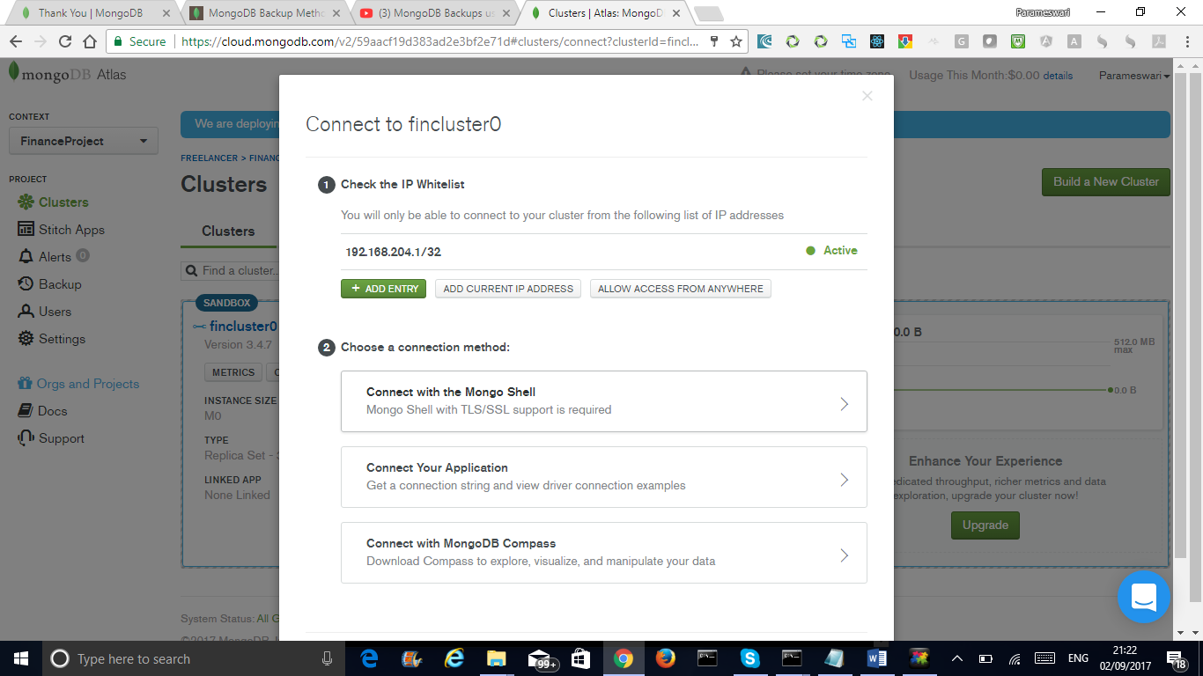

mongo "mongodb://fincluster0-shard-00-00-tfhsh.mongodb.net:27017,fincluster0-shard-00-01-tfhsh.mongodb.net:27017,fincluster0-shard-00-02-tfhsh.mongodb.net:27017/test?replicaSet=fincluster0-shard-0" --authenticationDatabase admin --ssl --username eswaribala --password <PASSWORD>