

Student Grade book

Submitted by:

Sreemaye Chakrabortty

Roll No: 133114

2nd year, 3rd semester,

Department of Computer Science & Engineering, RUET

Email: sreemaye44@gmail.com

Course No: 2100

Course Tittle: Software Development Project

Submitted to:

Dr.Boshir Ahmed  
 Assosiate Professor,  
 Department of Computer Science &   
 Engineering, RUET

# Student Grade book

# A Performance record book in Java for student

*CONTENTS*

# 

1. Related Information

2. Project Summary

3. Project Description

4. Requirements

5. Block Diagram

6. User Manual

7. Possibilities of Future Improvement

8. Conclusion

9. Resources

*RELATED INFORMATION*

**Project Name:** Student Grade Book

**Project Language:** Java

**Course No:** CSE 2100

**Course Title:** Software Development Project

**Department:** Computer Science & Engineering

**Faculty:** Electrical & Computer Engineering

**Institute Name:** Rajshahi University of Engineering & Technology

**Project Advisor:**

Dr. Boshir Ahmed

Assosiate Professor,

Dept. of CSE, RUET

Contact: [boshir_bd@ruet.ac.bd](mailto:boshir_bd@ruet.ac.bd)

boshir_bd@yahoo.com

**Project Duration:** 3rd Semester

**Project Code Link:** <https://github.com/Encryptioner/BaghBondi-Game/commit/f4b18f5dda990c9d6f1bb892cdb3a0cb432db6cd>

*PROJECT SUMMARY*

The aim of the course is to assist the student in understanding the basic theory of software engineering, and to apply these basic theoretical principles to a group software development project. Students will gain an understanding of the testing role within an agile project and be able to effectively apply practical skills associated with that role.

“BaghBondi” is a two-player abstract strategy board game from Bangladesh and India. It is a hunt game. It uses an Alquerque board, and therefore, “BaghBondi” is specifically a tiger hunt game played by two player where a person acts as human with seven people and other as tiger. Person who acts as man wins if he can trap tiger like tiger can’t move. Other Person who acts as tiger wins if he can eat enough people to free himself in every possible condition.

It is a rural Bangladeshi game which is unknown to most of people in Bangladesh especially to younger generation. The goal of this project is to make familiar this rural game to younger generation as well as improving software development skill.

*PROJECT DESCRIPTION*

The source code of this project is written in Java. As Java is a most common and machine independent language, this source code can be used to run in any device if it has proper Java environment supported by Java Virtual Machine (JVM).

This project assures a successful implementation of Graphical User Interface (GUI) programming which was made by appropriate class definition and importing built in class of Java library.

This game has a nice graphical view to understand every option simply and clicking button user can continue this game smoothly. This game provides New Game, Continue Game option with instructions and exit menu.

This game has a main logic function to derive the game logically with every turn by clicking button. In the main game board paint component was used to describe every move and instructions for next move.

*REQUIREMENTS*

1. Java Runtime Environment (JRE)

2. Java Development Kit (JDK)

3. Integrated Development Environment (IDE)

*BLOCK DIAGRAM*

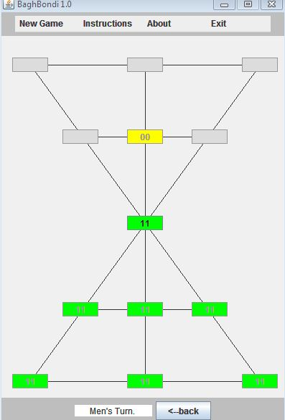

**Game Board**

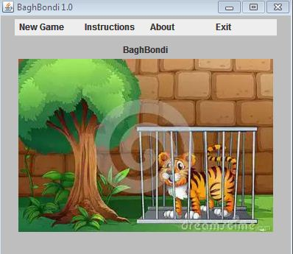

**User Interface**

**(GUI)**

**BaghBondi Game**

*USER MANUAL*

C:\Program Files\Microsoft Office\MEDIA\CAGCAT10\j0301252.wmfHere is a diagram to show the options of this game. To play a new game user should find a opponent partner and then he should click New game menu and then Player vs Player menu. To support them there has Instructions menu and user can easily back to main window by clicking Back button. By clicking About menu user can know about this project and by clicking Exit user can terminate the game.

Menu Bar

New Game

Instructions

About

Exit

Player vs Player

Back

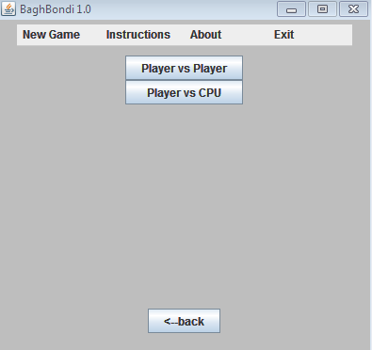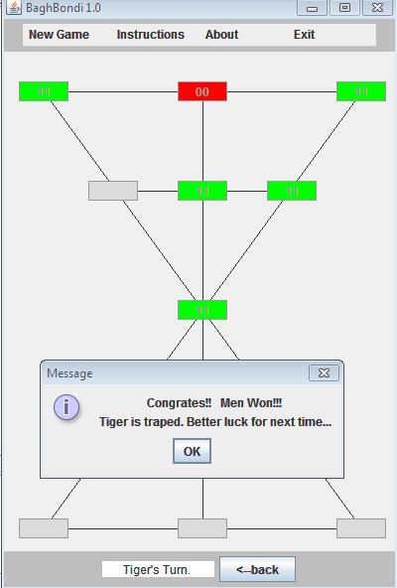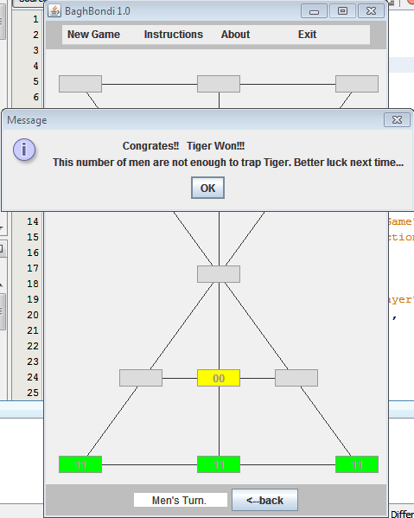

There are three possible results of the game. Either Men wins by trapping Tiger or Tiger wins by eating enough Men. Match tie if there are no move for both Tiger and Men.

*POSSSIBLITIES OF FUTURE IMPROVEMENTS*

This project has a good opportunity of future improvements. It can turn on a single player game by initializing opponent as CPU. There is another game named “SholoGuti” which is similar to “BaghBondi”. It is possible to make that game software. Moreover, with this source code it is possible to make same game for mobile and tablet.

*CONCLUSION*

This project is an implementation of software development projects of course no 2100. It provides a rural game named “BaghBondi” where Java Runtime Environment (JRE) is available. It is expected that user will enjoy the contents of this game. All the people who helped by inspiring and suggesting this project get special thanks.

*RESOURCES*

There are numerous web sites and books on topics related to this module.The following list of addresses is intended to provide a starting pointonly. Note articles found via the Internet and books are only used to improve skills to make this project better.

1. Wikipedia (<https://en.wikipedia.org/wiki/Bagh_bandi>)

2. Youtube (<https://youtube.com/>)

2. Github (<https://github.com/>)

3. Stack Overflow (<https://stackoverflow.com/>)

4. Quora (<https://quora.com/>)

5. Introduction to JAVA programming by Daniel Liang

6. Java the Complete Reference by Herbert Schieldt