# 

# Usability evaluation of Yammer website

Arindra Kumar Das & Panagiota Tziova

Microsoft + KTH Royal Institute of Technology, Stockholm

# Abstract

This report evaluates the usability of the Yammer website based on the users’ satisfaction, efficiency and effectiveness. The variables investigated during the study are error rate, task completion and task completion time. The evaluation is a validation test performed upon two user groups: the novice and the expert users, who are asked to complete five tasks. The T-model observation method is used during the test, complemented by a pre-test background questionnaire and a post-test semi-structured interview. The test takes place in a controlled usability lab with the help of the Morae tracking system. The results show that the participants faced difficulties in completing more advanced tasks in the system. Based on our findings we came up with the recommendations of relabelling, increasing visibility, avoiding creeping featurism and reorganising the information structure.

**Contents**

Abstract ………………………………………………………………………….…..… 1

Introduction …...………………………………………………………………….……. 3

Method …...……………………………………………………………………………. 4

Design of study …...…………………………………………………………….……. 4

Testing environment and equipment …...………………………………………….. 5

User selection and categorization …...……………………………………………... 5

Evaluator Roles …...…………………………………………….…………………. 6

Data to be collected and evaluation measures …...………………………...………. 7

Task formulation …...…………………………………………………………….... 8

Test procedure …...………………………………………………………………… 9

Results …...………………………………………………………………………….... 10

Quantitative Data Analysis …...…………………………………………………... 10

Quantitative results …...…………………………………………………….… 10

Qualitative Data Analysis …...……………………………………………………. 12

Qualitative results …...………………………………………………………... 13

Findings …...………………………………………………………………….…... 14

Recommendations …...……………………………………………………………….. 16

Discussion …...……………………………………………………………………….. 18

Conclusions …...…………………………………………………………………….... 19

References …...……………………………………………………………………….. 20

Appendix ………...……………………………………………………………… …... 22

Appendix A Task Plan …...………………………………………………………. 22

Appendix B Participant’s consent form …...…………………… ……...………. 25

Appendix C Introduction Script …...……………………………………………... 26

Appendix D Background Questionnaire …...…………………………………….. 27

Appendix E1 Semi-structure Interview for Expert User Group …...……………... 29

Appendix E2 Semi-structure Interview for Novice User Group ……………….… 30

Appendix F Test Protocol …...…………………………………………………… 31

# 

# 

# Introduction

The purpose of this usability evaluation is to assess the efficiency and effectiveness of the Yammer website (https://about.yammer.com/) for the use by both novice and expert users, and also the satisfaction they get from the overall usage.

Yammer is a freemium enterprise social network service that was officially launched in September 2008 and it is already used by 8 Million users today (Lunden, 2013). It is available as a website, desktop and mobile application; the current evaluation focuses on the website.

Due to the fact that the features are constantly changing and being updated, the implementation used in this evaluation report is during the period of 6th to 10th December, 2013.

The obstacles of completing common tasks on the site are to be identified and suggestions for improving the overall usability of the website shall be given.

As illustrated in Figure 1, the research questions that helped to accomplish the goals of this study were the following:

* How easily and successfully do users perform common tasks, e.g. starting/viewing a public, group or private conversation, search for an old post?
* How easily can the user recognise, understand and find the different functions on the website?
* How accessible are the settings for the user to customize?
* How do the users characterise their experience of the system?

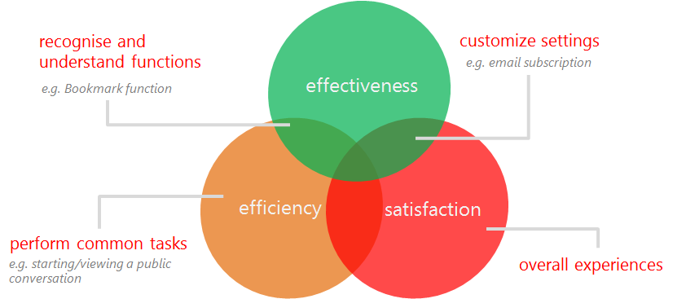

*Figure 1: Relationship between research questions and purposes of the usability evaluation*

To evaluate Yammer, various evaluation methods were considered. According to literature study on usability evaluation methods on social networks, the results of traditional methods, such as the heuristic evaluation, diverge from those of newer user experience methods, e.g., interviews and self-reporting experience questionnaires (Bailey,Wolfson, Nall & Koyani, 2009).

# Method

As Yammer is already a fully-developed platform, this report aims at evaluating its usability against established benchmarks with a validating approach (Rubin & Chisnell, 2008). The method focused on evaluating a number of different functions on the website from a usability perspective and identify if they fulfil the predefined usability criteria, which are efficiency, effectiveness and satisfaction. For the purpose of the evaluation, a controlled environment of a usability laboratory was chosen (Karampelas, 2012).

## Design of study

This evaluation is a comparative study against predefined benchmarks which were set according to existing literature, educated guesses by the evaluators, and further adjusted after pilot testing (Dumas & Redish, 1999).

In order to answer the research questions, a combination of quantitative and qualitative methods were adopted for extracting accurate and reliable results. In specific, a validation usability test was performed, involving the T-model method (Abdulhak, Hwang & Kang, 2011) complemented by a background questionnaire in the beginning (see Appendix D) and an in-depth semi-structured interview afterwards (see Appendix E) (Bailey, Wolfson, Nall & Koyani, 2009).

The background questionnaire is a means to understand the related experience of the subjects with their general usage of social networks and the Yammer website, as well as a confirmation of the oral screening.

A “within-subjects design” was used in the usability tests, because individual differences could be eliminated and fewer participants are needed. To address the problem of the learning effect in within-subjects design, the technique of counterbalancing was used, which was achieved by randomizing the order of the tasks (Rubin & Chisnell, 2008). Related tasks were grouped together to form a taskset, which was given to the participant, and only the order of taskset was randomized among participants (see Appendix F for the taskset sequence).

The reason for choosing semi-structured personal interviews for measuring the satisfaction of the participants was that the nature of the interviews allows access to people’s perceptions, definitions and explanations of situations (Punch, 2008). In addition, the semi-structured method supports flexibility in elaborating on participants’ responses and clarifying how they perceive the system, in order to avoid misunderstanding or misconception of the participants’ views (Ingebricson, 2010).

## Testing environment and equipment

The usability evaluation test took place in the Usability Lab of KTH University’s Media Technology and Interaction Design Department. The lab is equipped with a film camera and three terminals with the Morae tracking software installed. Morae Version 3 enables setting up, recording, observing, and analyzing usability studies ([http://www.techsmith.com/morae.html)](http://www.techsmith.com/morae.html). One monitor was situated in the room where the subject was facilitated, and was monitored through a webcam. Two other terminals are at the other side of the lab, one for monitoring the users and their actions and one for editing the Morae recording. That part of the lab was not visible to the subjects.

## User selection and categorization

According to Virzi (Virzi, 1990), six participants form a satisfactory number for a usability evaluation of a user-interface to succeed. Therefore, six subjects were asked to assist the process. All the users had prior experience in browsing the Internet, which was defined by two requirements: using Internet for more than one year and using Internet at least five hours per week.

To obtain wider variety of results, thus increasing the validity of the evaluation, the group was divided in three categories, the “expert users”, the “intermediate users” and the “novice users”. The test targeted only novice and expert users, and each user group consisted of 3 subjects.

In order to find representative participants and categorize them, an oral screening questionnaire (Karampelas, 2012; Rubin & Chisnell, 2008) was used. The categorization was based on criteria such as how long they have been using the system, how often and how many features they have used. Specifically, any user, who has never used the Yammer website before, was classified as a novice user. Users meeting the below classifiers were regarded as expert users, while the remaining ones are the intermediate users:

* More than three months experience with the Yammer website
* Actively using the Yammer website for more than 1 hour per week
* Experience of using more than 5 features on Yammer website

## Evaluator Roles

The evaluators divided their roles into 3 categories, the moderator, the observer and the computer operator and were rotated amongst team members (Rubin & Chisnell, 2008). All the roles are explicitly described below.

**Moderator’s role:** The moderator was sitting in the room with the participant throughout the session. He/she provided the consent form and the background questionnaire and also introduced the process using an introduction script. During the task completion, there was no further interaction between the moderator and the participant (Rubin & Chisnell, 2008). When the test was completed, the moderator conducted an interview while an observer was taking notes . Then both of them started to analyze the data for finalising the session.

**Observer’s role:** The observer’s primary role was to sit next to the computer operator and make unstructured observations of the behaviour and facial expressions of the subjects during the test. During the semi-structured interview he/she would take notes.

**Computer Operator’s role**: The computer operator was responsible for randomizing the tasks in the Morae Recorder, setting up and operating the Morae Observer by structurally observing the users during the test and taking notes of any relevant action based on the benchmarks that were defined.

## 

## 

## Data to be collected and evaluation measures

The performance data were collected from the test based on the above tasks (Benyon, 2010; Rubin & Chisnell, 2008) and the preference data were gathered through observations during the test and the semi-structured interview; all of the data is illustrated in Figure 2.

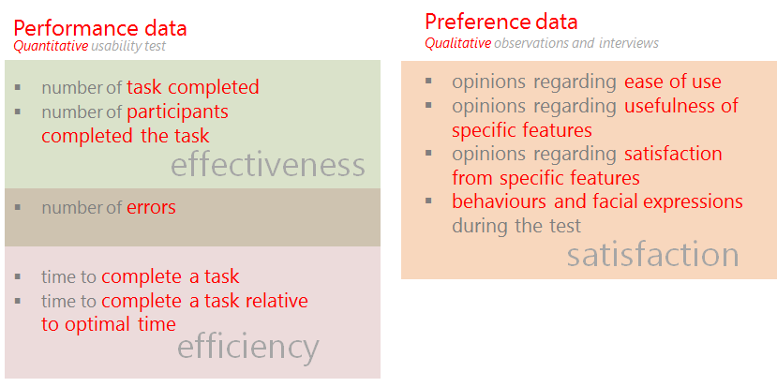

*Figure 2: Usability test variables*

Based on the above quantitative metrics, the following primary data were measured for each task during the test, while the remainings were secondary data derived from them.

The successful completion of the task was determined by the observer, and registered to the system by the computer operator. The number of errors, which was defined as the number of deviations from the optimal path, was measured by the computer operator, who was registering the errors during the test and re-checked them at the end of the test. The time to complete a task was automatically measured by the Morae system.

During the test the observer was also taking notes on the behaviour and the facial expressions of the users and, where applicable, what the users were saying during the test. Opinions regarding Yammer’s ease of use, usefulness and satisfaction derived from specific features were recorded during the interview after completing the test.

## 

## Task formulation

To answer the research questions mentioned earlier, the following tasks were designed to be performed by the subjects in the testing sessions, which were classified into basic and advanced tasks for the purpose of setting the benchmark.

The basic tasks were listed as follows:

* post a message to a public group
* send a message in a new private group conversation
* upload a document in the group conversation
* search for an old post

and the advanced tasks:

* change the email notification settings
* bookmark a post in a public group

A detailed task list was written where the task components, e.g. state, successful completion criteria, benchmark, of each task were defined in detail (see Appendix A for task plan). Related tasks were grouped together to form a taskset, and only the order of the task sets would be randomized among participants’ testing.

For each task, a short description, task description, is written for the evaluators to identify the task, which would not be disclosed to the participants for avoiding to giving them hints concerning some commonly-used wordings or jargons in the system (Rubin & Chisnell, 2008). Therefore, another text description, Instructions to Participants, was given to the subjects offering more detailed requirements and motivations for the task. A task was considered successfully completed when the defined successful completion criteria were met without any assistance from the moderator (Rubin & Chisnell, 2008). Also, optimal paths were defined by the evaluators using the shortest path and other possible alternatives to complete the task. In order to set a predefined benchmark for each task, an optimal time of completion was measured by taking the average time the evaluators used to complete the task. For general tasks, the benchmark was set at 3 times the optimal time while for advanced task,s a multiplier of 5 was used. Apart from the time, an error number of smaller than 3 was also set as a reasonable benchmark for basic tasks, and 5 for advanced ones. All these preset benchmarks were based on the evaluators’ guesses and further adjusted after the pilot test, if necessary. For task completion rate, a benchmark of 70% was used for all tasks, which was set based on general standard (Rubin & Chisnell, 2008).

## Test procedure

The process that each test session followed is illustrated in Figure 3 below.

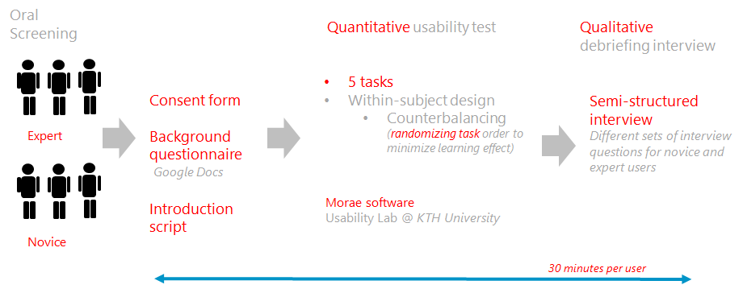

*Figure 3: Testing process*

Before beginning the test, the participants were given time to read and sign the consent form, and also complete a background questionnaire. The first 5 minutes were devoted in discussing with the participant and explaining him/her the process and the facilities. The users were introduced to the purpose of the study and how important their role is at this phase. The role of the moderator was explained and descriptions of how the recording system works and how the lab is set up were given, so as to accommodate him/her to the controlled environment. Afterwards, the user was asked to complete 5 task sets, which were estimated to last for 15 minutes.

At the end of the session, we spent 5-7 minutes on debriefing, when the users were asked to answer some questions regarding their experience as well as some background information about Yammer and social network usage. Each session lasted about 20-30 minutes in total. Fully Automated Data Logger (Rubin & Chisnell, 2008), in particular the Morae software , was used to log the data.

# Results

For the quantitative study, statistical analysis was used in order to draw the results, while the qualitative one was based on content analysis (Elo & Kyngäs, 2008). The duration of the usability tests and data collection with the aid of the Morae Manager was approximately 12 hours, 8 hours for the quantitative analysis and another 8 hours for the qualitative analysis.

## Quantitative Data Analysis

Three quantitative variables, i.e. successful completion, number of errors and time for completion, were collected from each task during the test, were re-checked and exported from the Morae system after the test session.

After the data collection from all test sessions, a comprehensive analysis was performed consisting of these steps, compiling, summarizing and analysing data (Rubin & Chisnell, 2008). For data compilation, all collected data were inputted and organised in a master spreadsheet and classified in different user groups and tasks. Afterwards, statistics like count, percentage, total sum, mean and median were summarized from the primary data, while secondary data, like completion time relative to optimal time, were also derived from the primary ones for the purpose of recognising trends and patterns. Finally, the summarised data were analysed and compared between user groups and tasks and also against preset benchmarks. The analysis was done in an task-orientated manner because the tasks represent the viewpoints or goals of the user and so it can help us to find the problems in the system. All data were summarized for each task by user group and significant results were presented in the section below.

### Quantitative results

The mean number of errors, i.e. error rate, on each tasks by user group is shown in Figure 4 below. As shown in the diagram, task 5 was the only task which failed the benchmark, i.e. a maximum acceptable number of 5 errors. Not only did the novice users make an average number of 9 errors, but also a peak was identified from the expert users who generally did not make many errors in the other tasks. Therefore, this task was considered to be a problematic task.

Other than the problems identified in this diagram, some positive findings regarding the system could also be drawn. Comparing novice with expert users, novice generally made more errors than the experts, which was understandable because they were using the system for the first time. However, in tasks 1, 2 and 3b, it can be seen that the results from novice and expert users were very close. Hence, we could conclude that these aforementioned tasks are effective and efficient even for first-time users.

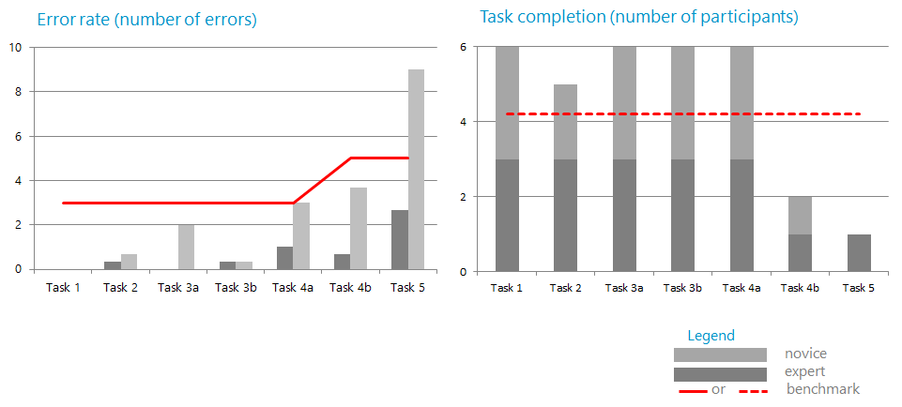

*Figure 4: Error rates (left) and task completion (right)*

Task completion rate is reflected by two metrics, total number of tasks, completed by each participant showing the general effectiveness, and number of participants having completed each task, showing the task-specific effectiveness, where in both cases, the mean values were taken. As shown in Figure 4, the chart on the right illustrated the mean number of participants who completed the task where the maximum number is 6. A benchmark of 70% was used here which was a minimum number of 4.2 participants to be met. Aligning with the error rate result mentioned earlier, task 5 again failed the benchmark, together with task 4, for which these two tasks were identified to be ineffective.

Task completion time is a metric which can show the efficiency of a task, and this data was counted only when the subject had successfully completed the task. Due to the reason that a number of subjects could not successfully complete some tasks, there was a significant problem of missing data for tasks 4b and 5, where only 1 or 2 samples were recorded respectively. Therefore, the results of tasks 4b and 5 would be neglected here due to the missing and limited sampling size.

As the benchmark was a bit strictly set, most of the tasks could just barely pass and just fail the benchmark as displayed in Figure 5. Still, a significant problem could be noticed for task 4a which failed the benchmark more severely than the other tasks.

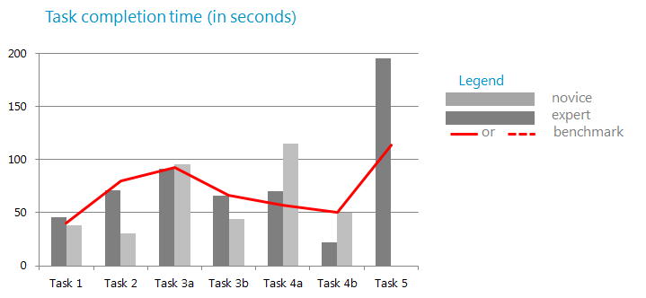

*Figure 5: Task completion time*

As a brief conclusion of the quantitative results, problems were identified in all the advanced tasks, i.e. tasks 4b and 5, as well as task 4a. Further analysis regarding the source of errors on these tasks shall be examined.

## Qualitative Data Analysis

After the collection of data from the observations and interviews, the next step was to reduce this data in an summarized form.

A first reading of the interviews’ notes took place and the data that was related with the satisfaction taken from the system was identified, while other data that was not useful and necessary for the study was dismissed. The second revision of the notes took place with a more content aware approach, headings were written next to each interview question, using content characteristic words, and different colouring was used to indicate relative content. Afterwards, the information from each interview was grouped into three categories, based on the predefined variables; the first one included all the sentences related to the ease of use, the second one concerning the usefulness and satisfaction from the available features and the third one included information suggesting other reasons that have to do with users’ satisfaction.

All the responses, both from the expert and from the novice users, were correlated based on these three concepts. The correlation was done separately for each group at first, and later on a comparison between the group findings was carried out. Similarities and differences were identified and more general results were derived.

The same process took place also for the analysis of the observations that were focused on facial expressions and behaviours for positive and negative feelings, while subjects were using the Yammer website.

### Qualitative results

Based on the analysis of the interviews, in general both novice and expert users found it easy to use Yammer. That confirmed our initial observations that the participants seemed confident and relaxed while performing the tasks, despite the occasional stressing factor. However, when trying to perform the advanced tasks the subjects were scrolling up and down helplessly, they seemed to have tension and confusion, which was confirmed at the semi-structured interview; quoting one of the users, “why should I go to my profile in order to change the notification settings?”. This suggests that the site is not providing the correct mental model for the user to be able to navigate through its functions with ease.

Novice users mentioned that it was easy for them to use Yammer as it is similar to other social networks they use, more particularly Facebook. Only one user mentioned that it was not easy to use but this could be related to his negative attitude to learning another social network; more specifically he mentioned “Too many social networks I don’t want to learn another one. How is it different than other platforms?”. The fact that Yammer is easy for novice users to learn complies with the opinion of the expert users who mentioned that “Yammer was easy to learn in the beginning”.

The expert users claimed than they are satisfied with the features that Yammer offers them, but they are not satisfied with the way they are attributed, as the features are not easily recognisable or visible. One consideration that should be pointed out, however, is that all of the expert users were not familiar with many of the features of Yammer, just with ones that they frequently use. The aforementioned findings were enhanced by the novice users’ opinions. It should be pointed out that the novice analysis cannot give reliable results, as the users were not comfortable with the system. Nonetheless, comparing with other social networks, the novice users could provide valuable feedback regarding the features tested during the evaluation. More specifically, one of the users mentioned that he was missing some basic attributes, like contact filtering.

Finally, other things not directly related to usability, were identified, which are important for the satisfaction of both novice and expert users. All of the users mentioned the significance of the network effect, which would make even the most reluctant ones use the system; a response from an expert user was “if only more people would use it” and from a novice one, “it would be nice to use, if others were using it as well”. In addition, the privacy factor came up, but here there were contradicting opinions; some users felt safe to share information within a professional network, however one mentioned feeling censored for what they were posting in public groups.

## Findings

Both from the quantitative and the qualitative analysis it became clear that it is easy to conduct basic tasks on Yammer website, even for novice users with prior experience of other social networks. More specifically, users completed the basic tasks successfully; tasks 1, 2, 3 and 4a without failing error and time benchmarks, except for task 4a, and when using the system, they were confident and did their tasks without difficulties and second thoughts. In contrast, the advanced features, task 4b and 5, were proved to be difficult to use, as less than two subjects successfully completed the corresponding task. Further error analysis was conducted in order to attribute a product-related reason for user difficulties.

The most problematic task was identified to be the one of changing settings, task 5, where the subjects were asked to change email notification settings for a specific group they belong and only 1 subject could successfully complete the task. The most general difficulty observed from the subjects is that most of them tried to look for this settings in the group page, instead of the settings page. Some of them clicked the “Subscribe to this group by email” on the right-side menu bar of the page but failed to change settings for the activity digest. Besides, even when the user clicked the “More” button on the top menu bar, which is a correct action as defined in our optimal path, the user could not know that the settings page is located under the “Edit Profile” section (see Figure 7 for item 1 & 2). These were regarded as visibility and labeling problems.

The bookmark feature, task 4b, was another problem we found during the analysis. There are a few sources of error for this. Generally, users got confused a lot by other similar functions located around, e.g. “Follow” (see Figure 6 for item 1), “Follow in inbox”, “View conversation” (see Figure 6, item 2) etc. The function of “Follow” is not so useful but is highly visible to user, and it appears when the user’s cursor is over it, while in contrast, the “Bookmark” function cannot be easily discovered by the user. We recognised these as problems of creeping featurism and low visibility.

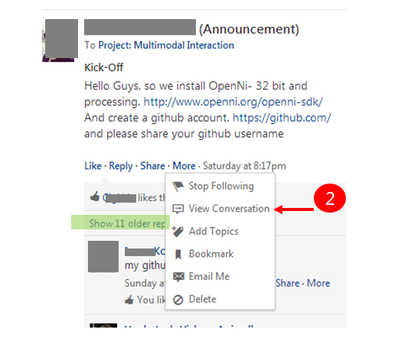

*Figure 6: Examples of creeping featurism*

Finally, regarding task 4a, i.e. searching for a public post, all participants could complete this task but a comparatively less severe problem of efficiency was found. The reason for this can be found from the interview with one of the participants, questioning “why is there only one auto-suggesting result while there could be more?”.

Considering the severity of the above mentioned problems, the email notifications’ setting was considered to be the most severe because it is found to be very ineffective, while at the same time being a basic feature for a general user. The efficiency problem of the searching function is also severe, because it is considered to be a basic function of the system that users use frequently, as well. Finally, the bookmark function is considered to be less severe because it is not a core feature of the system.

The main reasons of these problems could be attributed to labelling, visibility, complexity of structure and the creeping featurism problems of the Yammer website. All these problems forced the users to spend too much time scrolling up and down, clicking links, the functions of which they could not understand, thus becoming confused and frustrated.

Finally, an interesting outcome was that the satisfaction from the system is not related only to its usability, which of course is an important factor, but also to other reasons. As pointed out from the qualitative analysis, there is a strong desire towards an internal private network, for it provides a sense of security of the data that are shared. A significant factor for such a system to work, is the number of people who are using the system and how popular it becomes; the so-called network effect.

# Recommendations

Given the results presented and based on the above findings, we present some recommendations to show how the Yammer website could be improved in terms of usability performance.

1. Relabelling the features would aid the user identify and recognise easier and more effectively each function. For example it will be useful to change the “Edit Profile” label to “Settings”.

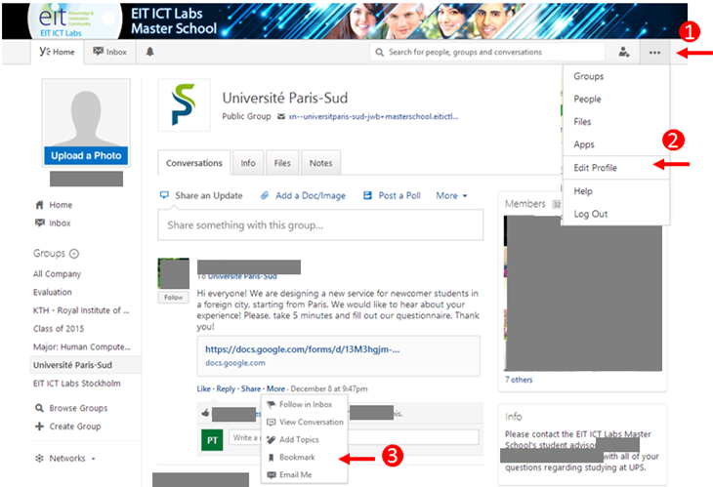

*Figure 7: Examples of visibility (1 &3) and labelling problem (2)*

1. Increase feature visibility: None of the expert users knew about the existence of the “Bookmark” choice, which is provided for every post. A similar effect of “Follow” (see Figure 6, item 1) would be used, in which the feature will appear when the user’s cursor is over the link. Therefore, the visibility of the function can be improved.
2. Avoid creeping featurism: When there are links or files in a post, besides the basic distinct functions like “Like”, “Reply” and “Share”, there are many functions under the “More” menu (see Figure 7, item 3) and also some functions when the user’s cursor hovers over the post (see Figure 6, item 1). These functions confuse the users a lot when they just want to “remember” a post. Especially “Follow in inbox”, “Bookmark” or “Email me” all possess similar functions, which are “retaining” a post, for which we consider further study should be conducted so as to remove the excess functions of less usage. Besides, some other features are not even useful, e.g. “View conversation” (see Figure 6, item 2) and “Follow” functions (see Figure 6, item 1), which simply do not provide any more values to the users, so we suggested that these should be removed.
3. An important aspect that should be considered is reorganising the information structure.
   1. For most of the subjects it was difficult to find the notification settings, which is under the “Edit profile” tab. A more suitable category like “Settings” is suggested to replace “Edit profile” so all other subcategories, like “Edit profile”, “Preferences” and “Notifications”, belong under it.
   2. Reorganizing the result page after searching, using one global category, or making better categories could be some suggestions.
4. Effectiveness and efficiency of the search function:
   1. When the user is typing a search keyword, the auto-suggestion feature can be more exhaustive so as to provide more related search results in the scroll-down menu.
   2. Also, as observed during the test, one subject made a typing error in the keyword, so no results were retrieved after he searched. In order to increase the efficiency and cope with the human typing error, it is also recommended that the system can also return results when there is a recognised typo in the searching keyword.
5. Direct manipulation such as “drag-and-drop” files could also be implemented while users want to “Add file” in a group conversation, as it is a common user’s behaviour.

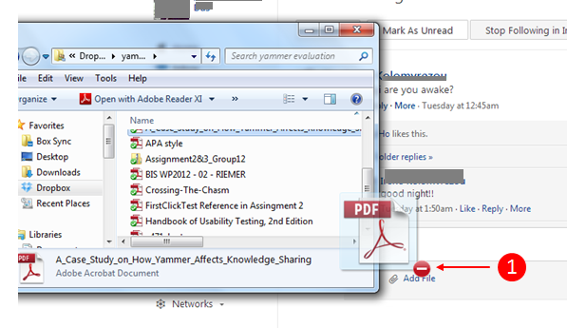

*Figure 8: Need of direct manipulation*

# Discussion

The design of the study was made in such a way so as to eliminate any ethical issues that may have risen from asking the participants to be recorded and to use their personal data for the purpose of the evaluation. During the test process the participants were accompanied by the moderator, so that the controlled environment of the Usability Lab would be more friendly (Rubin & Chisnell, 2008).

The purpose of this study was to test the usability aspects, i.e. effectiveness, efficiency and satisfaction, of the Yammer website through the means answering the aforementioned research questions. The participants were separated into two groups, the expert users and novice ones. There is evident from the findings that it is quite easy for both user groups to perform common tasks, which are also related to functions they perform when using other social networks. However, the analysis showed that both user groups found difficulties in performing more advanced tasks, such as bookmarking a post and changing email notification settings, because the corresponding features are hard to identify or recognise. In particular, when asked to modify the settings, only one user managed to enter the right menu in order to complete the task, hence it is reckoned that the settings feature is not so accessible to users.

In overall, expert users were partly satisfied with the system, pointing out that there are a lot of things that need to be improved and, also, that they are using it because other colleagues are using it as well. The novice users seemed more satisfied, but their inexperience does not qualify them as reliable judges as to the satisfaction. Once again, they stressed the fact that they would use the system, if other people were using it as well.

# Conclusions

As a general conclusion, Yammer is a useful closed network platform for enterprise use. The common tasks provided are easy for users to recognize and use with efficiency. However, some usability problems were identified in the evaluation and certain suggestions are given for the improvements so as to ease the user’s accomplishing advanced tasks.

The recommendations which are presented in this report take a first step towards evaluating the Yammer website. Further research should be done for identifying problems and less useful functions, which should be removed for making Yammer easier to use in a more effective and efficient way. The system after these changes will provoke positive emotions and avoid confusion and frustration of the users.

However, certain aspects were not carefully taken into consideration, e.g the personality of the subjects; in cases where the user was too persistent to finish a task, the time needed exceeded the set benchmark by far. To avoid such implications, a pre-defined time limit for each task should have been set in advance.

Furthermore, while performing the quantitative analysis, the time benchmarks proved to be too strict and should be re-defined in case of further studying.

Last but not least, giving some time for the novice users to explore the system before starting the usability test, might have given different results, not so much for the basic tasks, in which as described earlier most of the subjects completed successfully, but for the advanced ones.

# 

# 

# References

Abdulhak, S. A., Hwang, G. H., & Kang, D. K., (2011). T-Model for evaluation and identification of social network site: Usability drawbacks and user-experience enhancements. *2011 International Conference on User Science and Engineering (i-USEr)*, pp. 240-244.

Bailey, R. W., Wolfson, C. A., Nall, J., & Koyani, S., (2009). Performance-Based Usability Testing: Metrics that have the greatest impact for improving a system’s usability. *Human Centered Design*. Springer Berlin Heidelberg, pp. 3-12.

Benyon, D., (2010). Designing Interactive Systems: A comprehensive guide to HCI and interaction design. *Pearson Education Limited*, 2nd Ed., pp. 156-162.

Dumas, J. S., & Redish, J. C., (1999). A practical Guide to Usability Testing. *Intellect Books*, pp.263-270.

Elo, S. & Kyngäs, H., (2008). The qualitative content analysis process. *Journal of Advanced Nursing*, 62(1), pp.107–115. Retrieved from <http://www.ncbi.nlm.nih.gov/pubmed/18352969>.

Ingebricson, D. T., (2010). Corporate Microblogging: A Case Study on How Yammer Affects Knowledge Sharing in a Multinational Consultancy Company. Unpublished master’s thesis, University of Oslo, Oslo, Norway. Retrieved from <https://www.duo.uio.no/handle/10852/17676>.

Karampelas, P., (2012). Techniques and Tools for Designing an Online Social Network Platform. *Springer*, pp. 160-162.

Lunden, I., (2013). A Year After Microsoft Bought It, Yammer Nears 8M Users, Deeper MSFT Integration ... And Klout. *TechCrunch Inc.*. Retrieved from <http://techcrunch.com/2013/06/25/a-year-after-microsoft-bought-it-yammer-nears-8m-users-plans-for-deeper-integration-and-a-new-klout-partnership/>.

Punch, K. F. (2008). Introduction to Social Research: Quantitative and Qualitative Approaches (2nd Edition. utg.). London: Sage Publications.

Rubin, J., & Chisnell, D., (2008). Handbook of Usability Testing: How to Plan, Design and Conduct Effective Tests. *Wiley Publishing Inc.*, 2nd Ed..

Virzi, R. A., (1990). Streamlining the design process: Running fewer subjects. In D., Woods and E., Roth, (eds.) *Proceedings of the Human Factors Society 34th Annual Meeting*, Santa Monica, USA, 1990, pp. 291-294. Retrieved from <http://pro.sagepub.com/content/34/4/291.full.pdf>.

# 

# 

# Appendix

## Appendix A

## Task Plan

|  |  |  |  |  |  |  |  |
| --- | --- | --- | --- | --- | --- | --- | --- |
| **Task No.** | **Task description** | **Instructions to Participants** | **State** | **Successful completion criteria** | **Optimal Path** | **Opti-mal Time** | **Benchmark** |
| 1 | Post a message to a public group | Return to home page. Say hi and introduce yourself (by telling your name) to the “Evaluation” group. | Yammer Homepage after user login | A message is successfully posted to the group | Path 1: Select the group > Write in the box (share something with this group...) > Post (3 steps)  Path 2: Type in the search bar “evaluation” > Enter > write msg in the box > Post (4 steps)  Path 3: Write msg in “Share Update” box > Click on “Post to my colleagues” > Select “evaluation” group > Post (4 steps) | 10s | Time to complete the task < 30s,  Number of errors <= 3 |
| 2 | Send a message in a new private group conversation | Return to home page. You are planning a lunch with two of your friends (Gigi and Weiwei) tomorrow. Ask them. | Yammer Homepage after user login | A message is successfully sent to the friends | Path 1: Select a friend of yours from the “Online Now” window on the right bottom > Add the other friend from the “Add” logo in the chat pane > Write the message > Enter (4 steps)  Path 2: Inbox > Create Message > Send Private Message > Type the names (or select them) > Type the message > Send (6 steps)  Path 3: Select a friend of yours > Type the message > Enter (do that 2 times separately) (6 steps) | 20.5s | Time to complete the task < 62s,  Number of errors <= 3 |
| 3a | Create a new group conversation | Return to home page. Create a space for your project group, so that you may exchange ideas and share documents within your group partners in later stage. Greet by saying “Hi, guys”. (Group members: You, Panagiota, Weiwei and Gigi) | Yammer Homepage after user login | A group conversation is created with a message sent | Path 1: Go to Inbox > Create message > Send private message > Add participants > Type the names > Type the message > Send  Path 2: Click the “Online Now” window on the right bottom > Click one friend (anyone out of three) to start a conversation > add other 2 people in the opened conversation > Type the message > Enter (5 steps)  Path 3: Click “Create Group” | 31s | Time to complete the task < 93s,  Number of errors <= 3 |
| 3b | Upload a document to the group | You go back to the homepage because you want to see the latest post. Then you remember you want to share the template of an assignment to the project group you have just created (a file “template.txt” on the desktop). | Yammer Homepage after user login | A document is shared inside the group conversation | Path 1: Go to Inbox > Find the previous message > Add file > Upload a file from your computer > Select the file > Post (6 steps)  Path 2: Go to the group > Go to files > Click on “Upload file” > Choose file > Upload (5 steps) | 22s | Time to complete the task < 66s,  Number of errors <= 3 |
| 4a | Search for an old post | Return to home page. You remember that lately you saw an interesting event on Yammer about a christmas party, for which you remember there is a keyword “christmas” posted by Elisabeth. Find this piece of specific information and view the full information. | Yammer Homepage after user login | The specific post about the christmas party is selected and full conversation is shown. | Click on “Search” bar > Write the Keyword > Press “Enter” > Locate the needed information > Select it (6 steps) | 19s | Time to complete the task < 57s,  Number of errors <= 3 |
| 4b | Bookmark a post in a public group | After finding the information, also save this message, so that you can find this piece of information again easily next time without losing your time. | Search result page of the full conversation of the Christmas party post | The specific post is bookmarked with an success alert message | Click the information > Click “More” > Select “Bookmark ” (3 steps) | 10s | Time to complete the task < 50s,  Number of errors <= 5 |
| 5 | Change the email notification settings | Return to home page. Recently there are many interesting posts in the “KTH” group about different competitions. For this reason you want to dosomething so that Yammer will inform you by email when someone in the group sends something new. You also want to receive a weekly activity digest. | Yammer Homepage after user login, with KTH notification turned off. | Email notification settings for KTH group is turned on with weekly settings. | Path 1: click “...”on the right corner of the navigation > select “edit profile” > select “notification” on the left sidebar > Select “weekly” > Check “KTH” group > click “save” (6 steps)  Path 2: click on profile picture > select “edit profile” > select “notification” on the left sidebar > Select “weekly” > Check “KTH” group > click “save” (6 steps)  Path 3: click on your name > select “edit profile” > select “notification” on the left sidebar > Select “weekly” > Check “KTH” group > click “save” (6 steps) | 38s | Time to complete the task < 114s,  Number of errors <= 3 |

## 

## Appendix B

## Participant’s consent form

Usability test for **Evaluation Methods in Human-Computer Interaction (DH2408)**, a KTH course, by Arindra Kumar Das, Gigi Ho, Eirini Kolomvrezou, Panagiota Tziova and Weiwei Zhang.

Participant’s Name: .............................................................................................

This form informs you of your rights and our responsibilities for protecting your personal data.

Your voice and your face will be recorded throughout the process. All your actions inside the system will be recorded, as well. The data collected will be used only by our research group for the purpose of the study. Part of the recordings may be presented to our academics, but always within the framework of this course.

You can stop the experiment at any time. Also, you can refuse answering any question, if you want or if you feel uncomfortable.

By signing this form, you acknowledge to have read the above and allow us to use the data.

You are free to collect a PDF version of our report. If you wish to, please leave your email here:

...................................................................................

Signature Date, Place

.......................................................................................................................

## 

## Appendix C

## Introduction Script

Thank you for agreeing to participate in our usability study today. During our session, I’ll be using this script to ensure that, as far as possible, my instructions to everyone who participates this test are the same.

Our objective today is to evaluate the usability of Yammer website by observing general user like you using the system. Yammer is a social media network service designed for enterprise use. During the session, you’ll be working on your own while we observe you from another room.

We’ll be taking notes and we’re recording the session.

In this session, we’ll have you do typical tasks, to learn how these programs work for people like you. Please keep in mind that we’re not testing you—it’s you who are helping us evaluate the system. If you cannot complete a task, it’s not your problem, but rather it’s the system’s problem.

Here’s how the session will work:

* After the recording session starts, you will see instruction box appearing on the top of the screen that we would want you to do.
* Please read and understand the instructions carefully.
* When you are ready to start, you can press the ‘Start’ button and start doing the task. Once you press ‘Start’, the time will start counting.
* Once you are done, press ‘End’ so the time will stop counting.
* At the end of the session, you will answer one more questionnaire, which will be followed by a debriefing session with us.

Do you have any question before we begin?

## Appendix D

## Background Questionnaire

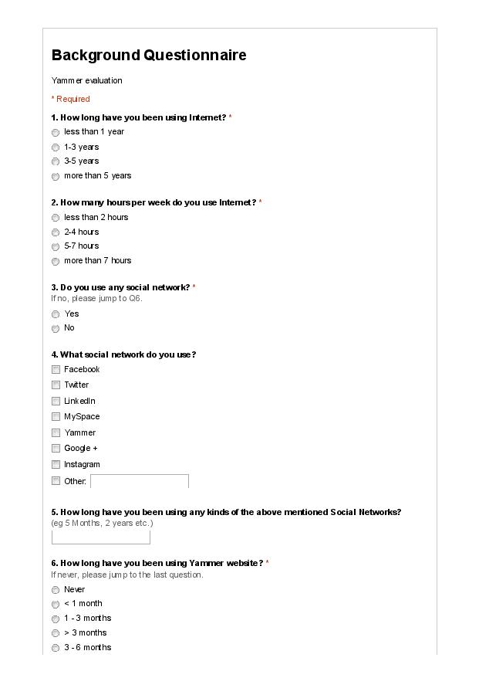

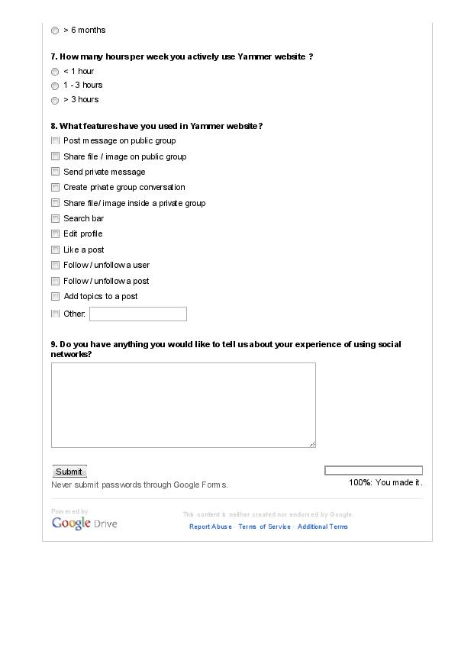

## 

## 

## Appendix E1

## Semi-structure Interview for Expert User Group

1. How do you feel about your experience using the Yammer website?

1a. (follow-up) How do you feel about the features you use frequently in Yammer?

2. Are you satisfied with the features that are available on Yammer?

2a. (follow-up) What are they? Why?

3. Do you find any problems in using Yammer website?

3a. (follow-up) What are the problems?

3b. (follow-up) Are you annoyed by the problems?

## Appendix E2

## Semi-structure Interview for Novice User Group

1. How do you feel about your first experience using the Yammer website?

1a. (follow-up) Did you find it easy to use and understand?

2. Did you find any problems using Yammer?

2a. (follow-up) What were the problems?

2b. (follow-up) Were you annoyed by the problems?

3. Compared to other social networks, how did you find Yammer?

4. Would you like to use it again?

## Appendix F

## Test Protocol

**Test Arrangement**

1. Equipment setup (Yammer, questionnaires, Morae system)
2. Pre-test arrangement (5 minutes)
   1. Sign recording consent form
   2. Background Questionnaire
3. Briefing the participant using introduction script
4. Test (15 minutes)
5. Debriefing Interview (10 minutes)

|  |  |  |  |  |  |
| --- | --- | --- | --- | --- | --- |
| **#** | **Date/ Time** | **Participant** | **User Group** | **Taskset sequence** | **Roles**  Moderator (M), Observer (O), Computer Operator (C) |
| 1 | 6Dec2013, 13:00 | Participant 1 | Expert | 4, 1, 3, 5, 2 | M: Gigi, O: Panagiota, C: Weiwei |
| 2 | 6Dec2013, 14:30 | Participant 2 | Expert | 2, 3, 5, 1, 4 | M: Arindra, O: Panagiota, C: Weiwei |
| 3 | 6Dec2013, 16:00 | Participant 3 | Expert | 3, 2, 5, 4, 1 | M: Eirini, O: Weiwei, C: Gigi |
| 4 | 10Dec2013,  12:00 | Participant 4 | Novice | 3, 4, 1, 2, 5 | M: Panagiota, O: Eirini, C: Weiwei |
| 5 | 10Dec2013,  14:00 | Participant 5 | Novice | 1, 5, 2, 3, 4 | M: Panagiota, O: Eirini, C: Gigi |
| 6 | 10Dec2013,  16:00 | Participant 6 | Novice | 4, 3, 2, 1, 5 | M: Gigi, O: Eirini, C: Arindra |

**Roles and responsibilities**

|  |  |  |  |
| --- | --- | --- | --- |
|  | Before the test | During the test | After the test |
| Moderator | * Greet the user * Sign the consent form * Fill in background questionnaire * Briefing participant using introduction script * Prepare to start recording | * Sit next to subject * Explain task instructions to subject (if needed) * When subject seek help, reply “Sorry, we cannot answer your question.” | * Hold the debriefing interview |
| Observer | * Set up Morae system (observing machine) * Login yammer | * Sit next to observing computer and observe * Keep the task plan and sequence handy * Measure data: if the user has completed the task * Take notes about facial expression | * Take notes during debriefing interview * Help the computer operator for compiling the data |
| Computer operator | * Set up Morae system (testing machine) * Randomize the task sequence | * Observe through Morae Observer * Keep the task plan and sequence handy * Take notes on subject’s interaction * Measure data: number of errors | * Compiling the data after the debriefing interview |