
Sri Lanka Institute of Information Technology
IE3151 – Information Systems Project Management
Final Project Report
Final Report Submission: Project Execution, Monitoring and Control, Closure, Performance Domains, Project Management Principles and Lessons Learned
Client organisation: Saara Ketha Harvest Hub (Agricultural Collection Centre Management System)
Group ID: ISE_WE_0101_23
Submitted by:
IT24100087 – Wanigasekara A.M.D (Scrum Master, Epic 1)
IT24101423 – Perera D.L.A.C (Epic 2)
IT24102123 – Abesingha U.D (Epic 3)
IT24101750 – Kahatapitiya P.A.K (Epic 4)

Submitted to:
Ms. Buddhima Attanayaka
Lecturer in charge, IE3151
Date of submission: 19 October 2026

Table of Contents
Executive Summary 4
1. Introduction 5
1.1 Background and business context 5
1.2 The client 5
1.3 Problem statement 5
1.4 Purpose and business idea 5
1.5 Objectives 6
1.6 Scope 6
1.7 Solution overview 6
2. Project Execution, Monitoring and Control, and Closure 8
2.1 Execution approach 8
2.2 Progress over time 8
2.3 Monitoring and control activities 9
2.4 Changes and change control 9
2.5 Issues and corrective actions 10
2.6 Risk management 11
2.7 Progress and status at closure 11
2.8 Closure 12
3. Project Performance Domains Analysis 13
3.1 Stakeholders 13
3.2 Team 14
3.3 Development approach and life cycle 14
3.4 Planning 15
3.5 Project work 15
3.6 Delivery 15
3.7 Measurement 16
3.8 Uncertainty 16
4. Application of the 12 Project Management Principles 17
4.1 Stewardship 17
4.2 Collaborative team environment 17
4.3 Stakeholder engagement 18
4.4 Focus on value 18
4.5 System interactions 18
4.6 Leadership 18
4.7 Tailoring 18
4.8 Quality 18
4.9 Complexity 19
4.10 Risk responses 19
4.11 Adaptability and resiliency 19
4.12 Enabling change 19
5. Lessons Learned 20
5.1 What worked 20
5.2 What did not work 20
5.3 Top three improvements 21
6. Future Work 22
7. Conclusion 23
References 24
Appendices 25
Appendix A – Product Backlog and Story Status at Closure 25
Appendix B – Change and Commit Log 26
Appendix C – Definition of Done Verification 27
Appendix D – Test and Verification Evidence 28
Appendix E – Deployment and Configuration Evidence 28
Appendix F – Stakeholder Register and Engagement 29
Appendix G – Showcase and Data-Source Evidence 29

List of Figures
Figure 1: High-level system architecture of Saara Ketha Harvest Hub 7
Figure 2: Cumulative commits by day, 13 August to 19 October 2026 8
Figure 3: User stories per epic by audit status at closure 12
Figure 4: Stakeholder power and interest map with the engagement strategy for each quadrant 14

List of Tables
Table 1: Business problems caused by the client's manual processes 5
Table 2: Objectives, measures of success and results 6
Table 3: Project scope: what was in and out of scope 6
Table 4: Execution phases, outputs and assessments 8
Table 5: Monitoring and control activities and their evidence 9
Table 6: Change requests accepted after the Sprint 0 baseline 9
Table 7: Significant issues and corrective actions 10
Table 8: Risk register at closure 11
Table 9: Closure activities and status 12
Table 10: Summary assessment of the eight performance domains 13
Table 11: Proposal benefits, delivered capabilities and measures after go-live 15
Table 12: Application of the twelve PMBOK principles 17
Table 13: Lessons learned: what worked 20
Table 14: Lessons learned: what did not work 20
Table 15: Future work, priority and justification 22
Table 16: Appendices and the report sections they support 25
Table 17: Product backlog and story status at closure 25
Table 18: Repository commits, newest first, with the linked change, issue or risk 26
Table 19: Definition of Done criteria and how each was verified 27
Table 20: Automated and manual verification results 28
Table 21: Deployed components and required settings 28
Table 22: Database setup scripts and their status at closure 29
Table 23: Stakeholder register and engagement 29
Table 24: Showcase deliverables and price data 30

Executive Summary
The project delivered all 43 user stories of the Sprint 0 backlog as a live web system, deployed on 9 October 2026 and passing 72 automated tests. It replaces paper logbooks, WhatsApp ordering and per-centre spreadsheets with one platform for nine user roles, from farmer registration to buyer payment.
The team ran Scrum with one owner per epic and analysed its work against the eight performance domains and twelve principles of the PMBOK Guide, 7th edition [1]. Monitoring found that 25 of the 43 stories in the Sprint 0 proposal [2] needed rework before they met the Definition of Done, mostly for security and data-integrity defects; 10 stories had to be built new. Integration came late: 28 of the project's 36 commits landed in three days, 9 to 11 October 2026.
The main lessons are to baseline the backlog and Definition of Done before writing code, to integrate and deploy from the first sprint, and to keep every member's work visible in version control. Future work focuses on a mobile field app, scale and SMS integration, and a trained crop model once the system has collected real harvest data.
The live system can be reviewed as a web application and a REST API.

1. Introduction
The project replaced the paper, phone and WhatsApp operations of Saara Ketha Harvest Hub's collection centres with one web system that follows produce from farmer registration to buyer payment.

1.1 Background and business context
Sri Lanka loses an estimated 30 to 40% of its fruit and vegetables after harvest, about Rs. 20 billion a year, according to a National Audit Office figure reported to Parliament's Committee on Public Accounts [3]. Collection centres, such as the client's hubs [4], sit where much of that loss can be measured and reduced: they weigh, grade, store and resell produce from many smallholders.
Prices move every day. The Hector Kobbekaduwa Agrarian Research and Training Institute (HARTI) and the Central Bank of Sri Lanka (CBSL) publish daily wholesale prices for economic centres such as Dambulla and Peliyagoda [5], [6]. A centre that pays farmers and sells to buyers without current prices risks either underpaying farmers or selling at a loss.

1.2 The client
Saara Ketha Harvest Hub is a medium-scale agricultural collection and distribution enterprise. It links smallholder farmers with commercial buyers through collection hubs in several Sri Lankan districts [4]. Its centres run on paper logbooks, hand-written receipts, phone and WhatsApp ordering, and spreadsheets kept separately by each centre manager [4].

1.3 Problem statement
The client's manual processes cause six measurable business problems, identified in the Sprint 0 proposal [2] and confirmed in the group's architecture assessment [4].
Table 1: Business problems caused by the client's manual processes
Problem area | Current practice | Business impact
Farmer and crop records | Paper registers, re-entered at each visit | Duplicate or outdated farmer records; no verification before delivery
Weighing and grading | Hand-written weights and grades | Weight errors and grading disputes with farmers
Stock and expiry | No live view of batches or expiry dates | Spoilage and wastage noticed too late
Buyer orders | Phone and WhatsApp | Overselling and poor stock allocation
Farmer payments | Manual calculation from receipts | Slow, opaque payments that erode farmer trust
Management information | Separate spreadsheet per centre | No timely view of supply, demand, prices or farmer performance

1.4 Purpose and business idea
The purpose of the project was to design, build and hand over a secure, integrated web platform that digitises the full collection-centre process within the module's timeline. The business idea is a single system that connects every party in the chain and adds a multilingual crop advisor: farmers get crop suggestions for their district, and the centre gains early visibility of future supply [2].
The product vision from Sprint 0 framed the value: "an integrated digital platform that improves the management and traceability of agricultural produce" [2].

1.5 Objectives
The main objective was to develop a secure, integrated web-based Agricultural Collection Centre Management System within the project period that digitises farmer and crop management, collection and quality inspection, inventory and orders, financial processing, AI-based crop advisory and analytics [2]. Each sub-objective maps to one epic and was measured by accepted user stories against the Definition of Done.
Table 2: Objectives, measures of success and results
Objective | Measure of success | Result
Main: integrated system, live by the final evaluation | All four epics working end-to-end on a public deployment | Deployed on Vercel and Supabase on 9 October 2026
SO1: farmer, crop and multilingual AI advisory module (E1) | 11 E1 stories accepted; advisor gives a suitability score with reasons in English, Sinhala or Tamil | 11 of 11; score computed from district fit, crop rotation, soil pH and rainfall
SO2: digital collection, weighing and quality inspection (E2) | 9 E2 stories accepted; net weight computed by the server; accepted plus rejected must equal net weight | 9 of 9; rule enforced in the database and the form
SO3: inventory, buyer orders and distribution (E3) | 14 E3 stories accepted; overselling and expired-stock allocation blocked | 14 of 14; first-expiry-first-out reservation with a 70% reservation cap
SO4: payments, analytics and reporting (E4) | 9 E4 stories accepted; payments from approved inspections and active prices; CSV and PDF export | 9 of 9; three-month demand forecast and exports in place

1.6 Scope
The scope covered the four epics and 43 user stories of the Sprint 0 backlog [2], delivered as a responsive web application for nine roles: administrator, collection centre officer, farmer, quality inspector, inventory manager, buyer, finance officer, transport coordinator and manager. The team followed Scrum [7] and kept the backlog as the single source of scope.
Table 3: Project scope: what was in and out of scope
In scope | Out of scope (and why)
Farmer self-registration, verification, profiles, documents and crops | Native Android and iOS apps: the responsive web app covers phones for the prototype
Delivery appointments, weighing, grading, rejection reasons, evidence photos, QR batch codes and receipts | Live connection to digital weighing scales: weights are entered by the officer and validated
Inventory batches, warehouses, expiry tracking, orders, auctions and delivery scheduling | Online payment gateway: payments are recorded and receipted, not processed by card
Farmer and buyer payments, receipts, outstanding balances, management reports and exports | SMS alerts: notifications are in-app and, when configured, by email
Crop advisor bot, market price list for 55 Sri Lankan products, audit and complaint handling | A trained machine-learning model in production: no harvest history existed yet to train it

1.7 Solution overview
The solution uses three layers: a React single-page application [8], an Express REST API with role-based access control, and Supabase PostgreSQL with row-level security, authentication, storage and realtime [9]. Both the web application and the API are hosted on Vercel [10].
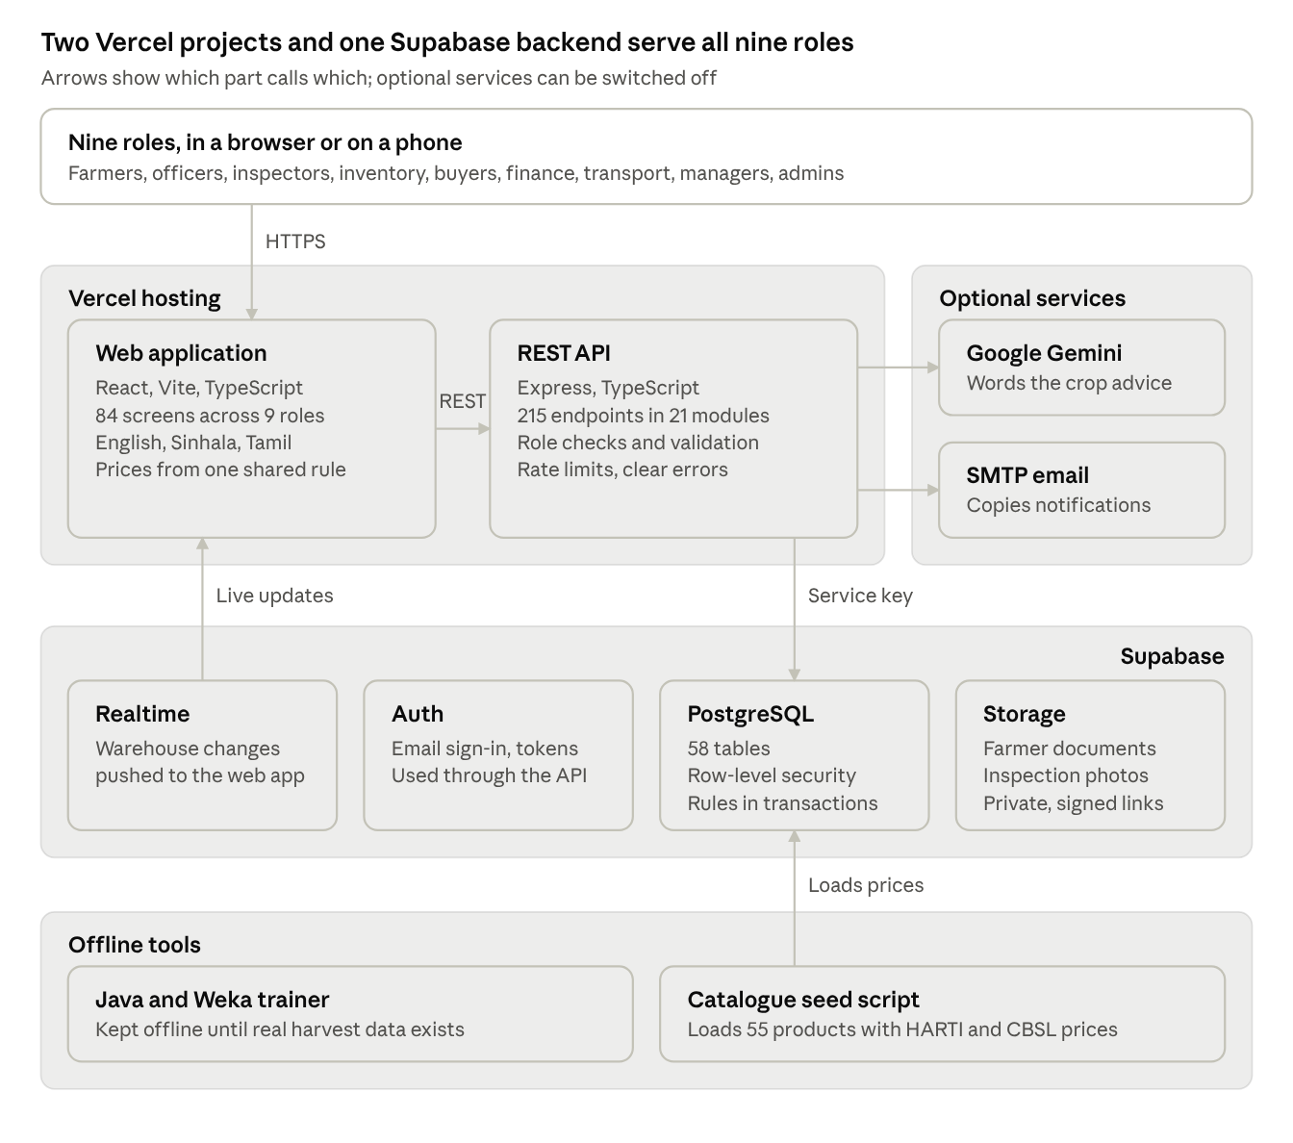
Figure 1: High-level system architecture of Saara Ketha Harvest Hub
Business rules run in the API and are enforced again in PostgreSQL. The web app talks to Supabase directly only for live warehouse updates, which row-level security still guards.

2. Project Execution, Monitoring and Control, and Closure
Execution ran in five phases, from a committed code baseline on 13 August 2026 to the showcase on 18 and 19 October 2026. Monitoring caught 25 stories that did not meet the Definition of Done and twelve defects before closure; all were corrected and the system was released.

2.1 Execution approach
The team used Scrum [7] with one owner per epic. The Scrum Master facilitated planning, reviews and the backlog, and each member owned one epic across its screens, API and database tables. Shared work (authentication, deployment, common components) was taken by whoever was free. Sprint 1 took the 21 highest-priority stories, at least half of each epic, as the proposal required [2].
Table 4: Execution phases, outputs and assessments
Phase | Dates | Goal | Main outputs | Assessment
Initiation and Sprint 0 | to 29 Aug 2026 | Agree problem, vision, epics, backlog and Definition of Done | Proposal: 4 epics, 43 stories, 195 story points, DoD, budget of LKR 95,500 | Proposal presentation (10%) and report (15%)
Sprint 1: core functions | Sep 2026 | Create, read, update and delete with validation for 21 stories | Registration, collection, inventory and payment basics | Sprint 1 evaluation (15%)
Sprint 2: integration | Sep to early Oct 2026 | End-to-end workflows across the four epics | Inspection to batch to payment flow, order reservation, auctions | Sprint 2 evaluation (15%)
Stabilisation and release | 9 to 11 Oct 2026 | Every story meets the DoD; public deployment | 28 commits; Vercel release; 10 new stories completed | Internal acceptance
Closure and showcase | 18 to 19 Oct 2026 | Hand over and present | 55-product price list, A3 poster, 60-second video, this report | Final demo and viva (20%), report (25%)

2.2 Progress over time
The version-control record is the most objective progress evidence the project has. It shows a baseline committed before the proposal and a long quiet period, then a concentrated release push.
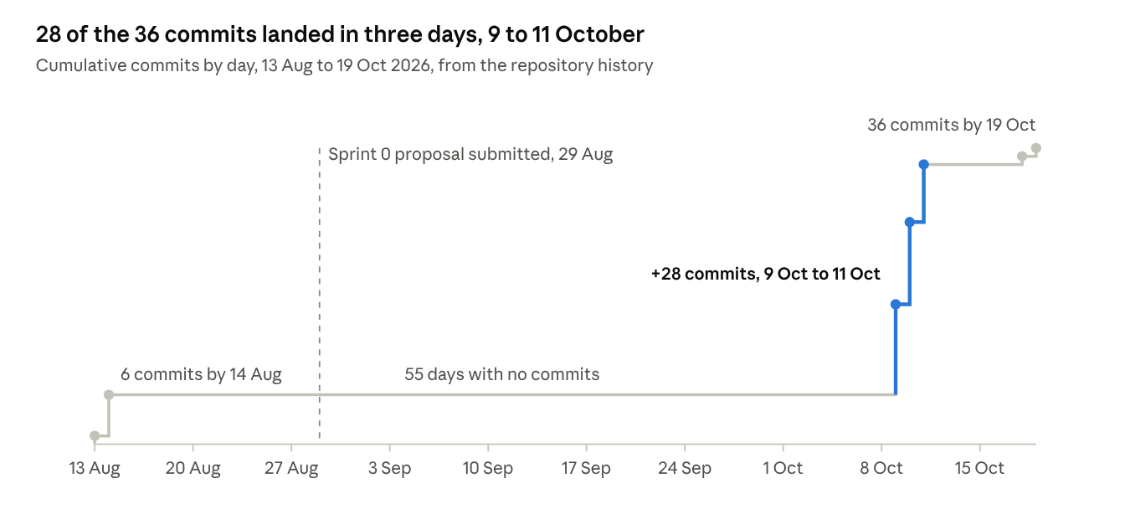
Figure 2: Cumulative commits by day, 13 August to 19 October 2026
Commits are an imperfect measure of effort, because all of them were pushed from one account. The shape is still clear: almost no work reached the shared repository between the proposal and the release week.

2.3 Monitoring and control activities
Seven control activities compared the work with the baseline and the Definition of Done. Each one produced evidence that is kept in the repository and summarised in the appendices.
Table 5: Monitoring and control activities and their evidence
Control activity | What was checked | When | Evidence
Story-coverage audit | Each of the 43 stories against the DoD; status marked Audited, Reworked or New | Before release | Appendix A
Automated tests | Auction rules, crop-advisor scoring, CSV export safety and error mapping, farmer validation | Every change | 72 Jest tests in 4 suites; SQL tests for reservation, wastage and payments (Appendix D)
Type checking | Backend and frontend compile with no type errors | Every change | TypeScript compiler, no errors
Role-based API probes | Each role's endpoints called with a test session; test data removed and the removal verified | After each fix batch | Appendix D
Deployment checks | Build logs, login, CORS and environment variables on Vercel | Every deployment | Appendix E
Stakeholder review of the increment | Defects and requests raised by users testing the system became backlog items | 9 to 11 Oct 2026 | Change log (Section 2.4, Appendix B)
Data-source checks | Market prices compared with HARTI and CBSL bulletins | 19 Oct 2026 | Appendix G

2.4 Changes and change control
Twelve changes were accepted after the Sprint 0 baseline. Each became a backlog item and was accepted only if it served an existing epic objective; four requests that did not fit the time left were deferred to future work.
Table 6: Change requests accepted after the Sprint 0 baseline
ID | Change | Trigger | Impact | Decision
CR-01 | Manager role with read-only reports and orders | E4-US6 to US9 name a Manager, but no such role existed | New role across database enum, routes, menus and translations | Accepted
CR-02 | Crop advisor scores computed from four weighted factors, replacing fixed scores of 97, 92 and 87 by rank | Audit: scores were neither explainable nor testable | E1-US9 to US11 reworked; Java and Weka trainer kept offline | Accepted
CR-03 | API and web app both hosted on Vercel instead of the planned Render or Railway | One platform, free tier, simpler configuration | Serverless entry point and CORS allow-list | Accepted
CR-04 | Farmer documents, buyer feedback and email notifications | Named in epic descriptions but missing from the stories | Migration 027, three features | Accepted
CR-05 | Complaint management for staff roles | Users found complaints could be raised but not resolved | New page and routes | Accepted
CR-06 | Near-expiry register with history | Request to keep a record of stock flagged near expiry | Migration 029 | Accepted
CR-07 | Product photos stored in the database; marketplace lists products with prices | User request | Migration 030 and image endpoint | Accepted
CR-08 | Product-level prices editable by administrators and collection centre officers | User request | Price routes and validation | Accepted
CR-09 | Driver NIC, phone and licence validation; warehouse pickup list; deliver action | Defects found in acceptance testing | E3-US8 reworked | Accepted
CR-10 | Expected-harvest revisions tracked per crop | Farmers' expected harvests change during the season | Migration 031 | Accepted
CR-11 | Crop advisor filtered by district and redesigned | Usability feedback | E1-US10 reworked | Accepted
CR-12 | Catalogue of 55 Sri Lankan products with grade A, B and C prices | Prices in the system were placeholders | Seed script and price list | Accepted

Deferred: online payment gateway, SMS alerts, native mobile apps and live scale integration (Section 6).

2.5 Issues and corrective actions
Twelve significant issues were found and closed. Six came from the code audit, three of them access-control and injection faults of the kinds listed in the OWASP Top 10 [11]; six appeared when the system was deployed and used.
Table 7: Significant issues and corrective actions
ID | Issue | Impact | Root cause | Corrective action
I-01 | Anyone could self-register as an administrator | Critical security gap | Role taken from the request body | Self-registration limited to farmer and buyer; server rejects other roles
I-02 | Farmer search filter accepted raw query text | Data exposure | User input placed directly in a query filter | Safe search and field whitelists
I-03 | Farmers could change their own verification status | Bypass of E1-US4 | Update accepted any field | Field whitelist on profile updates
I-04 | Payments used invented grade-A inspections and fallback prices of Rs 200, 170 and 140 | Wrong farmer payments | Placeholder code left in place | Payments only from approved inspections and the active price list
I-05 | Inventory showed invented 50 kg batches | Stock overstated | Demo data in production code | Real batches only
I-06 | Inspection photo upload called an API method that did not exist | E2-US6 broken | Contract drift between client and server | Method added and tested
I-07 | Deployed web app called the local API address | Login failed in production | API address not set at build time | Build variable set in Vercel and redeployed
I-08 | API rejected the hosted web app | Login failed in production | Environment values differed in case and domain | Values normalised; allow-list read from configuration
I-09 | Vercel builds failed | No deployment | Lockfile generated on Windows; missing build tools | Install without the Windows lockfile; root build configuration
I-10 | Days-to-expiry differed between local and hosted servers | Inconsistent stock risk | Hosted server runs in UTC | Dates computed in Sri Lanka time
I-11 | Order subtotal ignored product, grade and centre | Buyers saw wrong prices | Price looked up by category only | One price function shared by web app and API
I-12 | Users were logged out while navigating | Failed demonstrations | Login rate limiter counted the session check on every page load | Session checks excluded from the limiter

2.6 Risk management
The Sprint 0 register listed six risks [2]. Three of them materialised and were contained; three new risks emerged during execution and were added to the register.
Table 8: Risk register at closure
ID | Risk | Probability | Impact | Planned response | Outcome | Status
R1 | Requirement changes | High | Medium | Regular requirement reviews | 12 changes absorbed through the backlog | Closed
R2 | Development delays | High | High | Sprint monitoring and task tracking | Materialised: 28 of 36 commits in 3 days | Closed; testing time was squeezed
R3 | Data security | Medium | High | Authentication and role-based access | Materialised as I-01 to I-03; fixed before release | Closed
R4 | AI and ML implementation | Medium | Medium | Phased implementation and testing | No training data; transparent weighted score used instead | Mitigated
R5 | Database or service failure | Low | High | Backups and recovery | Managed database; migrations 001 to 031 can rebuild the schema | Open, monitored
R6 | Integration issues | High | High | Continuous testing | Materialised: I-06 to I-11 | Closed
R7 | Configuration drift between local and hosted environments (new) | High | High | Not planned | Caused I-07, I-08 and I-10 | Closed; settings documented
R8 | Personal data leaking through exports and media (new) | Medium | High | Not planned | Readable data exports and showcase media kept out of version control | Closed
R9 | Dependence on an external AI service (new) | Medium | Low | Not planned | Advisor works without it; the service only words the explanation | Open

2.7 Progress and status at closure
All 43 stories meet the Definition of Done at closure. The audit shows how much of that came from rework rather than first-time delivery.
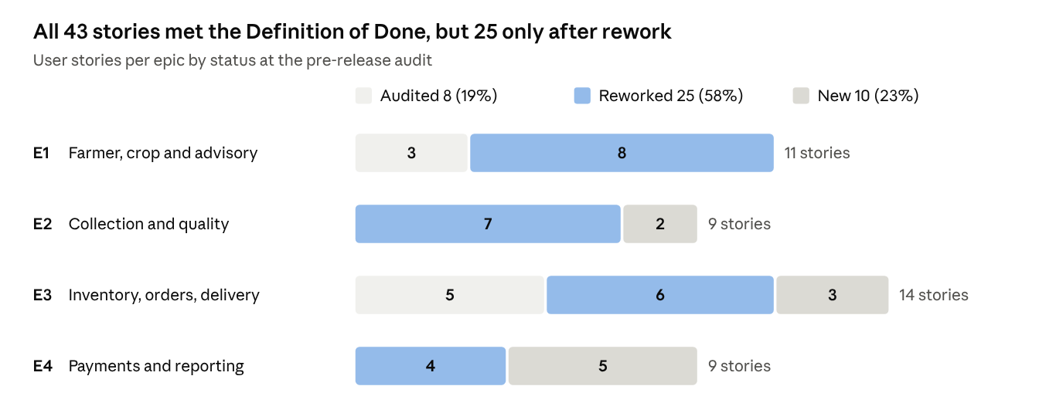
Figure 3: User stories per epic by audit status at closure
E1 had the highest share of rework, 8 of 11 stories, mostly in registration and the crop advisor. E4 needed the most new work: five of its nine stories, the receipts and management reports, did not exist before the audit.

2.8 Closure
Closure confirmed acceptance, released the system and handed over everything needed to run it. Two items are handed to the client to finish.
Table 9: Closure activities and status
Closure activity | Output | Status
Acceptance against the DoD | 43 of 43 stories accepted (Appendix A) | Done
Release | Public web app and API on Vercel; database on Supabase | Done
Handover documentation | README, database migrations 001 to 031, setup scripts, per-epic study guides, price-list note | Done
Showcase | A3 poster and 60-second promotional video with narration and subtitles | Done
Lessons learned | Recorded in Section 5 | Done
Open items for the client | Run the bidding and near-expiry setup scripts on the live database if not yet run; update the AI service model name; replace the published demo passwords before real use | Handed over
Final demonstration and viva | System demonstration and individual viva | Scheduled

3. Project Performance Domains Analysis
The project was strongest in Delivery and Stakeholders and weakest in Planning and Measurement. Each domain below is judged against the outcomes the PMBOK Guide sets for it [1], using evidence from the project.
Table 10: Summary assessment of the eight performance domains
Domain | Key evidence | Assessment | Main gap
Stakeholders | Every primary stakeholder became a system role; user feedback drove 7 of 12 changes | Strong | Feedback came late; no named Product Owner
Team | One owner per epic; Scrum Master role | Adequate | Nobody owned cross-epic integration; contributions not visible in version control
Development approach and life cycle | Hybrid: fixed assessment milestones, Scrum inside | Adequate | Hosted system not exercised until release week
Planning | Backlog of 43 estimated stories, DoD, budget, Sprint 1 plan | Weak | Inconsistent estimates; no dependency plan
Project work | Runbooks, setup scripts, study guides; zero-cost stack | Adequate | Manual database changes; defects reported without IDs
Delivery | 43 of 43 stories accepted; live system | Strong | 25 stories reworked; benefits not yet measured in use
Measurement | Story status, 72 tests, commit record | Weak | No velocity, burndown or estimate-versus-actual record
Uncertainty | Risk register; graceful fallbacks for AI and prices | Adequate | Register not updated during execution

3.1 Stakeholders
The project engaged its users directly through the product: each of the eight primary stakeholder groups in the Sprint 0 register [2] became a role with its own dashboard, plus a Manager role added later (CR-01). Farmers, the least technical group, were served in English, Sinhala and Tamil.
The weakness was timing. Most user feedback arrived after the system was deployed, so seven change requests (CR-05 to CR-11) landed in the last three days. The Sprint 0 role table also names no Product Owner, so the team set priorities itself instead of a client representative doing so.
Secondary stakeholders were reached only through data. Agricultural officers' knowledge entered through district crop tables, and market data through HARTI and CBSL bulletins [5], [6]; none were consulted directly, which limits confidence in the advisor's recommendations.
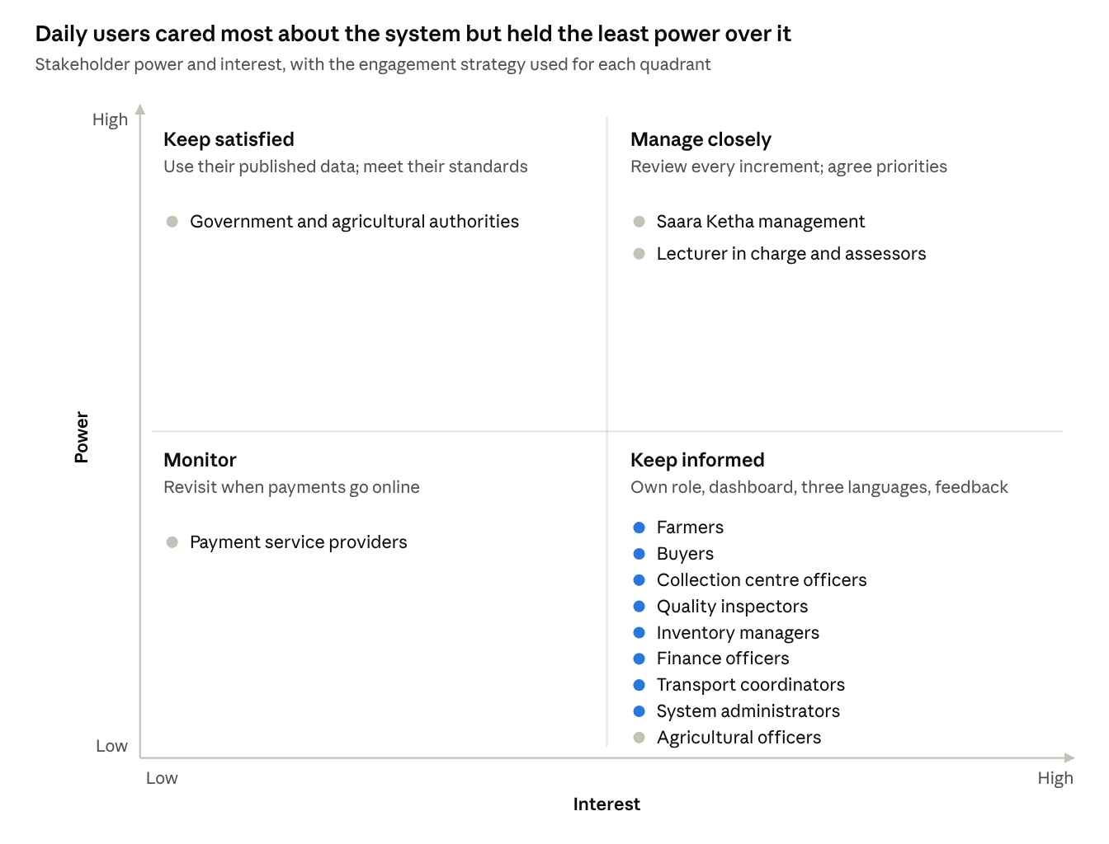
Figure 4: Stakeholder power and interest map with the engagement strategy for each quadrant
The eight groups that use the system every day (blue) sit in the low-power, high-interest quadrant. Moving their feedback earlier, through a Product Owner who speaks for them, is the main stakeholder improvement for the next project.

3.2 Team
Epic ownership gave every member a clear area of accountability, and the same allocation was reused in the group's architecture work [4], which kept a shared understanding across modules. The Scrum Master kept the backlog and the evaluation deadlines in view.
The gap was between the epics. The most valuable workflows cross epic boundaries: an inspection (E2) creates a batch (E3) that sets a farmer payment (E4). No one owned those joins, and the broken upload call (I-06) and the late integration push followed from that.
All 36 commits were made from a single account. Individual contributions are therefore not visible in version control, which weakens accountability, peer review and evidence for the individual viva.

3.3 Development approach and life cycle
The project used a hybrid approach, as recommended for most information-systems projects [12], [13]. The module fixed the milestones and deliverables in a predictive way, while the work inside each sprint was adaptive, with a re-prioritised backlog and working software reviewed at each evaluation [14].
Two life-cycle choices cost time. Each sprint was kept as a full copy of the code in its own folder, so fixes made in the main code had to be carried into three copies; tags or release branches would have avoided this. A first hosting configuration was committed on 14 August, but the hosted system was not exercised again until the release week, so environment faults I-07 to I-10 surfaced then instead of in Sprint 1.

3.4 Planning
Sprint 0 produced a complete plan: 43 stories in the "As a, I want, so that" form [15], 195 story points with hour estimates and priorities, a Definition of Done, a Sprint 1 selection of 21 stories, hardware and software requirements and a budget [2].
The plan was internally inconsistent. Three stories carry different points in the backlog and the Sprint 1 plan (E1-US2, E3-US2 and E4-US3: 2 versus 3). The schedule appendix planned six sprints, but three were run plus a stabilisation phase. The budget appears as LKR 95,500 in the budget section and LKR 213,500 per year in the appendix without saying which is build cost and which is running cost.
The largest omission was dependency planning. Stories were estimated one by one, but the plan did not show that E2 inspections must exist before E3 batches and E4 payments can be tested. A dependency map with integration milestones would have pulled integration forward.

3.5 Project work
The team kept the work reproducible. The README gives a setup runbook, migrations 001 to 031 rebuild the database, setup scripts were handed to the database owner, and each epic has a study guide. The whole stack used open-source tools and free hosting tiers, so no procurement was needed; product photographs were sourced with licence credits recorded.
Two process gaps added effort. Database changes had to be run by hand in the Supabase editor, and at closure two scripts were still unconfirmed on the live database. Defects were reported as screenshots without IDs and were numbered only for this report; a tracked issue list from the first day would have given traceability.

3.6 Delivery
The project delivered its full scope: 43 of 43 stories meet the Definition of Done on a public deployment, and each proposal benefit now has a working capability behind it.
Table 11: Proposal benefits, delivered capabilities and measures after go-live
Proposal benefit [2] | Capability delivered | How to measure it after go-live
Improved data accuracy | Server-computed net weight; accepted plus rejected must equal net weight | Weight disputes per 100 collections
Faster farmer payments | Payments calculated from approved inspections and active prices, with approval and receipts | Days from collection to payout
Inventory visibility and less wastage | Live stock by crop and grade, expiry risk, write-off register | Kilograms written off per month
No overselling | First-expiry-first-out reservation with a 70% cap | Orders cancelled for lack of stock
Better traceability | QR batch codes linking farmer, inspection, batch and order | Share of batches traceable to a farmer
Better decisions | Management reports, forecasts, CSV and PDF exports | Report preparation time

Quality, however, was reached through rework rather than built in. 25 of the 43 stories (58%) failed the Definition of Done at the audit and had to be reworked. The benefits are also not yet measured, because the client has no baseline figures from the manual process.

3.7 Measurement
The project can show solid output measures: 43 accepted stories, 72 passing automated tests, 215 API endpoints, 84 screens, 58 database tables and a dated commit record. These describe what was built, not how efficiently or how predictably.
The repository holds no velocity, burndown or estimate-versus-actual record, so the 195-point estimate cannot be compared with the effort actually spent. Progress was judged by finished stories, which hides partial progress until late. Delivery measures such as deployment frequency and change failure rate [16] would have exposed the integration risk weeks earlier.

3.8 Uncertainty
The team turned two uncertainties into design decisions. With no harvest history to train a model, the advisor uses a transparent weighted score that farmers can follow; with prices changing daily, the price list keeps effective dates and a superseded history instead of overwriting values.
Other responses were reactive. The register in the repository is the Sprint 0 version, and the three new risks (R7 to R9) were recorded at closure, so their responses came after they had already caused issues. Reviewing the register at each sprint review would have flagged configuration drift before release week.

4. Application of the 12 Project Management Principles
Four of the twelve PMBOK principles [1] were applied well throughout the project. The other eight shaped real decisions too, but mostly in response to problems rather than by design, and that pattern explains most of the rework.
Table 12: Application of the twelve PMBOK principles
# | Principle | Strongest project example | Applied
1 | Be a diligent, respectful and caring steward | Personal data kept out of version control; price estimates labelled honestly | Well
2 | Create a collaborative team environment | One owner per epic; shared architecture work | Partly
3 | Effectively engage with stakeholders | User feedback turned into seven changes | Partly
4 | Focus on value | Sprint 1 covered at least half of every epic | Well
5 | Recognise, evaluate and respond to system interactions | One price function shared by the web app and the API | Partly
6 | Demonstrate leadership behaviours | Full audit of 43 stories before release | Partly
7 | Tailor based on context | Hybrid approach and light, repository-based artefacts | Well
8 | Build quality into processes and deliverables | Validation in form, API and database; 72 tests | Partly
9 | Navigate complexity | Nine roles managed through layered, role-based design | Partly
10 | Optimise risk responses | Fallbacks for the AI service and price history | Partly
11 | Embrace adaptability and resiliency | Twelve changes absorbed; advisor redesigned | Well
12 | Enable change to achieve the envisioned future state | Multilingual screens and receipts that build farmer trust | Partly

4.1 Stewardship
The team treated the client's data and money with care. Readable database exports and showcase media containing personal data were kept out of version control (R8), farmer identity documents sit in a private store behind signed links, and 14 of the 55 prices are openly marked as estimates rather than presented as official figures.
The stack cost nothing to license or host at prototype scale, well inside the LKR 95,500 budget [2]. One lapse remains: demo passwords are published in the project documents and must be replaced before real use, which is why it is listed as a closure item.

4.2 Collaborative team environment
Epic ownership gave each member a clear, respected area, and the team reused one shared model of the system across its project and architecture work [4]. This reduced arguments over who did what.
Collaboration stopped at the epic boundary. With every commit made from one account and no pull-request reviews, members did not see or check each other's code, and the joins between epics were nobody's job (Section 3.2).

4.3 Stakeholder engagement
The stakeholder register [2] was carried straight into the product: every primary group became a role with its own dashboard, and farmers can work in Sinhala or Tamil. Users testing the deployed system raised the defects behind CR-05 to CR-11, and each was acted on within days.
Engagement was reactive and late. Without a named Product Owner, priorities were set by the team, and users saw the integrated system only in the release week, when changes were most expensive.

4.4 Focus on value
Value drove scope decisions. Sprint 1 took the highest-priority stories covering at least half of each epic, so every stakeholder group got something usable early [2]. The payment gateway, SMS and native apps were deferred because a recorded payment with a receipt already gives the client most of the value.
The catalogue of 55 products with HARTI and CBSL prices (CR-12) turned the payment and ordering screens from a demonstration into something a centre could actually use. The missing piece is measured value: no baseline from the manual process exists yet (Section 3.6).

4.5 System interactions
Several fixes show systems thinking. Prices feed farmer payments (E4) and buyer orders (E3), so one shared price function now serves both the web app and the API (I-11). Inspection results and batch creation are written in a single database transaction, so a failure cannot leave half a record.
These interactions were mostly found through defects rather than mapped in advance. The broken upload call (I-06) and the time-zone mismatch (I-10) are both interaction faults that a simple context diagram, drawn at Sprint 0, would likely have exposed.

4.6 Leadership
The key leadership decision was to stop adding features and audit all 43 stories against the Definition of Done before release. That decision found the security faults I-01 to I-03 before any real user could exploit them.
Leadership was concentrated at the end and was mostly directive. Earlier, servant-leadership practices such as removing blockers at each sprint review would have spread the effort and reduced the release-week push.

4.7 Tailoring
The team tailored its method to an academic project with fixed evaluation dates: a hybrid life cycle, markdown artefacts kept beside the code, free hosting, and plain SQL scripts that the database owner could run without command-line tools [12], [13].
Tailoring was too aggressive in one direction. Dropping a burndown chart and an issue log saved little time but removed the early warnings the project most needed (Sections 3.7 and 3.5).

4.8 Quality
The delivered quality controls are strong. Business rules are enforced three times: in the form, in the API and in the database, as with accepted plus rejected quantity equalling the net weight. 72 automated tests run in about one second, and missing records now return clear 404, 400 or 409 errors instead of server failures.
Quality was inspected in rather than built in. 25 of 43 stories (58%) failed the Definition of Done at the audit, which means the DoD was not applied when those stories were first called finished.

4.9 Complexity
The technical complexity of nine roles, 58 tables and 215 endpoints was contained by a layered design: 21 route modules, role checks on every route, and row-level security in the database [9]. Per-epic study guides made each part understandable on its own.
The social complexity was handled less well. The same team delivered this project alongside its Enterprise Architecture report, submitted on 14 October 2026 [4], and the clash of deadlines added to the October crunch.

4.10 Risk responses
Some responses were well judged. The crop advisor works even when the external AI service is unavailable (R9), prices are superseded rather than overwritten so an error can be traced, and stock reservations are capped at 70% to protect other buyers.
The planned responses to the two biggest risks were not scheduled. "Sprint monitoring" and "continuous testing" were written in the register [2] but had no owner or date, so delays (R2) and integration faults (R6) both materialised.

4.11 Adaptability and resiliency
The team adapted well. It absorbed twelve changes, replaced fixed advisor scores with an explainable model, and moved hosting to Vercel when that proved simpler. The system itself is resilient: it recovers cleanly from bad input, and the login limiter was tuned so normal navigation no longer logs users out (I-12).
The schedule was not resilient. With no buffer before the final evaluations, late changes cut into testing time.

4.12 Enabling change
The product is designed to change how the client works, not just to store data. Farmers register themselves, see their own receipts and payments in their own language, and can follow their payment status, which addresses the trust problem at the heart of the manual process.
The organisational side of that change was not planned. There is no training plan for centre staff, no plan to migrate the paper registers, and no parallel-run period; these are carried into future work (Section 6).

5. Lessons Learned
The project's most expensive lesson is that code written before the backlog and Definition of Done were agreed had to be rebuilt: 25 of 43 stories were reworked. The lessons below are drawn from the evidence in Sections 2 to 4 and each ends in an action the team will apply on its next project.

5.1 What worked
Table 13: Lessons learned: what worked
ID | Lesson | Evidence | Why it worked | Keep doing
W1 | Audit every story against the DoD before release | I-01 to I-06 found and fixed before any real user saw them | A story-by-story checklist leaves nothing unchecked | Run the same audit at the end of every sprint, not only at release
W2 | Enforce money and stock rules in the database, not only in the screens | Net-weight, 70% reservation and overpayment rules covered by SQL tests | No client, script or bug in the web app can bypass them | Make it the default for every rule that affects money or stock
W3 | Prefer an explainable advisor when data is thin | Weighted score (district 40, rotation 30, soil pH 15, rainfall 15) shown with its breakdown | No harvest data existed to train a model; farmers can see why a crop is suggested | Choose explainable models until real data justifies a trained one
W4 | Use official public data and label its source | 41 of 55 prices from HARTI and CBSL bulletins, 14 marked as estimates | Credible to the client and to assessors; easy to update | Cite data sources inside the product
W5 | Respond quickly to user feedback | Seven changes (CR-05 to CR-11) delivered in three days | Clear epic ownership and a modular codebase | Keep the speed, but collect the feedback in every sprint

5.2 What did not work
Table 14: Lessons learned: what did not work
ID | Lesson | Evidence | Cause | Impact | Action for the next project
L1 | Building before the baseline creates rework | Code baseline committed 13 Aug; proposal and DoD submitted 29 Aug; 25 stories reworked | Development started before acceptance criteria and the DoD were agreed | 58% of stories built twice; security faults shipped into early versions | Write no production code until the backlog, acceptance criteria and DoD are baselined; use throw-away spikes only
L2 | Late integration and deployment concentrate risk | 28 of 36 commits on 9 to 11 Oct; five deployment faults (I-07 to I-10, I-12) in release week | Hosting configured in August but not used again until release week; no owner for cross-epic flows | Testing time squeezed; failed logins during demonstrations | Deploy a thin end-to-end version in Sprint 1, deploy every sprint, rotate an integration owner
L3 | Invisible individual work weakens the team | All 36 commits from one account; no pull-request reviews | Work combined and pushed from one account | No peer review; weak evidence of individual contribution | Every member commits from their own account through branches and reviewed pull requests
L4 | Plan documents drifted apart | Three stories with two different estimates; six sprints planned, three run; two budget figures; sprint plan still shows Sprint 1 "In Progress" at closure | Artefacts written separately and never reconciled | Less trust in the plan; progress harder to measure | Keep one source of truth (a task board) and generate plan views from it; review it at each sprint
L5 | Without progress data, slippage is invisible | No burndown, velocity or estimate-versus-actual record | Tailoring removed tracking to save time | Delays (R2) found only when deadlines arrived | Update a burndown and log actual hours per story each sprint
L6 | Environment settings must be controlled like code | I-07, I-08 and I-10 all came from settings that differed between laptops and Vercel | Settings undocumented and set by hand | Production login failed twice | Commit a settings template, validate settings at start-up, test date logic in Sri Lanka time
L7 | Manual database changes leave the live system uncertain | Setup scripts RUN_4 to RUN_9 run by hand; two unconfirmed at closure | No automated migration step | Live database may differ from the code | Apply migrations automatically from the pipeline on every deployment

5.3 Top three improvements
- Baseline before building: agree acceptance criteria and the DoD in Sprint 0, and apply the DoD audit at every sprint review (L1, W1).
- Integrate and deploy from Sprint 1, with one rotating integration owner and automated migrations (L2, L6, L7).
- Make the work visible: individual commits with reviews, one task board, and a burndown updated each sprint (L3, L4, L5).

6. Future Work
The next release should close the gaps users meet at the collection counter: field use on phones, weighing, and messages for farmers without smartphones. Each item below comes from a scope exclusion, a lesson or a stakeholder need recorded in this report.
Table 15: Future work, priority and justification
Priority | Improvement | Limitation or need it addresses | Justification
Next release | Offline-capable mobile web app for officers and farmers | Rural connectivity is patchy; the current app needs a live connection | Reuses the React code, so it costs far less than separate Android and iOS apps
Next release | Digital scale and QR scanner integration | Weights are typed in by hand (Section 1.6); weight disputes were a core problem | Reading the scale directly removes transcription errors; QR batch codes already exist
Next release | SMS alerts in Sinhala and Tamil | Notifications are in-app and email only | Reaches farmers without smartphones or mobile data, the users most exposed to slow payments
Next release | Daily automatic import of HARTI and CBSL prices | Prices were loaded once, on 19 Oct 2026, but markets move daily [5], [6] | Keeps farmer payments and buyer prices fair without manual updates
Next release | Delivery pipeline with automated tests, migrations and preview deployments | Lessons L2, L6 and L7 | Removes the configuration and database drift behind five release-week issues
Next release | Go-live change package: staff training, migration of paper registers, two-week parallel run | Principle 12 gap (Section 4.12) | Adoption fails if staff fall back to paper while records are incomplete
Next release | Benefit dashboard with baseline figures from the paper process | Benefits are not yet measured (Section 3.6) | Lets the client prove payment speed, wastage and dispute improvements
Later | Trained crop-recommendation model | The advisor uses weighted rules; the Java and Weka trainer is unused | Worth training once one or two seasons of harvest, inspection and price data exist, and only if it beats the rule-based score
Later | Payment disbursement through a bank or mobile-wallet provider | Payments are recorded and receipted but paid outside the system | Cuts payout time further; needs a provider agreement and security review
Later | Multi-centre load and failover testing | The client runs hubs in several districts [4] | Confirms the system holds up before every centre uses it at once

7. Conclusion
The project met its main objective: Saara Ketha Harvest Hub now has a live, integrated system covering all four epics and all 43 user stories, from farmer registration to buyer payment. Each sub-objective was met against its measure (Section 1.5), and the deployment, documentation and showcase were handed over at closure.
As project management, the result was sound but uneven. Stakeholder focus, value-driven scope and fast adaptation were real strengths, while planning consistency, measurement and early integration were weak, and 58% of stories had to be reworked. The PMBOK lens [1] shows a team that applied the principles mostly when problems forced it to.
The lessons are specific and actionable: baseline before building, integrate and deploy from the first sprint, and make every member's work and progress visible. With the future work in Section 6, the system is ready for a supervised pilot at one collection centre.

References
[1] Project Management Institute, The Standard for Project Management and a Guide to the Project Management Body of Knowledge (PMBOK Guide), 7th ed. Newtown Square, PA, USA: PMI, 2021.
[2] A. M. D. Wanigasekara, D. L. A. C. Perera, U. D. Abesingha, and P. A. K. Kahatapitiya, "Saara Ketha Harvest Hub: Sprint 0 project proposal," Project ISE_WE_0101_23, IE3151 Information Systems Project Management, Sri Lanka Inst. of Inf. Technol., Malabe, Sri Lanka, Aug. 2026.
[3] "Post-harvest losses cost SL Rs. 20 b annually: COPA," Daily FT, Colombo, Sri Lanka, Apr. 10, 2021. [Online]. Available: https://www.ft.lk/Front-Page/Post-harvest-losses-cost-SL-Rs-20-b-annually-COPA/44-716201 (accessed Oct. 19, 2026).
[4] A. M. D. Wanigasekara, D. L. A. C. Perera, U. D. Abesingha, and P. A. K. Kahatapitiya, "Information, application and technology architecture assessment report: Saara Ketha Harvest Hub," IE3121 Enterprise Architecture, Evaluation 2, Sri Lanka Inst. of Inf. Technol., Malabe, Sri Lanka, Oct. 14, 2026.
[5] Hector Kobbekaduwa Agrarian Research and Training Institute, "Daily food commodities bulletin," Colombo, Sri Lanka, Oct. 16 to 18, 2026. [Online]. Available: https://www.harti.gov.lk
[6] Central Bank of Sri Lanka, "Daily price report," Colombo, Sri Lanka, Oct. 16, 2026. [Online]. Available: https://www.cbsl.gov.lk/en/statistics/economic-indicators/price-report
[7] K. Schwaber and J. Sutherland, "The Scrum Guide," Nov. 2020. [Online]. Available: https://scrumguides.org/scrum-guide.html
[8] Meta Platforms, Inc., "React documentation," 2026. [Online]. Available: https://react.dev
[9] Supabase, Inc., "Supabase documentation," 2026. [Online]. Available: https://supabase.com/docs
[10] Vercel, Inc., "Vercel documentation," 2026. [Online]. Available: https://vercel.com/docs
[11] OWASP Foundation, "OWASP Top 10:2021," 2021. [Online]. Available: https://owasp.org/Top10/
[12] Project Management Institute and Agile Alliance, Agile Practice Guide. Newtown Square, PA, USA: PMI, 2017.
[13] B. Attanayaka, "IE3151 Information systems project management, Lectures 01 to 04," lecture notes, Sri Lanka Inst. of Inf. Technol., Malabe, Sri Lanka, 2026.
[14] K. Beck et al., "Manifesto for agile software development," 2001. [Online]. Available: https://agilemanifesto.org
[15] M. Cohn, User Stories Applied: For Agile Software Development. Boston, MA, USA: Addison-Wesley, 2004.
[16] N. Forsgren, J. Humble, and G. Kim, Accelerate: The Science of Lean Software and DevOps. Portland, OR, USA: IT Revolution Press, 2018.

Appendices
The appendices hold the evidence behind Sections 2 to 5. Each is referenced from the section it supports.
Table 16: Appendices and the report sections they support
Appendix | Content | Supports
A | Product backlog and story status at closure | Sections 2.3, 2.7, 3.6
B | Change and commit log | Sections 2.2, 2.4, 3.2, 5.2
C | Definition of Done verification | Sections 2.8, 4.8
D | Test and verification evidence | Sections 2.3, 4.8
E | Deployment and configuration evidence | Sections 2.3, 2.5, 3.5
F | Stakeholder register and engagement | Sections 3.1, 4.3
G | Showcase and data-source evidence | Sections 2.3, 2.8, 4.4

Appendix A – Product Backlog and Story Status at Closure
Story points are from the Sprint 0 backlog [2] and total 195. Status is the result of the story-coverage audit: Audited (met the DoD as built), Reworked (rebuilt to meet it) or New (built during stabilisation). All 43 stories met the DoD at closure.
Table 17: Product backlog and story status at closure
Story | Summary | Points | Audit status
E1-US1 | Farmer creates own account | 5 | Reworked
E1-US2 | Choose English, Sinhala or Tamil | 2 | Reworked
E1-US3 | Officer registers and manages farmers | 5 | Reworked
E1-US4 | Officer verifies farmer registrations | 3 | Reworked
E1-US5 | Farmer views and updates profile | 3 | Reworked
E1-US6 | Farmer registers crops | 5 | Audited
E1-US7 | Farmer views crop history | 3 | Audited
E1-US8 | Officer searches and filters farmers | 3 | Audited
E1-US9 | Farmer uses the crop advisor bot | 8 | Reworked
E1-US10 | Farmer gives location, previous crop, soil and climate | 5 | Reworked
E1-US11 | Farmer sees recommendations with scores and reasons | 8 | Reworked
E2-US1 | Farmer schedules a delivery | 3 | Reworked
E2-US2 | Officer registers scheduled and walk-in deliveries | 5 | Reworked
E2-US3 | Officer records gross and container weight | 5 | Reworked
E2-US4 | Inspector inspects and grades produce | 5 | Reworked
E2-US5 | Inspector records accepted and rejected quantities | 5 | Reworked
E2-US6 | Inspector uploads evidence photos | 3 | Reworked
E2-US7 | System generates batch numbers and QR codes | 5 | Reworked
E2-US8 | Collection receipts and status | 3 | New
E2-US9 | System validates weights, quantities and approval | 5 | New
E3-US1 | Inventory batches | 5 | Reworked
E3-US2 | Warehouses and storage locations | 2 | Audited
E3-US3 | Real-time stock levels | 5 | Reworked
E3-US4 | Expiry and spoilage tracking | 5 | New
E3-US5 | Buyer registers and browses products | 3 | Reworked
E3-US6 | Buyer creates and tracks orders | 5 | Reworked
E3-US7 | Order approval and stock reservation | 5 | Reworked
E3-US8 | Delivery preparation and tracking | 5 | Reworked
E3-US9 | Block overselling, expired stock and excess reservation | 8 | New
E3-US10 | Buyer places bids | 5 | Audited
E3-US11 | Buyer views own bids | 2 | Audited
E3-US12 | Manager reviews bids | 5 | Audited
E3-US13 | Manager accepts or rejects bids | 5 | Audited
E3-US14 | Buyer is notified of bid result | 3 | New
E4-US1 | Calculate farmer payment from quantity and grade | 5 | Reworked
E4-US2 | Deductions and payment approval | 5 | Reworked
E4-US3 | Farmer tracks payments | 2 | Reworked
E4-US4 | Buyer payments and invoices | 5 | Reworked
E4-US5 | Receipts and outstanding payments | 3 | New
E4-US6 | Collection, inventory and quality reports | 5 | New
E4-US7 | Farmer, buyer and waste analysis | 5 | New
E4-US8 | Revenue, expenses, supply, demand and price trends | 8 | New
E4-US9 | Forecasts and PDF or CSV export | 5 | New

Appendix B – Change and Commit Log
The repository holds 36 commits, all on one branch from one account, with no merge commits. The table lists them newest first with the change request (CR), issue (I) or risk (R) each one serves.
Table 18: Repository commits, newest first, with the linked change, issue or risk
Date | Commit | Change | Linked item
2026-10-19 | 630cb21 | Sri Lankan catalogue of 55 products with market prices and photos | CR-12
2026-10-18 | ffa5ab6 | Stop rate-limiting the session check; keep showcase media out of version control | I-12, R8
2026-10-11 | 61e246b | Modal backdrop covers the whole window | UI defect
2026-10-11 | 07e9a09 | Expected-harvest revisions in their own table | CR-10
2026-10-11 | a1f4bbc | Crop advisor redesign | CR-11
2026-10-11 | 03a158f | Advisor offers previous crops that match the district | CR-11
2026-10-11 | 6a82a72 | Register-crop link, centre contact validation, order price and subtotal | I-11
2026-10-11 | cbaafe0 | Edit product prices from the product cards | CR-08
2026-10-11 | 842ba6a | Product-level prices for administrators and centre officers, validated | CR-08
2026-10-10 | 544e52f | Licensed product photo seed | CR-07
2026-10-10 | e2f9f3d | Product photos stored in the database and served by the API | CR-07
2026-10-10 | 5fe5ea3 | Marketplace product view with prices | CR-07, CR-08
2026-10-10 | e30e7e1 | Near-expiry register; exported data kept out of version control | CR-06, R8
2026-10-10 | a0e63d8 | Driver validation, warehouse pickup list, deliver action | CR-09
2026-10-10 | f16ba49 | Near-expiry days computed in Sri Lanka time | I-10
2026-10-10 | 51b070e | Menu labels fall back when a translation is missing | UI defect
2026-10-10 | bb7b5ee | Farmer payments use the active price list | I-04
2026-10-10 | c1e817d | Normalise environment name casing | I-08
2026-10-10 | e1e76e7 | Production defaults on Vercel; clear CORS rejection | I-08
2026-10-09 | 300ab40 | Separate configuration errors from wrong passwords at login | I-07
2026-10-09 | ec226f4 | Clear 404 and 400 errors instead of server failures | DoD: error handling
2026-10-09 | 8702d89 | Complaint handling for staff roles, notification links, CSV exports | CR-05
2026-10-09 | 2a547cb | Complaint management page | CR-05
2026-10-09 | fe9d730 | Complaints list, farmer auctions and profile access fixes | Defects
2026-10-09 | a8ab15a | API and web app made safe for Vercel | I-09
2026-10-09 | 989e539 | Install without the Windows lockfile | I-09
2026-10-09 | c87220c | Root build configuration | I-09
2026-10-09 | ecb97ec | Web app deployment configuration | I-09
2026-10-09 | 8ad2fc3 | Configure Vercel deployments | CR-03
2026-10-09 | aee507d | Audit rework synchronised: 206 files, 25,331 lines added, 3,319 removed | Appendix A, I-01 to I-06, CR-01, CR-02, CR-04
2026-08-14 | d8052d1 | Fix hosting configuration syntax | CR-03
2026-08-14 | 7957dc0 | Hosting configuration | CR-03
2026-08-14 | 2057b9d | Hosting configuration | CR-03
2026-08-14 | 470fbf1 | Root hosting configuration | CR-03
2026-08-14 | 17711ba | Floating crop-advisor button on the farmer dashboard | UI change
2026-08-13 | e0120d4 | Initial baseline of the full-stack platform | Baseline (L1)

Appendix C – Definition of Done Verification
Seven of the nine DoD criteria [2] were verified with evidence; two were only partly met and are carried into the lessons learned.
Table 19: Definition of Done criteria and how each was verified
DoD criterion | How it was verified | Result
Implemented to the story and its acceptance criteria | Story-by-story audit (Appendix A) | Met
Integrated without breaking other functions | End-to-end smoke scenarios (Appendix D) | Met
Validation, error handling, security and business rules in place | Server schemas, role checks on every route, database constraints and row-level security | Met
Data stored, updated and retrieved correctly | Role-based API probes with verified clean-up | Met
Interface complete, responsive and usable | Review at desktop and phone widths; promotional video recorded from the live interface | Met
Tested, with critical defects fixed | 72 automated tests, SQL tests, issues I-01 to I-12 closed | Met
Code reviewed and follows agreed standards | Type checking passes; no peer review recorded in version control | Partly met (L3)
Documentation and story updates completed | README, story coverage, study guides, this report | Met
Approved by the Product Owner or a stakeholder | Accepted at module evaluations; no named Product Owner | Partly met (Section 3.1)

Appendix D – Test and Verification Evidence
All automated checks passed on 19 October 2026.
Table 20: Automated and manual verification results
Check | Scope | Result
Backend unit and API tests (Jest) | 4 suites: auction rules, crop-advisor scoring, CSV export safety and error mapping, farmer registration validation | 72 of 72 passed in about 1 second
Database tests (SQL) | Stock reservation and wastage; buyer payments and receipts | Passed on PostgreSQL 16
Type checking | Backend and frontend | No errors
Role-based API probes | Each role's endpoints called with a test session; test records deleted and the deletion verified | Passed after each fix batch

The five end-to-end smoke scenarios used for integration acceptance:
- A farmer registers, an officer verifies them, the farmer books a delivery, the officer weighs it and an inspector grades it; an accepted plus rejected total that differs from the net weight is refused.
- A buyer orders more than 70% of a crop's stock and is refused; an order within the limit is approved and reserved, and cancelling returns the stock.
- Wastage is recorded on a batch and the expiry write-off runs; both appear in the wastage records and the manager report.
- A partial buyer payment and then the balance produce two receipts, and the invoice becomes paid.
- A manager logs in, management reports load and export to CSV, and no edit buttons appear.

Appendix E – Deployment and Configuration Evidence
The system runs as two Vercel projects over one Supabase database [9], [10]. Only setting names are listed; values are kept out of this report.
Table 21: Deployed components and required settings
Component | Location | Required settings
Web application | sara-ketha-harvest-hub-w8ld.vercel.app | VITE_API_BASE_URL (set at build time; its absence caused I-07)
REST API | sara-ketha-harvest-hub.vercel.app | SUPABASE_URL, SUPABASE_SERVICE_ROLE_KEY, SUPABASE_ANON_KEY, FRONTEND_URL, CRON_SECRET
Database | Supabase PostgreSQL | 30 migrations, 001 to 031 (010 unused), then the setup scripts below

Table 22: Database setup scripts and their status at closure
Setup script | Purpose | Status at closure
RUN_4 | Inspection evidence images | Run
RUN_5 | Bidding status fix | To be confirmed on the live database
RUN_6 | Readable views of the data | Optional; run when readable views are needed
RUN_7 | Near-expiry register | To be confirmed on the live database
RUN_8 | Product images | Run
RUN_9 | Expected-harvest revisions | Run

System size at closure: 58 database tables, 215 API endpoints in 21 route modules, 84 screens and about 38,300 lines of TypeScript.

Appendix F – Stakeholder Register and Engagement
The register extends the Sprint 0 version [2] with how each group was engaged and served.
Table 23: Stakeholder register and engagement
Stakeholder | Type | Main interest | How the project engaged or served them
Farmers | Primary | Easy registration, fair grading, payment transparency, crop advice | Farmer role in three languages; receipts; crop advisor
Collection centre officers | Primary | Verification, deliveries, weighing | Officer role; centre phone and capacity validation added
Quality inspectors | Primary | Accurate grading and evidence | Inspector role with photos and rejection reasons
Inventory managers | Primary | Stock levels, expiry, allocation | Inventory role; near-expiry register (CR-06)
Buyers | Primary | Availability, orders, invoices, delivery | Marketplace with prices and photos (CR-07); auctions
Finance officers | Primary | Accurate payments and reports | Finance role; active price list in payments (I-04)
Transport coordinators | Primary | Scheduling and vehicles | Transport role; driver validation (CR-09)
System administrators | Primary | Users, configuration, security | Administrator role; complaint management (CR-05)
Collection centre management | Secondary | Performance, revenue, supply and demand | Manager role (CR-01) with reports and exports
Agricultural officers | Secondary | Accuracy of crop advice | Represented through district crop tables only
Payment service providers | Secondary | Reliable transactions | Deferred to future work
Government and agricultural authorities | Tertiary | Sector data and transparency | Their published price data used as the price source [5], [6]
Lecturer in charge and assessors | Academic | Module deliverables and standards | Sprint evaluations, showcase and this report

Appendix G – Showcase and Data-Source Evidence
The showcase files are kept outside version control because they show personal data from the system (R8); they are included in the submission package.
Table 24: Showcase deliverables and price data
Item | Description | File
A3 poster | System name, the four epics and the high-level architecture | docs/showcase/poster/poster-A3.pdf
Promotional video | 60 seconds recorded from the live system, with narration and subtitles | docs/showcase/SaraKetha_Promo_voice_subtitles.mp4
Market price note | 55 products (26 vegetables, 18 fruits, 11 rice) with purchase and selling prices per grade | docs/MARKET_PRICES.md

Price method: the purchase price is about 90% and the selling price about 115% of the median wholesale price; grade B is 85% and grade C 70% of grade A. Sources: HARTI for 35 products [5], CBSL for 6 [6], and 14 market estimates, each labelled in the system.

