Bioinformatics, 2026, 3–22
doi: 10.1093/bioinformatics/xxxxx
Manuscript Category

Microbiome
SkinMicroMap: An interactive pipeline for visualising the geographical distribution and microbial composition of skin microbiome datasets
Ariane Neumann
Department of Biology, Box 118, 221 00, Lund University, Sweden

Abstract
Motivation: Microbiome analysis can often be overwhelming due to a vast amount of software tools available and the complexity of the analysis itself. SkinMicroMap aims to provide reproducible workflow and interactive interface for exploring geographical distribution and taxonomic composition of skin microbiome metagenomic data.
Results: Implementing a list of sample IDs, SkinMicroMap fetches metadata, resolves inconsistent country labelling via reverse-geocoding and visualises sampling density. While a sampling bias towards North America was observed with the available data set, deeper profiling of the samples for body sites achieved species level profiles based on Kraken2 and Bracken. The findings were visualised using Krona plots, linked to an interactive Folium map. The interactive web application supports meta data exploration, sequencing-type filtering (16S vs shotgun) and per-sample interactive taxonomy visualisation.

Availability: https://github.com/arineu84-lab/Microbiome_BINP29
Contact: ariane.neumann@med.lu.se

Introduction

The skin microbiome is composed of bacteria and other microorganisms, such as viruses and fungi. The state of the skin microbiome can impact the overall health of the host organism, modulating host immune responses and protection against invading pathogens. The development of more advanced sequencing tools in the last decade, including metagenomics, resulted in an increase in approaches of identifying therapeutic targets based on the microorganism. However, in wounds or in immuno-compromised hosts, protective barriers like the skin can be breached [1], and usually commensal bacteria may turn into opportunistic pathogens causing infection or inflammatory conditions. Precise removal of selected negatively associated microorganism based on the metagenomic profiles could contribute to increased overall improvement of skin barrier, repair and health [2].

Several powerful microbiome analysis pipelines already exist; however, these primarily focus on taxonomic and functional profiling, not on the geographical distribution. QIIME2 is a well-established tool which provides analysis for 16S as well as shotgun metagenomics [3] however, it does not utilise global meta data or interactive mapping. Similarly, automated analysis pipelines like MGnify from EBI provide a wide range of data sets [4], still, the user cannot interactively visualise geographical patterns with their own samples. In addition to these frameworks, recently a ML-based method used to analyse microbiome geographic population structures (mGPS) was reported [5]. mGPS addresses geographical distribution through supervised modelling, but again, the interactive part is missing from this tool.

SkinMicroMap aims to close this gap, making the analysis of microbiome metagenomic data easy-to-use by integrating essential steps, such as metadata retrieval, reverse-geocoding for geolocations, distribution plots and taxonomic classification into a single, streamlined workflow.

Taken together, SkinMicroMap links geographical data with microbial profiles, providing an interactive interface.

Methods

Overview and implementation

The workflow was implemented with Python 3.11 (analysis/visualisation), Bash (task automation), and Conda for environment management. Exact tool versions (Kraken2/Bracken/Krona/TaxonKit/Folium/Seaborn/Streamlit) are found in environment.yml (repository). The analysis accepts two text inputs: the sample ID list (NCBI.skin.metagenome.sampleID.txt) and an aggregated metadata table (metadata.tsv).

Metadata retrieval, filtering, and quality checks

Bash script “fetch_metadata.sh” retrieved per sample metadata (coordinates, body site, sequencing method, fastq links) and wrote tsv output. Python script “filter_columns.py” retained relevant fields (lat/lon coordinates, body site, sequencing type, identifiers). Exploratory filters using awk quantified initially scarce Swedish skin samples and motivated a broader selection, expanding to other Nordic countries. Sanity check routines verified presence of coordinates and consistent column naming prior to downstream steps.

Country assignment and global distribution

Because country codes were inconsistent, reverse geocoding was used to assign a country to each sample by intersecting coordinates with Natural Earth country polygons. This produced per country sample counts and a choropleth for visualising global sampling bias.

Sequencing type distribution and sample selection

Parsing the sequencing type column separated 16S rRNA from shotgun samples and seaborn plots were used for distribution visualisation [6]. For deep profiling, a small set of 16S samples was selected using “select_samples.py”, and fastq files were pulled with “pull_fastq.sh”.

Taxonomic profiling (Kraken2 and Bracken)

A SILVA 16S database [7] was built for Kraken2 [8], followed by a classification step (kraken2.py). Bracken [9] re-estimated read counts to deliver species/genus level abundances, improving accuracy in the presence of near identical species.

Taxonomic visualisation (Krona) and lineage extraction

Using TaxonKit [10], lineage strings were generated and merged with Bracken outputs (krona_bracken.py) to create Krona compatible tsv files. Krona [11] produced interactive, browser viewable plots for each sample.

Interactive Folium map and Streamlit UI

A Folium script (interactive_map.py) rendered a world map with clickable markers; for the selected samples from the previous step a corresponding Krona plot html opens. Finally, an optional Streamlit app (app.py) exposes the same exploration features through a browser UI.

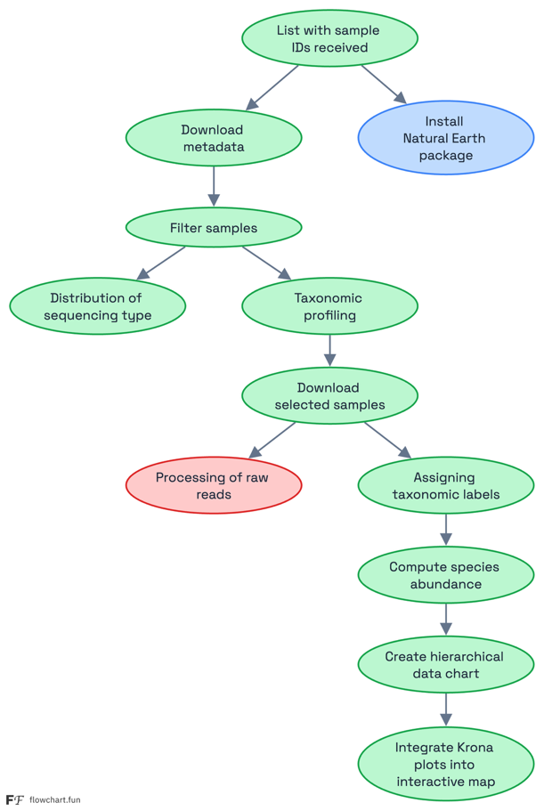

Figure 1. SkinMicroMap workflow: metadata retrieval → coordinate cleanup & reverse geocoding → sequencing type exploration → 16S selection & fastq fetch → Kraken2+Bracken profiling → Krona plots → interactive Folium map. (Flowchart created with Flowchart fun; figure and code provided in repository.)

Features
SkinMicroMap requires only a simple list of sample IDs as input, from which it automatically retrieves all available metadata into a unified table containing geographic coordinates, body‑site annotations, sequencing type information, and links to fastq files. Based on these metadata, the application generates a geographical overview of the dataset by reverse‑geocoding sampling coordinates and producing a country‑level distribution map. This representation highlights sampling density and potential geographical biases within the dataset.
In addition, the workflow summarises the distribution of sequencing modalities, allowing users to quickly distinguish between 16S rRNA amplicon data and shotgun metagenomes (or others, which can be modified with a single line change in the respective script), which is especially helpful in multi‑project environments where different analytical responsibilities may be distributed across collaborators.
Once samples of interest are identified, SkinMicroMap performs taxonomic profiling using Kraken2, followed by abundance reestimation with Bracken to obtain species‑ and genus‑level composition profiles. These outputs are visualised through interactive Krona plots, enabling users to explore hierarchical taxonomic relationships in a dynamic and intuitive manner. To integrate geographic and taxonomic information, each Krona plot is linked to its corresponding sampling location on an interactive Folium‑based map. This allows users to examine microbial composition directly within its spatial context, supporting exploratory comparisons across regions or body sites.
The tool is available both as a command‑line pipeline and as an optional web‑based Streamlit interface. The web application lowers the barrier for non‑technical users by removing the need for command‑line interaction and offering a clear, interactive environment for data exploration. This approach provides advantages such as ease of access, minimal setup, and the ability to investigate results visually through maps and taxonomy browsers. However, running the tool as a web application can introduce practical constraints, including increased dependency on server resources, potential limits in computational capacity for large datasets, and the requirement for hosting infrastructure. A standalone local pipeline, while less immediately user‑friendly, offers greater control, scalability, and independence from server availability.
Together, these complementary modes of operation allow SkinMicroMap to serve both computational users and researchers who prefer an accessible, GUI‑based environment.

Results
SkinMicroMap successfully assembled metadata for all provided sample IDs, resolving inconsistencies in country annotations by integrating geographic coordinates and applying automatic location correction routines. During initial inspection, the global dataset exhibited a strong sampling bias, with a disproportionate number of samples originating from North America. These patterns underscore the uneven global distribution of publicly available skin microbiome data and informed subsequent filtering steps.
After restricting the dataset to skin‑associated body sites and applying coordinate‑based refinement, a curated subset of 16S rRNA amplicon samples remained for detailed downstream analysis. This subset allowed for biologically meaningful cross‑regional comparisons while minimising noise from mixed sampling environments and inconsistent metadata.
Taxonomic classification using Kraken2 followed by abundance estimation with Bracken generated high‑resolution species‑level tables suitable for both comparative and exploratory analyses. Krona plots provided an intuitive mechanism for inspecting hierarchical community structure, enabling visual identification of both dominant and low‑frequency taxa within individual samples. The interactive implementation of SkinMicroMap linked these Krona taxonomies directly to the geographic origins of each sample, facilitating rapid, question‑driven exploration (see Figures 2 and 3).
Together, these results demonstrate that SkinMicroMap provides a scalable and transparent framework for integrating geographic, ecological, and taxonomic information in skin microbiome research, while also exposing key gaps in global sampling coverage.
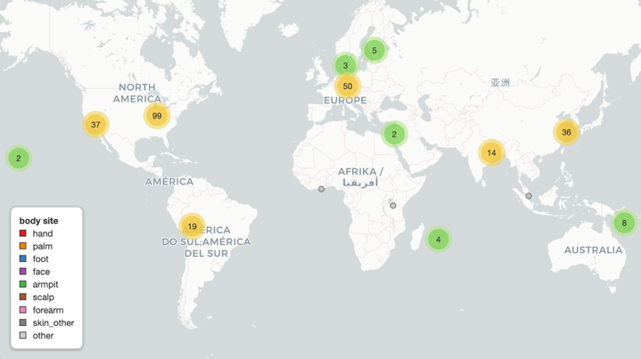
Figure 2. Global distribution of microbiome samples used in SkinMicroMap. A world‑map visualisation displaying aggregated sample counts per geographic region, stratified by annotated body site. North America and Europe show the highest sample densities, while smaller clusters appear in Asia, Australia, Africa, and South America. This visualisation highlights strong sampling biases and the geographic filtering steps preceding downstream analyses.

Discussion
SkinMicroMap provides a streamlined and reproducible framework for exploring skin microbiome data by integrating metadata curation, geospatial context, and taxonomic profiling into a single platform. The combination of automated metadata harmonisation, coordinate‑aware filtering, and interactive visual analytics offers a practical solution to the persistent challenges of inconsistent sample annotations and fragmented data sources.
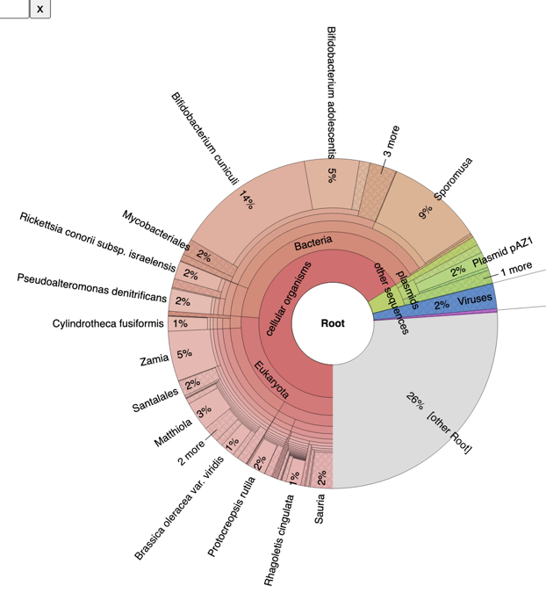
A core strength of the workflow lies in its ease of use, allowing users to proceed directly from a list of identifiers to fully interactive, publication‑ready visualisations without constructing or maintaining complex pipelines. The geospatial layer, combining choropleth‑style sample density patterns with coordinate‑anchored markers, enables intuitive inspection of global sampling imbalances and supports geographically driven hypotheses. Likewise, hierarchical Krona visualisations provide immediate clarity at multiple taxonomic levels, making patterns in dominant and low-abundance taxa accessible for both novices and experts.
SkinMicroMap is well suited for students, biologists, clinicians, and researchers who need to quickly orient themselves within the public dataset landscape. Common use will include screening for body‑site–specific sample cohorts, evaluating regional representation, or preparing high‑quality interactive figures for teaching, collaboration, or exploratory analyses prior to committing to deeper computational workflows.
Despite these advantages, several important limitations should be recognised. In its current form, the workflow uses raw reads without trimming, quality filtering, or host‑read removal, which may bias downstream taxonomic classification. Additionally, performance is inherently linked to the composition and completeness of the underlying Kraken2/Bracken databases, which influences sensitivity at different taxonomic depths. True strain‑level resolution, as well as robust functional inference, remain beyond the present scope. A key consideration is the dependency on metadata availability and accuracy. If geo‑selected samples lack body‑site annotations, downstream Krona plots can legitimately return “no hits” for the targeted cohort because those samples are excluded during body‑site filtering and thus contribute no classified reads to the visualisation.
Together, these results highlight that SkinMicroMap not only simplifies exploratory analyses but also exposes structural gaps in publicly available skin microbiome data. By continuing to expand its analytical breadth and dataset coverage, the platform has the potential to become a central resource for geographically contextualised microbiome research.

Figure 3. Taxonomic composition of a representative microbiome sample visualised using Krona. Each concentric ring represents increasing taxonomic resolution from root to species. Coloured sectors indicate major domains (Bacteria, Eukaryota, Archaea, Viruses), with proportional segment sizes reflecting relative abundance. This interactive format enables detailed exploration of taxonomic diversity across microbiome samples.

Acknowledgment
I am grateful to the editor and two anonymous reviewers for their valuable comments on the manuscript and to Lund University for their financial support.

References
- Casqueiro J., Casqueiro J., Alves C. (2012) Infections in patients with diabetes mellitus: a review of pathogenesis. Indian J Endocrinol Metab, 16(Suppl 1), S27–S36.
- Oh, J. and A. Y. Voigt (2025). The human skin microbiome: from metagenomes to therapeutics. Nat Rev Microbiol 23(12): 771-787.
- Bolyen, E., et al. (2019). Reproducible, interactive, scalable and extensible microbiome data science using QIIME 2. Nat Biotechnol 37(8): 852-857.
- Richardson, L., et al. (2023). MGnify: the microbiome sequence data analysis resource in 2023. Nucleic Acids Res 51(D1): D753-D759.
- Zhang, Y., et al. (2024). Microbiome Geographic Population Structure (mGPS) Detects Fine-Scale Geography. Genome Biol Evol 16(11).
- Waskom, M. L., (2021). seaborn: statistical data visualization. Journal of Open Source Software, 6(60), 3021
- Chuvochina, M., et al. (2026). SILVA in 2026: a global core biodata resource for rRNA within the DSMZ digital diversity. Nucleic Acids Res 54(D1): D334-D341.
- Wood D.E., Lu J., Langmead B. (2019) Improved metagenomic analysis with Kraken 2. Genome Biology, 20, 257. https://doi.org/10.1186/s13059-019-1891-0
- Lu J., Breitwieser F.P., Thielen P., Salzberg S.L. (2017) Bracken: estimating species abundance in metagenomics data. PeerJ Comput. Sci., 3, e104.
- Shen, W. and H. Ren (2021). TaxonKit: A practical and efficient NCBI taxonomy toolkit. J Genet Genomics 48(9): 844-850.
- Ondov B.D., Bergman N.H., Phillippy A.M. (2011) Interactive metagenomic visualization in a web browser. BMC Bioinformatics, 12, 385.

