Detection Engineering Program Proposal

Prepared for: Cybersecurity Leadership Team

Prepared by: Adam Ring

Date: July 2025

Version: 2

# Table of Contents

Appendix A: Visual Summary of Detection Engineering Program

Appendix B: Palantir Detection-as-Code (DaC) Framework Recommendation

Appendix C: Detection Engineering Behavior Maturity Model (DEBMM) Assessment

Appendix D: Priority Data Sources for Detection Engineering

Appendix E: RACI & Operating Model

Appendix F: Resourcing & Budget

Appendix G: KPI Targets & Reporting Cadence

Appendix H: Data Onboarding Plan (ranked table)

Appendix I: Purple-Team Validation Plan

# Proposal: Establishing a Detection Engineering Program

**Prepared by:** Adam Ring  
**Date:** 7/30/2025  
**Audience:** Executive & Technical Leadership

## Why We Need a Detection Engineering Program

Cyber threats are increasingly sophisticated, targeted, and persistent. Traditional alerting, compliance-driven monitoring, and ad hoc detection development are no longer sufficient.

**Current Challenges:**

* Inconsistent coverage of adversary behaviors
* High false positive rates reduce SOC efficiency
* Lack of structured process to evolve detections
* Reactive rather than proactive posture

**Business Risk:**

* Extended dwell time of attackers
* Missed compliance requirements
* Undetected lateral movement and privilege abuse

**Solution:** A formal, repeatable Detection Engineering program.

## Goals of the Program

* Threat-informed detection aligned with MITRE ATT&CK
* Continuous improvement through feedback loops
* Reduced mean time to detect (MTTD)
* Scalable and auditable detection lifecycle
* Central integration of red team, IR, CTI, and SOC inputs

## Key Detection Engineering Frameworks

### Strategic Frameworks

1. **MITRE ATT&CK** – Adversary TTPs and detection alignment
2. **MITRE D3FEND** – Countermeasure mapping to ATT&CK
3. **MITRE Engage** – Adversary engagement planning
4. **MITRE Insider Threat Framework** – Enhancing insider threat capability
5. **Detection Maturity Matrix (DMM)** – Detection engineering progression
6. **Threat Detection Maturity Framework** – Evaluate detection maturity
7. **ADS Framework** – Standardized alert and detection documentation
8. **Insider Threat Program Maturity Framework** – Best practices for internal risk

### Industry Standards

1. **NIST SP 800-92** – Security log management guidance
2. **NIST SP 800-171/172** – Protection of Controlled Unclassified Information (CUI)
3. **NIST SP 800-61** – Incident handling and response
4. **NIST SP 800-86** – Forensic techniques in incident response
5. **CIS Benchmarks** – Secure configurations and system hardening

### Detection Engineering-Specific Tools

1. **DeTT&CT** – Scoring log source and detection coverage quality
2. **Detection-as-Code** – Version-controlled, YAML-based rule development
3. **MaGMa Framework** – Use case management for security monitoring
4. **OTHF** – Open Threat Hunting Framework
5. **TaHiTI** – Threat hunting methodology
6. **RE&CT Framework** – Categorized incident response techniques

## Detection Engineering Lifecycle

### 1. Intake

1. Detection requests from IR, CTI, SOC, red team, audits
2. Prioritize based on risk, coverage gaps, and business impact

### 2. Research

1. Understand relevant TTPs, behaviors, and threat actors
2. Validate data sources for coverage (via DeTT&CT, log analysis)

### 3. Build

1. Translate hypotheses into KQL or SIGMA/YAML rules
2. Apply ATT&CK mappings, metadata, alert logic, suppression filters

### 4. Test

1. Simulate threats using tools like Atomic Red Team or CALDERA
2. Validate true/false positive behavior with test data

### 5. Deploy

1. Code reviewed and pushed to main via GitHub CI/CD
2. Detection deployed into Sentinel, monitored with version control

### 6. Monitor

1. Evaluate alert quality and volume
2. Use analyst feedback and telemetry to refine logic

### 7. Maintain

1. Track rule decay, threat landscape shifts, and stale logic
2. Retire, improve, or replace based on feedback, hunts, and KPIs
3. Incident analysis and investigation
4. Response execution (containment, eradication, remediation)
5. Use of forensic tools and RE&CT for process adherence
6. Integration with CSIRT and lessons learned feedback loop

## Operational Model Options

### Option A: Centralized Detection Engineering Team

1. Dedicated engineers build and maintain detections
2. CI/CD, quality control, versioned pipeline

### Option B: Hybrid Intake Model (Recommended)

1. SOC, IR, CTI, and Red Team submit detection requests
2. DE team triages, builds, and maintains quality

### Option C: Federated Contributions with Governance

1. All teams contribute detection logic
2. DE sets standards and approves deployments

## Metrics and KPIs

1. Time to detection (TTD) and alert-to-incident rate
2. MITRE ATT&CK tactic/technique coverage
3. False positive/false negative ratios
4. Number of rules tied to incidents or red team validation
5. Coverage of high-priority threat scenarios

## Progress to Date: Engineering Milestones Completed

## Proposed Implementation Timeline

| Phase | Timeline | Milestone |
| --- | --- | --- |
| Planning | Month 1 | Team formation, metrics, framework adoption |
| Foundation | Months 2–3 | CI/CD setup, repo creation, rule templates |
| Detection Build | Months 4–6 | 25+ rules from red team/IR threats |
| Evaluation | Month 7+ | Metric review, purple teaming, roadmap updates |

## Next Steps: Detection Engineering Roadmap

The following key initiatives remain to fully operationalize and mature the Detection Engineering program:

## Final Recommendation

1. Establish a Detection Engineering program under the Security org
2. Use MITRE ATT&CK, D3FEND, DMM, and NIST frameworks
3. Employ a hybrid detection intake model
4. Integrate detection-as-code, CI/CD, and operational metrics

**Next Steps:**

1. Executive sponsorship
2. Assign DE lead and engineering resources
3. Begin detection onboarding and tuning
4. Report on progress quarterly using maturity frameworks

## 

## Appendix: Supporting Frameworks & References

1. Snowflake – Detection DevOps best practices
2. NIST 800-92, 800-61, 800-171/172, 800-86
3. MITRE ATT&CK, D3FEND, Engage
4. DeTT&CT, OTHF, TaHiTI, MaGMa, RE&CT

# Visual Summary of Detection Engineering Program

## Detection Engineering Lifecycle

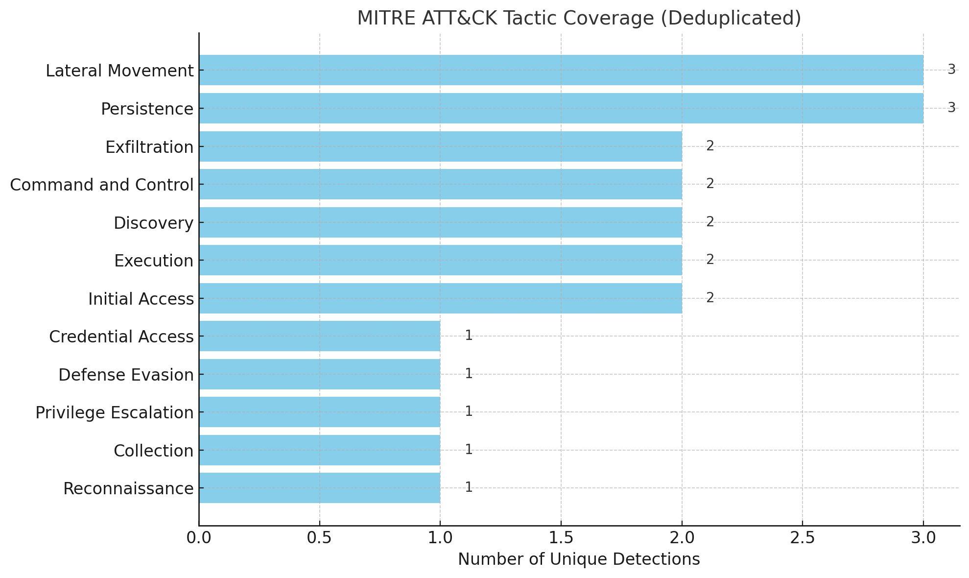

## Detection Rule Development Timeline

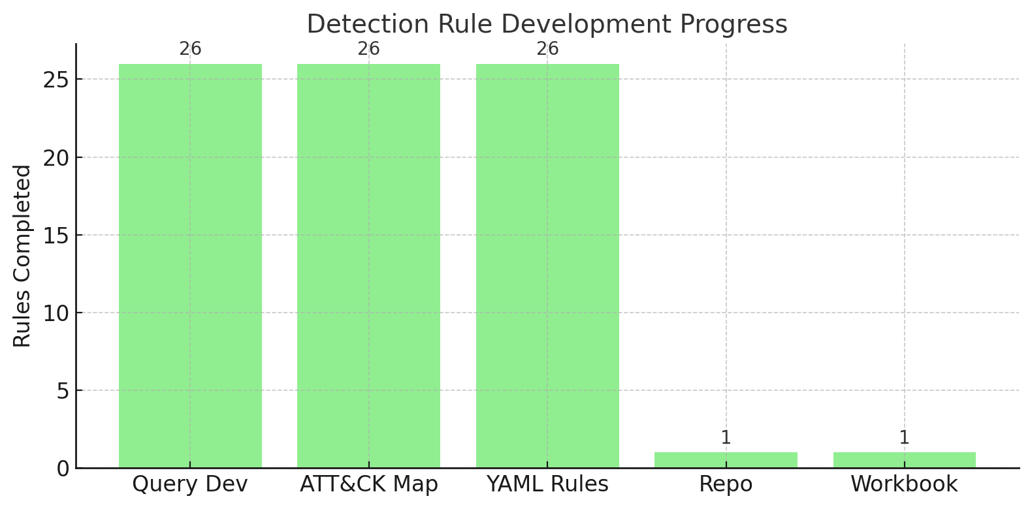

## Cyber Kill Chain Detection Coverage

## Detection Coverage: MITRE Tactics vs CKC Phases

# Progress to Date: Engineering Milestones Completed

As of July 30, 2025, the following core elements of the Detection Engineering program have been successfully completed:

|  |  |  |
| --- | --- | --- |
| Phase | Description | Status |
| 1. Define Mission & Scope | Focused on MITRE ATT&CK and Cyber Kill Chain coverage within Microsoft Sentinel and Defender ecosystem | ✅ Completed |
| 2. Data Ingestion | Logs from Microsoft Defender, Azure AD, Office 365, and Device Telemetry are integrated and verified | ✅ Completed |
| 3. Detection Query Development | Authored 31 KQL queries covering real-world TTPs across execution, credential access, defense evasion, and C2 | ✅ Completed |
| 4. ATT&CK Mapping | Each query mapped to corresponding MITRE ATT&CK tactics and techniques, visualized in a Sentinel workbook | ✅ Completed |
| 5. Rule Conversion | All queries converted into YAML-based, version-controlled detection rules with ATT&CK metadata | ✅ Completed |
| 6. GitHub Repo Creation | Detection-as-code repository with organized folder structure, ready for CI/CD integration | ✅ Completed |
| 7. Workbook for Coverage | MITRE ATT&CK tactic/technique coverage workbook generated for tracking detection maturity | ✅ Completed |

# Detection Engineering Lifecycle Status Overview

As of July 30, 2025, the following core elements of the Detection Engineering program have been successfully completed. This table outlines the complete lifecycle of the detection engineering program, indicating which phases are completed and which are in progress or pending:

|  |  |  |
| --- | --- | --- |
| Phase | Description | Status |
| 1. Define Mission & Scope | Focused on MITRE ATT&CK and Cyber Kill Chain coverage within Microsoft Sentinel and Defender ecosystem | ✅ Completed |
| 2. Data Ingestion | Logs from Microsoft Defender, Azure AD, Office 365, and Device Telemetry are integrated and verified | ✅ Completed |
| 3. Detection Query Development | Authored 31 KQL queries covering real-world TTPs across execution, credential access, defense evasion, and C2 | ✅ Completed |
| 4. ATT&CK Mapping | Each query mapped to corresponding MITRE ATT&CK tactics and techniques, visualized in a Sentinel workbook | ✅ Completed |
| 5. Rule Conversion | All queries converted into YAML-based, version-controlled detection rules with ATT&CK metadata | ✅ Completed |
| 6. GitHub Repo Creation | Detection-as-code repository with organized folder structure, ready for CI/CD integration | ✅ Completed |
| 7. Workbook for Coverage | MITRE ATT&CK tactic/technique coverage workbook generated for tracking detection maturity | ✅ Completed |
| 8. CI/CD Deployment Pipeline | Build a GitHub Actions (or Azure DevOps) workflow to validate YAML syntax and push detection rules to Microsoft Sentinel | ⬜ In Progress |
| 9. Alert Triage & Playbooks | Integrate detection rules with Sentinel playbooks to automate triage, enrich alerts, and initiate response actions | ⬜ Not Started |
| 10. Validation & Simulation Testing | Use Atomic Red Team, Prelude Operator, or custom scripts to simulate adversary behavior and validate rule effectiveness | ⬜ Not Started |
| 11. Tuning & False Positive Reduction | Refine logic using watchlists, suppression filters, and scoped exclusions based on telemetry and analyst feedback | ⬜ Not Started |
| 12. Reporting & Dashboarding | Build dashboards to track alert volume, rule performance, and MITRE/Kill Chain coverage trends | ⬜ Not Started |
| 13. Purple Teaming & Feedback Loops | Establish regular feedback between Red Team, CTI, IR, and Detection Engineering | ⬜ Not Started |
| 14. Documentation & Knowledge Transfer | Develop rule documentation templates, tuning guides, and onboarding material | ⬜ Not Started |

# Appendix B: Palantir Detection-as-Code (DaC) Framework Recommendation

Recommendation: Adopt Palantir’s Detection-as-Code Framework

### Executive Summary

To enhance the maturity, agility, and consistency of our Security Operations Center (SOC), we recommend implementing a Detection-as-Code (DaC) approach using Palantir’s open-source DaC framework. This strategy aligns with modern detection engineering best practices and will support scalable, auditable, and collaborative detection development, particularly as we expand our use of Microsoft Sentinel, Databricks, and hybrid cloud infrastructure.

### Why Palantir Detection-as-Code

Palantir’s DaC framework is a vendor-agnostic, open-source solution that helps security teams implement software engineering principles into detection engineering. It offers:

#### Version-Controlled YAML Detection Rules

Write detection logic in human-readable YAML.

Enables Git-based change tracking, code review, and rollback.

#### CI/CD Pipeline Integration

Automate validation, testing, and deployment of detection rules.

Enforces quality control and reduces configuration drift.

#### Modular, Reusable Components

Use macros, tags, and shared logic blocks.

Promotes consistent rule development across threat categories.

#### Cross-Platform Compatibility

Translate rules to KQL (Microsoft Sentinel), SQL (Databricks), SPL (Splunk), etc.

Allows for unified detection strategy across different platforms.

#### Improved Collaboration and Transparency

Encourages cross-functional contributions with pull requests, peer review, and Git issue tracking.

Enables structured handoffs between detection engineering, threat hunting, and incident response.

### Palantir Detection Lifecycle

Palantir defines a structured lifecycle that guides the end-to-end process of detection engineering. This ensures detections are reliable, testable, and sustainable.

#### 1. Ideation

Identify detection needs based on threat intel, incidents, purple teaming, or MITRE ATT&CK gaps.

Define hypotheses and threat behaviors.

#### 2. Development

Write detection logic in YAML format using standard templates and macros.

Tag rules with MITRE ATT&CK techniques, severity levels, and relevant metadata.

#### 3. Testing

Validate syntactic correctness (detection_rules validate).

Write rule-specific unit tests using sample logs or synthetic data.

Use adversary emulation (e.g., Atomic Red Team) for behavior verification.

#### 4. Deployment

Automate deployment via GitHub Actions or Azure DevOps.

Translate and push queries into Sentinel or other SIEM platforms via APIs or Terraform.

#### 5. Monitoring & Feedback

Monitor rule performance (true/false positive rates).

Feed detection feedback into backlog for tuning or retirement.

#### 6. Maintenance

Review and refactor rules based on telemetry changes or evolving TTPs.

Ensure detection coverage is preserved as infrastructure evolves.

This lifecycle is repeatable and auditable, allowing security teams to treat detections with the same rigor as production code.

### Implementation Plan

#### Step 1: Repository Setup

Create a GitHub or Azure DevOps repo (e.g., detection-engineering).

Structure folders for /rules, /tests, /macros, /deployment, /configs.

#### Step 2: Rule Development

Convert existing Sentinel KQL rules into YAML.

Enrich with MITRE tags, owner fields, and macro logic for reusability.

#### Step 3: CI/CD Integration

Set up a pipeline for:

Syntax validation

Unit test execution

Rule translation and deployment to Sentinel/Databricks

#### Step 4: Lifecycle Enforcement

Integrate the detection lifecycle into SOC SOPs.

Require test coverage, review approvals, and deployment logs before promotion.

#### Step 5: Dashboard Integration

Use MITRE tags to visualize coverage in Microsoft Sentinel workbooks.

Automate reporting on rules by ATT&CK technique, owner, last update, and coverage gaps.

### Conclusion

Adopting Palantir’s Detection-as-Code framework and lifecycle will allow us to transform detection engineering from ad-hoc query writing into a scalable, testable, and collaborative discipline. This approach enhances detection fidelity, speeds up deployment, and supports a resilient and future-proof SOC.

# Appendix C: Detection Engineering Behavior Maturity Model (DEBMM) Assessment

## DEBMM Overview

• Elastic’s DEBMM defines five maturity levels—Foundation (Tier 0), Basic (Tier 1), Intermediate, Advanced, and Expert (Tier 4). It emphasizes structured development and continuous improvement of detection engineering behaviors over time.

• (Reference: https://www.elastic.co/security-labs/elastic-releases-debmm)

## Current DEBMM Tier Alignment

• Tier 1 – Basic:

• Version-controlled and documented rule library in GitHub

• ~15–30 YAML rules with MITRE ATT&CK and Cyber Kill Chain tags

• Minimal stakeholder review, structured metadata present

• Tier 2 – Intermediate (In Progress):

• Heatmap coverage mapping and workbook correlation

• Detection suppression and watchlist filtering

• Consistent lifecycle tagging and auditability in YAML

• Tier 3 – Advanced (Partial):

• Behavioral simulation in lab environments

• Threat-informed rule enhancements in development

• Tier 4 – Expert (Planned):

• No current automation or SOAR integration

• No auto-deploy or feedback-driven suppression pipelines

## DEBMM Tier Summary

• Tier 0 – Foundation: Ad hoc rules, no structure — ✅ Surpassed

• Tier 1 – Basic: Consistent naming, small ruleset, version control — ✅ Completed

• Tier 2 – Intermediate: Review process, tuning, data coverage — ✅ In Progress

• Tier 3 – Advanced: Threat emulation, feedback loops — ⚠️ Partial

• Tier 4 – Expert: Full automation, SOAR integration — ⬜ Planned

## Recommendations to Progress

• 1. Establish routine false-positive reviews and tuning.

• 2. Correlate hunt results with detection gaps.

• 3. Begin integration with automated playbooks and response tools.

• 4. Tag detection rules with response strategies and confidence levels.

• 5. Consider use of AI-assisted detection refinement and tuning.

# Appendix D: Priority Data Sources for Detection Engineering

This appendix identifies and prioritizes core data sources required to support high-fidelity detections, threat hunting, and incident response across the environment. Focus initial onboarding, enrichment, and quality assurance on the sources below.

* Assets:
* User endpoints (laptops, desktops, mobile devices)
* Servers:
* Are any of these servers public-facing?
* What type of servers are they? Domain controllers, web servers, file servers, etc.
* Software:
* Operating systems running on the various assets
* Software/applications used throughout the organization
* Network architecture diagram
* Cloud assets:
* SaaS applications
* Security solutions:
* SIEM
* Endpoint protection (AV/EDR)
* Network protection (IPS/firewall/WAF)