Flight Data Quality Checks
  - Reporting Carrier On Time Performance January 2026
This report documents the import and validation of the RawFlight table. The full dataset contains 544,003 records covering January 1 through January 31, 2026. Most missing values are consistent with cancelled or diverted flights; four scheduled-duration records require review.

1. Import Row Count
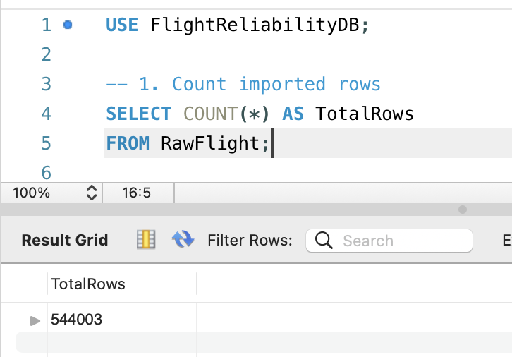
Passed: The full monthly dataset contains 544,003 rows.

2. Date Range
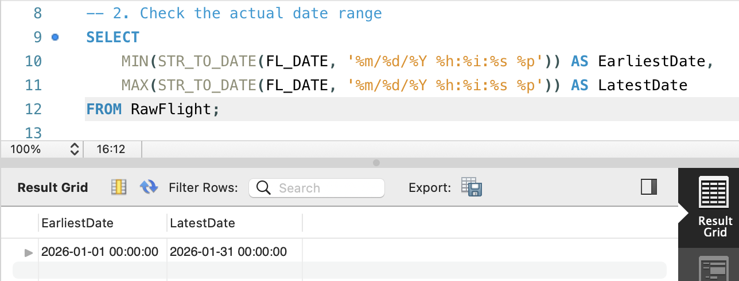
Passed: After converting FL_DATE from text to a date, the results correctly cover January 1 through January 31, 2026.

3. Cancelled and Diverted Flights
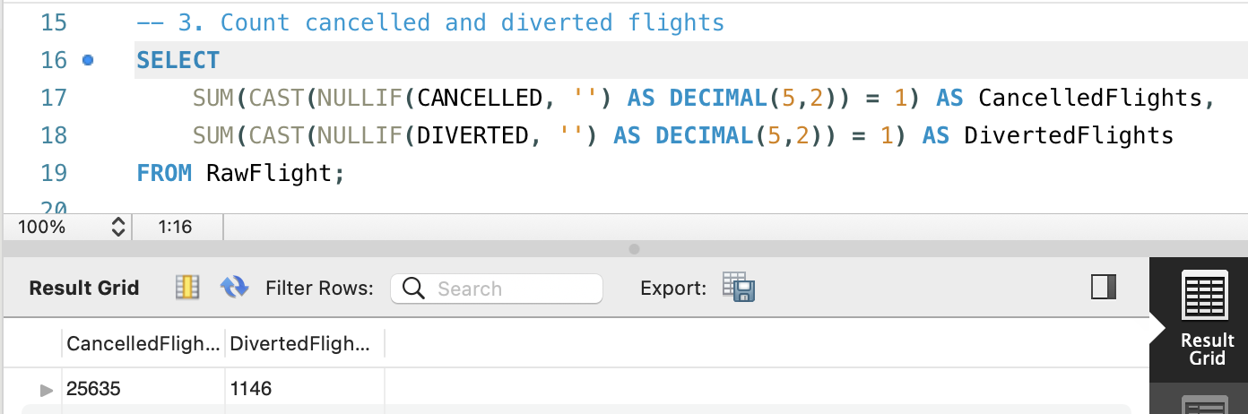
Passed: The dataset contains 25,635 cancelled flights and 1,146 diverted flights.

4. Missing Value Summary
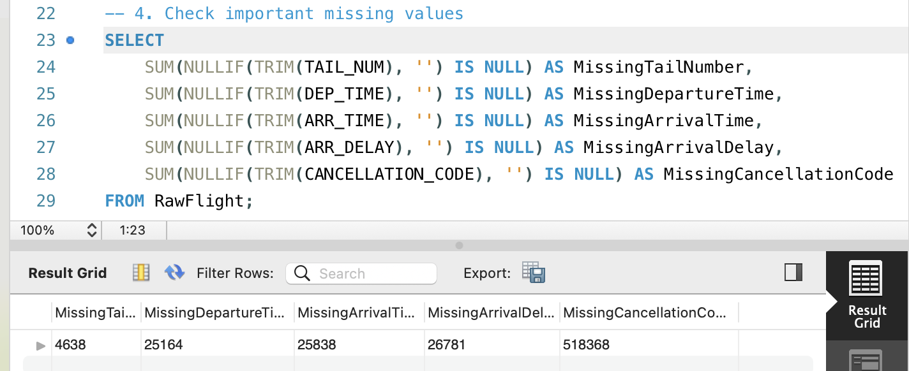
Expected: The cancellation-code total is correct because non-cancelled flights have no cancellation reason. Missing operational times should be interpreted with flight status rather than removed automatically.

5. Missing Values by Flight Status
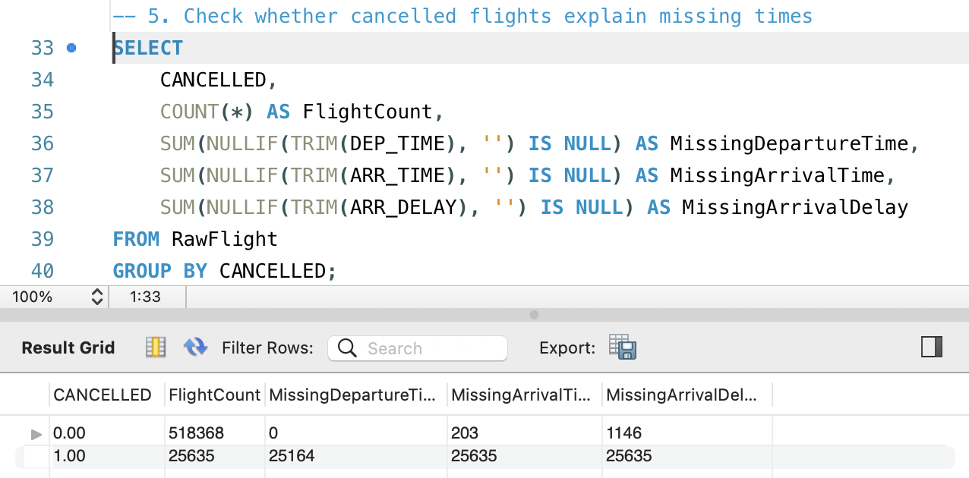
Expected: All cancelled flights lack arrival time and arrival delay, while 25,164 of them also lack departure time. Among non-cancelled flights, the 1,146 missing arrival-delay values match the number of diverted flights.

6. Duplicate Flight Check
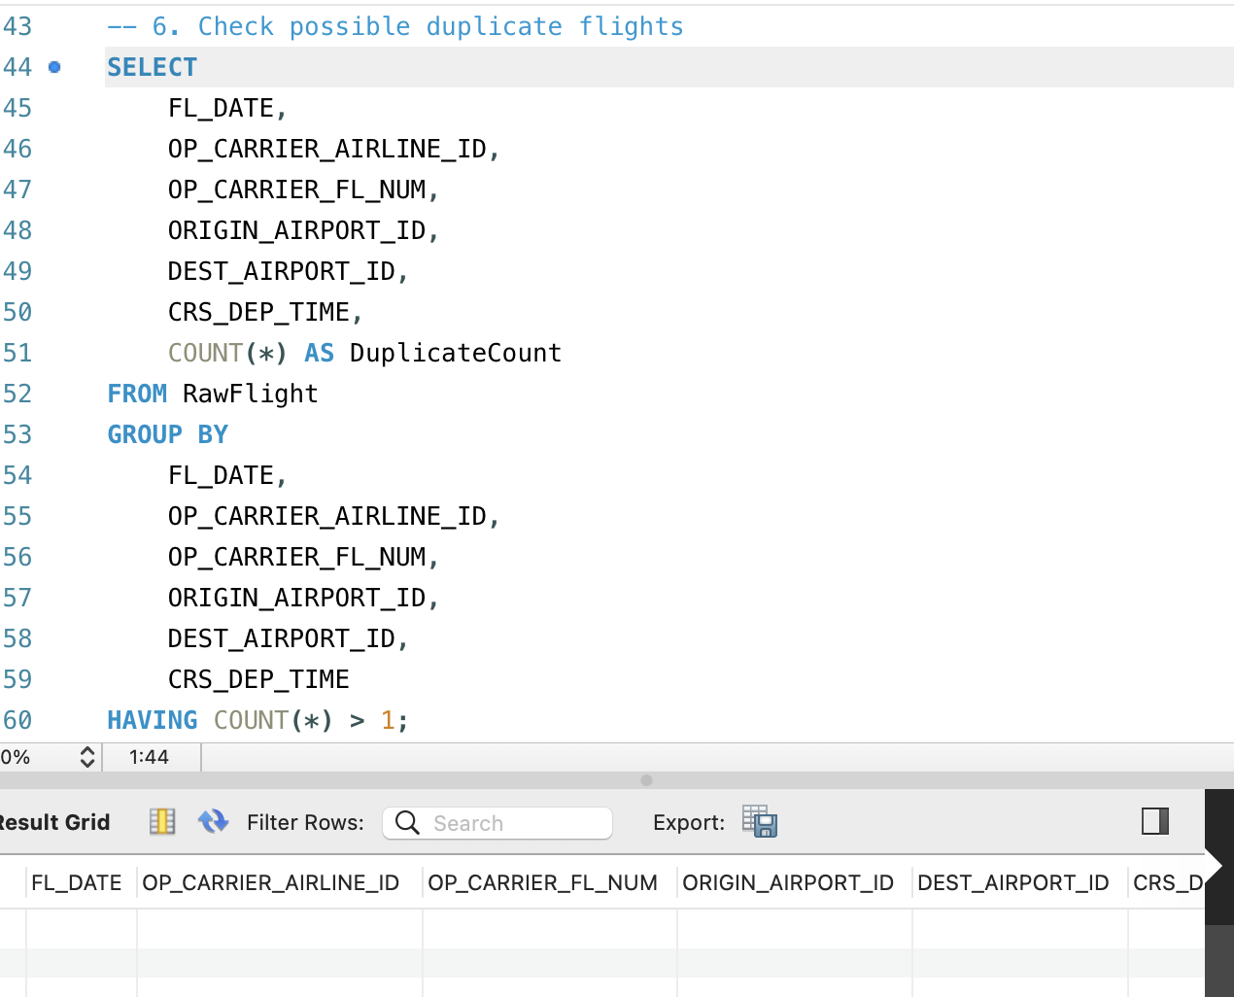
Passed: No duplicate groups were returned using the selected flight identifiers and scheduled departure time.

7. Invalid Scheduled Duration Count
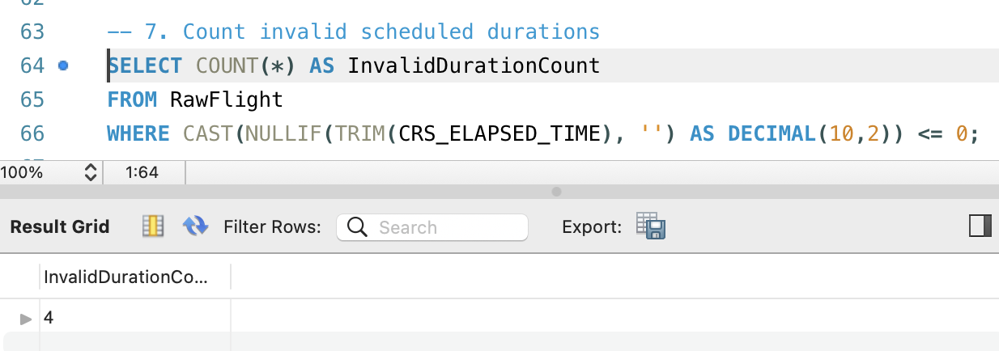
Review: Four records have a scheduled elapsed time of zero or less. This is a very small share of the dataset, but these records should be excluded or treated as NULL in duration-based analysis.

8. Invalid Scheduled Duration Records
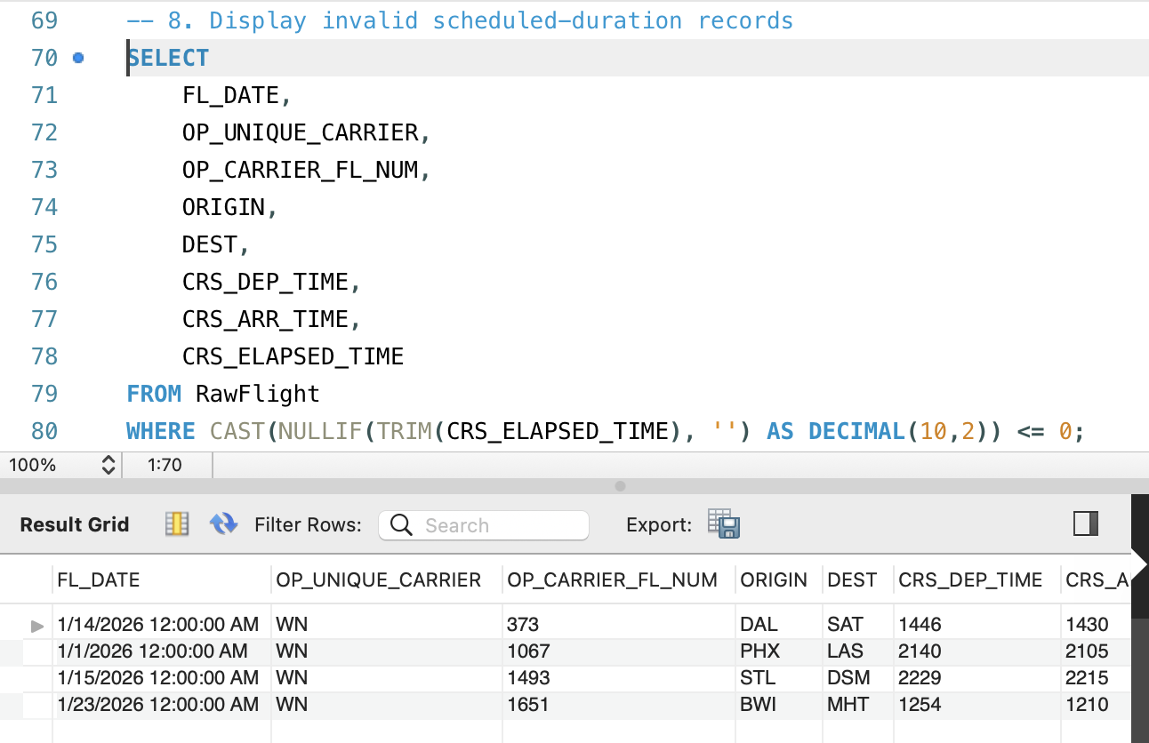
Review: The four affected flights are displayed. For the clearest evidence, move CRS_ELAPSED_TIME next to FL_DATE in the SELECT list so its value appears in the visible result columns.

9. Airport ID and Code Consistency
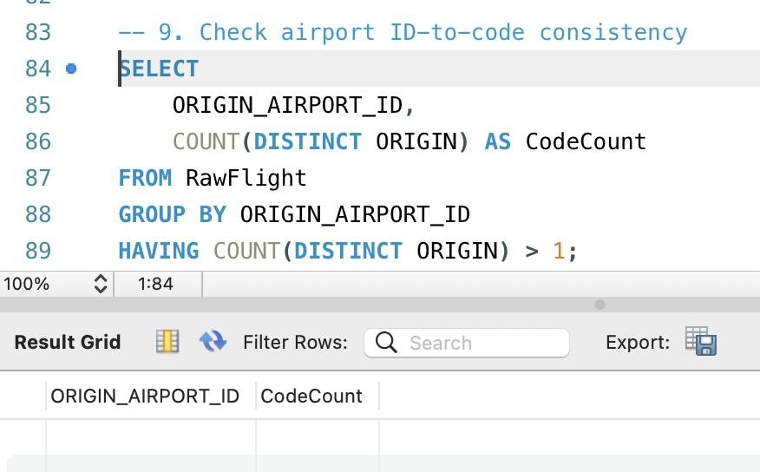
Passed: No origin airport ID is associated with more than one origin airport code.

Summary
Check | Status | Finding
Import | Passed | 544,003 rows
Date range | Passed | January 1 to January 31, 2026
Missing values | Expected | Mainly cancellation and diversion related
Duplicates | Passed | No duplicate groups returned
Scheduled duration | Review | Four non-positive values
Airport mapping | Passed | One code per origin airport ID
Recommended treatment: retain valid NULL values, document their connection to flight status, and exclude the four non-positive scheduled-duration records only from analyses that require a valid duration.

