Contents
1 General Notes 2
2 Design and Function 3
2.1 Brief Description 3
2.2 Design 3
2.2.1 Touch-Enabled Screen 3
2.2.2 Card Insertion Slot 4
2.2.3 Transaction Receipt Outlet 4
2.2.4 Cash Outlet 4
2.2.5 Keypad 4
2.2.6 Buttons 4
3 Operating Procedure 5
3.1 Prerequisites 5
3.2 Steps for Cash Withdrawal 5

General Notes
This operating manual describes all the conditions, activities, and safety instructions necessary for the withdrawal of money using an Automated Teller Machine (ATM).
All the instructions must be strictly followed during operation. Always keep the manual near the ATM.

Design and Function

Brief Description
An ATM is used for performing the following primary banking activities:
- Cash withdrawal
- Cash deposit
- Money transfer

Design
Touch-enabled screen
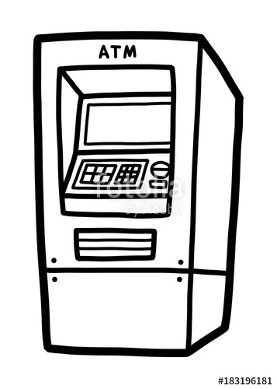
Buttons
Transaction receipt outlet
Card insertion slot
Cash outlet
Keypad
- Primary parts of ATM
An ATM has the following primary parts:
- Touch-enabled screen
- Card insertion slot
- Transaction receipt outlet
- Cash outlet
- Keypad
- Buttons

Touch-Enabled Screen
The touch-enabled screen displays graphical instructions and options. To select an option, the user can tap the option displayed on the screen.

Card Insertion Slot
The card insertion slot allows the user to insert the ATM card provided by the bank.

Transaction Receipt Outlet
The transaction receipt outlet provides a receipt containing all the transaction-related information.

Cash Outlet
The cash outlet provides the cash requested by the user.

Keypad
The keypad contains number keys and various editing keys such as Correction, Cancel, and Enter.

Buttons
To select an option, the user can press the button near the option displayed on the screen.

Operating Procedure

CAUTION!
Risk of fraudulent case!
► Ensure that no suspicious device is attached to the ATM.
► Ensure to cover the keypad with your other hand while entering the 4-digit PIN.

Prerequisites
Keep the ATM card ready.

Steps for Cash Withdrawal
The steps for the cash withdrawal are as follows:
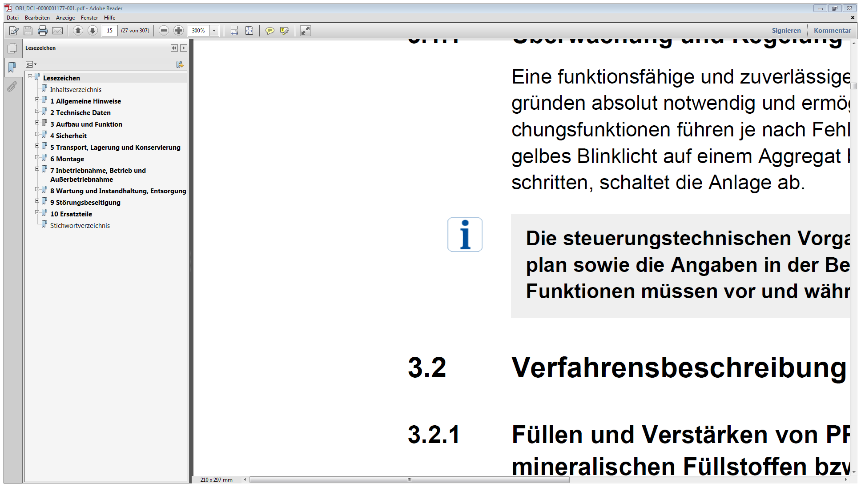 | To select any option, do one of the following as applicable:  - Press the button near the option displayed on the screen.  - Tap the option on the screen.

 | The instructions are audible and visible.

- After the LEDs on the card insertion slot start blinking, insert the card in the card insertion slot, keeping the card number visible to you.
- After the card is inserted, do not remove the card until the transaction is complete.
Step result: The banking menu is displayed.
- Select the Withdraw cash option.
Step result: The dialogue box containing types of account is displayed.
- Select the Savings account option.
- Enter the 4-digit PIN using the keypad and select Enter.
- Enter the withdrawal amount and wait while the transaction is being processed.
- After the cash comes out of the cash outlet, pull the cash gently.
- After the Remove your card message is displayed, remove the card from the card insertion slot.
- If opted, collect the transaction receipt from the transaction-receipt outlet.
Step result: The withdrawal is complete.

