# **Exercise 1 - Used to with documentation**

* Copy this boilerplate code and complete all of these tasks.
* After completing each task check the checkbox.
* This exercise will make you familiar with the documentation.

**Code boilerplate :**

<div>

<h1>Tailwind CSS ❤</h1>

<p>

Tailwind CSS is basically a utility-first CSS framework for

rapidly building custom user interfaces. It is a highly

customizable, low-level CSS framework that gives you all of the

building blocks you need to build bespoke designs.

</p>

</div>

## **Tasks for Heading(h1) :**

* Font size = 1.875rem
* Font weight = Bold(700)

## **Tasks for Paragraph (p):**

* Font weight = Medium(500)
* Font size = 1.125rem
* Line height = 1.5rem
* Text color = gray-800

## **Tasks for Div :**

* Width = 50%
* Margin & Padding = 1.5rem
* Background Color = purple-100
* Border radius = 0.75rem
* Box Shadow = Medium
* Border Top = 2px
* Border color = purple-900

**Output :**

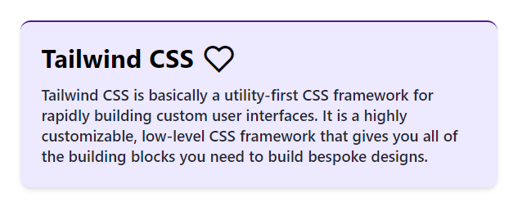

# **Exercise 2 - Advance concepts (Effects, Responsive Design, Dark mode and other concept)**

* Copy this boilerplate code and complete all of these tasks.
* After completing each task check the checkbox.
* This exercise will clear some advanced concepts of Tailwind:)

**Code boilerplate :**

<main class="m-4">

<img src="https://cdn.wallpapersafari.com/21/76/v26KTO.jpg" alt="RDJ"

class="rounded-2xl transition-all duration-200" />

<section>

<p class="font-bold my-3">Robert Downey Jr. is an American actor and producer. His career

has been characterized by critical and popular success in his youth, followed by a period of substance abuse and

legal troubles, before a resurgence of commercial success later in his career.</p>

<button class="bg-black text-yellow-300 py-2 px-4 rounded-md font-bold transition-all duration-300">Visit

Instagram</button>

</section>

</main>

**Tasks for Main (main) :**

* Display Flex for “640px and larger than that”
* Flex-direction to Row for “640px and larger than that”
* Align-items to center for “640px and larger than that”

**Tasks for Image (img) :**

* Width 15rem for “640px and larger than that”
* Height 18rem for “640px and larger than that”
* Apply class scale-110 for “hover effect”

**Tasks for Section (section) :**

* Margin left and right both to 1.25rem(20px) for “640px and larger than that”

**Tasks for Paragraph (p) :**

* Font size to 1.125rem(18px) for “768px and larger than that”
* Font size to 1.5rem(24px) for “1024px and larger than that”
* Change font color to White for “Dark Mode”

**Tasks for Button (button) :**

* Font size to 1.125rem(18px) for “640px and larger than that”
* Font size to 1.5rem(24px) for “1024px and larger than that”
* Change background color to yellow-300 for “Dark Mode”
* Change font color to black for “Dark Mode”
* Change background color yellow-300 on “Hover” only for “640px and larger than that”
* Change font color to black on “Hover” only for “640px and larger than that”

**Output for Small Devices :**

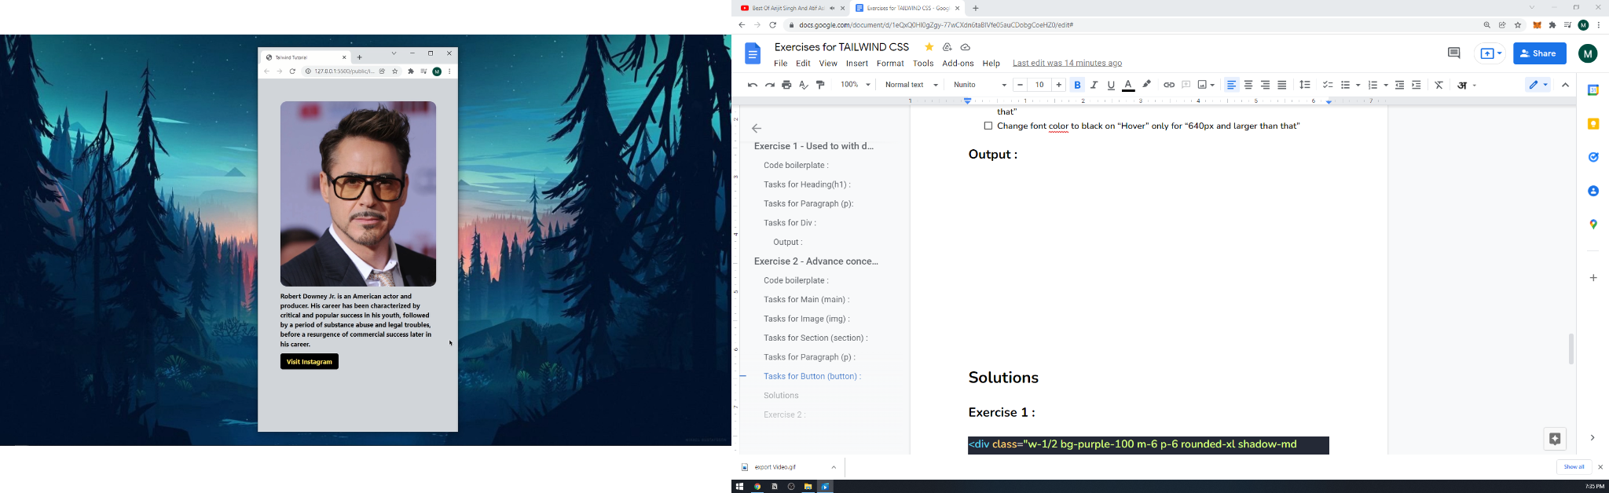

**Output for Large Devices :**

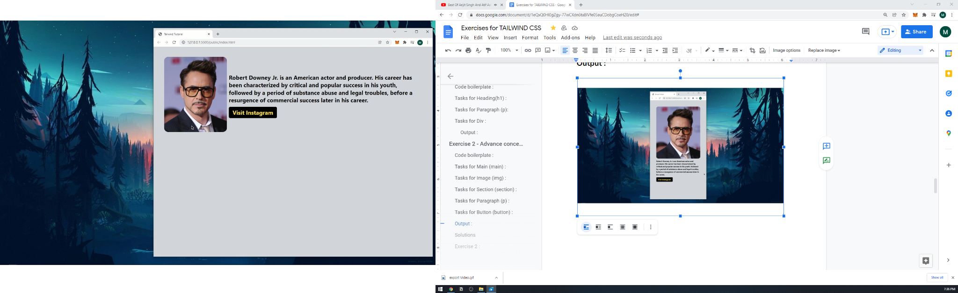

**Solutions**

**Exercise 1 :**

<div class="w-1/2 bg-purple-100 m-6 p-6 rounded-xl shadow-md border-t-2 border-purple-900">

<h1 class="text-3xl font-bold">Tailwind CSS ❤</h1>

<p class="leading-6 font-medium mt-3 text-gray-800 text-lg">

Tailwind CSS is basically a utility-first CSS framework for

rapidly building custom user interfaces. It is a highly

customizable, low-level CSS framework that gives you all of the

building blocks you need to build bespoke designs.

</p>

</div>

**Exercise 2 :**

<main class="m-4 sm:flex sm:flex-row sm:items-center">

<img src="https://cdn.wallpapersafari.com/21/76/v26KTO.jpg" alt="RDJ"

class="rounded-2xl transition-all duration-200 sm:w-60 sm:h-72 hover:scale-110" />

<section class="sm:mx-5">

<p class="font-bold my-3 md:text-lg lg:text-2xl dark:text-white">Robert Downey Jr. is an American actor and

producer. His career

has been characterized by critical and popular success in his youth, followed by a period of substance abuse and

legal troubles, before a resurgence of commercial success later in his career.</p>

<button

class="bg-black text-yellow-300 py-2 px-4 rounded-md font-bold transition-all duration-300 sm:text-lg lg:text-2xl dark:bg-yellow-300 dark:text-black sm:hover:bg-yellow-300 md:hover:text-black">Visit

Instagram</button>

</section>

</main>