What If You Need to Wait for DB to Be Ready?

Option 1:
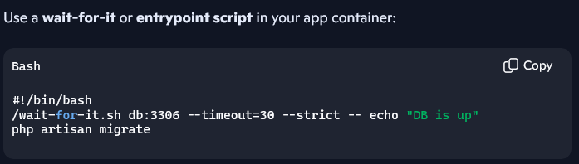

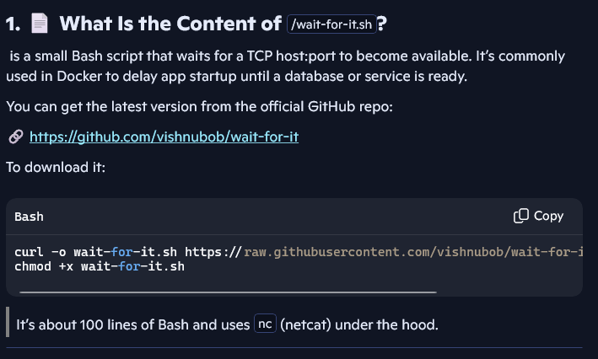

Option 2:
