Two-reaction (couples) summary of findings
18 July 2018

1. General information

Ranges of Vmax looked at (same as one-reaction):
0.5 – 2.0
0.1 – 1.0
0.1 – 10.0

Reactions looked at:
pairs from 'CITRA_SYN', 'GLT', 'LPD', 'ATP_MAINTENANCE', 'GDH', 'ATP_syn', 'ACEA', 'ZWF'

I choose the first eight enzymes from the top of the list of enzymes sorted by effect on citramalate productivity, excluding GROWTH, as described in the one-reaction summary of findings, section 2.

Note that ATP_MAINTENANCE produces jagged regions between 0.1 and 0.3 Vmax. ATP_MAINTENANCE isn’t a reaction that can be controlled by changing enzyme concentration.

2. Results (extended)

Overview

The heatmaps look roughly what I expect from meshing two graphs together. This is unexpected, as I expected that changing the Vmax values of two enzymes at once will create patterns apart from that. Perhaps it has to do with the fact that flux through a pathway cannot be increased by increasing the flux of just one or two enzymes of the pathway (Niederberger et al, 1992).

Whether two enzymes adjacent to each other in the glycolytic pathway exhibit a synergistic effect still looks inconclusive (see appendix 1). Although GPM and ENO seem to exert some synergistic effect, LPD and GDH seem to too, and ACEA and ACEB seem to exert an antagonistic effect (which doesn't make sense). Ultimately there are just too few enzymes that create an appreciable change in the citramalate productivity while Vmax changes to draw any useful conclusions. This can change if I use another metric, such as the concentration of a specific species, or growth, in place of citramalate productivity. Furthermore, the complex branched nature of the network may have confounded things.
The differential evolution genetic algorithm confirms the location of the maximum productivity points. Apart from ATP_MAINTENANCE, the heatmaps look smooth with no surprises, including the enzymes that exhibit inflection points.

ATP_MAINTENANCE

ATP_MAINTENANCE exhibits a strange one-reaction plot in the region of 0.20-0.25 Vmax as shown:

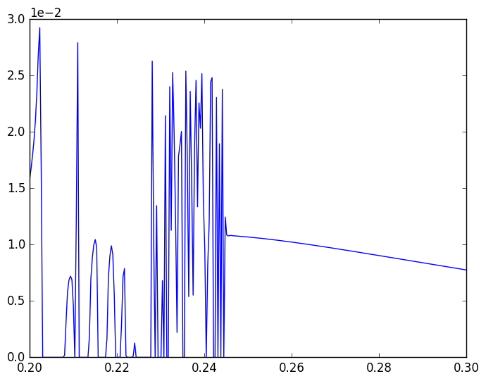
Consequently, all the plots that involve this enzyme show strange behaviour, including unusually high productivities that cluster in small ‘islands’. This is exemplified in these plots:

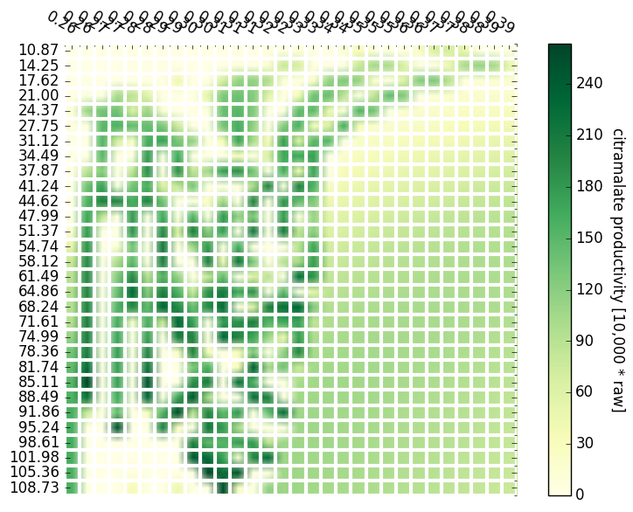
Illustration 1: ATP_MAINTENANCE vs ATP_syn
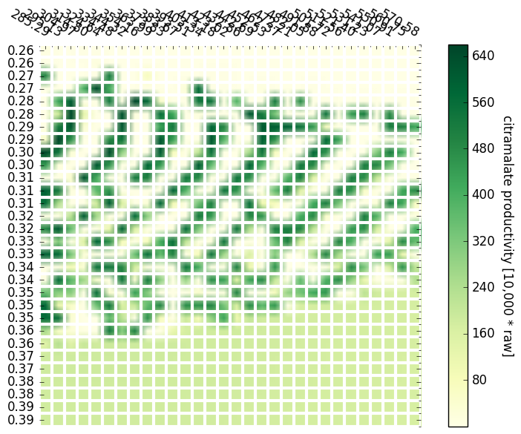
Illustration 2: GLT vs ATP_MAINTENANCE
Naturally, using differential evolution returns strange returns. Jorge suggests that this may be because the model does not account for small values of Vmax for ATP_MAINTENANCE very well. (ATP_MAINTENENCE has a wild-type Vmax of 1.30166, but other enzymes have even lower values)

Steady state checking

Generated heatmaps with steady state checking built in for pairs in ['CITRA_SYN', 'GLT', 'LPD', 'ATP_MAINTENANCE', 'GDH', 'ATP_syn', 'ACEA', 'ZWF'] for Vmax 0.1-10.0. The derivative of the rate of change of concentration of all species was calculated, using RoadRunner’s built-in tools, and the value with the largest absolute value was picked to be compared with an ‘epsilon’ value. If the value exceeds epsilon, it is taken that steady-state is not reached. I used the epsilon values of 1e-6, 1e-7, 1e-8, and 1e-9. Also generated heatmaps for the max concentration rate (value used to check for steady state).
In most cases the species that have the highest concentration rates are: ATP, ADP, P, Hout - these hover around 1e-6 and 1e-8 (the max floating species concentration in the wild type model is 4.72e-5 for reference)
Removing these species reveals:
- BPG for all reactions involving ATP_MAINTENANCE, at around 0.09
- GLCx/GLCp for all reactions involving GDH, at the order of 0.000X
- FDP for CITRA_SYN vs GDH; GLT vs GDH
- SUC for GLT vs LPD
- OAA for ATP_MAINTENANCE vs ATP_syn
- SUCCOA for GDH vs ATP_syn
- G6P for ATP_syn vs ZWF

Looking at the heatmaps for the max concentration rates:
- As expected, ATP_MAINTENANCE reliably screws everything up in its low Vmax ranges, giving rates at the order of 1e-1 while every other data point in the heatmap ranges from 1e-6 to 1e-11
- But so does ATP_syn (order of 1e-2 to 1e-3 generally) in its low Vmax ranges. ATP_MAINTENANCE and ATP_syn are obviously responsible for the ATP derivates listed earlier.
- GDH produces 1e-3 values in its low Vmax ranges - this is the GLCx/GLCp
- Apart from that, no obvious patterns

Appendix 1

Testing the DE algorithm on couples
2018-07-12
Chose GLT and ATP_MAINTENANCE because the 0.1-1.0 and the 0.1-10.0 heatmaps
suggest different maxima in their areas.

Parameters used: Mut = 0.8, CR = 0.3, N = 20, generations = 20
(following Storn's 'rules of thumb' for the DE algorithm)

These are results of four runs using these parameters:
wild type productivity = 0.00112225918623
(displayed as 11.2 in heatmaps)

1.
[5.52188954e+02 3.02267809e-01]
Fitness: -0.051718725334093704

2.
[255.18826593 0.35968837]
Fitness: -0.05394868382389423

3.
[4.03415023e+02 3.82242003e-01]
Fitness: -0.017993766434961637

4.
[5.54944322e+02 3.02494502e-01]
Fitness: -0.05116415677700649

5.
[5.37607693e+02 2.85223583e-01]
Fitness: -0.04989046000808085

Here I increase the number of generations to 40.
The algorithms locks itself to a different minimum, and there is less variation
in the Vmax values found, but the variation is still quite substantial.

1.
[3.41204982e+02 2.76319798e-01]
Fitness: -0.0674142114076012

2.
[2.84664180e+02 2.70553859e-01]
Fitness: -0.06991276303001635

3.
[2.93569427e+02 2.81904952e-01]
Fitness: -0.06788739734211077

Compare this with higher-resolution heatmaps of GLT and ATP_MAINTENANCE.

Did same thing with GLT-ACEA (40 generations)

1.
[3.25581574e+02 1.52595000e-01]
Fitness: -0.016267897243601503

2.
[3.25609705e+02 1.52595000e-01]
Fitness: -0.016267894779482494

3.
[3.2558171e+02 1.5259500e-01]
Fitness: -0.016267896963297758

ATP_MAINTENANCE and ATP_syn (because of its interesting graph) - 40 generations

1.
[3.93455867e-01 1.08733000e+03]
Fitness: -0.016976885324356972

2.
[ 0.34469146 24.55672389]
Fitness: -0.014976564972861614

3.
[4.02351990e-01 6.13073791e+02]
Fitness: -0.0134822838594439

It's probably safe to say at this point that using DE with pairs that contain
ATP_MAINTENANCE creates a lot of variation because of the behaviour of the
ATP_MAINTENANCE function. DE works well with other enzymes.

