|  |
| --- |
| Rutgers university |
| Problem Set 5 |
| Econ 510 |
|  |
| **Arinze Nwoye** |
| **10/26/2015** |

|  |
| --- |
|  |

1a) The data uses UK GDP series from 1977 quarter 1 till 2015 quarter 1. We estimate a two state, AR(4) model for the GDP growth process allowing the AR coefficients to vary across regimes. The table of transition probabilities from the estimation is as follows:

|  |  |  |
| --- | --- | --- |
|  | **Regime 1** | **Regime 2** |
| **Regime 1** | 0.8898512 | 0.4105902 |
| **Regime 2** | 0.1101488 | 0.5894098 |

1b) Below is a plot of the filtered and smooth probabilities. Regime 1 is the expansionary regime and Regime 2 is the recession regime.

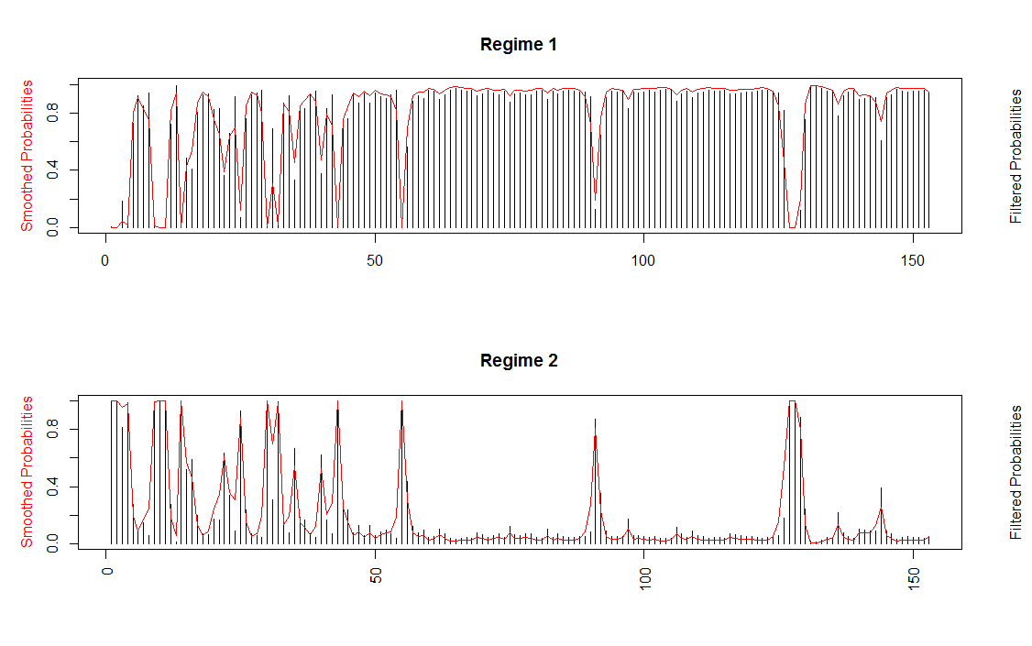

1c) The left table below is UK Quarterly Recession Dates derived from the model and assuming a smoothed probability of 50% or more is a recession. The right table is US Monthly Recession dates as gotten from NBER. Comparing the recessions of the US and the UK using the tables below, both the US and the UK had a recession in the third quarter of 1982. Both countries also had recessions in the third and fourth quarters of 2008 and the first quarter of 2009.



1d) I also compare the quarters that the UK and the US are in recession using the alternative rule that a UK recession is two consecutive quarters of negative growth. The table below shows all the dates where the UK experienced negative growth. A look through the table for consecutive dates (quarters) will reveal consecutive quarters of negative growth.

I compare the table below with the right table above of US recession. Both countries experience a recession in the first two quarters of 1980. The US and the UK also experience a recession in the third and fourth quarters of 1990 and the first quarter of 1991. Finally, both countries also experience recessions in the second, third and fourth quarters of 2008. Also in the first and second quarters of 2009.



2a) The graph of the series below is the expected values of the growth rate constructed using the filtered probabilities and the conditional means of the two regimes.

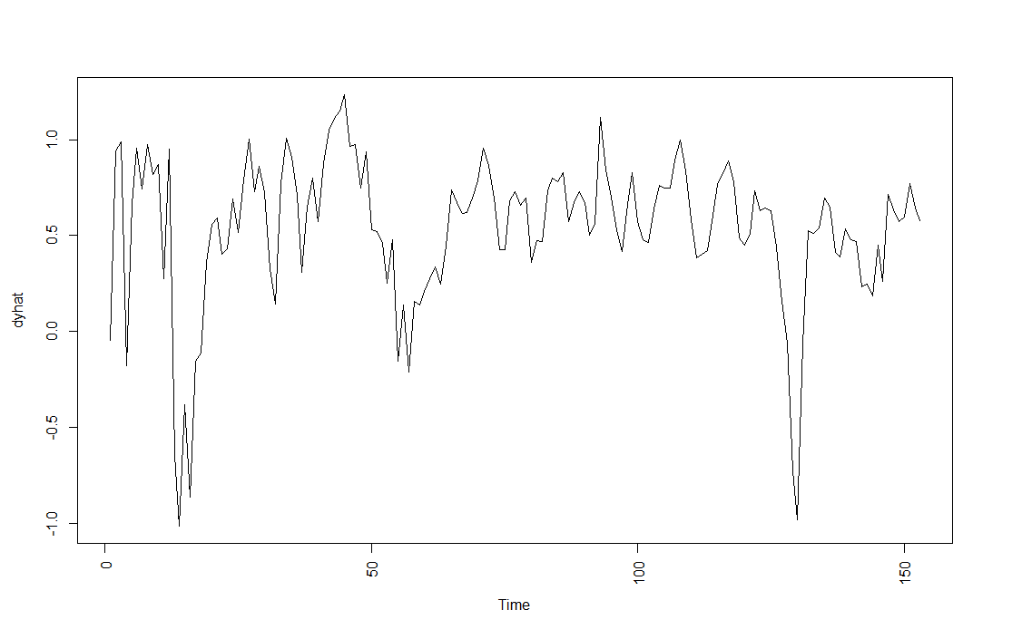

2b) I construct the residuals from the difference between UK GDP Growth (yt) and the fitted linear model UK GDP Growth from the model (yhat). A test for neglected nonlinearity is constructed using the BDS test using maximum embedding dimension of 4. The results are printed below:

BDS Test

data: res

Embedding dimension = 2 3 4

Epsilon for close points = 0.3261 0.6522 0.9784 1.3045

Standard Normal =

[ 0.3261 ] [ 0.6522 ] [ 0.9784 ] [ 1.3045 ]

[ 2 ] -0.0194 0.7921 2.9173 3.9279

[ 3 ] 0.8162 1.8113 3.9887 4.9578

[ 4 ] 1.1886 2.3835 4.5159 5.1366

p-value =

[ 0.3261 ] [ 0.6522 ] [ 0.9784 ] [ 1.3045 ]

[ 2 ] 0.9846 0.4283 0.0035 1e-04

[ 3 ] 0.4144 0.0701 0.0001 0e+00

[ 4 ] 0.2346 0.0172 0.0000 0e+00

The null hypothesis of the BDS test is that the data is iid and based on the P-values for the different combinations of m-dimensions and epsilon (standard deviations) we cannot reject the null hypothesis within 2 standard deviations (epsilon = 0.3261 and 0.6522) regardless of the dimension suggesting that there is no neglected nonlinearity in the series. However for epsilon=0.9784 and 1.3045, we reject the null hypothesis regardless of the dimension. The result is somewhat confusing. However, it might be due to seasonality in the data.

2c) A Voltera polynomial approximation to UK GDP Growth was estimated

2d) The residuals of the model of the Voltera polynomial approximation of UK GDP Growth was tested for neglected nonlinearity using the BDS test.

BDS Test

data: res2

Embedding dimension = 2 3 4

Epsilon for close points = 0.3488 0.6977 1.0465 1.3953

Standard Normal =

[ 0.3488 ] [ 0.6977 ] [ 1.0465 ] [ 1.3953 ]

[ 2 ] 3.4644 3.7023 3.8304 3.2372

[ 3 ] 2.6770 4.0465 4.3072 4.3272

[ 4 ] 2.7175 4.8310 4.7604 4.6222

p-value =

[ 0.3488 ] [ 0.6977 ] [ 1.0465 ] [ 1.3953 ]

[ 2 ] 0.0005 2e-04 1e-04 0.0012

[ 3 ] 0.0074 1e-04 0e+00 0.0000

[ 4 ] 0.0066 0e+00 0e+00 0.0000

The results of the BDS test show that you can reject the null hypothesis at almost all combinations of m and epsilon. This suggests neglected nonlinearity in the model.