Machine Learning Algorithms
  - A Visual Framework
Uchenna Arinze
October 19, 2026
Professional Portfolio Artifact

Introduction
Machine learning offers several ways to learn patterns, make predictions, and support decisions. This portfolio artifact explains ten algorithms in an accessible visual framework and connects their mechanisms to practical applications. The main lesson is that algorithm selection depends on the task, available data, and desired outcome.

Description
The artifact contains a color-coded infographic, ten algorithm profiles, and comparisons of related methods. Each profile identifies the learning type, relevant application domains, an example use case, and a brief explanation. The framework covers seven supervised algorithms, two unsupervised algorithms, and Q-learning as a separate reinforcement learning method.

Objective
My objective is to distinguish common machine learning methods and explain when they may be useful. This artifact demonstrates my ability to classify algorithms, compare their purposes, and communicate technical concepts clearly to readers with different levels of experience.
The intended learning outcomes are to distinguish classification from regression, separate clustering from dimensionality reduction, recognize reinforcement learning, and connect algorithms to tabular data, computer vision, and natural language processing. It also clarifies why these methods are not standard modern generative AI models.

Scope
This is a conceptual comparison. No datasets were analyzed and no models were trained or evaluated. The examples illustrate potential uses rather than results from completed implementations.

Process
- Selected ten algorithms spanning supervised, unsupervised, and reinforcement learning.
- Classified each algorithm by learning approach and task, then documented its mechanism, domains, and a practical example.
- Compared related methods, including linear and logistic regression, decision trees and random forests, and k-means and PCA.
- Organized the infographic into color-coded sections with consistent labels and illustrations. Added detailed profiles to support readers who need more explanation.
- Reviewed terminology and layout, consulted the references listed at the end, and considered possible applications in electrical engineering.

Tools and Technologies Used
ChatGPT supported content drafting, organization, development. OpenAI image generation produced the infographic. Python and python-docx assembled the Word document, and document rendering supported visual layout checks. Official scikit-learn documentation provided supporting reference material; the scikit-learn software was not used to train models in this assignment.

Value Proposition

Unique Value
This artifact pairs a visual overview with readable algorithm profiles, allowing readers to move from a quick comparison to a more detailed explanation. Its connection to electricity-demand forecasting, equipment-failure prediction, and operating-condition analysis makes the concepts relevant to my electrical engineering background.

Relevance
The framework can serve as an introductory study aid and a starting point for discussions about selecting analytical methods. For my professional development, it demonstrates technical communication and foundational machine learning knowledge. Actual selection would still require data assessment, validation, and consideration of accuracy, interpretability, and operational constraints.

Visual Guide
Blue denotes supervised learning, teal denotes unsupervised learning, and purple denotes reinforcement learning. Classification predicts categories; regression predicts numbers. The categories are distinct learning approaches, not stages in a progression.

Visual Framework
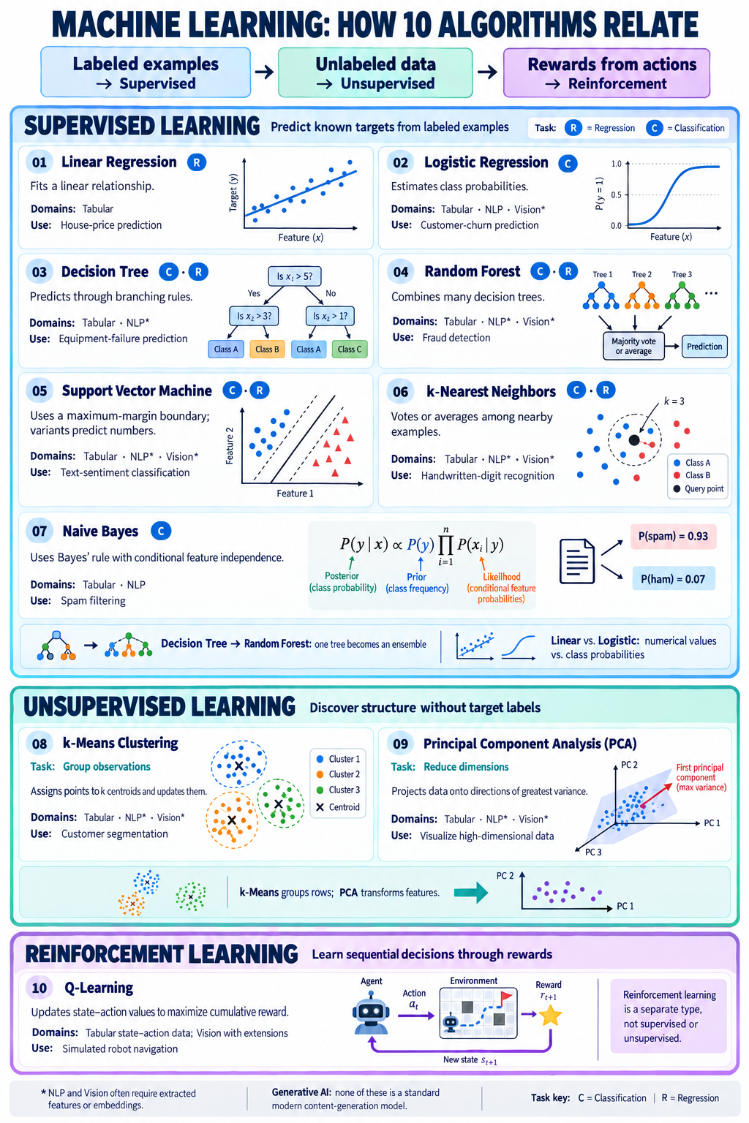
Figure 1. Ten algorithms grouped by learning approach. The arrows across the top indicate reading order, not progression between learning types.

Algorithm Profiles

1 Linear Regression
Type: Supervised | Regression
Domains: Tabular Data
Example: Predicting house prices or electricity demand.
How it works: Fits a linear relationship between input features and a continuous outcome by minimizing prediction error.

2 Logistic Regression
Type: Supervised | Classification
Domains: Tabular Data, NLP, Computer Vision
Example: Predicting customer churn or detecting spam.
How it works: Converts a weighted combination of features into class probabilities; it is a classification method despite its name.

3 Decision Tree
Type: Supervised | Classification and Regression
Domains: Tabular Data, NLP
Example: Predicting equipment failure or classifying customer complaints.
How it works: Repeatedly splits data using feature-based rules. Leaf nodes provide class predictions or numerical estimates.

4 Random Forest
Type: Supervised | Classification and Regression
Domains: Tabular Data, Computer Vision, NLP
Example: Detecting fraud or classifying land cover from satellite-image features.
How it works: Trains many trees using varied samples and feature subsets, then combines predictions through voting or averaging.

5 Support Vector Machine
Type: Supervised | Classification and Regression variants
Domains: Tabular Data, Computer Vision, NLP
Example: Recognizing handwritten digits or classifying text sentiment.
How it works: For classification, finds a boundary with a wide margin between classes. Kernels support nonlinear boundaries; regression variants estimate numerical values.

Algorithm Profiles Continued

6 k-Nearest Neighbors
Type: Supervised | Classification and Regression
Domains: Tabular Data, Computer Vision, NLP
Example: Recognizing handwritten digits or categorizing documents using embeddings.
How it works: Finds the k closest training examples, then uses majority voting for classification or averaging for regression.

7 Naive Bayes
Type: Supervised | Classification
Domains: Tabular Data, NLP
Example: Filtering spam or categorizing news articles.
How it works: Uses Bayes’ rule to estimate class probabilities, assuming features are conditionally independent given the class.

8 k-Means Clustering
Type: Unsupervised | Clustering
Domains: Tabular Data, Computer Vision, NLP
Example: Segmenting customers or reducing image colors.
How it works: Assigns observations to the nearest of k centroids and updates those centroids to reduce within-cluster squared distances.

9 Principal Component Analysis
Type: Unsupervised | Dimensionality Reduction
Domains: Tabular Data, Computer Vision, NLP
Example: Visualizing high-dimensional datasets or reducing image-feature dimensions.
How it works: Transforms features into orthogonal components ordered by captured variance. Keeping fewer components reduces dimensionality; feature scaling can affect the result.

10 Q-Learning
Type: Reinforcement Learning | Sequential Decisions
Domains: Tabular state–action data; Computer Vision with extensions
Example: Learning routes for an agent in a simulated warehouse.
How it works: Updates state–action values using observed rewards and estimates of future rewards to learn a policy that seeks high cumulative reward.

Application Domain Notes
Computer Vision and NLP applications often use extracted features or embeddings. None of the ten methods, as presented here, is a standard modern generative AI model. Naive Bayes is a generative classifier in the statistical sense, but it is typically used for classification rather than content generation.

References
scikit-learn developers. (n.d.). Supervised learning. scikit-learn documentation. Retrieved October 19, 2026, from https://scikit-learn.org/stable/supervised_learning.html
scikit-learn developers. (n.d.). Unsupervised learning. scikit-learn documentation. Retrieved October 19, 2026, from https://scikit-learn.org/stable/unsupervised_learning.html
Sutton, R. S., & Barto, A. G. (2018). Reinforcement learning: An introduction (2nd ed.). MIT Press. Chapter 6 discusses temporal-difference learning, including Q-learning.
Reference mapping: The scikit-learn guides support the supervised and unsupervised algorithm groupings. Sutton and Barto provide background for reinforcement learning and Q-learning. Application examples in this artifact are illustrative rather than cited case studies.

AI Assistance Disclosure
OpenAI ChatGPT assisted with drafting and organization, and OpenAI image generation produced the infographic. The author should review the content before submission.

