# ERV-5086 Assignment 1

# Calculus Review

## Slope

Run

Rise

x1

x2

y2

y1

Slope is defined as the rise over the run: *Slope = rise/run*. The rise is the change in the *y* value and the run is the change in the x value.

*Slope = rise/run = y/x = (y2 – y1)/(x2 – x1)*

Note that the result is the same if the subscripts identifying the points are reversed; for this case, numerator and denominator will both be negative and the negatives cancel. It is critical that the ordered pairs are kept separate however.

It also does not matter what quadrant the points lie in; the signs work out correctly.

The slope is closely related to the concept of a derivative in Calculus. In the simplest terms, the derivative is the slope at a point on a curve, which is the same as the slope of the tangent to the curve. Standard Leibniz notation for the derivative is based on *y/x*; the derivative is written *dy/dx*.

## Exponent Definition

*x0 = 1*

## Derivative of a Line

Recall the equation for a straight line: *y = ax + b*. The slope is *a* and the *y* axis intercept is *b*.

The derivative of a polynomial function of the form *y = axn + bxp* + … with respect to *x* is

*dy/dx = a n x(n-1)* + *b p x(p-1)* + ….

More terms can easily be added as necessary and the derivative of each term is simply added to the overall derivative.

If we recast the equation for the straight line (*y = ax + b*) in the form of a polynomial, we have

*y = ax1 + bx0*

Note that the second term [the constant *bx0*] has a derivative *0bx-1 = 0*, and it drops out of the overall derivative. The same is true for any constant.

For the straight line, *n = 1* so the derivative of the remaining term is

*dy/dx = a 1 x(0)*, or because *x0 = 1*,

*dy/dx = a*.

## Derivative of a Polynomial

In differential Calculus, we consider the slopes of curves rather than straight lines.

For a general polynomial *y = axn + bxp + cxq + …*, the derivative with respect to x is

*dy/dx = a n x(n-1) + b p x (p-1) + c q x (q-1) + …*

Here is an example with the following coefficients and exponents:

|  |  |
| --- | --- |
| a | 3 |
| n | 3 |
| b | 5 |
| p | 2 |
| c | 5 |
| q | 0 |



Note that the slope of this function, instead of being a constant, is itself a function of x. In this case, for *x* less than 0 the slope is negative and, for *x* > 0, the slope is positive. The sign and magnitude of the slope are given by the derivative.



## Derivative of Sine and Cosine

You will also need to know the derivative of the sine and cosine functions for this class. First, always remember that *sin(0) = 0* and that the period of both the sine and cosine functions is 2 radians. Now look at the sine function and notice that its initial slope is positive and that it becomes negative at /2. This is exactly the behavior of the cosine and in fact *d(sin(x))/dx = cos(x)*. You can also see that the initial slope of the cosine is negative so you can figure out that *d(cos(x))/dx = -sin(x)*.



## Numerical Derivatives

Numerical approximations of derivatives can be made by taking the slope between points and can serve as a useful check on the analytical derivative. Very often, there is no analytical derivative and all computations must rely on numerical derivatives. There are obvious limitations to this approach. Grid spacing and position of the computed derivative need to be considered.

## Partial Derivatives

What if the variable of interest – say water table elevation – is a function of both *x* and *y*? In this case we use the concept of a partial derivative.

Here is a plot of the function *h(x,y) = x4 + y3 + xy*. To compute the partial derivative of *h* with respect to *x* at a *y* location *y0* (indicated by the notation *∂h/∂x|y=y0*), we simply treat any terms containing *y* only as constants. If these constants stand alone (like *b* in the computation of the derivative of the straight line) they drop out of the result. If they are in multiplicative terms involving *x*, they are retained as constants. Thus ∂h/∂x|y=y0 = 4x3 + y0.



So what use are these partial derivatives?

One simple and important application is for the computation of gradients. The gradient function of *h(x,y)* can be written as

$∇h$ or **Grad** *h* or (‘**del**’)*h* (bold means vector)

|  |  |  |
| --- | --- | --- |
|  | $$∇h=i\frac{∂h}{∂x}+j\frac{∂h}{∂y}$$ | **( 1 )** |

**i** and **j** are the unit vectors in the *x* and *y* directions; that is they point in the positive x and y directions respectively and have length 1. The vector sum of these vectors multiplied by their respective partial derivatives gives the gradient vector.

# Implementation in Python

Next, we’ll demonstrate the computation of numerical partial derivatives using Python. Let’s use a realistic ground water potential surface (i.e., a solution of the Laplace equation that we will derive later).

Begin by importing the following packages:

import numpy as np

import matplotlib.pyplot as plt

Next load the csv file you created in Excel:

h=np.loadtxt('/content/x4_y3_xy.csv', delimiter=','))

In Excell, you probably need to save as the ‘plain’ csv option (not UTF-8, DOS, or Mac). The address of your file may be different. In Colab, you can upload it to session storage and then copy the path (among other options).

Then create a grid of x and y coordinates:

x_vec = np.arange(-1,1.1,0.1)

y_vec = np.arange(-1,1.1,0.1)

X,Y = np.meshgrid(x_vec,y_vec)

## Surface Plot

Now you can plot the surface (better than in Excel, because the coordinates are real):

# Plot the surface.

fig = plt.figure(figsize=[4,4], dpi=300)

ax = plt.axes(projection='3d')

surf = ax.plot_surface(X,Y,h)

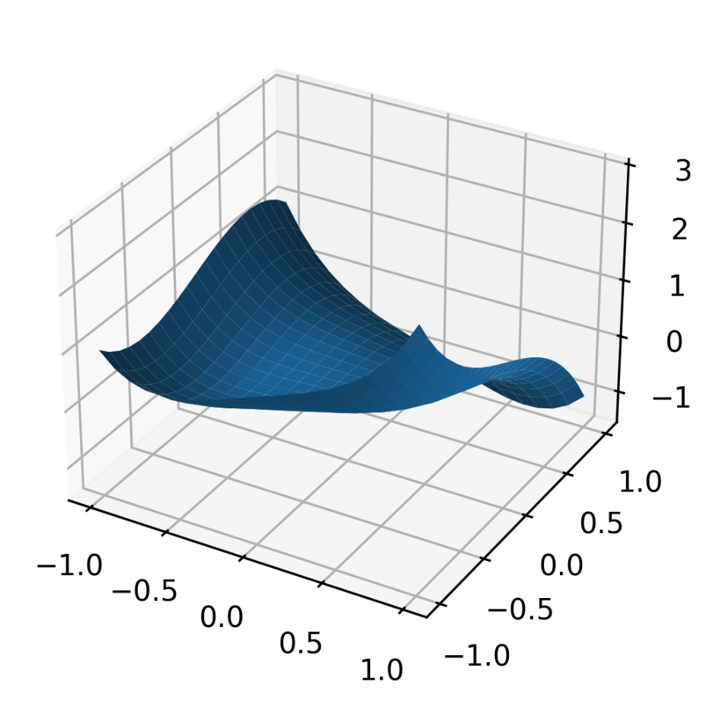

## Contour Map

Now plot the surface as a contour map:

plt.contourf(X,Y,h)

plt.colorbar()

plt.axis('equal')

plt.show()

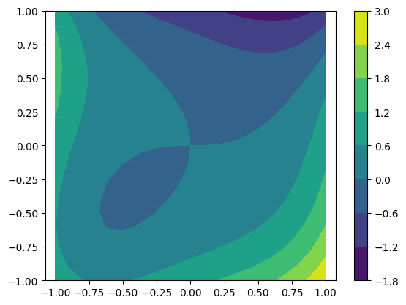

## Gradient/Partial derivatives

In Python, the gradient terms — the estimated partial derivatives $\frac{∂h}{∂x} and \frac{∂h}{∂y}$— can be computed using the following code:

[dhdy,dhdx]=np.gradient(h, x_vec, y_vec)

We can use the partial derivatives to plot flow vectors and streamlines.

## Flow vectors

A Quiver (vector) plot can be generated using code like

plt.contourf(X,Y,h)

plt.colorbar()

plt.axis('equal')

plt.quiver(X, Y, -dhdx, -dhdy)

plt.show()

The vectors have to be perpendicular to the contours! We use a minus sign in front of the partial derivatives because we want the flow to go downgradient from high to low head.

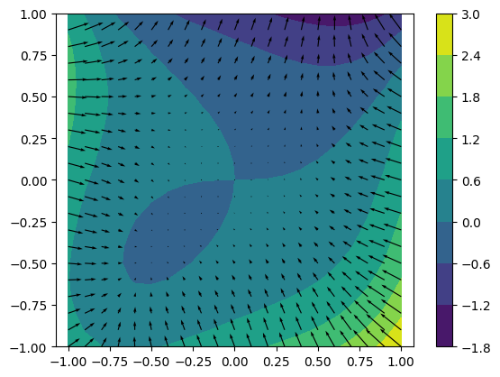

The length and direction of the arrows indicate the strength and direction of the gradient. Partial derivatives play a key role in ground water flow and many other models.

## Streamlines

Another useful way to look at such a field is known as ‘streamlines’, which trace the trajectory of a particle released at a given point in the domain. Python provides algorithms that make the necessary calculations and display the graphics.

plt.contourf(X,Y,h)

plt.colorbar()

plt.streamplot(X,Y,-dhdx,-dhdy)

plt.axis(‘equal’)

plt.show()

## Assignment

1. Plot the polynomial defined by the table below between x = -1 and x =1. Plot its analytical derivative as a solid line and its numerical derivative as open symbols. Discuss your observations and the limitations of the numerical derivative.

|  |  |
| --- | --- |
| a | 1 |
| n | 1 |
| b | 1 |
| p | 2 |
| c | 1 |
| q | 3 |

1. Solve the 2-D Laplace Equation [Eqn. (2)] using the numerical method described in class. Include one or more internal “boundary values”, to represent, for example, fixed high or low heads or temperatures. A dipole problem with one high (>0) value and one low (<0) value can be interesting. Tri-pole problems with say 1 high value and 2 different low values are even more interesting. Save the result as a csv file.

|  |  |  |
| --- | --- | --- |
|  | $$\frac{∂^{2}h}{∂x^{2}}+\frac{∂^{2}h}{∂y^{2}}=0$$ | **( 2 )** |
|  |  |  |

1. Read the csv file into Python. Plot and label contours of the solution and plot vector arrows indicating the strength and direction of the negative gradient using Python. Mark any ‘stagnation points’.
2. Instead of arrows as in Question 3, plot streamlines using Python.