Tugas 7

Hasil

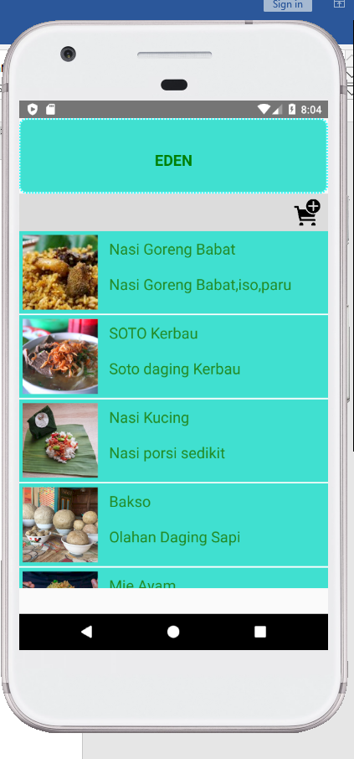ADD

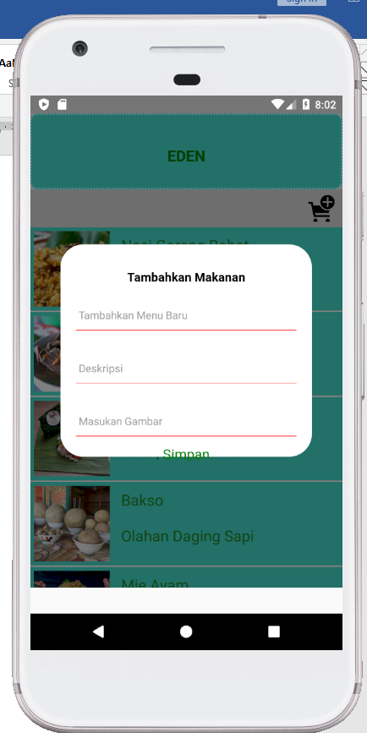

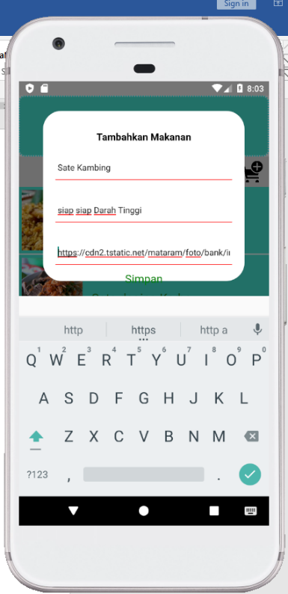

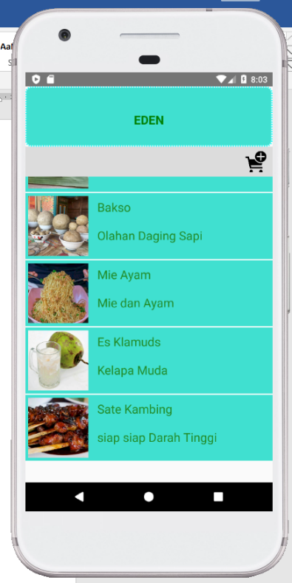

Hapus

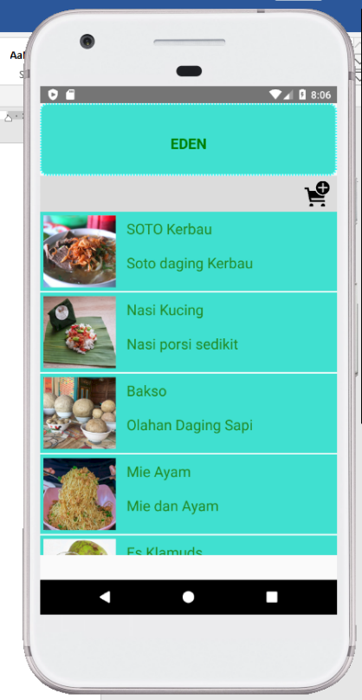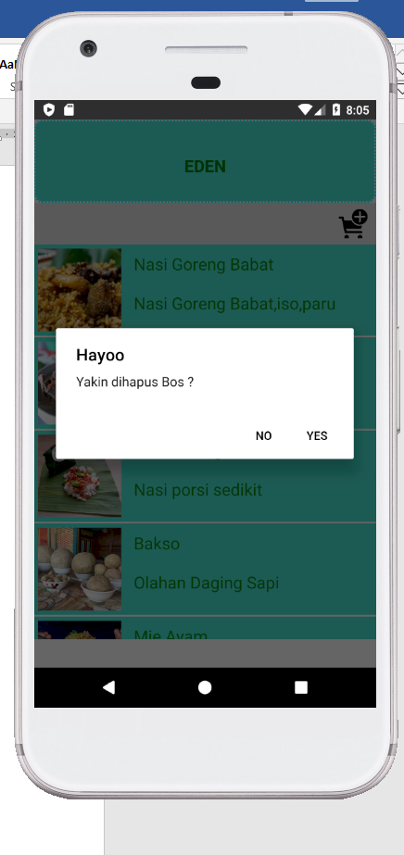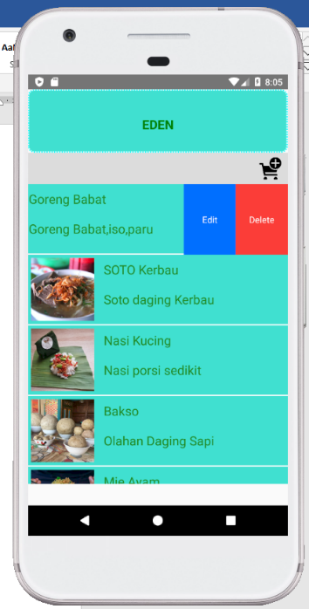

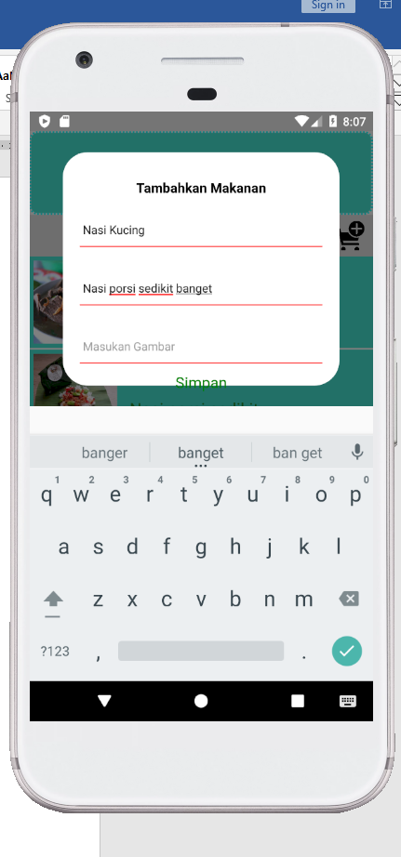EDIT

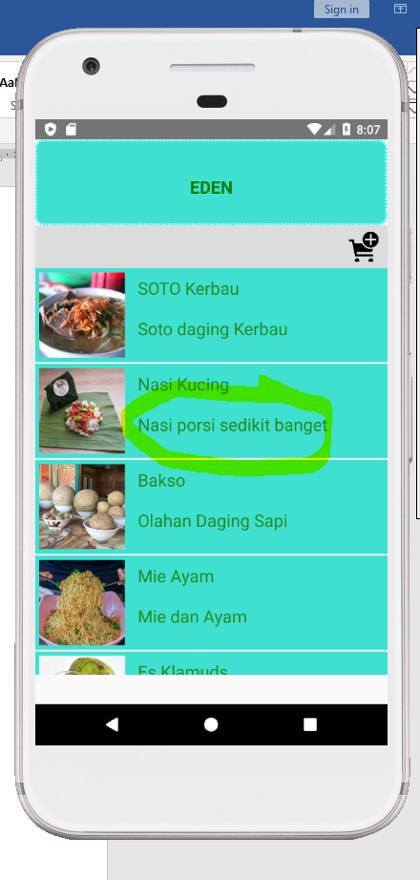

CODE .

BasicFlatListData

import React, {Component} from 'react' ;

import{AppRegistry,FlatList,StyleSheet,Text,View,Image,Alert,Platform,TouchableHighlight} from 'react-native';

import flatlistData from '../data/flatlistData';

import Header from '../components/header';

import Swipeout from 'react-native-swipeout';

import AddModal from '../components/AddModal';

import EditModal from '../components/EditModal';

class FlatListItem extends Component{

    constructor(props) {

        super(props);

        this.state = {

            activeRowkey: null

        };

    }

    render(){

        const swipeSettings = {

            autoClose: true,

            onClose: (secId, rowId , direction) =>{

                if (this.state.activeRowkey != null) {

                this.setState({activeRowkey:null});

                }

            },

            onOpen: (secId, rowId , direction) => {

                this.setState({activeRowkey: this.props.item.key});

            },

            right: [

                {

                    onPress: () => {

                        alert('update');

                        this.props.parentFlatList.refs.editModal.showEditModal(flatlistData[this.props.index],this);

                    },

                    text: 'Edit', type: 'primary'

                },

                {

                    onPress: () => {

                        const deletingRow = this.state.activeRowkey;

                        Alert.alert(

                            'Hayoo',

                            'Yakin dihapus Bos ?',

                            [

                                {text:'No', onPress: () => console.log('Cancel Procesd'), style: 'cancel'},

                                {text:'Yes', onPress:() =>{

                                    flatlistData.splice(this.props.index, 1);

                                    this.props.parentFlatList.refreshFlatList(deletingRow);

                                }},

                            ],

                            {cancelable:true}

                        )

                    },

                    text: 'Delete', type:'delete'

                }

            ],

            rowId: this.props.index,

            sectionId: 1

        };

        return (

            <Swipeout {...swipeSettings}>

 <View style={{

                flex:1,

                flexDirection:'column',

            }}>

            <View style={{

                flex:1,

                backgroundColor:'turquoise',

                flexDirection:'row',

            }}>

<Image

source={{uri:this.props.item.imageUrl}}

style={{width:100,height:100,margin:5}}

></Image>

<View style={{

flex:1,

flexDirection: 'column',

height:100

}}>

                <Text style={styles.FlatListItem}>{this.props.item.name}</Text>

                <Text style={styles.FlatListItem}>{this.props.item.description}</Text>

            </View>

            </View>

            <View

            style={{

                height:2,

                backgroundColor: 'white'

            }}

            >

            </View>

            </View>

            </Swipeout>

        )

    }

}

const styles = StyleSheet.create({

    FlatListItem:{

        color:'#228B22',

        padding:10,

        fontSize:20,

    },

})

export default class BasicFlatListData extends Component {

    constructor(props) {

        super(props);

        this.state = ({

            deletedRowKey:null,

        });

        this._onPressAdd = this._onPressAdd.bind(this);

    }

    refreshFlatList = (activeKey) => {

        this.setState((prevState) => {

            return {

                deletedRowKey: activeKey

            };

        });

        this.refs.flatList.scrollToEnd();

    }

    _onPressAdd () {

        //alert("Berhasil Ditambah");

        this.refs.addModal.showAddModal();

    }

    render() {

        return (

            <View style={{flex:1, marginBottom: Platform.OS === 'android' ? 34 : 0}}>

                <Header/>

                <View

                style={{

                    backgroundColor:'gainsboro',

                    height: 50,

                    flexDirection: 'row',

                    justifyContent: 'flex-end',

                    alignItems: 'center',

                }}>

                    <TouchableHighlight

                    style={{marginRight: 10}}

                    underLayColor='silver'

                    onPress={this._onPressAdd}

                    >

                        <Image

                        style={{width: 35, height: 35}}

                        source={require('../icons/addcart.png')}

                        />

                    </TouchableHighlight>

                </View>

                <FlatList

                ref={"flatList"}

                data={flatlistData}

                renderItem={({item ,index}) => {

                    return(

                        <FlatListItem item={item} index={index} parentFlatList={this}>

                        </FlatListItem>

                 );

                }}

                >

                </FlatList>

                <AddModal ref={'addModal'} parentFlatList={this}>

                </AddModal>

                <EditModal ref={'editModal'} parentFlatList={this}>

                </EditModal>

                </View>

        );

    }

}

flatlistData

var flatlistData = [

    {

    "key" : "bima2no45",

    "name": "Nasi Goreng Babat",

    "imageUrl":"https://encrypted-tbn0.gstatic.com/images?q=tbn%3AANd9GcRkQx2OQQnuc5nThvSWDSz31TV-OQ8aXp1byw&usqp=CAU",

    "description": "Nasi Goreng Babat,iso,paru",

    },

    {

        "key" : "bima2no46",

        "name": "SOTO Kerbau",

        "imageUrl":"https://www.inibaru.id/nuploads/1/umum/resep-soto-kerbau-khas-kudus-asli-2.jpg",

        "description": "Soto daging Kerbau",

        },

        {

            "key" : "bima2no47",

            "name": "Nasi Kucing",

            "imageUrl":"https://cdn.idntimes.com/content-images/community/2019/12/155271332658394-14750db9-77f5-4ba3-a5bd-1f6690b67e3a-71e3846eed74138dcdeb9cb5c08ff736_600x400.png",

            "description": "Nasi porsi sedikit",

            },

            {

                "key" : "bima2no48",

                "name": "Bakso",

                "imageUrl":"https://awsimages.detik.net.id/community/media/visual/2019/07/11/f3908d0b-fcc8-4d09-83bb-3ee1d0833c4e.jpeg?w=700&q=90",

                "description": "Olahan Daging Sapi",

                },

                {

                    "key" : "bima2no49",

                    "name": "Mie Ayam",

                    "imageUrl":"https://d1sag4ddilekf6.cloudfront.net/item/IDGFSTI00002gr91543666993915121623/photos/cfe96ea37ade4b129799122dda1ab6ed_1583055877034297374.jpg",

                    "description": "Mie dan Ayam",

                    },

                    {

                        "key" : "bima2no50",

                        "name": "Es Klamuds",

                        "imageUrl":"https://www.tokomesin.com/wp-content/uploads/2015/03/es-kelapa-muda-tokomesin.jpg",

                        "description": "Kelapa Muda",

                        },

];

module.exports = flatlistData;

EditModal

import React, {Component} from 'react' ;

import{AppRegistry,FlatList,StyleSheet,Text,TextInput,View,Image,Alert,Platform,TouchableHighlight, Dimensions} from 'react-native';

import Modal from 'react-native-modalbox';

import Button from 'react-native-button';

import flatListData, { keys } from '../data/flatlistData';

var screen = Dimensions.get('window');

export default class EditModal extends Component{

    constructor(props) {

        super(props);

        this.state={

            foodName:'',

            foodDescription:'',

            foodImage:"",

        };

    }

    showEditModal=(editingFood,flatListItem) => {

        console.log('editingFood = ${JSON.stringify(editingFood)}');

        this.setState({

            key: editingFood.key,

            foodName: editingFood.name,

            foodDescription: editingFood.description,

            foodImage: editingFood.image,

            flatListItem: flatListItem

        });

        this.refs.myModal.open();

    }

    generatekey = (numberOfCharacters) => {

        return require('random-string') ({length: numberOfCharacters});

    }

    render(){

        return (

            <Modal

            ref={"myModal"}

            style={{

                justifyContent: 'center',

                borderRadius: Platform.OS === 'android' ? 30: 0,

                shadowRadius:10,

                width: screen.width - 80,

                height:280

            }}

            position='center'

            backdrop={true}

            onClosed={() => {

                //alert("Modal ditutup");

            }}

            >

            <Text

            style={{

                fontSize:16,

                fontWeight:'bold',

                textAlign:'center',

                marginTop:40,

            }}

            >Tambahkan Makanan</Text>

            <TextInput

            style={{

                height:40,

                borderBottomColor:'red',

                marginBottom:10,

                marginRight:20,

                marginLeft:20,

                marginTop:20,

                borderBottomWidth:1

            }}

            onChangeText={(text) => this.setState({foodName: text})}

            placeholder="Tambahkan Menu Baru"

            value={this.state.foodName}

            />

            <TextInput

            style={{

                height:40,

                borderBottomColor:'red',

                marginBottom:10,

                marginRight:20,

                marginLeft:20,

                marginTop:20,

                borderBottomWidth:1

            }}

            onChangeText={(text) => this.setState({foodDescription: text})}

            placeholder="Deskripsi"

            value={this.state.foodDescription}

            />

            <TextInput

            style={{

                height:40,

                borderBottomColor:'red',

                marginBottom:10,

                marginRight:20,

                marginLeft:20,

                marginTop:20,

                borderBottomWidth:1

            }}

            onChangeText={(text) => this.setState({foodImage: text})}

            placeholder="Masukan Gambar"

            value={this.state.foodImage}

            />

            <Button

            style={{

                fontSize:18,

                color:'green',

            }}

            containerstyle={{

                padding: 8,

                marginLeft:70,

                marginRight:70,

                height:40,

                borderRadius:8,

                backgroundColor:'silver',

            }}

            onPress={() => {

                if(this.state.foodName.length == 0 || this.state.foodDescription.length == 0){

                alert("Form belum diInput ");

                return;

            }

            // const newKey =this.generatekey(24);

            // const newFood = {

            //     key:this.generatekey(24),

            //     name: this.state.foodName,

            //     imageUrl:"https://www.inibaru.id/nuploads/1/umum/resep-soto-kerbau-khas-kudus-asli-2.jpg",

            //     description: this.state.foodDescription,

            // };

            // flatListData.push(newFood);

            // this.props.parentFlatList.refreshFlatList(newKey);

            var foundIndex = flatListData.findIndex(item => this.state.key == item.key );

            if (foundIndex < 0) {

                return;

            }

            flatListData[foundIndex].name = this.state.foodName;

            flatListData[foundIndex].description = this.state.foodDescription;

            flatListData[foundIndex].image = this.state.foodImage;

            this.refs.myModal.close();

            }}

            >

                Simpan

            </Button>

            </Modal>

        )

    }

}

AddModal

import React, {Component} from 'react' ;

import{AppRegistry,FlatList,StyleSheet,Text,TextInput,View,Image,Alert,Platform,TouchableHighlight, Dimensions} from 'react-native';

import Modal from 'react-native-modalbox';

import Button from 'react-native-button';

import flatListData, { keys } from '../data/flatlistData';

var screen = Dimensions.get('window');

export default class AddModal extends Component{

    constructor(props) {

        super(props);

        this.state={

            newFoodName:'',

            newFoodDescription:'',

            newFoodImage:'',

        };

    }

    showAddModal = () => {

        this.refs.myModal.open();

    }

    generatekey = (numberOfCharacters) => {

        return require('random-string') ({length: numberOfCharacters});

    }

    render(){

        return (

            <Modal

            ref={"myModal"}

            style={{

                justifyContent: 'center',

                borderRadius: Platform.OS === 'android' ? 30: 0,

                shadowRadius:10,

                width: screen.width - 80,

                height:280

            }}

            position='center'

            backdrop={true}

            onClosed={() => {

                //alert("Modal ditutup");

            }}

            >

            <Text

            style={{

                fontSize:16,

                fontWeight:'bold',

                textAlign:'center',

                marginTop:40,

            }}

            >Tambahkan Makanan</Text>

            <TextInput

            style={{

                height:40,

                borderBottomColor:'red',

                marginBottom:10,

                marginRight:20,

                marginLeft:20,

                marginTop:20,

                borderBottomWidth:1

            }}

            onChangeText={(text) => this.setState({newFoodName: text})}

            placeholder="Tambahkan Menu Baru"

            value={this.state.newFoodName}

            />

            <TextInput

            style={{

                height:40,

                borderBottomColor:'red',

                marginBottom:10,

                marginRight:20,

                marginLeft:20,

                marginTop:20,

                borderBottomWidth:1

            }}

            onChangeText={(text) => this.setState({newFoodDescription: text})}

            placeholder="Deskripsi"

            value={this.state.newFoodDescription}

            />

            <TextInput

            style={{

                height:40,

                borderBottomColor:'red',

                marginBottom:10,

                marginRight:20,

                marginLeft:20,

                marginTop:20,

                borderBottomWidth:1

            }}

            onChangeText={(text) => this.setState({newFoodImage: text})}

            placeholder="Masukan Gambar"

            value={this.state.newFoodImage}

            />

            <Button

            style={{

                fontSize:18,

                color:'green',

            }}

            containerstyle={{

                padding: 8,

                marginLeft:70,

                marginRight:70,

                height:40,

                borderRadius:8,

                backgroundColor:'silver',

            }}

            onPress={() => {

                if(this.state.newFoodName.length == 0 || this.state.newFoodDescription.length == 0){

                alert("Form belum diInput ");

                return;

            }

            const newKey =this.generatekey(24);

            const newFood = {

                key:this.generatekey(24),

                name: this.state.newFoodName,

                imageUrl:this.state.newFoodImage,

                description: this.state.newFoodDescription,

            };

            flatListData.push(newFood);

            this.props.parentFlatList.refreshFlatList(newKey);

            this.refs.myModal.close();

            }}

            >

                Simpan

            </Button>

            </Modal>

        )

    }

}

Header

import React from 'react';

import {StyleSheet,Text,View} from 'react-native';

export default function Header(){

    return (

<View style={styles.header}>

<Text style={styles.tittle}>EDEN</Text>

</View>

)

}

const styles = StyleSheet.create({

header:{

    height:100,

    paddingTop:40,

    backgroundColor: 'turquoise',

    borderColor:'cyan',

    borderWidth:2,

    borderStyle:'dotted',

    borderRadius: 10,

},

tittle: {

    textAlign:'center',

    color: 'green',

    fontSize:20,

    fontWeight:'bold'

},

});

INDEX

/**

 * @format

 */

import React, {component} from 'react';

import {AppRegistry} from 'react-native';

// import App from './App';

import {name as appName} from './app.json';

import BasicFlatlistData from './components/BasicFlatListData';

AppRegistry.registerComponent(appName, () => BasicFlatlistData);