Advanced Data Analysis and Visualization in Logistics
YuvaIntern – Logistics Data Analyst Internship | Week 3
Project: Logistics Delivery Performance Analysis and Predictive Modeling Using Python

1. Objective
The objective of Week 3 is to perform advanced exploratory data analysis (EDA) and visualization on a hypothetical logistics dataset. The analysis focuses on delivery times, shipment volumes, transportation costs, delays, regional performance, shipping modes, and product categories. Python is used to calculate descriptive statistics, examine distributions and correlations, create visualizations, and translate the results into operational insights.

2. Dataset and Analysis Approach
The analysis uses the cleaned Week 2 logistics dataset as the working dataset. It contains 200 logistics records with fields for order date, shipping mode, region, customer segment, product category, shipment quantity, product price, shipping cost, scheduled shipping days, actual shipping days, customer rating, delay days, and a late-delivery flag. A minor capitalization variation in the shipping-mode label was standardized before grouping for Week 3 analysis.
The workflow consists of data loading and validation, descriptive statistics, KPI calculation, distribution analysis, group comparisons, relationship analysis, correlation analysis, visualization, interpretation, and recommendations.

3. Exploratory Data Analysis
The dataset contains 200 records. The overall late-delivery rate is 43.5%, the average delay is 0.47 days, the average actual shipping time is 3.04 days, and the average shipping cost is 91.24. These baseline metrics provide a reference point for evaluating operational efficiency.

4. Descriptive Statistics and Central Tendencies
Variable | Mean | Median | Std. Dev. | Range
Shipment_Quantity | 5.55 | 6.00 | 2.89 | 1.00 – 10.00
Product_Price | 603.11 | 601.62 | 367.44 | 25.47 – 1773.58
Shipping_Cost | 91.24 | 92.69 | 51.75 | 7.77 – 253.91
Scheduled_Shipping_Days | 2.56 | 3.00 | 1.11 | 1.00 – 4.00
Actual_Shipping_Days | 3.04 | 3.00 | 1.32 | 1.00 – 6.00
Customer_Rating | 3.04 | 3.00 | 1.44 | 1.00 – 5.00
Delay_Days | 0.47 | 0.00 | 0.87 | -1.00 – 2.00
The mean and median values are close for several variables, suggesting that the simulated data does not contain extreme skew after the Week 2 preprocessing. Delay days have a median of 0, while the mean is positive because a portion of shipments experience late delivery.

5. Visualization 1 – Distribution of Actual Shipping Days
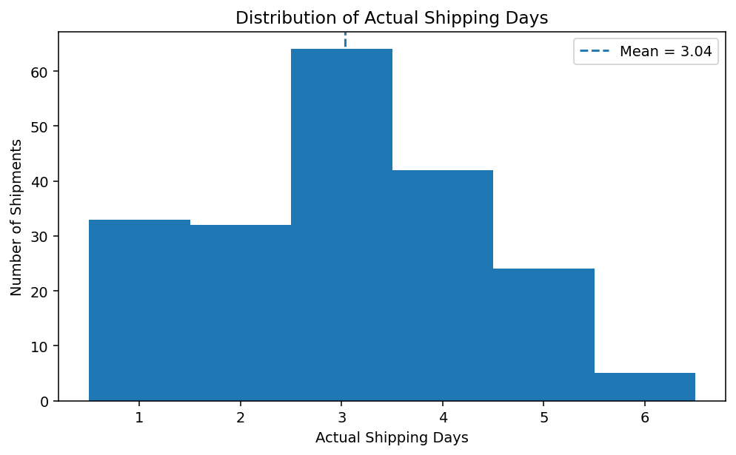
Interpretation: The histogram shows how actual shipping times are distributed. Most observations are concentrated around a small number of days, providing a useful baseline for identifying shipments that take longer than the normal operating range.

6. Visualization 2 – Average Delay by Shipping Mode
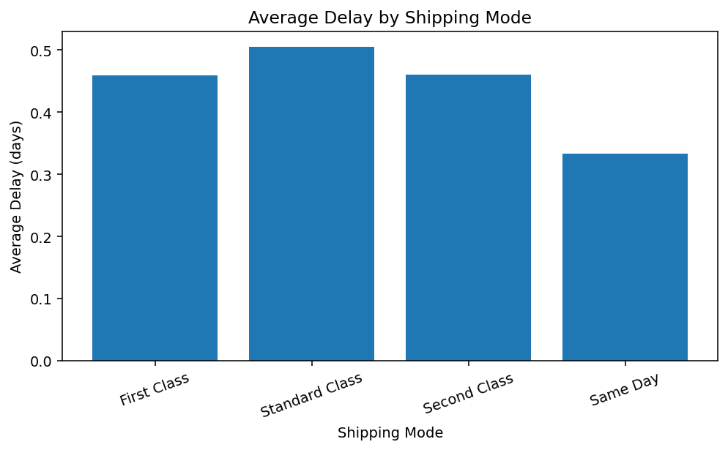
Interpretation: Shipping-mode comparison helps identify service modes that need closer monitoring. In this dataset, average delay ranges from 0.33 to 0.50 days across the modes.

7. Visualization 3 – Late Delivery Rate by Region
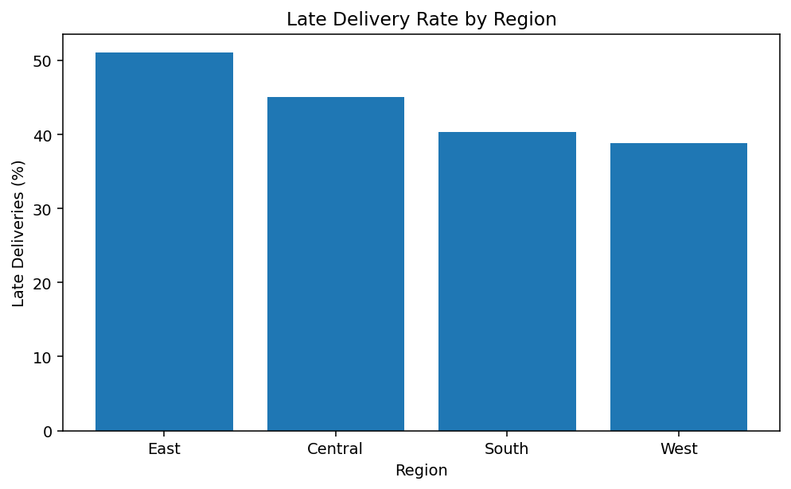
Interpretation: Regional performance is useful for locating geographic bottlenecks. The East region has the highest late-delivery rate in this simulated dataset (51.0%), so it would be a priority for further investigation.

8. Visualization 4 – Shipping Cost vs Product Price
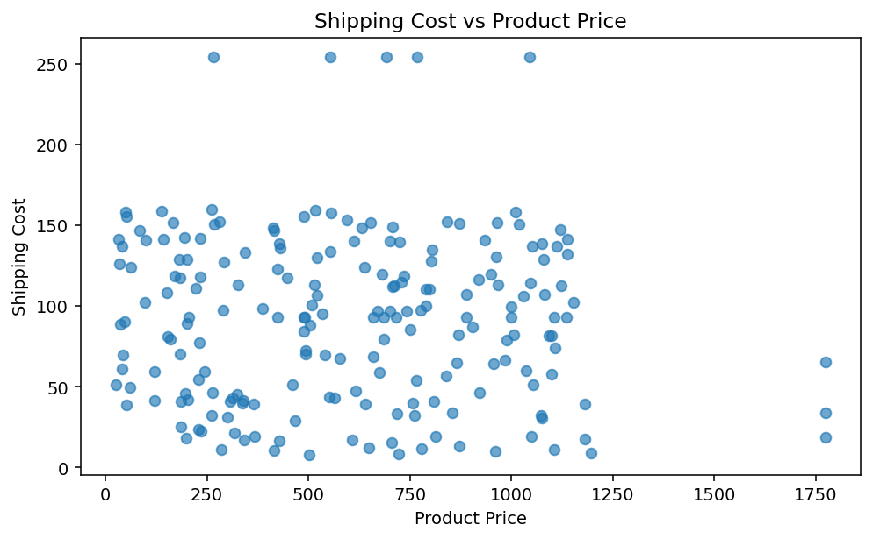
Interpretation: The scatter plot examines the relationship between product value and shipping cost. The Pearson correlation in this dataset is -0.05, indicating a weak linear relationship. This suggests that shipping cost is not determined by product price alone and may also depend on factors such as distance, service level, shipment characteristics, or carrier decisions.

9. Visualization 5 – Delay Distribution by Product Category
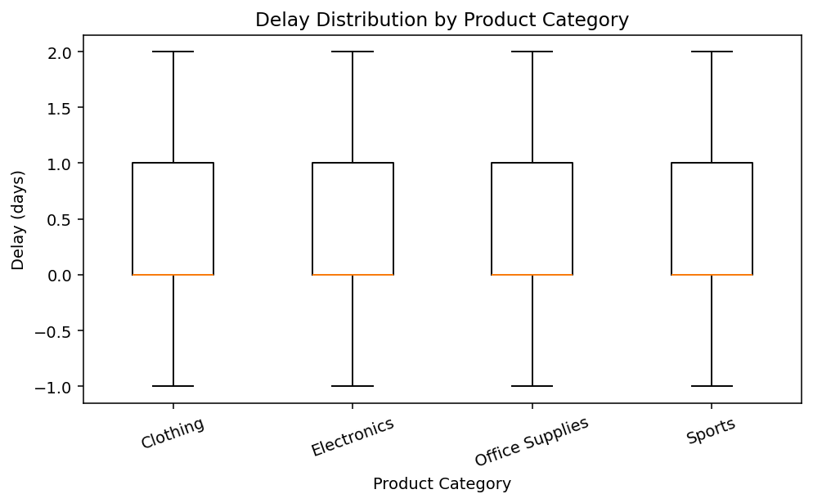
Interpretation: Category-level analysis reveals differences in delivery performance. The Sports category has the highest average delay in the simulated dataset (0.58 days), making it a useful candidate for additional process investigation.

10. Visualization 6 – Correlation Matrix
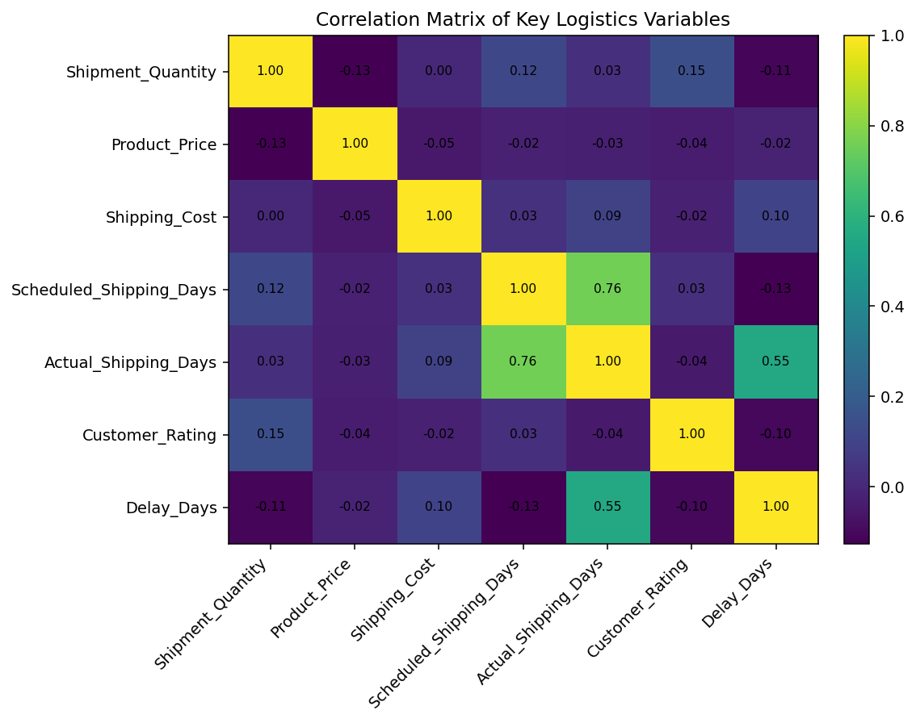
Interpretation: The correlation matrix summarizes linear relationships among key numerical variables. Actual shipping days and delay days have a correlation of 0.55. This relatively strong relationship is expected because delay days are calculated from actual and scheduled shipping time. Correlation should be interpreted as association, not proof of causation.

11. Analytical Insights
- Delivery reliability requires attention because 43.5% of simulated shipments are flagged as late.
- The average delay is 0.47 days, while the median delay is 0.00 days, showing that many shipments meet schedule but late shipments increase the average.
- Regional comparison identifies East as the highest late-delivery-rate region, making it a priority for carrier and route-level investigation.
- Shipping-mode comparison provides a practical way to monitor service-level performance and identify modes with relatively higher delay.
- Product-category analysis indicates that some categories experience higher average delays and should be examined for handling, inventory, or transportation constraints.
- The product-price/shipping-cost relationship is weak (correlation -0.05), suggesting that cost optimization should consider factors beyond item value.
- The correlation matrix is useful for selecting variables for future predictive modeling, while avoiding interpretation of correlation as causation.

12. Recommendations
- Monitor late-delivery KPIs by region and shipping mode instead of relying only on overall averages.
- Investigate the highest-delay region for carrier reliability, route distance, handoff delays, and capacity constraints.
- Review shipping modes with higher delay or late rates and compare their cost-benefit performance.
- Investigate product categories with higher delay levels for packaging, inventory availability, handling, or fulfillment bottlenecks.
- Use shipping-cost analysis together with distance, quantity, mode, and region in future models to improve cost-driver identification.
- For future predictive analysis, use delay or late-delivery status as a target and evaluate models with appropriate classification or regression metrics.

13. Python Tools and Techniques Used
Python, Pandas, NumPy, and Matplotlib were used. Pandas handled data loading, grouping, descriptive statistics, and correlation analysis. NumPy supported numerical operations and histogram/bin construction. Matplotlib was used to create histograms, bar charts, scatter plots, box plots, and the correlation matrix.

14. Reflection
This task demonstrated that exploratory analysis is not only about generating charts; it is about connecting quantitative evidence with operational questions. Descriptive statistics establish the baseline, grouped comparisons reveal where performance differs, and relationship plots help examine possible cost drivers. The analysis also reinforced the importance of using clean and consistently defined variables before drawing conclusions. The results provide a foundation for a future predictive modeling stage in which late delivery risk can be modeled using shipment, region, mode, cost, and scheduling attributes.

15. Conclusion
The Week 3 EDA successfully transformed the cleaned logistics dataset into interpretable operational insights. The visualizations highlighted delivery-time patterns, shipping-mode performance, regional reliability, cost relationships, category-level delays, and numerical correlations. These findings can support data-driven logistics decisions and provide a strong analytical foundation for subsequent predictive modeling.

16. Repository and Files
The GitHub repository contains the Week 2 cleaned dataset and the Week 3 EDA notebook. The notebook contains the Python workflow used to reproduce the analysis and visualizations.
Suggested repository structure:
- notebooks/Week3_Advanced_Logistics_EDA.ipynb
- data/week2_cleaned_logistics_data.csv
- reports/YuvaIntern_Week3_Logistics_Analysis_Visualization_Report.docx
- visuals/ (Week 3 visualization images)

17. References
DataCo SMART SUPPLY CHAIN FOR BIG DATA ANALYSIS, Mendeley Data, public dataset used as a structural reference in the Week 2 preprocessing stage.
Python documentation and standard Pandas/NumPy/Matplotlib analytical methods were used for implementation.

