Week 4: Predictive Modeling and Optimization in Logistics Systems
YuvaIntern – Logistics Data Analyst Internship
Predicting Actual Shipping Days Using Machine Learning

1. Objective
This task applies predictive modeling to a logistics problem and uses model insights to propose operational optimization strategies. The selected forecasting problem is prediction of actual shipping time in days. Accurate delivery-time prediction can support capacity planning, early delay detection, shipping-mode decisions, and customer service.

2. Problem Definition
The target variable is Actual_Shipping_Days. Predictors include shipment quantity, product price, shipping cost, scheduled shipping days, customer rating, shipping mode, region, customer segment, and product category. Delay_Days and Late_Delivery_Flag are excluded because they are derived from Actual_Shipping_Days; including them would cause target leakage and unrealistic performance.

3. Dataset and Data Preparation
The cleaned Week 2 logistics dataset was reused. Numerical variables were treated as numeric features and categorical variables were one-hot encoded. An 80:20 train-test split with random_state=42 was used. A preprocessing pipeline ensures consistent transformations during training, testing, and cross-validation.

4. Model Selection
Three regression models were compared. Linear Regression provides an interpretable baseline. Decision Tree Regression captures nonlinear rule-based relationships. Random Forest Regression combines many decision trees and can model more complex patterns robustly.

5. Evaluation Metrics
MAE is the average absolute prediction error in days. RMSE gives greater weight to larger errors and is useful for detecting serious forecasting mistakes. R² measures the proportion of variation in actual shipping days explained by the model.

6. Model Performance
Model | MAE | RMSE | R²
Linear Regression | 0.713 | 0.867 | 0.478
Random Forest | 0.756 | 0.935 | 0.393
Decision Tree | 0.800 | 1.051 | 0.233
The best initial model by test RMSE was Linear Regression.
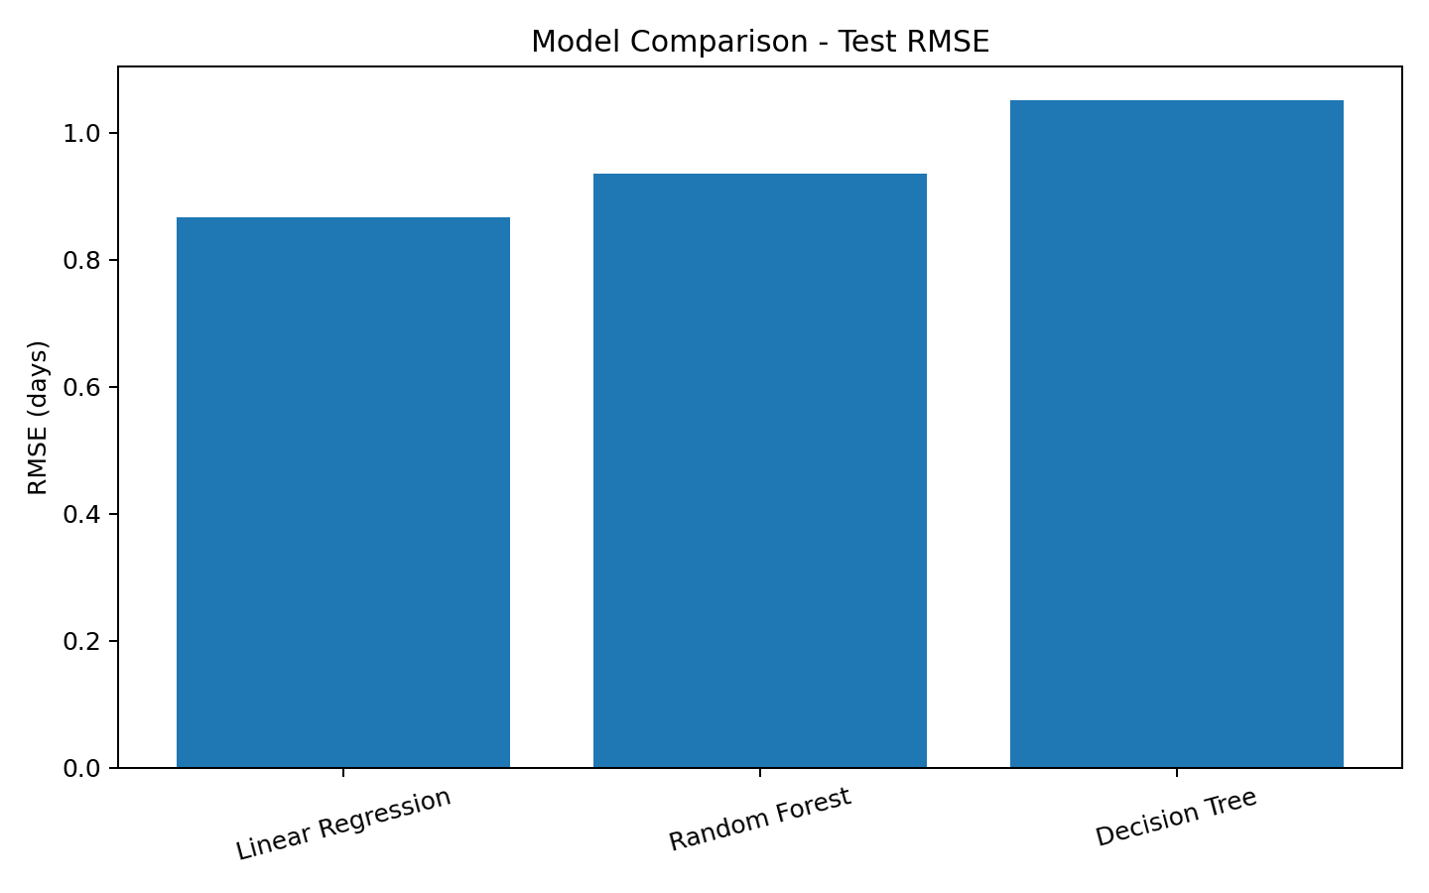
Figure 1. Test RMSE comparison.

7. Cross-Validation and Hyperparameter Tuning
Linear Regression: 5-fold mean CV RMSE = 0.929 days; standard deviation = 0.062.
Decision Tree: 5-fold mean CV RMSE = 1.124 days; standard deviation = 0.098.
Random Forest: 5-fold mean CV RMSE = 0.982 days; standard deviation = 0.059.
Random Forest was tuned using GridSearchCV over number of trees, maximum depth, and minimum samples per leaf.
Best parameters: {'model__max_depth': None, 'model__min_samples_leaf': 4, 'model__n_estimators': 100}
Tuned Random Forest test results: MAE=0.725 days, RMSE=0.900 days, R²=0.438.
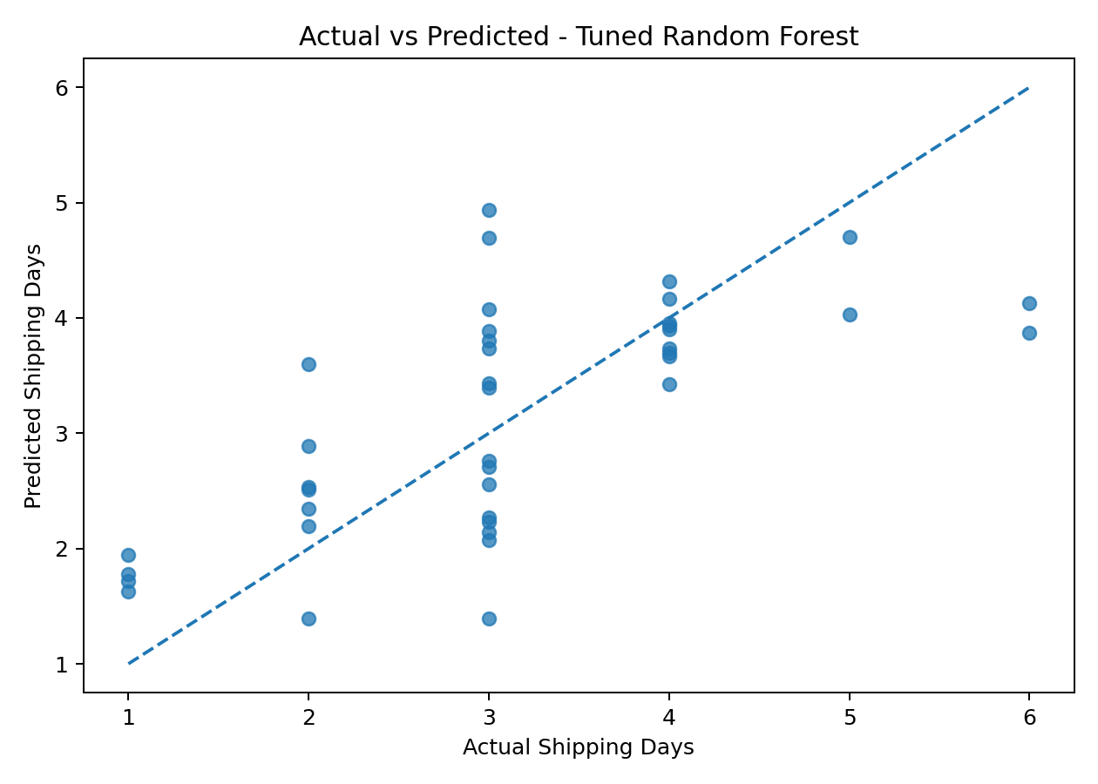
Figure 2. Actual versus predicted shipping days.
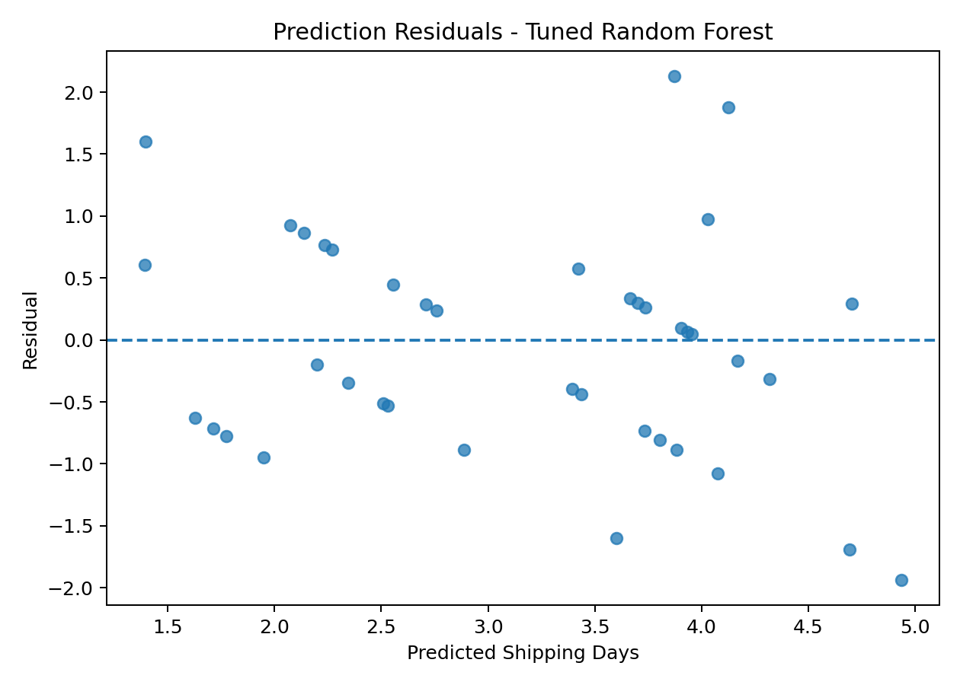
Figure 3. Prediction residuals.

8. Optimization Strategies
Predictive early warning: Flag shipments whose predicted duration exceeds the scheduled window.
Resource allocation: Use predicted delivery workload to allocate warehouse, dispatch, and transport resources.
Shipping-mode optimization: Compare predicted delivery time and transportation cost before assigning a shipping mode.
Route planning: Combine predicted duration with route distance, traffic, and route history in a production system.
Cost minimization: Balance faster delivery against higher transportation cost.
Continuous monitoring: Track errors and retrain the model as new logistics data arrives.

9. Python Tools and Techniques
Python, Pandas, NumPy, Scikit-learn, Matplotlib, preprocessing pipelines, one-hot encoding, regression, train-test splitting, cross-validation, and GridSearchCV were used. The accompanying notebook contains reproducible code for preparation, training, validation, evaluation, and tuning.

10. Key Findings
The experiment demonstrates an end-to-end logistics forecasting workflow. Linear Regression was the strongest initial model by test RMSE, while five-fold cross-validation provided a more reliable estimate across multiple data splits. Hyperparameter tuning was applied to Random Forest. The model can support decision-making, but the educational dataset should not be treated as production-level forecasting data.

11. Limitations and Future Improvements
The dataset is compact and educational. A real deployment should include more historical shipments and additional predictors such as route distance, traffic, warehouse processing time, carrier, weather, holidays, and time-based features. Future work could compare gradient boosting methods and add model explainability such as feature importance or SHAP.

12. Conclusion
This task demonstrated predictive modeling for logistics by defining a clear forecasting target, preparing features without target leakage, comparing multiple regression models, evaluating them with MAE, RMSE, and R², applying cross-validation, and tuning Random Forest. The resulting insights can support early delay detection, resource allocation, shipping-mode selection, route planning, and cost-aware decisions.

13. Repository
GitHub repository: https://github.com/aripakaramya/logistics-delivery-analysis

