South East European University
Faculty of Contemporary Sciences and Technologies
University Academic Analytics System
NoSQL Databases Project - MongoDB

Group Members
Besnik Zeqiri - 132125
Armend Sejfullahi - 132126
Arian Qamili - 132036
Academic Year 2025/2026

1. Scenario and Application Flow

1.1 Scenario Overview
The University Academic Analytics System is a database-driven platform designed to store, manage, and analyze student academic performance data. The system tracks students across multiple academic statuses, monitors their course enrollments, records performance metrics, and identifies students who are at risk of academic failure.

The core purpose of the system is to provide university administrators and academic advisors with actionable insights: which students are struggling, which courses are most difficult, and how student performance trends change across semesters.

1.2 Application Flow
The system operates through the following flow:

Step | Action | Collections Involved
1 | Students are registered in the system with their academic profile | students
2 | Students enroll in courses each semester | enrollments
3 | Grades are recorded per enrollment with grading method details | enrollments
4 | At the end of each semester, a performance snapshot is captured | performance_snapshots
5 | Analytics queries identify at-risk students and course difficulty | students, enrollments
6 | Advisors review trends and take action based on risk scores | performance_snapshots

1.3 Why MongoDB over Other Database Types
The selection of MongoDB as the database system for this scenario is justified by comparing it against all major NoSQL types and relational databases:

Database Type | Why Not Suitable for This Scenario
Relational (SQL) | Rigid schema requires all students to have identical columns. Adding a field like scholarshipAmount for scholarship students requires ALTER TABLE affecting all rows. Schema migrations are costly and risky.
Key-Value Store | Stores only simple key-value pairs. Cannot support complex queries like finding all high-risk enrolled students, aggregating grades by course, or comparing semester trends.
Column-Family (Cassandra) | Optimized for time-series and write-heavy workloads with known query patterns. Does not support flexible ad-hoc analytics queries or variable document structures per student status.
Graph Database (Neo4j) | Designed for relationship-traversal queries (e.g., social networks). Our scenario does not require deep relationship traversal, it requires document analytics and aggregation.
MongoDB (Document DB) | Naturally models students as flexible documents. Each student status (enrolled, probation, suspended, scholarship) can have different fields. The Aggregation Pipeline enables complex analytics directly in the database.

MongoDB is the optimal choice because: (1) schema flexibility allows different student statuses to have completely different attributes without wasted nullable columns; (2) the Aggregation Pipeline supports the analytics queries the system requires natively; (3) reference mode via ObjectId links collections without the overhead of JOIN-heavy relational schemas.

2. Building the Database

2a. Data Schema Design
The system uses 4 collections. The schema demonstrates two key NoSQL features: reference mode (ObjectId links between collections) and schema flexibility (documents within the same collection have different attributes based on context).

Collection 1: students
The students collection demonstrates schema flexibility, each document's structure depends on the student's status. This eliminates the need for nullable columns that would exist in a relational model.

Status | Unique Fields (not present in other statuses)
enrolled | currentGpa, prevGpa, absences, totalClasses, failedUnits, riskLevel, riskScore
scholarship | All enrolled fields + scholarshipType, scholarshipAmount, gpaRequirement, renewalDate, scholarshipProvider
probation | currentGpa, probationStartDate, probationEndDate, conditionsToMeet[], warningLevel, counselorNote
suspended | lastActiveSemester, currentGpa, prevGpa, suspensionReason, suspendedSince, reviewDate, canAppeal (some: disciplinaryCode)

Collection 2: courses
Courses are uniform documents serving as reference targets. They contain courseId, name, credits, department, deliveryMode (in-person / hybrid / online), and semester. The deliveryMode field enables course-level filtering in analytics queries.

Collection 3: enrollments
Enrollments implement reference mode, each document contains studentRef (ObjectId pointing to students._id) and courseRef (ObjectId pointing to courses._id). Schema flexibility is demonstrated through the gradingType field, which determines the document structure:

gradingType | Unique Fields
exam_only | midtermWeight, finalWeight, midtermScore, finalScore (some: oralExam, oralScore)
lab_based | labWeight, labHours, labScore, finalWeight, finalScore
project_based | projectWeight, projectTitle, teamSize, projectScore, examWeight, examScore
mixed | assignmentsWeight, examWeight, projectWeight + corresponding scores
retake (any type) | All fields of the grading type + isRetake: true, attemptNumber, previousGrade

Collection 4: performance_snapshots
Performance snapshots implement reference mode via studentRef (ObjectId). Each document captures a student's GPA, risk score, risk level, and signal breakdown (gpaDrop, absenceRate, failedUnits) at the end of a semester. This enables trend analysis across multiple semesters.

Reference Mode Diagram
The reference chain between collections:

From Collection | Field | References | To Collection
enrollments | studentRef | ObjectId → _id | students
enrollments | courseRef | ObjectId → _id | courses
performance_snapshots | studentRef | ObjectId → _id | students

2b. Data Population
The database was populated using a seed script executed in MongoDB Compass. The following records were inserted:

Collection | Record Count | Description
students | 21 | 4 statuses: 12 enrolled, 3 scholarship, 3 probation, 3 suspended
courses | 10 | 3 delivery modes: in-person, hybrid, online
enrollments | 60 | 4 grading types: exam_only, lab_based, project_based, mixed
performance_snapshots | 30 | 2 semesters tracked: Fall 2024 and Spring 2025

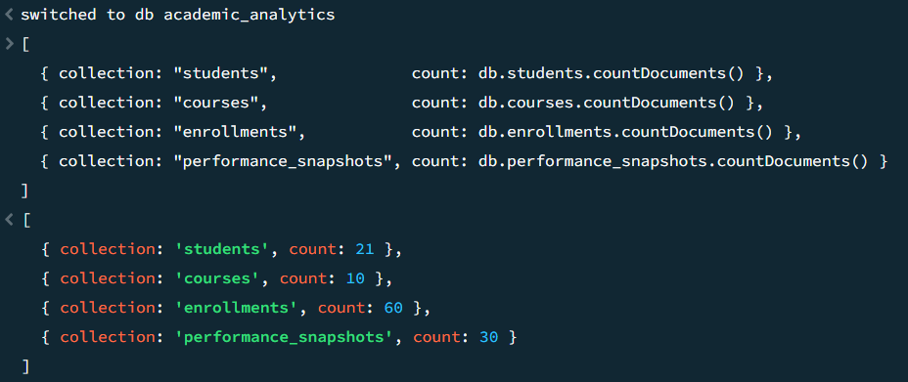
2c. CRUD Operations and Queries
INSERT Operations

Add a new enrolled student and Add enrollment for the new student:
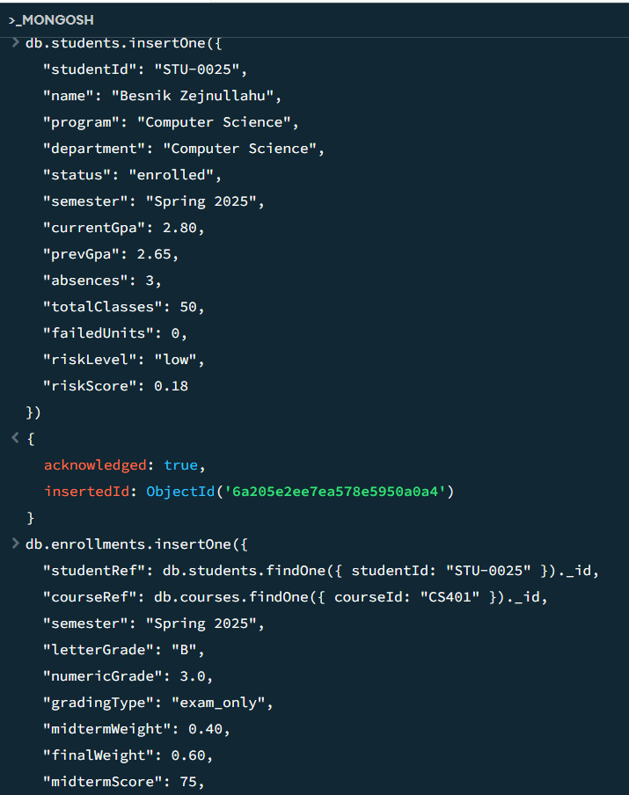

UPDATE Operations

Update GPA and risk level after semester results and Add a new field to all probation students:
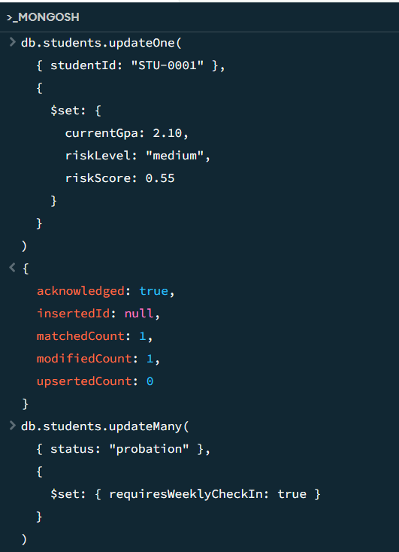 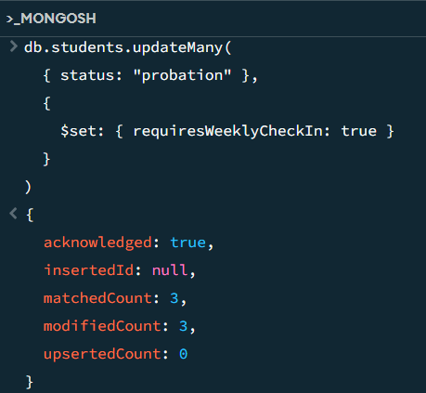
UPDATE 2 - Reinstate a suspended student to probation (status change with field restructure):

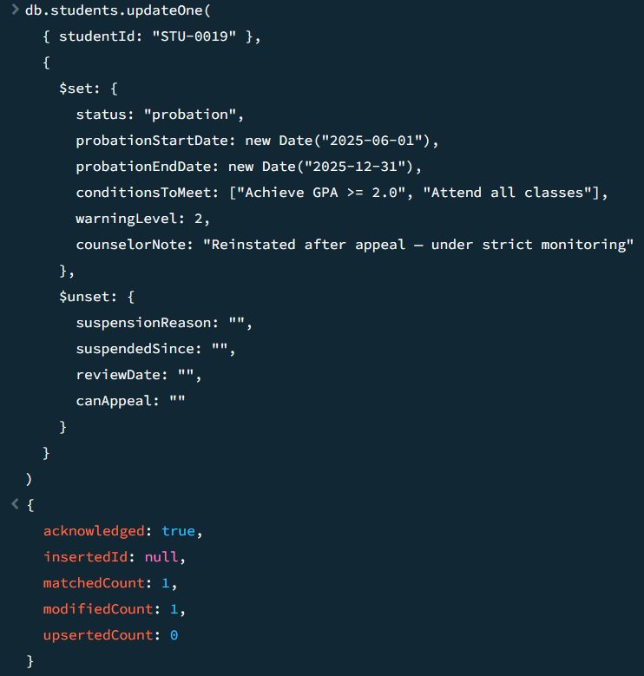

DELETE Operations

Remove a test enrollment and Remove the test student:
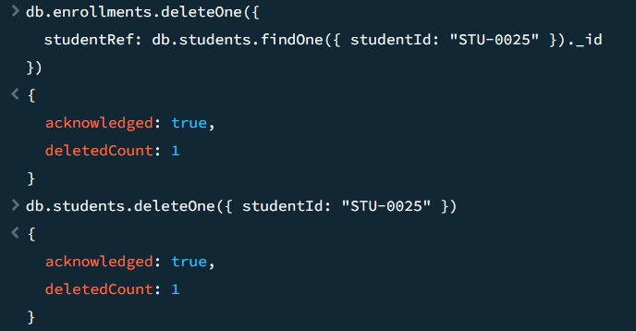
FIND with Conditions

FIND 1 - Find all high-risk enrolled students, sorted by risk score:
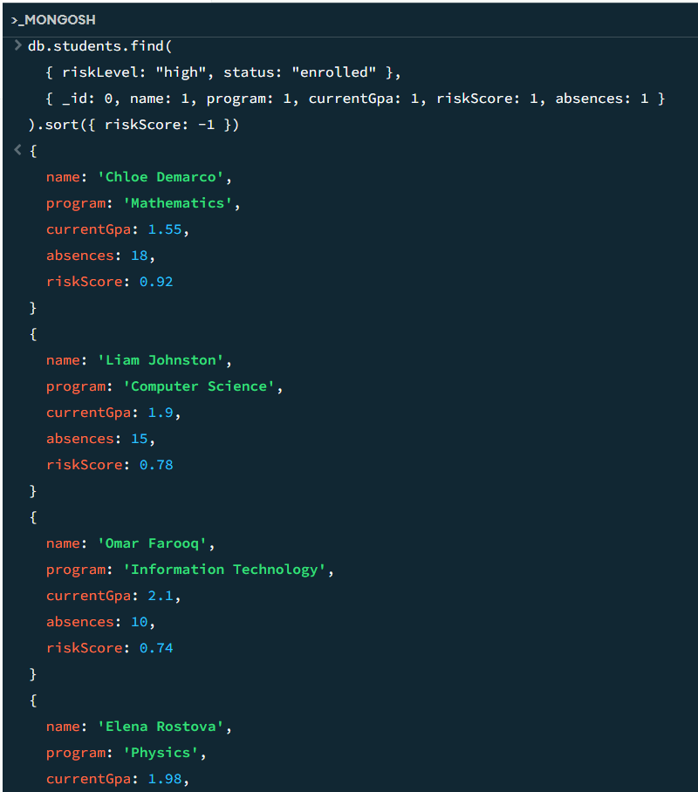

FIND 2 - Find all scholarship students with their scholarship details:
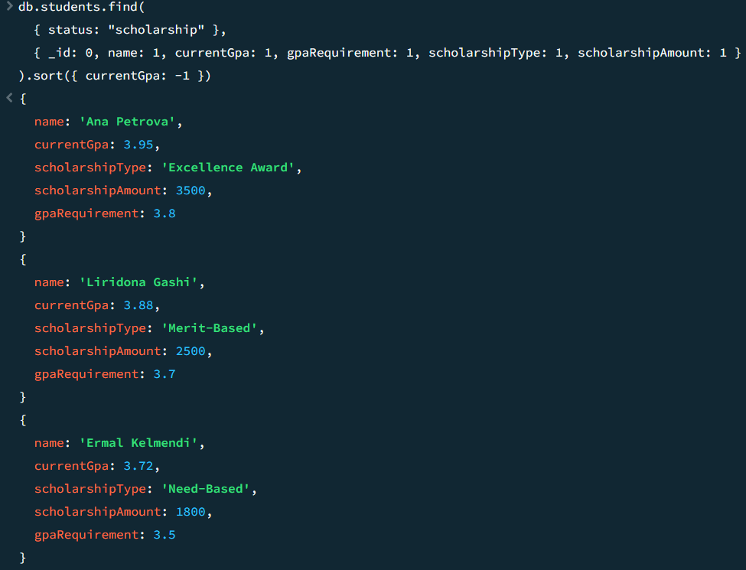
FIND 3 - Find probation students with high warning level:
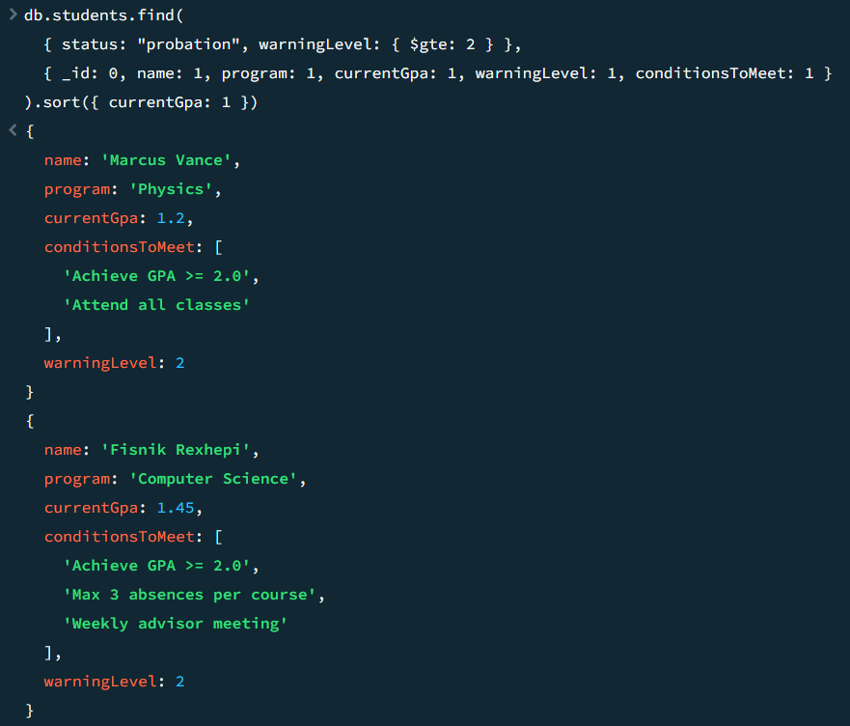

Complex Query 1 - At-Risk Student Detection with Score Breakdown
This query identifies all at-risk students among enrolled and scholarship students. It dynamically computes the absence rate and GPA drop for each student, filters those with a risk score above 0.20, and returns a ranked breakdown of why each student is at risk.
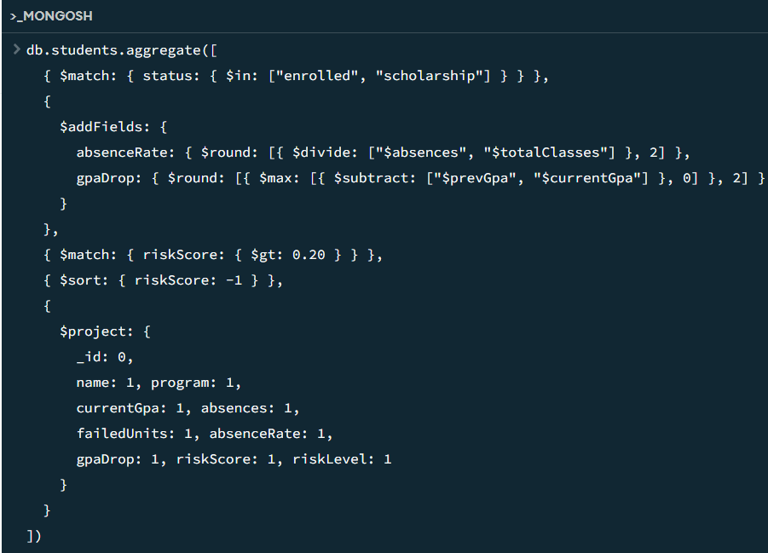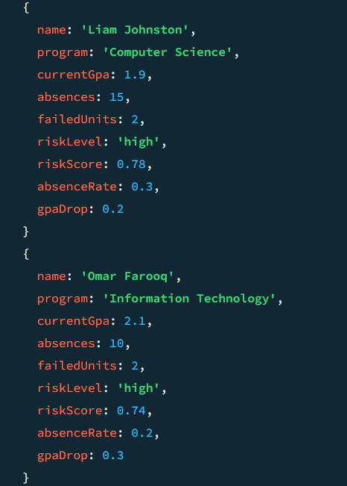
Complex Query 2 - Course Difficulty Ranking
This query ranks all courses by a computed difficulty index. It groups enrollments by course, calculates the average grade and fail rate, then computes a difficulty index as a weighted combination of both metrics. It uses $lookup to join with the courses collection to display course names.
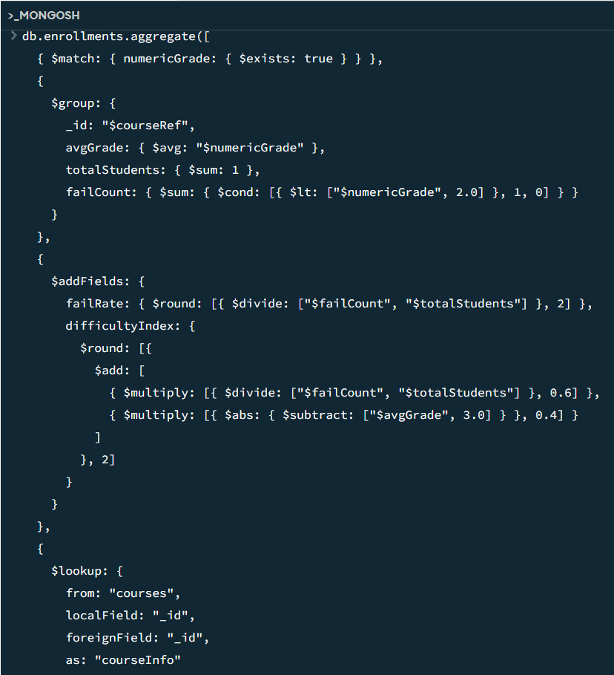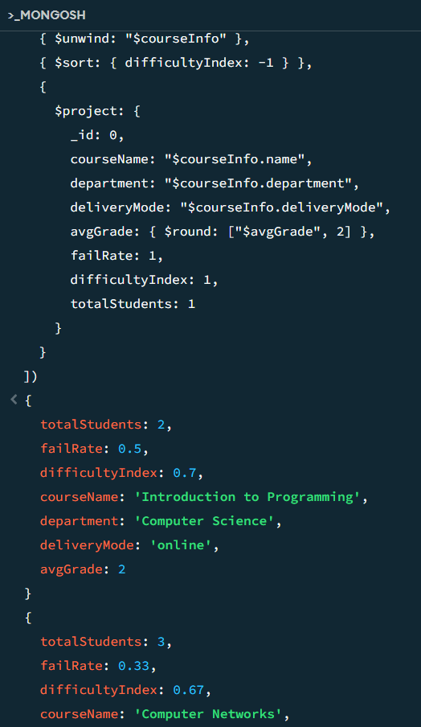
Complex Query 3 - Semester Performance Comparison
This query compares student performance between Fall 2024 and Spring 2025. It groups all enrollment records by semester and computes the average grade, total enrollments, fail count, pass count, pass rate, and fail rate for each semester.
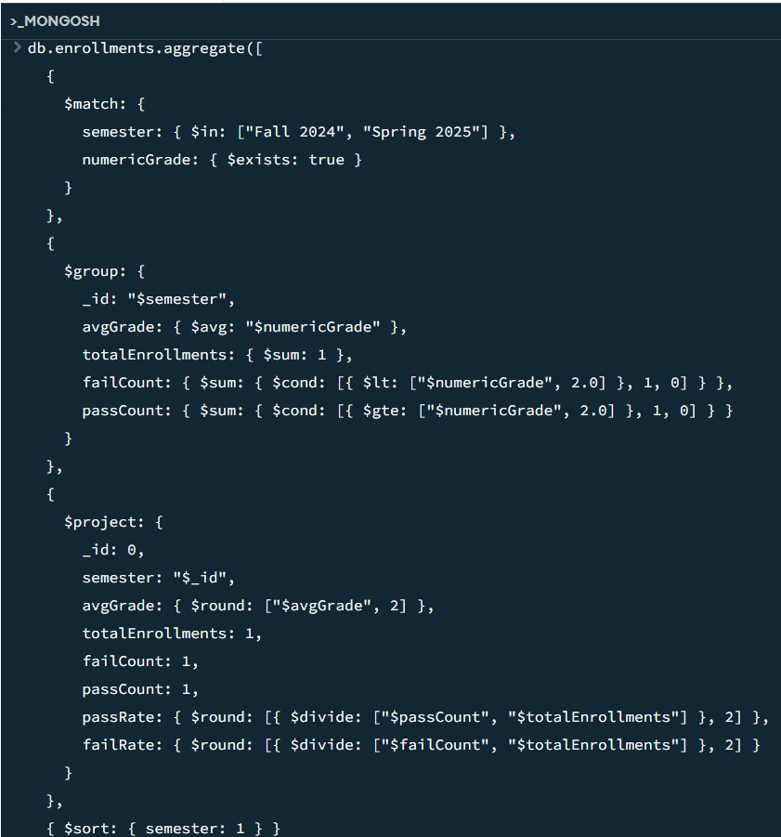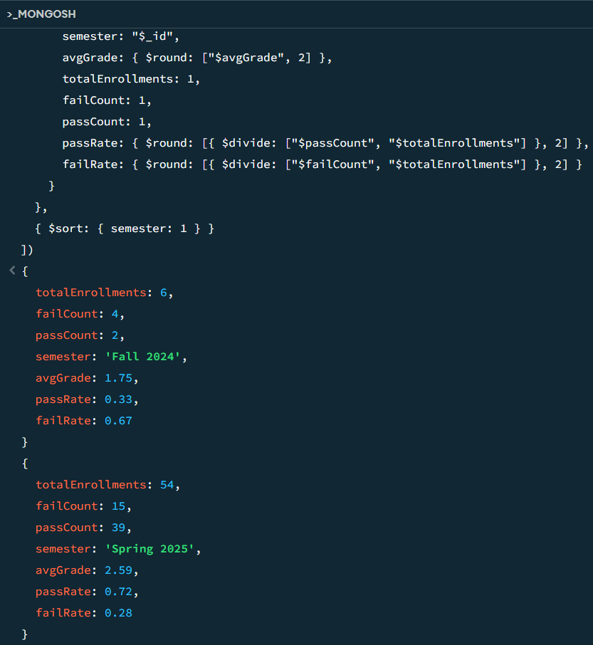

2d. Database-Specific Operations
Operation 1 - $lookup: Student Full Profile
The $lookup stage performs a join between collections using ObjectId references. This query retrieves a complete student profile including all enrollments and performance history from separate collections in a single query.
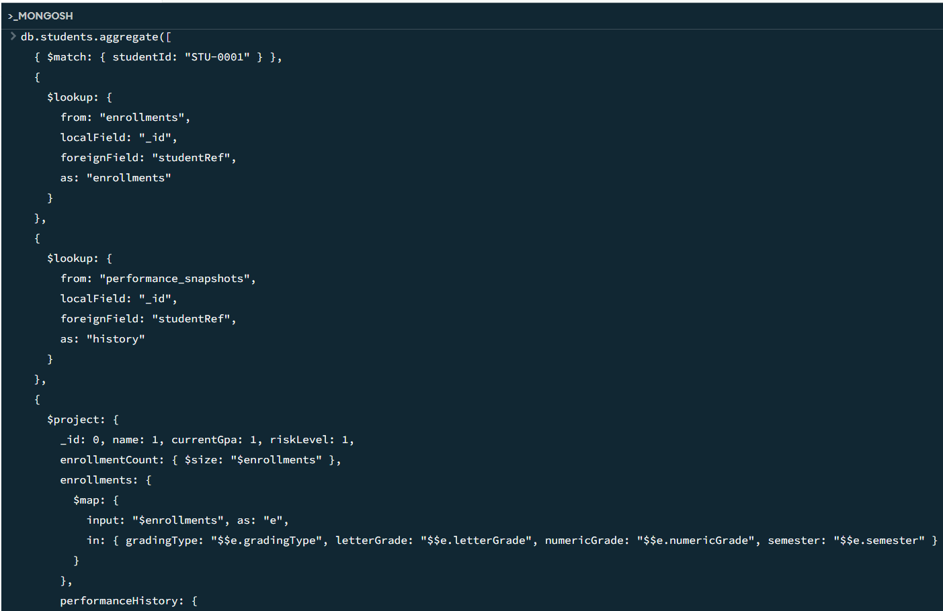
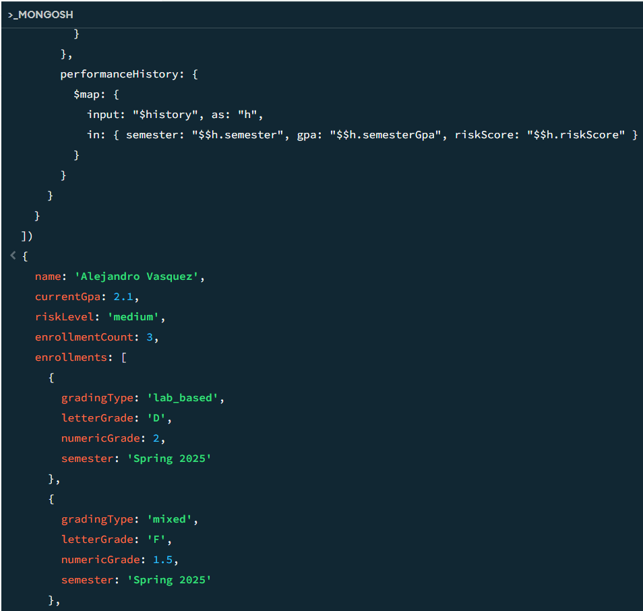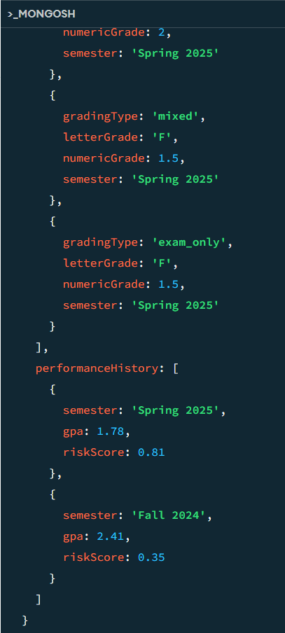
Operation 2 - $facet: University Overview Dashboard
The $facet stage runs multiple aggregation pipelines in parallel within a single query, returning a multi-dimensional summary of the entire student population. This is ideal for dashboard-style analytics.
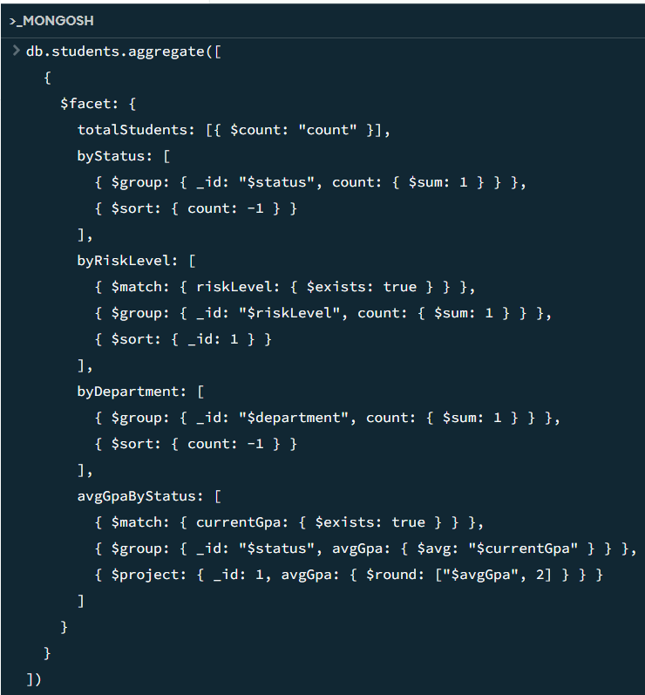
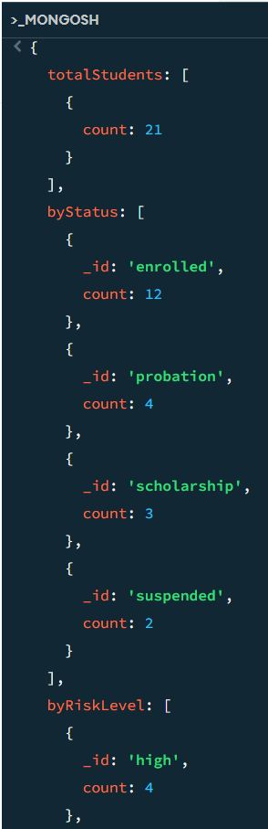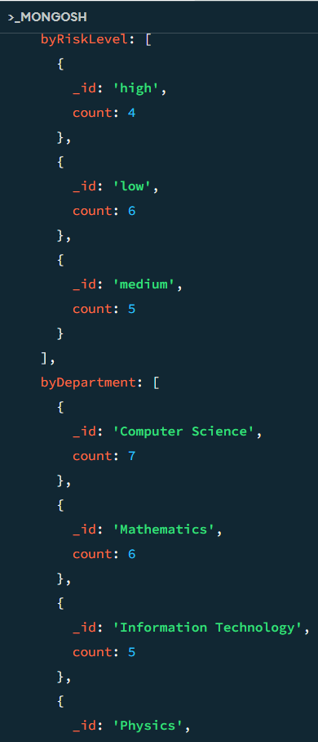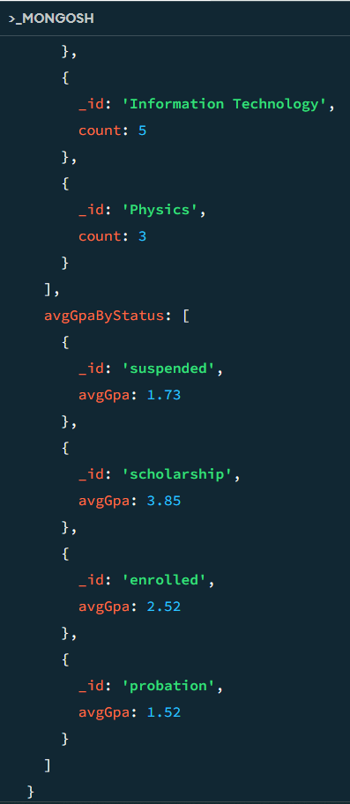
Operation 3 - $addFields + $switch: GPA Trend Labeling
This operation computes a GPA change value and assigns a trend label to every student using $switch - MongoDB's equivalent of a CASE statement. Students are classified as Improving, Declining, or Stable based on the difference between current and previous GPA.
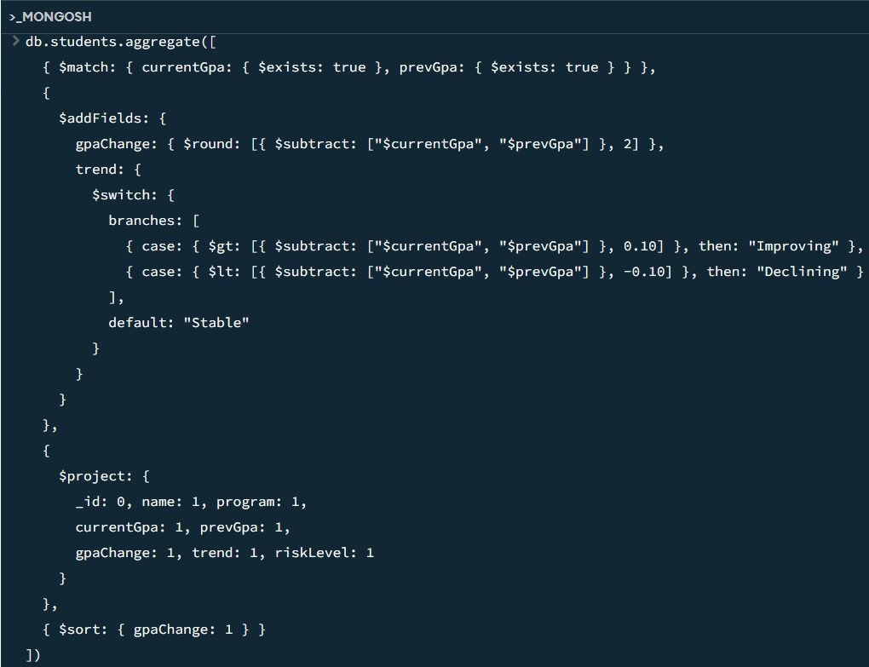
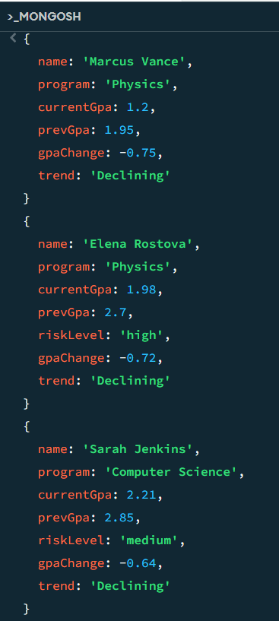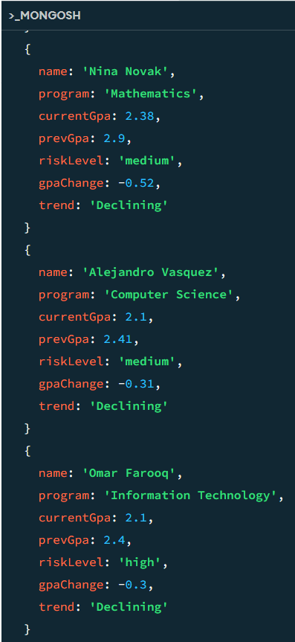
Operation 4 - Indexes: Performance Demonstration
Indexes dramatically improve query performance by allowing MongoDB to locate documents without scanning the entire collection. The following demonstrates the performance difference before and after index creation.

Step 1 - Run query before indexes:
Output: …


Step 2 - Create indexes:
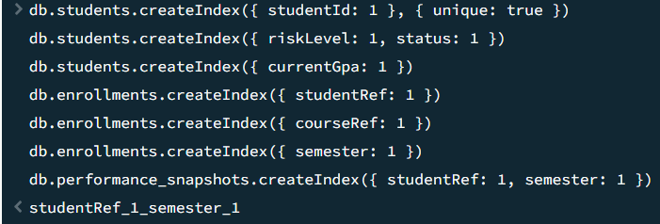

Step 3 - Run the same query after indexes:
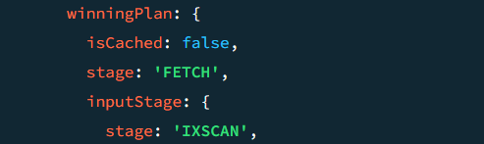

2e. Usage of the Project
The University Academic Analytics System is designed to be used by academic advisors and university administrators on a day-to-day basis. This section describes how the system is used in practice, following the natural workflow of an advisor during an active semester.

Starting the Semester
At the beginning of each semester, new student records are inserted into the students collection using the insertOne operation. Students who are enrolling in courses for the first time are added with their academic profile, program, and initial status. Existing students who have changed status, for example a student who was suspended and is now reinstated to probation, are updated using updateOne with the appropriate fields for their new status. Because MongoDB does not enforce a rigid schema, reinstating a student from suspended to probation simply means updating their status field and adding the probation-specific fields such as probationStartDate, conditionsToMeet, and counselorNote, without needing to restructure any other documents in the collection.

During the Semester
As the semester progresses, advisors use find queries to monitor specific groups of students. Running the high-risk student query returns a sorted list of enrolled students ranked by their risk score, allowing advisors to prioritize who to contact first. The scholarship monitoring query identifies scholarship students whose GPA is approaching the minimum renewal threshold, giving advisors time to intervene before the student loses their funding. Probation students with a high warning level can be filtered separately to track whether they are meeting their required conditions.
When a student drops a course or an enrollment record needs to be corrected, the deleteOne operation removes the specific enrollment document without affecting any other data in the system.

End of Semester Analytics
At the end of each semester, performance snapshots are inserted into the performance_snapshots collection for every active student. These snapshots capture the student's GPA, risk score, and signal breakdown for that semester. This is the data that powers the trend analysis across semesters.
The Course Difficulty Ranking query is run after grades are finalized to identify which courses had the highest fail rates and lowest average grades. This report is used by the academic department to decide which courses may need curriculum adjustments for the following semester.
The Semester Comparison query is run to compare the current semester against the previous one. If the overall average grade dropped or the fail rate increased, this signals a systemic issue that requires attention beyond individual student intervention.
Dashboard Overview
At any point during or after the semester, administrators can run the university dashboard query which uses the $facet operation to return a full overview of the student population in a single query: total number of students, breakdown by status, breakdown by risk level, and average GPA. This gives a high-level picture of the university's academic health without needing to run multiple separate queries.

Full Student Profile
When an advisor needs to review a specific student in detail, the $lookup query retrieves the student's complete academic record in one result: their personal profile, all course enrollments with grades and grading details, and their performance snapshot history across semesters. This gives the advisor everything they need to have an informed conversation with the student.

3. NoSQL Feature Investigation
Two specific MongoDB features are investigated in depth: the Aggregation Pipeline and Indexing. Both are directly applied in the University Academic Analytics System and contribute to its performance and reliability in concrete, measurable ways.

3.1 Feature 1 - Aggregation Pipeline
What is the Aggregation Pipeline
The Aggregation Pipeline is MongoDB's built-in framework for data transformation and analytics. It processes documents through a sequence of stages, where each stage transforms the data and passes it to the next. Unlike simple find() queries, the pipeline can group, compute, join, filter, and reshape data in a single database operation.

Each stage is represented by an operator such as $match, $group, $addFields, $lookup, $sort, $project, $facet, and $unwind. These stages can be chained in any order to build complex analytical queries.

How it Contributes to Performance and Reliability in Our Scenario
In the University Academic Analytics System, the Aggregation Pipeline is not just a convenience, it is the core mechanism through which the system delivers its primary value: identifying at-risk students, ranking course difficulty, and tracking performance trends.

Contribution | How it Applies to Our Scenario
Server-side computation | The risk score breakdown (absenceRate, gpaDrop) is computed inside MongoDB using $addFields, not in application code. This reduces data transfer and processing load on the application layer.
Single-query analytics | $facet allows the university dashboard to retrieve total students, distribution by status, distribution by risk level, and average GPA by status, all in one round-trip to the database.
Cross-collection joins | $lookup joins enrollments with courses to produce the Course Difficulty Ranking without requiring multiple separate queries from application code.
Flexible filtering | $match stages filter documents at each pipeline step, ensuring only relevant records are processed in subsequent expensive stages like $group or $lookup.
Trend computation | $switch inside $addFields computes GPA trend labels (Improving / Declining / Stable) directly in the database, enabling the advisor dashboard to display trends without additional processing.

Practical Implementation Example
The following example demonstrates the Aggregation Pipeline in our scenario. This query produces a complete at-risk report: it identifies enrolled and scholarship students, computes their absence rate and GPA drop dynamically, filters those with elevated risk, and returns a ranked list sorted by risk score.
This pipeline uses 4 stages in sequence:

Stage | Operator | Purpose
1 | $match | Filter only enrolled and scholarship students, exclude probation/suspended who are already flagged
2 | $addFields | Compute absenceRate (absences / totalClasses) and gpaDrop (prevGpa - currentGpa) dynamically for each student
3 | $match | Filter students with riskScore > 0.20 - eliminates low-risk students from the output
4 | $sort + $project | Sort by riskScore descending and return only the relevant fields for the advisor report



This single pipeline replaces what would require multiple SQL queries with JOINs and application-side processing in a relational system. The pipeline executes entirely within MongoDB, processes only the documents that pass each filter stage, and delivers the final ranked report ready for display. This approach is both performant and maintainable, adding a new risk signal requires only adding one more $addFields expression to the pipeline.

3.2 Feature 2 - Indexing
What is Indexing in MongoDB
An index in MongoDB is a data structure that stores a small portion of a collection's data in an easy-to-traverse form. Without an index, MongoDB must perform a Collection Scan (COLLSCAN), examining every document in the collection to find matching results. With an index, MongoDB performs an Index Scan (IXSCAN), jumping directly to the relevant documents using the index tree.

MongoDB supports several index types: single-field indexes, compound indexes (multiple fields), and multikey indexes (for array fields). Compound indexes are particularly powerful because they can satisfy queries that filter on multiple fields simultaneously, a common pattern in our analytics queries.

How it Contributes to Performance and Reliability in Our Scenario
The University Academic Analytics System runs frequent queries that filter students by riskLevel and status, sort enrollments by semester, and join collections via studentRef and courseRef. Without indexes, every query scans all documents, as the dataset grows, query time grows linearly. With indexes, query time stays near-constant regardless of dataset size.

Index | Collection | Why it Matters for Our Scenario
{ studentId: 1 } unique | students | Enforces uniqueness of student IDs and enables instant lookup by studentId in CRUD operations and $lookup joins.
{ riskLevel: 1, status: 1 } | students | Compound index that directly serves the at-risk detection query - filters both fields simultaneously without scanning all 21 students (critical as dataset scales to thousands).
{ currentGpa: 1 } | students | Enables fast range queries for GPA thresholds (e.g. finding all students with GPA < 2.0) used in scholarship risk analysis.
{ studentRef: 1 } | enrollments | Speeds up $lookup joins from students to enrollments, without this, every join scans all 60 enrollment documents.
{ courseRef: 1 } | enrollments | Speeds up Course Difficulty Ranking query, groups enrollments by courseRef efficiently.
{ semester: 1 } | enrollments | Enables fast filtering by semester for the Semester Comparison query.
{ studentRef: 1, semester: 1 } | performance_snapshots | Compound index for trend analysis -retrieves all snapshots for a student ordered by semester in a single index scan.

Practical Implementation Example: COLLSCAN vs IXSCAN
The following steps demonstrate the measurable performance difference that indexes provide in our scenario. The query finds all high-risk enrolled students, a query that runs every time an advisor opens the risk dashboard.

Step 1 - Run the query BEFORE creating indexes and observe the execution plan:

In the explain() output, look for the stage field. Without indexes, MongoDB reports stage: COLLSCAN, meaning it scanned every document in the students collection to find matches. The docsExamined value equals the total number of documents, while nReturned is only the matching subset.



Step 2 - Create the compound index on riskLevel and status:



Step 3 - Run the same query AFTER creating indexes:

Now the explain() output shows stage: IXSCAN - MongoDB used the compound index to jump directly to matching documents. The docsExamined value now equals nReturned, only the matching documents were examined, not the entire collection. This difference becomes critical at scale: a university with 10,000 students would see COLLSCAN examine all 10,000 documents, while IXSCAN examines only the handful that match the risk criteria.



Metric | Without Index (COLLSCAN) | With Index (IXSCAN)
Execution stage | COLLSCAN | IXSCAN
Documents examined | All documents in collection | Only matching documents
Performance at scale | Degrades linearly with collection size | Near-constant regardless of collection size
Reliability | Risk of timeout on large datasets | Consistent, predictable query time

