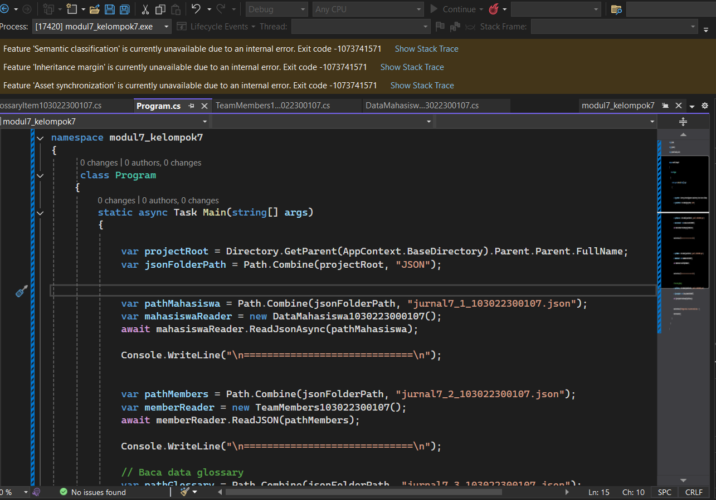

OUTPUT

