WebDALI help

Groups
This is a help file for WebDALI program's group-tab. This file is to be used for reference and understanding of this part of the software.

Tab Bar


Each page has access to this shared tab bar, which allows users to switch quickly between the different tabs in the program. The tabs are:
- Controls-tab
- Groups-tab (this tab)
- Programs-tab
- Help-tab

Groups
This tab is used for management of groups used in other parts of the program.

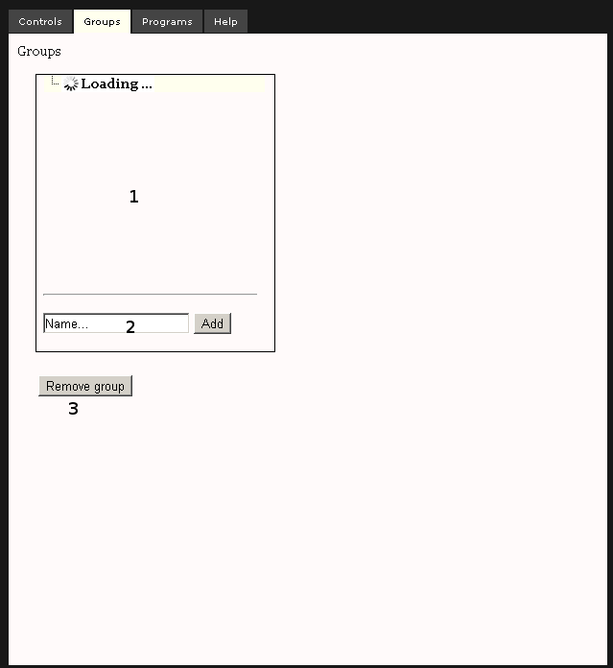

This page consists a box and option buttons for adding and removing groups. First box (marked as 1 in the picture above) contains already created groups. Add-option (marked as 2) is used to name and create new instances of groups. Below the programs-box is a button for deletion of selected programs (marked as 3).
To use this tab: add (at 2) and remove (at 3) and groups to the table (at 1) to create groups for the usage of the rest of the program.

