WebDALI help

Controls
This is a help file for WebDALI program's controls-tab. This file is to be used for reference and understanding of this part of the software.

Tab Bar

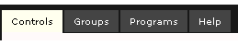

Each page has access to this shared tab bar, which allows users to switch quickly between the different parts of the program. The tabs are:
- Controls-tab (this tab)
- Groups-tab
- Programs-tab
- Help-tab

Controls
This tab is used to manage lights and programs into controls and to create different ways for the end-user to interact with them, e.g. embedded html code.
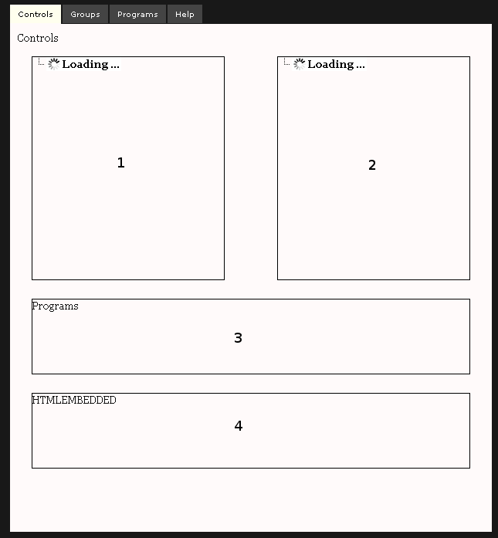

This page consists of two side by side boxes and two boxes that are found below them. First box (marked as 1 in the picture above) contains programs added in the programs-tab. Second box (marked as 2) contains a lights list that is updated automatically to correspond to DALI devices found. Third box (marked as 3) contains the program created in this tab. Fourth box (marked as 4) is the html code for the embedded html representation of the group created.
To use this tab: select programs (from 1) and lights (from 2) to create a control for those selections (in 3). This control can then be used from the end-users interface or copied from the html embed (in 4) for usage in other html environments.

