WebDALI help

Programs
This is a help file for WebDALI program's programs-tab. This file is to be used for reference and understanding of this part of the software.

Tab Bar

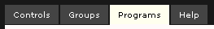

Each page has access to this shared tab bar, which allows users to switch quickly between the different parts of the program. The tabs are:
- Controls-tab
- Groups-tab
- Programs-tab (this tab)
- Help-tab

Programs
This tab is used to manage lights into programmable lists that can ease the management of multiple lights at the same time; i.e. programs.
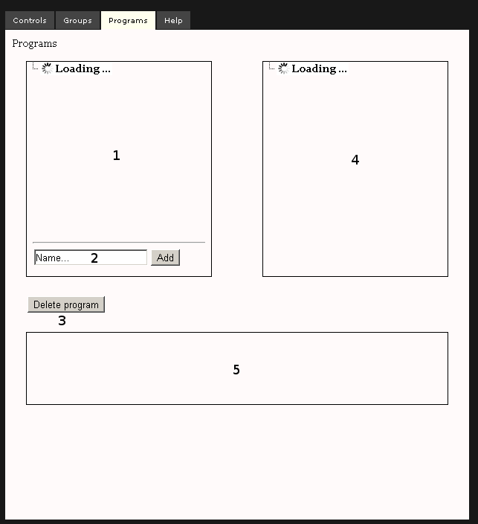

This page consists of two side by side boxes and one preview box that is found below them and some control buttons. First box (marked as 1 in the picture above) contains programs already added to the WebDALI application. In the programs box there is also an add-option (marked as 2) for naming and creating new programs. Below the programs-box is a button for deletion of selected programs (marked as 3). Second box (marked as 4) contains a lights list that is updated automatically to correspond to DALI devices found. Third box (marked as 5) contains a preview of the program / light -list created in this tab.
To use this tab: add a new program to the program list (from 2), select the programs (from 1) and lights (from 2) to create a control for those selections (previewed in 5). Redundant programs can be removed by choosing them (from 1) and using the delete button (from 3). These programs are used to easily manage lights for the use of other parts of the application.

