## 1280 Filling / Dosing PN191318

Date : 7/14/20

ELS #: SZnnnnnnn Version 1.02

S.O. #: nnnnnnn

Software User Guide

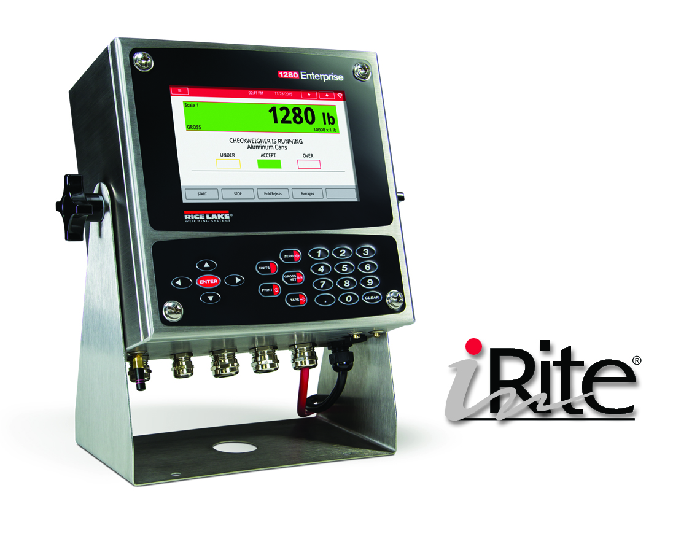

Scope

The 1280 Filling/Discharge PN191318 system is designed for a multitude of scenarios.

**Gross Filling:**

This software is for filling a container that is placed on a scale. It offers user simplicity of one-button operation and will automatically tare the empty container, begin and end filling of the container, and automatically store, display and transmit each fill weight and ongoing production accumulations. Built-in safety interlocks prevent startup of a fill cycle if an empty container is not in place, or if the previously filled container has not been removed.

**Net Filling:**

Simple one-button operation and will automatically fill your scale to a preset weight. Followed by an automatic discharge into a container. Remove the container from under the scale and replace it under the scale with another empty container and repeat the process. It can automatically store, display and transmit each fill weight and ongoing production accumulations. Built-in safety interlocks prevent startup of a fill cycle if an empty container is not in place, or if the previously filled container has not been removed.

**Dosing – Net Dispensing**

**Net Dispensing/Dosing Automatic Source Refill:**

This software is also designed for applications where a preset target weight is repeatedly dispensed from a tank or a hopper scale. The system maintains weight within high and low limits to guarantee enough content for a complete dispense cycle. Press Start and the system automatically tares the scale, begins the loss-in-weight dispense..

**Net Dispensing/Dosing Pause and Resume:**

Finally, this system is designed for applications where product supply containers are placed on the scale and net weight quantities are dispensed from the containers until empty. If a container does not have enough material during the dispense causing a Slow Cycle alarm the cycle is paused allowing the operator to change out containers or correct dispense control issues. When the software is Re-Started and the scale will tare and the remainder of the product will be dispensed.

All modes allow a transaction to be transmitted out a serial port to a printer and stored within an onboard database.

Sequence of Operation

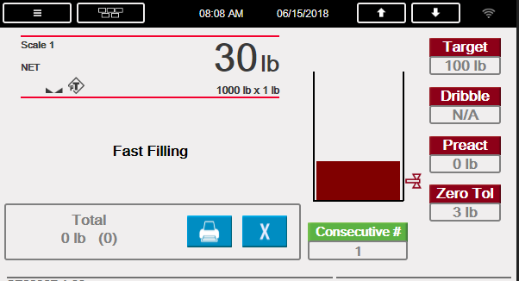

**Modifying Preset/Weights**

Operator presses **Target**, **Dribble, Preact**, **Zero Tolerance, or Consecutive #** touch widget to edit the corresponding weight/number.

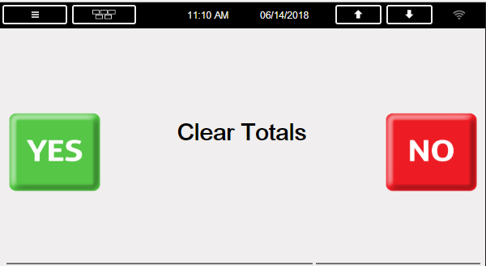**Printing and Clearing Totals**

1. Operator presses the **Printer** touch widget.
   1. System will print out current total



1. Operator presses the **Clear** touch widget
   1. Clears the total (after verification shown below)

**Gross Filling / Net Filling**

1. With the E-Stop out, the Operator toggles the Start/Abort switch to the **Start** position to begin a Fill.
2. System verifies the following before going to STEP 3. (If any conditions are not met, a relevant error message will be displayed i.e. ERROR: No Valid Target or ERROR: No Container etc.
   1. Gross weight within the **Zero Tolerance** (Disabled if **Zero Tolerance** = 0) or Gross weight above **Container Threshold** (Disabled if **Container Threshold** = 0).
   2. **E-Stop** pulled out.
   3. Valid **Target** entered (**Target** > 0)
   4. If Discharge is disabled and optional container photo eye is enabled, system will check for container.
3. System does the following:
   1. Increments the **Consecutive #** by 1 on the main display.
   2. Tares the scale if **Auto Tare** is enabled (Setup Menu).
4. System begins filling:
   1. Single Speed
      1. System turns on **Fast Fill** until the **Target – Preact Weight** is satisfied.
   2. Parallel Speed
      1. Turns on the **Fast Fill** and **Slow Fill** until the **Target - Dribble Weight** is satisfied. System turns off **the Fast Fill** and leaves the **Slow Fill** on until the **Target– Preact Weight** is satisfied.
   3. Dual Speed
      1. Turns on the **Fast Fill** until the **Target - Dribble Weight** is satisfied. System turns on the **Slow Fill** on
      2. until the **Target – Preact Weight** is satisfied.
5. System does the following when the target is reached:
   1. Captures a stable weight.
   2. Updates the total weight and number of fills.
   3. System adds a Transaction to the Transaction Database (*Deletes 25% of oldest records when full*)
   4. Sends a **Transaction Message** out TCP Client 1 if **Transaction Message** is **Enabled** in Setup menu.
   5. System prints out a Weigh Ticket if **Auto-Print** is enabled. Print keypad/button reprints last ticket.
   6. Turns on the **Fill Complete Light**.
6. System does one of the following:
   1. **Discharge Option Enabled** 
      1. If optional **Container In Place** photo eye is enabled, system will check for container in place.
      2. If Auto-Discharge is disabled: System displays – “**Press Discharge Button**”.
         1. Operator presses the **Discharge** touch widget.
      3. System turns on Discharge output until the weight drops below **Zero Tolerance**
      4. System turns off the **Fill Complete** output when the weight drops below **Zero Tolerance**.
      5. System delays for the **Delay After Discharge** before it completes the cycle.
   2. **Discharge Option Disabled** 
      1. System displays – “**Remove Container**” the **Fill Complete** output remains on until the scale drops below **Zero Tolerance** or **Container Threshold.**
7. Once the operator removes the container and the weight falls within the Zero Tolerance, the system is ready for the next fill.

**Dispensing Material - Dosing**

1. Operator presses the **Start** button.
2. System verifies the following before going to STEP 3.
   1. **E-Stop** pulled out.
   2. Valid **Target** entered (**Target** > 0)
3. If **Refill Option** Enabled.
   1. If weight above **Target Weight** and **Low Level** weight system goes to step 5.
   2. If weight is below **Target Weight** or below **Low Level** weight.
      1. ystem will refill (turn on **Refill** output) the scale to the **High** **Level** weight. When the weight reaches the **High** **Level** weight the **refill** output will turn off.
      2. Sytem goes back to step 1.
4. If **Refill Option** Disabled sytem goes to step 5.
5. System does the following:
   1. Turns off the **Dispense Complete** and **Refill** **Complete** (if enabled) outputs.
   2. Increments the **Consecutive Number** by 1 on the main display.
   3. Tares the scale if **Auto Tare** is enabled (Setup Menu).
6. System begins dispensing material (weight will be going negative):
   1. Single Speed
      1. System turns on **Fast Dispense** until the **Target – Preact Weight** is satisfied.
   2. Parallel Speed
      1. Turns on the **Fast Dispense** and **Slow Dispense** until the **Target** **-** **Dribble Weight** is satisfied. System turns off the **Fast Dispense** and leaves the **Slow Dispense** on until the **Target**– **Preact** **Weight** is satisfied.
   3. Dual Speed (Default)
      1. Turns on the **Fast Dispense** output until the **Target -** **Dribble Weight** is satisfied. System turns on the **Slow Dispense** on until the **Target** – **Preact** **Weight** is satisfied.
7. System does the following when the target is reached:
   1. Captures a stable net weight.
   2. Updates the total weight and number of fills.
   3. Turns on the **Dispense Complete** **Light.**
   4. Starts the **Delay After Discharge** time.
8. System prints out a Weigh Ticket

*NOTE: Print Key reprints last ticket.*

1. After the **Delay After Discharge** the weight display switches to gross mode and does one of the following:
   1. If **Refill Option** enabled
      1. If the gross weight is below **Low Level** weight or below the **Target Weight** the **Refill** output will automatically turn on until the gross weight exceeds the **High Level** weight.
   2. If **Refill Option** disabled
      1. Starts over at STEP 1.

**Pausing/Resume/Reset a Fill or Discharge**

1. Operator presses the **E-Stop**.
2. System turns off all outputs and displays – “**System Stopped**”.
3. A Fill can be resumed by releasing the E-Stop button and then toggling the Stat/Abort switch to the **Start** position. A Fill can be reset (terminated) by toggling the Start/Abort switch to the **Abort** position with the **E-Stop** switch depressed.

**Note**

If a container runs empty in the middle of a dispense causing a Slow Cycle the cycle is paused allowing the operator to change out containers or correct dispense control issues. Press Start and the system automatically tares the scale, begins the loss-in-weight dispense, and stops as programmed-all while storing the accumulated weight totals.

Serial Communications – Tickets, PLC

**Weigh Ticket (Auxfmt1)**

The ticket will be transmitted out Port 1. The format can be modified through the 1280 front panel or using a PC application called Revolution.

**User Strings**

**Consecitive # : 36**

**Target Weight : 100 lb**

**Actual Weight : 99 lb**

**11/29/2017 3:34 PM**

|  |  |
| --- | --- |
| **User Strings** | |
| User String 1 <US1> | Consecutive # |
| User String 2 <US2> | Gross Weight |
| User String 3 <US3> | Tare Weight |
| User String 4 <US4> | Net Weight |
| User String 5 <US5> | Date |
| User String 6 <US6> | Time |
| User String 7 <US7> | Scale Units String |
| User String 8 <US8> | Target Weight |
| User String 9 <US9> | Dribble Weight |
| User String 10 <US10> | Preact Weight |
| User String 11 <US11> | Total Count |
| User String 12 <US12> | Total Weight |

**Transaction Message (AuxFmt2)**

The message will be transmitted (Defaulted to Port None). The format can be modified through the 1280 front panel or using a PC application called Revolution. The same user strings using in the Weigh Out Ticket are used.

Consecutive Number, Target, Net, Time, Date<CR><LF>

|  |  |
| --- | --- |
| Input # | Description |
| 1 | Communication status. This will be an incrementing number that is updated every time the PLC sends back the same number. |
| 2 | Live Scale Status (see Indicator Status Data table right) |
| 3 | Digital Input Output Statuses (0 off : 1 on)  - Bit 0 Emergency Stop (Input)  - Bit 1 Start (Input)  - Bit 2 Fast Fill (Output)  - Bit 3 Slow Fill (Output)  - Bit 4 Fill Complete (Output)  - Bit 5 Zero Tolerance (Output)  - Bit 6 Discharge (Output)  - Bit 7 Container in Place (Input) |
| 4 | Live Gross Weight |
| 5 | Live Tare Weight |
| 6 | Live Net Weight |
| 7 | Last Fill Weight |

**Input Data from 1280 to PLC.**

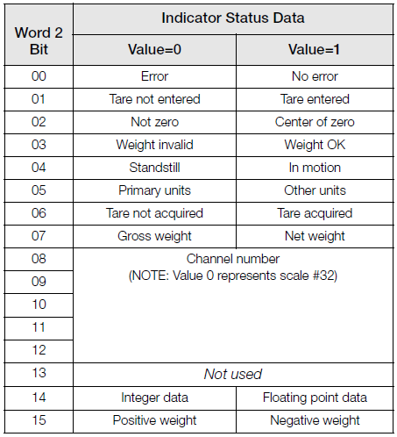

**Output Data From PLC to 1280**

|  |  |
| --- | --- |
| Output Number | Description |
| 1 | Commands  0= No Command  1 = Start  2 = Acknowledge  3 = Pause  4 = Abort   * PLC looks at the Center Of Zero Bit and then sets this to 0 if a Zero is acquired. |
| 2 | Communication status. The PLC will send back the same number that the 1280 is sending in Input #18.  This is the heart beat logic. System will wait 5 seconds before we will consider a loss of communications. |

Application Setup & Configuration

The S**etup** touch widget is password-protected and offers access to the following:

* Display Program Name & Version

|  |  |  |  |
| --- | --- | --- | --- |
| **Parameter** | **Default** | **Touch widget** | **Description** |
| System Password | “” | Setup Password | Changing the password that is required for entry into the Setup menu. Setting the password to nothing will cause the system to not prompt for a password when the[**Setup** **Menu** touch widget is pressed. |
| Filling Speeds | **Single-Speed /** Dual-Speed / Parallel Speed | Filling Speeds | Allows an operator to change the filling speed operation. |
| Filing Mode | **Gross/Net**  Dosing | Filling Mode | Displays the current mode whether it be Gross net Filling or Dosing |
| Refill Option (Dispensing/Dosing Mode) | **Enabled** / Disabled | Refill Option | Allows an operator to enable or disable the automatic refill option. |
| Slow Cycle Time | 20.0 Sec | Slow Cycle Time | Allows an operator to edit the Slow Cycle Time for dosing. |
| Auto Tare | **Enabled** / Disabled | Auto Tare | Allows an operator to enable/disable the auto tare feature. |
| Auto-Print | **Enabled** / Disabled | Auto-Print | Allows an operator to enable or disable the Auto-Print feature. |
| Discharging | **Enabled** / Disabled | Discharge | Allows an operator to Enable or Disable the discharge option. |
| Enable/Disable  Auto-Discharging | **Enabled** / Disabled | Auto-Discharge | Allows an operator to Enable or Disable the auto-discharge option. |
| Enable/Disable Container Photo Eye | **Disabled** / Enabled | Photo Eye | Allows an operator to Enable or Disable the container photo eye option. |
| Container Threshold | 3.0 lb | Container Threshold | Alloqs an operator to edit the Container Threshold Weight for filling and removing containers (primarily without discharge). |
| Delay After Discharge | 3.0 seconds | Delay After Discharge | Allows the operator to enter a time in seconds to delay after completion of Discharge before a new Start input is enabled. |
| Digital IO Testing | - | Digital IO Test | Allows an operator to turn on/off the digital outputs. Touch the corresponding square touch widget to toggle output. |
| Transaction Message | **Enabled** / Disabled | Trans Message | Sends a Transaction String out TCP Client 1 if enabled. |
| Clear Transaction |  | Clear Transaction | Allow an operator the ability to clear transaction database with yes no prompt. |
| Import / Export | - | Import / Export | Allows importing and exporting of databases |

* Display a weight widget-

Database Tables

***NOTE: System deletes 25% of oldest records when the database reaches maximum capacity.***

|  |  |  |
| --- | --- | --- |
| **Transactions (“Trans”) Database Table 5000 Records** | | |
| **Field** | **Type** | **Description** |
| Consec | Integer | Auto-Incrementing Consective Number |
| Target | Real | Target Weight |
| Dribble | Real | Dribble Weight |
| Preact | Real | Preact Weight |
| Actual | Real | Actual Dispensed Weight |
| CheckSum | String | Modulo 10 Check digit of transaction data. |
| DT | Date/Time | Time and Date of Transaction |

Hardware Setup

|  |  |
| --- | --- |
| **Option Card Locations** | |
| **Slot** | **Type** | |
| 1 | Single Channel A/D Card | |
| 2 | Ethernet IP Card | |

|  |  |  |  |
| --- | --- | --- | --- |
| **Digital I/O** | | | |
| **Slot** | **Bit** | **Type** | **Function** |
| 0 | 1 | Programmability | Start/Abort |
| 0 | 2 | Programmability | Emergency Stop |
| 0 | 3 | Programmability | Container in Place (to receive product if discharge enabled) |
| 0 | 4 | Output | Fast Fill / Fast Dispense |
| 0 | 5 | Output | Slow Fill / Slow Dispense |
| 0 | 6 | Output | Fill Complete / Dispense Complete |
| 0 | 7 | Output | Zero Tolerance |
| 0 | 8 | Output | Discharge / Refill |

|  |  |  |  |
| --- | --- | --- | --- |
| **Serial Port** | | | |
| **Port** | **Type** | **Description** | **Setup** |
| 1 | CMD | Printer | 9600,8,N,1 |
| 2 | CMD | *Currently Not Used* | 9600,8,N,1 |

|  |  |  |  |
| --- | --- | --- | --- |
| **Ethernet TCP/IP Port** | | | |
| **Port** | **Type** | **Description** | **Setup** |
| 10001 | CMD | Revolution Downloads | TCP Server |
| 10001 | CMD | Transaction Message Output (if enabled) | TCP Client 1 |
| 10002 | CMD | *Currently Not Used* | TCP Client 2 |
| 3000 | CMD | Web Server | Web Server |

|  |  |  |  |
| --- | --- | --- | --- |
| **USB Device Port** | | | |
| **Port** | **Type** | **Description** | **Setup** |
| 3 | CMD | Qwerty Keyboard (optional) | - |

|  |  |  |  |
| --- | --- | --- | --- |
| **USB Type-A Port** | | | |
| **Port** | **Type** | **Description** | **Setup** |
| - | CMD | *Currently Not Used* | - |
| - | CMD | *Currently Not Used* | - |

|  |  |  |  |
| --- | --- | --- | --- |
| **SD Card Slot** | | | |
| **Port** | **Type** | **Description** | **Setup** |
| - | CMD | 8GB Micro SD Card | Images |

Version Changes

|  |  |  |  |
| --- | --- | --- | --- |
| **Version** | **Changes** | **Date** | **Firmware** |
| 1.00 | * Initial Release | 06/15/2018 | 1.07 |
| 1.01 | * Lock Zero and Tare key after start is pressed | 06/19/2019 | 1.07 |
| 1.02 | * Added Check Digit to transaction db | 07/10/2020 | 1.07 |
| Download: **SC****NC** **TF** **SP** **W** **DB** **COD**  Add Image(s) To Micro SD Card Required?: **Yes** **No**  **SC =**  Standard Configuration **NC =**  Network Configuration **TF =**  Ticket Formats **SP =** Setpoints **W =**  Widgets  **DB =**  Database Tables **COD =** Program | | | |

Dealer Responsibilities

**Interfacing with other Contractors**

Should the distributor solicit the services of a third party organization to install or fabricate additional products or those products provided by Rice Lake Weighing Systems, prior arrangements must be made with Rice Lake Weighing Systems to review, direct or consult with the third party organization before and during the construction and installation process. This will serve to maintain the integrity of the warranty and special considerations between Rice Lake Weighing Systems and the distributor.

**Local Considerations**

All local environmental conditions described by the distributor must not change or deviate from the specification. In the event local conditions change or have been misrepresented; a non-refundable engineering charge (NRE) to redesign the product shall be enforced. Any changes to local conditions must be communicated in writing to Rice Lake Weighing Systems when applicable.

**System Installation and On-site Maintenance**

It is recommended by Rice Lake Weighing Systems that experienced qualified electricians install any and all products supplied by Rice Lake Weighing Systems. This is to provide maximum protection and total compliance with the National Electrical Code, state and local policies, and to ensure that OSHA safety regulations are followed.

Site labor is the responsibility of the distributor and any third party electrical contractors involved.

**After Sale Support and Service**

It is the responsibility of the distributor to provide front line service and support of the Rice Lake Weighing Systems provided product. Rice Lake Weighing Systems does not build these costs into our products and must rely on our customers to ensure that:

The equipment specified is properly matched to the end user application.

Skilled service and support is provided during the start-up, training and troubleshooting phases.

An adequate repair parts stock and tools to accomplish on-site repairs are carried in the repair vehicle.

The installer always inspects for shipping damage and accomplishes a functional bench check prior to proceeding to the end user site.

System Installation Assistance

The following rates apply to on-site installation assistance and training services provided by Rice Lake Weighing Systems-Engineered Product Development Department or Representatives.

|  |
| --- |
| **Rate Charge** |
| **Per Day Net Charge**  $1,320.00 per work day (not to exceed 8 work hours). Additional daily hours prorated at $247.50/ hour.  An additional 50% charge will be added for Saturday and Sunday services performed.  **Travel Expenses**  Cost between Rice Lake, Wisconsin and the Job location, regardless of mode of transportation.  **Travel Time**  Included in the per-day charge.  **Living Expenses**  At cost, to cover meals and lodging.  **Shipping Expense**  Cost for shipment of special equipment to and from job location. |

Terms and Conditions

**Financial Terms**

Our Financial Service Group reviews open account requests. Upon approval of open account terms, orders are subject to the terms listed on the actual quotation-pricing sheet.

**Discounts and Selling Price**

All custom system prices quoted are LIST and NET.

**Cancellations and Returns**

Cancellation of an order at any time after the acceptance of specification and receipt of a corresponding purchase order will result in forfeiture of the greater of the initial down payment or the balance of time and material accrued to date less any down payment.

Due to the “special” nature of each RLWS-EPD custom system, RLWS-EPD will not accept returns of any custom systems except as provided for in its Limited Warranty Statement.

1. PRICES

(a) Our prices are net 30 days F.O.B. our plant. Orders are subject to approval of our credit department with rights reserved to change or withdraw credit terms without notice and to terminate any orders when invoices for work done thereon have gone unpaid for 60 days.

(b) All prices quoted herein or otherwise represent our selling prices; any costs will be added which result from taxes, legal regulations or restrictions now in effect or which may be imposed in the future.

(c) This quotation is made upon the basis of the cost of materials and labor as of the date of this quotation. A change in such costs shall give us the right to alter our prices to reflect such changes in cost.

2. SHIPMENT, TITLE, RISK OF LOSS

(a) All shipments are F.O.B. point of shipment. Title and risk of loss or damage passes to Customer on delivery to carrier at Seller’s facility, except that title and risk of loss or damage as to Customer’s partially manufactured parts and raw materials delivered to Seller, and as to jigs, fixtures and tools specially ordered for Customer shall at all times remain with Customer.

(b) We do not carry fire insurance upon jigs, fixtures and tooling built by us for Customers or supplied to us by Customers, nor do we carry insurance upon raw materials supplied to us by Customers. Customers assume all risk of loss, damage or destruction of jigs, fixtures, tooling or raw materials belonging to Customer in our custody caused by fire, water, gas, acts of God, strikes, insurrection, riots or by acts of the civil or military authorities and whether or not such loss, damage or destruction was the result of our negligence or misconduct or that of our agents or employees. Customer agrees to indemnify and hold us harmless from all direct and consequential costs and damages resulting from such loss.

(c) Except as hereinabove stated, we agree to maintain all jigs, fixtures and tooling built by us in working condition for their normal life only, except that our liability in this respect shall not extend more than one year after the completion of the most recent production order.

3. QUANTITY, MATERIALS AND TOLERANCES

(a) Unless dimensions are limited by a specific tolerance, it is understood that the production variations as published by us will be acceptable.

(b) We will not be responsible for color, thickness variations, or flaws in sheets or parts from which fabrications are made, nor for other material variations beyond our control.

(c) We assume no responsibility for loss or damage occurring by reason of delay or inability to deliver caused by fires, strikes, accidents, embargoes, car shortages, delays of carriers, insurrection, riots, acts of the civil or military authorities, nor will we assume responsibility for any reason whatever for damages of any kind on account of failure to deliver at the time specified. Customer shall indemnify and hold us harmless from all

direct and consequential costs and damages resulting from such loss or delay.

(d) Unless otherwise specified, delivery of ten percent (10%) more or less of completed parts than the quantity specified shall constitute fulfillment of this order and any excess not exceeding 10 percent shall be accepted and paid for by Customer.

(e) In the event any raw material specified for incorporation into the product covered by this proposal shall become unavailable, we shall notify Buyer and Buyer may direct us to substitute available material for that originally specified, it being understood and agreed that Buyer shall assume any and all consequences resulting from such substitution.

4. PATENTS

If this quotation covers parts made specifically for the Customer, Customer agrees to indemnify and hold us harmless against any loss resulting from infringement of patents or trademarks, or from claims of such infringements and shall pay all legal and defense costs incurred by Seller in the defense of such actions.

5. SOFTWARE

Unless specifically otherwise stated, any and all software-associated or part of any product sold, loaned on trial or demonstration to Customer is to be considered proprietary to Rice Lake Weighing Systems. Customer agrees not to duplicate for distribution, attempt to copyright, sell or distribute in any way without the prior written consent of Rice Lake Weighing Systems.

6. CHANGES AND CANCELLATION: REJECTION, CLAIMS

(a) Orders placed with us are not subject to cancellation, change or reduction in amount, or suspension of deliveries except with our consent and upon terms that indemnify us against loss. Unless confirmed in writing, all verbal agreements are void.

(b) We will not be responsible for changes in design, deliveries or other instructions, unless they are furnished in writing. Customer agrees to pay for all tooling charges caused by changes in design or specifications.

(c) Samples submitted shall be deemed approved unless written rejection is received within two weeks of submission.

(d) Manufactured parts will be shipped and billed as they are produced.

(e) Claims for shortage or rejections for defects must be made within 10 days of receipt of goods. Credit will be rendered on such defective parts after we have had an opportunity to inspect them, provided they are returned to our factory, transportation charges prepaid, within 30 days, and provided they have not been altered or defaced in any way.

7. TOOLING AND DESIGNING

(a) In consideration of the engineering service necessary in the designing of jigs, fixtures and tooling not being charged for, but being quoted on the basis of labor and material only, and not at their fair market value,

such jigs, fixtures and tooling shall remain in our possession for at least one year. Thereafter, the Customer desiring delivery of such jigs, fixtures and tooling shall pay an engineering charge of fifty percent (50%) of the original price of said jigs, fixtures and tooling and accept same as is.

(b) When requested, we will submit suggestions concerning design and construction of parts, but we will not accept responsibility of liability for the practicability of these suggestions if adopted by the Customer.

8. DELIVERY AND ADJUSTMENT TO PRICE

(a) If the Buyer requests that the goods be manufactured and shipped on a date (or dates) earlier than originally agreed to by us and Buyer, and we agree to the earlier date (or dates), any increase in the cost of performance incurred by us resulting from earlier manufacture and shipment will be included in an adjustment of the purchase price to be made by us and will be paid by the Buyer.

(b) Should shipments be held beyond scheduled date for convenience of the Buyer, goods will be billed and charges will be made for warehousing, trucking, and other expenses incident to such delay. Reasonable and sufficient care is taken by us in crating its goods. We cannot be held responsible for breakage after having received “in good order” receipts from the transportation carrier. All claim for loss and damage must be made by Buyer to the carrier, but we will assist insofar as practical in securing satisfactory adjustment of such claims.

9. PAYMENT AND LIENS

(a) All invoices shall be due and payable when submitted for payment in accordance with the revisions of our terms. No withholding of funds, back charges or credits against amounts otherwise due us will be permitted unless specifically agreed to in writing by us. Settlement of any amounts due Buyer will be negotiated as separate items and not as offsets against amounts otherwise due us from Buyer for products sold hereunder.

(b) Any unpaid account for work done shall constitute a lien on any jigs, fixtures, manufactured parts and raw materials in our possession. In the event any account remains open and unpaid for 90 days, we reserve the right to use the Customer’s jigs and fixtures to make parts therefrom, and to sell or dispose of manufactured parts and raw materials.

(c) Buyer shall not assign or transfer any rights or obligations arising from this proposal, or monies payable thereunder, without the prior written consent of us, and any such assignment or transfer made without such written consent shall be deemed null and void.

10. ADDITIONAL PROVISIONS

(a) Errors—Stenographic and clerical errors are subject to correction.

(b) These terms and conditions constitute the entire contract between Buyer and us, transcending any oral arrangements or representations which may be inconsistent therewith.

(c) This quotation is made under and shall be governed by the laws of the State of Wisconsin.

11. WARRANTY AND LIMITATION OF LIABILITY

For products supplied without prior approval of a sample by Customer, Seller warrants components manufactured or supplied by it to be free from defects in material and workmanship when shipped from Seller’s facility. If parts shall be proved to Seller’s satisfaction to be defective, such parts shall, at Seller’s sole option, be repaired or replaced. This warranty shall not apply:

(a) to components supplied by Customer;

(b) to goods or parts and components therefor which have been subjected to negligence, accident or damage by circumstances beyond the control of Seller and, in particular, to damage incurred as a result of the prolonged or improper storage by the Customer.

For products supplied after prior approval of a sample by Customer, Seller warrants that all parts supplied will be substantially identical to such sample. The warranty on sampled parts is subject to the same restrictions as that set forth above with respect to non-sample products.

THE FOREGOING WARRANTIES ARE EXCLUSIVE AND IN LIEU OF ALL OTHER EXPRESS AND IMPLIED WARRANTIES WHATSOEVER, INCLUDING BUT NOT LIMITED TO IMPLIED WARRANTIES OF MERCHANTABILITY AND FITNESS FOR A PARTICULAR PURPOSE. SELLER SHALL NOT BE SUBJECT TO ANY OTHER OBLIGATIONS OR LIABILITIES WHATSOEVER WITH RESPECT TO PARTS MANUFACTURED OR SUPPLIED BY SELLER OR SERVICES RENDERED BY IT. ANYTHING HEREIN TO THE CONTRARY NOTWITHSTANDING, SELLER SHALL NOT BE LIABLE FOR INCIDENTAL AND CONSEQUENTIAL DAMAGES, AND IN SUBSTITUTION FOR ALL REMEDIES WHICH BUYER MAY HAVE UNDER ANY APPLICABLE LAW. BUYER’S SOLE AND EXCLUSIVE REMEDY AGAINST SELLER FOR ANY BREACH OF WARRANTY OR ANY OTHER BREACH RELATING TO GOODS DELIVERED PURSUANT HERETO SHALL BE FOR REPAIR OR REPLACEMENT (AT SELLER’S OPTION) OF THE GOODS OR PARTS EFFECTED BY SUCH BREACH.

Warranty Statements

**Hardware Warranty Statement**

Rice Lake Weighing Systems (RLWS) warrants that all RLWS brand equipment and systems properly installed by a Distributor or Original Equipment Manufacturer (OEM) will operate per written specifications as confirmed by the Distributor/OEM and accepted by RLWS. All systems and components are warranted against defects in materials and workmanship for one (1) year, unless otherwise stated.

RLWS warrants that the equipment sold hereunder will conform to the current written specifications authorized by RLWS. RLWS warrants the equipment against faulty workmanship and defective materials. If any equipment fails to conform to these warranties, RLWS will, at its option, repair or replace such goods returned within the warranty period subject to the following conditions:

Upon discovery by Buyer of such non-conformity, RLWS will be given prompt written notice with a detailed explanation of the alleged deficiencies.

Individual electronic components returned to RLWS for warranty purposes must be packaged to prevent electrostatic discharge (ESD) damage in shipment. Packaging requirements are listed in a publication, "Protecting Your Components From Static Damage in Shipment,” available from RLWS Equipment Return Department.

Examination of such equipment by RLWS confirms that the non-conformity actually exists, and was not caused by accident, misuse, neglect, alteration, improper installation, improper repair, or improper testing. RLWS shall be the sole judge of all alleged non-conformities.

Such equipment has not been modified, altered, or changed by any person other than RLWS or its duly authorized repair agents.

RLWS will have a reasonable time to repair or replace the defective equipment. Buyer is responsible for shipping charges both ways

In no event will RLWS be responsible for travel time or on-location repairs, including assembly or disassembly of equipment. Nor will RLWS be liable for the cost of any repairs made by others.

THESE WARRANTIES EXCLUDE ALL OTHER WARRANTIES, EXPRESSED OR IMPLIED, INCLUDING WITHOUT LIMITATION WARRANTIES OF MERCHANTABILITY OR FITNESS FOR A PARTICULAR PURPOSE. NEITHER RLWS NOR DISTRIBUTOR Will, IN ANY EVENT, BE LIABLE FOR INCIDENTAL OR CONSEQUENTIAL DAMAGES.

RLWS AND BUYER AGREE THAT RLWS' SOLE AND EXCLUSIVE LIABILITY HEREUNDER IS LIMITED TO REPAIR OR REPLACEMENT Of SUCH GOODS. IN ACCEPTING THIS WARRANTY, THE BUYER WAIVES ANY AND ALL Other CLAIMS TO WARRANTY.

SHOULD THE SELLER BE OTHER THAN RLWS, THE BUYER AGREES TO LOOK ONLY TO THE SELLER FOR WARRANTY CLAIMS.

No terms, conditions, understanding, or agreements purporting to modify the terms of this warranty shall have any legal effect unless made in writing and signed by a corporate officer of RLWS and the Buyer.

**Software Warranty Statement**

Rice Lake Weighing Systems (RLWS) warrants that (a) the software will perform in accordance with the accompanying printed materials for a period of ninety (90) days from the date of receipt. And (b) any hardware accompanying the software will be free from defects in materials and workmanship under normal use and service for a period of one (1) year from the date of receipt.

This Limited Warranty is void if failure of the software or hardware has resulted from accident, abuse, misapplication, or incorrect customer specification. Any replacement software will be warranted for the remainder of the original warranty period or thirty (30) days, whichever is longer.

If the software fails to conform to these warranties, RLWS will at its option, repair or replace such goods returned within the warrant period subject to the following conditions:

Upon discovery by Buyer of such non-conformity, RLWS will be given prompt written notice with a detailed explanation of the alleged deficiencies.

Examination of software by RLWS confirms that the non-conformity actually exists, and was not caused by accident, misuse, neglect, alteration, improper installation, improper repair, improper testing, or incorrect customer specification. RLWS shall be the sole judge of all alleged non-conformities.

RLWS will have a reasonable time to repair or replace the software. Buyer is responsible for shipping charges both ways.

In no event will RLWS be responsible for travel time or on-location repairs, including assembly or disassembly of equipment. Nor will RLWS be liable for the cost of any repairs made by others.

THESE WARRANTIES EXCLUDE ALL OTHER WARRANTIES, EXPRESSED OR IMPLIED, INCLUDING WITHOUT LIMITAION WARRANTIES OF MERCHANTABILITY OR FITNESS FOR A PARTICULAR PURPOSE. NEITHER RLWS NOR DISTRIBUTOR WILL, IN ANY EVENT, BE LIABLE FOR INCIDENTAL OR CONSEQUENTIAL DAMAGES.

RLWS AND BUYER AGREE THAT RLWS’ SOLE AND EXCLUSIVE LIABILITY HEREUNDER IS LIMITED TO REPAIR OR REPLACEMENT OF SUCH GOODS. IN ACCEPTING THIS WARRANTY, THE BUYER WAIVES ANY AND ALL OTHER CLAIMS TO WARRANT.

SHOULD THE SELLER BE OTHER THAN RLWS, THE BUYER AGREES TO LOOK ONLY TO THE SELLER FOR WARRANTY CLAIMS.

No terms, conditions, understanding or agreements purporting to modify the terms of this warranty shall have any legal effect unless made in writing and signed by a corporate officer of RLWS and the Buyer.

**System Acceptance**

Please review this detailed specification very carefully. Note any corrections or additions and fax to my attention. Be aware that subsequent changes could affect the stipulated price. If the project specification is acceptable, signatures are required from representatives of both the Rice Lake Weighing System's Distributor and the End User/Customer before we will continue with this project. **NOTE: The project/lead time will not be started UNTIL the specification signoff is completed and returned.** Please complete and return the ***entire*** document via Fax: **715-234-6967**

**RLWS Sales Engineer Sign Off**



**RLWS Distributor Sign Off**

Company Name: ______________________ Phone: (____)______________

Address: ___________________________ Fax: (____)______________

City: __________________________________State: ______Zip: ______

Name: ______________________Position: __________________________



**End User/Customer Sign Off**

Company Name: ______________________ Phone: (____)______________

Address: ___________________________ Fax: (____)______________

City: __________________________________State: ______Zip: ______

Name: ______________________Position: __________________________

