## 1280 Recipe Batching

### Software User Guide

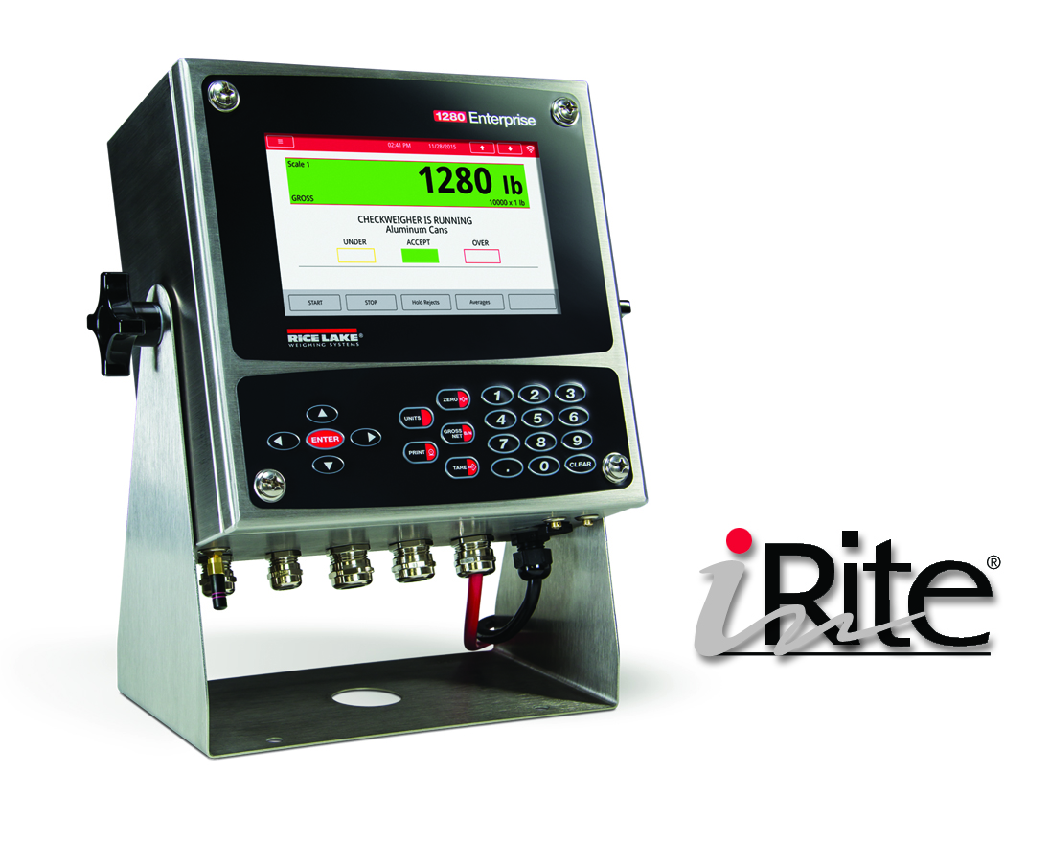

**Scope**

The 1280 Recipe Batching application is included with the 1280 standard firmware and is loaded by importing the application from the Configuration menu “Import Files”.

Sequence of Operation

The buttons on powerup and exit configuration are **Setup** **Menu**.

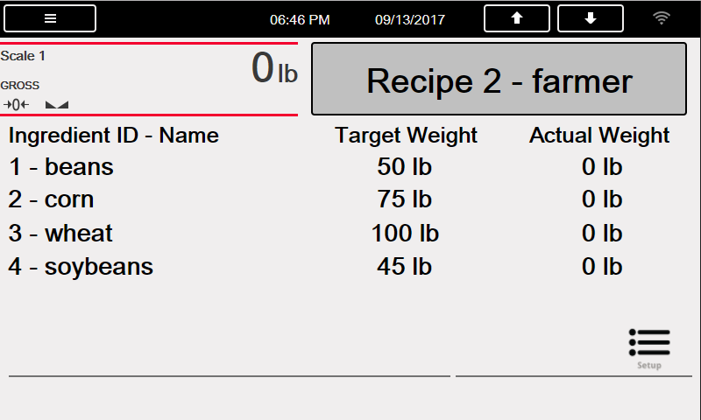**Recalling the Recipe**

1. Operator presses the **Recipe** button
2. System prompts – “Enter Recipe ID”
3. Operator enters the RECIPE ID and presses the **ENTER** key.
4. System queries the RECIPE database table and performs one of the following:
   1. ID NOT FOUND
      1. Prompts – “Recipe NOT Found - Retry”
   2. ID FOUND
      1. Recalls all of the recipe information and updates the display.

**Processing a Batch**

* 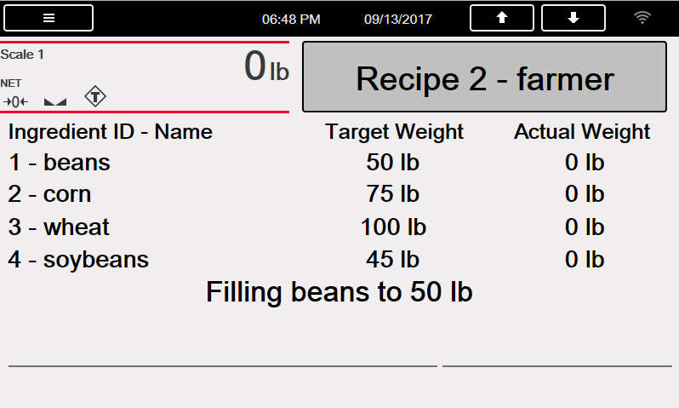System stops the batch if the **Emergency Stop Mushroom** input is OFF while running a batch and turns off ALL outputs.
* If **Emergency Stop Mushroom** input is ON and pressing the **Abort-Run-Start** button during a paused batch will cause the system to restart the batch at the paused step.
* If **Emergency Stop Mushroom** input is OFF and pressing the **Abort-Run-Start** button during a paused batch will abort and exit the batching sequence. System will not store or print any data.

1. Scales is empty and sitting at zero.
2. Operator performs the **Recalling the Recipe** procedure if the displayed recipe is incorrect.
3. Operator pulls out the **Emergency Stop Mushroom** switch and momentarily turns the **Abort-Run-Start** switch to **Start**.
4. System verifies the weight is below the **Empty Weight** value.
5. System tares the scale.
6. System activates the output for the 1st ingredient until its **Target Weight – Preact Weight** value is met.
7. System captures and records the stable weight of the just added ingredient.
8. System returns to STEP 5 if there are more ingredients left; otherwise it continues with STEP 9.
9. System activates the **Discharge Scale** output until the weight drops below the **Empty Weight** value. It then maintains the output for the **Discharge Time**. Setting the **Discharge Time** to *Zero* will skip to STEP 10 and not perform a discharge.
10. System prints a Ticket and returns to STEP 1.

Serial Communications – Tickets, PC

**Batch Ticket**

Recipe ID: 1

Recipe Name: Fall Blend

Ingredient Target Actual

-----------------------------------

Corn 200 lb 192 lb

Winter Wheat 300 lb 323 lb

Chicory 222 lb 318 lb

Total 722 lb 833 lb

Printed @ 09:36AM 09/15/2014

The program uses the Auxiliary Print Format #1, 2 and 3 so that the dealer may modify the print format thru the 920i front panel or by using iRev PC software.

Application Setup & Configuration

The **Setup Menu** button is password-protected and offers access to the following:

* Display Program Name & Version
* Display a weight widget

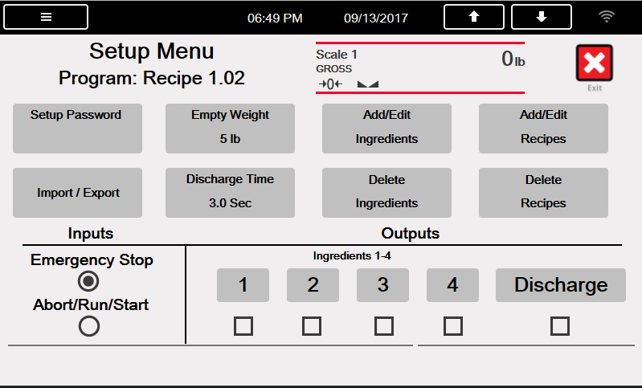

|  |  |  |  |
| --- | --- | --- | --- |
| **Parameter** | **Default** | **Button** | **Description** |
| System Password | “” | Setup Password | Changing the password that is required for entry into the Setup menu. Setting the password to nothing will cause the system to not prompt for a password when the [**Setup Menu**] softkey is pressed. |
| Empty Weight | 5.0 lb | Empty Weight | Minimum amount of weight to recognize the scale is empty. |
| Discharge Time | 3.0 sec | Discharge Time | Length of time the discharge output remains on after reaching the empty weight. |
| Import/Export | - | Import/Export | Used to export database to micro SD or USB driver. |
| Add/Edit Ingredients | - | Add/Edit Ingredients | Ability to add/edit ingredients from the INGREDIENT database table. |
| Delete Ingredient | - | Delete Ingredients | Ability to delete ingredients from the INGREDIENT database table. |
| Add/Edit Recipes | - | Add/Edit Recipes | Ability to add/edit Recipes from the RECIPE database table. |
| Delete Recipe | - | Add/Edit Recipes | Ability to delete Recipe from the RECIPE database table. |
| Digital IO Testing | - | Ingredients 1/2/3/4  Discharge | Ability to turn off and on digital outputs. |

Application Setup & Configuration

* Pressing the scale widget on the main screen will go to a screen where you can used the main keypad

keys.

* Pressing the Exit button will go back to the main screen.

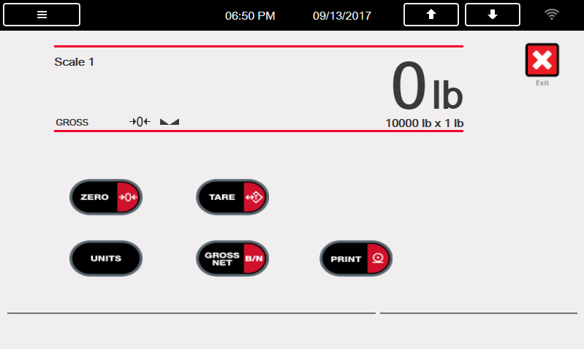

Database Tables

|  |  |  |
| --- | --- | --- |
| **RECIPE (“RECIPE”) Database Table – 200 Records** | | |
| **Field** | **Type** | **Description** |
| ID | Integer | Unique numeric recipe identifier |
| Name | String | Recipe name – up to 15 characters |
| Ingred1 | Integer | Ingredient #1 Number |
| Target1 | Real | Ingredient #1 Target Weight |
| Ingred2 | Integer | Ingredient #2 Number |
| Target2 | Real | Ingredient #2 Target Weight |
| Ingred3 | Integer | Ingredient #3 Number |
| Target3 | Real | Ingredient #3 Target Weight |
| Ingred4 | Integer | Ingredient #4 Number |
| Target4 | Real | Ingredient #4 Target Weight |

|  |  |  |
| --- | --- | --- |
| **INGREDIENT (“INGRED”) Database Table – 4 Records** | | |
| **Field** | **Type** | **Description** |
| ID | Integer | Unique numeric ingredient identifier (1-4 & Ingredient Output) |
| Name | String | Ingredient name – up to 15 characters |
| Preact | Real | Preact weight |

Hardware Setup

|  |  |
| --- | --- |
| **Option Card Locations** | |
| **Slot** | **Type** | |
| 1 | Single Channel A/D Card | |
| 2-6 | Currently Not Used | |

|  |  |  |  |
| --- | --- | --- | --- |
| **Digital I/O** | | | |
| **Slot** | **Bit** | **Type** | **Function** |
| 0 | 1 | Programmability | Batch Abort-Run-Start switch |
| 0 | 2 | Programmability | Batch Emergency Stop Mushroom switch |
| 0 | 3 | Output | Ingredient 1 Output |
| 0 | 4 | Output | Ingredient 2 Output |
| 0 | 5 | Output | Ingredient 3 Output |
| 0 | 6 | Output | Ingredient 4 Output |
| 0 | 7 | Output | Discharge Output |
| 0 | 8 | Output | Currently Not Used |

|  |  |  |  |
| --- | --- | --- | --- |
| **Serial Port** | | | |
| **Port** | **Type** | **Description** | **Setup** |
| 1 | CMD | Ticket Printer | 9600,8,N,2 |
| 2 | CMD | Currently Not Used | 9600,8,N,2 |

**Version Changes**

|  |  |  |  |
| --- | --- | --- | --- |
| **Version** | **Changes** | **Date** | **Firmware** |
| 1.00 | * Initial Release | 3/1/2015 | 1.00 |
| 1.01 | * Added Import/Export option. * Added Setup Menu touch buttons. * Added Recipe select button | 12/06/2016 | 1.04 |
| 1.02 | * Remved softkeys and made touch buttons | 05/15/2017 | 1.06 |
| Download:  **SC**  **N**  **TF**  **SP**  **W**  **DB**  **COD**  **SC =**  Standard Configuration **N** = Network Configuraiton **TF =**  Ticket Formats **SP =** Setpoints  **W =**  Widgets **DB =**  Database Tables **COD =** Program | | | |