1280 Checkweigher

Software User Guide

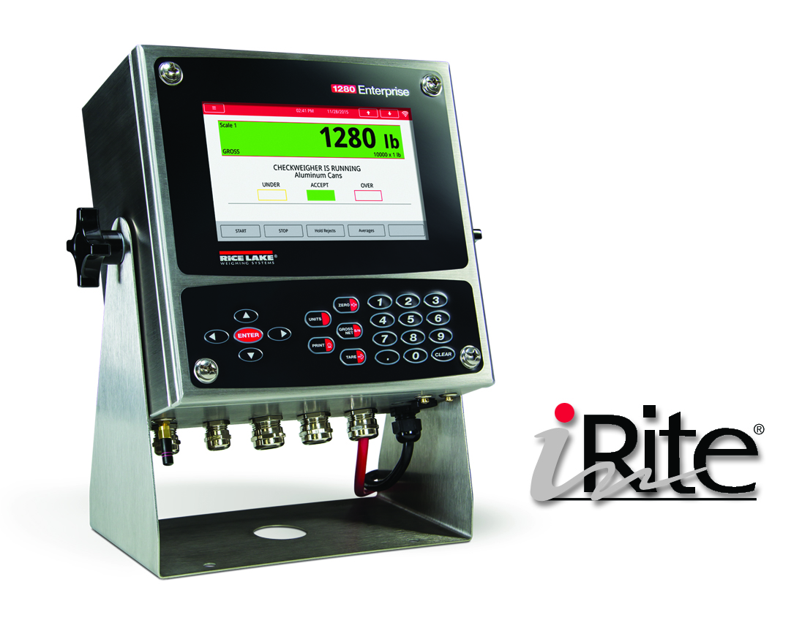
Scope
The 1280 Checkweigher application is included with the 1280 standard firmware and is loaded by importing the application from the Configuration menu “Import Files”. This application is a static checkweigher with a stored low and high weight associated with an ID. A digital output will be activated based on under, accept or over, and stores the ID, weight, status (under, accept, over), and time/date in a database.
Sequence of Operation
The touch buttons on powerup and exit configuration are Setup and ID.
Select an ID
- Operator presses the ID button.
- System prompts - “Enter ID to Checkweigh”.
- Operator enters the ID and presses the ENTER/DONE key.
- System does one of the following:
  - CW-90 WeighVault Enabled
    - System queries the CW-90 WeighVault over the Ethernet TCP/IP interface and performs one of the following:
      - ID FOUND
        - Sets the TARE and updates the display with the recalled ID information (ID, Description 1, Tare Weight, Under Weight and Over Weight). The operator can override the tare but it will not reflect in the tare display widget.
      - ID NOT FOUND
        - Displays – “ID NOT Found – Contact Office”
      - ERROR RETREIVING INFORMATION
        - Displays – “Error Retrieving Information”
      - NO COMMUNCTION WITH WEIGHVAULT
        - Displays – “Network Problems – Contact Office”
  - CW-90 WeighVault Disabled
    - System queries the PART database table and performs one of the following:
      - ID FOUND
        - Recalls the Name, Low and High values.
      - ID NOT FOUND
        - Displays – “ID NOT Found - Retry”.
        - Goes back to STEP 3.
- Systems waits for the Threshold Weight to be triggered.

Checkweigh
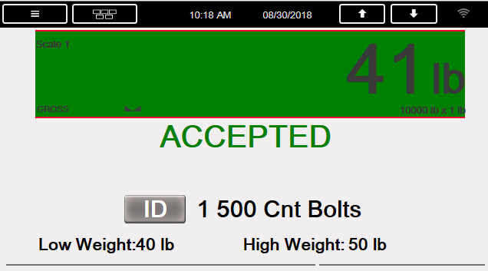
- When the weight exceeds the Threshold Weight the indicator verifies a ID is selected.
- System captures the live net weight.
  - Weight < Low Weight
    - Displays “UNDER”.
    - Turns on the Under output.
  - Weight > High Weight
    - Displays “OVER”.
    - Turns on the Over output.
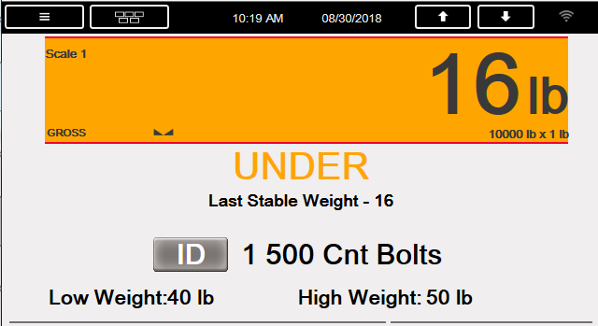
  - Weight > Low Weight and Weight < High Weight
    - Displays “ACCEPTED”.
    - Turns on the Accept output.
  - If weight is stable the weight is temporarily stored in a register and displayed on the screen.
- STEP 2 is repeated until the operator presses the PRINT button or removes the item dropping below the Threshold Weight.
  - PRINT key
    - Captures stable net weight
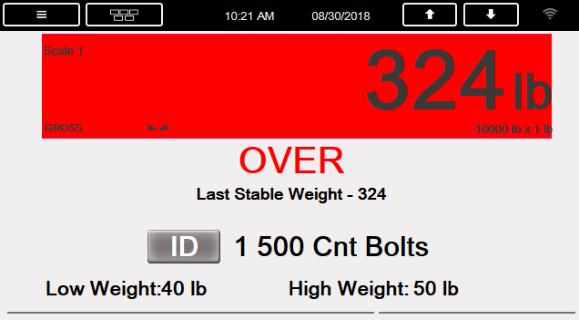
    - Turns on corresponding output
    - Updates the display
    - CW-90 WeighVault Enabled
      - Sends information to Weigh Vault. The data is NOT stored to the local transaction database. System does not verify if the data was successfully sent to WeighVault.
    - CW-90 WeighVault Disabled
      - A record will be stored to the database with the ID, the weight, the status (U, A, O) and time/date. It is the operators responsibility to maintain the Transaction Database. The program does not delete if full.
    - Prints a ticket.
    - When the weight goes under the Threshold Weight the display status will clear (but the ID, Low and High values will remain) and all digital outputs will turn off.
  - Weight < Threshold Weight (Item Removed)
    - The display will clear (but the ID, Low and High values will remain) and all digital outputs will turn off.
    - CW-90 WeighVault Enabled
      - Sends information to Weigh Vault (ID, the last stored weight, the status (U, A, O) and time/date). The data is NOT stored to the local transaction database. System does not verify if the data was successfully sent to WeighVault.
    - CW-90 WeighVault Disabled
      - A record will be stored to the database with the ID, the last stored weight, the status (U, A, O) and time/date. It is the operator’s responsibility to maintain the Transaction Database. The program does not delete if full.
    - If the Auto Print feature is ON (default is ON), a ticket will print (see Serial Communications below)
Serial Communications – Tickets, PC
The program uses the Auxiliary Print Format #1 so that the dealer may modify the print format thru the 920i front panel or by using Revolution PC software.
ID: 555
Gross: 0.25 lb
ACCEPTED

1/1/2015 01:00 PM

Application Setup & Configuration
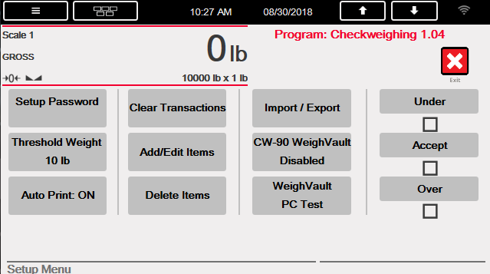
The Setup button is password-protected and offers access to the following:
- Display Program Name & Version
- Display a weight widget

Parameter | Default | Button | Description
System Password | “” | Setup Password | Changing the password that is required for entry into the Setup menu. Setting the password to nothing will cause the system to not prompt for a password when the Setup button is pressed.
Threshold Weight | 10 lb | Threshold Weight | This is the weight that when exceeded the system checks that an ID is selected and if so it waits for standstill before reading the weight and categorizing it based on Low and High weight. This is the same weight that when the weight goes below it clears out the last weighment information and turns off the output.
Auto Print Feature | On / Off | Auto Print | Allows an operator to enable/disable the auto print feature.
Clear Transactions | - | Clear Transactions | Allows the operator to clear the transaction database with Yes/No option.
Add/Edit Items |  | Add/Edit Items | Allows an operator to add or edit stored IDs with associated Low and High weight values.
Delete Items |  | Delete Times | Allows an operator to delete stored IDs that are no longer used.
Import/Export | - | Import/Export | Used to export database to micro SD or USB driver.
Digital IO Testing | - | Under / Accept / Over | Ability to turn off and on digital outputs.
CW-90 WeighVault Option | Enabled/  Disabled | CW-90 WeighVault | Ability to enable and disable communication with CW-90 WeighVault.
Weigh Vault Communications Test | - | WeighVault PC Test | Test the communications with WeighVault.

Database Tables
Item Database 100 (Only used when WeighVault Disabled)
Field | Type | Description
ID | String | Item ID
Name | String | Item Name
Low | Real | Low weight that when below the weighment is marked UNDER
High | Real | High weight that when above the weighment is marked OVER

Transaction Database 10,000 (Only used when WeighVault Disabled)
Field | Type | Description
ItemID | String | Item ID
ItemName | String | Item Name
Weight | Real | Actual weight stored after standstill (Net Weigh)
Status | String | U, A or O based on weight vs Low and High stored weights
DT | DateTime | Time and date of transaction

Hardware Setup
Option Card Locations
Slot | Type
1 | Single Channel A/D Card
2-6 | Currently Not Used

Digital I/O
Slot | Bit | Type | Function
0 | 1 | Output | UNDER
0 | 2 | Output | ACCEPT
0 | 3 | Output | OVER
0 | 4 -8 | Off | Currently Not Used

Serial Port
Port | Type | Description | Setup
1 | CMD | Serial Printer | 9600,8,N,2
2 | CMD | Currently Not Used | 9600,8,N,2

Version Changes
Version | Changes | Date | Firmware
1.00 | - Initial Release | 3/1/2015 | 1.01
1.01 | - Added WeighVault Option.  - Added Import/Export option.  - Added Setup Menu touch buttons.  - Added Clear Transactions option.  - Added ID button. | 12/06/2016 | 1.04
1.02 | - Fixed some setup menu variables to convert to the right type |  | 1.05
1.03 | - Removed softkey | 04/11/2017 | 1.06
1.04 | - Added ability to update display and output all the time when above threshold unless the PRINT key is pressed. | 08/30/2017 | 1.09
Download: SC NC TF SP W DB COD
SC = Standard Configuration NC = Network Configuration TF = Ticket Formats SP = Setpoints
W = Widgets DB = Database Tables COD = Program

