Subtree Modularization of an Agentic Security-Analysis System
Empirical analysis of the b1-batch-autogen study (81 successful runs, one per CVE), grounded entirely in the event store. Each run decomposes a CVE-reproduction task into a tree: a Boss root spawns four phase modules — Builder, Exploiter, Fixer, Reporter — each a subtree of worker agents. We reconstruct each run's interaction graph from the events and measure, with software-architecture metrics, how modular the execution is.

1. Data & scope
stage | runs | note
B1 manifests | 124 | all runs tagged study_id=b1-batch-autogen
unique CVEs (de-duplicated) | 112 | one run per CVE instance; 12 repeat runs dropped
analyzed (success, complete tree) | 81 | primary stratum; all 4 modules present

Source of truth is the Postgres event store; membership, run-id triangulation, and one-run-per-CVE de-duplication are enforced mechanically. Extraction of file touches was validated against on-disk diffs (Fixer patch-file recall ≈ 0.99).

2. Definitions (with a worked example)
These are operationalizations computed from agent events — inspired by, but not identical to, the textbook software-engineering metrics. Each is illustrated with one representative run, exiv2.cve-2017-14857 (20 nodes, 37 interaction edges, Q = 0.44, recovery NMI = 0.89).
Node / Module — A node is one agent (an event aggregate). Its module is the phase it belongs to, found by walking up to its depth-1 ancestor (the Boss's direct child) and reading that ancestor's [Builder]/[Exploiter]/[Fixer]/[Reporter] task prefix.
- Example: In exiv2.cve-2017-14857: 20 nodes — a Boss, four module managers, and 15 workers split across the modules.
Interaction graph — One vertex per node; an undirected edge weighted by how much two nodes interact = (#messages between them: parent→child briefings + child→parent reports) + (#producer→consumer file dependencies between them). Every coupling/modularity number is computed on this graph; the DSM figures draw it as a matrix.
- Example: In exiv2.cve-2017-14857: 37 weighted edges over the 20 nodes.
Dataflow edge (producer→consumer) — The behavioral dependency: if node A writes a file and node B later reads that same file (B≠A), record a directed edge A→B ("B used what A produced").
- Example: In exiv2.cve-2017-14857: 5 cross-module edges, all Exploiter→Fixer — the Exploiter wrote /src/exiv2/src/image.cpp and an analysis note, and the Fixer read them.
Cohesion vs coupling — Cohesion = total interaction-edge weight inside a module (its nodes talking to each other). Coupling = total edge weight between two different modules. Coupling ratio = coupling/(cohesion+coupling): the fraction of a module's interaction that crosses its boundary.
- Example: In exiv2.cve-2017-14857: the Exploiter has cohesion 18 vs coupling 5 (ratio 0.22); the Fixer 20 vs 5 (0.20) — each talks to itself far more than to others.
Modularity Q + recovery (NMI/ARI) — Q (Newman) scores how much edge weight falls inside the prescribed modules versus a random graph of the same degrees (>0 = clustered; ~0.3–0.7 = modular). Recovery asks the harder question: if we did NOT know the modules, would unsupervised clustering of the graph rediscover them? NMI and ARI (0–1, name-invariant) measure that agreement; a random-relabel baseline is the chance floor.
- Example: In exiv2.cve-2017-14857: Q = 0.44, and clustering recovers the four modules at NMI = 0.89 / ARI = 0.88.
Instability I — Per module, using only cross-module dataflow: Ca = #edges where the module is the WRITER (others depend on it ⇒ a stable producer); Ce = #edges where it is the READER (it depends on others ⇒ unstable). I = Ce/(Ca+Ce): 0 = pure producer, 1 = pure consumer.
- Example: In exiv2.cve-2017-14857: the Exploiter is a pure producer (Ca=5, Ce=0, I=0.0) and the Fixer a pure consumer (Ca=0, Ce=5, I=1.0) — exactly the prescribed Exploiter→Fixer dependency.
Permutation null — To test whether low coupling is below chance, we shuffle which module each node belongs to (keeping module sizes) 1000× and recompute the cross-module dataflow fraction; z = (observed − shuffled mean)/sd, with z≪0 meaning more self-contained than random.
- Example: In exiv2.cve-2017-14857: 5 of 19 dataflow edges cross modules (fraction 0.26 — the statistic the null operates on), well under the shuffled-label mean.
Global-context write — An entry a worker publishes to the shared blackboard: a DecisionRecorded (key→value+rationale) or ArtifactStored (key→description), attributed to the author's module. Measures reliance on shared state.
- Example: In exiv2.cve-2017-14857: 78 writes — Exploiter 38, Fixer 26, Builder 11, Reporter 3.

3. Figures

Role-resolved interaction DSM (all-runs average)
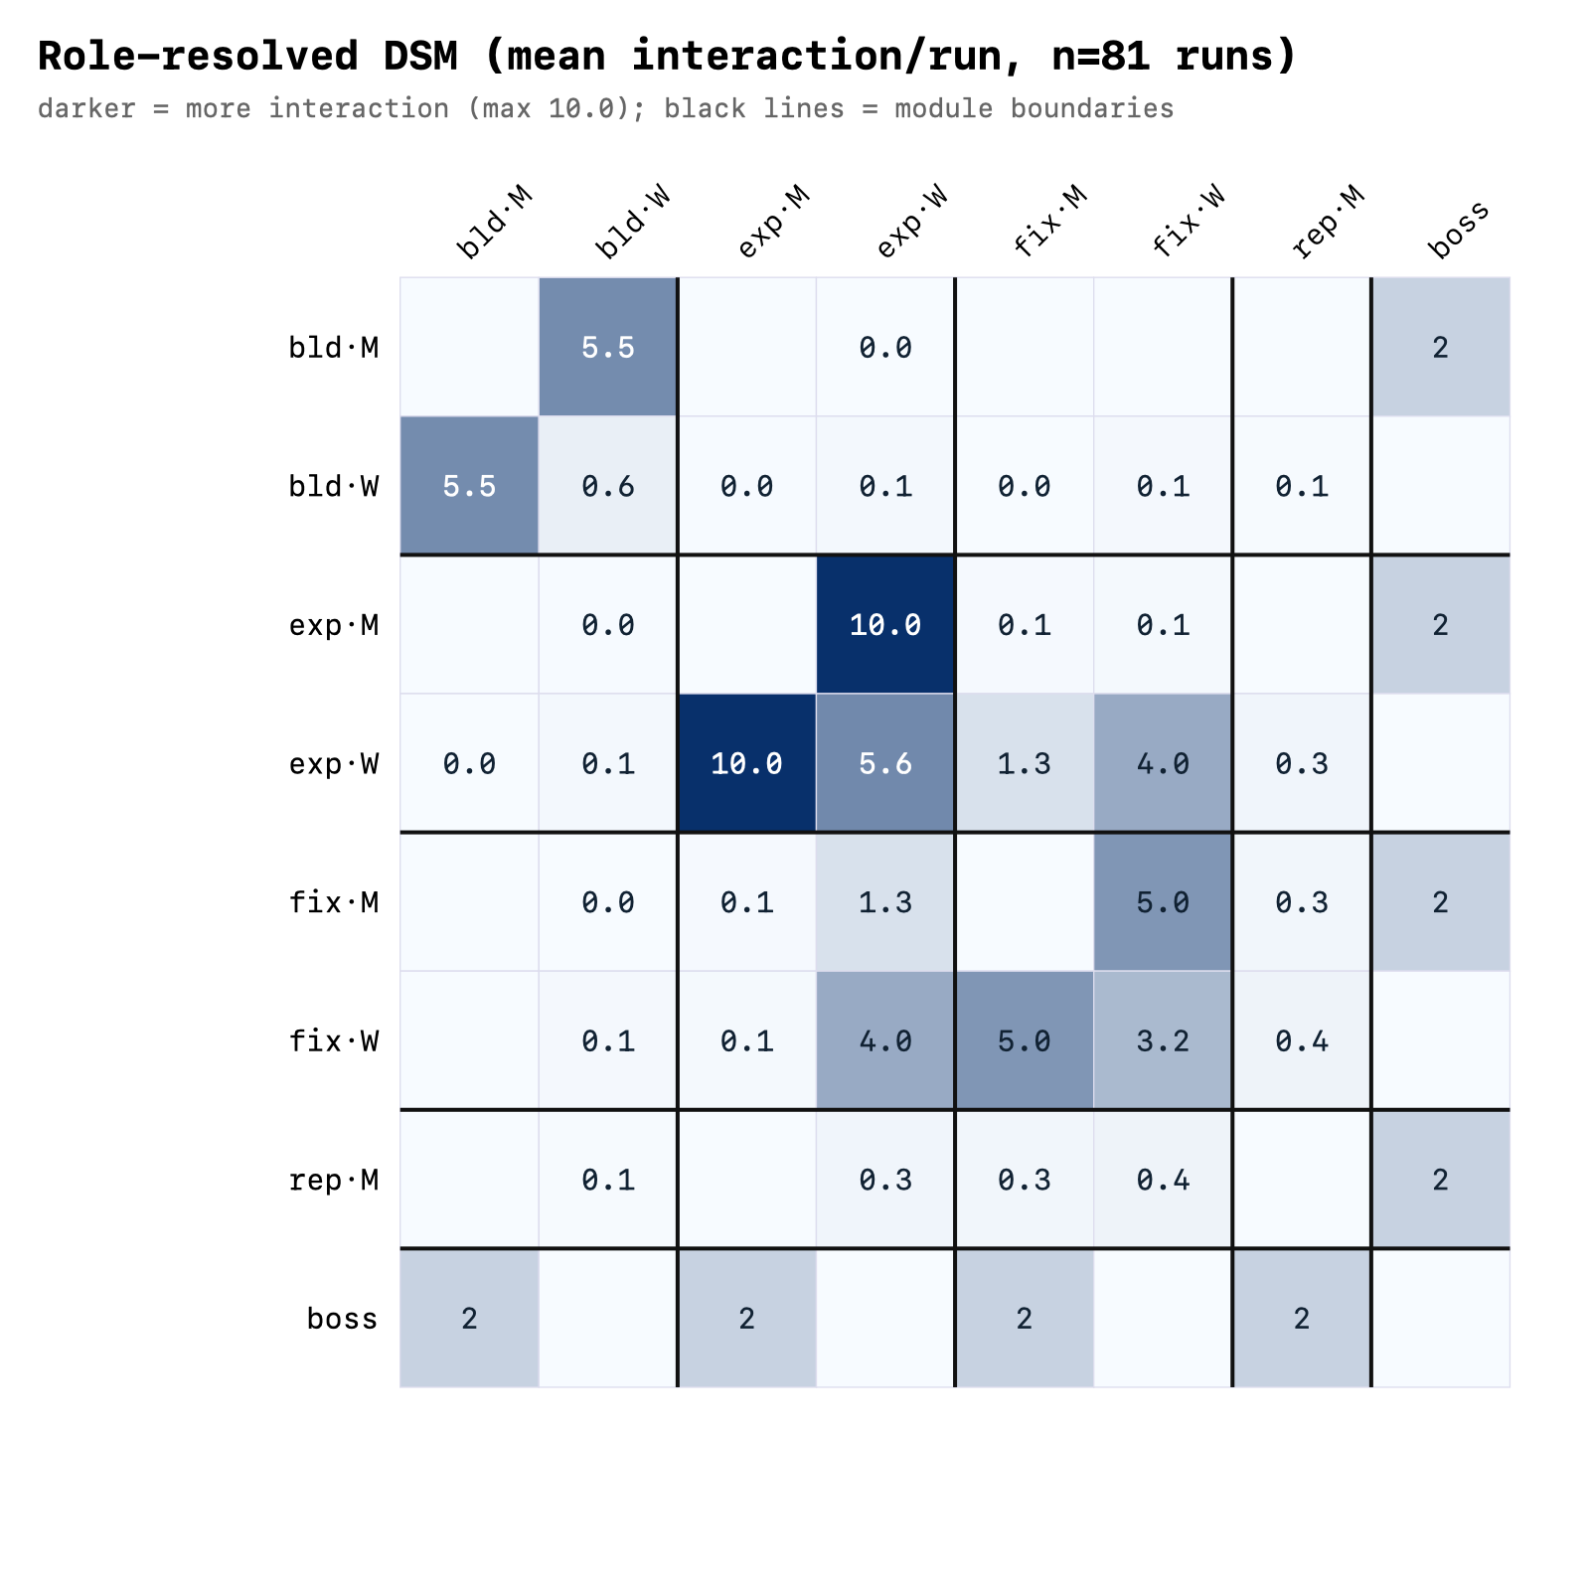
Legend. Rows and columns are role slots, one per (module, tier): **bld·M / bld·W** = Builder manager-tier / worker-tier; **exp·M / exp·W** = Exploiter; **fix·M / fix·W** = Fixer; **rep·M** = Reporter (a single worker); **boss** = the Boss root. Each cell = the mean interaction weight per run between those two slots (messages + producer→consumer dataflow); darker = more interaction. Black lines separate modules.
How to read. Dense dark blocks on the diagonal (manager↔worker inside one module) show cohesion; the near-empty off-diagonal shows low inter-module coupling; the boss row/column is the relay. A clean block-diagonal = modular.

Module×module interaction DSM (mean per run)
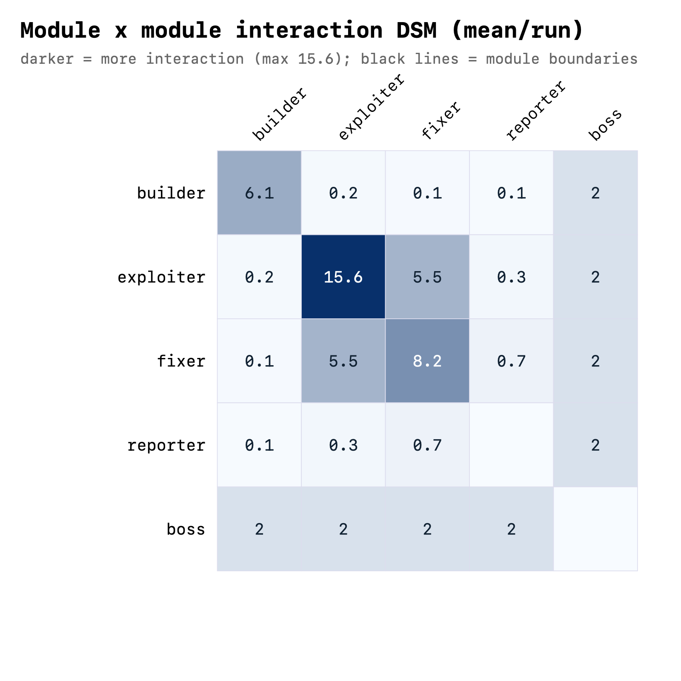
Legend. Rows/cols are the five components builder / exploiter / fixer / reporter / boss. Each cell = mean interaction weight per run between the two modules; the diagonal is within-module (cohesion), off-diagonal is between-module (coupling), and the boss row/column is the relay.
How to read. Bright diagonal + bright boss row/col, with a dim non-boss off-diagonal = cohesive modules whose only cross-talk is via the Boss.

Directed producer→consumer dataflow (mean edges/run)
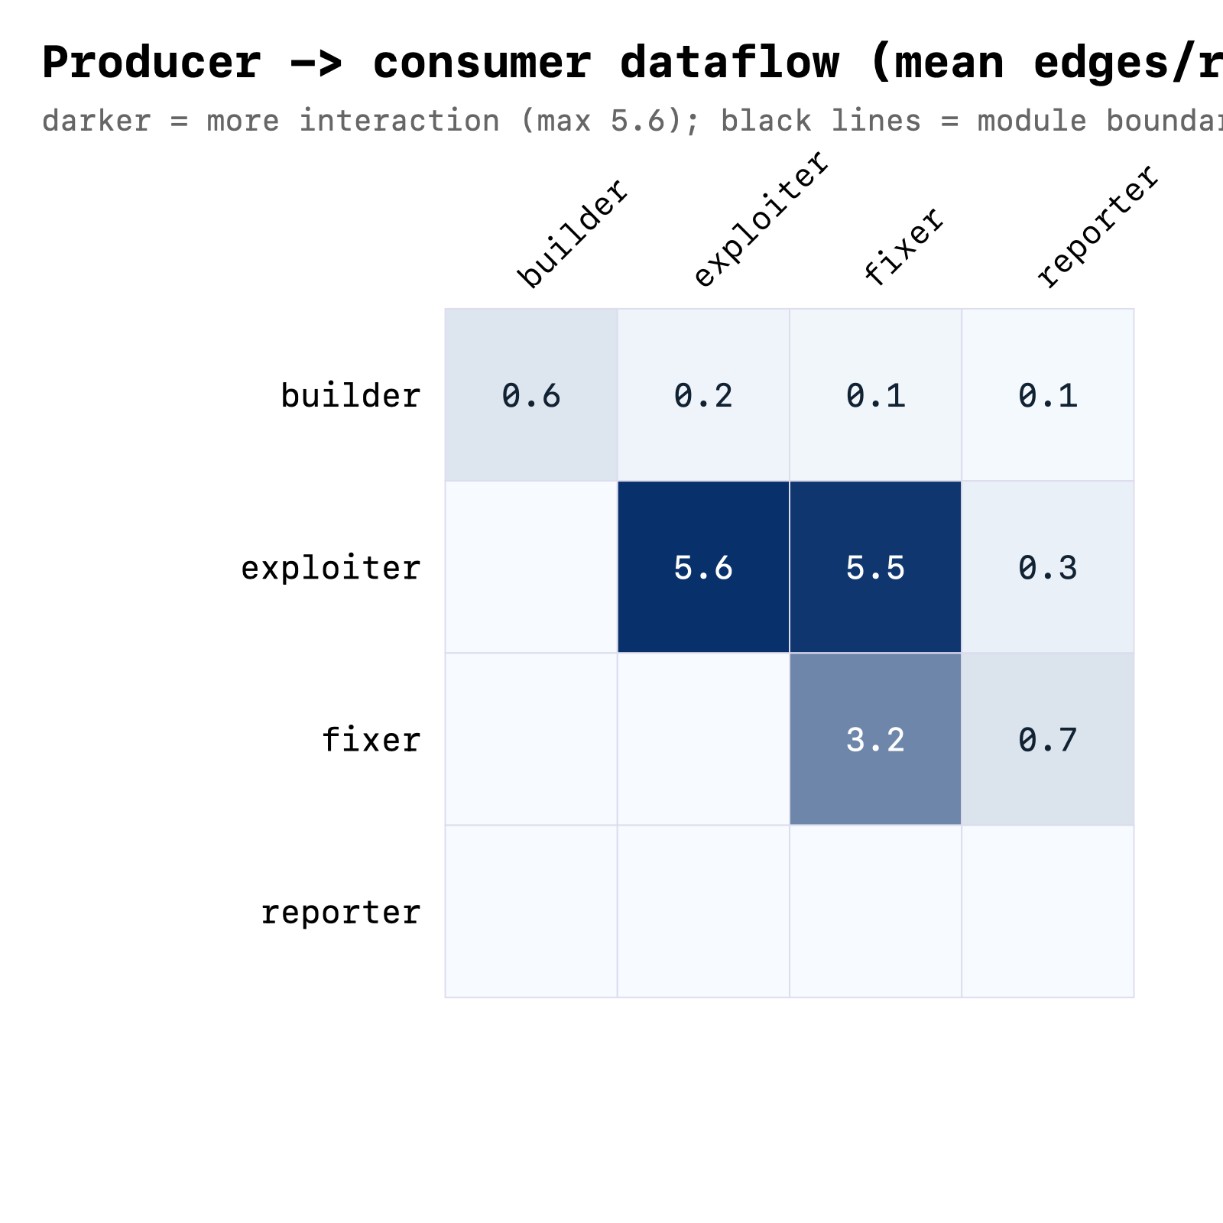
Legend. A 4×4 directed matrix: the ROW is the producer (the module that wrote a file) and the COLUMN is the consumer (the module that later read it); each cell = mean such edges per run.
How to read. Weight on the Builder→Exploiter→Fixer→Reporter direction (above the diagonal) means data flows along the prescribed pipeline; little back-flow.

Module recovery: detected communities vs the real modules
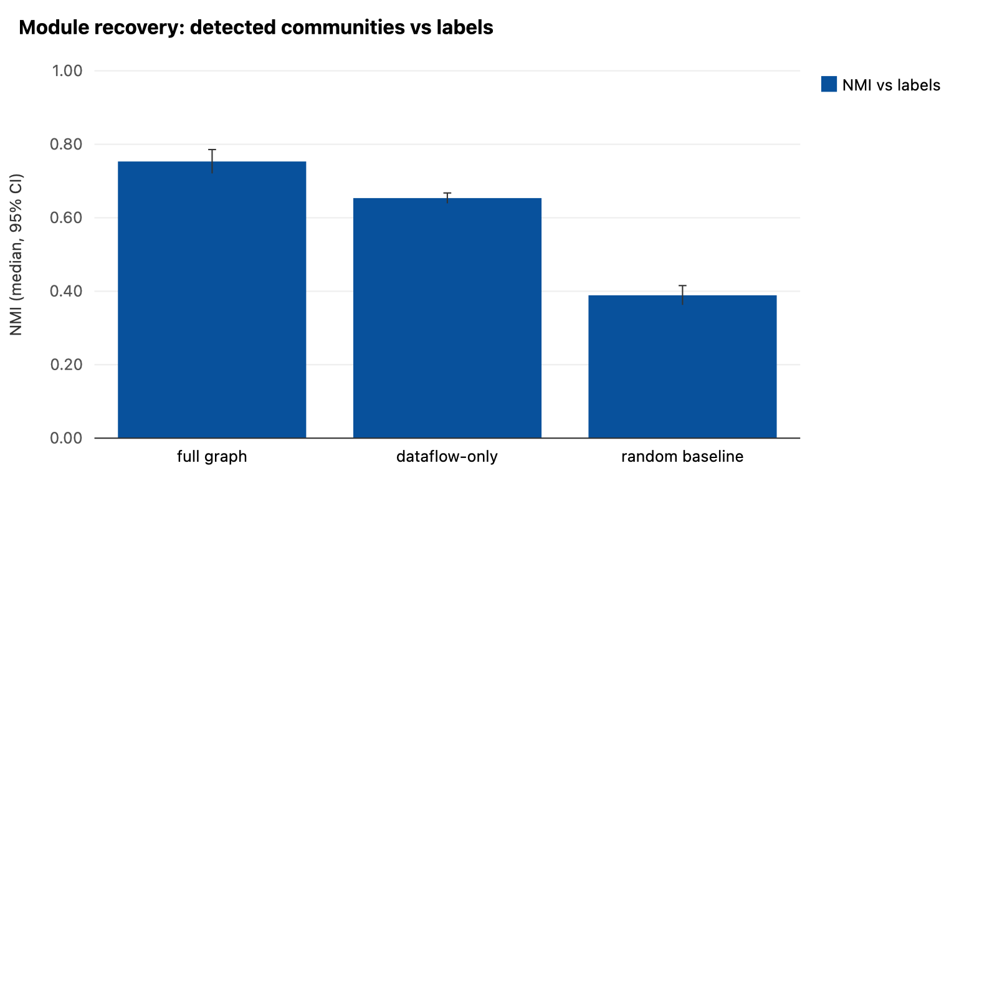
Legend. Three bars = NMI (agreement, 0–1) between an unsupervised clustering of the interaction graph and the true module labels, for: the full graph, the dataflow-only (behavioral) graph, and a random-partition baseline. Whiskers = 95% CI of the mean.
How to read. Full and dataflow-only bars far above the random baseline = the modules are recoverable from behavior alone; the gap between the first two = how much recovery is due to tree topology.

Inter-module coupling vs a permutation null (per-run z)
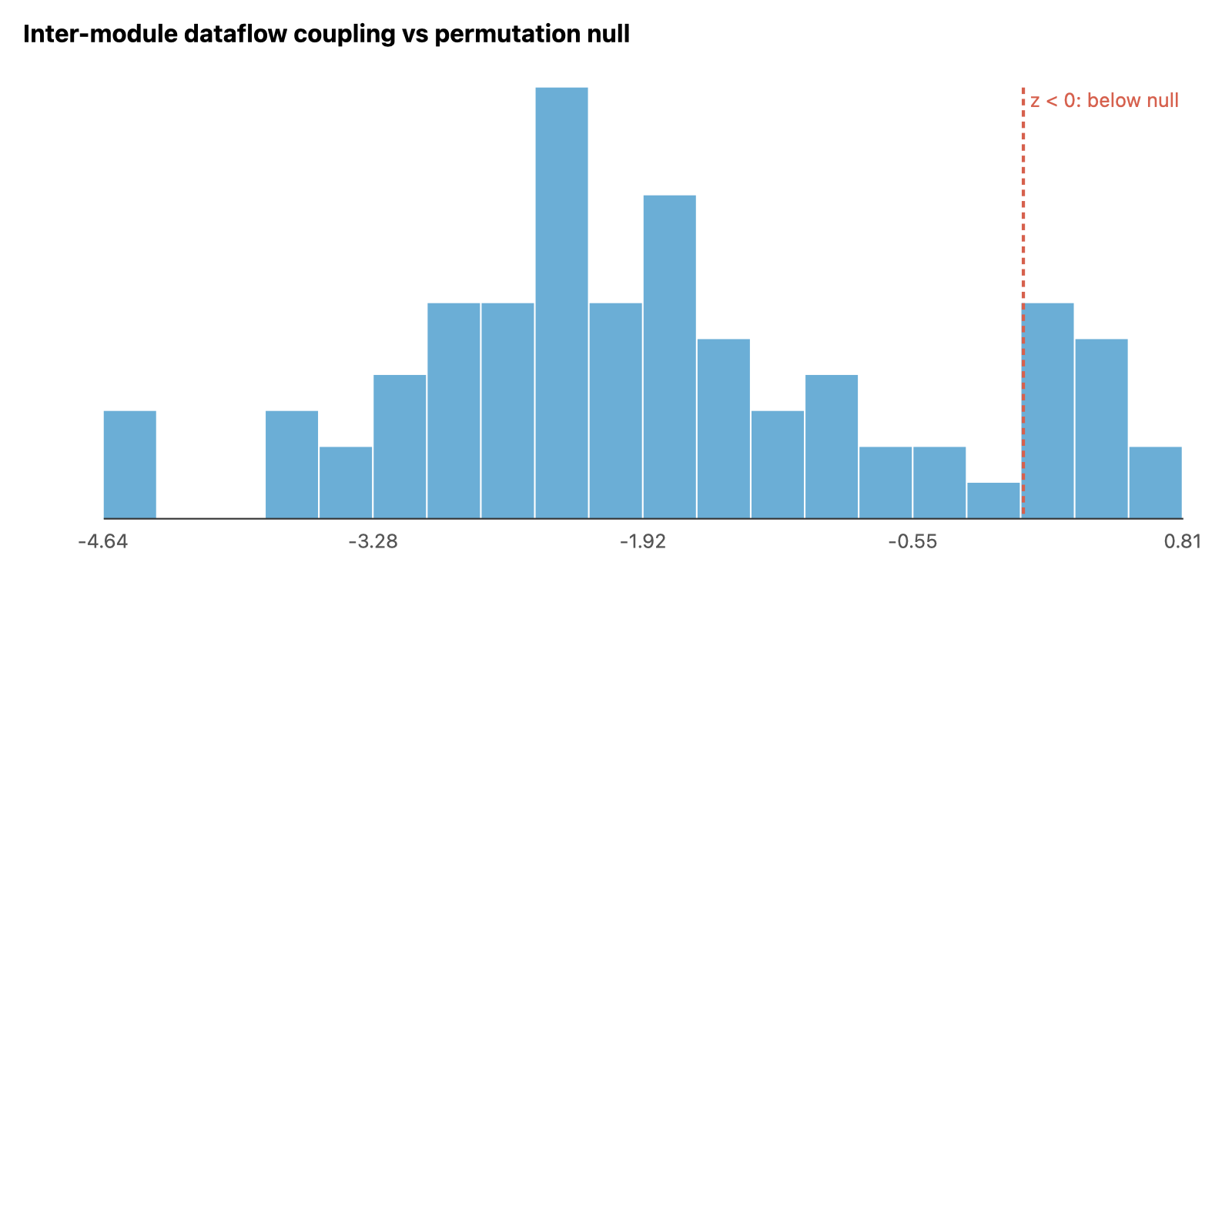
Legend. Histogram of the per-run z-score of the observed cross-module dataflow fraction against a label-shuffling null. The dashed line is z = 0 (= chance).
How to read. Mass to the LEFT of 0 = coupling lower than a random module assignment would give; further left = stronger (the per-run mean z is reported in Finding F2).

Per-module instability I = Ce/(Ca+Ce)
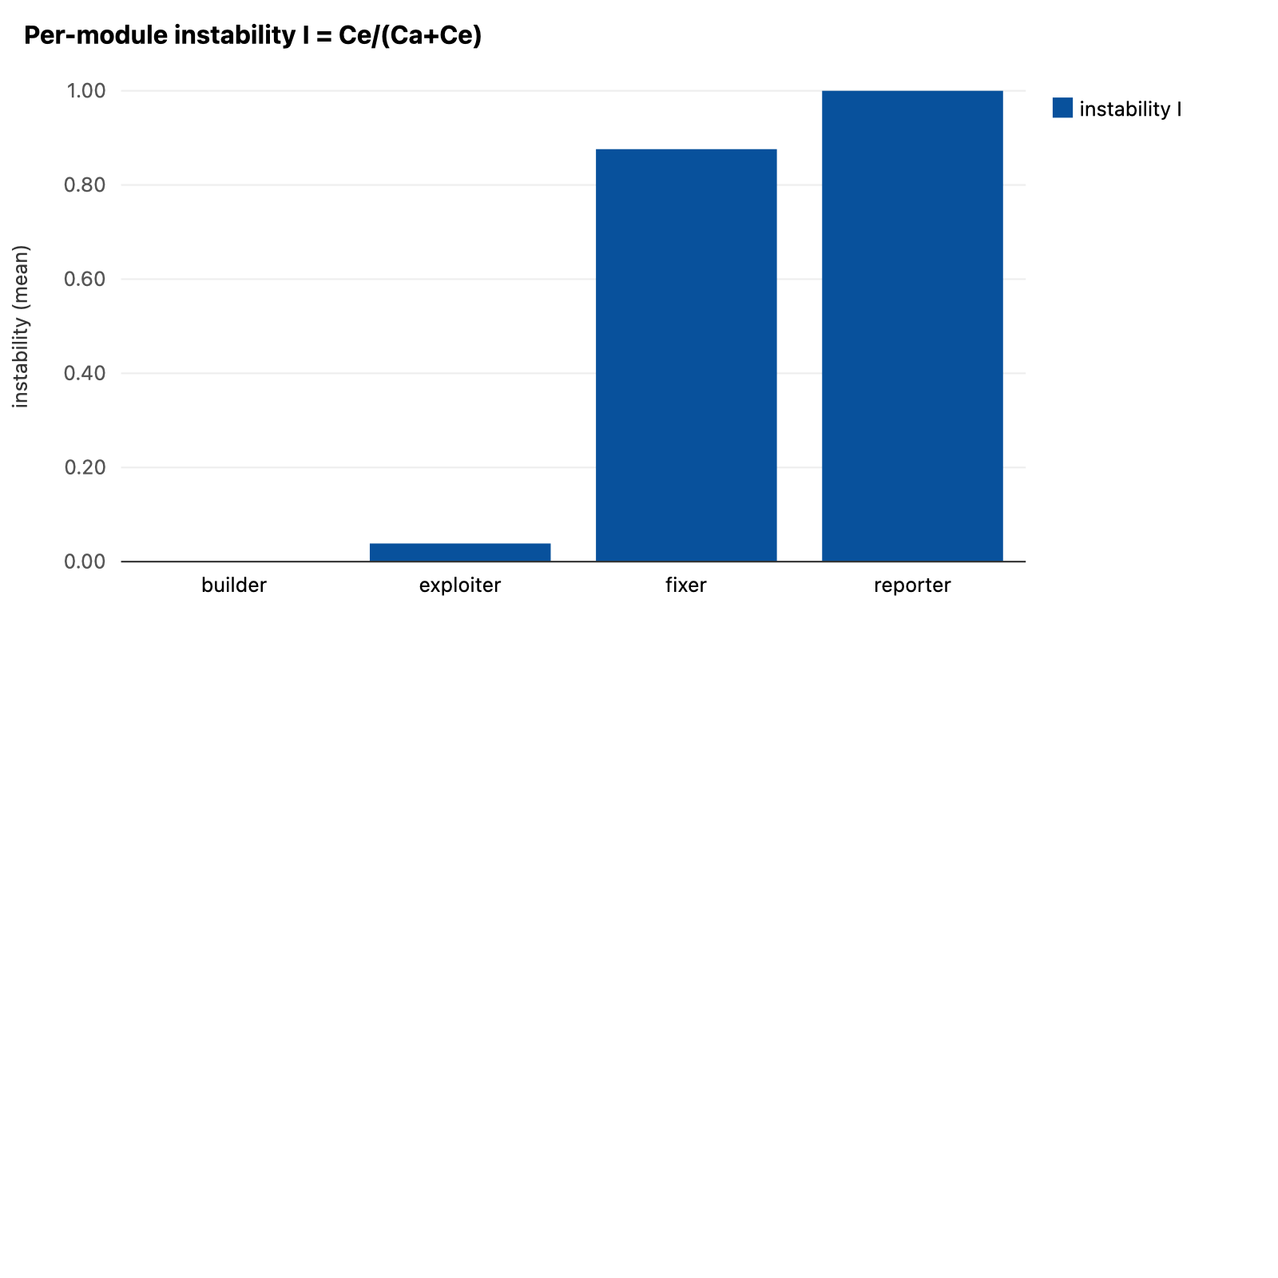
Legend. One bar per module = mean instability: 0 = a pure producer others depend on (stable), 1 = a pure consumer that depends on others (unstable).
How to read. The ascending Builder→Reporter staircase = the data-dependency direction mirrors the prescribed pipeline (Builder stable, Reporter unstable) — Conway's law.

Per-module cohesion vs coupling (mean weight/run)
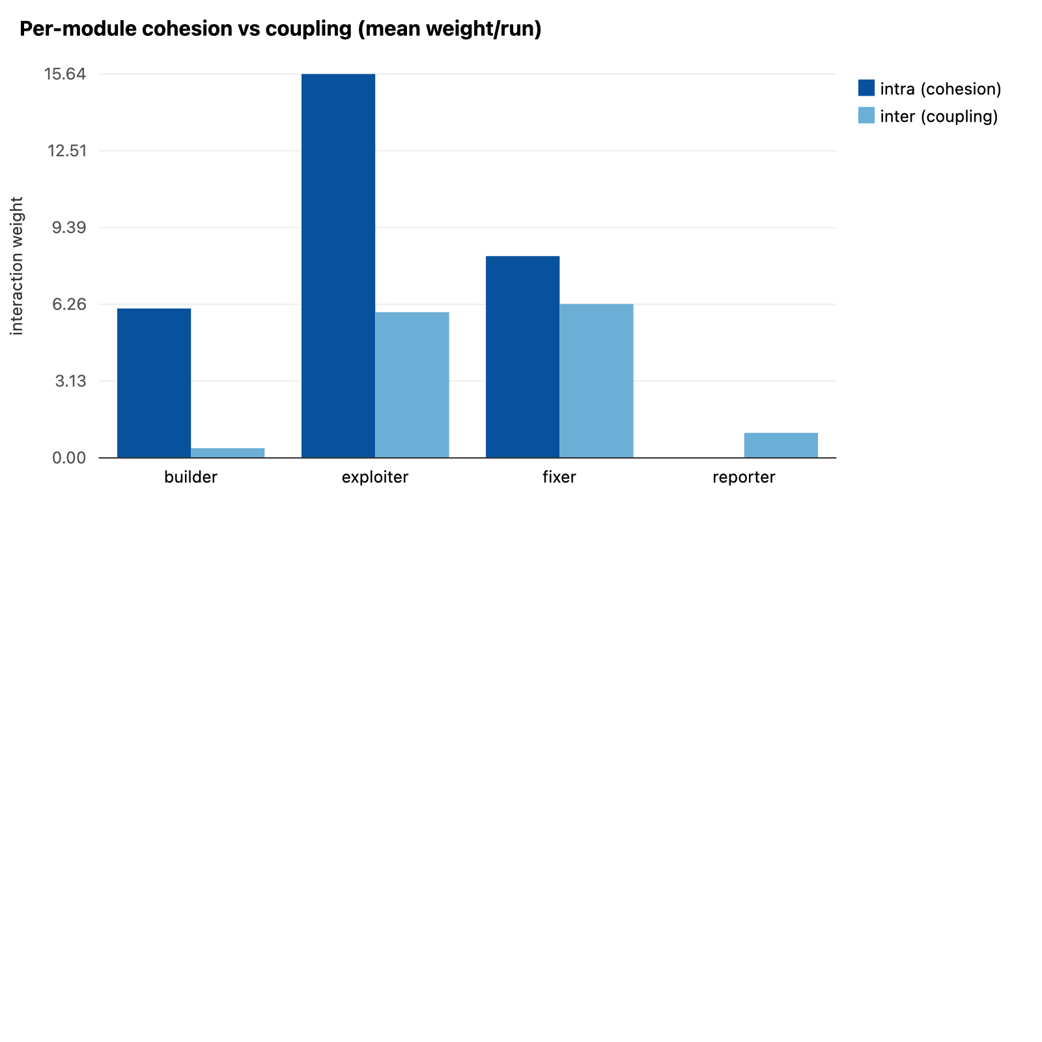
Legend. Two bars per module: intra-module interaction (cohesion) vs inter-module interaction (coupling).
How to read. Cohesion ≥ coupling for the three composite modules (Builder/Exploiter/Fixer). Reporter is a single node, so it has no internal cohesion and shows only coupling (a pure consumer).

Cross-module file interaction by workspace zone (mean/run)
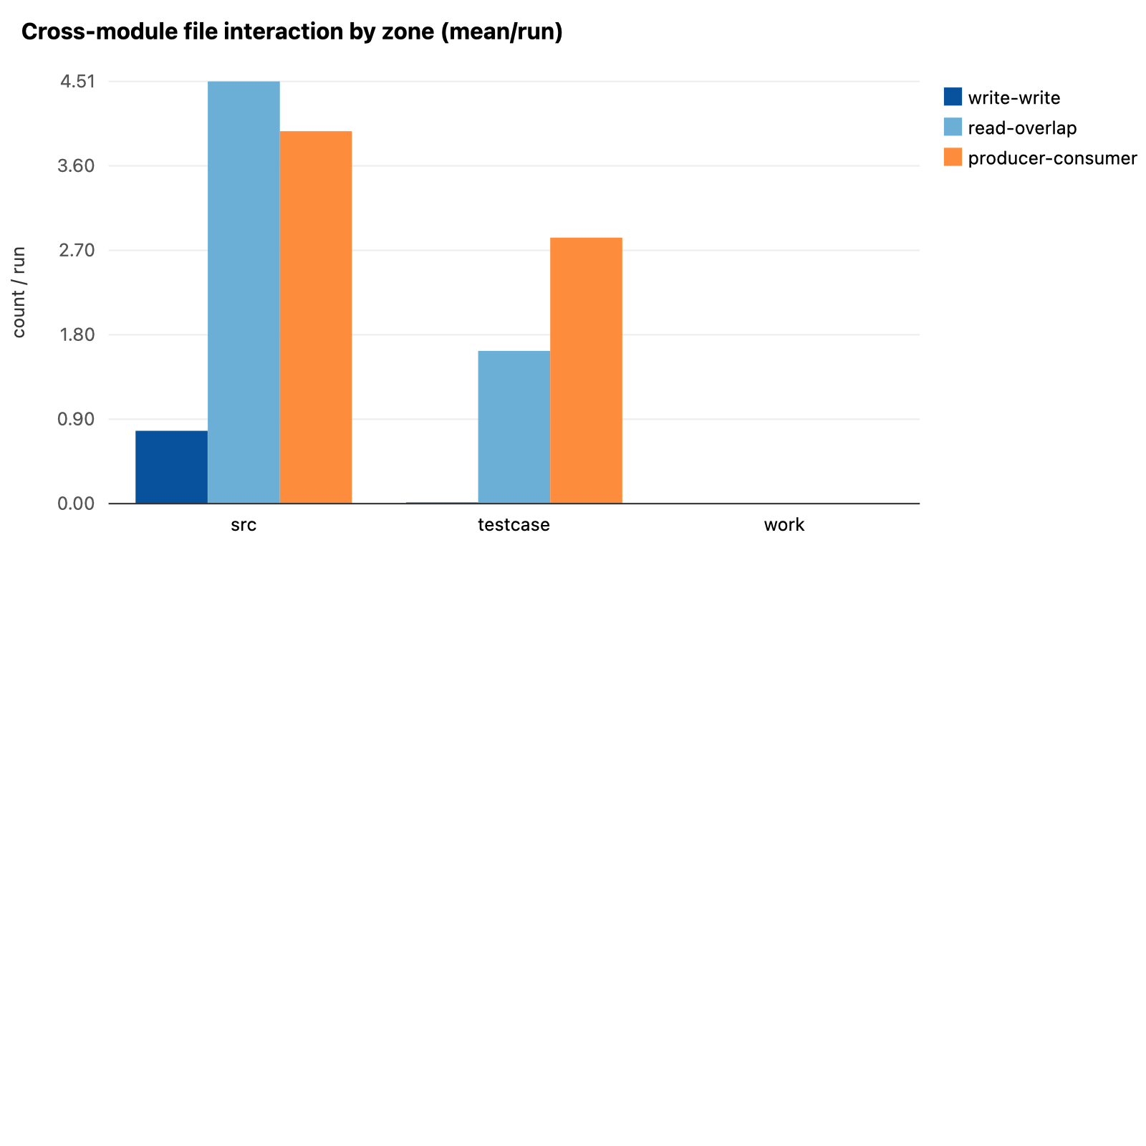
Legend. Per zone (`/src` target source, `/testcase` deliverables/handoff, `/work` scratch): write-write overlap, read-overlap, and producer→consumer edges, per run.
How to read. Low write-write everywhere = little contention; read-overlap on `/src` = shared input (expected); producer→consumer on `/testcase`+`/src` = the prescribed handoff.

4. Findings (data-backed)
F1. The prescribed modules are recoverable from behavior.
Unsupervised clustering of the interaction graph rediscovers the four modules far above chance — and still does on the purely-behavioral (dataflow-only) graph.
recovery signal | median (IQR; mean, 95% CI)
full interaction graph | 0.753 (IQR 0.723–0.875; mean 0.762, 95% CI [0.726, 0.791])
dataflow-only (behavioral) | 0.653 (IQR 0.622–0.691; mean 0.655, 95% CI [0.641, 0.669])
random-partition baseline | 0.389 (IQR 0.365–0.431; mean 0.432, 95% CI [0.407, 0.459])
ARI (full graph) | 0.668 (IQR 0.610–0.835; mean 0.691, 95% CI [0.653, 0.726])
modularity Q (labeled) | 0.323 (IQR 0.267–0.384; mean 0.293, 95% CI [0.260, 0.322])

See Figure 4 (recovery) and Figure 1/2 (DSMs).
F2. Inter-module coupling is below chance.
The fraction of file-dependency edges that cross module boundaries is well below what a random module assignment produces (permutation null), on average.
quantity | value
observed cross-module dataflow fraction (median) | 0.389
permutation-null fraction (median) | 0.722
mean z-score | -1.80
runs individually significant (p<0.05) | 49%
inter-module interaction fraction (msgs+dataflow) | 0.163 (IQR 0.125–0.216; mean 0.174, 95% CI [0.153, 0.194])

See Figure 5 (per-run z histogram).
F3. Each composite module is more cohesive than coupled; F4. instability mirrors the prescribed pipeline (Conway's law).
Within-module interaction dominates cross-module interaction for the three composite modules (Builder, Exploiter, Fixer); the Reporter is a single-node consumer with no internal cohesion (cohesion 0, coupling 1.0). Producer/consumer instability rises monotonically Builder→Reporter (0.00 → 0.04 → 0.88 → 1.00) — the data-dependency direction the Boss prescribed.
module | cohesion (intra) | coupling (inter) | coupling ratio | instability I
builder | 6.1 | 0.4 | 0.06 | 0.00
exploiter | 15.6 | 5.9 | 0.29 | 0.04
fixer | 8.2 | 6.3 | 0.52 | 0.88
reporter | 0.0 | 1.0 | 0.40 | 1.00

See Figure 7 (cohesion vs coupling) and Figure 6 (instability).
F5. Cross-module data flows along the prescribed handoff.
Producer→consumer file dependencies concentrate on Exploiter→Fixer, matching the Builder→Exploiter→Fixer→Reporter DAG; inter-module *messages* are 0 by construction.
producer → consumer | mean edges/run
exploiter->fixer | 5.46
fixer->reporter | 0.67
exploiter->reporter | 0.3
builder->exploiter | 0.19
builder->fixer | 0.15
builder->reporter | 0.06

Inter-module messages across all 81 runs: 0 (a structural zero — briefings/reports only run along tree edges). See Figure 3.
F6. The shared 'global context' is heavily used and Exploiter-dominated — an annotation layer, not a payload store.
Used in 79/81 runs (median 53 writes/run). Across all runs, 0 of 2000 artifacts contain actual file content (they are prose pointers/summaries of workspace files), and ~75% of keys are run-unique/ad-hoc — so it functions as a human-readable changelog, not the machine-keyable table the prompts specify.
module | decisions/run | artifacts/run | total/run
builder | 6.07 | 6.25 | 12.32
exploiter | 12.16 | 12.33 | 24.49
fixer | 7.02 | 5.42 | 12.44
reporter | 0.4 | 0.69 | 1.09

F7. Modules share recon reads (no strict task de-duplication); F8. file contention is minimal and matches the handoff.
Modules re-read overlapping source files during analysis (so 'no duplicated analysis' does not hold strictly — but the overlap is shared input on /src). Files written by ≥2 modules are few and are almost all the Exploiter+Fixer pair co-editing the vulnerable source.
metric | value
recon-read Jaccard between modules | 0.132 (IQR 0.093–0.200; mean 0.165, 95% CI [0.141, 0.190])
write-write overlaps by zone (total over 81 runs) | {'src': 63, 'testcase': 1, 'other': 0}
write-write by module pair | {'exploiter+fixer': 63, 'builder+exploiter': 1}
producer→consumer edges by zone (total) | {'src': 322, 'testcase': 230}
read overlap by zone (total) | {'src': 365, 'testcase': 132, 'work': 0, 'other': 0}

See Figure 8 (file interaction by zone).

5. Reading of the evidence & limitations
- Supported: the system executes a clean, recoverable, low-coupling modular decomposition whose data-dependency direction mirrors the prescribed pipeline.
- Not supported as stated: 'no duplicated analysis' (modules share recon reads) and 'minimal global-context reliance' (it is heavily used).
- The module partition is prescribed by the Boss prompt, so this is execution fidelity + recoverability, not spontaneous emergence.
- Inter-module messaging is 0 by construction (the schema cannot encode it); the interaction graph is message-dominated, so dataflow-only recovery (0.65 NMI) is the behavioral lower bound. Shell-mediated writes are under-captured (low confidence).

