LIVE-APSRTC

A CSP internship report submitted in partial fulfilment of requirements for the award of the Degree of

BACHALOR OF TECHNOLOGY
IN
COMPUTER SCIENCE AND ENGINEERING (DATA SCIENCE)
CSP Internship Project Submitted by
Student Name: Haneesha
Roll No: 248T1A4415
Under the Esteemed Guidance of S.Vamsi
Assistant Professor, Department of CSE (Data Science)



DHANEKULA INSTITUTE OF ENGINEERING & TECHNOLOGY

(Autonomous)
GANGURU :: VIJAYAWADA – 521 139.
(Approved by AICTE, New Delhi, Permanently Affiliated to JNTU Kakinada)
ISO 9001:2015 Certified Institution, NAAC-A & Accredited by NBA for ECE & CSE.
1

DHANEKULA INSTITUTE OF ENGINEERING AND TECHNOLOGY

(Autonomous)
GANGURU :: VIJAYAWADA – 521 139.
(Approved by AICTE, New Delhi, Permanently Affiliated to JNTU Kakinada)
ISO 9001:2015 Certified Institution, NAAC-A & Accredited by NBA for ECE & CSE.

DEPERTMENT OF COMPUTER SCIENCE AND ENGINEERING
(DATA SCIENCE)


CERTIFICATE
This is to certify that the report entitled “SMART-APSRTC” is a bona fide work of Miss Navya, bearing Regd. No: 248T1A4415, submitted to the Department of Computer Science and Engineering (Data Science), in partial fulfillment of the requirements for the award of the degree of Bachelor of Technology in Computer Science and Engineering (Data Science) from Dhanekula Institute of Engineering & Technology, Vijayawada, during the academic year 2025–26, as part of the CSP Internship Programme.

GUIDE HEAD OF THE DEPARTMENT
S.Vamsi, M. Tanooj Kumar
Assistant Profeesor, Professor & HoD
Department of CSE (Data Science) Department of CSE(Data Science).

ACKNOWLEDGEMENTS

We express our sincere gratitude to Dr. K. Ravi, Principal, and Dr. M. Tanooj Kumar, Head of the Department of Computer Science and Engineering (Data Science), Dhanekula Institute of Engineering and Technology, Vijayawada, for providing the necessary facilities, institutional support, and encouragement to carry out this project successfully.
We extend our heartfelt gratitude to our project coordinator, S.Vamsi,
Assistant Professor, Department of Computer Science and Engineering (Data Science), for her invaluable guidance, continuous encouragement, constructive suggestions, and unwavering support throughout the Community Service Project (CSP) Internship Programme. Her mentorship and motivation have played a significant role in the successful completion of our project entitled “Life Flow – Smart Blood Donation System.”
We also express our sincere appreciation to all the faculty members of the Department of Computer Science and Engineering (Data Science) for their valuable assistance, cooperation, and encouragement during the execution of this project, undertaken in partial fulfillment of the requirements for the award of the Bachelor of Technology (B.Tech) degree.
Finally, we convey our heartfelt gratitude to our parents, family members, and friends for their constant support, encouragement, and motivation throughout our academic journey and the successful completion of this project.

DECLARATION

I hereby declare that the project report entitled “Career Vision”, submitted to the Department of Computer Science and Engineering (Data Science), Dhanekula Institute of Engineering & Technology, Vijayawada, is a record of original work carried out by me under the supervision of S.Vamsi, Assistant Professor, Department of CSE (Data Science).
I further declare that the work presented in this project report has not been submitted, either in part or in full, for the award of any other degree or diploma at this institute or any other institute or university.

Name: Haneesha
Roll No: 248T1A4415

1.INTRODUCTION

1.1 Introduction:
The Smart APSRTC – Live Location Bus Tracking System is a smart transportation solution designed to improve the public bus travelling experience by providing information about bus locations, routes, estimated arrival times, and bus availability. It aims to make public transportation more convenient, reliable, and user-friendly through modern technologies.
The Smart APSRTC system provides a digital platform where passengers can search for buses, view available routes, check estimated arrival times, and access bus-related information. It also provides an administrative dashboard to monitor bus details and manage transportation-related information.

1.2 Background of the Project:
Public transportation plays an important role in the daily lives of students, employees, and other passengers. APSRTC provides bus transportation services to people across Andhra Pradesh. However, passengers may experience difficulties due to a lack of real-time bus information.
Traditional bus tracking methods depend mainly on fixed schedules and manual enquiries. These methods do not always provide accurate information about delays, traffic conditions, or changes in bus arrival times.

1.3 Need for the Project:
The main reasons for developing this project are:
- To improve communication between passengers and administrators.
- To support better monitoring and management of buses.
- To encourage the use of smart public transportation services.

1.4 Scope of the Project:
The scope of the Smart APSRTC project includes:
- Live Bus Tracking: Displaying bus locations using GPS-based tracking in the proposed system.
- Route Information: Providing bus route and destination details.
- Arrival Time Estimation: Showing estimated arrival times based on distance and speed.
- Bus Search: Allowing users to search for buses and routes.
- Passenger Dashboard: Providing a simple interface to access bus information.
- Admin Dashboard: Supporting bus information monitoring and management.
- Emergency Support: Including a proposed SOS feature for passenger assistance.

2.OBJECTIVES
The main objective of the Smart APSRTC – Live Location Bus Tracking System is to develop a smart and user-friendly transportation platform that helps passengers access bus location, route, and arrival-time information easily. The system aims to improve passenger convenience, reduce waiting time, and support efficient bus monitoring.
2.1 Primary Objectives:
- To develop a smart bus tracking system for APSRTC transportation services.
- To provide bus location information through a digital platform.
- To display bus routes, destinations, and estimated arrival times.
- To reduce passenger waiting time and travel inconvenience.
2.2 Technical Objectives:
- To use GPS technology for identifying bus locations in the proposed system.
- To integrate communication technologies such as GSM, 4G, or internet connectivity for transmitting location data.
- To develop an interactive web-based dashboard.
- To implement bus searching and route filtering features.
2.3 User Objectives:
- To allow passengers to search for available buses.
- To help users view bus routes and destination details.
- To provide estimated bus arrival information.
- To make transportation information accessible and understandable.
2.4 Performance Objectives:
- To provide a responsive and easy-to-use dashboard.
- To display bus information clearly and accurately based on available data.
- To reduce the time required to search for bus details.
- To support multiple bus records and route information.

3.TOOLS & TECHNOLOGIES
The Smart APSRTC project uses different software tools, hardware components, and communication technologies to develop a smart bus tracking system.

3.1 Software Technologies:
- HTML5: Creates the structure of the web application.
- CSS3: Provides styling, layout, and responsive design.
- JavaScript: Implements interactive features and dynamic functions.
- Web Browser: Runs and displays the application.
- Google Maps: Provides transit directions.
- Visual Studio Code: Used for writing and editing code.

3.2 Hardware Technologies:
- GPS Module (NEO-6M): Tracks the bus location.
- ESP32 / Arduino: Processes GPS data.
- GSM / 4G Module: Transmits location data to the server.
- Power Supply: Provides power to hardware components.
- Computer / Smartphone: Used to access the application.

3.3 Backend and Database Technologies :
- Node.js: Handles server-side operations.
- Express.js: Creates REST APIs.
- MongoDB: Stores bus and route information.
- Firebase: Supports real-time data synchronization.
- REST API / MQTT: Transfers location data between devices and servers.

4.EXISTING SYSTEM

The existing bus transportation system mainly depends on fixed bus schedules and manual enquiries. Passengers visit bus stations or bus stops to get information about bus timings, routes, and availability.
In the traditional system, passengers cannot easily know the exact location of a bus or its expected arrival time. They may have to wait for long periods due to traffic, delays, and schedule changes.

4.1 Limitations of Existing System:
- No real-time bus location tracking.
- Passengers face long waiting times.
- Difficulty in knowing accurate arrival times.
- Limited information about bus routes and availability.
- Dependence on manual enquiries and fixed schedules.
- No centralized platform for accessing bus information.
- Difficulty in monitoring buses efficiently.

4.2 Disadvantages:
- Wastage of passengers' time.
- Lack of accurate travel information.
- Inconvenience during unexpected delays.
- Poor communication between passengers and transport authorities.
- Difficulty in planning journeys.

5.PROPOSED SYSTEM

The proposed system, Smart APSRTC – Live Location Bus Tracking System, is designed to provide passengers with easy access to bus location, route details, and estimated arrival times through a web-based application.
The system provides an interactive dashboard where passengers can search for buses, view available routes, check bus details, and access transit directions. It also provides an admin dashboard to monitor bus information.
The proposed system uses GPS technology to collect the real-time location of buses. The location data can be transmitted through GSM or 4G networks to a server and displayed on the passenger application.
5.1 Features of Proposed System:
- Live Bus Tracking: Helps passengers identify bus locations using GPS technology.
- Bus Search: Allows users to search for available buses.
- Route Information: Displays bus routes and destination details.
- Arrival Time: Provides estimated bus arrival times.
- User-Friendly Dashboard: Offers a simple and interactive interface.
- Admin Dashboard: Helps administrators monitor bus information.
- SOS Support: Provides an emergency assistance feature in the proposed design.
- Google Maps Integration: Helps users access transit directions.
5.2 Advantages of Proposed System:
- Reduces passenger waiting time.
- Provides easy access to bus information.
- Helps passengers plan their journeys.
- Improves transportation monitoring.
- Reduces manual enquiries.
- Supports future real-time GPS integration.
- Improves passenger convenience.

6.SYSTEM DESIGN

6.1 System Design:
The Smart APSRTC system follows a modular architecture that connects bus location tracking, data processing, server communication, and passenger applications.
The proposed system collects bus location information using a GPS module. The ESP32 processes the GPS data and sends it to the server through a GSM/4G communication module. The server processes and stores the information, which is displayed on the passenger dashboard.

6.2 System Components:
The Smart APSRTC system consists of the following major components:
1. GPS Module: Collects the geographical location of the bus using satellite signals.
2. ESP32 / Arduino: Receives and processes GPS information.
3. GSM / 4G Module: Sends bus location data to the server through the internet or mobile network.
4. Backend Server: Processes user requests and manages bus information.
5. Database: Stores bus details, routes, and location records.
6. Passenger Dashboard: Allows passengers to search buses, view routes, and check estimated arrival times.
7. Admin Dashboard: Helps administrators monitor bus details and manage transportation information.
8. Google Maps Integration: Provides transit directions to selected destinations.

System Flow :
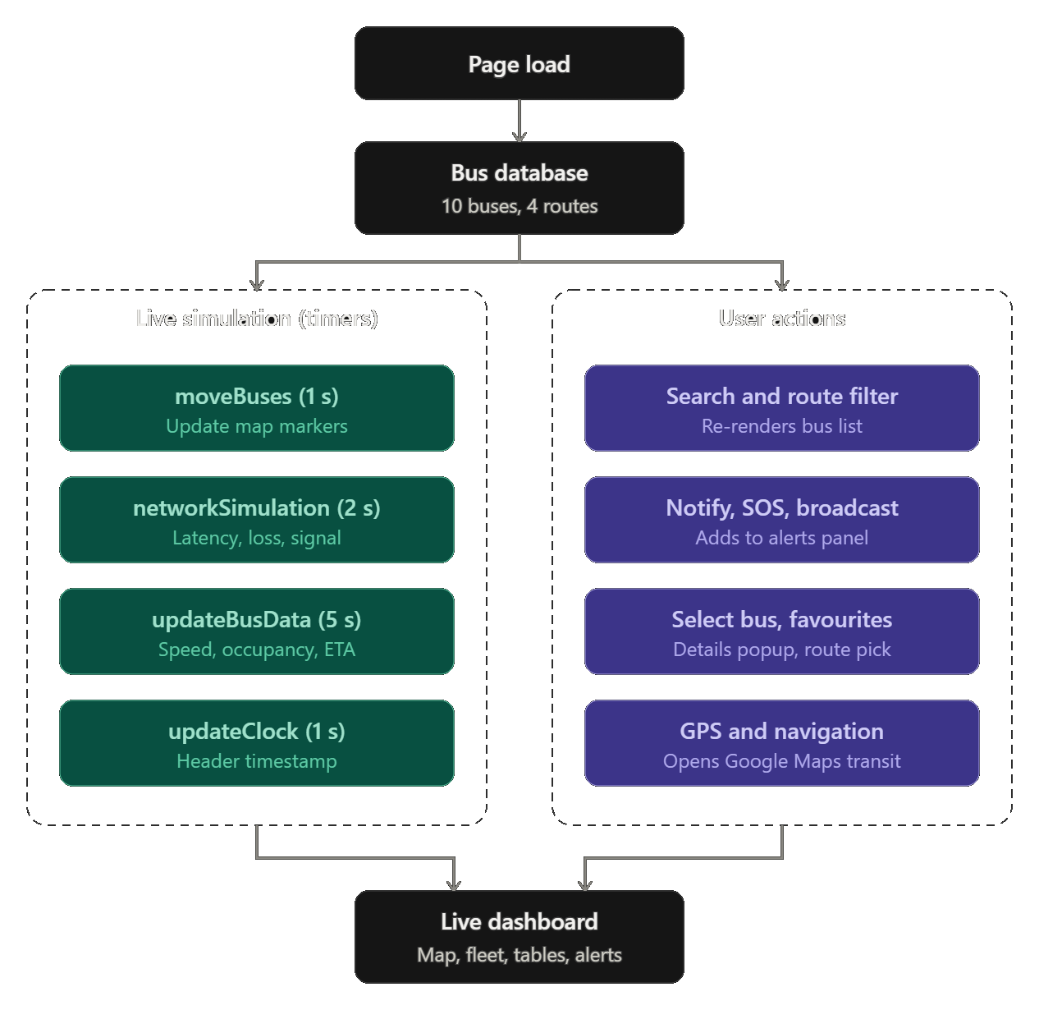

7.METHODOLOGY & ALGORITHM :

7.1 Methodology:
The Smart APSRTC system follows a step-by-step methodology to provide bus information and tracking facilities to passengers.
Step 1: User Input
Passengers open the web application and search for buses, routes, or destinations.
Step 2: Data Collection
The proposed system collects bus location information using a GPS module.
Step 3: Data Processing
The controller processes the GPS coordinates and prepares the location data.
Step 4: Data Transmission
The processed information is transmitted to the server using GSM or 4G communication.
Step 5: Data Storage
The server stores bus details, route information, and location records in the database.
Step 6: ETA Calculation
The system estimates bus arrival time using the remaining distance and average speed.
Step 7: Display Results
The passenger dashboard displays bus details, routes, locations, and estimated arrival times.

7.2 Algorithm :
Algorithm: Smart APSRTC Bus Tracking

- Start the application.
- Load the available bus details.
- Allow the passenger to search for a bus or route.
- Collect the selected bus location.
- Process the location information.
- Calculate the remaining distance to the destination.
- Calculate the estimated arrival time.
- Display bus details, route, and arrival time.
- Allow the user to search for another bus.
- Stop the application.

Flowchart:

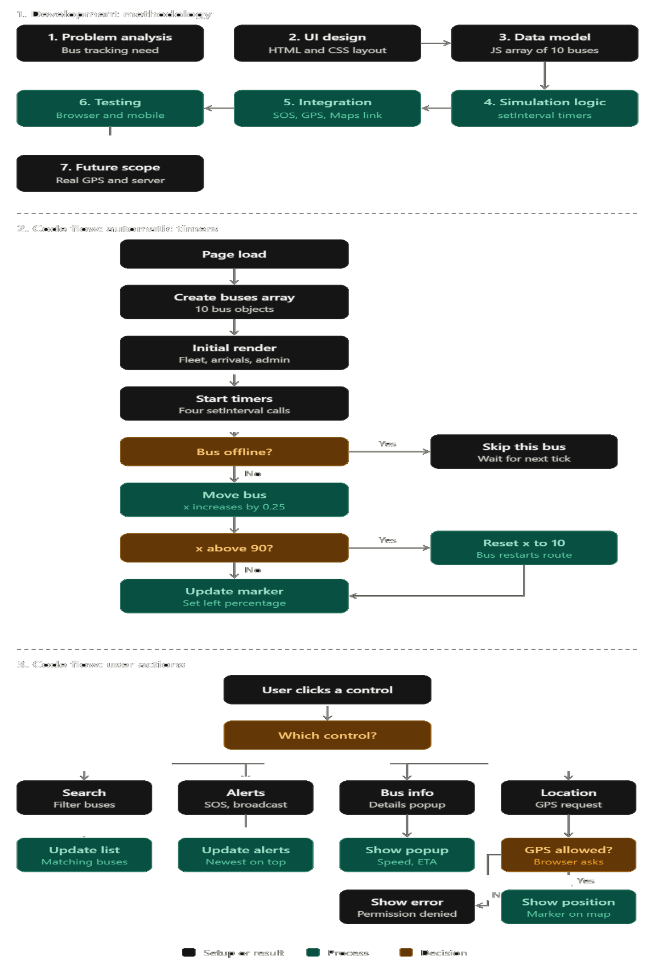

- CODE / IMPLEMENTATION:

https://github.com/ambatimanosaikumar-cloud/Smart--APSRTC

OUTPUT:
8.1 Smart APSRTC Dashboard Output :

The Smart APSRTC dashboard provides a user-friendly interface for monitoring bus operations and accessing transportation information.
The dashboard displays the following features:
- Active Buses: Displays the number of currently active buses (10).
- Offline Buses: Shows the number of offline buses (0).
- Delayed Buses: Displays delayed buses (2).
- Latency: Shows network response time (66 ms).
- Packet Loss: Displays packet loss percentage (1.2%).
- Messages: Shows the number of messages (1978).
- Uptime: Displays network uptime (99.4%).
- Bus Search: Allows users to search buses by ID.
- Route Filter: Helps users select specific bus routes.
- Nearby Buses: Provides a nearby-bus option.
- SOS Alert: Provides an emergency alert option.

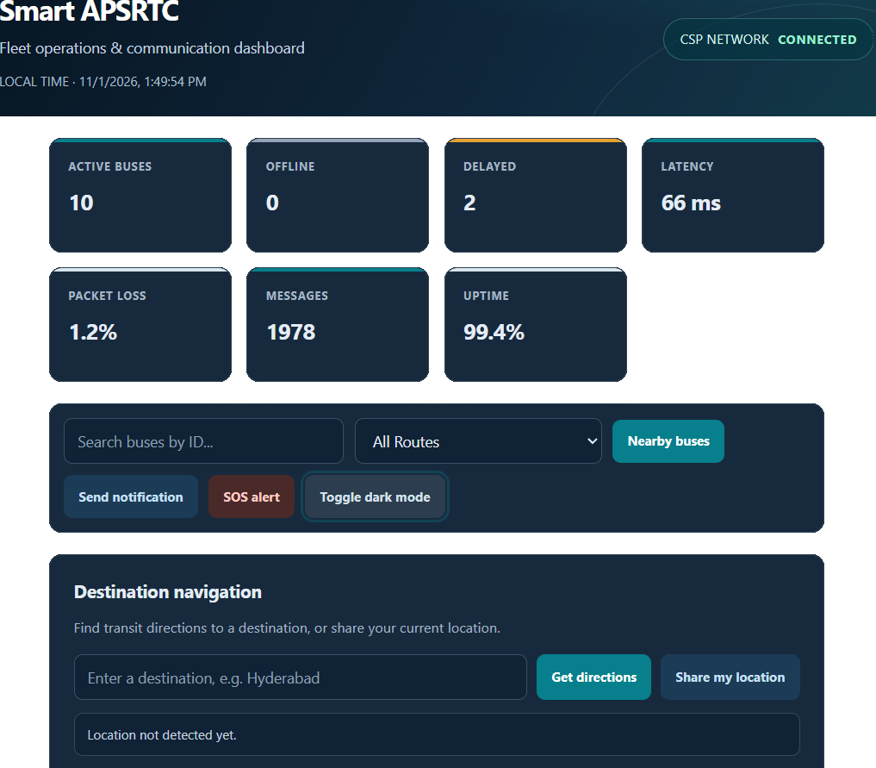
8.2 Live Fleet Map and Destination Navigation :

The Smart APSRTC system provides a destination navigation feature that allows passengers to enter their destination and access transit directions. It also displays a map-style view of bus routes and bus locations.
The main features shown in this screen are:
- Destination Navigation: Allows users to enter their desired destination.
- Get Directions: Helps users access transit directions.
- Share My Location: Allows users to share their current location after permission.
- Live Fleet Map: Displays the bus route and location markers.
- Bus Identification: Shows bus numbers such as 101, 102, 206, 310, 311, 401, 402, 501, and 502.
- Route Locations: Displays locations such as Vijayawada, Guntur, Chilakaluripet, Nalgonda, and Hyderabad.
- Bus Status: Uses different marker colors to visually distinguish bus statuses.

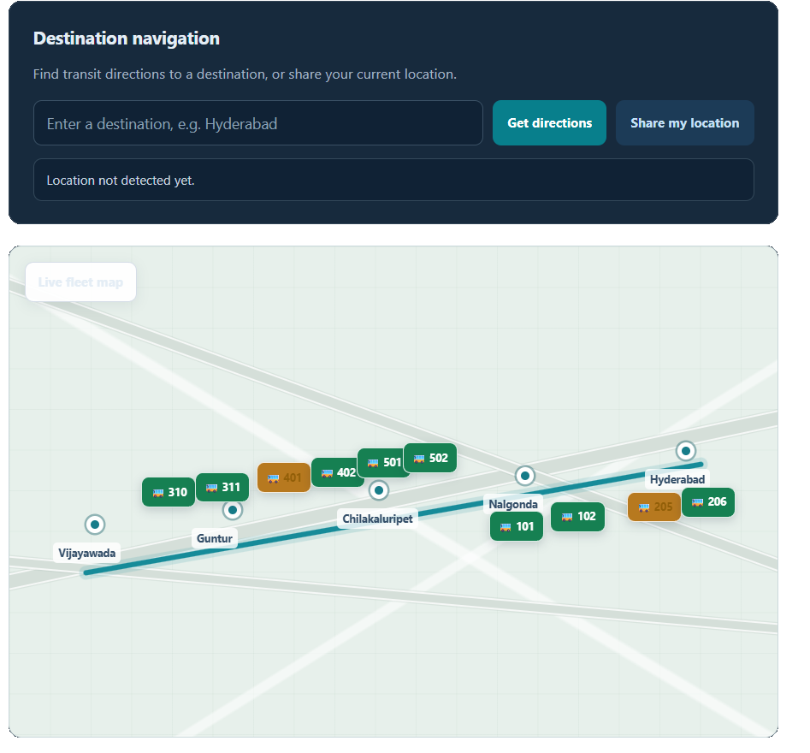
8.3 Google Maps Transit Navigation:

The Smart APSRTC system provides Google Maps integration to help passengers find public transportation directions from their current location to their selected destination.
The screenshot demonstrates transit directions from the user's current location to Chennai, Tamil Nadu.
The main features are:
- Source Location: Displays the user's current location.
- Destination Selection: Allows users to enter their destination.
- Transit Options: Displays available public transportation routes.
- Travel Duration: Shows the estimated journey time.
- Train Information: Displays train numbers and names.
- Departure and Arrival Times: Shows journey timings.
- Route Map: Displays the selected travel route on Google Maps.
- Multiple Routes: Provides alternative travel options.

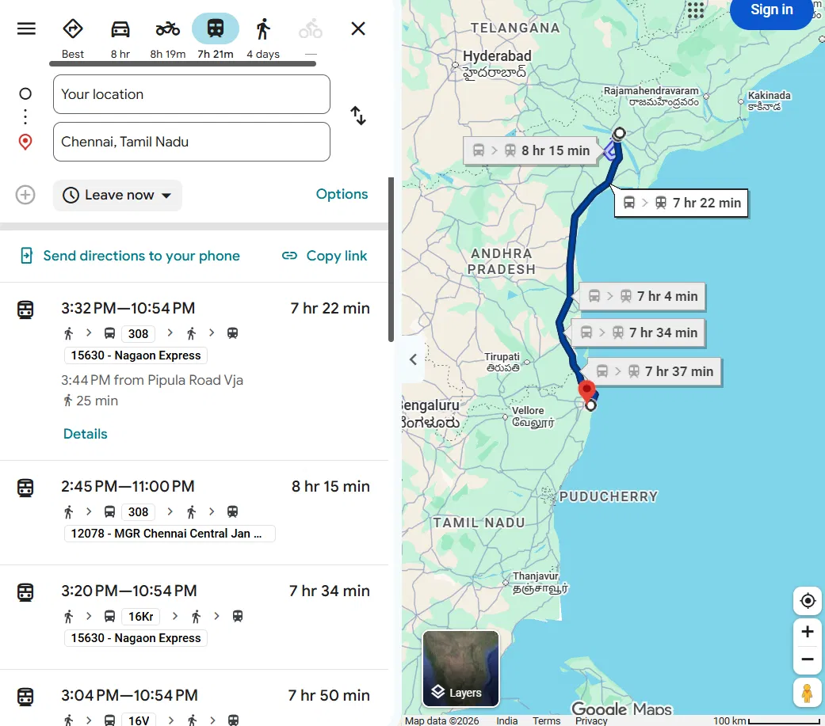
8.4 Live Bus Fleet and Network Monitoring:

The Smart APSRTC system provides a Live Bus Fleet section to display bus details, journey information, and communication status. It helps passengers and administrators monitor bus activities through a single dashboard.
The main features are:
- Bus Identification: Displays bus numbers such as AP-101, AP-102, and AP-205.
- Bus Status: Shows whether buses are active or delayed.
- Route Details: Displays source and destination information.
- Next Stop: Shows the upcoming bus stop.
- Estimated Arrival Time (ETA): Displays the expected arrival time.
- Speed Monitoring: Displays the current bus speed in km/h.
- Network Signal: Shows 4G signal strength.
- Occupancy: Displays the number of passengers compared with bus capacity.
- Traffic Status: Displays traffic conditions such as low or moderate.
- Communication Center: Displays messages exchanged between the control room and drivers.
- Network Monitoring: Displays network type, signal strength, latency, and packet loss.

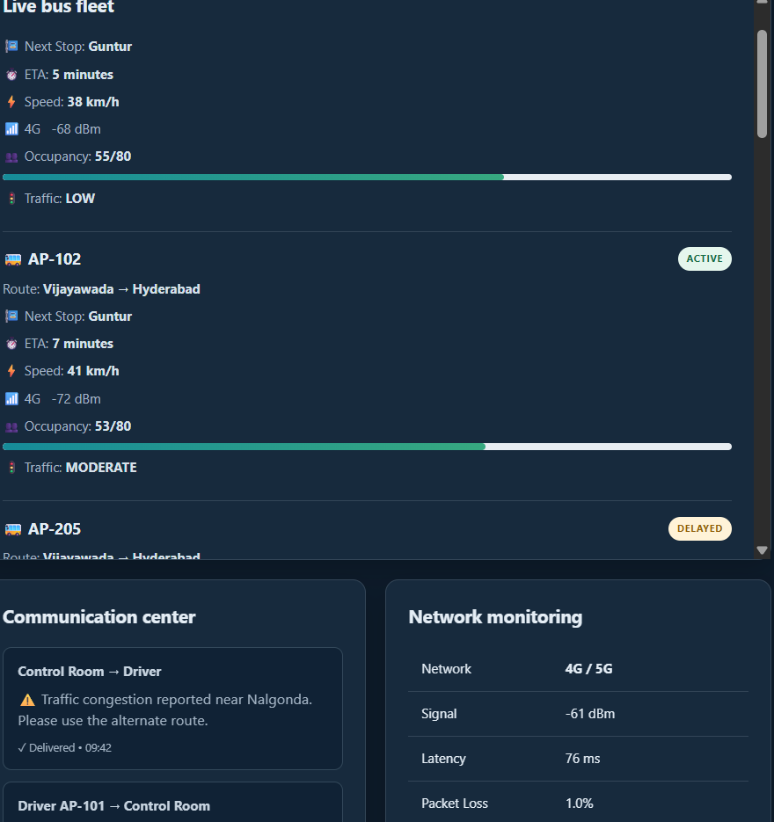
8.5 Next Bus Arrivals and Admin Control Room:
The Smart APSRTC system provides a Next Bus Arrivals section to display bus arrival information and an Admin Control Room to monitor bus operations.
A. Next Bus Arrivals:
This section displays the following details:
- Bus Number: Displays bus identification numbers such as AP-101, AP-102, and AP-205.
- Bus Stop: Shows the next stop of each bus.
- ETA: Displays the estimated arrival time in minutes.
- Traffic: Shows traffic conditions such as LOW, MODERATE, and HIGH.
- Network: Displays the available 4G or 5G network.
- Occupancy: Shows the number of passengers compared with bus capacity.
- Status: Displays whether the bus is ACTIVE or DELAYED.
B. Admin Control Room:
The Admin Control Room helps administrators monitor bus performance and operational details.
- Bus number and route details.
- Current bus speed.
- Passenger occupancy.
- Network connectivity.
- Signal strength in dBm.
- Bus operational status.
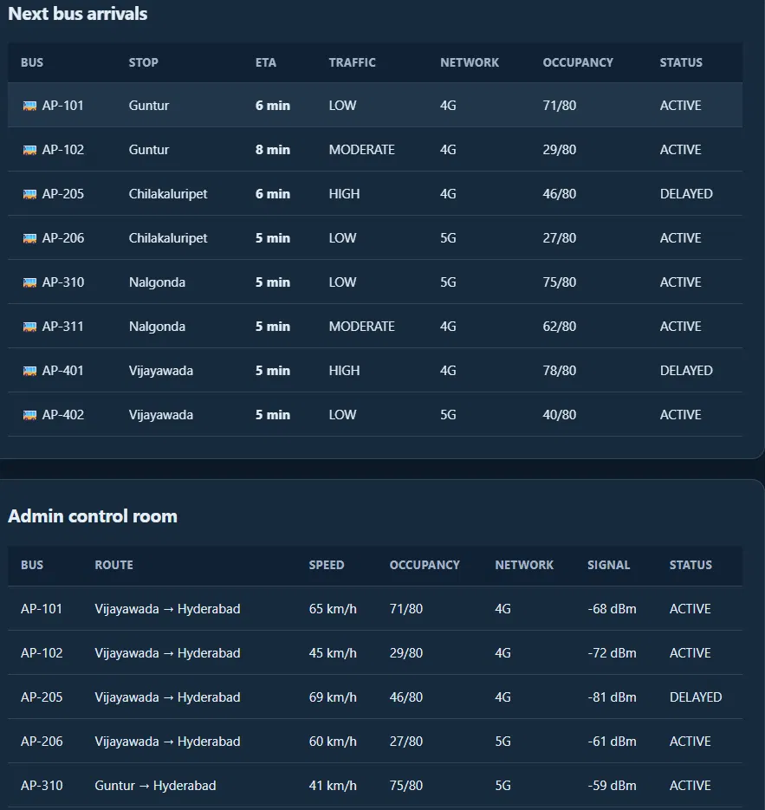

9.RESULT ANALYSIS

9.1 Result:
The Smart APSRTC – Live Location Bus Tracking System was successfully developed as a web-based prototype. The application provides an interactive dashboard to display bus information, route details, estimated arrival times, and network monitoring information.
The system displays the following results:
- Displays 10 sample buses in the dashboard.
- Shows active, offline, and delayed bus status.
- Provides bus searching and route filtering options.
- Displays bus locations on a map-style interface.
- Shows estimated arrival times and next bus stops.
- Provides destination navigation using Google Maps.
- Displays passenger occupancy and bus speed.
- Provides a communication center for driver and control-room messages.
- Displays network information such as latency, signal strength, and packet loss.
- Provides an SOS alert and notification interface.

9.2 Performance Analysis:
Parameter | Displayed Value
Active Buses | 10
Offline Buses | 0
Delayed Buses | 2
Latency | 66 ms
Packet Loss | 1.2%
Uptime | 99.4%
Messages | 1978

CONCLUSION :

The Smart APSRTC – Live Location Bus Tracking System is designed to improve public transportation services by providing bus information through a user-friendly web application. The project helps passengers access bus details, routes, estimated arrival times, and destination navigation.
The system includes important features such as bus searching, route filtering, bus status monitoring, passenger occupancy details, network monitoring, and Google Maps integration. It also provides an admin dashboard and communication center to support transportation management.
The project demonstrates how technologies such as HTML, CSS, JavaScript, GPS, and communication networks can be used to develop a smart transportation platform.
The current prototype successfully demonstrates the dashboard and its major functionalities using sample data and simulated bus movements. In the future, actual GPS devices, backend servers, and database connectivity can be integrated to provide real-time bus tracking.
Overall, the Smart APSRTC project provides a foundation for developing an intelligent, efficient, and passenger-friendly public transportation system.

REFERENCES :

1. APSRTC Official Website – Andhra Pradesh State Road Transport Corporation.
https://www.apsrtconline.in/
2. HTML5 Documentation – W3Schools.
https://www.w3schools.com/html/
3. CSS3 Documentation – W3Schools.
https://www.w3schools.com/css/
4. JavaScript Documentation – MDN Web Docs.
https://developer.mozilla.org/en-US/docs/Web/JavaScript
5. Google Maps Platform – Maps and Directions Documentation.
https://developers.google.com/maps/documentation
6. GPS Technology – Official GPS Information.
https://www.gps.gov/
7. Node.js Documentation – Server-side JavaScript Development.
https://nodejs.org/docs/
8. MongoDB Documentation – Database Management.
https://www.mongodb.com/docs/
9. Visual Studio Code – Development Environment.
https://code.visualstudio.com/docs
10. ESP32 Documentation – Espressif Systems.
https://docs.espressif.com/

